PROJECT PROPOSAL
IT Asset & Inventory
Log System
A Database Management System (DBMS) Project Proposal
Submitted By: MD Ahsanul Kabir Mohit - 2241091304
Sajedul hasan - 2241091323
Md Arman Khan - 2241091341

Himel Biswas - 2241091345

Department: Bachelor of Science in Computer Science and Engineering (B.Sc. in CSE)
Project Type: Database Management System (DBMS) Project
Duration: 6 – 8 Weeks
Version: 1.2
Submission Date: AUG 07, 2026
(Week 2 progress)

Submitted in partial fulfilment of the requirements of the Database Management Systems course

Database Design
The system is supported by a relational database consisting of three core tables, described below.

1 Table: Users
Field | Type | Description
UserID | INT (PK) | Unique identifier for each user
FullName | VARCHAR(100) | Full name of the employee
Department | VARCHAR(50) | Department the user belongs to
Email | VARCHAR(100) | Contact email address

2 Table: Assets
Field | Type | Description
AssetID | INT (PK) | Unique identifier for each asset
SerialNo | VARCHAR(100) | Manufacturer serial number
DeviceType | VARCHAR(50) | Category of hardware
Brand | VARCHAR(50) | Manufacturer / brand name
Model | VARCHAR(50) | Model number or name
PurchaseDate | DATE | Date of purchase
AssignedUserID | INT (FK) | References Users.UserID
Status | VARCHAR(30) | Operational / Under Repair / Retired

Entity Relationship Diagram (ERD)
The diagram below illustrates the relationships between the Users, Assets, and Log tables. Each user may be assigned multiple assets and each asset may have multiple records .

ER DIAGRAM OF IT ASSET INVENTORY LOG SYSTEM
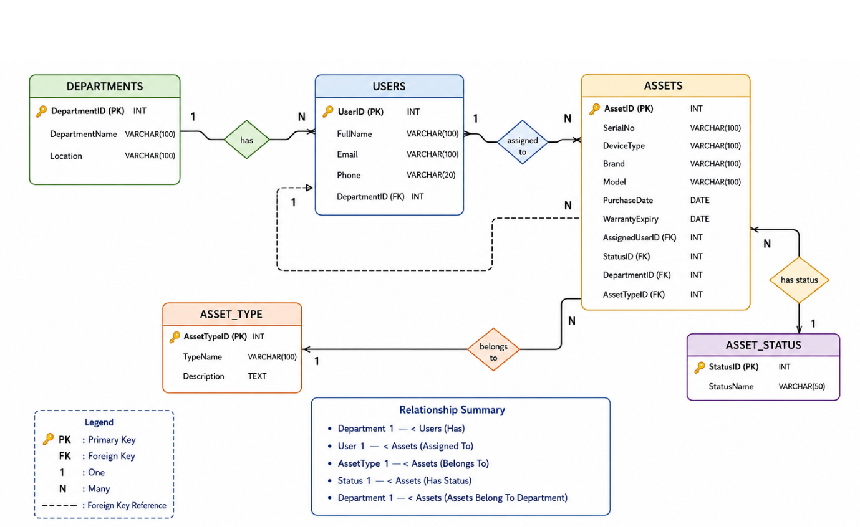

Technology Stack
Component | Technology
Frontend | HTML5
Styling | CSS3
Programming (Client-side) | JavaScript
Backend | PHP
Database | MySQL
Web Server | XAMPP
IDE | Visual Studio Code

Set up XAMPP & Create Database
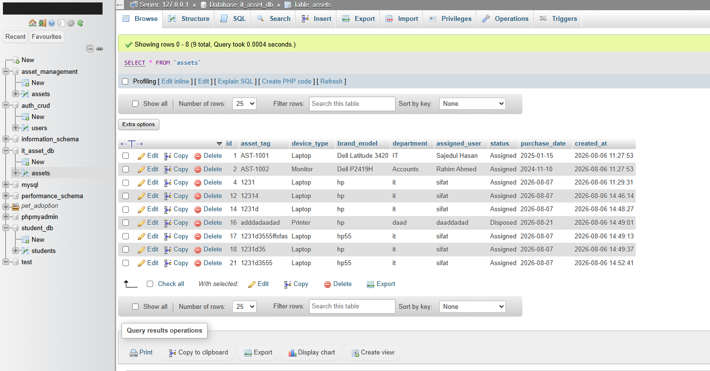

Website Interface

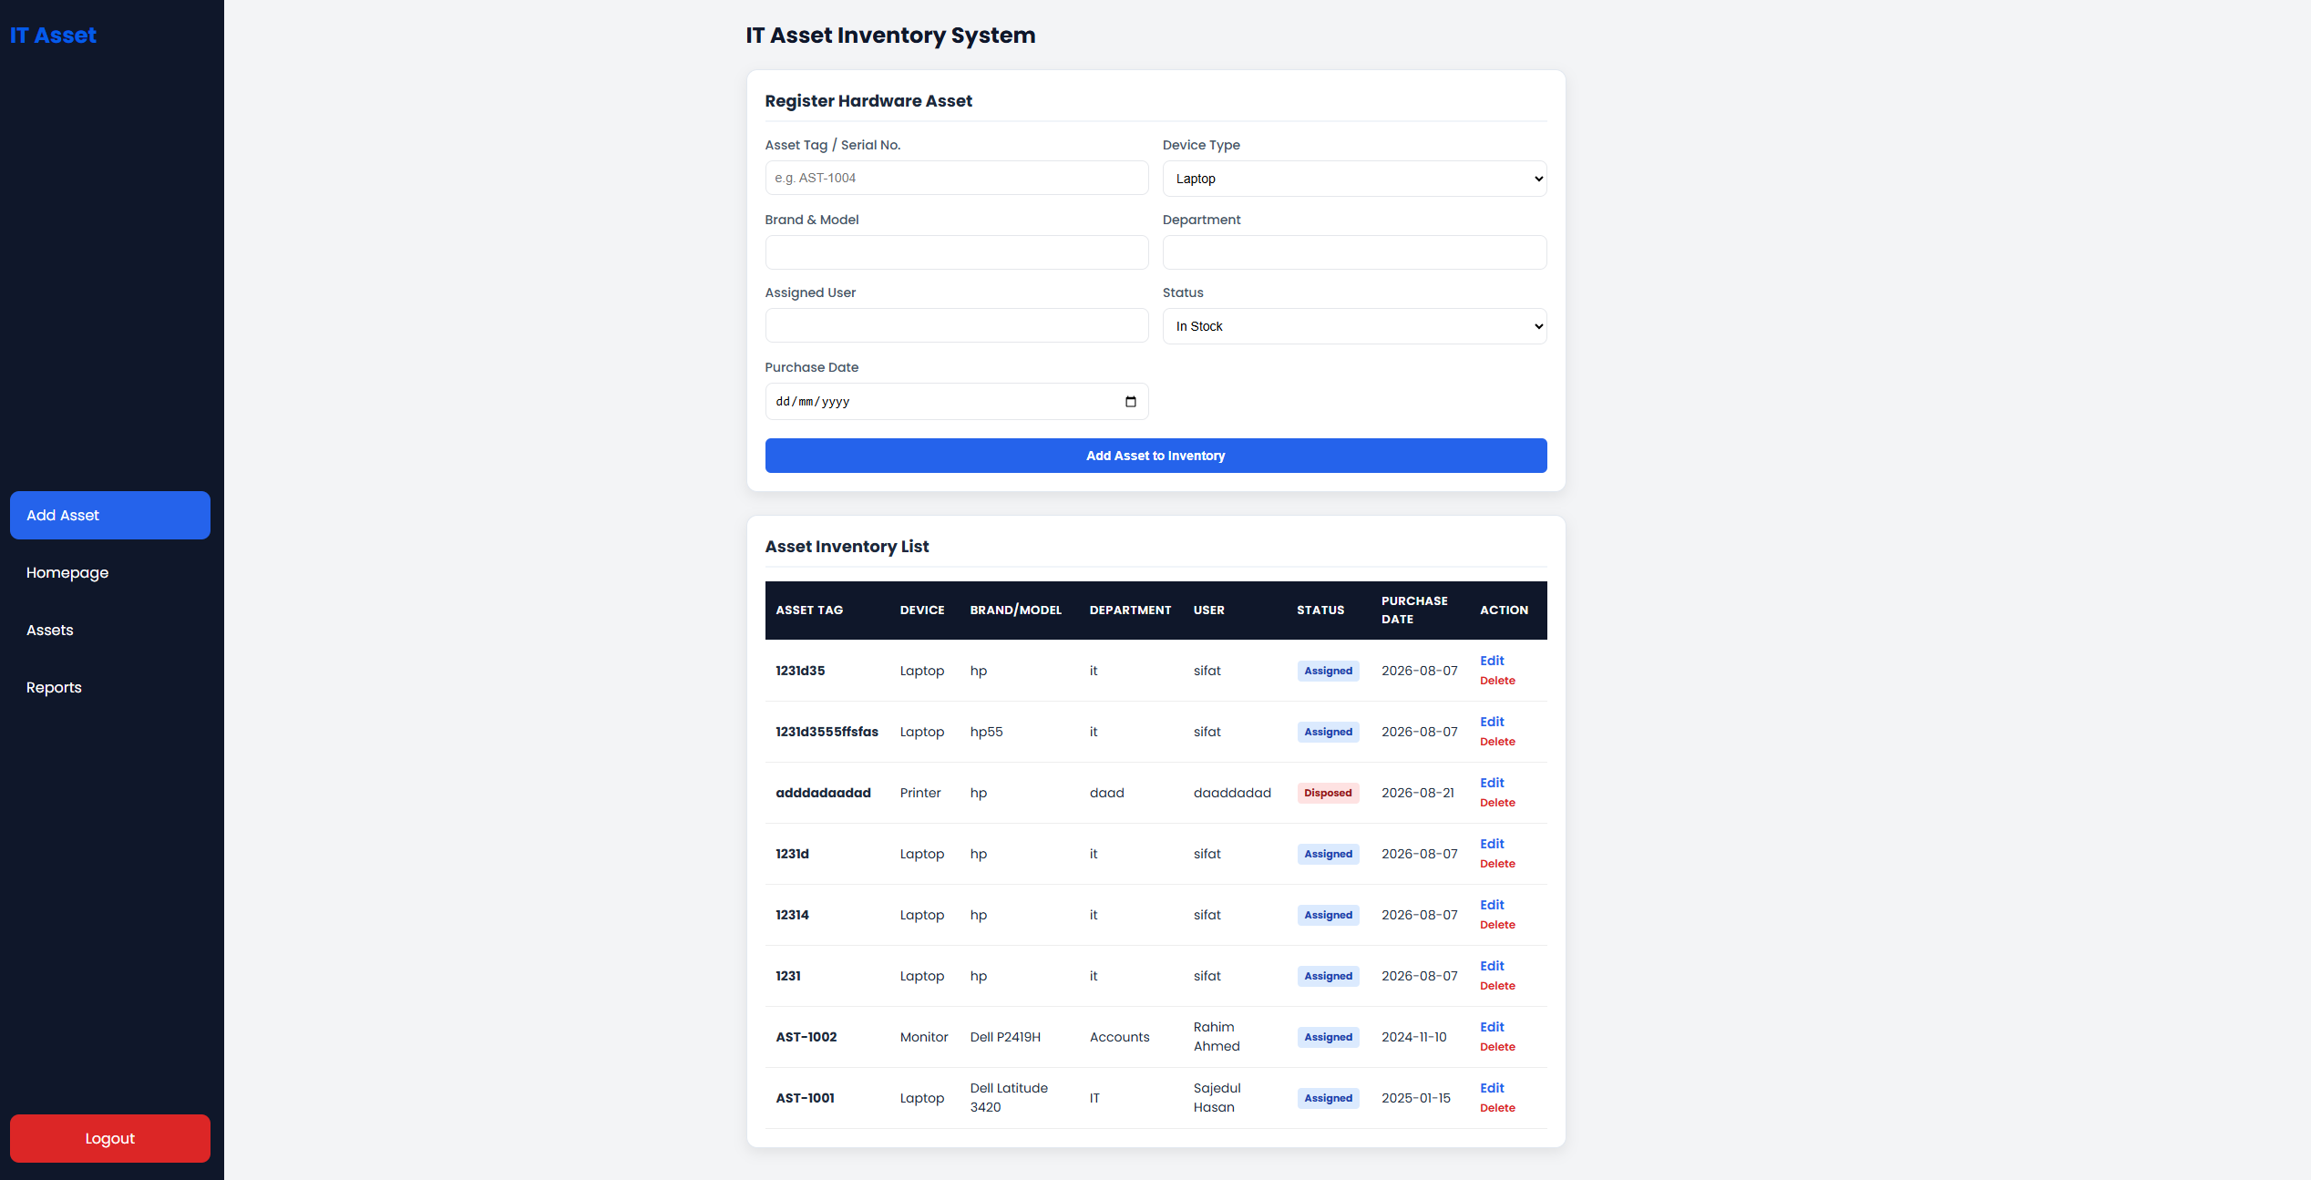

PHP logic for Insert, View, and Update

