Project Report on

University Network Design with FTP Server Using CPT

##### A Project Report

***Submitted in partial fulfillment for the award of the degree of***

## BACHELOR OF TECHNOLOGY

##### IN

**COMPUTER SCIENCE AND ENGINEERING**

***By***

# Vishvajeet (21001001913)

**Mohit Jangra (21001001908)**

**Under The Supervision of**

# Dr. Dinesh Singh

**(Professor, CSED)**



Session July-Dec 2023

**DEPARTMENT OF COMPUTER SCIENCE AND ENGINEERING**

### Deenbandhu Chhotu Ram University of Science and Technology, Murthal, Sonepat-131039

1

## DECLARATION

We hereby declare that the project entitled “**University Network Design with FTP Server Using Cisco Packet Tracer**” submitted by us in partial fulfillment of the requirement for the award of BACHELOR OF TECHNOLOGY Degree in COMPUTER SCIENCE AND ENGINEERING,

comprises our original work and due references have been made in text to all other material used.

Signature of the Students:

Vishvajeet (21001001913)

Mohit Jangra (21001001908)

Place: DCRUST, Murthal Date:

2

## CERTIFICATE

This is to certify that the project entitled “University Network Design with FTP Server Using Cisco Packet Tracer” is the bona fide work carried out by Vishvajeet (21001001913) and Mohit Jangra (21001001908) who are the students of B. Tech, DCRUST, Murthal, during the year 2023, in partial fulfillment of the requirements for the award of the Degree of Bachelor of Technology and that the project has not formed the basis for the award of any degree earlier.

Signature of the Guide: Dr. Dinesh Singh

Place: DCRUST, Murthal Date:

3

## ABSTRACT

Computer networks have a significant impact on the working of an organization. Universities depend on the proper functioning and analysis of their networks for education, administration, communication, e-library, automation, etc. An efficient network is essential to facilitate the systematic and cost-efficient transfer of information in an organization in the form of messages, files, and resources. The project provides insights into various concepts such as topology design, IP address configuration, and how to send information in the form of packets to the wireless networks of different areas of a university.

The aim of this project is to design the topology of the university network using the software Cisco Packet Tracer with the implementation of FTP (File Transfer Protocol) Server. This university network consists of the following devices:

Router (PT) Switches (PT) Email server (PT) DNS server (PT) WEB server (PT) FTP server (PT)

PCs and Laptops (PT) Printers (PT)

The design includes the following parts of the University:

* **Hostel Blocks**: Girls Block and Boys Block and Hospital
* **Academic Blocks**: MV, CVR and JCB
* Dome Building (UCC) and Library
* **Admin Block, Guest house**

4

## ACKNOWLEDGEMENTS

Acknowledgement is the perfect way to convey heartiest thanks to all outstanding personalities. We consider ourself fortunate to get the opportunity of doing a project, yet the opportunity could not have been utilized without the guidance and support of many individuals. We register our immense gratitude to project guide Dr. Dinesh Singh (CSE Dept.), DCRUST.

We are highly indebted to “Dr. Dinesh Singh” for giving us a rare opportunity to undertake this project.

We also extend our immense gratitude to “Dr. Sukhdeep Singh” (Chairperson of Computer Science Dept) for his kind help and support.

Finally, we would be failing to our duty if we did not put on record our deep sense of obligation to our parents and friends, who provided us an environment conducive to hard work.

5

|  |  |  |  |  |  |  |
| --- | --- | --- | --- | --- | --- | --- |
| **Table Of Content** | | | | | |  |
|  | 1. | Cover Page | 1 |  | |
| 2. | Declaration & Certificate | 2-3 |
| 3. | Abstract & Acknowledgement | 4-5 |
| 4. | Table of Content | 6-7 |
| 5. | Chapter 1: Introduction | 8-10 |
| 6. | Chapter 2: Literature Review | 11-16 |
| 7. | Chapter 3: Work Done | 17-20 |
| 8. | Chapter 4: Results and Discussion | 21-37 |
| 9. | Chapter 5: Conclusions and Future Work | 38 |
| 10. | Chapter 6: References | 39 |
|  | | |  | |
|  | | | | |  |  |
|  | | | | | 6 | |

|  |  |  |  |  |  |
| --- | --- | --- | --- | --- | --- |
| **Table Of Figures** | | | | |  |
|  | 1. | Figure 1: Devices used in the network | 18 |  |
| 2. | Figure 2: Router Config. | 19 |
| 3. | Figure 3: The complete diagram of the University Network Scenario created in CPT | 21 |
| 4. | Figure 4: Final simulation to check all the connections | 22 |
| 5. | Figure 5: Ping test 1  Figure 6: Ping test 2 | 23  24 |
| 6. | Figure 7: HTTP/WEB Server | 25 |
| 7. | Figure 8: DNS Server | 26 |
| 8. | Figure 9: Email Server  Figure 10: Email Server (Sender Side) Figure 11: Email Server (Receiver Side) | 27  28  29 |
| 9. | Figure 12: FTP Server  Figure 13: FTP Server (User vishu) Figure 14: FTP Server (User staff)  Figure 15: FTP Server (get command for file transfer) | 30  31  32  33 |
| 10. | Figure 16: MV Block Figure 17: CVR Block  Figure 18: JCB Block | 34 |
| 11. | Figure 19: ADMIN Block Figure 20: UCC Block | 35 |
| 12. | Figure 21: Boys Hostel  Figure 22: Girls Hostel Figure 23: Guest House | 36 |
| 13. | Figure 24: Final Network Design | 37 |
|  | | |  |
|  | | | |  |  |
|  | | | | 7 | |

## CHAPTER 1

**INTRODUCTION**

A university network serves as the backbone of communication and information exchange within an academic institution. It is a complex infrastructure that interconnects various departments, faculty, students, and administrative offices, facilitating seamless collaboration, access to resources, and the sharing of information. The importance of a well-designed and robust university network cannot be overstated in today's digital age, where technology plays a central role in education, research, and administrative processes.

Motivation to Use FTP Servers in a University Network:

1. **Academic Resource Sharing:**

A university network often involves the sharing of academic resources such as lecture notes, research papers, and study materials. FTP servers provide a secure and organized platform for students and faculty to access and contribute to these shared resources.

1. Collaborative Research:

Universities engage in extensive research activities, and collaborative efforts often require the exchange of large datasets, research papers, and other files. FTP servers facilitate efficient data sharing, enabling researchers to collaborate seamlessly across departments and institutions.

1. Course Material Distribution:

Professors and instructors can use FTP servers to distribute course materials, assignments, and supplementary resources to students. This ensures that students have centralized access to the latest educational materials.

1. Remote Access for Students:

Students, especially those engaged in distance learning or remote study programs, can benefit from FTP servers to access course materials, submit assignments, and interact with university resources from any location with an internet connection.

8

1. Administrative Document Management:

University administrations generate and manage a vast number of documents related to student records, admissions, financial transactions, and more. FTP servers provide a secure platform for storing, organizing, and sharing these administrative documents among authorized personnel.

1. Backup and Recovery:

The critical nature of academic and administrative data in a university necessitates robust backup solutions. FTP servers can serve as a secure backup repository, ensuring that essential data is regularly backed up and can be recovered in the event of data loss or system failures.

1. Secure File Transfers:

With the option to implement secure variants such as FTPS or SFTP, universities can ensure that sensitive data, including research findings and student records, is transmitted securely over the network, safeguarding it from unauthorized access.

1. Media and Content Distribution:

Universities often produce multimedia content, including recorded lectures, presentations, and educational videos. FTP servers can efficiently handle the distribution of such content, allowing students and faculty to access and download multimedia resources as needed.

1. Remote Server Management:

IT administrators can utilize FTP servers for remote server management tasks, allowing them to update software, apply patches, and perform maintenance activities without physically accessing every server on the campus network.

1. Integration with Learning Management Systems (LMS):

Many universities use Learning Management Systems to deliver courses and manage educational content. FTP servers can seamlessly integrate with these systems, providing a reliable means for content storage and retrieval.

9

* + Project Objectives: -

1. FTP Server Implementation:
   * Introduce a dedicated File Transfer Protocol (FTP) server to streamline the exchange of academic resources, research data, and administrative documents within the university network.
   * Facilitate secure and organized file transfers, enabling students, faculty, and administrators to share and access resources seamlessly.
2. DNS Infrastructure Enhancements:
   * Strengthen the Domain Name System (DNS) infrastructure to improve the speed, reliability, and overall performance of domain resolution within the university network.
   * Optimize DNS configurations to ensure efficient routing of network traffic and enhance the user experience for students, faculty, and staff.
3. Centralized Email Server:
   * Establish a centralized Email Server to enhance communication and collaboration among university members.
   * Implement advanced email security measures to protect against phishing, malware, and unauthorized access, ensuring the confidentiality and integrity of university communications.
4. HTTP Server Implementation:
   * Introduce a dedicated Hypertext Transfer Protocol (HTTP) server to centralize the hosting of web-based educational content, academic resources, and multimedia materials.
   * Enhance the accessibility and delivery of online content, supporting the evolving needs of digital education and providing students with a seamless learning experience.

10

## CHAPTER 2 LITERATURE REVIEW

* What is Packet Tracer?

Packet Tracer is a cross-platform visual simulation tool designed by Cisco Systems that allows users to create network topologies and imitate modern computer networks. The software allows users to simulate the configuration of Cisco routers and switches using a simulated command-line interface. Packet Tracer makes use of a drag-and-drop user interface, allowing users to add and remove simulated network devices as they see fit. The software is mainly focused on Certified Cisco Network Associate Academy students as an educational tool for helping them learn fundamental CCNA concepts. Previously students enrolled in a CCNA Academy program could freely download and use the tool free of charge for educational use.

* Router

A router is a device like a switch that routes data packets based on their IP addresses. The router is mainly a Network Layer device. Routers normally connect LANs and WANs together and have a dynamically updating routing table based on which they make decisions on routing the data packets. Router divides broadcast domains of hosts connected through it.

* Switch

A network switch (also called switching hub, bridging hub, officially MAC bridge is networking hardware that connects devices on a computer network by using packet switching to receive and forward data to the destination device. A network switch is a multiport network bridge that uses MAC addresses to forward data at the data link layer (layer 2) of the OSI model. Some switches can also forward data at the network layer (layer 3) by additionally incorporating routing functionality. Such switches are commonly known as layer-3 switches or multilayer switches.

11

* Network Packet

A network packet is a formatted unit of data carried by a packet-switched network. A packet consists of control information and user data, which is also known as the payload.

* Wireless Network

A wireless network broadcasts an access signal to the workstations or PCs. This enables mobility among laptops, tablets, and PCs from room to room while maintaining a firm network connection continuously. A wireless network also presents additional security requirements.

* Server

A server is a computer or system that provides resources, data, services, or programs to other computers, known as clients, over a network. In theory, whenever computers share resources with client machines, they are considered servers. There are many types of servers, including web servers, mail servers, and virtual servers.

Many networks contain one or more of the common servers. The servers used in our project are as follows:

* + DNS Server

DNS stands for Domain Name System servers which are application servers that provide a human-friendly naming method to the user computers in order to make IP addresses readable by users. The DNS system is a widely distributed database of names and other DNS servers, each of which can be used to request an otherwise unknown computer name. When a user needs the address of a system, it sends a DNS request with the name of the desired resource to a DNS server. The DNS server responds with the necessary IP address from its table of names.

12

* + WEB Server

One of the widely used servers in today’s market is a web server. A web server is a special kind of application server that hosts programs and data requested by users across the Internet or an intranet. Web servers respond to requests from browsers running on client computers for web pages, or other web-based services.

* + EMAIL Server

An e-mail server is a server that handles and delivers e-mail over a network, using standard email protocols. For example, the SMTP protocol sends messages and handles outgoing mail requests. The POP3 protocol receives messages and is used to process incoming mail. When you log on to a mail server using a webmail interface or email client, these protocols handle all the connections behind the scenes.

* Ethernet

This is the backbone of our network. It consists of the cabling and is typically able to Transfer data at a rate of 100mb/s. It is a system for connecting a number of computer systems to form a local area network, with protocols to control the passing of information and to avoid simultaneous transmission by two or more systems. Among the different types of ethernet, we have used Gigabit Ethernet, which is a type of Ethernet network capable of transferring data at a rate of 1000 Mbps and fast Ethernet is a type of Ethernet network that can transfer data at a rate of 100 Mbps.

* Computing Device

Computing devices are the electronic devices that take user inputs, process the inputs, and then provide us with the end results. These devices may be Smartphones, PC Desktops, Laptops, printer, and many more.

13

* Internet Protocol

Internet Protocol (IP) is one of the fundamental protocols that allow the internet to work. IP addresses are a unique set of numbers on each network and they allow machines to address each other across a network. It is implemented on the internet layer in the IP/TCP model.

* SSH Protocol

Secure Shell enables a user to access a remote device and manage it remotely. However, with SSH, all data transmitted over a network (including usernames and passwords) is encrypted and secure from eavesdropping.

SSH is a client-server protocol, with an SSH client and an SSH server. The client machine (such as a PC) establishes a connection to an SSH server running on a remote device (such as a router). Once the connection has been established, a network admin can execute commands on the remote device.

* Simulation Environment

The simulations of our network topology can be easily achieved using cisco packet tracer. Using a simulation mode, you can see packets flowing from one node to another and can also click on a packet to see detailed information about the OSI layers of the networking. Packet Tracer offers a huge platform to combine realistic simulation and visualize them simultaneously. Cisco Packet Tracer makes learning and teaching significantly easier by supporting multi-user collaboration and by providing a realistic simulation environment for experimenting with projects.

14

# FTP Server

Purpose:

* + An FTP server is designed to facilitate the exchange of files between computers on a network.
  + It enables users to upload (send) or download (receive) files to and from a server.

Client-Server Model:

* + FTP operates on a client-server model where the server stores the files and the client accesses them.
  + The client initiates a connection to the server and requests file transfers.

Authentication:

* + Users typically need to authenticate themselves with a username and password to access the FTP server.
  + Some FTP servers support anonymous logins, allowing users to connect without a username or password, but with limited access.

Modes of FTP:

* + FTP operates in two modes: Active mode and Passive mode. In Active mode, the client opens a random port for data transfer, while in Passive mode, the server opens a port for data transfer.

File Management:

* + FTP servers allow users to create, delete, rename, and organize directories (folders) and files on the server.
  + Common operations include uploading (put), downloading (get), deleting, and moving files.

Security:

* + FTP can operate in a secure mode called FTPS (FTP Secure) which adds encryption to the

15

data transfer process.

* + SFTP (SSH File Transfer Protocol) is another secure alternative that uses the Secure Shell (SSH) protocol for encryption.

Bandwidth Control:

* + Some FTP servers provide features for managing bandwidth, allowing administrators to control and limit the amount of network resources dedicated to FTP transfers.

Logging and Monitoring:

* + FTP servers often keep logs of user activities, providing administrators with information about who accessed the server, when, and what operations were performed.
  + Monitoring tools may be available to track server performance and resource usage.

User Permissions:

* + FTP servers support user permissions and access controls to restrict or allow certain actions for different users or groups.
  + This ensures that users only have access to the files and directories they are authorized to use.

Passive Mode and NAT:

* + Passive mode is often used in scenarios involving Network Address Translation (NAT) as it helps overcome some of the challenges associated with firewalls and dynamic IP addresses.

FTP servers are widely used for various purposes, such as website maintenance, software distribution, and general file sharing across networks.

16

## CHAPTER 3 WORK DONE

In order to make our project understandable, we have divided the content into steps. They are as follow: -

1. Software and hardware requirements

Before heading towards the implementation, we need to make sure of the following requirements.

* + A proper workstation (any mid-high range laptop will suffice).
  + Packet Tracer by Cisco
  + 8 GB RAM.
  + Any 10,000+ Average CPU Mark scored processor.
  + 16 GB of dedicated hard disk space.
  + USB 3.0+ port.

1. Network Requirements

DCRUST MURTHAL University outline is considered for this university network. The network is divided into 2 areas:

##### Campus Area

The Campus area is further divided into various accessing points like: -

* + Academic Blocks: MV and CVR and JCB
  + Dome Building (UCC) and Library
  + Admin Block, Guest house

##### Hostel Area

The Hostel area is further divided into Boys blocks and Girls blocks respectively: -

* + Hostel Blocks: Girls Block, Boys Block and Hospital

17

|  |  |  |  |  |  |  |
| --- | --- | --- | --- | --- | --- | --- |
| **3. Devices Used in The Network** | | | | | |  |
|  | Devices | | Quantity |  | |
| 1) | Router (PT) | 3 |
| 2) | Switches (PT) | 8 |
| 3) | Email server (PT) | 1 |
| 4) | DNS server (PT) | 1 |
| 5) WEB server (PT) | | 1 |
| 6) | FTP server (PT) | 1 |
| 7) | PCs (PT) | 25 |
| 8) | Laptops (PT) | 1 |
| 9) | Printers (PT) | 6 |
| Figure 1: Devices used in the network | | |  | |
|  | | | | |  |  |
|  | | | | | 18 | |

1. Implementation and Flow Diagram
   * To design the network of the university we initially started by placing the core devices into the frame as mentioned in the layout.
   * Firstly, we placed the **main router** at the center of the university outline, which was further connected to the **server switch** using the gigabit ethernet port with copper straight-through cable and sub routers (**campus router and hostel router**) using the serial port with serial DCE cable at the hostel area and campus area respectively.
   * The server switch was further connected to the **EMAIL, DNS, WEB and FTP**

servers respectively.

* + Campus router was connected to the campus switch of the academic block (**MV, JCB and CVR**), **dome building**, **library, Admin Block** and **Guest House.**
  + The switches were then connected to computing devices (PCs, laptops, and printers).
  + Similarly, the hostel router was connected to the hostel switch of boys block and girls block with hospital.
  + The switches were then connected to the computing devices (PCs, laptops, and printers), every area has a dedicated switch.
  + All these connections are made through ethernet ports (gigabit ethernet and fast ethernet) using copper straight-through cables

19

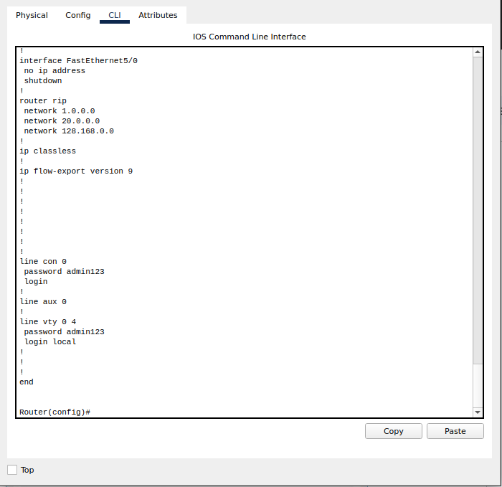

###### Figure 2: Router Config.

20

## CHAPTER 4 RESULT & DISCUSSION

Finally, we have combined all the steps as mentioned in chapter 3 (work done) and implemented

the desired network for university. We have the complete network providing various facilities to the teaching staff, non-teaching staff, and students.

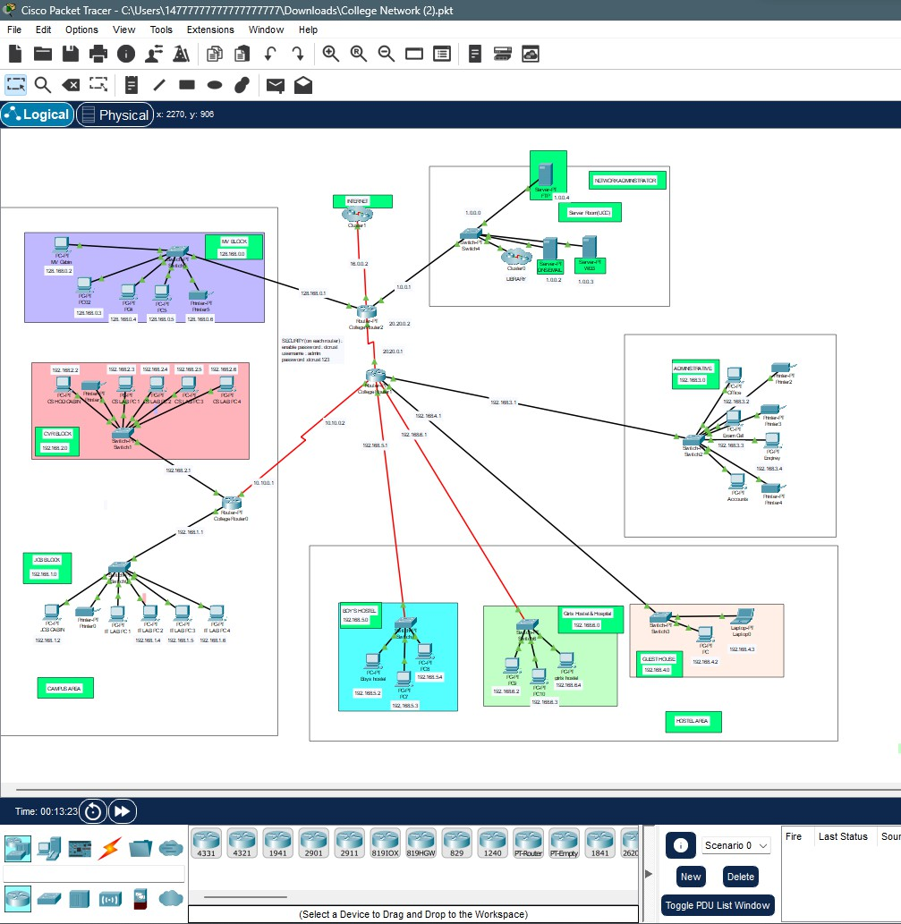

###### Figure 3: The complete diagram of the University Network Scenario created in CPT

21

##### Final Simulation

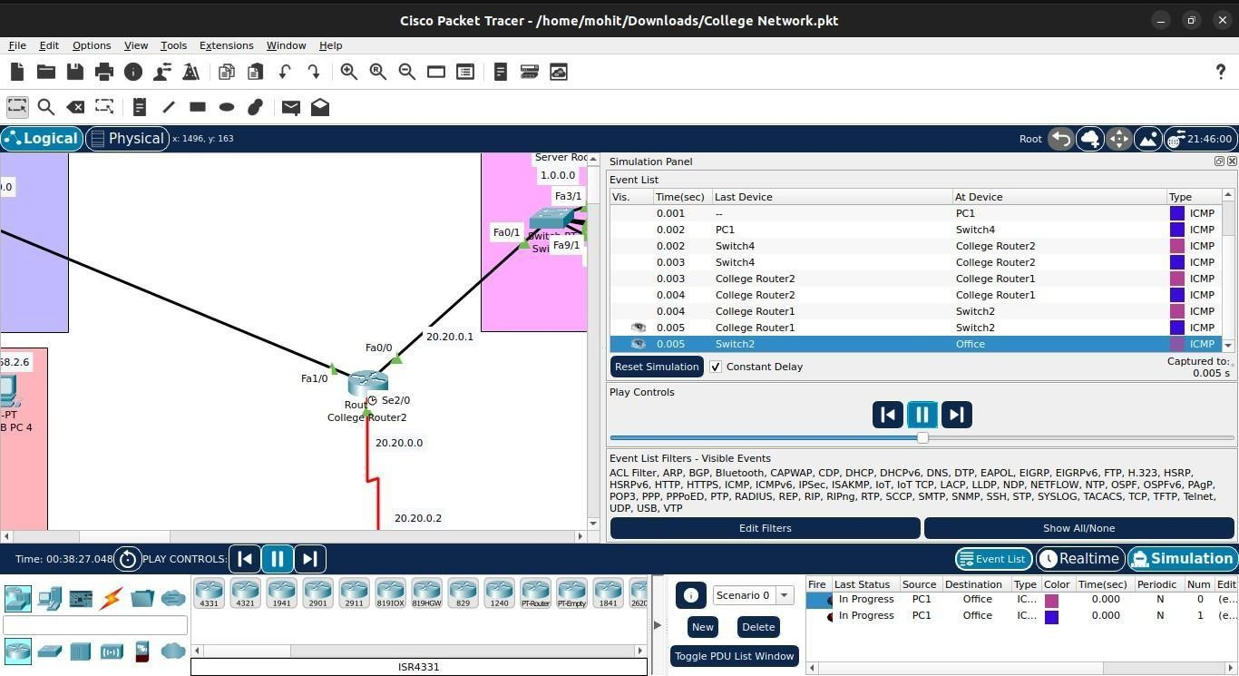

In Simulation Mode, you can watch your network run at a slower pace, observing the paths that packets take and inspecting them in detail. The proposed architecture, when simulated on Cisco Packet Tracer, produced results which are demonstrated as follows:

###### Figure 4: Final simulation for the network system to check all the connections

22

##### Ping Test:

Network connectivity and communication can be tested using the ping command, followed by the domain name or the IP address of the device (equipment) whose connectivity one wishes to verify.

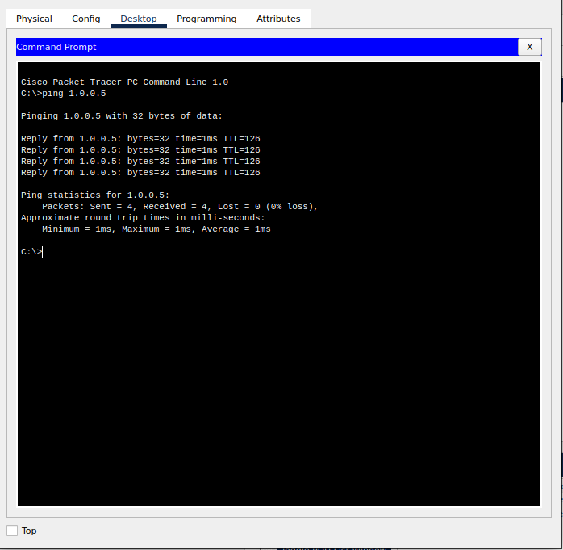

###### Figure 5: Ping test 1

23

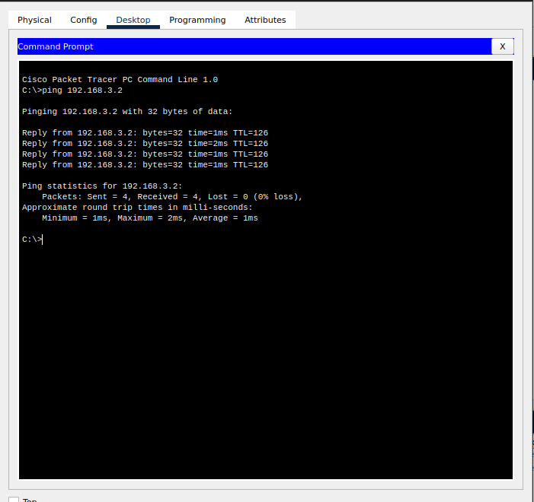

###### Figure 6: Ping test 2

24

##### HTTP/Web Server:

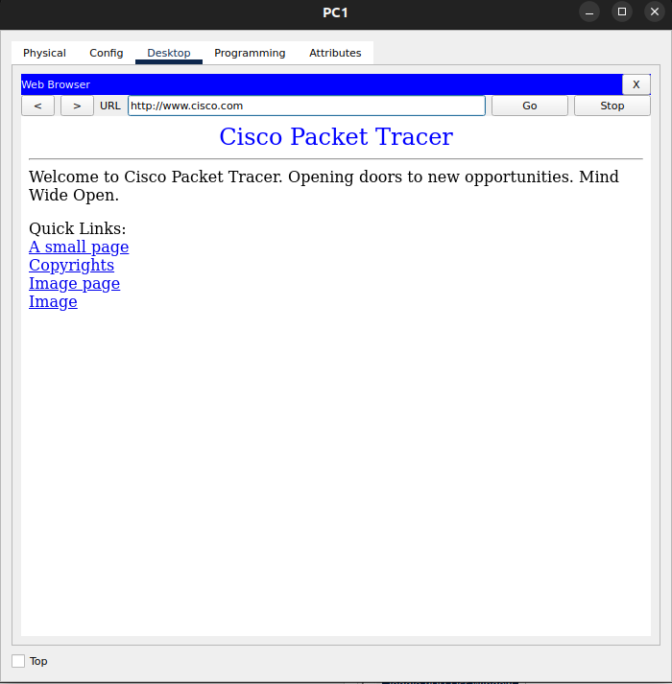

###### Figure 7: HTTP/WEB Server

25

##### DNS Server:

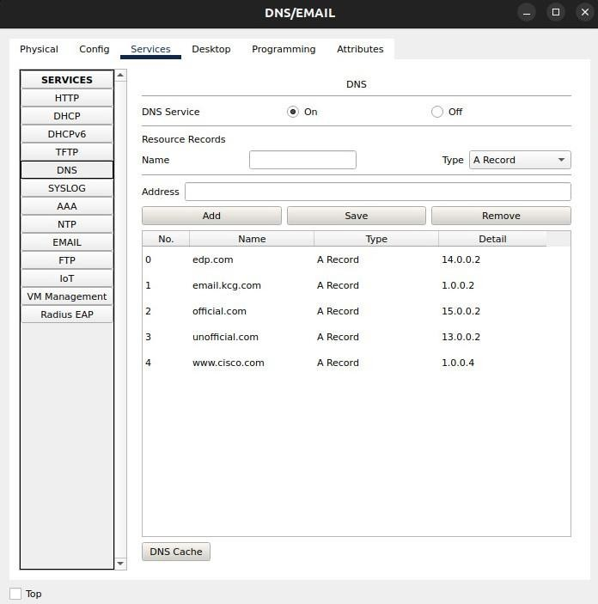

###### Figure 8: DNS Server

26

##### Email Server:

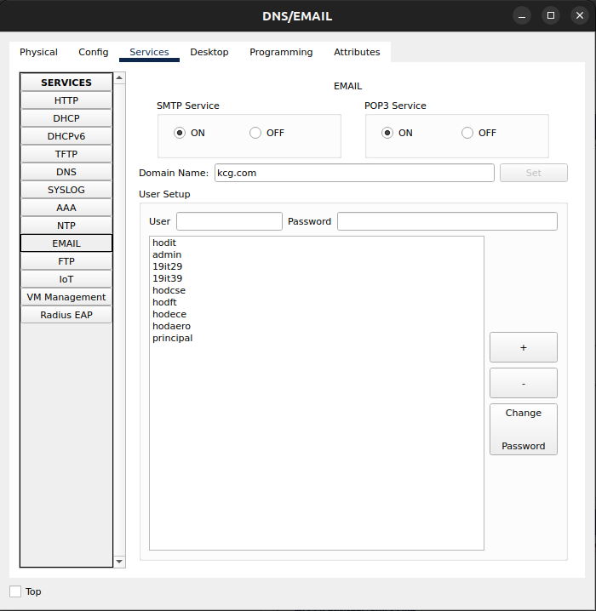

###### Figure 9: Email Server

27

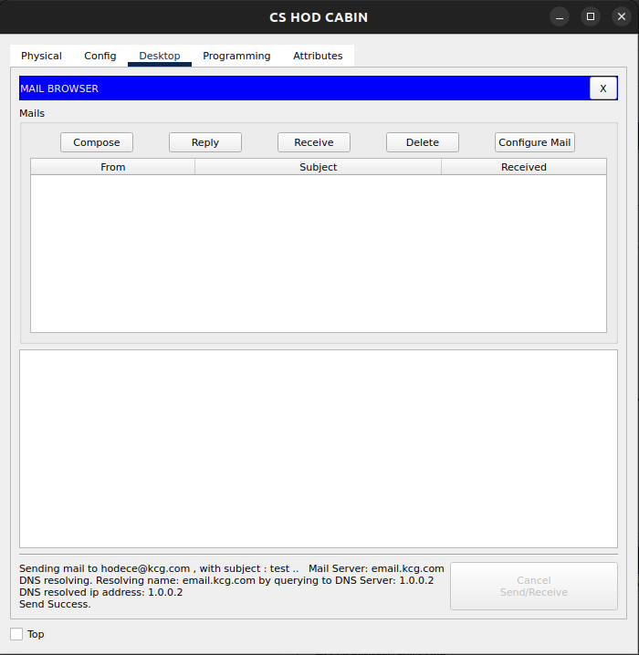

###### Figure 10: Email Server (Sender Side)

28

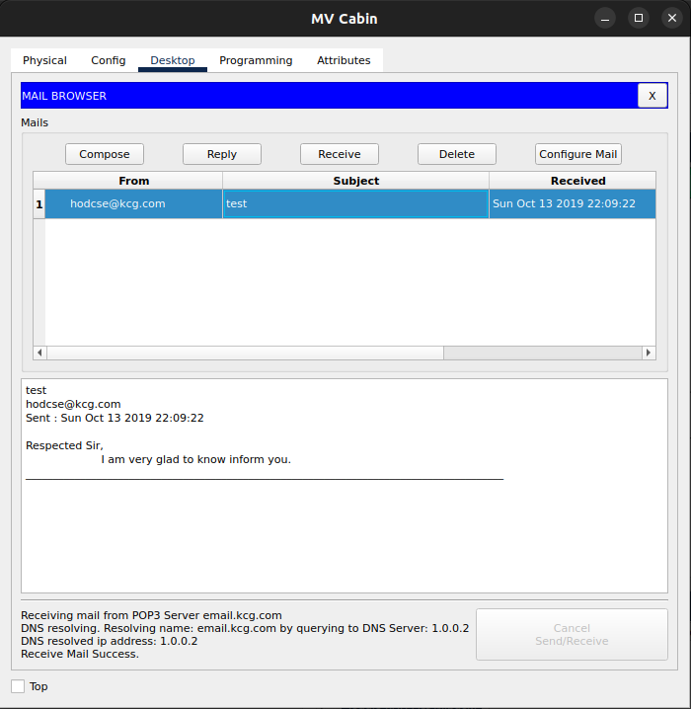

###### Figure 11: Email Server (Receiver Side)

29

##### FTP Server:

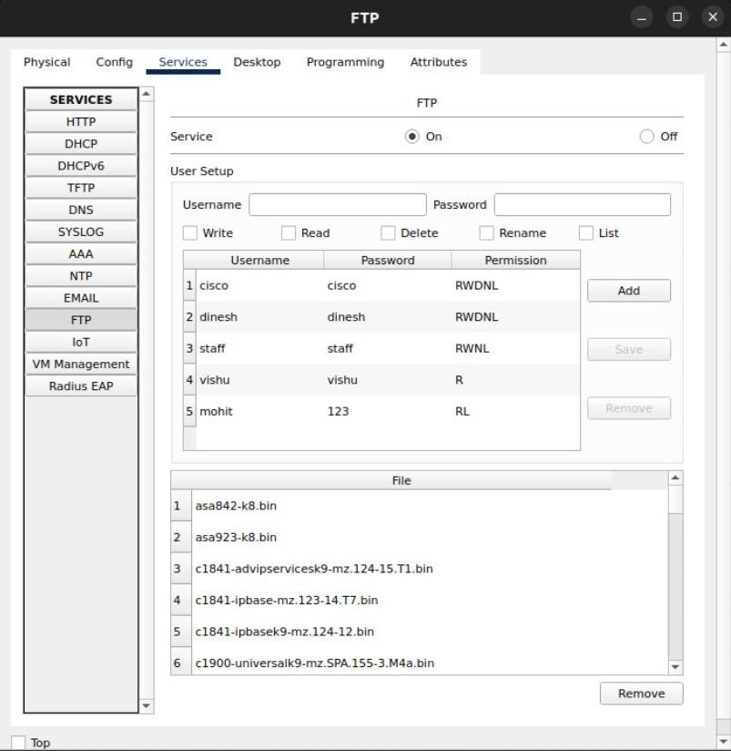

###### Figure 12: FTP Server

30

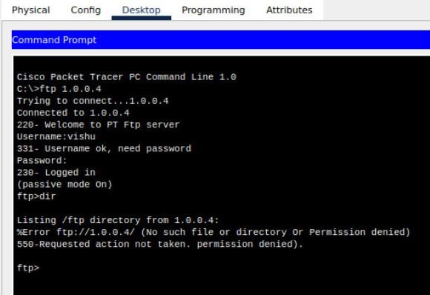

###### Figure 13: FTP Server (User visnu)

31

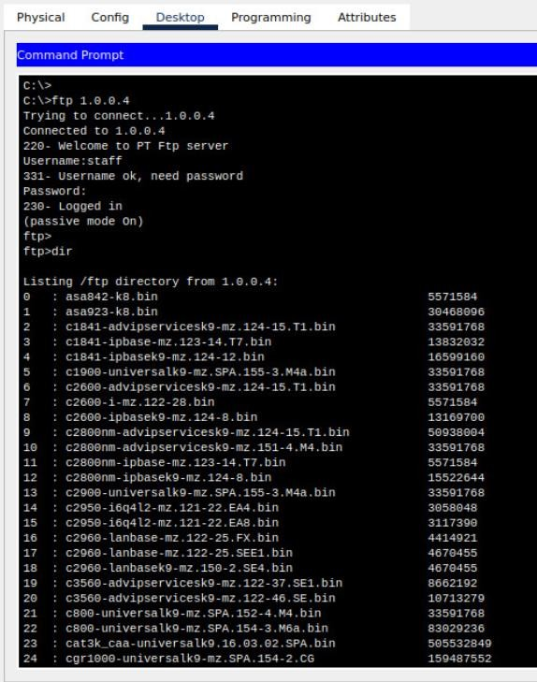

###### Figure 14: FTP Server (User staff)

32

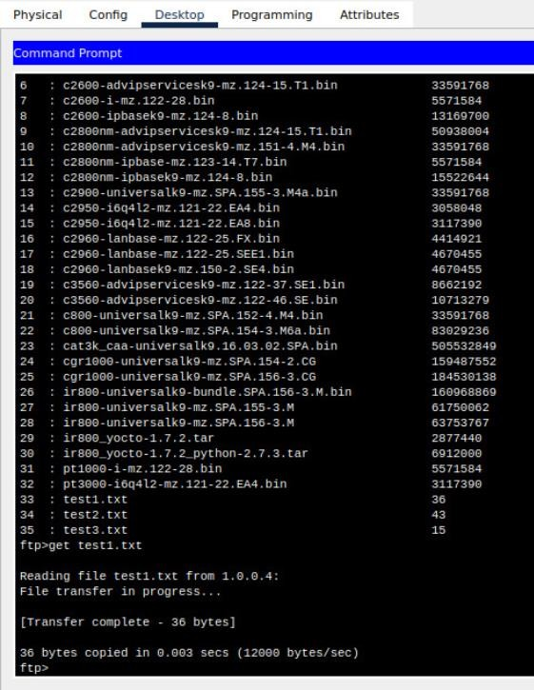

###### Figure 15: FTP Server (get command for file transfer

33

#### Logical View – (CAMPUS AREA)

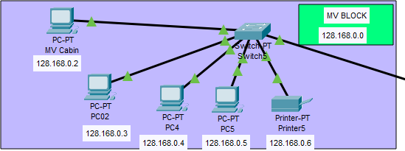

Figure 16: MV Block

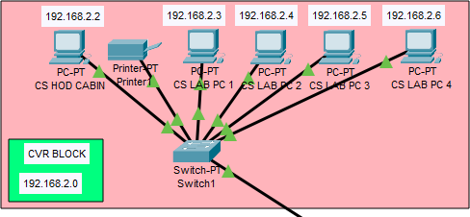

Figure 17: CVR Block

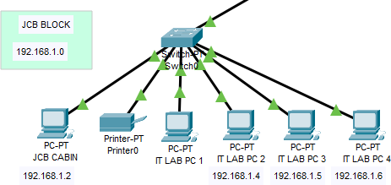

Figure 18: JCB Block

34

#### Logical View – (ADMIN BLOCK)

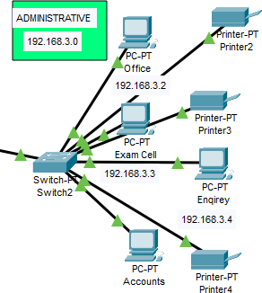

Figure 19: ADMIN Block

#### Logical View – (UCC or NETWORK ADMIN)

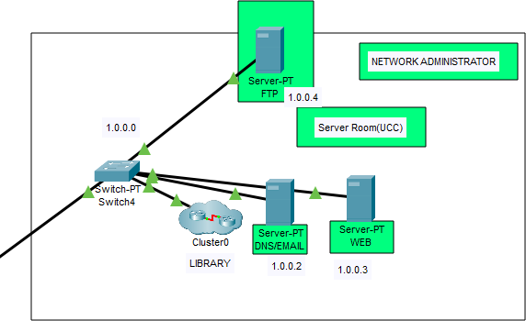

###### Figure 20: UCC Block

35

#### Logical View – (HOSTAL AREA)

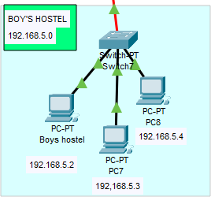

Figure 21: Boys Hostel

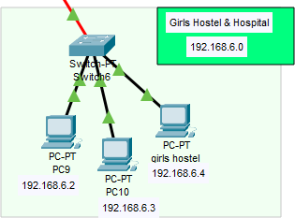

Figure 22: Girls Hostel

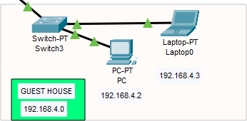

Figure 23: Guest House

36

##### Final Network Design –

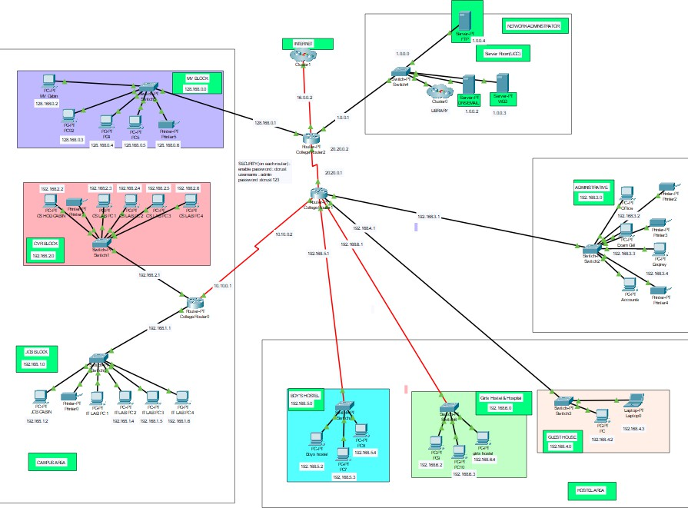

###### Figure 24: Finally Whole Design

37

## CHAPTER 5 CONCLUSION AND FUTURE WORK

* Conclusion

In this project, we designed a University Network using Cisco Packet Tracer that uses a networking topology implemented using servers, routers, switches, and end devices in a multiple area network.

We have covered all the necessary features that are required for a network to function properly. We have included a DNS server and a WEB server for establishing a smooth communication system between different areas of our network and specifically for the communication between students and teachers.

We have included an EMAIL server to facilitate intra university communication through emails within the domain.

An FTP server is also used to facilitate the exchange of files between computers on a network. It enables users to upload (send) or download (receive) files to and from a server. We have used console passwords and ssh protocol to ensure a safe and secure transfer of data.

* Future Work

The configuration and specifications are for the initial prototype and can further be developed and additional functionality can be added to increase support and coverage of our existing network.

38

## CHAPTER 6 REFFERENCES

### Cisco Packet Tracer: -

Link: <https://en.wikipedia.org/wiki/Packet_Tracer>

### Concepts: -

Link: <https://www.paessler.com/it-explained/server>

### Router Config: -

Link: [http://router.over-blog.com/article-how-to-configure-](http://router.over-blog.com/article-how-to-configure-cisco-router-password-106850439.html) [cisco-router-password-106850439.html](http://router.over-blog.com/article-how-to-configure-cisco-router-password-106850439.html)

**Project Files: -** Link:[https://drive.google.com/drive/folders/1mZsXkz7BWrM](https://drive.google.com/drive/folders/1mZsXkz7BWrMX0-zT7S2Bun1trMYwhk6s?usp=drive_link) [X0-zT7S2Bun1trMYwhk6s?usp=drive_link](https://drive.google.com/drive/folders/1mZsXkz7BWrMX0-zT7S2Bun1trMYwhk6s?usp=drive_link)

39