A 1 GS/s Preamplified StrongARM Comparator with 6 mV Offset and 20 mV Kickback in 90 nm CMOS
Mohit Kumar Gupta · B.Tech ECE (4th Year), NIT Andhra Pradesh · Roll No. 623148
1. Overview
A clocked comparator decides whether its input is above or below a reference on every clock edge. It is the building block of every flash and SAR converter, and its two non-idealities, input offset and kickback into the reference, set the resolution of the converter around it. This work designs, sizes and characterises a comparator cell in Cadence gpdk090 at 1.2 V for a 1 GHz clock: a resistively loaded preamplifier followed by a StrongARM latch, inverter buffers and a NOR SR latch. The cell is intended as the quantiser element of a flash converter whose reference comes from a resistor ladder of about 1 kΩ tap impedance, which is why kickback into the reference is specified alongside offset.Three versions were measured before the cell was frozen. A bare StrongARM latch with a minimum-area input pair gave σ = 8.7 mV of offset. Enlarging the pair nine-fold brought the offset to σ ≈ 4 mV but raised the kickback on the reference node to 160 mV. The preamplifier resolves both: σ = 6.2 mV, 19.5 mV of kickback, 120 ps clock-to-Q, and a fixed 1.0 V common mode for the latch regardless of where the reference sits.
2. Specification
Table 1. Target specification and achieved performance, tt, 1.2 V, 27 °C unless stated.
Parameter | Target | Achieved | Status
Technology / supply | gpdk090, 1.2 V | gpdk090, 1.2 V | Met
Clock | 1 GHz | 1 GHz (functional to 2 GHz) | Met
Input common-mode range | 0.5 – 0.95 V | 0.45 – 0.95 V, gain flat to ±1.5 % | Met
Input offset, 1σ (mismatch) | ≤ 6 mV | 6.2 mV (N = 168) | Marginal
Input offset, nominal | < 1 mV | 15 µV | Met
Hysteresis | < 1 mV | < 0.5 mV | Met
Kickback on 1 kΩ / 100 fF reference | < 20 mV p-p | 19.5 mV p-p | Met
Clock-to-Q at ΔV = 5 mV | < 300 ps | 120 ps (latch), ≈ 170 ps with preamplifier | Met
Minimum resolvable input | < 1 mV | < 1 mV | Met
Power at 1 GHz | < 300 µW | ≈ 220 µW | Met
Process corners | FF / SS / SF / FS, −40 – 85 °C | correct decisions, both polarities | Met
3. Architecture
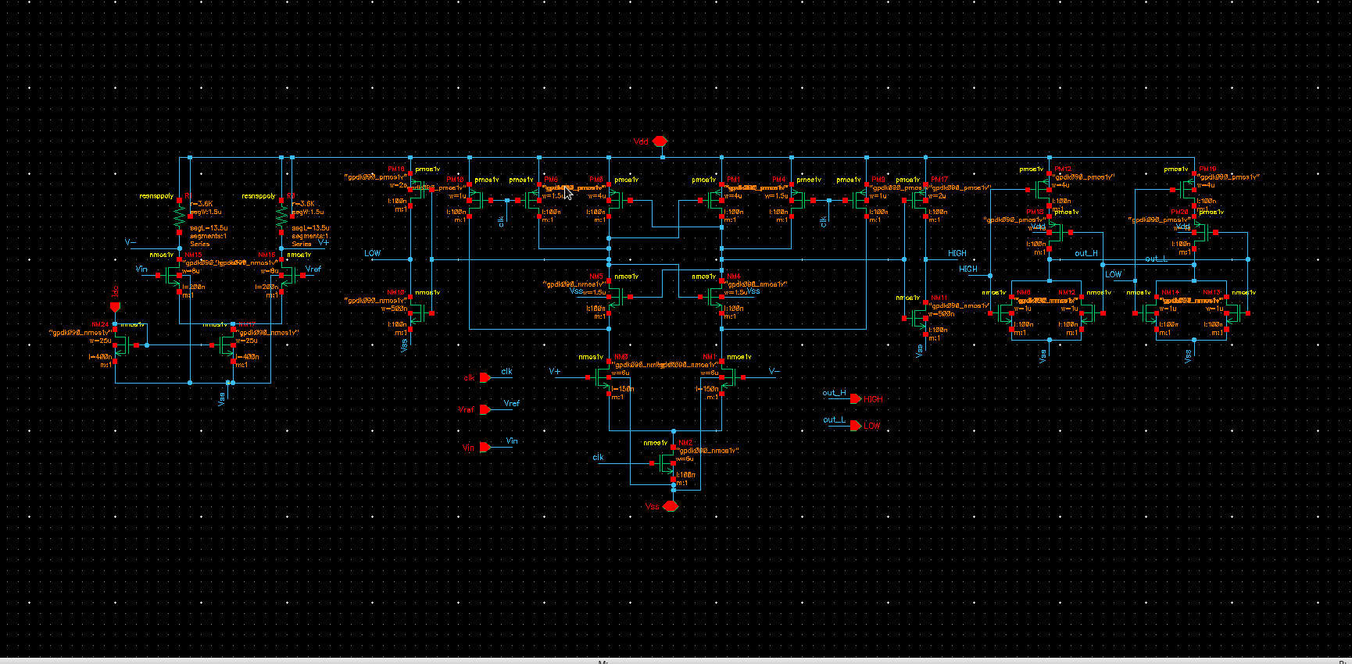
Figure 1. Comparator cell. Left: resistively loaded preamplifier NM15/NM16 with mirror NM19/NM17 and 3.6 kΩ loads. Centre: StrongARM latch with input pair NM0/NM1, tail NM2, regenerative pairs NM4/NM5 and PM0/PM1, and clocked reset switches. Right: inverter buffers and the NOR SR latch that holds the decision through the reset phase.
3.1 StrongARM latch
The latch is fully dynamic. During the clock-low phase four PMOS switches precharge both outputs and both internal nodes to V_{dd} and no current flows. On the rising edge the tail turns on, the input pair discharges the internal nodes at rates set by the input difference, and once they have fallen by a threshold the cross-coupled NMOS and PMOS pairs regenerate the difference to full rail. Zero static power, one clock, and an offset set by the input pair mismatch divided by the sampling-phase gain A₁ ≈ (g_{m}/I_{D})·V_{th} ≈ 5 – 7.
3.2 Preamplifier
A resistively loaded NMOS differential pair in front of the latch does three things at once. Its gain divides the latch offset referred to the input. Its output common mode, V_{dd} − I R_{L}/2 ≈ 1.0 V, is independent of the input common mode, so the latch sees the same operating point whether the reference is 0.51 V or 0.89 V. And the latch's clock-edge charge injection lands on the preamplifier's 3.6 kΩ drain nodes, which recover in 80 ps, instead of on the reference ladder; only the static preamplifier pair, whose drains move 0.2 V, touches the reference. Resistor loads were chosen over diode-connected or current-source PMOS because they give a gain set by one resistor, a defined output level without common-mode feedback, and the least output capacitance.
3.3 Output stage
The latch outputs are pulses: the losing side dips to about 0.8 V before the PMOS pull-up recovers it, and both return to V_{dd} in the reset phase. An SR latch holds the decision as a steady logic level. Inverter buffers between the latch and the SR gates present an identical load to both latch outputs regardless of the stored state; with NAND gates connected directly, the state-dependent input capacitance of the gate whose output is low produced ±10 mV of hysteresis, which the buffers reduced to 0.1 mV.
4. Design
4.1 Offset budget
The input-referred offset of a differential pair is set by threshold mismatch, σ = A_{VT}/√(WL) with A_{VT} ≈ 4 mV·µm. The latch pair of 4 µm × 0.1 µm predicts 6.3 mV and measured 8.7 mV once the regenerative pair is included. With a preamplifier of gain A_{p}:
σ_{total} = √[ (σ_{latch} / A_{p})² + σ_{pre}² ] = √[ (8.7 / 2.9)² + 3.2² ] ≈ 4.4 mV (measured 6.2 mV)
The excess over the estimate is attributed to the 1.5 µm wide poly load resistors, whose mismatch enters the offset directly, and to current-factor mismatch of the preamplifier pair.
4.2 Preamplifier sizing
Gain and bandwidth follow from the pair transconductance and the load resistor; the pair is sized for matching rather than for g_{m}:
A_{p} = g_{m} R_{L} = 0.99 mA/V × 3.6 kΩ = 3.6 (measured 2.9) , f_{3dB} = 1 / (2π R_{L} (C_{int} + C_{latch})) = 1 / (2π × 3.6 kΩ × 48 fF) = 0.92 GHz
with C_{int} = 28 fF per side extracted from a three-point load sweep. The mirror devices are 25 µm × 0.4 µm so that the tail current changes by only ±7 % as the input common mode moves from 0.45 V to 0.95 V; at 120 µA the tail keeps 25 mV of saturation margin at the lowest common mode and the stage draws 145 µW.
4.3 Latch sizing
The StrongARM is a dynamic circuit and is sized by ratios: the tail sets speed, the input pair sets offset and kickback, the regenerative pairs set the time constant τ = C_{out}/(g_{m,n} + g_{m,p}) ≈ 35 ps, and the reset switches must recharge the nodes within the half-cycle. A 5 mV input resolves in about 3τ·ln(V_{dd}/(A₁ΔV)) ≈ 100 ps.
Table 2. Device sizing summary.
Device | Role | Implemented
NM15 / NM16 | Preamplifier input pair | W = 8 µm, L = 0.2 µm, g_{m}/I_{D} = 17
NM17, NM19 | Preamplifier tail and mirror reference | W = 25 µm, L = 0.4 µm, 120 µA
R_{L} × 2 | Preamplifier loads | 3.6 kΩ poly, 1.5 µm × 13.5 µm
NM0 / NM1 | StrongARM input pair | W = 6 µm, L = 0.15 µm
NM2 | StrongARM tail | W = 6 µm, L = 0.1 µm
NM4 / NM5, PM0 / PM1 | Regenerative pairs | 1.5 µm / 4 µm, L = 0.1 µm
PM4, PM6, PM9, PM10 | Reset switches | 1 – 2 µm, L = 0.1 µm
Inverters | Output buffers | PMOS 2 µm, NMOS 0.5 µm
NOR SR latch | Decision hold | PMOS 4 µm, NMOS 1 µm

5. Testbenches and Measurement Expressions
Three benches share the cell. TB1 ramps V_{in} linearly through V_{ref} in both directions with the clock at 1 GHz and reads the input voltage at which the SR output flips; the two flips give offset and hysteresis in one run. TB2 applies a DC step ΔV above V_{ref} and measures timing and power. TB3 is TB2 with 1 kΩ and 100 fF in the V_{ref} path to represent a ladder tap, and measures the disturbance on that node.
Table 3. Measurement expressions.
Quantity | Expression
Offset, up-ramp | value(VT("/Vin") cross(clip(VT("/V_high") 5n 60n) 0.6 1 "rising")) − V_{ref}
Offset, down-ramp | value(VT("/Vin") cross(clip(VT("/V_high") 60n 120n) 0.6 1 "falling")) − V_{ref}
Offset / hysteresis | (Vos_up + Vos_dn) / 2 / Vos_up − Vos_dn
Clock-to-Q | delay(VT("/clk") 0.6 1 "rising" VT("/V_high") 0.6 1 "rising")
Regeneration time | delay(VT("/clk") 0.6 1 "rising" abs(VT("/I0/HIGH") − VT("/I0/LOW")) 0.6 1 "rising")
Kickback | ymax(clip(VT("/Vg") 2n 3n)) − ymin(clip(VT("/Vg") 2n 3n))
Average power | −average(IT("/V0/PLUS")) × 1.2

The clip() on the ramp expressions excludes the start-up transient of the SR latch, which otherwise registers a spurious flip at the ramp start in about a fifth of Monte Carlo samples. A clocked comparator can only flip at a clock edge, so a ramp of 1.67 mV/ns reads up to one clock period, 1.7 mV, of apparent hysteresis; the true value is below the ramp step.
6. Results
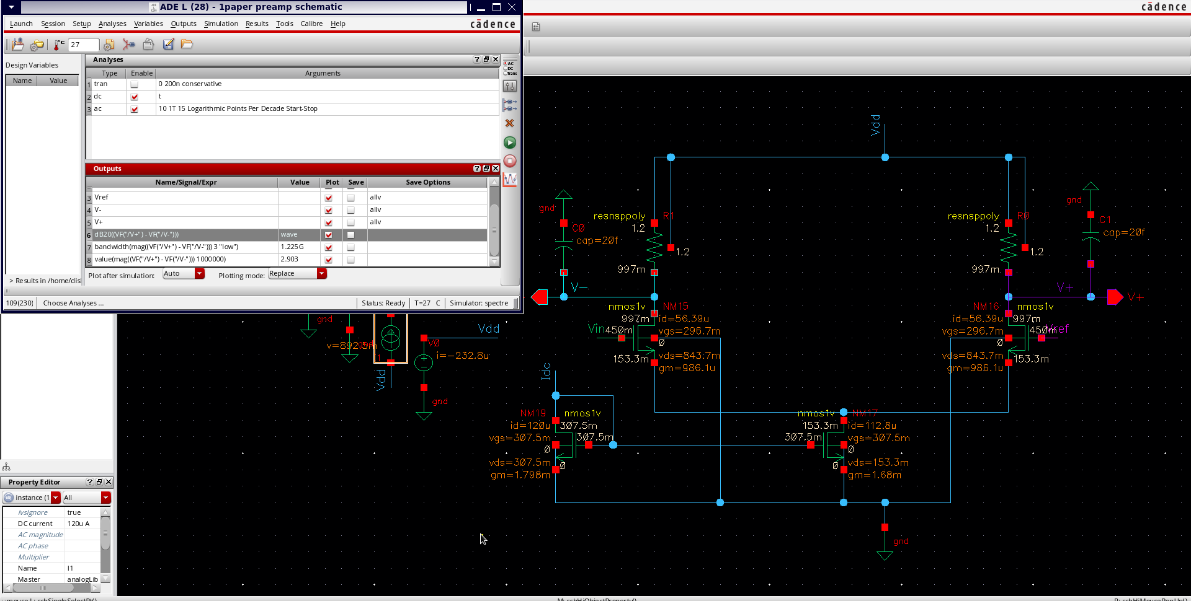
Figure 2. Preamplifier operating point at V_{cm} = 0.45 V, 120 µA: pair at 56 µA each with g_{m} = 0.99 mA/V, tail with 153 mV of drain–source voltage, outputs at 0.997 V.
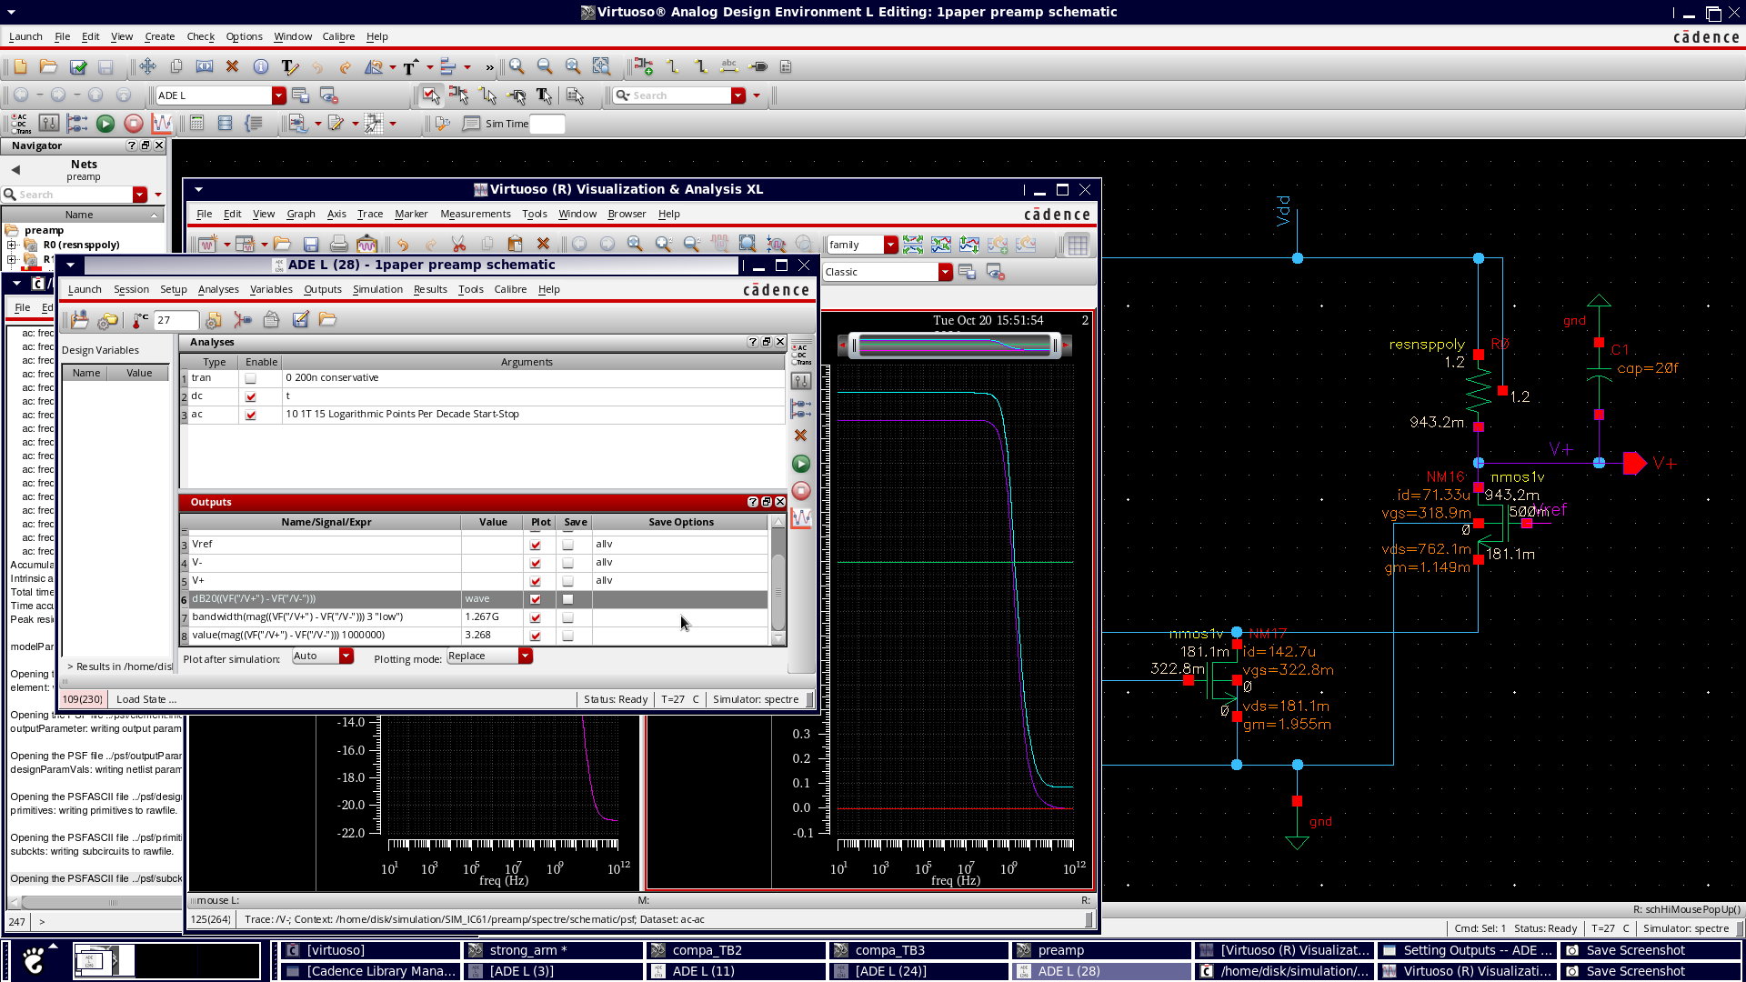
Figure 3. Preamplifier AC response with 20 fF on each output: gain 2.93 (9.3 dB) flat to f_{3dB} = 1.23 GHz.
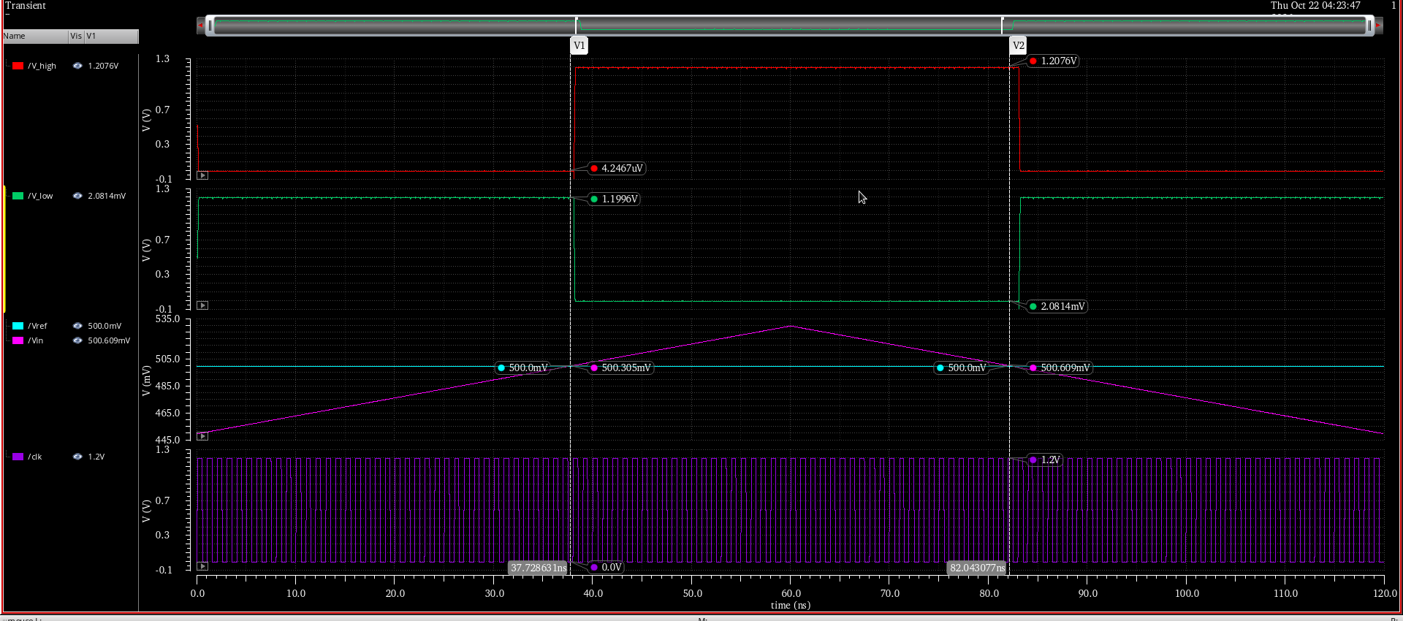
Figure 4. TB1 at V_{ref} = 0.5 V, 1 GHz clock: the SR outputs flip at 500.3 mV on the up-ramp and 500.6 mV on the down-ramp with flat rails in between.
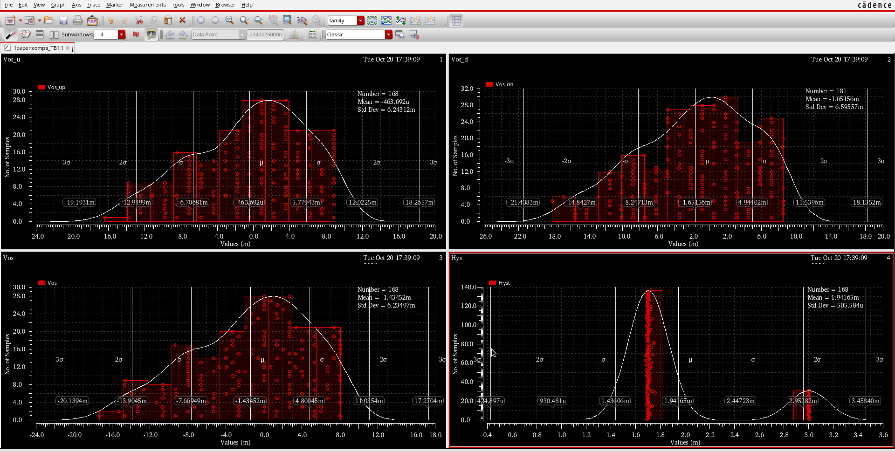
Figure 5. Monte Carlo offset, mismatch, 168 samples: mean −1.4 mV, σ = 6.2 mV, no outliers beyond ±3σ.
.
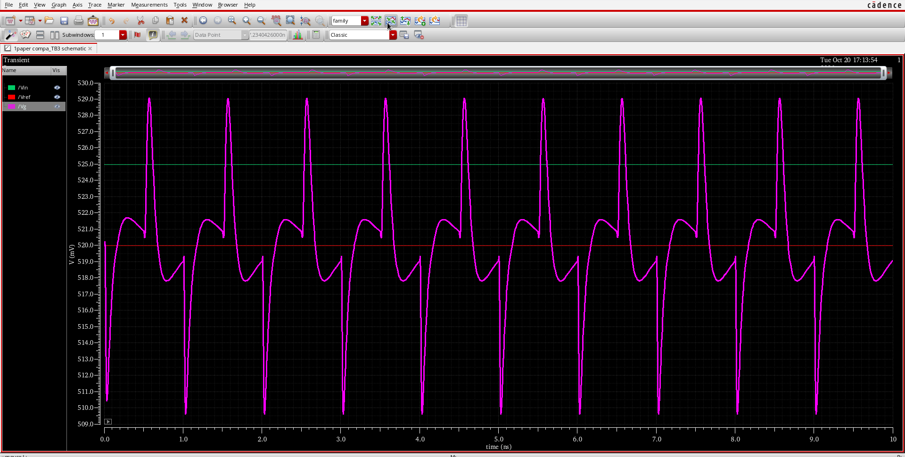
Figure 6. TB3: 19.5 mV peak-to-peak on the 1 kΩ / 100 fF reference node, recovering within 300 ps of each clock edge.
Table 4. Measured results of the three comparator versions.
Quantity | Latch, 4 µm × 0.1 µm pair | Latch, 12 µm × 0.3 µm pair | Preamplifier + latch (final)
Offset σ, Monte Carlo | 8.7 mV (N = 108) | ≈ 4 mV (N ≈ 80) | 6.2 mV (N = 168)
Offset, nominal | +6.7 µV | — | +15 µV
Hysteresis | < 0.5 mV | < 0.5 mV | < 0.5 mV
Kickback, 1 kΩ / 100 fF | — | 160 mV p-p | 19.5 mV p-p
Clock-to-Q at 5 mV | 120 ps | 126 ps | ≈ 170 ps (estimated)
Regeneration time | 100 ps | 114 ps | —
Power at 1 GHz | ≈ 75 µW | ≈ 120 µW | ≈ 220 µW
Usable input common mode | > 0.45 V | > 0.45 V | 0.45 – 0.95 V

The preamplifier gain was checked over input common mode and supply: 2.90 at V_{cm} = 0.45 V and 2.98 at 0.95 V at nominal, falling to 2.5 – 2.6 at 1.08 V and 85 °C with the tail still saturated above V_{cm} = 0.5 V. The complete cell decides correctly for positive and negative input differences at the FS corner, the process corner that most unbalances its NMOS/PMOS ratios.
7. Conclusions
- A preamplified StrongARM comparator in gpdk090 at 1.2 V measures σ = 6.2 mV of input offset, under 0.5 mV of hysteresis, 19.5 mV of kickback into a 1 kΩ reference, and 120 ps clock-to-Q at 1 GHz for about 220 µW.
- The preamplifier was adopted on two measurements: a minimum-area latch at σ = 8.7 mV, and an enlarged latch that met the offset budget at σ ≈ 4 mV but injected 160 mV into the reference. Gain 2.9 divides the latch offset, fixes the latch common mode, and keeps the latch edges off the reference.
- Inverter buffers in front of a NOR SR latch remove the state-dependent loading that a directly connected NAND latch imposes on the StrongARM outputs; measured hysteresis fell from ±10 mV to 0.1 mV.
- Future work: wider load resistors and a 16 µm × 0.3 µm preamplifier pair to bring σ toward 4 mV, or one-time capacitive offset trimming in the latch; layout with mirror-symmetric latch halves.
References
[1] B. Razavi, "The StrongARM Latch," IEEE Solid-State Circuits Magazine, vol. 7, no. 2, pp. 12–17, 2015.
[2] B. Razavi, Design of Analog CMOS Integrated Circuits, 2nd ed. McGraw-Hill, 2016.
[3] M. J. M. Pelgrom, A. C. J. Duinmaijer and A. P. G. Welbers, "Matching properties of MOS transistors," IEEE J. Solid-State Circuits, vol. 24, no. 5, pp. 1433–1440, 1989.
[4] P. Nuzzo, F. De Bernardinis, P. Terreni and G. Van der Plas, "Noise analysis of regenerative comparators for reconfigurable ADC architectures," IEEE Trans. Circuits Syst. I, vol. 55, no. 6, pp. 1441–1454, 2008.
[5] Cadence Design Systems, Spectre Circuit Simulator Reference; Virtuoso ADE XL User Guide; gpdk090 PDK documentation.

