Experiment 5A: Use Case Diagram
1. Description of the Diagram
A Use Case Diagram is a behavioural UML diagram that captures the functional requirements of a system from the point of view of its users. It shows the actors that interact with the system, the use cases (functions/services) the system offers, and the relationships between them. Unlike a Class or DFD, a Use Case Diagram describes what a system does, not how it does it internally.
The supplied diagram models the Skill Exchange Platform, a system that allows members to exchange skills with one another. It identifies three actors — Skill Provider, Skill Seeker, and Platform Administrator — placed outside a system boundary labelled “Skill Exchange Platform”, and the set of use cases each actor can invoke inside that boundary.
The diagram also captures dependency relationships between use cases using the «include» and «extend» stereotypes, and a generalization relationship between two administrator-side use cases, giving a fairly complete picture of the platform's functional scope.
2. Actors and Use Cases Identified
- Skill Provider: Register/Login, Search & Match Skills, Chat with Match, Report Inappropriate Content, Rate & Review Partner.
- Skill Seeker: Send/Respond to Match Requests, Send Notification, Schedule & Manage Sessions, Receive Certificate, Track Session Progress.
- Platform Administrator: Monitor Platform & Generate Reports, Generate Skill Analytics, Manage Users & Content.

3. Notations Used in a Use Case Diagram
A. Actor
An actor represents a role played by a person or an external system that interacts with the system being modelled. It is drawn as a stick figure with its name below it.
● (stick figure) Skill Provider
Where it is used: Placed outside the system boundary. In the supplied diagram, Skill Provider, Skill Seeker, and Platform Administrator are the three actors.
B. Use Case
A use case represents a specific function, service, or goal that the system provides to an actor. It is drawn as an oval containing the name of the function.
( Search & Match Skills )
Where it is used: Placed inside the system boundary. Examples in the supplied diagram include Register/Login, Search & Match Skills, and Schedule & Manage Sessions.
C. System Boundary
The system boundary is a rectangle that encloses all the use cases, marking the scope of the system being modelled. The actors are drawn outside this rectangle.
┌── Skill Exchange Platform ──┐ │ ( use cases inside ) │ └──────────────────────────┘
Where it is used: The outer rectangle titled “Skill Exchange Platform” in the supplied diagram encloses every use case of the system.
D. Association (Actor–Use Case)
An association is a solid line that connects an actor to a use case, showing that the actor participates in / triggers that use case.
Skill Seeker ———▶ ( Track Session Progress )
Where it is used: Every actor-to-use-case link in the diagram, such as Skill Provider to Search & Match Skills, is drawn using a solid association line.
E. Include Relationship («include»)
An include relationship is a dashed arrow labelled «include», pointing from a base use case to a use case whose behaviour it always incorporates.
( Search & Match Skills ) ──▶ «include» ──▶ ( Register / Login )
Where it is used: In the supplied diagram, Search & Match Skills includes Register/Login and Manage Profile & Skills, and Schedule & Manage Sessions includes Send Notification, since these steps are always required.
F. Extend Relationship («extend»)
An extend relationship is a dashed arrow labelled «extend», pointing from an optional/conditional use case to the base use case it extends, typically annotated with the condition under which it applies.
( Report Inappropriate Content ) ──▶ «extend» (if flagged) ──▶ ( Chat with Match )
Where it is used: Report Inappropriate Content optionally extends Chat with Match “if flagged”, and Receive Certificate optionally extends Schedule & Manage Sessions “on completion”.
G. Generalization
Generalization is shown as a solid line with a hollow (unfilled) triangular arrowhead pointing to the more general use case, indicating that one use case is a specialised form of another.
( Generate Skill Analytics ) ──▷ ( Monitor Platform & Generate Reports )
Where it is used: Generate Skill Analytics is shown as a specialised version of Monitor Platform & Generate Reports using the hollow-triangle generalization arrow.
4. Advantages of a Use Case Diagram
- Simple and intuitive: Actors and ovals are easy for both technical and non-technical stakeholders to understand.
- Captures functional requirements: Clearly lists what the system must do, without getting into implementation detail.
- Good communication tool: Bridges the gap between clients, analysts, and developers during requirement gathering.
- Shows system scope: The system boundary makes it clear what is inside versus outside the system.
- Reusability of behaviour: «include» relationships let common steps be modelled once and reused across use cases.
- Models optional behaviour: «extend» relationships capture conditional or exceptional flows separately from the main flow.
- Basis for test-case design: Each use case can be traced to one or more test scenarios.
5. Disadvantages of a Use Case Diagram
- No internal logic: It does not show how a use case is actually implemented step-by-step.
- Limited detail: Complex business rules and data validations cannot be represented.
- Can become cluttered: A system with many actors and use cases can produce a visually crowded diagram.
- Ambiguous relationships: Overuse of «include»/«extend» can make the diagram hard to interpret correctly.
- No sequencing information: It does not show the order in which use cases occur.
- Needs supporting documentation: Use case descriptions/specifications are usually still required for full clarity.
6. Conclusion
The Use Case Diagram provides a high-level, actor-centric view of the Skill Exchange Platform's functionality. It identifies the three key actors and the services available to each, and uses «include», «extend», and generalization relationships to express shared, optional, and specialised behaviour respectively. It forms a useful starting point for detailed design and test-case development.
7. Output – Complete Use Case Diagram
Output: Skill Exchange Platform – Use Case Diagram
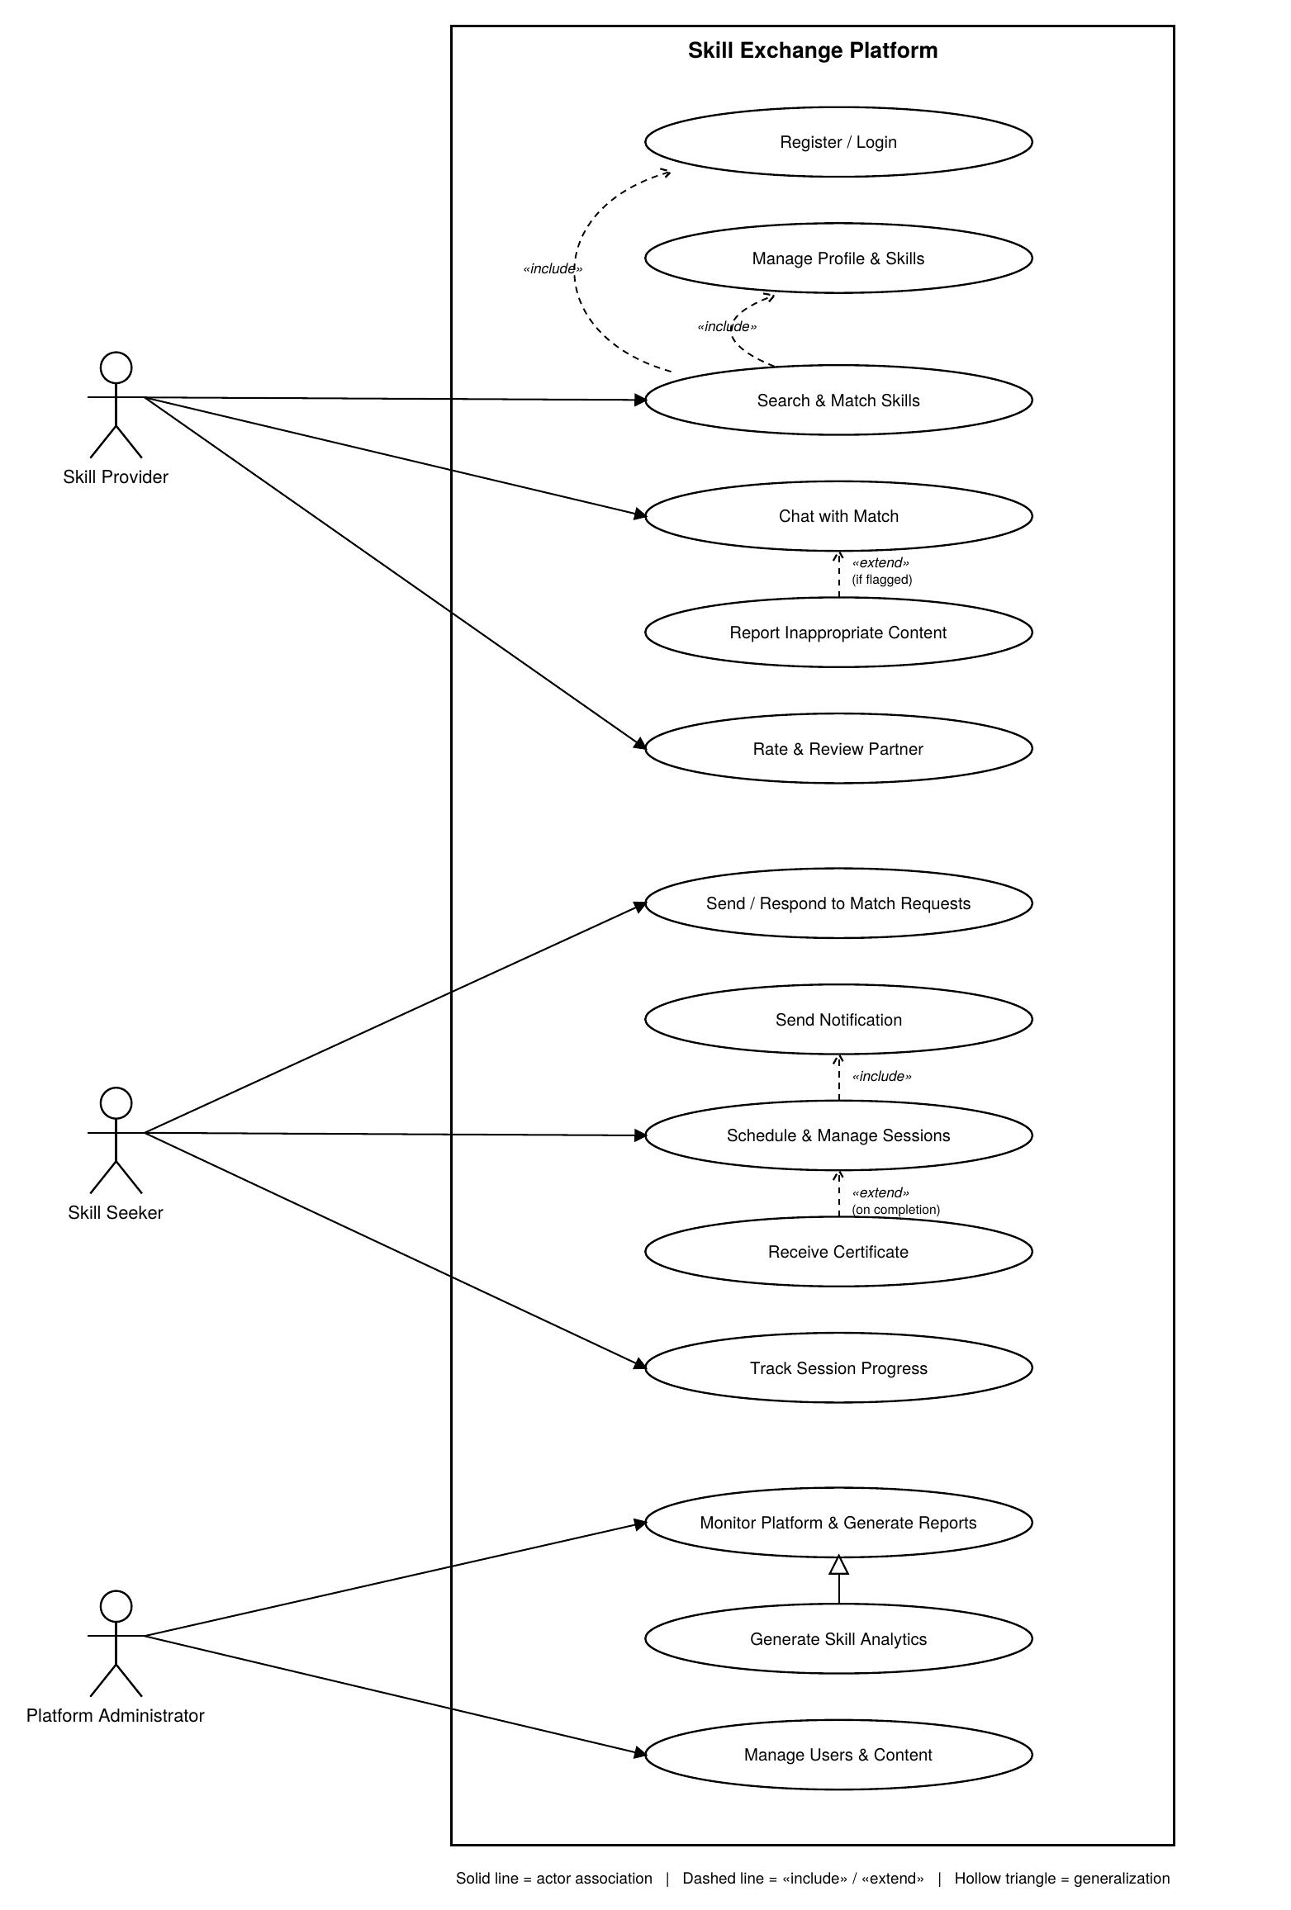

Experiment 5B: Class Diagram
1. Description of the Diagram
A Class Diagram is a structural UML diagram that models the static design of a system. It shows the classes that make up the system, their attributes and operations, and the relationships — association, aggregation, composition, and generalization — that exist between those classes.
The supplied diagram models the Community Skill Exchange Platform. It defines an abstract User class that is specialised into Member and Admin, along with supporting classes such as Skill, SkillListing, Availability, ExchangeSession, Message, and Review. Together these classes describe how members list skills, book exchange sessions, exchange messages, and leave reviews, and how an administrator moderates the platform.
2. Classes Identified
- User («abstract») – base class holding common attributes such as userId, name, email, and role.
- Member – a registered user who can create listings, book sessions, and rate exchanges.
- Admin – a user who can moderate listings, ban users, and resolve reports.
- Skill – represents a skill that can be searched and matched.
- SkillListing – a listing created by a member offering or requesting a skill.
- Availability – the date/time slots and mode attached to a listing.
- ExchangeSession – a scheduled session between two participants.
- Message – a message sent between users.
- Review – a rating and comment submitted after an exchange.

3. Notations Used in a Class Diagram
A. Class
A class is drawn as a rectangle divided into three compartments: the class name, its attributes, and its operations.
┌─────── Skill ───────┐ │ -skillId : String │ │ -name : String │ ├─────────────────────┤ │ +matches(query) : bool │ └─────────────────────┘
Where it is used: Every box in the supplied diagram, such as Skill, SkillListing, ExchangeSession, Message, and Review, follows this three-compartment format.
B. Abstract Class
An abstract class is a class that cannot be instantiated directly; it is marked with the «abstract» stereotype above its name (and/or an italicised name).
┌─── «abstract» ───┐ │ User │ ├───────────────────┤ │ -userId, -email ... │ └───────────────────┘
Where it is used: The User class is marked «abstract», since every real user of the platform is always either a Member or an Admin, never a plain User.
C. Attributes and Operations with Visibility
Attributes and operations are prefixed with a visibility symbol: “-” for private and “+” for public, followed by the name and, optionally, its type.
-reputationScore : float +createListing() : SkillListing
Where it is used: Applied consistently across every class, e.g. Member's private -bio, -location, -reputationScore attributes and public +createListing(), +bookSession() operations.
D. Generalization / Inheritance
Generalization is shown as a solid line ending in a hollow (unfilled) triangle pointing to the parent class, indicating an “is-a” relationship.
Member ───▷ User Admin ───▷ User
Where it is used: Both Member and Admin extend the abstract User class via a hollow-triangle generalization arrow.
E. Association with Multiplicity
An association is a plain line connecting two classes, optionally labelled with a name and with multiplicities (e.g. 1, 0..*, 1..*) at each end describing how many instances participate.
ExchangeSession “1..*” ──── “scheduledFrom” ──── “0..*” SkillListing
Where it is used: Examples include Member – ExchangeSession (“2 participants”), and ExchangeSession – SkillListing (“scheduledFrom”, 0..* / 1..*).
F. Aggregation
Aggregation is a “has-a” whole-part relationship where the part can exist independently of the whole. It is shown with a hollow (unfilled) diamond at the whole end of the association.
SkillListing ◇─── “1..1” ─── Skill
Where it is used: The link between SkillListing and Skill uses a hollow diamond, showing that a Skill exists independently of any one listing that references it.
G. Composition
Composition is a stronger whole-part relationship where the part's lifecycle depends on the whole. It is shown with a filled (solid) diamond at the whole end of the association.
Member ◆─── “1..*” ─── SkillListing SkillListing ◆─── “1..*” ─── Availability
Where it is used: Filled diamonds appear on the Member–SkillListing and SkillListing–Availability links in the supplied diagram, indicating tightly-owned parts.
4. Advantages of a Class Diagram
- Clear structural view: Shows all classes, attributes, and operations of the system at a glance.
- Foundation for coding: Class diagrams map closely to actual object-oriented source code.
- Reveals relationships: Association, aggregation, composition, and generalization make dependencies between entities explicit.
- Encourages reuse: Common attributes/behaviour can be pulled into an abstract parent class, as with User.
- Supports database design: Classes and their multiplicities can be mapped directly to database tables and relationships.
- Improves communication: Provides a shared, precise vocabulary for developers, testers, and designers.
- Useful for documentation: Serves as a long-term structural reference for maintaining the system.
5. Disadvantages of a Class Diagram
- No behavioural detail: It does not show how objects interact over time or in what sequence methods are called.
- Can grow complex: Large systems can produce diagrams with many classes and crossing relationship lines.
- Static view only: It captures structure at a point in time, not runtime state changes.
- Requires UML knowledge: Readers unfamiliar with UML notation (diamonds, triangles, multiplicities) may misinterpret the diagram.
- Maintenance overhead: Diagrams must be kept in sync manually whenever the code structure changes.
- Does not capture business rules: Constraints and validation logic must be documented separately.
6. Conclusion
The Class Diagram gives a precise, structural blueprint of the Community Skill Exchange Platform. It shows how the abstract User class is specialised into Member and Admin, and how these interact with SkillListing, Skill, ExchangeSession, Availability, Message, and Review through a combination of generalization, association, aggregation, and composition relationships. It acts as a direct foundation for implementing the system's object model and database schema.
7. Output – Complete Class Diagram
Output: Community Skill Exchange Platform – Class Diagram
