UNISKILL
Software Requirement Specification
Systematic and project-specific SRS for the UniSkill student skill exchange platform

Document Type: Software Requirement Specification
Prepared for final year project submission
Source baseline: UniSkill repository, project documents, and verified product flows
This edition removes unrelated project content and organizes the document for concise academic review

Table of Contents
1. Introduction
2. Overall Description
3. External Interface Requirements
4. System Features and Functional Requirements
5. Non-Functional Requirements
6. Data Requirements and Data Dictionary
7. Security, Privacy, and Compliance
8. Validation, Acceptance, and Traceability
9. Appendices

1. Introduction

1.1 Purpose
This SRS defines the functional and non-functional requirements for UniSkill, a verified student skill exchange marketplace that supports profile verification, service listing, mentor discovery, booking, credits, and real-time collaboration.

1.2 Document Conventions
Requirement identifiers use FR for functional requirements, NFR for non-functional requirements, and DR for data-related requirements. The words shall and must indicate mandatory behavior; should indicates a desirable but non-blocking behavior.

1.3 Intended Audience and Reading Suggestions
This document is intended for project evaluators, developers, designers, testers, deployment engineers, and future maintainers. Readers may begin with overall description, then move to the system feature section and data dictionary.

1.4 Product Scope
UniSkill enables a university student to create a trusted profile, declare skills and learning goals, publish or consume teaching services, request sessions, and exchange value through a controlled credits economy.

2. Overall Description

2.1 Product Perspective
- UniSkill is a web-native campus marketplace that integrates browser clients, SSR-aware server handlers, an Express backend, and Supabase-managed data services.
- The product may be deployed as a modular full-stack application, with the Next.js frontend and Express backend hosted independently while sharing identity, environment configuration, and origin policy agreements.

2.2 Product Functions
- Register student users and create baseline profiles.
- Verify identity through OTP and private vault storage.
- Expose public teaching signals and learning goals.
- Manage service listings, sessions, rooms, and credits.
- Maintain auditability, privacy boundaries, and future admin extensibility.

2.3 User Classes and Characteristics
- Learner: a student seeking help in an academic, technical, or extracurricular skill.
- Mentor: a student offering one or more services or teachable skills in exchange for credits.
- Admin or reviewer: a trusted governance role responsible for verification, moderation, and dispute review in future releases.

2.4 Operating Environment
- Modern browsers on desktop and mobile devices.
- Node.js runtime for frontend and backend services.
- Supabase-hosted PostgreSQL, auth, storage, and real-time features.

2.5 Design and Implementation Constraints
- The system depends on environment variables for auth keys and allowed origins.
- Sensitive verification data must not be exposed through public profile responses.
- The evolving schema requires compatibility-aware access logic during transition phases.

2.6 User Documentation
- Onboarding guide, verification instructions, profile setup help, mentor listing tips, and wallet usage notes should be available in-app or through linked documentation.

2.7 Assumptions and Dependencies
- Students possess valid email access and stable internet connectivity.
- The Supabase project remains available and correctly configured with migrations and RLS policies.
- Email delivery infrastructure for OTP or password reset messages remains operational.

3. External Interface Requirements

3.1 User Interfaces
The system shall provide responsive interfaces for landing, signup, login, dashboard, explore, profile, wallet, and live room interactions. The visual language should remain clear enough for frequent campus use and flexible enough to distinguish learning mode from teaching mode.
Interface | Primary user goal | Key inputs | Expected outputs
Signup / Login | Join and authenticate | Email, password, OTP, identity details | Authenticated session and initial profile state
Profile | Manage public presence | Skills, goals, services, rate, bio | Updated public data and mentor availability
Explore | Find mentors and offers | Filters, searches, session selection | Service and profile results
Wallet | Monitor or move credits | Top-up and transfer requests | Balance and transaction history
Room | Conduct live interaction | Join room, messages, signaling | Connected peer session

3.2 Hardware Interfaces
UniSkill has no mandatory custom hardware interface. Optional camera, microphone, and speakers become relevant when live sessions use WebRTC-enabled room experiences.

3.3 Software Interfaces
- Supabase Auth for identity and browser/server session state
- Supabase PostgreSQL for tables, triggers, and policy-bound data access
- Socket.io for room events and lightweight live signaling
- Nodemailer or equivalent email dispatch service for OTP and reset flows
- Prisma schema for typed database modeling and reference consistency

3.4 Communications Interfaces
The system shall use HTTPS for standard application traffic and WebSocket-compatible transport for live room events. CORS configuration must permit only approved front-end origins, and session cookies must remain synchronized between SSR route handlers and the browser client.
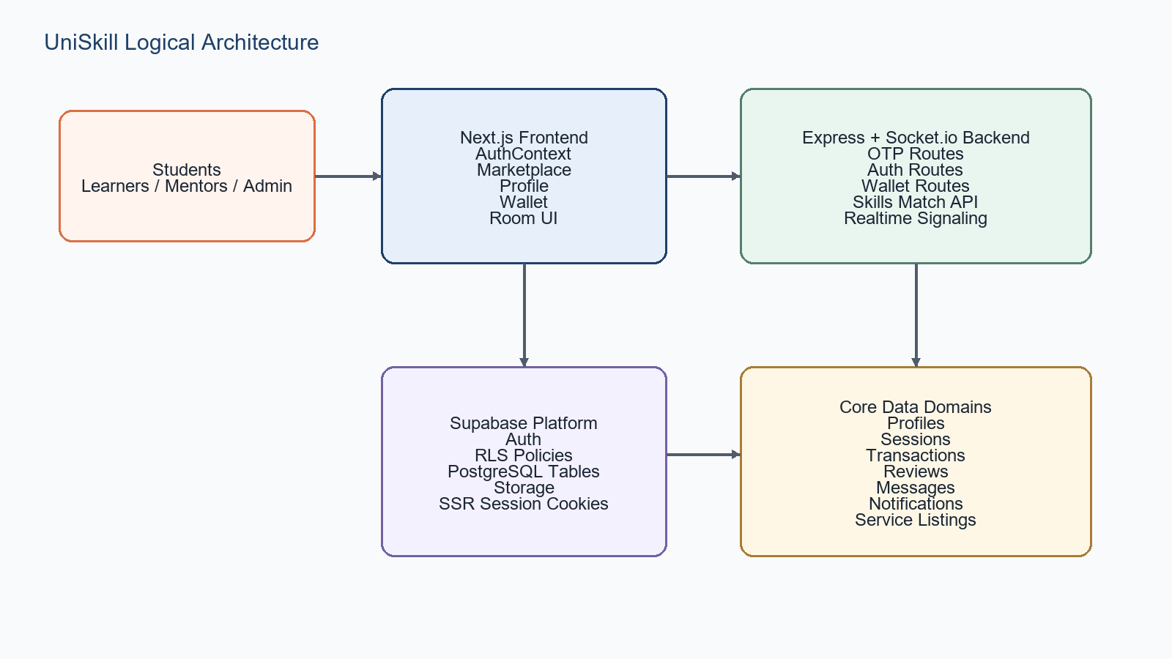
Figure 3.4: Cross-layer interface view connecting users, web clients, backend services, and Supabase

4. System Features and Functional Requirements

4.1 FR1: User Registration and Login

4.1 FR1: User Registration and Login.1 Description and Priority

4.1 FR1: User Registration and Login.2 Functional Requirements
- FR1.1 The system shall allow a student to create an account using email and password credentials.
- FR1.2 The system shall create or reconcile a profile record associated with the authenticated user identifier.
- FR1.3 The system shall allow login through Supabase-authenticated credentials and return usable session information.
- FR1.4 The system shall provide a logout mechanism that clears active local session state.

4.1 FR1: User Registration and Login.3 Rationale

4.2 FR2: OTP and Identity Verification

4.2 FR2: OTP and Identity Verification.1 Description and Priority

4.2 FR2: OTP and Identity Verification.2 Functional Requirements
- FR2.1 The system shall send a six-digit OTP to an email or phone target for supported verification types.
- FR2.2 The system shall validate OTP value, type, and expiry before marking the verification step successful.
- FR2.3 The system shall expose verification status by user identifier for guided onboarding flows.
- FR2.4 The system shall maintain sensitive verification artifacts separately from public profile data.

4.2 FR2: OTP and Identity Verification.3 Rationale

4.3 FR3: Profile Management

4.3 FR3: Profile Management.1 Description and Priority

4.3 FR3: Profile Management.2 Functional Requirements
- FR3.1 The system shall allow authenticated users to read and update their editable profile fields.
- FR3.2 The system shall support skills and learning goal arrays for discovery and matching.
- FR3.3 The system shall preserve compatibility across legacy and reconciled field names where required by the current codebase.
- FR3.4 The system shall prevent direct editing of protected fields such as credits through ordinary profile updates.

4.3 FR3: Profile Management.3 Rationale

4.4 FR4: Service Listing Management

4.4 FR4: Service Listing Management.1 Description and Priority

4.4 FR4: Service Listing Management.2 Functional Requirements
- FR4.1 The system shall allow a mentor to create, edit, read, and delete teaching service listings.
- FR4.2 A service listing shall contain title, category, description, duration, and price in credits.
- FR4.3 Creation of a teaching service shall mark the user as a mentor in profile state.

4.4 FR4: Service Listing Management.3 Rationale

4.5 FR5: Marketplace Discovery

4.5 FR5: Marketplace Discovery.1 Description and Priority

4.5 FR5: Marketplace Discovery.2 Functional Requirements
- FR5.1 The system shall expose mentor profiles for discovery in explore views.
- FR5.2 The system shall allow filtering by skill and minimum rating where supported.
- FR5.3 The system shall return service or mentor data ordered and shaped for interface consumption.

4.5 FR5: Marketplace Discovery.3 Rationale

4.6 FR6: Skill Match Recommendations

4.6 FR6: Skill Match Recommendations.1 Description and Priority

4.6 FR6: Skill Match Recommendations.2 Functional Requirements
- FR6.1 The system shall compute perfect matches when another user teaches what the current user wants and wants what the current user teaches.
- FR6.2 The system shall compute partial matches when another user teaches what the current user wants without a full reciprocal overlap.
- FR6.3 The system shall provide overlap details and rough match scores in response payloads.

4.6 FR6: Skill Match Recommendations.3 Rationale

4.7 FR7: Session Booking

4.7 FR7: Session Booking.1 Description and Priority

4.7 FR7: Session Booking.2 Functional Requirements
- FR7.1 The system shall allow an authenticated learner to create a pending session with a selected mentor.
- FR7.2 The booking process shall generate a room identifier for subsequent room-based interaction.
- FR7.3 The system shall persist session status, title, scheduled time, duration, and price.

4.7 FR7: Session Booking.3 Rationale

4.8 FR8: Wallet and Credits

4.8 FR8: Wallet and Credits.1 Description and Priority

4.8 FR8: Wallet and Credits.2 Functional Requirements
- FR8.1 The system shall expose wallet balance and recent transactions for a user.
- FR8.2 The system shall support addition of credits through a server-side route that records the transaction metadata.
- FR8.3 The system shall support peer transfer of credits between two distinct users subject to balance checks.
- FR8.4 Transfer activity shall produce transaction records for both sender and receiver.

4.8 FR8: Wallet and Credits.3 Rationale

4.9 FR9: Messaging and Live Room Signaling

4.9 FR9: Messaging and Live Room Signaling.1 Description and Priority

4.9 FR9: Messaging and Live Room Signaling.2 Functional Requirements
- FR9.1 The system shall allow clients to join a room and receive join and disconnect notifications.
- FR9.2 The system shall relay signal payloads for peer connection establishment.
- FR9.3 The system shall relay room-scoped chat messages with sender and timestamp metadata.
- FR9.4 The system shall broadcast explicit end-call events within a room.

4.9 FR9: Messaging and Live Room Signaling.3 Rationale

4.10 FR10: Reviews, Notifications, and Governance

4.10 FR10: Reviews, Notifications, and Governance.1 Description and Priority

4.10 FR10: Reviews, Notifications, and Governance.2 Functional Requirements
- FR10.1 The data model shall support reviews associated with sessions and reviewer-reviewee pairs.
- FR10.2 The data model shall support notifications with type, message, and read state.
- FR10.3 The platform shall remain extensible for admin review, moderation, and audit features.

4.10 FR10: Reviews, Notifications, and Governance.3 Rationale
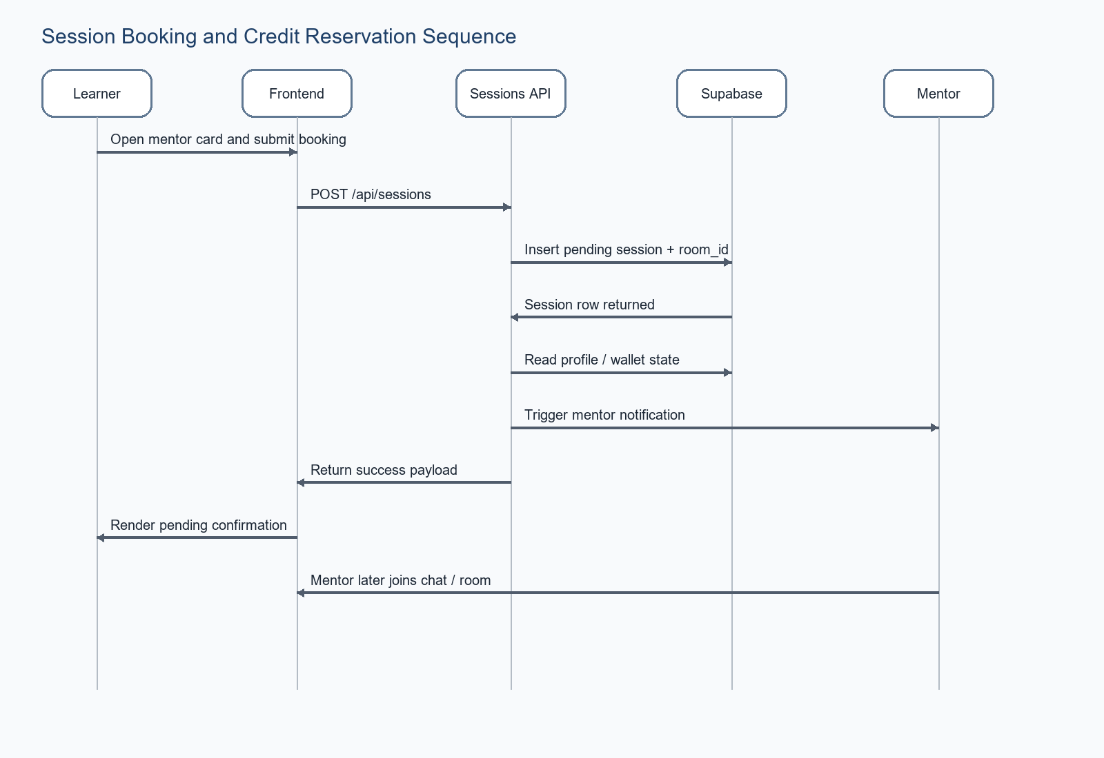
Figure 4.10: Booking and credit reservation sequence used to derive session-related requirements

5. Non-Functional Requirements

5.1 Performance
- NFR1 The marketplace and dashboard should render primary data within acceptable interactive latency under normal campus loads.
- NFR2 OTP verification responses should complete fast enough to avoid user abandonment during signup.
- NFR3 Room signaling events should propagate with low delay suitable for live session setup.
Performance requirements are essential because UniSkill is not only a demo interface; it coordinates identity, discovery, and value movement for real users.

5.2 Security
- NFR4 Sensitive verification artifacts must remain inaccessible to unauthorized users.
- NFR5 Profile, session, transaction, and message access shall respect row-level or route-level authorization checks.
- NFR6 Secrets, service role keys, and email credentials must not be exposed to browser clients.
Security requirements are essential because UniSkill is not only a demo interface; it coordinates identity, discovery, and value movement for real users.

5.3 Reliability
- NFR7 Critical writes such as session creation and wallet transfer should avoid partial failure states where possible.
- NFR8 The system should degrade gracefully if email, socket, or one auxiliary service is temporarily unavailable.
Reliability requirements are essential because UniSkill is not only a demo interface; it coordinates identity, discovery, and value movement for real users.

5.4 Usability
- NFR9 The product shall remain understandable for first-time student users without formal training.
- NFR10 The UI should preserve readable layouts across mobile and desktop widths.
Usability requirements are essential because UniSkill is not only a demo interface; it coordinates identity, discovery, and value movement for real users.

5.5 Scalability
- NFR11 The architecture should support modular growth in users, listings, and session traffic without requiring a full rewrite.
- NFR12 Data indexes, policy design, and API partitioning should anticipate campus-scale load expansion.
Scalability requirements are essential because UniSkill is not only a demo interface; it coordinates identity, discovery, and value movement for real users.

5.6 Maintainability
- NFR13 Clear route boundaries and schema migration history shall support future maintenance.
- NFR14 Compatibility handling should be documented until legacy field drift is eliminated.
Maintainability requirements are essential because UniSkill is not only a demo interface; it coordinates identity, discovery, and value movement for real users.

6. Data Requirements and Data Dictionary

6.1 Core Data Entities
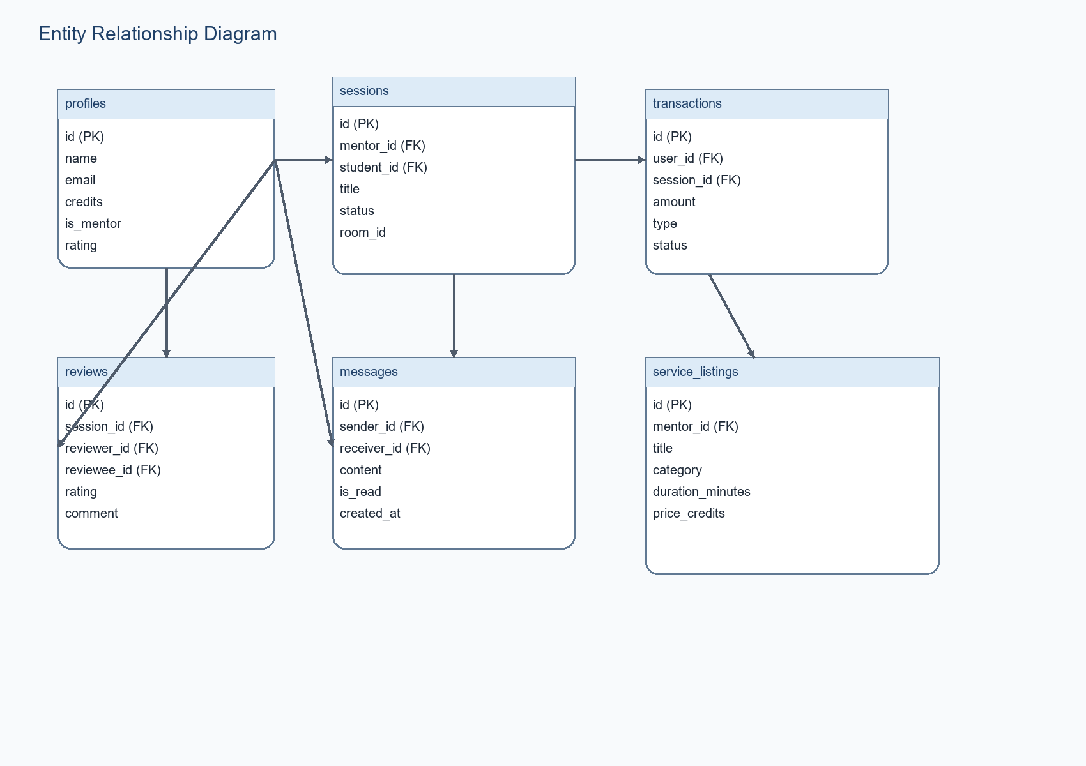
Figure 6.1: Core persistent entities in the UniSkill domain

6.2 Data Dictionary
Table | Field | Type | Description
profiles | id | UUID | Primary user identifier linked to auth user
profiles | skills / learning_goals | TEXT[] | Public learning and teaching metadata
user_verification_vault | college_email | TEXT | Private verified institution contact
sessions | status | TEXT | Lifecycle state for a booked engagement
sessions | room_id | TEXT | Logical room key for live communication
transactions | amount | INTEGER | Credit movement value
service_listings | price_credits | INTEGER | Credits required for a mentor service
messages | content | TEXT | Direct communication payload
notifications | data | JSONB | Auxiliary structured metadata

6.3 Data Integrity Rules
- Session rows shall reference valid mentor and student profile identifiers.
- Transaction rows for a peer transfer should be paired logically for sender and receiver visibility.
- Verification vault entries shall reference the same user identifier as their public profile counterpart.
- Service listings shall only be editable by their owning mentor.

7. Security, Privacy, and Compliance
Security requirements in UniSkill are unusually central because the platform blends private identity proofing with public mentor discovery. The schema and route structure therefore distinguish discoverability from confidentiality.
Concern | Current design approach | Required assurance
Profile privacy | Public profile table plus private verification vault | Sensitive identity artifacts never leak through public browse flows
Session authorization | User-bound session policies and authenticated access | Only session participants can inspect protected session data
Wallet control | Server-side balance checks and transaction logging | No arbitrary client-side balance mutation
Auditability | Audit log trigger on profile changes | Administrative review trail exists for sensitive mutations

7.1 Compliance Considerations
- Minimize exposure of personally identifiable student data.
- Keep clear consent boundaries for email, phone, and identity document use.
- Support institutional review through logs and moderation paths where needed.

8. Validation, Acceptance, and Traceability

8.1 Validation Strategy
- Requirement walkthroughs against implemented routes and pages
- Scenario testing for signup, verification, mentor publishing, booking, and transfer
- Regression checks whenever schema reconciliation changes compatibility behavior
- Security-focused checks for private table exposure and policy bypass risk

8.2 Acceptance Criteria
- A student can create an account and retrieve an authenticated profile state.
- A student can publish teaching metadata and see discoverable mentor-facing results.
- A learner can create a pending session tied to a room identifier.
- A user can inspect wallet data and complete a valid credit transfer.
- Realtime room events can be exchanged between participants.

8.3 Requirement Traceability Summary
Requirement group | Primary source artifact | Verification method
FR1-FR3 | Auth routes, OTP routes, AuthContext | Integration and UI flow tests
FR4-FR7 | Teaching-services route, sessions route, profile and explore pages | Scenario tests and DB inspection
FR8 | Wallet routes and dashboard/wallet UI | Balance and transaction assertions
FR9 | Socket.io setup and room page | Live room event verification
Security / Data | Supabase migrations and RLS policies | Policy review and guarded access tests

9. Appendices

9.1 Glossary of domain terms

9.2 Environment configuration summary

9.3 Assumed production deployment topology

9.4 Known schema compatibility considerations

9.5 Potential future requirement additions

Appendix A: Detailed Use Case Specifications

A1 Student Registration
Field | Specification
Primary actor | Prospective student
Goal | Student Registration
Preconditions | No active account for the same identity
Postconditions | Baseline profile exists and user can continue onboarding

A1.1 Main Flow
- Open signup page
- Enter personal details
- Submit registration request
- Receive authenticated account or fallback guidance
- Proceed to verification steps

A1.2 Notes

A2 OTP Verification
Field | Specification
Primary actor | Authenticated student
Goal | OTP Verification
Preconditions | User has a valid target email or phone; OTP request has been generated
Postconditions | Verification status is updated

A2.1 Main Flow
- Request verification code
- Receive OTP
- Enter six-digit code
- System validates type and expiry
- Verification step advances

A2.2 Notes

A3 Publish Mentor Service
Field | Specification
Primary actor | Mentor
Goal | Publish Mentor Service
Preconditions | User is authenticated; Profile contains at least one teachable skill
Postconditions | Service listing is stored and mentor flag remains true

A3.1 Main Flow
- Open profile page
- Fill service title, category, duration, and price
- Submit service form
- System validates values
- Service becomes available in listings

A3.2 Notes

A4 Browse and Select Mentor
Field | Specification
Primary actor | Learner
Goal | Browse and Select Mentor
Preconditions | Learner is authenticated
Postconditions | Learner has enough information to initiate booking

A4.1 Main Flow
- Open explore page
- Search or filter mentor results
- Inspect profile or service details
- Compare rates and focus areas
- Choose a mentor or service

A4.2 Notes

A5 Book Session
Field | Specification
Primary actor | Learner
Goal | Book Session
Preconditions | Learner is authenticated; Target mentor exists
Postconditions | Session row is persisted

A5.1 Main Flow
- Submit booking data
- Server creates pending session
- Room identifier is attached
- Client receives success response
- Learner sees pending status

A5.2 Notes

A6 Transfer Credits
Field | Specification
Primary actor | Student
Goal | Transfer Credits
Preconditions | Sender and receiver are distinct users; Sender balance is sufficient
Postconditions | Economic state is updated for both parties

A6.1 Main Flow
- Submit transfer request
- Server validates users and amount
- Sender balance decreases
- Receiver balance and earnings increase
- Transactions are logged

A6.2 Notes

A7 Join Live Room
Field | Specification
Primary actor | Session participant
Goal | Join Live Room
Preconditions | Session exists with room identifier
Postconditions | Participants share a synchronized live room state

A7.1 Main Flow
- Connect to socket server
- Join room
- Exchange signal payloads
- Send chat messages
- Optionally end call

A7.2 Notes

A8 Review Session
Field | Specification
Primary actor | Student
Goal | Review Session
Preconditions | Completed session exists
Postconditions | Mentor or learner receives quality feedback

A8.1 Main Flow
- Open review form
- Choose rating
- Submit comment
- Persist review record

A8.2 Notes

Appendix B: Expanded Requirement Traceability Matrix
Requirement ID | Domain | Primary artifact source | Validation mode
REQ-01 | Verification | Repository route, page, migration, or schema artifact | Integration / UI / policy verification
REQ-02 | Profile | Repository route, page, migration, or schema artifact | Integration / UI / policy verification
REQ-03 | Services | Repository route, page, migration, or schema artifact | Integration / UI / policy verification
REQ-04 | Marketplace | Repository route, page, migration, or schema artifact | Integration / UI / policy verification
REQ-05 | Sessions | Repository route, page, migration, or schema artifact | Integration / UI / policy verification
REQ-06 | Wallet | Repository route, page, migration, or schema artifact | Integration / UI / policy verification
REQ-07 | Realtime | Repository route, page, migration, or schema artifact | Integration / UI / policy verification
REQ-08 | Security | Repository route, page, migration, or schema artifact | Integration / UI / policy verification
REQ-09 | Data | Repository route, page, migration, or schema artifact | Integration / UI / policy verification
REQ-10 | Auth | Repository route, page, migration, or schema artifact | Integration / UI / policy verification
REQ-11 | Verification | Repository route, page, migration, or schema artifact | Integration / UI / policy verification
REQ-12 | Profile | Repository route, page, migration, or schema artifact | Integration / UI / policy verification
REQ-13 | Services | Repository route, page, migration, or schema artifact | Integration / UI / policy verification
REQ-14 | Marketplace | Repository route, page, migration, or schema artifact | Integration / UI / policy verification
REQ-15 | Sessions | Repository route, page, migration, or schema artifact | Integration / UI / policy verification
REQ-16 | Wallet | Repository route, page, migration, or schema artifact | Integration / UI / policy verification
REQ-17 | Realtime | Repository route, page, migration, or schema artifact | Integration / UI / policy verification
REQ-18 | Security | Repository route, page, migration, or schema artifact | Integration / UI / policy verification
REQ-19 | Data | Repository route, page, migration, or schema artifact | Integration / UI / policy verification
REQ-20 | Auth | Repository route, page, migration, or schema artifact | Integration / UI / policy verification

Appendix C: Error Handling, Boundary Conditions, and Recovery Requirements

C.1 Invalid credential handling
- Design note for invalid credential handling: the feature must remain understandable for a first-time student user.
- Technical note for invalid credential handling: API, schema, and UI state should remain synchronized.
- Quality note for invalid credential handling: failures should preserve traceability and user confidence.

C.2 Email-not-confirmed responses
- Design note for email-not-confirmed responses: the feature must remain understandable for a first-time student user.
- Technical note for email-not-confirmed responses: API, schema, and UI state should remain synchronized.
- Quality note for email-not-confirmed responses: failures should preserve traceability and user confidence.

C.3 OTP expiry and retry limitations
- Design note for otp expiry and retry limitations: the feature must remain understandable for a first-time student user.
- Technical note for otp expiry and retry limitations: API, schema, and UI state should remain synchronized.
- Quality note for otp expiry and retry limitations: failures should preserve traceability and user confidence.

C.4 Profile-auth desynchronization recovery
- Design note for profile-auth desynchronization recovery: the feature must remain understandable for a first-time student user.
- Technical note for profile-auth desynchronization recovery: API, schema, and UI state should remain synchronized.
- Quality note for profile-auth desynchronization recovery: failures should preserve traceability and user confidence.

C.5 Missing service-listing ownership
- Design note for missing service-listing ownership: the feature must remain understandable for a first-time student user.
- Technical note for missing service-listing ownership: API, schema, and UI state should remain synchronized.
- Quality note for missing service-listing ownership: failures should preserve traceability and user confidence.

C.6 Wallet insufficient funds
- Design note for wallet insufficient funds: the feature must remain understandable for a first-time student user.
- Technical note for wallet insufficient funds: API, schema, and UI state should remain synchronized.
- Quality note for wallet insufficient funds: failures should preserve traceability and user confidence.

C.7 Network interruption during room join
- Design note for network interruption during room join: the feature must remain understandable for a first-time student user.
- Technical note for network interruption during room join: API, schema, and UI state should remain synchronized.
- Quality note for network interruption during room join: failures should preserve traceability and user confidence.

C.8 Unauthorized route access
- Design note for unauthorized route access: the feature must remain understandable for a first-time student user.
- Technical note for unauthorized route access: API, schema, and UI state should remain synchronized.
- Quality note for unauthorized route access: failures should preserve traceability and user confidence.

C.9 Invalid environment configuration
- Design note for invalid environment configuration: the feature must remain understandable for a first-time student user.
- Technical note for invalid environment configuration: API, schema, and UI state should remain synchronized.
- Quality note for invalid environment configuration: failures should preserve traceability and user confidence.

C.10 Migration mismatch and compatibility fallback
- Design note for migration mismatch and compatibility fallback: the feature must remain understandable for a first-time student user.
- Technical note for migration mismatch and compatibility fallback: API, schema, and UI state should remain synchronized.
- Quality note for migration mismatch and compatibility fallback: failures should preserve traceability and user confidence.

Appendix D: Detailed Data Rules and Quality Constraints

D.1 Profile field semantics
- Design note for profile field semantics: the feature must remain understandable for a first-time student user.
- Technical note for profile field semantics: API, schema, and UI state should remain synchronized.
- Quality note for profile field semantics: failures should preserve traceability and user confidence.

D.2 Verification vault semantics
- Design note for verification vault semantics: the feature must remain understandable for a first-time student user.
- Technical note for verification vault semantics: API, schema, and UI state should remain synchronized.
- Quality note for verification vault semantics: failures should preserve traceability and user confidence.

D.3 Session status semantics
- Design note for session status semantics: the feature must remain understandable for a first-time student user.
- Technical note for session status semantics: API, schema, and UI state should remain synchronized.
- Quality note for session status semantics: failures should preserve traceability and user confidence.

D.4 Transaction classification rules
- Design note for transaction classification rules: the feature must remain understandable for a first-time student user.
- Technical note for transaction classification rules: API, schema, and UI state should remain synchronized.
- Quality note for transaction classification rules: failures should preserve traceability and user confidence.

D.5 Review integrity rules
- Design note for review integrity rules: the feature must remain understandable for a first-time student user.
- Technical note for review integrity rules: API, schema, and UI state should remain synchronized.
- Quality note for review integrity rules: failures should preserve traceability and user confidence.

D.6 Notification state semantics
- Design note for notification state semantics: the feature must remain understandable for a first-time student user.
- Technical note for notification state semantics: API, schema, and UI state should remain synchronized.
- Quality note for notification state semantics: failures should preserve traceability and user confidence.

D.7 Service listing validation rules
- Design note for service listing validation rules: the feature must remain understandable for a first-time student user.
- Technical note for service listing validation rules: API, schema, and UI state should remain synchronized.
- Quality note for service listing validation rules: failures should preserve traceability and user confidence.

D.8 Message ownership rules
- Design note for message ownership rules: the feature must remain understandable for a first-time student user.
- Technical note for message ownership rules: API, schema, and UI state should remain synchronized.
- Quality note for message ownership rules: failures should preserve traceability and user confidence.

D.9 Favorites consistency rules
- Design note for favorites consistency rules: the feature must remain understandable for a first-time student user.
- Technical note for favorites consistency rules: API, schema, and UI state should remain synchronized.
- Quality note for favorites consistency rules: failures should preserve traceability and user confidence.

D.10 Audit logging expectations
- Design note for audit logging expectations: the feature must remain understandable for a first-time student user.
- Technical note for audit logging expectations: API, schema, and UI state should remain synchronized.
- Quality note for audit logging expectations: failures should preserve traceability and user confidence.

9.3 Pilot Launch and Rollout Notes
UniSkill should be introduced first as a controlled campus pilot for one department or student club so that onboarding quality, wallet behavior, and session coordination can be observed before the platform is opened more broadly.
The first rollout phase should focus on high-signal categories such as programming, design tools, spoken English, aptitude preparation, and resume review because these skills are easy for students to describe, compare, and validate through quick sessions.
A pilot launch must include clear governance rules for verified identity, acceptable service behavior, session cancellation, and review etiquette. These controls reduce the trust deficit that usually weakens informal peer-learning groups.
Awareness should be built through orientation sessions, department groups, and student ambassador campaigns. The goal is not only sign-ups, but also a balanced supply of mentors and learners so the marketplace does not feel empty during its first weeks.
Operational review checkpoints should be scheduled weekly during the pilot. The project team should inspect failed OTP attempts, abandoned bookings, unresolved disputes, room join failures, and wallet anomalies to decide whether the next rollout phase is justified.

9.4 Detailed Module Walkthrough Summary
Authentication and Verification Module: This module captures the initial student account, checks ownership of the institutional contact method through OTP, and separates public profile data from sensitive verification data stored in the private vault.
Profile and Identity Module: After registration, the student prepares a visible profile with headline, bio, skills, learning goals, pricing signals, and availability indicators so that discovery quality improves across the marketplace.
Marketplace and Discovery Module: The explore surface combines category filters, search, service cards, and mentor summaries so a learner can move quickly from browsing to deciding which peer is most suitable for a session.
Session Lifecycle Module: Booking, approval, scheduling, cancellation, completion, and room access are treated as explicit states. This avoids ambiguity and gives the platform enough structure to support fair review and credit transfer rules.
Wallet and Transaction Module: Credit balance, top-up history, transfer records, and booking-linked deductions must remain consistent across every transaction. The design assumes server-side enforcement for all balance mutations.
Realtime Communication Module: Chat, room signaling, and session-side interaction are not separate add-ons; they are part of the core teaching workflow. This lets UniSkill support the full mentor-learner journey inside one platform.
Governance and Audit Module: Audit events, moderation hooks, verification status, and notification history together provide the accountability layer expected in an academic environment where safety and traceability matter.

9.5 Success Metrics and Operational Checkpoints
The synopsis and design material indicate that UniSkill should be measured as both a learning marketplace and a controlled campus service. The following checkpoints provide a concise way to evaluate whether the first deployment is healthy.
Metric Area | Primary Measure | Expected Operational Signal
Adoption | Verified student sign-ups and active weekly users | New users continue beyond signup and create usable profiles
Liquidity | Ratio of published services to learner requests | Learners can discover multiple relevant mentors per category
Trust | OTP completion rate and dispute frequency | Most sessions proceed without identity or conduct concerns
Execution | Booking-to-completion ratio and room join success | Scheduled sessions convert into completed learning events
Economy | Wallet transfer accuracy and refund consistency | No unexplained balance drift or duplicate transactions
Retention | Repeat sessions and review submission rate | Students return for additional exchanges and leave feedback
If these measures remain healthy during the pilot, the system is ready for broader rollout with stronger moderation tools, richer recommendations, and deeper departmental collaboration.
If the measures show weak marketplace liquidity or repeated session failures, the project should prioritize onboarding quality, mentor seeding, scheduling clarity, and operational support before further expansion.

9.6 Academic Evaluation Checklist
The SRS, synopsis, and UML-oriented design material all point to the same evaluation logic: UniSkill should be judged not only on interface completeness, but also on whether the platform can support a trustworthy, traceable, and repeatable peer-learning workflow.
Requirement completeness: evaluators should confirm that signup, verification, profile management, discovery, booking, credits, notifications, and live-room support are all represented clearly in the implemented product.
Consistency across layers: the documented user journey should match the available frontend pages, route handlers, database entities, and policy rules rather than existing only as a conceptual diagram.
Trust and safety posture: the project should demonstrate that sensitive identity data is separated from public data, that wallet mutations are controlled, and that moderation or audit hooks exist for later expansion.
Usability evidence: onboarding steps, mentor discovery, service comparison, and booking confirmation should be understandable to a student user without requiring expert guidance.
Operational readiness: the team should be able to explain deployment assumptions, environment configuration, core dependencies, and the limits of the current pilot release.
Future extensibility: the current version should leave clear space for institutional administration, richer recommendation logic, analytics, and stronger dispute handling without forcing a redesign of the core data model.
This final appendix keeps the first document aligned with typical faculty review expectations while staying tightly focused on UniSkill rather than the unrelated SQL optimizer content that originally occupied the target file.

