UNISKILL
UML and Design Documentation
Analysis model, design model, diagrams, dictionaries, and screen-oriented architecture notes for UniSkill

Document Type: UML / Design Report
Prepared for final year project submission
Source baseline: UniSkill repository, backend routes, frontend flows, and Supabase schema migrations
Generated as a comprehensive reference package with analysis, requirements, design, tables, and diagrams

Table of Contents
1. Introduction
2. Analysis Model
3. Design Model
4. Database Design
5. Component and Interface Design
6. Dynamic Behavior Models
7. Screen and Interaction Notes
8. Design Decisions and Future Evolution

1. Introduction

1.1 Purpose
This document presents the analysis and design model of UniSkill using UML-style views, data flow abstractions, and architecture-level diagrams derived from the implemented repository and its intended product direction.

1.2 Document Conventions
Diagrams are presented as logical views rather than exact code-generation artifacts. Entity names mirror repository terminology wherever possible.

1.3 Intended Audience and Reading Suggestions
Developers, reviewers, database designers, and evaluators should use this document to understand how UniSkill behaves structurally, dynamically, and visually.

1.4 References
References include the project repository, route handlers, database migration files, and official framework documentation used by the current implementation.

2. Analysis Model

2.1 Methodology Used
The analysis model combines user-centric use cases, data-oriented conceptual modeling, and control-flow reasoning. This blend suits UniSkill because the platform must explain not only what the user sees, but how trust, exchange, and persistence interact under the surface.

2.2 Use Case Diagram
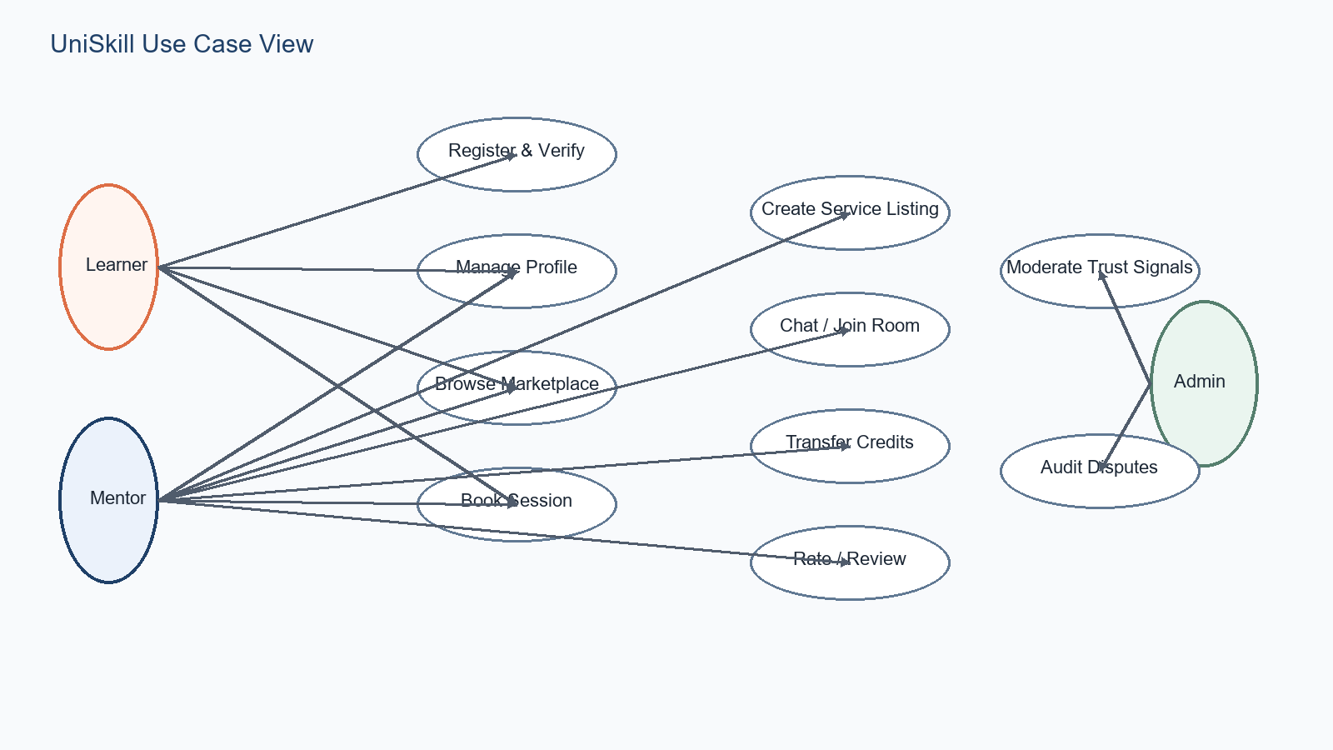
Figure 2.2: Major actors and use cases in the UniSkill platform
The use case view emphasizes that students act in multiple roles. A single user may learn, teach, publish services, move credits, and join rooms, while administrative review remains a secondary but important trust function.

2.3 ER Model
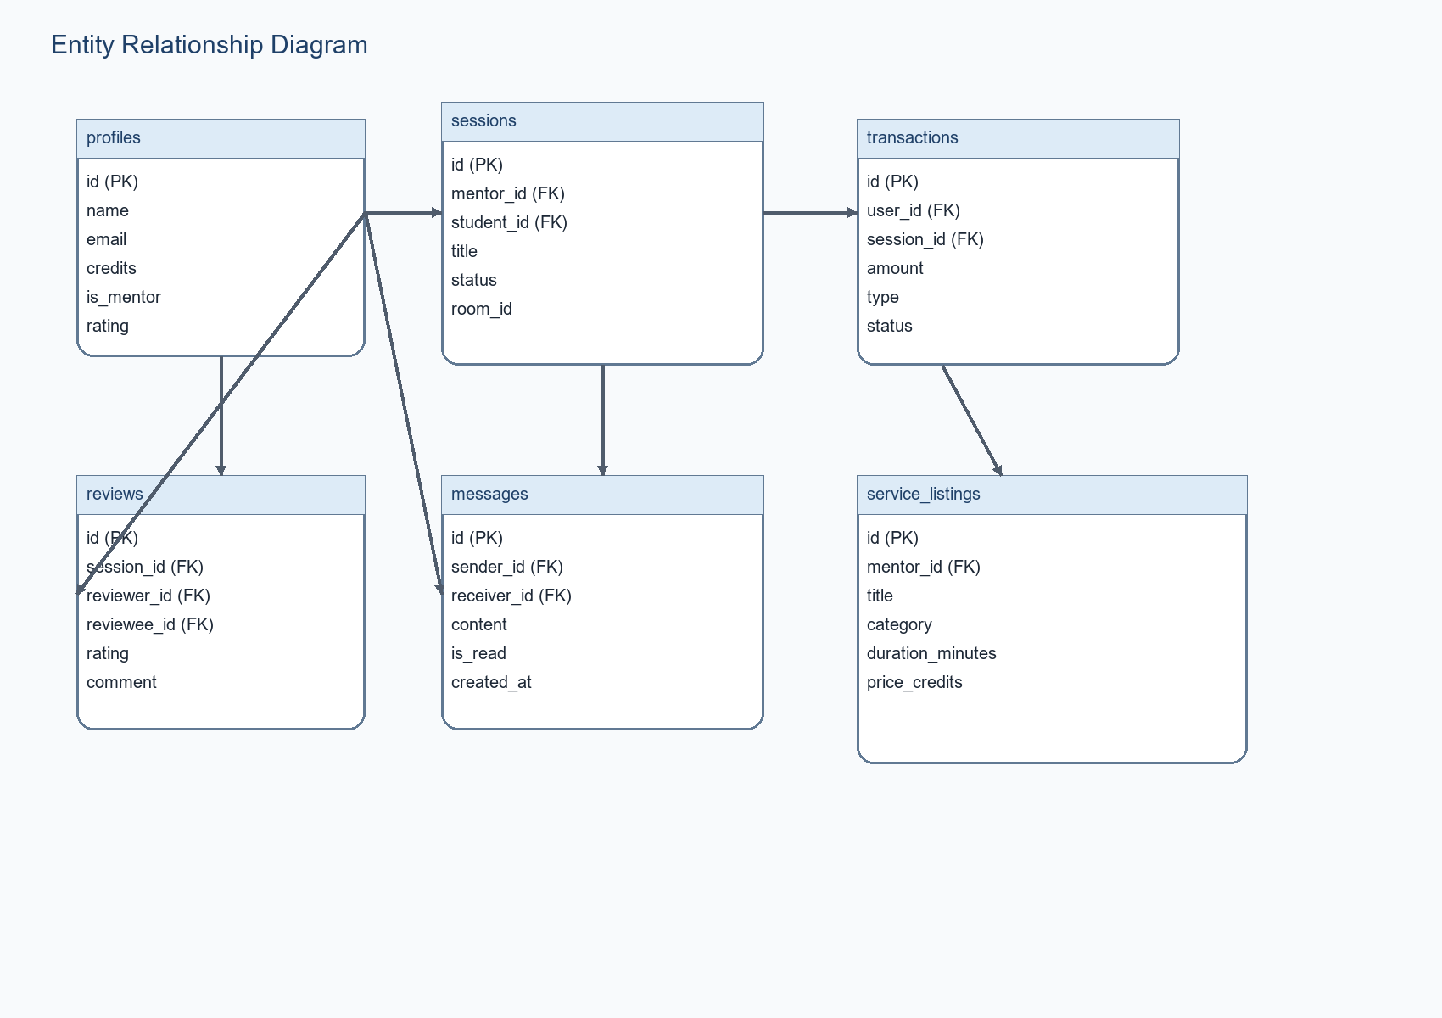
Figure 2.3: ER model for profiles, sessions, transactions, messages, and service listings

2.4 Data Flow Diagram
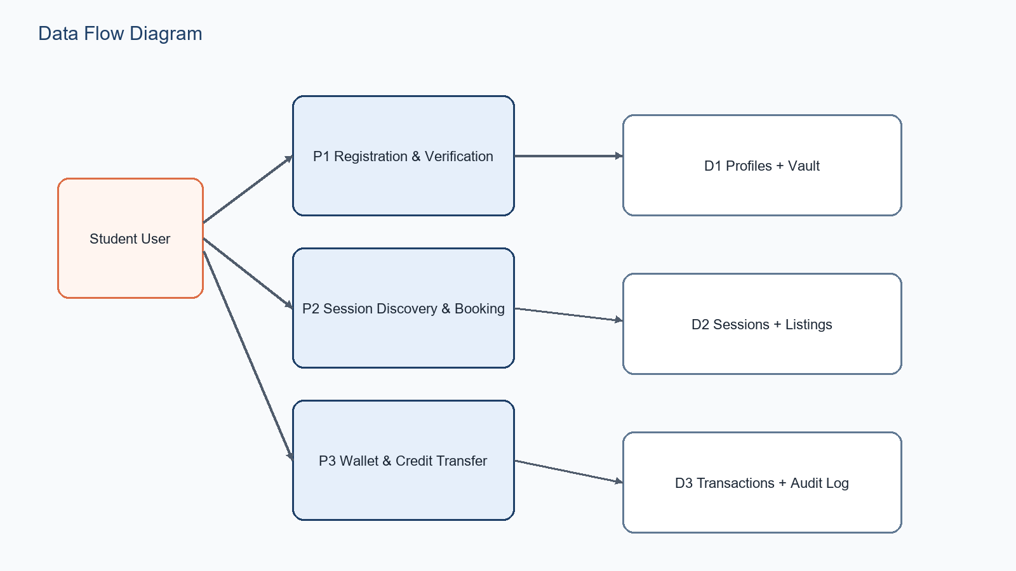
Figure 2.4: Data flow between student actors, processing units, and data stores

2.5 Control Flow Diagram
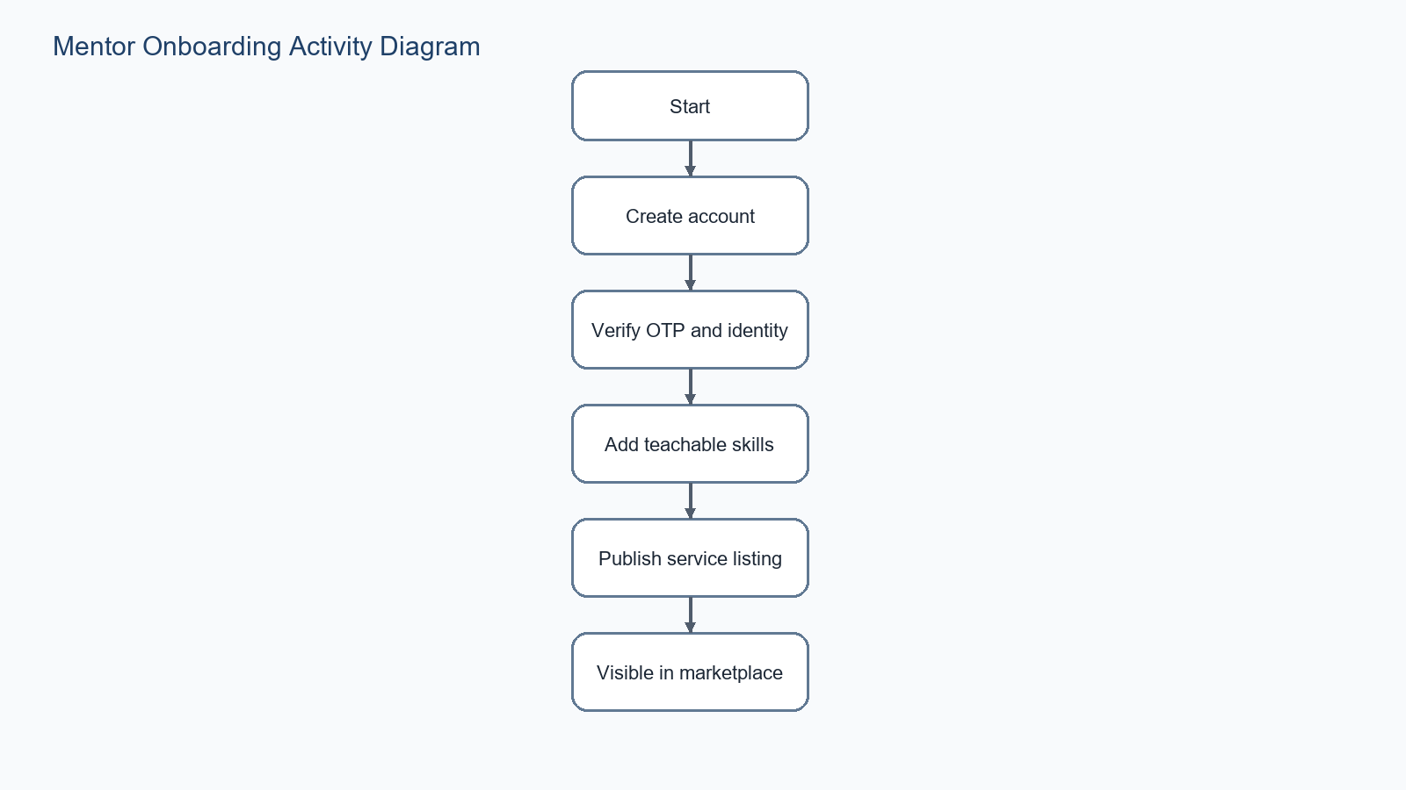
Figure 2.5: Mentor onboarding control flow

2.6 State Transition Diagram
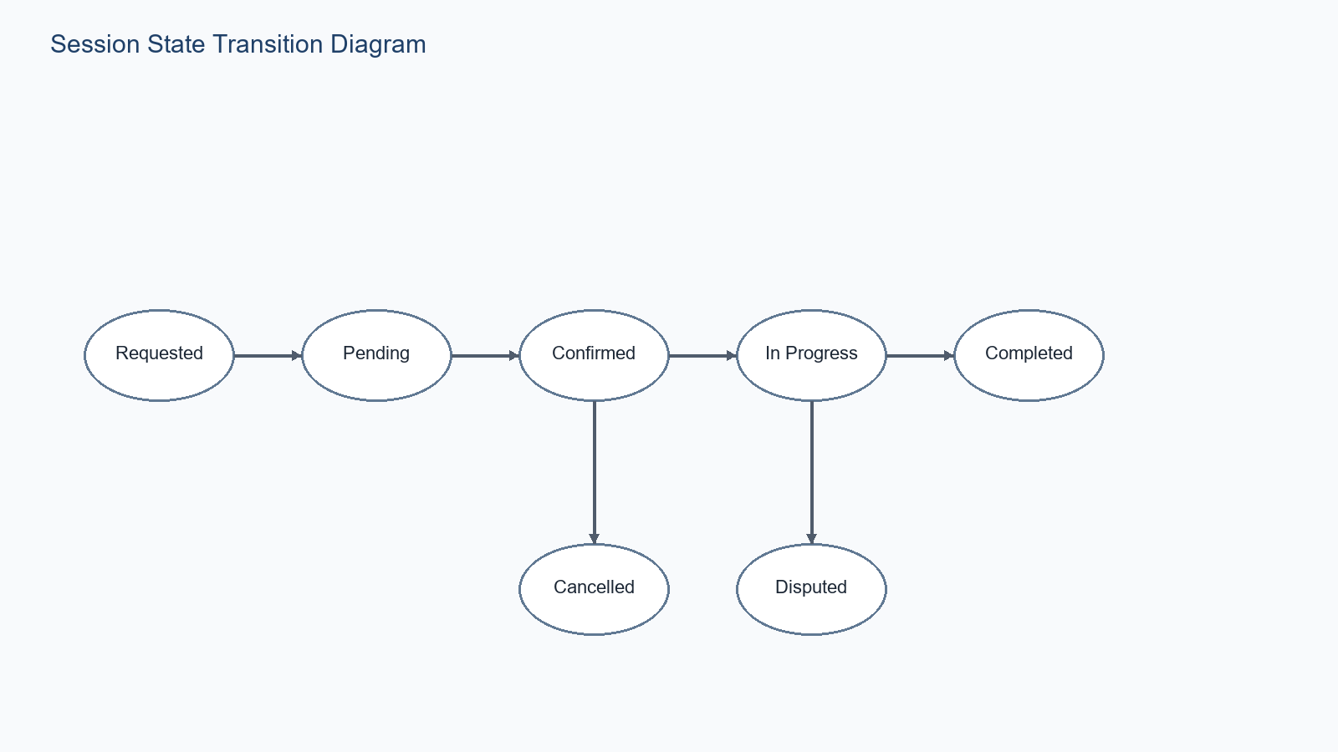
Figure 2.6: Session state progression and exception branches

2.7 Narrative Analysis
UniSkill approaches analysis modeling through a campus-first design lens in which UniSkill depends on transitions between trusted states, not on static profile pages alone. The current repository shows that the platform blends verification steps, mentor publication, booking state, and credit movement, allowing the system to support both immediate usability and disciplined back-end control. From a project documentation perspective, this matters because diagrammatic analysis is a necessary design aid, which makes the design traceable from user need through schema, API behavior, and interface flow.
UniSkill approaches analysis modeling through a campus-first design lens in which the system has both event-driven and data-driven behavior. The current repository shows that the platform blends socket events, REST-style writes, and policy-protected reads, allowing the system to support both immediate usability and disciplined back-end control. From a project documentation perspective, this matters because a single UML notation would not explain the product adequately by itself, which makes the design traceable from user need through schema, API behavior, and interface flow.
UniSkill approaches analysis modeling through a campus-first design lens in which students move fluidly between platform roles. The current repository shows that the platform blends shared profile identity with contextual behavior, allowing the system to support both immediate usability and disciplined back-end control. From a project documentation perspective, this matters because actor analysis must account for dual-role journeys, which makes the design traceable from user need through schema, API behavior, and interface flow.

3. Design Model

3.1 Architectural Design

3.1.1 System Architecture Diagram
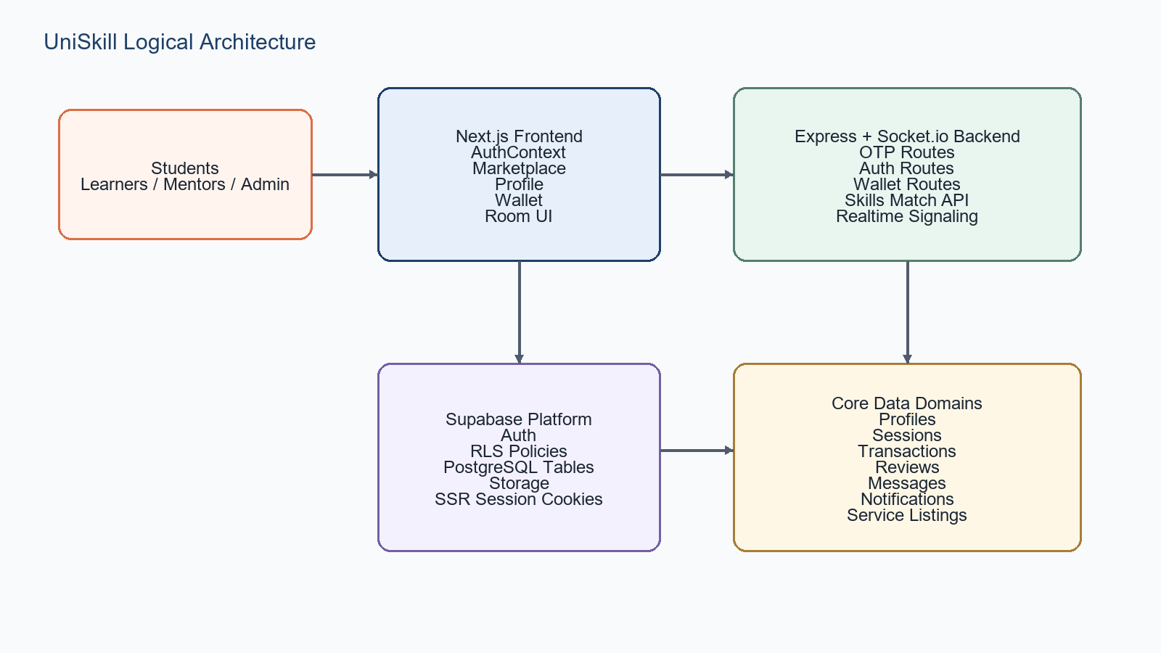
Figure 3.1.1: System architecture diagram for UniSkill

3.1.2 Description of Architectural Design
The architecture separates presentation, route mediation, business logic, realtime event transport, and persistence. This keeps the student-facing experience responsive while allowing secure server-side coordination of stateful operations.
Next.js pages and SSR-aware route handlers own browser-facing behavior. Express encapsulates server-level services such as OTP, wallet logic, and cross-origin socket configuration. Supabase anchors storage, identity, and policy enforcement.

3.2 Database Design

3.2.1 Data Dictionary
Entity | Responsibility | Key relationships
profiles | Public user identity and participation state | Related to sessions, transactions, reviews, messages, favorites
user_verification_vault | Private identity proofing and institutional contact data | One-to-one with profile/auth user
sessions | Booked learning engagements | Connects learner, mentor, room, reviews, and transactions
transactions | Credit movement log | Belongs to user and optionally a session
service_listings | Bookable mentor offers | Belongs to mentor profile

3.2.2 Normalization
UniSkill approaches normalization through a campus-first design lens in which core transactional data is mostly decomposed into separate entities with explicit references. The current repository shows that the platform blends sessions, reviews, transactions, and messages, allowing the system to support both immediate usability and disciplined back-end control. From a project documentation perspective, this matters because write boundaries remain understandable, which makes the design traceable from user need through schema, API behavior, and interface flow.
UniSkill approaches normalization through a campus-first design lens in which some compatibility fields intentionally duplicate business meaning during migration periods. The current repository shows that the platform blends name versus display_name and credits versus credits_balance, allowing the system to support both immediate usability and disciplined back-end control. From a project documentation perspective, this matters because normalization discussion should acknowledge pragmatic transitional design, which makes the design traceable from user need through schema, API behavior, and interface flow.

3.3 Component Design

3.3.1 Flow Chart
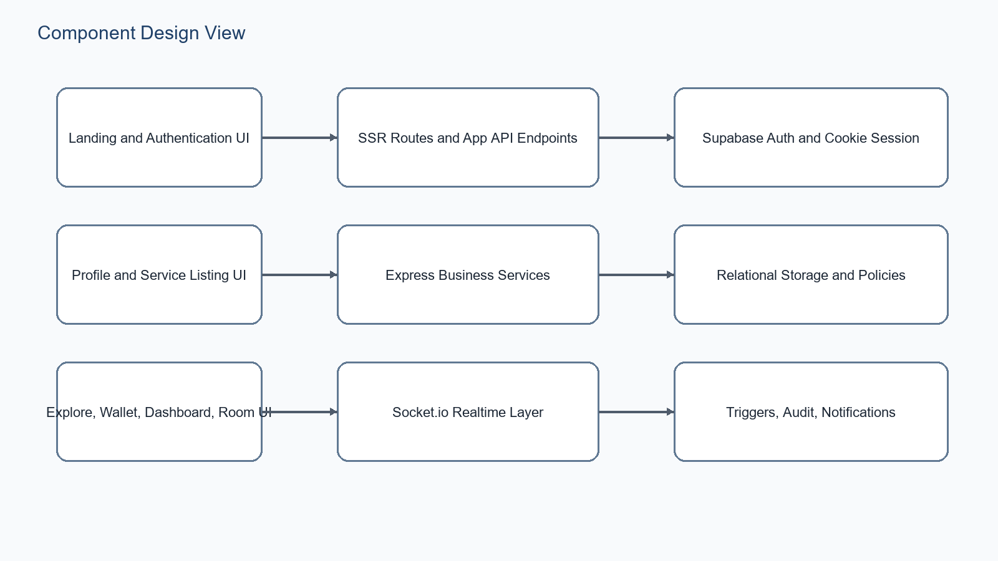
Figure 3.3.1: Component relationship flow for primary UniSkill modules

3.3.2 Component Responsibilities
- AuthContext bridges authenticated identity, compatibility mapping, and verification-state hydration for the client.
- Teaching-service routes encapsulate mentor-owned CRUD logic and profile mentor-state updates.
- Session routes translate booking intent into persistent session records and room identifiers.
- Wallet routes own balance lookup, credit addition, and transfer record generation.
- Socket.io handlers coordinate join, signal, chat, disconnect, and call-end room behavior.

3.4 Interface Design

3.4.1 Screenshots and Surface Mapping
UniSkill approaches screen design through a campus-first design lens in which the landing page positions UniSkill as a verified campus network. The current repository shows that the platform blends hero statistics, feature cards, and action buttons, allowing the system to support both immediate usability and disciplined back-end control. From a project documentation perspective, this matters because the UI communicates trust and momentum before the user signs up, which makes the design traceable from user need through schema, API behavior, and interface flow.
UniSkill approaches screen design through a campus-first design lens in which dashboard and home overview pages summarize session rhythm and credit movement. The current repository shows that the platform blends activity charts, quick links, and recent sessions, allowing the system to support both immediate usability and disciplined back-end control. From a project documentation perspective, this matters because design aligns with repeat-use student behavior, which makes the design traceable from user need through schema, API behavior, and interface flow.
UniSkill approaches screen design through a campus-first design lens in which profile and explore pages are task-oriented rather than merely descriptive. The current repository shows that the platform blends service authoring forms, discoverable filters, and public mentor signals, allowing the system to support both immediate usability and disciplined back-end control. From a project documentation perspective, this matters because interface design is tied directly to transaction readiness, which makes the design traceable from user need through schema, API behavior, and interface flow.

4. Database Design

4.1 Table Relationships
The relationship graph is anchored by profiles. Sessions establish bidirectional participation between student and mentor. Transactions create economic traceability, while reviews and messages create qualitative and conversational continuity.

4.2 Security Policy Notes
- Profiles are publicly selectable for discovery-oriented use cases.
- Verification vault rows are private to the owning authenticated user.
- Transactions are viewable by the owning user, with broader control reserved for service-role contexts.
- Messages and notifications remain user-scoped.

4.3 Trigger and Automation Design
UniSkill approaches triggers and automation through a campus-first design lens in which signup automation reduces profile bootstrap friction. The current repository shows that the platform blends on_auth_user_created and profile initialization, allowing the system to support both immediate usability and disciplined back-end control. From a project documentation perspective, this matters because the design links auth creation to domain readiness, which makes the design traceable from user need through schema, API behavior, and interface flow.
UniSkill approaches triggers and automation through a campus-first design lens in which audit triggers increase accountability for profile mutation. The current repository shows that the platform blends user_audit_log inserts, allowing the system to support both immediate usability and disciplined back-end control. From a project documentation perspective, this matters because design governance becomes concrete rather than aspirational, which makes the design traceable from user need through schema, API behavior, and interface flow.
UniSkill approaches triggers and automation through a campus-first design lens in which updated_at triggers standardize freshness semantics across mutable tables. The current repository shows that the platform blends profile and session maintenance, allowing the system to support both immediate usability and disciplined back-end control. From a project documentation perspective, this matters because timestamp usage stays reliable, which makes the design traceable from user need through schema, API behavior, and interface flow.

5. Component and Interface Design

5.1 Realtime Collaboration View
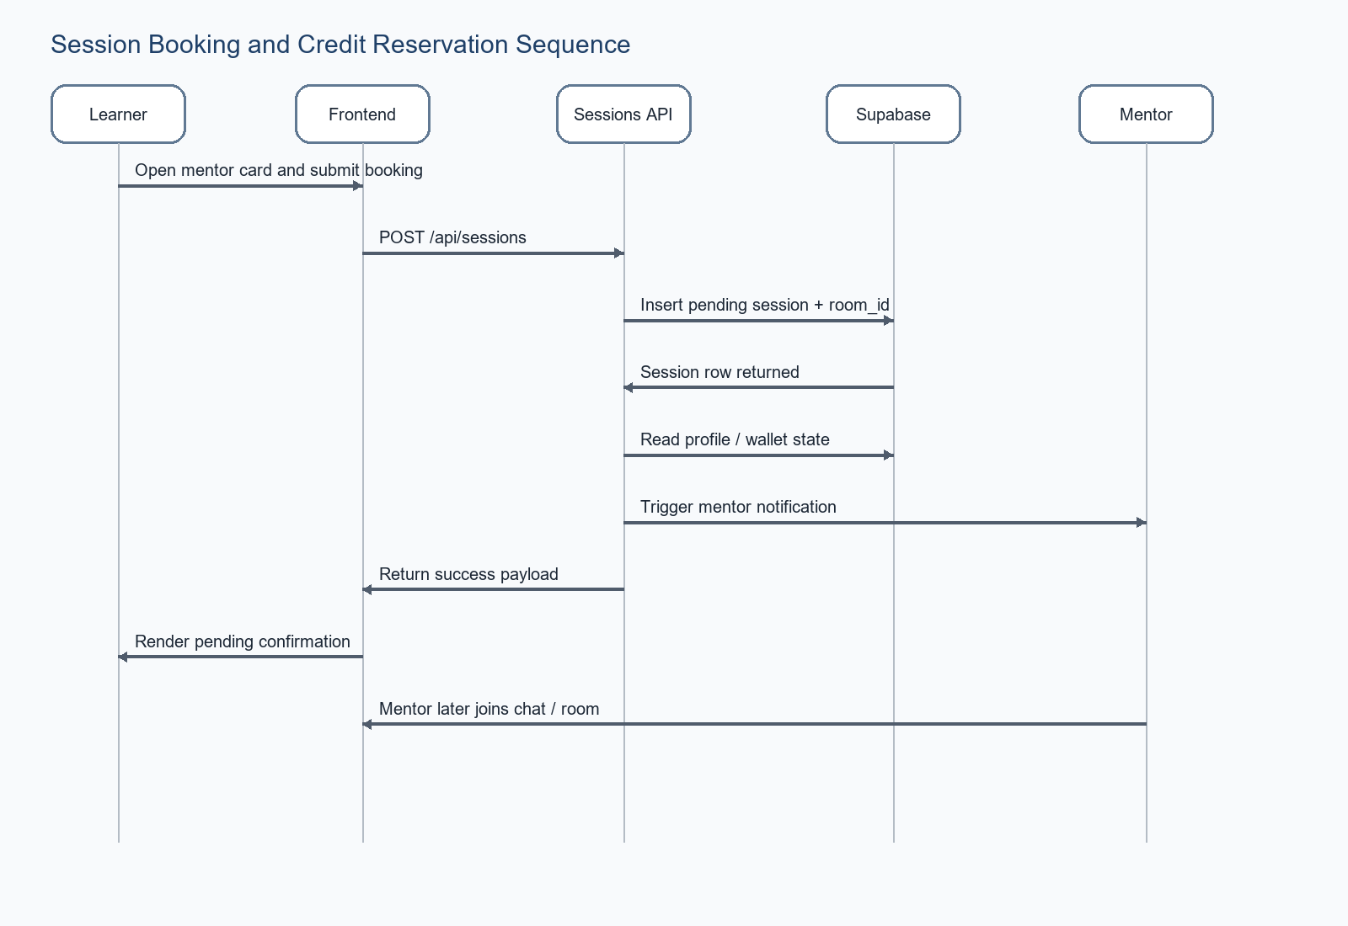
Figure 5.1: Sequence view for booking and follow-up room interaction

5.2 API Surface Summary
Endpoint family | Representative path | Purpose
Auth | /api/auth/register | Create user and reconcile profile state
OTP | /api/otp/send | Dispatch verification code
Wallet | /api/wallet/transfer | Move credits between users
Skills | /api/skills/match/:userId | Compute reciprocal learning opportunities
Services | /api/teaching-services | Manage mentor service offers
Sessions | /api/sessions | Create pending bookings

5.3 UI Surface Design Notes
Explore mode and freelance mode indicate that the product supports distinct but related user intentions.
Profile management intentionally brings skill curation and service authoring into the same operational surface.
The room page acts as a session execution boundary where previously independent booking and communication flows converge.

6. Dynamic Behavior Models

6.1 Booking Sequence
Booking begins when a learner selects a mentor or service and ends when a pending session row and room identifier are returned to the interface. Downstream wallet reservation and final settlement logic can deepen this sequence in future revisions.

6.2 Mentor Onboarding Activity

Figure 6.2: Mentor onboarding activity view

6.3 Session State Machine

Figure 6.3: Session state machine

6.4 Event Model Narrative
UniSkill approaches event behavior through a campus-first design lens in which user-visible progress depends on a sequence of explicit state transitions. The current repository shows that the platform blends pending sessions, room joins, and transfer records, allowing the system to support both immediate usability and disciplined back-end control. From a project documentation perspective, this matters because dynamic models are necessary for test design, which makes the design traceable from user need through schema, API behavior, and interface flow.
UniSkill approaches event behavior through a campus-first design lens in which realtime behavior supplements but does not replace persistent data. The current repository shows that the platform blends socket events and stored rows, allowing the system to support both immediate usability and disciplined back-end control. From a project documentation perspective, this matters because the system remains recoverable after transient disconnects, which makes the design traceable from user need through schema, API behavior, and interface flow.

7. Screen and Interaction Notes

7.1 Landing and value proposition communication
UniSkill approaches Landing and value proposition communication through a campus-first design lens in which interface choices shape trust as much as backend policies do. The current repository shows that the platform blends surface hierarchy, readable metrics, and visible state, allowing the system to support both immediate usability and disciplined back-end control. From a project documentation perspective, this matters because screen notes belong in technical documentation, which makes the design traceable from user need through schema, API behavior, and interface flow.
UniSkill approaches Landing and value proposition communication through a campus-first design lens in which UniSkill is intended for repeated campus use rather than occasional novelty visits. The current repository shows that the platform blends quick actions, summary cards, and operational forms, allowing the system to support both immediate usability and disciplined back-end control. From a project documentation perspective, this matters because interaction design must stay efficient, which makes the design traceable from user need through schema, API behavior, and interface flow.

7.2 Signup and login interaction structure
UniSkill approaches Signup and login interaction structure through a campus-first design lens in which interface choices shape trust as much as backend policies do. The current repository shows that the platform blends surface hierarchy, readable metrics, and visible state, allowing the system to support both immediate usability and disciplined back-end control. From a project documentation perspective, this matters because screen notes belong in technical documentation, which makes the design traceable from user need through schema, API behavior, and interface flow.
UniSkill approaches Signup and login interaction structure through a campus-first design lens in which UniSkill is intended for repeated campus use rather than occasional novelty visits. The current repository shows that the platform blends quick actions, summary cards, and operational forms, allowing the system to support both immediate usability and disciplined back-end control. From a project documentation perspective, this matters because interaction design must stay efficient, which makes the design traceable from user need through schema, API behavior, and interface flow.

7.3 Profile authoring and verification cues
UniSkill approaches Profile authoring and verification cues through a campus-first design lens in which interface choices shape trust as much as backend policies do. The current repository shows that the platform blends surface hierarchy, readable metrics, and visible state, allowing the system to support both immediate usability and disciplined back-end control. From a project documentation perspective, this matters because screen notes belong in technical documentation, which makes the design traceable from user need through schema, API behavior, and interface flow.
UniSkill approaches Profile authoring and verification cues through a campus-first design lens in which UniSkill is intended for repeated campus use rather than occasional novelty visits. The current repository shows that the platform blends quick actions, summary cards, and operational forms, allowing the system to support both immediate usability and disciplined back-end control. From a project documentation perspective, this matters because interaction design must stay efficient, which makes the design traceable from user need through schema, API behavior, and interface flow.

7.4 Explore filters, cards, and conversion actions
UniSkill approaches Explore filters, cards, and conversion actions through a campus-first design lens in which interface choices shape trust as much as backend policies do. The current repository shows that the platform blends surface hierarchy, readable metrics, and visible state, allowing the system to support both immediate usability and disciplined back-end control. From a project documentation perspective, this matters because screen notes belong in technical documentation, which makes the design traceable from user need through schema, API behavior, and interface flow.
UniSkill approaches Explore filters, cards, and conversion actions through a campus-first design lens in which UniSkill is intended for repeated campus use rather than occasional novelty visits. The current repository shows that the platform blends quick actions, summary cards, and operational forms, allowing the system to support both immediate usability and disciplined back-end control. From a project documentation perspective, this matters because interaction design must stay efficient, which makes the design traceable from user need through schema, API behavior, and interface flow.

7.5 Wallet transparency and transaction visibility
UniSkill approaches Wallet transparency and transaction visibility through a campus-first design lens in which interface choices shape trust as much as backend policies do. The current repository shows that the platform blends surface hierarchy, readable metrics, and visible state, allowing the system to support both immediate usability and disciplined back-end control. From a project documentation perspective, this matters because screen notes belong in technical documentation, which makes the design traceable from user need through schema, API behavior, and interface flow.
UniSkill approaches Wallet transparency and transaction visibility through a campus-first design lens in which UniSkill is intended for repeated campus use rather than occasional novelty visits. The current repository shows that the platform blends quick actions, summary cards, and operational forms, allowing the system to support both immediate usability and disciplined back-end control. From a project documentation perspective, this matters because interaction design must stay efficient, which makes the design traceable from user need through schema, API behavior, and interface flow.

7.6 Room interaction with peer connection events
UniSkill approaches Room interaction with peer connection events through a campus-first design lens in which interface choices shape trust as much as backend policies do. The current repository shows that the platform blends surface hierarchy, readable metrics, and visible state, allowing the system to support both immediate usability and disciplined back-end control. From a project documentation perspective, this matters because screen notes belong in technical documentation, which makes the design traceable from user need through schema, API behavior, and interface flow.
UniSkill approaches Room interaction with peer connection events through a campus-first design lens in which UniSkill is intended for repeated campus use rather than occasional novelty visits. The current repository shows that the platform blends quick actions, summary cards, and operational forms, allowing the system to support both immediate usability and disciplined back-end control. From a project documentation perspective, this matters because interaction design must stay efficient, which makes the design traceable from user need through schema, API behavior, and interface flow.

8. Design Decisions and Future Evolution

8.1 Notable Current Design Decisions
- Use Supabase for identity, storage, and RLS rather than building custom auth and policy infrastructure from scratch.
- Preserve a compatibility layer while the schema transitions from early and reconciled field sets.
- Split public profile data from private verification data to protect sensitive information.
- Keep realtime behavior lightweight and room-scoped, with persistence handled separately by database writes.

8.2 Future Evolution Paths
- Richer admin moderation dashboards and dispute flows
- Full session settlement logic with stronger transactional guarantees
- Recommendation and ranking models for mentor discovery
- Analytics surfaces for learner progress and campus engagement
- Cross-campus tenancy and institution-specific verification rules

8.3 Closing Design Summary
The UniSkill design is strongest when read as a coherent service ecosystem rather than as disconnected pages or tables. Its diagrams show a project that already has real structure and clear room for disciplined growth.

Appendix A: Detailed Entity and Relationship Commentary

A.1 Profile identity decomposition
UniSkill approaches Profile identity decomposition through a campus-first design lens in which the project must translate abstract product intent into operational behavior. The current repository shows that the platform blends student-facing interactions, server validation, and storage outcomes, allowing the system to support both immediate usability and disciplined back-end control. From a project documentation perspective, this matters because design review can evaluate whether the platform is internally coherent, which makes the design traceable from user need through schema, API behavior, and interface flow.
UniSkill approaches Profile identity decomposition through a campus-first design lens in which UniSkill behaves as a living service ecosystem rather than a one-time form submission. The current repository shows that the platform blends identity, discovery, booking, communication, and credit loops, allowing the system to support both immediate usability and disciplined back-end control. From a project documentation perspective, this matters because documentation needs enough depth to describe sustained use, which makes the design traceable from user need through schema, API behavior, and interface flow.
UniSkill approaches Profile identity decomposition through a campus-first design lens in which each topic affects both usability and platform trust. The current repository shows that the platform blends visible interface cues and invisible policy or schema enforcement, allowing the system to support both immediate usability and disciplined back-end control. From a project documentation perspective, this matters because engineering and product decisions remain traceable, which makes the design traceable from user need through schema, API behavior, and interface flow.
UniSkill approaches Profile identity decomposition through a campus-first design lens in which institutional adoption would depend on consistent treatment of this topic. The current repository shows that the platform blends roles, policies, and structured records, allowing the system to support both immediate usability and disciplined back-end control. From a project documentation perspective, this matters because the report should show implementation maturity beyond a prototype demo, which makes the design traceable from user need through schema, API behavior, and interface flow.
- Design note for profile identity decomposition: the feature must remain understandable for a first-time student user.
- Technical note for profile identity decomposition: API, schema, and UI state should remain synchronized.
- Quality note for profile identity decomposition: failures should preserve traceability and user confidence.

A.2 Verification vault separation rationale
UniSkill approaches Verification vault separation rationale through a campus-first design lens in which the project must translate abstract product intent into operational behavior. The current repository shows that the platform blends student-facing interactions, server validation, and storage outcomes, allowing the system to support both immediate usability and disciplined back-end control. From a project documentation perspective, this matters because design review can evaluate whether the platform is internally coherent, which makes the design traceable from user need through schema, API behavior, and interface flow.
UniSkill approaches Verification vault separation rationale through a campus-first design lens in which UniSkill behaves as a living service ecosystem rather than a one-time form submission. The current repository shows that the platform blends identity, discovery, booking, communication, and credit loops, allowing the system to support both immediate usability and disciplined back-end control. From a project documentation perspective, this matters because documentation needs enough depth to describe sustained use, which makes the design traceable from user need through schema, API behavior, and interface flow.
UniSkill approaches Verification vault separation rationale through a campus-first design lens in which each topic affects both usability and platform trust. The current repository shows that the platform blends visible interface cues and invisible policy or schema enforcement, allowing the system to support both immediate usability and disciplined back-end control. From a project documentation perspective, this matters because engineering and product decisions remain traceable, which makes the design traceable from user need through schema, API behavior, and interface flow.
UniSkill approaches Verification vault separation rationale through a campus-first design lens in which institutional adoption would depend on consistent treatment of this topic. The current repository shows that the platform blends roles, policies, and structured records, allowing the system to support both immediate usability and disciplined back-end control. From a project documentation perspective, this matters because the report should show implementation maturity beyond a prototype demo, which makes the design traceable from user need through schema, API behavior, and interface flow.
- Design note for verification vault separation rationale: the feature must remain understandable for a first-time student user.
- Technical note for verification vault separation rationale: API, schema, and UI state should remain synchronized.
- Quality note for verification vault separation rationale: failures should preserve traceability and user confidence.

A.3 Session ownership and lifecycle commentary
UniSkill approaches Session ownership and lifecycle commentary through a campus-first design lens in which the project must translate abstract product intent into operational behavior. The current repository shows that the platform blends student-facing interactions, server validation, and storage outcomes, allowing the system to support both immediate usability and disciplined back-end control. From a project documentation perspective, this matters because design review can evaluate whether the platform is internally coherent, which makes the design traceable from user need through schema, API behavior, and interface flow.
UniSkill approaches Session ownership and lifecycle commentary through a campus-first design lens in which UniSkill behaves as a living service ecosystem rather than a one-time form submission. The current repository shows that the platform blends identity, discovery, booking, communication, and credit loops, allowing the system to support both immediate usability and disciplined back-end control. From a project documentation perspective, this matters because documentation needs enough depth to describe sustained use, which makes the design traceable from user need through schema, API behavior, and interface flow.
UniSkill approaches Session ownership and lifecycle commentary through a campus-first design lens in which each topic affects both usability and platform trust. The current repository shows that the platform blends visible interface cues and invisible policy or schema enforcement, allowing the system to support both immediate usability and disciplined back-end control. From a project documentation perspective, this matters because engineering and product decisions remain traceable, which makes the design traceable from user need through schema, API behavior, and interface flow.
UniSkill approaches Session ownership and lifecycle commentary through a campus-first design lens in which institutional adoption would depend on consistent treatment of this topic. The current repository shows that the platform blends roles, policies, and structured records, allowing the system to support both immediate usability and disciplined back-end control. From a project documentation perspective, this matters because the report should show implementation maturity beyond a prototype demo, which makes the design traceable from user need through schema, API behavior, and interface flow.
- Design note for session ownership and lifecycle commentary: the feature must remain understandable for a first-time student user.
- Technical note for session ownership and lifecycle commentary: API, schema, and UI state should remain synchronized.
- Quality note for session ownership and lifecycle commentary: failures should preserve traceability and user confidence.

A.4 Transaction pairing logic
UniSkill approaches Transaction pairing logic through a campus-first design lens in which the project must translate abstract product intent into operational behavior. The current repository shows that the platform blends student-facing interactions, server validation, and storage outcomes, allowing the system to support both immediate usability and disciplined back-end control. From a project documentation perspective, this matters because design review can evaluate whether the platform is internally coherent, which makes the design traceable from user need through schema, API behavior, and interface flow.
UniSkill approaches Transaction pairing logic through a campus-first design lens in which UniSkill behaves as a living service ecosystem rather than a one-time form submission. The current repository shows that the platform blends identity, discovery, booking, communication, and credit loops, allowing the system to support both immediate usability and disciplined back-end control. From a project documentation perspective, this matters because documentation needs enough depth to describe sustained use, which makes the design traceable from user need through schema, API behavior, and interface flow.
UniSkill approaches Transaction pairing logic through a campus-first design lens in which each topic affects both usability and platform trust. The current repository shows that the platform blends visible interface cues and invisible policy or schema enforcement, allowing the system to support both immediate usability and disciplined back-end control. From a project documentation perspective, this matters because engineering and product decisions remain traceable, which makes the design traceable from user need through schema, API behavior, and interface flow.
UniSkill approaches Transaction pairing logic through a campus-first design lens in which institutional adoption would depend on consistent treatment of this topic. The current repository shows that the platform blends roles, policies, and structured records, allowing the system to support both immediate usability and disciplined back-end control. From a project documentation perspective, this matters because the report should show implementation maturity beyond a prototype demo, which makes the design traceable from user need through schema, API behavior, and interface flow.
- Design note for transaction pairing logic: the feature must remain understandable for a first-time student user.
- Technical note for transaction pairing logic: API, schema, and UI state should remain synchronized.
- Quality note for transaction pairing logic: failures should preserve traceability and user confidence.

A.5 Review authorship and reputation impact
UniSkill approaches Review authorship and reputation impact through a campus-first design lens in which the project must translate abstract product intent into operational behavior. The current repository shows that the platform blends student-facing interactions, server validation, and storage outcomes, allowing the system to support both immediate usability and disciplined back-end control. From a project documentation perspective, this matters because design review can evaluate whether the platform is internally coherent, which makes the design traceable from user need through schema, API behavior, and interface flow.
UniSkill approaches Review authorship and reputation impact through a campus-first design lens in which UniSkill behaves as a living service ecosystem rather than a one-time form submission. The current repository shows that the platform blends identity, discovery, booking, communication, and credit loops, allowing the system to support both immediate usability and disciplined back-end control. From a project documentation perspective, this matters because documentation needs enough depth to describe sustained use, which makes the design traceable from user need through schema, API behavior, and interface flow.
UniSkill approaches Review authorship and reputation impact through a campus-first design lens in which each topic affects both usability and platform trust. The current repository shows that the platform blends visible interface cues and invisible policy or schema enforcement, allowing the system to support both immediate usability and disciplined back-end control. From a project documentation perspective, this matters because engineering and product decisions remain traceable, which makes the design traceable from user need through schema, API behavior, and interface flow.
UniSkill approaches Review authorship and reputation impact through a campus-first design lens in which institutional adoption would depend on consistent treatment of this topic. The current repository shows that the platform blends roles, policies, and structured records, allowing the system to support both immediate usability and disciplined back-end control. From a project documentation perspective, this matters because the report should show implementation maturity beyond a prototype demo, which makes the design traceable from user need through schema, API behavior, and interface flow.
- Design note for review authorship and reputation impact: the feature must remain understandable for a first-time student user.
- Technical note for review authorship and reputation impact: API, schema, and UI state should remain synchronized.
- Quality note for review authorship and reputation impact: failures should preserve traceability and user confidence.

A.6 Message privacy and read-state design
UniSkill approaches Message privacy and read-state design through a campus-first design lens in which the project must translate abstract product intent into operational behavior. The current repository shows that the platform blends student-facing interactions, server validation, and storage outcomes, allowing the system to support both immediate usability and disciplined back-end control. From a project documentation perspective, this matters because design review can evaluate whether the platform is internally coherent, which makes the design traceable from user need through schema, API behavior, and interface flow.
UniSkill approaches Message privacy and read-state design through a campus-first design lens in which UniSkill behaves as a living service ecosystem rather than a one-time form submission. The current repository shows that the platform blends identity, discovery, booking, communication, and credit loops, allowing the system to support both immediate usability and disciplined back-end control. From a project documentation perspective, this matters because documentation needs enough depth to describe sustained use, which makes the design traceable from user need through schema, API behavior, and interface flow.
UniSkill approaches Message privacy and read-state design through a campus-first design lens in which each topic affects both usability and platform trust. The current repository shows that the platform blends visible interface cues and invisible policy or schema enforcement, allowing the system to support both immediate usability and disciplined back-end control. From a project documentation perspective, this matters because engineering and product decisions remain traceable, which makes the design traceable from user need through schema, API behavior, and interface flow.
UniSkill approaches Message privacy and read-state design through a campus-first design lens in which institutional adoption would depend on consistent treatment of this topic. The current repository shows that the platform blends roles, policies, and structured records, allowing the system to support both immediate usability and disciplined back-end control. From a project documentation perspective, this matters because the report should show implementation maturity beyond a prototype demo, which makes the design traceable from user need through schema, API behavior, and interface flow.
- Design note for message privacy and read-state design: the feature must remain understandable for a first-time student user.
- Technical note for message privacy and read-state design: API, schema, and UI state should remain synchronized.
- Quality note for message privacy and read-state design: failures should preserve traceability and user confidence.

A.7 Notification payload design
UniSkill approaches Notification payload design through a campus-first design lens in which the project must translate abstract product intent into operational behavior. The current repository shows that the platform blends student-facing interactions, server validation, and storage outcomes, allowing the system to support both immediate usability and disciplined back-end control. From a project documentation perspective, this matters because design review can evaluate whether the platform is internally coherent, which makes the design traceable from user need through schema, API behavior, and interface flow.
UniSkill approaches Notification payload design through a campus-first design lens in which UniSkill behaves as a living service ecosystem rather than a one-time form submission. The current repository shows that the platform blends identity, discovery, booking, communication, and credit loops, allowing the system to support both immediate usability and disciplined back-end control. From a project documentation perspective, this matters because documentation needs enough depth to describe sustained use, which makes the design traceable from user need through schema, API behavior, and interface flow.
UniSkill approaches Notification payload design through a campus-first design lens in which each topic affects both usability and platform trust. The current repository shows that the platform blends visible interface cues and invisible policy or schema enforcement, allowing the system to support both immediate usability and disciplined back-end control. From a project documentation perspective, this matters because engineering and product decisions remain traceable, which makes the design traceable from user need through schema, API behavior, and interface flow.
UniSkill approaches Notification payload design through a campus-first design lens in which institutional adoption would depend on consistent treatment of this topic. The current repository shows that the platform blends roles, policies, and structured records, allowing the system to support both immediate usability and disciplined back-end control. From a project documentation perspective, this matters because the report should show implementation maturity beyond a prototype demo, which makes the design traceable from user need through schema, API behavior, and interface flow.
- Design note for notification payload design: the feature must remain understandable for a first-time student user.
- Technical note for notification payload design: API, schema, and UI state should remain synchronized.
- Quality note for notification payload design: failures should preserve traceability and user confidence.

A.8 Service-listing evolution path
UniSkill approaches Service-listing evolution path through a campus-first design lens in which the project must translate abstract product intent into operational behavior. The current repository shows that the platform blends student-facing interactions, server validation, and storage outcomes, allowing the system to support both immediate usability and disciplined back-end control. From a project documentation perspective, this matters because design review can evaluate whether the platform is internally coherent, which makes the design traceable from user need through schema, API behavior, and interface flow.
UniSkill approaches Service-listing evolution path through a campus-first design lens in which UniSkill behaves as a living service ecosystem rather than a one-time form submission. The current repository shows that the platform blends identity, discovery, booking, communication, and credit loops, allowing the system to support both immediate usability and disciplined back-end control. From a project documentation perspective, this matters because documentation needs enough depth to describe sustained use, which makes the design traceable from user need through schema, API behavior, and interface flow.
UniSkill approaches Service-listing evolution path through a campus-first design lens in which each topic affects both usability and platform trust. The current repository shows that the platform blends visible interface cues and invisible policy or schema enforcement, allowing the system to support both immediate usability and disciplined back-end control. From a project documentation perspective, this matters because engineering and product decisions remain traceable, which makes the design traceable from user need through schema, API behavior, and interface flow.
UniSkill approaches Service-listing evolution path through a campus-first design lens in which institutional adoption would depend on consistent treatment of this topic. The current repository shows that the platform blends roles, policies, and structured records, allowing the system to support both immediate usability and disciplined back-end control. From a project documentation perspective, this matters because the report should show implementation maturity beyond a prototype demo, which makes the design traceable from user need through schema, API behavior, and interface flow.
- Design note for service-listing evolution path: the feature must remain understandable for a first-time student user.
- Technical note for service-listing evolution path: API, schema, and UI state should remain synchronized.
- Quality note for service-listing evolution path: failures should preserve traceability and user confidence.

A.9 Audit-log governance role
UniSkill approaches Audit-log governance role through a campus-first design lens in which the project must translate abstract product intent into operational behavior. The current repository shows that the platform blends student-facing interactions, server validation, and storage outcomes, allowing the system to support both immediate usability and disciplined back-end control. From a project documentation perspective, this matters because design review can evaluate whether the platform is internally coherent, which makes the design traceable from user need through schema, API behavior, and interface flow.
UniSkill approaches Audit-log governance role through a campus-first design lens in which UniSkill behaves as a living service ecosystem rather than a one-time form submission. The current repository shows that the platform blends identity, discovery, booking, communication, and credit loops, allowing the system to support both immediate usability and disciplined back-end control. From a project documentation perspective, this matters because documentation needs enough depth to describe sustained use, which makes the design traceable from user need through schema, API behavior, and interface flow.
UniSkill approaches Audit-log governance role through a campus-first design lens in which each topic affects both usability and platform trust. The current repository shows that the platform blends visible interface cues and invisible policy or schema enforcement, allowing the system to support both immediate usability and disciplined back-end control. From a project documentation perspective, this matters because engineering and product decisions remain traceable, which makes the design traceable from user need through schema, API behavior, and interface flow.
UniSkill approaches Audit-log governance role through a campus-first design lens in which institutional adoption would depend on consistent treatment of this topic. The current repository shows that the platform blends roles, policies, and structured records, allowing the system to support both immediate usability and disciplined back-end control. From a project documentation perspective, this matters because the report should show implementation maturity beyond a prototype demo, which makes the design traceable from user need through schema, API behavior, and interface flow.
- Design note for audit-log governance role: the feature must remain understandable for a first-time student user.
- Technical note for audit-log governance role: API, schema, and UI state should remain synchronized.
- Quality note for audit-log governance role: failures should preserve traceability and user confidence.

A.10 Compatibility-field retirement strategy
UniSkill approaches Compatibility-field retirement strategy through a campus-first design lens in which the project must translate abstract product intent into operational behavior. The current repository shows that the platform blends student-facing interactions, server validation, and storage outcomes, allowing the system to support both immediate usability and disciplined back-end control. From a project documentation perspective, this matters because design review can evaluate whether the platform is internally coherent, which makes the design traceable from user need through schema, API behavior, and interface flow.
UniSkill approaches Compatibility-field retirement strategy through a campus-first design lens in which UniSkill behaves as a living service ecosystem rather than a one-time form submission. The current repository shows that the platform blends identity, discovery, booking, communication, and credit loops, allowing the system to support both immediate usability and disciplined back-end control. From a project documentation perspective, this matters because documentation needs enough depth to describe sustained use, which makes the design traceable from user need through schema, API behavior, and interface flow.
UniSkill approaches Compatibility-field retirement strategy through a campus-first design lens in which each topic affects both usability and platform trust. The current repository shows that the platform blends visible interface cues and invisible policy or schema enforcement, allowing the system to support both immediate usability and disciplined back-end control. From a project documentation perspective, this matters because engineering and product decisions remain traceable, which makes the design traceable from user need through schema, API behavior, and interface flow.
UniSkill approaches Compatibility-field retirement strategy through a campus-first design lens in which institutional adoption would depend on consistent treatment of this topic. The current repository shows that the platform blends roles, policies, and structured records, allowing the system to support both immediate usability and disciplined back-end control. From a project documentation perspective, this matters because the report should show implementation maturity beyond a prototype demo, which makes the design traceable from user need through schema, API behavior, and interface flow.
- Design note for compatibility-field retirement strategy: the feature must remain understandable for a first-time student user.
- Technical note for compatibility-field retirement strategy: API, schema, and UI state should remain synchronized.
- Quality note for compatibility-field retirement strategy: failures should preserve traceability and user confidence.

Appendix B: Use Case Realization Notes

B1 Registration Realization
Field | Specification
Primary actor | Student
Goal | Registration Realization
Preconditions | Signup surface is available
Postconditions | User reaches a coherent starting profile

B1.1 Main Flow
- Frontend captures values
- Auth route attempts admin create or signup fallback
- Profile is read or created
- AuthContext hydrates client state

B1.2 Notes
UniSkill approaches Registration Realization through a campus-first design lens in which the scenario must be intelligible from both product and engineering perspectives. The current repository shows that the platform blends user actions, route execution, and resulting state changes, allowing the system to support both immediate usability and disciplined back-end control. From a project documentation perspective, this matters because use-case specification becomes a bridge between requirements and implementation, which makes the design traceable from user need through schema, API behavior, and interface flow.
UniSkill approaches Registration Realization through a campus-first design lens in which UniSkill often couples trust decisions with convenience expectations. The current repository shows that the platform blends verification feedback, booking state, and balance rules, allowing the system to support both immediate usability and disciplined back-end control. From a project documentation perspective, this matters because alternate flows deserve explicit attention, which makes the design traceable from user need through schema, API behavior, and interface flow.

B2 Verification Realization
Field | Specification
Primary actor | Student
Goal | Verification Realization
Preconditions | User has a target for OTP
Postconditions | Trust state advances

B2.1 Main Flow
- OTP route stores code
- Email service dispatches message
- Verify route checks code
- Status endpoint reflects progress

B2.2 Notes
UniSkill approaches Verification Realization through a campus-first design lens in which the scenario must be intelligible from both product and engineering perspectives. The current repository shows that the platform blends user actions, route execution, and resulting state changes, allowing the system to support both immediate usability and disciplined back-end control. From a project documentation perspective, this matters because use-case specification becomes a bridge between requirements and implementation, which makes the design traceable from user need through schema, API behavior, and interface flow.
UniSkill approaches Verification Realization through a campus-first design lens in which UniSkill often couples trust decisions with convenience expectations. The current repository shows that the platform blends verification feedback, booking state, and balance rules, allowing the system to support both immediate usability and disciplined back-end control. From a project documentation perspective, this matters because alternate flows deserve explicit attention, which makes the design traceable from user need through schema, API behavior, and interface flow.

B3 Booking Realization
Field | Specification
Primary actor | Learner
Goal | Booking Realization
Preconditions | Mentor and service context exist
Postconditions | Booking artifact exists

B3.1 Main Flow
- Explore flow exposes choices
- Session API inserts row
- Room identifier is attached
- Dashboard can later surface recent activity

B3.2 Notes
UniSkill approaches Booking Realization through a campus-first design lens in which the scenario must be intelligible from both product and engineering perspectives. The current repository shows that the platform blends user actions, route execution, and resulting state changes, allowing the system to support both immediate usability and disciplined back-end control. From a project documentation perspective, this matters because use-case specification becomes a bridge between requirements and implementation, which makes the design traceable from user need through schema, API behavior, and interface flow.
UniSkill approaches Booking Realization through a campus-first design lens in which UniSkill often couples trust decisions with convenience expectations. The current repository shows that the platform blends verification feedback, booking state, and balance rules, allowing the system to support both immediate usability and disciplined back-end control. From a project documentation perspective, this matters because alternate flows deserve explicit attention, which makes the design traceable from user need through schema, API behavior, and interface flow.

B4 Transfer Realization
Field | Specification
Primary actor | Student
Goal | Transfer Realization
Preconditions | Sender balance is adequate
Postconditions | Economic narrative is persisted

B4.1 Main Flow
- Wallet route reads sender
- Wallet route reads receiver
- Balances mutate
- Transaction rows are inserted

B4.2 Notes
UniSkill approaches Transfer Realization through a campus-first design lens in which the scenario must be intelligible from both product and engineering perspectives. The current repository shows that the platform blends user actions, route execution, and resulting state changes, allowing the system to support both immediate usability and disciplined back-end control. From a project documentation perspective, this matters because use-case specification becomes a bridge between requirements and implementation, which makes the design traceable from user need through schema, API behavior, and interface flow.
UniSkill approaches Transfer Realization through a campus-first design lens in which UniSkill often couples trust decisions with convenience expectations. The current repository shows that the platform blends verification feedback, booking state, and balance rules, allowing the system to support both immediate usability and disciplined back-end control. From a project documentation perspective, this matters because alternate flows deserve explicit attention, which makes the design traceable from user need through schema, API behavior, and interface flow.

B5 Room Realization
Field | Specification
Primary actor | Participant
Goal | Room Realization
Preconditions | Room identifier exists
Postconditions | Interaction state remains synchronized

B5.1 Main Flow
- Socket join-room fires
- Signal and chat events propagate
- Disconnect or end-call notifications broadcast

B5.2 Notes
UniSkill approaches Room Realization through a campus-first design lens in which the scenario must be intelligible from both product and engineering perspectives. The current repository shows that the platform blends user actions, route execution, and resulting state changes, allowing the system to support both immediate usability and disciplined back-end control. From a project documentation perspective, this matters because use-case specification becomes a bridge between requirements and implementation, which makes the design traceable from user need through schema, API behavior, and interface flow.
UniSkill approaches Room Realization through a campus-first design lens in which UniSkill often couples trust decisions with convenience expectations. The current repository shows that the platform blends verification feedback, booking state, and balance rules, allowing the system to support both immediate usability and disciplined back-end control. From a project documentation perspective, this matters because alternate flows deserve explicit attention, which makes the design traceable from user need through schema, API behavior, and interface flow.

Appendix C: Interface-State and Screenflow Commentary

C.1 Landing to signup transition
UniSkill approaches Landing to signup transition through a campus-first design lens in which the project must translate abstract product intent into operational behavior. The current repository shows that the platform blends student-facing interactions, server validation, and storage outcomes, allowing the system to support both immediate usability and disciplined back-end control. From a project documentation perspective, this matters because design review can evaluate whether the platform is internally coherent, which makes the design traceable from user need through schema, API behavior, and interface flow.
UniSkill approaches Landing to signup transition through a campus-first design lens in which UniSkill behaves as a living service ecosystem rather than a one-time form submission. The current repository shows that the platform blends identity, discovery, booking, communication, and credit loops, allowing the system to support both immediate usability and disciplined back-end control. From a project documentation perspective, this matters because documentation needs enough depth to describe sustained use, which makes the design traceable from user need through schema, API behavior, and interface flow.
UniSkill approaches Landing to signup transition through a campus-first design lens in which each topic affects both usability and platform trust. The current repository shows that the platform blends visible interface cues and invisible policy or schema enforcement, allowing the system to support both immediate usability and disciplined back-end control. From a project documentation perspective, this matters because engineering and product decisions remain traceable, which makes the design traceable from user need through schema, API behavior, and interface flow.
UniSkill approaches Landing to signup transition through a campus-first design lens in which institutional adoption would depend on consistent treatment of this topic. The current repository shows that the platform blends roles, policies, and structured records, allowing the system to support both immediate usability and disciplined back-end control. From a project documentation perspective, this matters because the report should show implementation maturity beyond a prototype demo, which makes the design traceable from user need through schema, API behavior, and interface flow.
- Design note for landing to signup transition: the feature must remain understandable for a first-time student user.
- Technical note for landing to signup transition: API, schema, and UI state should remain synchronized.
- Quality note for landing to signup transition: failures should preserve traceability and user confidence.

C.2 Signup to verification transition
UniSkill approaches Signup to verification transition through a campus-first design lens in which the project must translate abstract product intent into operational behavior. The current repository shows that the platform blends student-facing interactions, server validation, and storage outcomes, allowing the system to support both immediate usability and disciplined back-end control. From a project documentation perspective, this matters because design review can evaluate whether the platform is internally coherent, which makes the design traceable from user need through schema, API behavior, and interface flow.
UniSkill approaches Signup to verification transition through a campus-first design lens in which UniSkill behaves as a living service ecosystem rather than a one-time form submission. The current repository shows that the platform blends identity, discovery, booking, communication, and credit loops, allowing the system to support both immediate usability and disciplined back-end control. From a project documentation perspective, this matters because documentation needs enough depth to describe sustained use, which makes the design traceable from user need through schema, API behavior, and interface flow.
UniSkill approaches Signup to verification transition through a campus-first design lens in which each topic affects both usability and platform trust. The current repository shows that the platform blends visible interface cues and invisible policy or schema enforcement, allowing the system to support both immediate usability and disciplined back-end control. From a project documentation perspective, this matters because engineering and product decisions remain traceable, which makes the design traceable from user need through schema, API behavior, and interface flow.
UniSkill approaches Signup to verification transition through a campus-first design lens in which institutional adoption would depend on consistent treatment of this topic. The current repository shows that the platform blends roles, policies, and structured records, allowing the system to support both immediate usability and disciplined back-end control. From a project documentation perspective, this matters because the report should show implementation maturity beyond a prototype demo, which makes the design traceable from user need through schema, API behavior, and interface flow.
- Design note for signup to verification transition: the feature must remain understandable for a first-time student user.
- Technical note for signup to verification transition: API, schema, and UI state should remain synchronized.
- Quality note for signup to verification transition: failures should preserve traceability and user confidence.

C.3 Verification to profile-completion transition
UniSkill approaches Verification to profile-completion transition through a campus-first design lens in which the project must translate abstract product intent into operational behavior. The current repository shows that the platform blends student-facing interactions, server validation, and storage outcomes, allowing the system to support both immediate usability and disciplined back-end control. From a project documentation perspective, this matters because design review can evaluate whether the platform is internally coherent, which makes the design traceable from user need through schema, API behavior, and interface flow.
UniSkill approaches Verification to profile-completion transition through a campus-first design lens in which UniSkill behaves as a living service ecosystem rather than a one-time form submission. The current repository shows that the platform blends identity, discovery, booking, communication, and credit loops, allowing the system to support both immediate usability and disciplined back-end control. From a project documentation perspective, this matters because documentation needs enough depth to describe sustained use, which makes the design traceable from user need through schema, API behavior, and interface flow.
UniSkill approaches Verification to profile-completion transition through a campus-first design lens in which each topic affects both usability and platform trust. The current repository shows that the platform blends visible interface cues and invisible policy or schema enforcement, allowing the system to support both immediate usability and disciplined back-end control. From a project documentation perspective, this matters because engineering and product decisions remain traceable, which makes the design traceable from user need through schema, API behavior, and interface flow.
UniSkill approaches Verification to profile-completion transition through a campus-first design lens in which institutional adoption would depend on consistent treatment of this topic. The current repository shows that the platform blends roles, policies, and structured records, allowing the system to support both immediate usability and disciplined back-end control. From a project documentation perspective, this matters because the report should show implementation maturity beyond a prototype demo, which makes the design traceable from user need through schema, API behavior, and interface flow.
- Design note for verification to profile-completion transition: the feature must remain understandable for a first-time student user.
- Technical note for verification to profile-completion transition: API, schema, and UI state should remain synchronized.
- Quality note for verification to profile-completion transition: failures should preserve traceability and user confidence.

C.4 Profile to explore transition
UniSkill approaches Profile to explore transition through a campus-first design lens in which the project must translate abstract product intent into operational behavior. The current repository shows that the platform blends student-facing interactions, server validation, and storage outcomes, allowing the system to support both immediate usability and disciplined back-end control. From a project documentation perspective, this matters because design review can evaluate whether the platform is internally coherent, which makes the design traceable from user need through schema, API behavior, and interface flow.
UniSkill approaches Profile to explore transition through a campus-first design lens in which UniSkill behaves as a living service ecosystem rather than a one-time form submission. The current repository shows that the platform blends identity, discovery, booking, communication, and credit loops, allowing the system to support both immediate usability and disciplined back-end control. From a project documentation perspective, this matters because documentation needs enough depth to describe sustained use, which makes the design traceable from user need through schema, API behavior, and interface flow.
UniSkill approaches Profile to explore transition through a campus-first design lens in which each topic affects both usability and platform trust. The current repository shows that the platform blends visible interface cues and invisible policy or schema enforcement, allowing the system to support both immediate usability and disciplined back-end control. From a project documentation perspective, this matters because engineering and product decisions remain traceable, which makes the design traceable from user need through schema, API behavior, and interface flow.
UniSkill approaches Profile to explore transition through a campus-first design lens in which institutional adoption would depend on consistent treatment of this topic. The current repository shows that the platform blends roles, policies, and structured records, allowing the system to support both immediate usability and disciplined back-end control. From a project documentation perspective, this matters because the report should show implementation maturity beyond a prototype demo, which makes the design traceable from user need through schema, API behavior, and interface flow.
- Design note for profile to explore transition: the feature must remain understandable for a first-time student user.
- Technical note for profile to explore transition: API, schema, and UI state should remain synchronized.
- Quality note for profile to explore transition: failures should preserve traceability and user confidence.

C.5 Explore to booking transition
UniSkill approaches Explore to booking transition through a campus-first design lens in which the project must translate abstract product intent into operational behavior. The current repository shows that the platform blends student-facing interactions, server validation, and storage outcomes, allowing the system to support both immediate usability and disciplined back-end control. From a project documentation perspective, this matters because design review can evaluate whether the platform is internally coherent, which makes the design traceable from user need through schema, API behavior, and interface flow.
UniSkill approaches Explore to booking transition through a campus-first design lens in which UniSkill behaves as a living service ecosystem rather than a one-time form submission. The current repository shows that the platform blends identity, discovery, booking, communication, and credit loops, allowing the system to support both immediate usability and disciplined back-end control. From a project documentation perspective, this matters because documentation needs enough depth to describe sustained use, which makes the design traceable from user need through schema, API behavior, and interface flow.
UniSkill approaches Explore to booking transition through a campus-first design lens in which each topic affects both usability and platform trust. The current repository shows that the platform blends visible interface cues and invisible policy or schema enforcement, allowing the system to support both immediate usability and disciplined back-end control. From a project documentation perspective, this matters because engineering and product decisions remain traceable, which makes the design traceable from user need through schema, API behavior, and interface flow.
UniSkill approaches Explore to booking transition through a campus-first design lens in which institutional adoption would depend on consistent treatment of this topic. The current repository shows that the platform blends roles, policies, and structured records, allowing the system to support both immediate usability and disciplined back-end control. From a project documentation perspective, this matters because the report should show implementation maturity beyond a prototype demo, which makes the design traceable from user need through schema, API behavior, and interface flow.
- Design note for explore to booking transition: the feature must remain understandable for a first-time student user.
- Technical note for explore to booking transition: API, schema, and UI state should remain synchronized.
- Quality note for explore to booking transition: failures should preserve traceability and user confidence.

C.6 Booking to dashboard transition
UniSkill approaches Booking to dashboard transition through a campus-first design lens in which the project must translate abstract product intent into operational behavior. The current repository shows that the platform blends student-facing interactions, server validation, and storage outcomes, allowing the system to support both immediate usability and disciplined back-end control. From a project documentation perspective, this matters because design review can evaluate whether the platform is internally coherent, which makes the design traceable from user need through schema, API behavior, and interface flow.
UniSkill approaches Booking to dashboard transition through a campus-first design lens in which UniSkill behaves as a living service ecosystem rather than a one-time form submission. The current repository shows that the platform blends identity, discovery, booking, communication, and credit loops, allowing the system to support both immediate usability and disciplined back-end control. From a project documentation perspective, this matters because documentation needs enough depth to describe sustained use, which makes the design traceable from user need through schema, API behavior, and interface flow.
UniSkill approaches Booking to dashboard transition through a campus-first design lens in which each topic affects both usability and platform trust. The current repository shows that the platform blends visible interface cues and invisible policy or schema enforcement, allowing the system to support both immediate usability and disciplined back-end control. From a project documentation perspective, this matters because engineering and product decisions remain traceable, which makes the design traceable from user need through schema, API behavior, and interface flow.
UniSkill approaches Booking to dashboard transition through a campus-first design lens in which institutional adoption would depend on consistent treatment of this topic. The current repository shows that the platform blends roles, policies, and structured records, allowing the system to support both immediate usability and disciplined back-end control. From a project documentation perspective, this matters because the report should show implementation maturity beyond a prototype demo, which makes the design traceable from user need through schema, API behavior, and interface flow.
- Design note for booking to dashboard transition: the feature must remain understandable for a first-time student user.
- Technical note for booking to dashboard transition: API, schema, and UI state should remain synchronized.
- Quality note for booking to dashboard transition: failures should preserve traceability and user confidence.

C.7 Dashboard to wallet transition
UniSkill approaches Dashboard to wallet transition through a campus-first design lens in which the project must translate abstract product intent into operational behavior. The current repository shows that the platform blends student-facing interactions, server validation, and storage outcomes, allowing the system to support both immediate usability and disciplined back-end control. From a project documentation perspective, this matters because design review can evaluate whether the platform is internally coherent, which makes the design traceable from user need through schema, API behavior, and interface flow.
UniSkill approaches Dashboard to wallet transition through a campus-first design lens in which UniSkill behaves as a living service ecosystem rather than a one-time form submission. The current repository shows that the platform blends identity, discovery, booking, communication, and credit loops, allowing the system to support both immediate usability and disciplined back-end control. From a project documentation perspective, this matters because documentation needs enough depth to describe sustained use, which makes the design traceable from user need through schema, API behavior, and interface flow.
UniSkill approaches Dashboard to wallet transition through a campus-first design lens in which each topic affects both usability and platform trust. The current repository shows that the platform blends visible interface cues and invisible policy or schema enforcement, allowing the system to support both immediate usability and disciplined back-end control. From a project documentation perspective, this matters because engineering and product decisions remain traceable, which makes the design traceable from user need through schema, API behavior, and interface flow.
UniSkill approaches Dashboard to wallet transition through a campus-first design lens in which institutional adoption would depend on consistent treatment of this topic. The current repository shows that the platform blends roles, policies, and structured records, allowing the system to support both immediate usability and disciplined back-end control. From a project documentation perspective, this matters because the report should show implementation maturity beyond a prototype demo, which makes the design traceable from user need through schema, API behavior, and interface flow.
- Design note for dashboard to wallet transition: the feature must remain understandable for a first-time student user.
- Technical note for dashboard to wallet transition: API, schema, and UI state should remain synchronized.
- Quality note for dashboard to wallet transition: failures should preserve traceability and user confidence.

C.8 Dashboard to room transition
UniSkill approaches Dashboard to room transition through a campus-first design lens in which the project must translate abstract product intent into operational behavior. The current repository shows that the platform blends student-facing interactions, server validation, and storage outcomes, allowing the system to support both immediate usability and disciplined back-end control. From a project documentation perspective, this matters because design review can evaluate whether the platform is internally coherent, which makes the design traceable from user need through schema, API behavior, and interface flow.
UniSkill approaches Dashboard to room transition through a campus-first design lens in which UniSkill behaves as a living service ecosystem rather than a one-time form submission. The current repository shows that the platform blends identity, discovery, booking, communication, and credit loops, allowing the system to support both immediate usability and disciplined back-end control. From a project documentation perspective, this matters because documentation needs enough depth to describe sustained use, which makes the design traceable from user need through schema, API behavior, and interface flow.
UniSkill approaches Dashboard to room transition through a campus-first design lens in which each topic affects both usability and platform trust. The current repository shows that the platform blends visible interface cues and invisible policy or schema enforcement, allowing the system to support both immediate usability and disciplined back-end control. From a project documentation perspective, this matters because engineering and product decisions remain traceable, which makes the design traceable from user need through schema, API behavior, and interface flow.
UniSkill approaches Dashboard to room transition through a campus-first design lens in which institutional adoption would depend on consistent treatment of this topic. The current repository shows that the platform blends roles, policies, and structured records, allowing the system to support both immediate usability and disciplined back-end control. From a project documentation perspective, this matters because the report should show implementation maturity beyond a prototype demo, which makes the design traceable from user need through schema, API behavior, and interface flow.
- Design note for dashboard to room transition: the feature must remain understandable for a first-time student user.
- Technical note for dashboard to room transition: API, schema, and UI state should remain synchronized.
- Quality note for dashboard to room transition: failures should preserve traceability and user confidence.

C.9 Profile to mentor-publishing transition
UniSkill approaches Profile to mentor-publishing transition through a campus-first design lens in which the project must translate abstract product intent into operational behavior. The current repository shows that the platform blends student-facing interactions, server validation, and storage outcomes, allowing the system to support both immediate usability and disciplined back-end control. From a project documentation perspective, this matters because design review can evaluate whether the platform is internally coherent, which makes the design traceable from user need through schema, API behavior, and interface flow.
UniSkill approaches Profile to mentor-publishing transition through a campus-first design lens in which UniSkill behaves as a living service ecosystem rather than a one-time form submission. The current repository shows that the platform blends identity, discovery, booking, communication, and credit loops, allowing the system to support both immediate usability and disciplined back-end control. From a project documentation perspective, this matters because documentation needs enough depth to describe sustained use, which makes the design traceable from user need through schema, API behavior, and interface flow.
UniSkill approaches Profile to mentor-publishing transition through a campus-first design lens in which each topic affects both usability and platform trust. The current repository shows that the platform blends visible interface cues and invisible policy or schema enforcement, allowing the system to support both immediate usability and disciplined back-end control. From a project documentation perspective, this matters because engineering and product decisions remain traceable, which makes the design traceable from user need through schema, API behavior, and interface flow.
UniSkill approaches Profile to mentor-publishing transition through a campus-first design lens in which institutional adoption would depend on consistent treatment of this topic. The current repository shows that the platform blends roles, policies, and structured records, allowing the system to support both immediate usability and disciplined back-end control. From a project documentation perspective, this matters because the report should show implementation maturity beyond a prototype demo, which makes the design traceable from user need through schema, API behavior, and interface flow.
- Design note for profile to mentor-publishing transition: the feature must remain understandable for a first-time student user.
- Technical note for profile to mentor-publishing transition: API, schema, and UI state should remain synchronized.
- Quality note for profile to mentor-publishing transition: failures should preserve traceability and user confidence.

C.10 Session closure to review transition
UniSkill approaches Session closure to review transition through a campus-first design lens in which the project must translate abstract product intent into operational behavior. The current repository shows that the platform blends student-facing interactions, server validation, and storage outcomes, allowing the system to support both immediate usability and disciplined back-end control. From a project documentation perspective, this matters because design review can evaluate whether the platform is internally coherent, which makes the design traceable from user need through schema, API behavior, and interface flow.
UniSkill approaches Session closure to review transition through a campus-first design lens in which UniSkill behaves as a living service ecosystem rather than a one-time form submission. The current repository shows that the platform blends identity, discovery, booking, communication, and credit loops, allowing the system to support both immediate usability and disciplined back-end control. From a project documentation perspective, this matters because documentation needs enough depth to describe sustained use, which makes the design traceable from user need through schema, API behavior, and interface flow.
UniSkill approaches Session closure to review transition through a campus-first design lens in which each topic affects both usability and platform trust. The current repository shows that the platform blends visible interface cues and invisible policy or schema enforcement, allowing the system to support both immediate usability and disciplined back-end control. From a project documentation perspective, this matters because engineering and product decisions remain traceable, which makes the design traceable from user need through schema, API behavior, and interface flow.
UniSkill approaches Session closure to review transition through a campus-first design lens in which institutional adoption would depend on consistent treatment of this topic. The current repository shows that the platform blends roles, policies, and structured records, allowing the system to support both immediate usability and disciplined back-end control. From a project documentation perspective, this matters because the report should show implementation maturity beyond a prototype demo, which makes the design traceable from user need through schema, API behavior, and interface flow.
- Design note for session closure to review transition: the feature must remain understandable for a first-time student user.
- Technical note for session closure to review transition: API, schema, and UI state should remain synchronized.
- Quality note for session closure to review transition: failures should preserve traceability and user confidence.

Appendix D: Design Alternatives and Trade-off Discussion

D.1 Centralized backend versus serverless-heavy design
UniSkill approaches Centralized backend versus serverless-heavy design through a campus-first design lens in which the project must translate abstract product intent into operational behavior. The current repository shows that the platform blends student-facing interactions, server validation, and storage outcomes, allowing the system to support both immediate usability and disciplined back-end control. From a project documentation perspective, this matters because design review can evaluate whether the platform is internally coherent, which makes the design traceable from user need through schema, API behavior, and interface flow.
UniSkill approaches Centralized backend versus serverless-heavy design through a campus-first design lens in which UniSkill behaves as a living service ecosystem rather than a one-time form submission. The current repository shows that the platform blends identity, discovery, booking, communication, and credit loops, allowing the system to support both immediate usability and disciplined back-end control. From a project documentation perspective, this matters because documentation needs enough depth to describe sustained use, which makes the design traceable from user need through schema, API behavior, and interface flow.
UniSkill approaches Centralized backend versus serverless-heavy design through a campus-first design lens in which each topic affects both usability and platform trust. The current repository shows that the platform blends visible interface cues and invisible policy or schema enforcement, allowing the system to support both immediate usability and disciplined back-end control. From a project documentation perspective, this matters because engineering and product decisions remain traceable, which makes the design traceable from user need through schema, API behavior, and interface flow.
UniSkill approaches Centralized backend versus serverless-heavy design through a campus-first design lens in which institutional adoption would depend on consistent treatment of this topic. The current repository shows that the platform blends roles, policies, and structured records, allowing the system to support both immediate usability and disciplined back-end control. From a project documentation perspective, this matters because the report should show implementation maturity beyond a prototype demo, which makes the design traceable from user need through schema, API behavior, and interface flow.
- Design note for centralized backend versus serverless-heavy design: the feature must remain understandable for a first-time student user.
- Technical note for centralized backend versus serverless-heavy design: API, schema, and UI state should remain synchronized.
- Quality note for centralized backend versus serverless-heavy design: failures should preserve traceability and user confidence.

D.2 Public profile breadth versus privacy minimization
UniSkill approaches Public profile breadth versus privacy minimization through a campus-first design lens in which the project must translate abstract product intent into operational behavior. The current repository shows that the platform blends student-facing interactions, server validation, and storage outcomes, allowing the system to support both immediate usability and disciplined back-end control. From a project documentation perspective, this matters because design review can evaluate whether the platform is internally coherent, which makes the design traceable from user need through schema, API behavior, and interface flow.
UniSkill approaches Public profile breadth versus privacy minimization through a campus-first design lens in which UniSkill behaves as a living service ecosystem rather than a one-time form submission. The current repository shows that the platform blends identity, discovery, booking, communication, and credit loops, allowing the system to support both immediate usability and disciplined back-end control. From a project documentation perspective, this matters because documentation needs enough depth to describe sustained use, which makes the design traceable from user need through schema, API behavior, and interface flow.
UniSkill approaches Public profile breadth versus privacy minimization through a campus-first design lens in which each topic affects both usability and platform trust. The current repository shows that the platform blends visible interface cues and invisible policy or schema enforcement, allowing the system to support both immediate usability and disciplined back-end control. From a project documentation perspective, this matters because engineering and product decisions remain traceable, which makes the design traceable from user need through schema, API behavior, and interface flow.
UniSkill approaches Public profile breadth versus privacy minimization through a campus-first design lens in which institutional adoption would depend on consistent treatment of this topic. The current repository shows that the platform blends roles, policies, and structured records, allowing the system to support both immediate usability and disciplined back-end control. From a project documentation perspective, this matters because the report should show implementation maturity beyond a prototype demo, which makes the design traceable from user need through schema, API behavior, and interface flow.
- Design note for public profile breadth versus privacy minimization: the feature must remain understandable for a first-time student user.
- Technical note for public profile breadth versus privacy minimization: API, schema, and UI state should remain synchronized.
- Quality note for public profile breadth versus privacy minimization: failures should preserve traceability and user confidence.

D.3 Wallet credits versus direct payments
UniSkill approaches Wallet credits versus direct payments through a campus-first design lens in which the project must translate abstract product intent into operational behavior. The current repository shows that the platform blends student-facing interactions, server validation, and storage outcomes, allowing the system to support both immediate usability and disciplined back-end control. From a project documentation perspective, this matters because design review can evaluate whether the platform is internally coherent, which makes the design traceable from user need through schema, API behavior, and interface flow.
UniSkill approaches Wallet credits versus direct payments through a campus-first design lens in which UniSkill behaves as a living service ecosystem rather than a one-time form submission. The current repository shows that the platform blends identity, discovery, booking, communication, and credit loops, allowing the system to support both immediate usability and disciplined back-end control. From a project documentation perspective, this matters because documentation needs enough depth to describe sustained use, which makes the design traceable from user need through schema, API behavior, and interface flow.
UniSkill approaches Wallet credits versus direct payments through a campus-first design lens in which each topic affects both usability and platform trust. The current repository shows that the platform blends visible interface cues and invisible policy or schema enforcement, allowing the system to support both immediate usability and disciplined back-end control. From a project documentation perspective, this matters because engineering and product decisions remain traceable, which makes the design traceable from user need through schema, API behavior, and interface flow.
UniSkill approaches Wallet credits versus direct payments through a campus-first design lens in which institutional adoption would depend on consistent treatment of this topic. The current repository shows that the platform blends roles, policies, and structured records, allowing the system to support both immediate usability and disciplined back-end control. From a project documentation perspective, this matters because the report should show implementation maturity beyond a prototype demo, which makes the design traceable from user need through schema, API behavior, and interface flow.
- Design note for wallet credits versus direct payments: the feature must remain understandable for a first-time student user.
- Technical note for wallet credits versus direct payments: API, schema, and UI state should remain synchronized.
- Quality note for wallet credits versus direct payments: failures should preserve traceability and user confidence.

D.4 Service listings versus skill-only discovery
UniSkill approaches Service listings versus skill-only discovery through a campus-first design lens in which the project must translate abstract product intent into operational behavior. The current repository shows that the platform blends student-facing interactions, server validation, and storage outcomes, allowing the system to support both immediate usability and disciplined back-end control. From a project documentation perspective, this matters because design review can evaluate whether the platform is internally coherent, which makes the design traceable from user need through schema, API behavior, and interface flow.
UniSkill approaches Service listings versus skill-only discovery through a campus-first design lens in which UniSkill behaves as a living service ecosystem rather than a one-time form submission. The current repository shows that the platform blends identity, discovery, booking, communication, and credit loops, allowing the system to support both immediate usability and disciplined back-end control. From a project documentation perspective, this matters because documentation needs enough depth to describe sustained use, which makes the design traceable from user need through schema, API behavior, and interface flow.
UniSkill approaches Service listings versus skill-only discovery through a campus-first design lens in which each topic affects both usability and platform trust. The current repository shows that the platform blends visible interface cues and invisible policy or schema enforcement, allowing the system to support both immediate usability and disciplined back-end control. From a project documentation perspective, this matters because engineering and product decisions remain traceable, which makes the design traceable from user need through schema, API behavior, and interface flow.
UniSkill approaches Service listings versus skill-only discovery through a campus-first design lens in which institutional adoption would depend on consistent treatment of this topic. The current repository shows that the platform blends roles, policies, and structured records, allowing the system to support both immediate usability and disciplined back-end control. From a project documentation perspective, this matters because the report should show implementation maturity beyond a prototype demo, which makes the design traceable from user need through schema, API behavior, and interface flow.
- Design note for service listings versus skill-only discovery: the feature must remain understandable for a first-time student user.
- Technical note for service listings versus skill-only discovery: API, schema, and UI state should remain synchronized.
- Quality note for service listings versus skill-only discovery: failures should preserve traceability and user confidence.

D.5 RLS-first data protection versus app-only authorization
UniSkill approaches RLS-first data protection versus app-only authorization through a campus-first design lens in which the project must translate abstract product intent into operational behavior. The current repository shows that the platform blends student-facing interactions, server validation, and storage outcomes, allowing the system to support both immediate usability and disciplined back-end control. From a project documentation perspective, this matters because design review can evaluate whether the platform is internally coherent, which makes the design traceable from user need through schema, API behavior, and interface flow.
UniSkill approaches RLS-first data protection versus app-only authorization through a campus-first design lens in which UniSkill behaves as a living service ecosystem rather than a one-time form submission. The current repository shows that the platform blends identity, discovery, booking, communication, and credit loops, allowing the system to support both immediate usability and disciplined back-end control. From a project documentation perspective, this matters because documentation needs enough depth to describe sustained use, which makes the design traceable from user need through schema, API behavior, and interface flow.
UniSkill approaches RLS-first data protection versus app-only authorization through a campus-first design lens in which each topic affects both usability and platform trust. The current repository shows that the platform blends visible interface cues and invisible policy or schema enforcement, allowing the system to support both immediate usability and disciplined back-end control. From a project documentation perspective, this matters because engineering and product decisions remain traceable, which makes the design traceable from user need through schema, API behavior, and interface flow.
UniSkill approaches RLS-first data protection versus app-only authorization through a campus-first design lens in which institutional adoption would depend on consistent treatment of this topic. The current repository shows that the platform blends roles, policies, and structured records, allowing the system to support both immediate usability and disciplined back-end control. From a project documentation perspective, this matters because the report should show implementation maturity beyond a prototype demo, which makes the design traceable from user need through schema, API behavior, and interface flow.
- Design note for rls-first data protection versus app-only authorization: the feature must remain understandable for a first-time student user.
- Technical note for rls-first data protection versus app-only authorization: API, schema, and UI state should remain synchronized.
- Quality note for rls-first data protection versus app-only authorization: failures should preserve traceability and user confidence.

D.6 Incremental schema compatibility versus forced migration cleanup
UniSkill approaches Incremental schema compatibility versus forced migration cleanup through a campus-first design lens in which the project must translate abstract product intent into operational behavior. The current repository shows that the platform blends student-facing interactions, server validation, and storage outcomes, allowing the system to support both immediate usability and disciplined back-end control. From a project documentation perspective, this matters because design review can evaluate whether the platform is internally coherent, which makes the design traceable from user need through schema, API behavior, and interface flow.
UniSkill approaches Incremental schema compatibility versus forced migration cleanup through a campus-first design lens in which UniSkill behaves as a living service ecosystem rather than a one-time form submission. The current repository shows that the platform blends identity, discovery, booking, communication, and credit loops, allowing the system to support both immediate usability and disciplined back-end control. From a project documentation perspective, this matters because documentation needs enough depth to describe sustained use, which makes the design traceable from user need through schema, API behavior, and interface flow.
UniSkill approaches Incremental schema compatibility versus forced migration cleanup through a campus-first design lens in which each topic affects both usability and platform trust. The current repository shows that the platform blends visible interface cues and invisible policy or schema enforcement, allowing the system to support both immediate usability and disciplined back-end control. From a project documentation perspective, this matters because engineering and product decisions remain traceable, which makes the design traceable from user need through schema, API behavior, and interface flow.
UniSkill approaches Incremental schema compatibility versus forced migration cleanup through a campus-first design lens in which institutional adoption would depend on consistent treatment of this topic. The current repository shows that the platform blends roles, policies, and structured records, allowing the system to support both immediate usability and disciplined back-end control. From a project documentation perspective, this matters because the report should show implementation maturity beyond a prototype demo, which makes the design traceable from user need through schema, API behavior, and interface flow.
- Design note for incremental schema compatibility versus forced migration cleanup: the feature must remain understandable for a first-time student user.
- Technical note for incremental schema compatibility versus forced migration cleanup: API, schema, and UI state should remain synchronized.
- Quality note for incremental schema compatibility versus forced migration cleanup: failures should preserve traceability and user confidence.

D.7 Socket-based signaling versus polling
UniSkill approaches Socket-based signaling versus polling through a campus-first design lens in which the project must translate abstract product intent into operational behavior. The current repository shows that the platform blends student-facing interactions, server validation, and storage outcomes, allowing the system to support both immediate usability and disciplined back-end control. From a project documentation perspective, this matters because design review can evaluate whether the platform is internally coherent, which makes the design traceable from user need through schema, API behavior, and interface flow.
UniSkill approaches Socket-based signaling versus polling through a campus-first design lens in which UniSkill behaves as a living service ecosystem rather than a one-time form submission. The current repository shows that the platform blends identity, discovery, booking, communication, and credit loops, allowing the system to support both immediate usability and disciplined back-end control. From a project documentation perspective, this matters because documentation needs enough depth to describe sustained use, which makes the design traceable from user need through schema, API behavior, and interface flow.
UniSkill approaches Socket-based signaling versus polling through a campus-first design lens in which each topic affects both usability and platform trust. The current repository shows that the platform blends visible interface cues and invisible policy or schema enforcement, allowing the system to support both immediate usability and disciplined back-end control. From a project documentation perspective, this matters because engineering and product decisions remain traceable, which makes the design traceable from user need through schema, API behavior, and interface flow.
UniSkill approaches Socket-based signaling versus polling through a campus-first design lens in which institutional adoption would depend on consistent treatment of this topic. The current repository shows that the platform blends roles, policies, and structured records, allowing the system to support both immediate usability and disciplined back-end control. From a project documentation perspective, this matters because the report should show implementation maturity beyond a prototype demo, which makes the design traceable from user need through schema, API behavior, and interface flow.
- Design note for socket-based signaling versus polling: the feature must remain understandable for a first-time student user.
- Technical note for socket-based signaling versus polling: API, schema, and UI state should remain synchronized.
- Quality note for socket-based signaling versus polling: failures should preserve traceability and user confidence.

D.8 Campus-only identity versus open marketplace enrollment
UniSkill approaches Campus-only identity versus open marketplace enrollment through a campus-first design lens in which the project must translate abstract product intent into operational behavior. The current repository shows that the platform blends student-facing interactions, server validation, and storage outcomes, allowing the system to support both immediate usability and disciplined back-end control. From a project documentation perspective, this matters because design review can evaluate whether the platform is internally coherent, which makes the design traceable from user need through schema, API behavior, and interface flow.
UniSkill approaches Campus-only identity versus open marketplace enrollment through a campus-first design lens in which UniSkill behaves as a living service ecosystem rather than a one-time form submission. The current repository shows that the platform blends identity, discovery, booking, communication, and credit loops, allowing the system to support both immediate usability and disciplined back-end control. From a project documentation perspective, this matters because documentation needs enough depth to describe sustained use, which makes the design traceable from user need through schema, API behavior, and interface flow.
UniSkill approaches Campus-only identity versus open marketplace enrollment through a campus-first design lens in which each topic affects both usability and platform trust. The current repository shows that the platform blends visible interface cues and invisible policy or schema enforcement, allowing the system to support both immediate usability and disciplined back-end control. From a project documentation perspective, this matters because engineering and product decisions remain traceable, which makes the design traceable from user need through schema, API behavior, and interface flow.
UniSkill approaches Campus-only identity versus open marketplace enrollment through a campus-first design lens in which institutional adoption would depend on consistent treatment of this topic. The current repository shows that the platform blends roles, policies, and structured records, allowing the system to support both immediate usability and disciplined back-end control. From a project documentation perspective, this matters because the report should show implementation maturity beyond a prototype demo, which makes the design traceable from user need through schema, API behavior, and interface flow.
- Design note for campus-only identity versus open marketplace enrollment: the feature must remain understandable for a first-time student user.
- Technical note for campus-only identity versus open marketplace enrollment: API, schema, and UI state should remain synchronized.
- Quality note for campus-only identity versus open marketplace enrollment: failures should preserve traceability and user confidence.

D.9 Managed services versus self-hosted infrastructure
UniSkill approaches Managed services versus self-hosted infrastructure through a campus-first design lens in which the project must translate abstract product intent into operational behavior. The current repository shows that the platform blends student-facing interactions, server validation, and storage outcomes, allowing the system to support both immediate usability and disciplined back-end control. From a project documentation perspective, this matters because design review can evaluate whether the platform is internally coherent, which makes the design traceable from user need through schema, API behavior, and interface flow.
UniSkill approaches Managed services versus self-hosted infrastructure through a campus-first design lens in which UniSkill behaves as a living service ecosystem rather than a one-time form submission. The current repository shows that the platform blends identity, discovery, booking, communication, and credit loops, allowing the system to support both immediate usability and disciplined back-end control. From a project documentation perspective, this matters because documentation needs enough depth to describe sustained use, which makes the design traceable from user need through schema, API behavior, and interface flow.
UniSkill approaches Managed services versus self-hosted infrastructure through a campus-first design lens in which each topic affects both usability and platform trust. The current repository shows that the platform blends visible interface cues and invisible policy or schema enforcement, allowing the system to support both immediate usability and disciplined back-end control. From a project documentation perspective, this matters because engineering and product decisions remain traceable, which makes the design traceable from user need through schema, API behavior, and interface flow.
UniSkill approaches Managed services versus self-hosted infrastructure through a campus-first design lens in which institutional adoption would depend on consistent treatment of this topic. The current repository shows that the platform blends roles, policies, and structured records, allowing the system to support both immediate usability and disciplined back-end control. From a project documentation perspective, this matters because the report should show implementation maturity beyond a prototype demo, which makes the design traceable from user need through schema, API behavior, and interface flow.
- Design note for managed services versus self-hosted infrastructure: the feature must remain understandable for a first-time student user.
- Technical note for managed services versus self-hosted infrastructure: API, schema, and UI state should remain synchronized.
- Quality note for managed services versus self-hosted infrastructure: failures should preserve traceability and user confidence.

D.10 Feature-rich room experience versus minimal coordination surface
UniSkill approaches Feature-rich room experience versus minimal coordination surface through a campus-first design lens in which the project must translate abstract product intent into operational behavior. The current repository shows that the platform blends student-facing interactions, server validation, and storage outcomes, allowing the system to support both immediate usability and disciplined back-end control. From a project documentation perspective, this matters because design review can evaluate whether the platform is internally coherent, which makes the design traceable from user need through schema, API behavior, and interface flow.
UniSkill approaches Feature-rich room experience versus minimal coordination surface through a campus-first design lens in which UniSkill behaves as a living service ecosystem rather than a one-time form submission. The current repository shows that the platform blends identity, discovery, booking, communication, and credit loops, allowing the system to support both immediate usability and disciplined back-end control. From a project documentation perspective, this matters because documentation needs enough depth to describe sustained use, which makes the design traceable from user need through schema, API behavior, and interface flow.
UniSkill approaches Feature-rich room experience versus minimal coordination surface through a campus-first design lens in which each topic affects both usability and platform trust. The current repository shows that the platform blends visible interface cues and invisible policy or schema enforcement, allowing the system to support both immediate usability and disciplined back-end control. From a project documentation perspective, this matters because engineering and product decisions remain traceable, which makes the design traceable from user need through schema, API behavior, and interface flow.
UniSkill approaches Feature-rich room experience versus minimal coordination surface through a campus-first design lens in which institutional adoption would depend on consistent treatment of this topic. The current repository shows that the platform blends roles, policies, and structured records, allowing the system to support both immediate usability and disciplined back-end control. From a project documentation perspective, this matters because the report should show implementation maturity beyond a prototype demo, which makes the design traceable from user need through schema, API behavior, and interface flow.
- Design note for feature-rich room experience versus minimal coordination surface: the feature must remain understandable for a first-time student user.
- Technical note for feature-rich room experience versus minimal coordination surface: API, schema, and UI state should remain synchronized.
- Quality note for feature-rich room experience versus minimal coordination surface: failures should preserve traceability and user confidence.

