OData, short for Open Data Protocol, defines a [protocol](https://www.webopedia.com/TERM/P/protocol.html) for the querying and updating of data utilizing existing Web protocols. OData is a [REST](https://www.webopedia.com/TERM/R/REST.html)-based protocol for querying and updating data and is built on standardized technologies such as [HTTP](https://www.webopedia.com/TERM/H/HTTP.html), [Atom](https://www.webopedia.com/TERM/A/Atom.html)/[XML](https://www.webopedia.com/TERM/X/XML.html), and [JSON](https://www.webopedia.com/TERM/J/JSON.html). It is different from other REST-based web services in that it provides a uniform way to describe both the data and the data model.

SAP provides FREE trial account for both Neo and Cloud Foundry. Refer to below articles to know more about it.

SAP Cloud Platform provides two different development environments: Cloud Foundry and Neo. The availability of different environments provides choices for technologies, runtimes, and services when using SAP Cloud Platform, thereby allowing for great flexibility in your development process.

**Cloud Foundry Environment**

SAP Cloud Platform Cloud Foundry environment contains the Cloud Foundry Application Runtime, which is based on the open-source application platform managed by the Cloud Foundry Foundation.

Application developers can use the Cloud Foundry environment to enhance SAP products and to integrate business applications, as well as to develop entirely new enterprise applications based on business APIs that are hosted on SAP Cloud Platform.

The Cloud Foundry environment allows you to use multiple programming languages such as Java, Node.js, and community/bring-your-own language options.

# ****Neo Environment****

SAP Cloud Platform Neo environment contains SAP propriety runtime. Neo is a feature-rich and easy-to-use development environment, allowing you to develop Java, SAP HANA XS, and HTML5 applications. You can also use SAPUI5 to develop rich user interfaces for modern web-based business applications.

The Neo environment also lets you use virtual machines, allowing you to install and maintain your own applications in scenarios that aren’t covered by the platform. A virtual machine is the virtualized hardware resource (CPU, RAM, disk space, installed OS) that blends the line between Platform-as-a-Service and Infrastructure-as-a-Service.

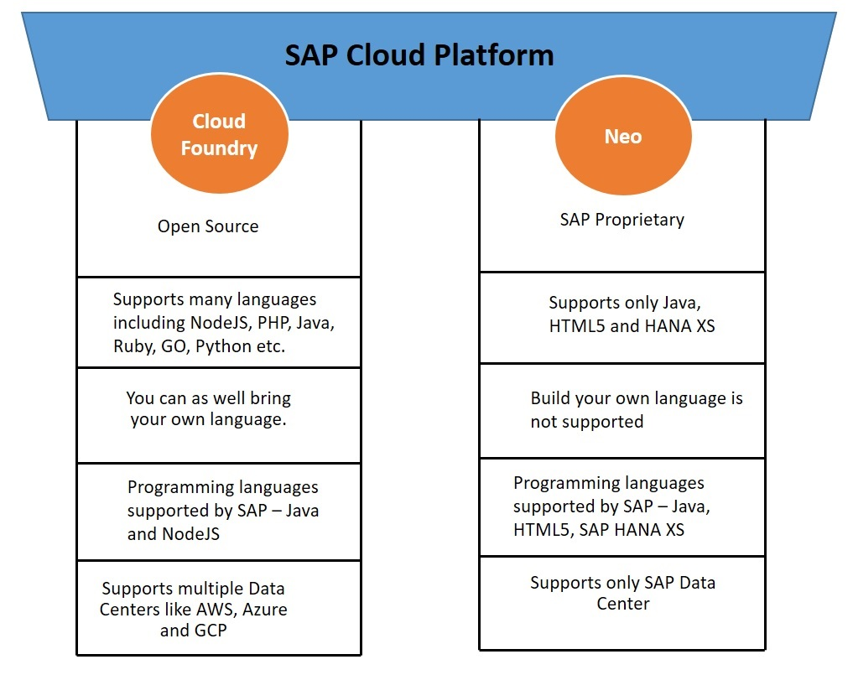

## **Use Cases for the Cloud Foundry Environment**

Application developers can use the Cloud Foundry environment to enhance SAP products and to integrate business applications, as well as to develop entirely new enterprise applications based on business APIs that are hosted on SAP Cloud Platform.

The Cloud Foundry environment allows you to use multiple programming languages such as Java, Node.js, and community/bring-your-own language options.

We can use Cloud Foundry environment for micro-services-based applications, for Internet of Things and machine learning scenarios, and for developing applications using SAP HANA extended application services, advanced model (SAP HANA XSA).

## **Use Cases for the Neo Environment**

Neo is a feature-rich and easy-to-use development environment, allowing you to develop Java, SAP HANA XS, and HTML5 applications. We can use the Neo environment to develop HTML5 and complex Java applications and for complex integration and extension scenarios.

# ****Central Cockpit****

To be able to administrate the two environments in a unified way, SAP provides one central cockpit.

The central cockpit is a Web-based user interface for administrators, providing access to a number of functions for configuring and managing applications and connecting them to services on the cloud platform. It can be used to manage resources, services, security, monitor application metrics, and perform actions on cloud applications.

A typical Cloud Platform cockpit looks like below.

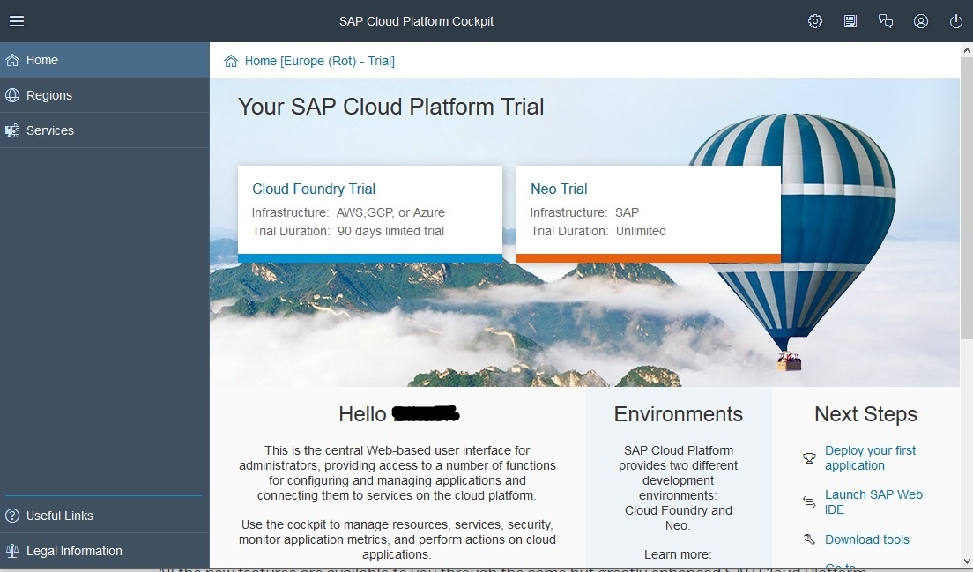

# SAP Cloud Platform ABAP Environment

Recently, there has been one more environment got added to the SAP Cloud Platform – ABAP Environment.

ABAP in SAP Cloud Platform is SAP’s new Platform as a Service (PaaS) offering for ABAP. Since many years, ABAP has been the foundation for SAP’s on-premise solutions. With ABAP in SAP Cloud Platform, ABAP developers can make use of their existing ABAP know-how to develop and run ABAP applications in the Cloud.

Customers and partners can build extensions for ABAP-based products like SAP S/4HANA Cloud as well as develop new cloud applications. ABAP in SAP Cloud Platform is also an option to transform existing ABAP-based custom code or extensions to the Cloud.

# Migrate Applications from Neo Environment to Cloud Foundry

When you migrate an application from the Neo to the Cloud Foundry environment following documents could be helpful.

[Migrate SAP Cloud SDK Based Applications from SAP Cloud Platform Neo Environment to Cloud Foundry](https://blogs.sap.com/2019/02/24/migrate-s4hana-sdk-based-applications-from-sap-cloud-platform-neo-environment-to-cloud-foundry/)

[Help document on CF Migration](https://help.sap.com/viewer/b017fc4f944e4eb5b31501b3d1b6a1f0/Cloud/en-US/01c03b42fe834e0da23adebf1077b0e7.html)

[Best Practices for Adapting SAP Cloud Platform Applications to the Cloud Foundry Environment](https://help.sap.com/doc/7fb15c0345694c45b439c0ed524c6414/Cloud/en-US/Best_Practices_for_Adapting_SAP_Cloud_Platform_Applications_to_the_Cloud_Foundry_Environment_en.pdf)

# Regions

# Each region represents the location of a data center, the physical location (for example, Europe, US East) where applications, data, or services are hosted.

Application performance (response time, latency) can be optimized by selecting a region close to the users. When deploying applications, consider that a subaccount is associated with a particular region and that this is independent of your own location. You may be located in the United States, for example, but operate your subaccount in a region in Europe.

Regions for the Cloud Foundry environment are provided by third-party data center providers such as Amazon or Microsoft. These third-party data center providers operate the infrastructure layer of regions. By contrast, SAP operates the platform layer and Cloud Foundry.

To deploy an application in more than one region, execute the deployment separately for each host.

Neo is the original environment of SCP, and Cloud Foundry arrived in 2017. Cloud Foundry is an open source project, whereas Neo is SAP proprietary.

Another difference is that the Neo environment is available in SAP data centers, and the Cloud Foundry environment is available in partner data centers (AWS, Azure, Google Cloud Platform, Alibaba Cloud). That's part of SAP's so-called multi-cloud strategy.

As for the trial versions, at the moment the Neo trial is unlimited, whereas there is a time limit on the Cloud Foundry trial. They both give you access to a number (but not all) of the services provided by the two environments.

Signing up is super easy, and the trial versions are a great way to start learning about SAP Cloud Platform at no cost.

Cloud Foundry is in open source, multi-cloud application platform and is governed by the Cloud Foundry Foundation – [www.cloudfoundry.org](http://www.cloudfoundry.org/).  Cloud Foundry has a container-based architecture that runs applications in any program language.

Cloud Foundry is an industry standard Platforms as a Service (PaaS) technology for developing and deploying cloud applications in both private and public cloud environments. It is designed to run on a variety of Infrastructure as a Service (IaaS), such as Amazon Web Services, OpenStack, Google Cloud Platform and Microsoft Azure. It enables developers to use different programming languages, runtimes and data / backing services. SAP is a founding Platinum level member of the Cloud Foundry Foundation, which oversees the development of Cloud Foundry Software and ecosystem.

The SAP Cloud NEO environment is a development environment that supports Java, SAP HANA XS and HTML5 applications.  Applications run in a modular and lightweight runtime container. Management of the HANA database is performed either in the SAP Cloud Platform using the Cockpit or WebIDE, or by using a local version of Eclipse configured with the SAP Hana Tools.

Application developers can use the Cloud Foundry environment to enhance SAP products and to integrate business applications, as well as to develop entirely new enterprise applications based on business APIs that are hosted on SAP Cloud Platform. The Cloud Foundry environment allows you to use multiple programming languages such as Java, Node.js, and community/bring-your-own language options. We recommend that you use the Cloud Foundry environment for 12-factor and/or micro-services-based applications, for Internet of Things and machine learning scenarios, and for developing applications using SAP HANA extended application services, advanced model (SAP HANA XSA).

#### **Use Cases for the Neo Environment**

Neo is a feature-rich and easy-to-use development environment, allowing you to develop Java, SAP HANA XS, and HTML5 applications. We recommend that you use the Neo environment to develop HTML5 and complex Java applications and for complex integration and extension scenarios.

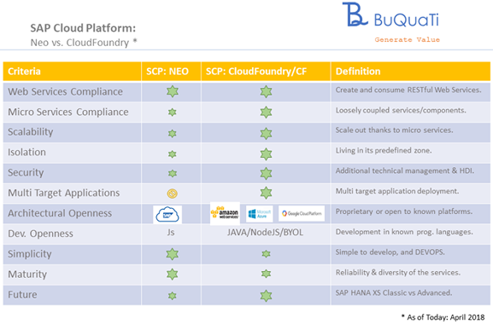

* One of the primary qualities of SAP Cloud Foundry is **Micro Services Compliance**. Develop, deliver and administer isolated units of software.
* SAP Cloud Foundry offers **Multi-Target Applications**. Modules can be written in different technologies and deployed to different targets, but all serving a particular purpose.  The positive consequence of using Cloud Foundry is once written, the MTA can be deployed on any platform (AWS, GCP, Azure or SAP CF).
* SAP NEO is simpler to use and more mature on SAP Cloud Platform. SAP Cloud Foundry has a larger learning curve and requires a larger investment in application development and administration, however appears to be the future for cloud development.
* SAP Cloud Foundry uses Maven and Spring tools and supports internal tools such as GitHub and Jenkins.



SAPUI5 ([SAP](https://searchsap.techtarget.com/definition/SAP) user interface for [HTML 5](https://searchmicroservices.techtarget.com/definition/HTML5)) is a collection of [libraries](https://searchsqlserver.techtarget.com/definition/library) that developers can use to build desktop and mobile applications that run in a [browser](https://searchwindevelopment.techtarget.com/definition/browser). With SAP's SAPUI5 [JavaScript](https://www.theserverside.com/definition/JavaScript) toolkit, developers can build SAP web applications using HTML5 web development standards.

[SAP Fiori](https://searchsap.techtarget.com/definition/SAP-Fiori), the company's line of web-based [apps](https://searchmobilecomputing.techtarget.com/definition/app) that have a device-agnostic user interface ([UI](https://searchmicroservices.techtarget.com/definition/user-interface-UI) ), have all been built using SAPUI5. There is also an open-source version of SAPUI5, called OpenUI5, which is available on Github.com.

SAP Fiori is a design language and user experience approach developed by SAP for use by SAP, its customers and its partners in business applications.

The SAP Fiori design language is used in SAP applications, including the [S/4HANA](https://searchsap.techtarget.com/definition/SAP-S-4HANA) and C/4HANA suites, SAP Analytics Cloud, [SAP Data Hub](https://searchsap.techtarget.com/definition/SAP-Data-Hub), SAP Ariba and others. Applications that use the Fiori design language are often called Fiori applications or Fiori user interfaces (UIs). SAP Fiori designs can be implemented using almost any technology, though SAP provides Fiori-compliant UI libraries in its [SAPUI5](https://searchsap.techtarget.com/definition/SAPUI5) JavaScript library, as well as the [SAP Cloud Platform](https://searchsap.techtarget.com/definition/SAP-HANA-Cloud-Platform) software development kit (SDK) for iOS and SAP Cloud Platform SDK for Android.

### Design guidelines

The Fiori design guidelines provide guidance on implementing UIs that adhere to the priorities of the Fiori design language. The goal of the Fiori design guidelines is to guide designers and developers in creating applications that are recognizable to users as Fiori applications and that behave in a consistent and predictable way. The guidelines define shared services like search, the Fiori Launchpad and message handling that may or may not appear in specific applications. They also define characteristics that are common to all applications like theme, look and feel, and behavior of common controls like buttons, tables and tiles.

# SAP BAPI (Business Application Programming Interface)

SAP BAPI (Business Application Programming Interface) is a standard interface to the business object models in [SAP](https://searchsap.techtarget.com/definition/SAP) products.

BAPIs are the primary method through which customer code and third-party applications interact with SAP products. BAPIs wrap the internal layers of SAP's business object model to ensure that all business logic, validations and authorization checks are executed properly when accessing or changing business objects.

BAPIs are implemented as function modules that call SAP internal code. Depending on which set of BAPIs is being used, they may call business object models defined using the Business Objects Processing Framework (BOPF) or legacy models defined using programs, tables and function modules.

SAP SE is a multinational software corporation that is currently the market leader in the enterprise resource planning (ERP) field. SAP was started in 1972 by five former IBM employees in Mannheim, Germany. The original name for SAP, *Systeme, Anwendungen und Produkte in der Dataverarbeitung,*translates from German to "Systems, Applications and Products in Data Processing."

The company currently serves more than 180 countries. An estimated 77% of the money exchanged through global business transactions touches an SAP system. A majority of the customers are small- and-medium sized businesses ([SMB](https://whatis.techtarget.com/definition/SMB-small-and-medium-sized-business-or-small-and-midsized-business)). The company offers on-premises, cloud and hybrid deployment models, with [cloud computing options](https://searchsap.techtarget.com/feature/SAP-S-4HANA-Cloud-vs-on-premises-benefits-limitations-adoption) being the focus for the company's future.

In 2011, the company launched [SAP HANA](https://searchsap.techtarget.com/definition/HANA-SAP-HANA), an in-memory database platform that is at the forefront of the company's future strategy. HANA was a major development project for SAP, which has said it intends HANA to take the place of the traditional databases SAP has used for its business applications.

### What is enterprise resource planning (ERP)?

SAP SE is one of the largest vendors of enterprise resource planning ([ERP](https://searcherp.techtarget.com/definition/ERP-enterprise-resource-planning)) software and related enterprise applications. The company's ERP system enables its customers to run their business processes, including accounting, sales, production, human resources and finance, in an integrated environment. The integration ensures that information flows from one SAP component to another without the need for redundant data entry and helps enforce financial, process and legal controls. It also facilitates the effective use of resources, including manpower, machines and production capacities.

The SAP ERP software system, called SAP ERP Central Component ([SAP ECC](https://searchsap.techtarget.com/definition/SAP-ERP-Central-Component-SAP-ECC)), is the collective term for [SAP's functional and technical modules](https://searchsap.techtarget.com/answer/What-core-components-does-the-SAP-ERP-system-include) that enable enterprises to manage business processes through a unified system. ECC is the on-premises version of SAP, and it is usually implemented in medium and large-sized companies. For smaller companies, SAP offers its Business One ERP platform.

SAP ERP software has different main modules, which are separated into [functional modules](https://searchsap.techtarget.com/tip/A-breakdown-of-10-commonly-used-SAP-ECC-components) and technical modules, each of which has submodules.

SAP's functional modules include:

* Human Capital Management ([SAP HCM](https://searchhrsoftware.techtarget.com/definition/human-capital-management-HCM))
* Production Planning ([SAP PP](https://searchsap.techtarget.com/definition/SAP-Production-Planning))
* Materials Management ([SAP MM](https://searchsap.techtarget.com/definition/SAP-Materials-Management-MM))
* Project System ([SAP PS](https://searchsap.techtarget.com/definition/SAP-Project-System-PS))
* Sales and Distribution ([SAP SD](https://searchsap.techtarget.com/definition/SAP-Sales-and-Distribution-SAP-SD))
* Plant Maintenance ([SAP PM](https://searchsap.techtarget.com/definition/SAP-Plant-Maintenance-PM))
* Finance and controlling ([SAP FICO](https://searchsap.techtarget.com/definition/SAP-FICO-SAP-Finance-and-SAP-Controlling))
* Quality Management ([SAP QM](https://searchsap.techtarget.com/definition/SAP-Quality-Management-QM))

[S/4HANA](https://searchsap.techtarget.com/definition/SAP-S-4HANA) is the vendor's in-memory version of the Business Suite ERP platform that was released in 2015. It is an ambitious rewrite of the Business Suite optimized for the HANA platform. S/4HANA is meant to reduce complexity, according to SAP, and to [replace SAP ECC](https://searchsap.techtarget.com/feature/Prepare-for-SAP-S-4HANA-2025-by-building-your-business-case-first), eventually.

[SAP S/4HANA Cloud](https://searchsap.techtarget.com/definition/SAP-S-4HANA-Cloud) is a SaaS version of S/4HANA, presenting the advantages of HANA's in-memory processing and real time data accessibility within a SaaS model, meaning users can access all of the software's functionality.

SAP also has industry-specific applications that support business processes unique to a particular industry. Some of these applications are:

* SAP for Utilities
* SAP for Insurance
* SAP for Oil and Gas
* SAP Healthcare

The SAP ERP system is often arranged in a three-tier, client-server architecture. This set up is recommended because it enables flexibility and increased scalability. The three tiers used by the SAP ERP software include: the presentation tier, the application tier and the database tier.

The presentation tier provides the user with the SAP graphical user interface (SAP [GUI](https://searchwindevelopment.techtarget.com/definition/GUI)). The SAP GUI can be installed on any computer that uses the Microsoft Windows operating system (OS) or Mac OS. The SAP GUI is the point of communication between the user and the SAP ERP system.

The application tier is the core of the SAP ERP system. This tier is responsible for processing client transactions, executing business logic, running reports, monitoring access to the database, printing jobs and communicating with other applications.

The database tier is where both the business generated data -- or data objects created by users through different business processes -- and SAP application programs are stored. The performance of this tier ultimately decides the scalability of the entire SAP ERP system since each system is usually deployed using one database instance.

When working together, the application tier will receive the input and then send the information to the presentation tier. The presentation will display the output in the SAP GUI. This data is then stored in the database tier.

* [SAP C/4HANA](https://searchsap.techtarget.com/definition/SAP-C-4HANA), a cloud-based customer experience and e-commerce platform that consists of the SAP Marketing Cloud, SAP Customer Cloud, SAP Sales Cloud, SAP Service Cloud and SAP Customer Data Cloud.
* [SAP Leonardo](https://searchsap.techtarget.com/definition/SAP-Leonardo), an integrated system of software and services that encompasses next-generation technologies such as the internet of things ([IoT](https://internetofthingsagenda.techtarget.com/definition/Internet-of-Things-IoT)), machine learning ([ML](https://searchenterpriseai.techtarget.com/definition/machine-learning-ML)), artificial intelligence ([AI](https://searchenterpriseai.techtarget.com/definition/AI-Artificial-Intelligence)), big data and [blockchain](https://searchcio.techtarget.com/definition/blockchain) under the [SAP Cloud Platform](https://searchsap.techtarget.com/definition/SAP-HANA-Cloud-Platform).
* [SAP Fiori](https://searchsap.techtarget.com/definition/SAP-Fiori), a collection of SAP software that the company intends to use as its predominant user experience (UX) and user interface (UI) model going forward. A number of Fiori apps run exclusively on S/4HANA, and the two are intended to more closely intertwine as they evolve.

### Advantages and disadvantages of the SAP ERP system

Advantages of SAP ERP include:

* The standardization of an organization's business processes.
* The ability to integrate with other third party systems and perform enterprise-wide services.
* The flexibility to create custom rules with the SAP structure that set the parameters for transactions.
* Various analytical features -- such as reporting and decision making -- that enable SAP to meet the needs of various complex businesses and government organizations.

Disadvantages of SAP ERP include:

* The high cost of purchasing and implementing the program, including buying the software and hardware, labor costs of internal IT employees and external consultants, the costs of training employees and the residual costs for software maintenance and periodic upgrades.
* The complexity of the system means most companies will only implement one feature of the SAP ERP software at a time, causing the complete implementation of the software to take up to several years.

Below are the 10 frequently implemented functional components that SAP ECC includes and the business functions they cover:

**Financial Accounting (FI)**

The FI component records a company's financial transactions, including transactions of its customers and vendors. FI handles receivables from sales, payables for procurement, and cash management as well as bank payment and reconciliation processes.

**Controlling (CO)**

The CO component manages cost center accounting, profit center accounting and internal orders and also offers financial planning. It also includes a product costing feature, which compares simulated costs and actual costs, and is primarily intended to help manufacturing organizations. (Note that the first two components are often referred to as FICO, FI-CO or FI/CO, as if they are one component.)

**Sales and Distribution (SD)**

The SD component manages major processes of sales and distribution, including selling products or services in national and international markets through direct sales to customers or through distribution networks. SD also handles customers' returns, along with billing and credit issuance.

**Materials Management (MM)**

The MM component manages procurement and inventory. Materials and services procurement can be from local vendors or international suppliers. In inventory management, MM manages all goods issuance, goods receipts and transfers of a material from one plant or storage location to another. Counting and reconciling materials' physical inventory is also managed in MM.

**Production Planning (PP)**

The PP component helps businesses create demand and manufacturing capacity alignment so they can plan product manufacturing, sales and distribution. PP plays a critical role in a manufacturer's supply chain and can be used for discrete, process or repetitive manufacturing or a combination of more than one type.

**Quality Management (QM)**

The QM component extensively integrates with procurement, production, sales, and equipment maintenance processes. Advanced features include managing complete internal or external audit's business processes and finding root causes of a product's failure to ensure ongoing quality improvements to a company's business processes.

**Plant Maintenance (PM)**

The PM component monitors machines and functional locations (such as a chiller room or a boiler room) to make sure they are in proper working order and provides alerts when issues are detected to prevent machine failures and production disruptions. Business processes such as preventive maintenance, corrective maintenance and refurbishment maintenance are all covered in the SAP PM component.

**Customer Services (CS)**

The CS component handles business processes related to a company providing maintenance services to customers' equipment. The option to bill customers for the maintenance services delivered is also part of the CS component.

**Project System (PS)**

PS is meant to manage large, complex projects such as setting up a new manufacturing plant or monitoring a plant's maintenance turnaround. All project-specific procurement or production through PS ensures that this component is able to allocate a project's costs correctly while remaining within the defined project's budget.

**Human Capital Management (HCM)**

The [HCM component](https://searchhrsoftware.techtarget.com/definition/human-capital-management-HCM) manages payroll, time management activities such as attendance and leaves, career development, travel and workplace safety. Functional modules have submodules, which can be implemented if they are required to run the business processes of the company.

SAP S/4HANA is short for SAP Business Suite 4 SAP HANA, meaning that it is the fourth version of SAP Business Suite, but is designed to run only on SAP HANA.

SAP Fiori is a collection of commonly used S/4HANA functions that are displayed in a simple, consumer-ready tile design and that can be accessed across various devices, including desktops, tablets and mobile devices.

AP Fiori is a design language and user experience approach developed by SAP for use by SAP, its customers and its partners in business applications.

The SAP Fiori design language is used in SAP applications, including the [S/4HANA](https://searchsap.techtarget.com/definition/SAP-S-4HANA) and C/4HANA suites, SAP Analytics Cloud, [SAP Data Hub](https://searchsap.techtarget.com/definition/SAP-Data-Hub), SAP Ariba and others. Applications that use the Fiori design language are often called Fiori applications or Fiori user interfaces (UIs). SAP Fiori designs can be implemented using almost any technology, though SAP provides Fiori-compliant UI libraries in its [SAPUI5](https://searchsap.techtarget.com/definition/SAPUI5) JavaScript library, as well as the [SAP Cloud Platform](https://searchsap.techtarget.com/definition/SAP-HANA-Cloud-Platform) software development kit (SDK) for iOS and SAP Cloud Platform SDK for Android.

SAP S/4HANA Cloud is a SaaS version of SAP S/4HANA ERP, a suite of integrated business applications.

SAP S/4HANA Cloud was launched in February 2017. According to SAP, the intent was to provide a "next-generation intelligent ERP" system that enables companies to achieve [digital transformation](https://searchcio.techtarget.com/definition/digital-transformation). SAP S/4HANA Cloud is built on [SAP HANA](https://searchsap.techtarget.com/definition/HANA-SAP-HANA) and takes advantage of HANA's in-memory processing and real-time data accessibility, but makes this available in a SaaS model.

SaaS deployment means users can access all of [S/4HANA's functionality](https://searchsap.techtarget.com/definition/SAP-S-4HANA) without committing resources to hardware, databases or IT staff. S/4HANA Cloud  includes technologies that can help bring "intelligence" into [ERP](https://searcherp.techtarget.com/definition/ERP-enterprise-resource-planning) applications, including machine learning, virtual and augmented reality, blockchain and voice-enabled technology. Main S/4HANA Cloud functions include finance, sourcing and procurement, sales, professional services, and manufacturing.

IDoc (intermediate document) is a standard data structure used in [SAP](https://searchsap.techtarget.com/definition/SAP) applications to transfer data to and from SAP system applications and external systems. Using IDocs, companies with SAP ERP systems, for example, can exchange data with external entities like their partners or customers.

The transfer between SAP systems is done through SAP's [Application Link Enabling](https://searchsap.techtarget.com/definition/Application-Link-Enabling) (ALE) system, while the transfer from an SAP system to an external system happens through [electronic data interchange](https://searchdatacenter.techtarget.com/definition/EDI) (EDI). This allows data to be exchanged between the different systems without having to convert data from one format to another.

**SAP UI5** is a Java script based framework that is used to design multi-platform business applications. It supports various data models and views do desktop and mobile applications. SAP UI5 compiles on open Ajax and can be combined with java script libraries.

**SAP UI5** was initially named phoenix that was later changed to **SAP UI5** in 2011.

The characteristics of SAP UI5 are as follows −

* Well Designed models, easy to consume.
* Performance optimized with compliant of SAP standards
* Support Ajax open source
* Includes JavaScript library
* Extensible UI component model
* Based on open standards like Ajax, JavaScript, CSS, and HTML 5.

**UI5 Browser Support**

SAP UI5 supports all the key web browsers and latest versions like IE, Mozilla Firefox, Google Chrome and Safari.

SAP UI5 Architecture consists of core JavaScript framework including jQuery. It consists of Extension libraries Controls and Themes. It has Optional Server components.

## **UI5 Control Libraries**

Common **SAP UI5** control libraries are given below.

* **Sap.ui.commons** − This includes controls like text fields, buttons, fonts, etc.
* **Sap.ui.table** − This includes the table controls like rows, columns, etc.
* **Sap.ui.ux3** − This includes properties for UX3 patterns.
* **Sap.m** − This includes controls for mobile devices like hand phones, tablets, etc.

### **SAP UI5 and Extensibility**

* SAP UI5 support extensibility for application developer and allows to add JavaScript, HTML, UI5 based pages.
* It allows to write new UI libraries and new controls.
* Write plug-ins for UI5 core.
* Create controls from existing UI5 controls.
* Includes other JavaScript libraries

**Views** − It can be defined using XML with HTM, mixed or standalone

* **XML** − (sap.ui.core.mvc.xmlview)
* **JavaScript** − (sap.ui.core.mvc.JSView)
* **JSON** − (sap.ui.core.mvc.JSONView)
* **HTML** − (sap.ui.core.mvc.HTMLView)

**Controller** − Controllers are bound to a view. It can also be used with multiple views

**Model** − Data binding can be used on the views.

## **I finally understood that OData is an open protocol to allow the creation and consumption of queryable and interoperable RESTful APIs in a simple and standard way.**

**Fiori** (in SAP context) means several things:

(Some of the infos may reflect a more or less current state of the art and may have been different in the past and may change in future.)

* **Fiori Apps** (or sometimes called SAP standard Fiori Apps) is a set of (several thousand?) Apps developed and offered by SAP. This includes Fiori Apps for various businesses (like retail) or various departments (like HCM) - See [SAP Fiori App Reference Library](https://fioriappslibrary.hana.ondemand.com/sap/fix/externalViewer/)
* **Fiori Launchpad** (FLP) is a Fiori App by itself, which is configurable using various methods. FLP exists for ABAP, SAP Enterprise Portal, SAP Cloud Portal, SAP Cloud Foundry and is configurable in different ways in these systems. Intent based navigation that you linked above is one of the ways in an ABAP System
  + **Custom Fiori Apps** are SAPUI5 Apps that follow the Fiori Design Guidelines, as stated by @sap-fiori-crew
  + also native mobile libraries like Fiori SDK for iOS or for Android will produce native Fiori iOS apps (or Android, respectively)
  + Some **non-ui5 Apps** like SAP Mobile Cards or Mendix Apps with Fiori Theme are considered Fiori apps by SAP

All in all, currently, SAP states that SAP Fiori is a user experience (see, e.g. [this roadmap, page 11](https://www.sap.com/products/roadmaps.cross-topics.html#pdf-asset=983e325c-c37c-0010-82c7-eda71af511fa&page=11))

From the technical point of view, an ui5 app must at least use the Component Paradigma to be seamlessly integrateable inside a Fiori Launchpad. For the rest of the answer, I’ll refer to any ui5 app that implements a Component as “Fiori App”

As for your original question, and the link you used, I don’t see any technical reason, why a sapui5 app, that implements a component, shouldn’t be callable using intent navigation.

You can configure a tile in FLP to call a certain Fiori App. Or to call a certain action of a semantic object. That action of that object is configured to call a Fiori App using Target Mapping. The good thing is that you can call such an action on such a semantic object from any other app without knowing which App will actually be called. This allows a customer to replace an App by changing a single target mapping rather than finding and extending all other apps that are calling the one replaced app.

SAPUI5 is a JavaScript framework like React just developed by SAP and comes with a big collection of custom controls out-of-the-box.

Fiori on the other hand is SAP´s Design Language. The SAP Fiori user experience is role-based, adaptive, simple, coherent, and delightful.

There is only one difference in sap fiori and SAPUI5.. SAP Fiori apps are standard app which is provided by sap... Just we need to configured in fiori launchpad.. Fiori application is build by using SAPUI5 only.. Thats why its saying SAPUI5.. SAPUI5 is custom app which we designed as per our requirement..

In sap fiori refrence library. There some other type application also there such as webdynpro, gui type of which can also be configured in fiori launchpad

**SAP UI5**

UI5 is SAP own user interface to develop web application.

UI5 is now a days is getting popular to outside of SAP to build NON-SAP application also.

UI5 uses web technologies like HTML, CSS and JavaScript.

SAPUI5 is technology whereas Fiori is a methodology.

SAPUI5 is Hybrid app (Because of HTML5).

SAPUI5 Apps runs on multiple platforms with full capability as like native apps such us SMP.

UI5 is a framework based on MVC pattern.By using this frame work developer can easily build web application.

**SAP Fiori**

Fiori is a new user experience for SAP software . To overcome the complexity of SAP traditional GUI ,New one has been developed which is Fiori.

Fiori focus mainly on mobility. Fiori uses SAPUI5 for frontend and it uses odata to get back end data.

Without knowing SAPUI5 knowledge fiori customization is difficult. Fiori contains all the business process in the form of Role based.Currently more than 1000 roles are created based on business process.

**SAP UI5**

UI5 is SAP own user interface to develop web application.

UI5 is now a days is getting popular to outside of SAP to build NON-SAP application also.

UI5 uses web technologies like HTML, CSS and JavaScript.

SAPUI5 is technology whereas Fiori is a methodology.

SAPUI5 is Hybrid app (Because of HTML5).

SAPUI5 Apps runs on multiple platforms with full capability as like native apps such us SMP.

UI5 is a framework based on MVC pattern.By using this frame work developer can easily build web application.

**SAP Fiori**

Fiori is a new user experience for SAP software . To overcome the complexity of SAP traditional GUI ,New one has been developed which is Fiori.

Fiori focus mainly on mobility. Fiori uses SAPUI5 for frontend and it uses odata to get back end data.

Without knowing SAPUI5 knowledge fiori customization is difficult. Fiori contains all the business process in the form of Role based.Currently more than 1000 roles are created based on business process.

SAP Fiori is a new user experience (UX) for SAP software and applications. It provides a set of applications that are used in regular business functions like work approvals, financial apps, calculation apps and various self-service apps.

SAP Fiori provides 300+ role-based applications like HR, Manufacturing, finance, etc. When you open the SAP Fiori home page application, you will see a picture of the flowers. It is because Fiori means ‘flowers’ in Italian.

SAP Fiori enables multiple device applications that allow users to start a process on their desktop/laptops and to continue that process on a smartphone or on a tablet. SAP has developed Fiori Apps based on User interface UI5.

SAP Fiori is a set of apps, newly written by SAP, that address the most broadly and frequently used SAP functions, such as workflow approvals, information lookups, and self-service tasks. They provide simple and easy-to-use access across desktops, tablets, and smartphones.

Fiori is more than just a new user interface. It is a set of cross-device applications that, among other things, allow users to start a process on their desktop and continue it on a tablet or smartphone. SAP is developing its Fiori apps on its latest user interface framework, SAPUI5.  
  
SAP lists [three types of Fiori apps](http://help.sap.com/fiori_bs2013/helpdata/en/ec/a941524a6b6760e10000000a423f68/content.htm):

1. **Transactional apps**, which allow users to perform SAP transactions on mobile devices as well as desktops. For instance, there is a transactional app for creating a leave of absence request and another for approving a purchase order.

1. **Fact sheets**, which display information about key business objects in SAP. For example, there is a fact-sheet app for viewing a central purchase contract; it allows users to also drill down into related entities, such as vendor contacts, items under contract, and terms.

1. **Analytical apps**, which allow users to display key performance measures and other aggregate information about the business.

A [complete list of current Fiori apps](http://help.sap.com/fiori_bs2013/helpdata/en/99/e464520e2a725fe10000000a441470/content.htm) is available on SAP's website. So far, SAP has released two waves of Fiori apps of 25 apps each, with additional waves under way.

<https://help.sap.com/fiori_bs2013/helpdata/en/99/e464520e2a725fe10000000a441470/content.htm?no_cache=true>

SAP HANA (high-performance analytic appliance) is an application that uses in-memory database technology that allows the processing of massive amounts of real-time data in a short time. The in-memory computing engine allows HANA to process data stored in RAM as opposed to reading it from a disk. This allows the application to provide instantaneous results from customer transactions and data analyses.

An in-memory database (IMDB) is a database management system that primarily depends on main memory for storing computer data. IMDBs are quicker than disk-optimized databases because they carry out fewer CPU instructions, and their internal optimization algorithms are much simpler. IMDB eradicates disk access by saving and manipulating data in the main memory. An IMDB commonly includes direct data manipulation and a dedicated memory-based architecture.

IMDBs are mainly used in applications where response time is crucial, such as telecommunications network devices and mobile ad networks.

An in-memory database also may be known as a main memory database (MMDB), real-time database (RTDB) or in-memory database system (IMDS).

In-memory databases are designed to attain minimal response time, as well as extremely high throughput for performance critical systems. This is possible because data is saved and manipulated in the form used by the application, which removes overheads related to translation and caching. IMDB technology is capable of supporting application-tier deployment, real-time data management and most ACID (atomicity, consistency, isolation, durability) properties.

The data structures and algorithms of IMDBs are exclusively designed to deliver data, event and transaction management in the application tier. When compared to fully cached relational database management systems, IMDBs make use of significantly less CPU. IMDB technology does not use magnetic disks, as the location for primary database storage. Instead, the magnetic disks are used for tolerance and recovery.

The advantages of IMDBs are as follows:

* Faster transactions
* No translation
* Multi-user concurrency
* High stability

IMDB is used for:

* Developing embedded software systems, like commercial off-the-shelf (COTS) embedded operating systems
* Applications in medical devices, intelligent connected devices, commercial communication products and transport systems, network switches, routers and set-top boxes, etc.
* Fulfilling the requirements of Web self service and e-commerce applications
* Managing all real-time rating, subscriber billing and balance information

In-memory computing is the storage of information in the main random access memory (RAM) of dedicated servers rather than in complicated relational databases operating on comparatively slow disk drives. In-memory computing helps business customers, including retailers, banks and utilities, to quickly detect patterns, analyze massive data volumes on the fly, and perform their operations quickly. The drop in memory prices in the present market is a major factor contributing to the increasing popularity of in-memory computing technology. This has made in-memory computing economical among a wide variety of applications.

OData, short for Open Data Protocol, defines a [protocol](https://www.webopedia.com/TERM/P/protocol.html) for the querying and updating of data utilizing existing Web protocols. OData is a [REST](https://www.webopedia.com/TERM/R/REST.html)-based protocol for querying and updating data and is built on standardized technologies such as [HTTP](https://www.webopedia.com/TERM/H/HTTP.html), [Atom](https://www.webopedia.com/TERM/A/Atom.html)/[XML](https://www.webopedia.com/TERM/X/XML.html), and [JSON](https://www.webopedia.com/TERM/J/JSON.html). It is different from other REST-based web services in that it provides a uniform way to describe both the data and the data model.

OData (Open Data Protocol) is an [OASIS standard](https://www.oasis-open.org/committees/tc_home.php?wg_abbrev=odata) that defines the best practice for building and consuming RESTful APIs. OData helps you focus on your business logic while building RESTful APIs without having to worry about the approaches to define request and response headers, status codes, HTTP methods, URL conventions, media types, payload formats and query options etc. OData also guides you about tracking changes, defining functions/actions for reusable procedures and sending asynchronous/batch requests etc. Additionally, OData provides facility for extension to fulfil any custom needs of your RESTful APIs.

OData RESTful APIs are easy to consume. The OData metadata, a machine-readable description of the data model of the APIs, enables the creation of powerful generic client proxies and tools. Some of them can help you interact with OData even without knowing anything about the protocol. The following 6 steps demonstrate 6 interesting scenarios of OData consumption across different programming platforms. But if you are a non-developer and would like to simply play with OData, [XOData](http://pragmatiqa.com/xodata/) is the best start for you.

**SAPUI5**

UI5 is nothing but development tool kit for html 5. It contains lot of predefined JavaScript library to design new user interface.

UI5 is mainly developed for SAP mobility which means Fiori.

UI5 is a framework based on MVC pattern.By using this frame work developer can easily build web application.

UI5 is SAP own user interface to develop web application.

UI5 is now a days is getting popular to outside of SAP to build  NON-SAP application also.

UI5 uses web technologies like HTML, CSS and JavaScript.

SAPUI5 is technology whereas Fiori is a methodology.

SAPUI5 is Hybrid app (Because of HTML5).

SAPUI5 Apps runs on multiple platforms with full capability as like native apps such us SMP.

**FIORI:**

Fiori is a new user experience for SAP software . To overcome the complexity of SAP traditional GUI ,New one has been developed  which is Fiori.

Fiori focus mainly on mobility. **Fiori uses SAPUI5 for frontend and it uses odata  to get back end data.**

Fiori is a design paradigm – not a methodology.

The primary technology used for Fiori is SAPUI5.

Without knowing SAPUI5 knowledge fiori customization is difficult. Fiori contains all the business process in the form of Role based.Currently more than 1000 roles are created  based on business process.

**One code line for all screen sizes.**

SAP back end contain  Business logic and odata service.

SAP front end which means Net weaver Gateway server contains SAPUI5 control libraries and App specific Fiori UX add-Ons.

In SAP ECC 6 and Ehp7, we can create odata service by using SEGW Transaction.

Fiori used across solutions such as SAP S/4HANA

Fiori apps are Hybrid which means based on web technologies(SAPUI5) and will be connecting to SAP via SAP NW gateway .

Fiori is a package which has collection of sapui5 apps .Refer below link.

<https://fioriappslibrary.hana.ondemand.com/sap/fix/externalViewer/>

SAP HANA is a database, an in-memory database, while SAP S/4HANA is an application which is designed to run on the SAP HANA database. It is a revolutionary platform-based in the company’s new In-memory database. Learning it will imply that choosing to pursue a career path that is both fulfilling and exciting to work with. SAP HANA acts as a hub for all SAP’s products strategy and it serves as the base for recent technology [***SAP S/4HANA***](https://en.wikipedia.org/wiki/SAP_S/4HANA) that is set to serve as a cornerstone for all SAP technologies.

Unlike other RDBMSs SAP HANA reduces the memory usage factor by 10 and improving performance as it uses column oriented storage which combines OLAP and OLTP into a single structure. The speed of both Online Transaction Processing (OLTP) and Online Analytical Processing (OLAP) can be drastically changed with the design of SAP HANA. Information of the majority databases is stored on the hard drive which in result keeps an only limited amount of information in main memory. Hard drives are relatively slow, which limits how fast they can recall information.

[***SAP HANA***](https://en.wikipedia.org/wiki/SAP_HANA) is made up of a simpler structure and lower memory footprint than other RDBMSs. A system like OLAP and OLTP are stored in different databases which result in insufficient memory, redundant information bloating the DB footprint.

Hence, SAP HANA can do real-time analytics, crunching data nearly instantaneously. This allows businesses to react more quickly to changing conditions, providing significant strategic benefits.

SAP HANA isn’t just a new choice for enterprise computing; because it handles data very differently from other databases, it is designed to run SAP software. SAP SE has been reworking their core ERP applications to better harness HANA’s speed and flexibility, and will only support older versions of the software until 2025, at which point customers need to have completed their SAP HANA migration, and upgraded to the new software.

### **What SAP S/4HANA is all about**

[***SAP S/4HANA***](https://news.sap.com/2015/03/what-is-sap-s4hana-13-questions-answered/) is the shorter form of SAP Business Suite 4 SAP HANA, which means it is the fourth version of SAP Business Suite. It is designed to run only on SAP HANA. The transition of SAP users to SAP S/4HANA is similar to the earlier transition from the ERP versions, SAP R/2 to SAP R/3.

The next generation Business Suite of SAP is SAP S/4HANA which is designed in a simplified way specifically to work with SAP HANA and to replace the SAP ECC/ERP.

SAP S/4HANA is the in-memory version of the Business Suite [***ERP platform***](https://www.sap.com/india/products/what-is-erp.html?infl=a7f5d80e-371f-4eb5-a034-165a740738b2). SAP S/4HANA was announced in February 2015 and billed as SAP’s “most important release in 23 years”, S/4HANA is intended to be easier to use and administer by helping to solve more complex problems and handle vastly larger amounts of data than its predecessors. S/4HANA is available in on-premises, cloud and hybrid deployment models.

As per the SAP, developers feel the changes in SAP as they find ERP system is more agile, simpler to understand and use. This change is termed as the opportunity for businesses to reinvent business models and re-generate revenues with the advantage of the Internet of Things (IoT) and big data by connecting people business networks and devices by the SAP.

As per the SAP, Batch processing is not required for [***S/4HANA***](https://www.zarantech.com/blog/top-reasons-migrate-towards-sap-s4hana/?utm_source=blog&utm_medium=blog-header-search-box&utm_term=) this makes the businesses to simplify their processes and drive them in real time which mean that the business user can access insight on data from anywhere in real time for prediction, execution, Planning and simulation.

SAP Simple Finance is one of the main components of S/4HANA, which aims to streamline financial processes and enable real-time analysis of financial data. Simple Finance helps companies align their financial and non-financial data into what SAP refers to as a “single source of truth.” Some Business Suite users are deploying Simple Finance as the first step in the road to S/4HANA.

SAP, which stands for Systems Applications and Products in Data Processing, is a powerful Enterprise Resource Planning (ERP) system. It contains a suite of software that includes a re-engineering software that provides end-to-end solutions.

SAP was founded in 1972 by five IBM engineers Hopp, Hector, Tschira, wellenreuther and plattner. It has come a long way since then.  They have released the latest version of SAP HANA in 2016, which allows it to be run on personal computers or on cloud computing platforms, for students as well as small-scale developers.

SAP is hugely successful and is implemented by many organizations for their everyday business activities. Today, SAP is considered to be the third largest independent software supplier in the world with more than 12 million users, 121,000 installations globally, 1,500+ SAP partners, 25+ industry-specific business solutions, and more than 41,200 customers spread across 120 countries.

### **SAP is employed in various businesses such as:**

* Aerospace
* Automotive
* Finance
* Defense & Security
* Healthcare
* Education
* Media
* Life science
* Oil & Gas
* Pharmaceuticals
* Telecommunications

### SAP ERP Modules:

There are two Types of SAP ERP Modules.

* Functional Modules
* Technical Modules

SAP has a total of 25 modules, however all the 25 SAP modules are not applied. The most implemented modules are the most successful and has the highest job opportunities. Such vital SAP Modules utilized by numerous organizations are as follows:

* FICO – Finance & Control
* PP – Production Planning
* MM – Material Management
* SD – Sales & Distribution
* HR – Human Resources
* CRM – Customer Relationship Management
* ABAP – Advanced Business Application Management
* XI – Exchange Infrastructure
* Net Viewer
* Basis
* BIW – Business Information Warehousing

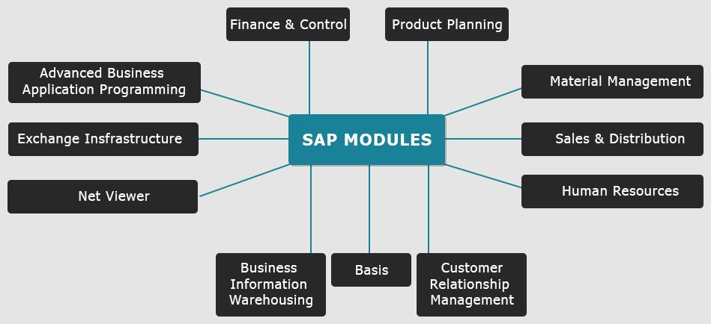

### Top 7 High In-Demand SAP Modules in 2017:

The higher the remuneration, the higher the demand. So, it’s safe to say that the pay package for a skill determines its popularity and demand.

According to TechTarget and STechies, the following are the top 7 ERP modules in SAP that are in huge demand. This is merely a list and is not ranked based on its demand or popularity.

**1. ECC FI**

This module deals in managing the financial transactions within the enterprise. ECC FI helps employees to manage data involved in any business and financial transaction in a unified system.

**2. SAP HR/HCM**

This module is SAP’s one of the important modules which manages all tasks from hiring an employee to its final termination in an organization. The various components this module consists of are Personnel Management, Organizational Management (OM), Time Management and Pay roll.

**3. SAP SCM (Supply Chain Management)**

SAP SCM stands for Supply Chain Management one of the module of SAP. This module covers the area of Production Planning (PP), Demand Planning and Business Forecasting. It also controls the information flow and product flow in the organizations.

**4. SAP NetWeaver**

SAP NetWeaver enables Provision, Composition and Management of SAP and non-SAP applications across all heterogeneous software environments.

**5. SAP BI**

This Module deals in analyzing and reporting of data from various heterogeneous data sources

**6. SAP HANA**

SAP HANA is very important module of SAP. It is an in-memory data platform that is deployable as an on-premise appliance, or in the cloud. It is a revolutionary platform, which is best suited for performing real-time analytics, and developing and deploying real-time applications.

**7. SD MM**

SAP MM that is Materials Management (MM) is a part of Logistics area and helps to manage the procurement activity of an organization from procurement.

It supports all aspects of material management (planning, control etc). It deals with material management and inventory management.

<https://www.guru99.com/abap-tutorial.html>

The full form of ABAP is Advanced Business Application . It allows large corporations to develop applications to organize and manage their business operations. ABAP can help customize workflows for financial accounting, materials management, asset management, and all other modules of SAP. SAP's current development platform NetWeaver also supports both ABAP and Java.

## Why ABAP?

Here are the reasons for using SAP ABAP:

* SAP ABAP is used by developers to develop the SAP R3 Platform.
* It is a simple language that is easy to learn when it comes to programming.
* It allows you to choose from procedural and object-oriented programming.
* It also helps SAP customers to improve their SAP-based applications.
* It allows you to create custom reports and interfaces.
* ABAP language is quite easy for programmers. However, it is not a right tool that can be used by non-programmers.

## ABAP Runtime Environment

All ABAP programs stored in SAP database. However, they are never stored in external files like C++ and Java programs.

In the database, all the code is written in ABAP present in two different forms:

Source code, which can be view and edit with the help of ABAP Workbench tools, and generated code. It is a binary representation that is quite similar to Java byte code.

ABAP programs allow you to control the runtime system, which is part of the SAP kernel. The runtime system also allows a process for ABAP statements. It controls the logic of screens and responds to user events like user click or mouse hover.

ABAP is a programming language that runs in the SAP ABAP runtime environment, created and used by SAP for the development of application programs including:

* Reports
* Module Pool Programming
* Interfaces
* Forms
* Data conversions
* User Exits & BADI

ABAP (Advanced Business Application Programming) is the primary programming language supported on the SAP [NetWeaver](https://searchsap.techtarget.com/definition/NetWeaver) ABAP application server platform and applications that run on it, such as SAP ERP (formerly R/3), [S/4HANA](https://searchsap.techtarget.com/definition/SAP-S-4HANA) and CRM.

SAP uses ABAP to implement its own applications on the NetWeaver ABAP platform, and SAP customers use ABAP to modify the functionality of SAP applications or build their own on the NetWeaver ABAP platform. ABAP is the oldest and, likely, the most widely used of SAP's four major application platforms, which also includes SAP NetWeaver Java, [SAP HANA](https://searchsap.techtarget.com/definition/HANA-SAP-HANA) and [SAP Cloud Platform](https://searchsap.techtarget.com/definition/SAP-HANA-Cloud-Platform).

It is extracted from the base computing languages Java, C, C++ and Python. It is currently positioned, alongside [Java](https://en.wikipedia.org/wiki/Java_(programming_language)), as the language for programming the [SAP NetWeaver Application Server](https://en.wikipedia.org/wiki/SAP_NetWeaver_Application_Server), which is part of the [SAP NetWeaver](https://en.wikipedia.org/wiki/SAP_NetWeaver) platform for building business applications.

SAP is a full [Enterprise Resource Planning](https://en.wikipedia.org/wiki/Enterprise_resource_planning) (ERP) system and business platform. SAP is the company, that produces the business platform and the associated modules (financials, general ledger, &c).

ABAP is the primary programming language used to write SAP software and customizations. It would do it injustice to think of it as COBOL and SQL on steroids, but that gives you an idea. ABAP runs within the SAP system.

SAP and ABAP abstract the DB and run atop various underlying DBMSs.

SAP produces other things as well and even publicly says they dabble in Java and even produce a J2EE container, but tried-and-true SAP is ABAP through-and-through.

I have worked with SAP since 1998. **SAP** is a type of software called ERP (Enterprise Resource Planning) that large companies use to manage their day to day affairs. On the macro, the software can be split into two categories: Technical and Functional

Let's go Technical first, as it answers the "What is ABAP" part of your question.

## **Technical**

There are two technical "stacks" within the SAP software, the first is the **ABAP** stack which is inclusive of all the original technology that SAP was. ABAP is the proprietary coding language for SAP to develop RICEFW objects (Reports, Interfaces, Conversions, Extensions, Forms and Workflows) within the ABAP stack.

The ABAP stack is traditionally navigated via Transaction Codes (T-Codes) to take you to different screens within the SAP Environment. From a technical perspective, you will do all of your performance and tuning of the WORK PROCESSES in the SAP system here, as well as configuring all of the system RFCs, building user profiles and also doing the necessary interfacing between the OS (usually Windows or HPUX) and the Oracle Database (currently Enterprise 11g).

The JAVA stack controls the "Netweaver" aspect of SAP which encapsulates SAP's ability to be accessed via the Internet via SAP Portal and it's ability to interface with other SAP and non-SAP legacy systems via Process Integration (PI).

SAP also has extensive capabilities in the Business Intelligence Field (BI) by accessing information stored within the Business Warehouse (BW). Currently, there is a new technology called HANA 1.0 that compresses the time to run reports against these repositories.

There are two primarily technologists that run ALL of these functions, they are called SAP Basis (Netweaver) Administrators and ABAP Developers.

**SAP Web IDE**

Develop applications rapidly using wizards, templates, samples, code and graphical editors, modelers, and more.

SAP Web IDE is a powerful, extensible, web-based tool that simplifies both the development of end-to-end SAP Fiori apps and the full-stack (UI, business logic and database) application lifecycle. You can develop, debug, build, test, extend and deploy role-based, consumer-grade apps.

• Build beautiful HTML5 based SAPUI5 applications applying SAP Fiori UX using wizards, templates, sample apps, layout editor (WYSIWYG) and a code editor with SAPUI5 code completion. • Extend SAP delivered applications using code editors and a visual extensibility pane. • Enhance the IoT development experience by offering the ability to create SAPUI5 applications for IoT scenarios. • Instantly preview applications for any device screen size - desktop, tablet or smartphone. • Use the sophisticated mock service for decoupling front-end development from the server and for testing purposes. • Create, test, build and deploy SAPUI5 hybrid mobile apps (based on Apache Cordova and Kapsel). • Deploy to SAP Cloud Platform, SAPUI5 ABAP Repository, SAP Fiori launchpad (FLP), SAP Cloud Platform mobile service for development and operations and SAP Mobile Platform (SMP). • Team development and collaboration via the SAP Web IDE integrated Git support. • Extend SAP Web IDE through features, plugins and templates leveraging its modular and extensible framework.

SAP Web IDE is integrated development environment for developing javascript apps using OpenUI5 and SAPUI5 frameworks.

SAP Mobile Platform is a one of a kind Mobile Application Development Platform (MADP). SMP simplifies cross-platform mobile app development and aids in rapidly delivering secure and highly scalable business and consumer app for all major mobile operating systems.

SAP Mobile Platform assists developers in building on-demand and lightweight apps to extend SAP’s existing enterprise solutions as well as to complement them. SMP provides interoperability via openness, and at the same time, offers integrity and security features that are essential for supporting mobile apps running in a distributed network environment. Geared with the right tools, services and infrastructure, the SAP Mobile Platform helps you quickly establish and maintain your apps with ease. This simplifies the necessary administration of apps and aids in troubleshooting via logs and traces.

### **SAP Mobile Platform Features**

For App Development and Consumption:

* Supports native and HTML5-based app development using the REST API service, Appcelerator and Sencha.
* Centralized admin dashboard for configuration and management of mobile apps.
* Reliable, secure, and easy-to-consume business systems that run on-premise or on the cloud.
* Faster deployment of SAP and custom productivity apps.
* Supports multi-tenancy for managing development, testing, and production landscapes.
* Eliminates the necessity of installing on-premise mobile platform servers.

SAP Mobile Platform is a one of a kind Mobile Application Development Platform (MADP). SMP simplifies cross-platform mobile app development and aids in rapidly delivering secure and highly scalable business and consumer app for all major mobile operating systems.

SAP Mobile Platform assists developers in building on-demand and lightweight apps to extend SAP’s existing enterprise solutions as well as to complement them. SMP provides interoperability via openness, and at the same time, offers integrity and security features that are essential for supporting mobile apps running in a distributed network environment. Geared with the right tools, services and infrastructure, the SAP Mobile Platform helps you quickly establish and maintain your apps with ease. This simplifies the necessary administration of apps and aids in troubleshooting via logs and traces.

### **SAP Mobile Platform Features**

For App Development and Consumption:

* Supports native and HTML5-based app development using the REST API service, Appcelerator and Sencha.
* Centralized admin dashboard for configuration and management of mobile apps.
* Reliable, secure, and easy-to-consume business systems that run on-premise or on the cloud.
* Faster deployment of SAP and custom productivity apps.
* Supports multi-tenancy for managing development, testing, and production landscapes.
* Eliminates the necessity of installing on-premise mobile platform servers.

### **SAP Mobile Platform SDK**

The SAP Mobile Platform SDK empowers developers to speed up app development through a common SDK that facilitates standard services and APIs. Thanks to the open development model, the developers get the leeway to opt for tools that they prefer for building native, hybrid and mobile web apps. Therefore, the app development speeds up and the productivity soars when the developers get to use the framework and their preferred tools.

SAP Mobile Platform SDK allows:

* Easy exchange and interoperability among multiple mobile devices and traditional back-end systems.
* Creation of enterprise grade apps which run on mobiles, desktops, and wearable devices, on a single development platform.
* Employees to access essential applications pertaining to the enterprise using either personal or corporate devices.

1. **Native OData App Development**  
   SAP Mobile Platform provides support to develop OData apps with the use of OData APIs along with an additional API to choose from, depending on the mode of connectivity i.e., either online app or offline app.

The OData API contains the following:

* OData Store API – this describes how the OData requests are sent to and received i.e., either synchronously or asynchronously.
* Payload API – this describes payload-related information such as entity, link, property, etc.
* Metadata API – this includes the OData Metadata that describes the structure of the data, feed, and resources.

1. **Hybrid SDK (Kapsel) Development**  
   Apache Cordova is a third party tool to create hybrid apps. A mobile web app is created using HTML5/JavaScript. This web app is then embedded into Cordova’s app template. Cordova provides app templates for Apple iOS, Google Android, and Microsoft’s Windows platform. After embedding the web app into the template, it is then transformed into a hybrid app for the desired mobile OS platform. The Cordova template app acts as a container for the web app.

### **SAP Mobile Platform Deployment Options**

SMP is available in both on-premise and on-cloud edition.

1. **SAP Mobile Platform Server 3.0 (On-premise)**

While using SMP on-premise, the SAP Mobile Platform Server 3.0 is to be used. The latest service pack for it being SP 11. While using the on-premise edition, the company has to maintain the landscape that is responsible for applying upgrades with latest service packs.

1. **SAP HANA Cloud Platform Mobile Services**

The cloud edition run on top of SAP HANA Cloud Platform. In cloud edition, the periodic updates are taken care by SAP, which reduces the company’s IT management burden and the customers tend to enjoy the latest upgrades as and when it happens. Cloud edition helps in significantly reducing TCO thus providing centralized access.

**The Bottom Line – Advantages of SAP Mobile Platform:**

* Life Cycle management of mobile apps is made easy.
* User management is simplified
* Manage apps on multiple mobile OS platforms simultaneously
* Provides analytics and reporting
* Maintains Logs and Traces which are essential for RCA and troubleshooting in case of errors.
* Logs and Traces provide significant insights in the usage analytics for Up-scaling, landscape alteration, finding causes of app and system failures/crashes.
* SDKs provides APIs and for data exchange.
* Kapsel plugins empower app capabilities by accessing device core functionalities, plugins and APIs.

SAP Ariba is how companies connect to get business done. On Ariba Network, trading partners from more than 3.6 million businesses, operating in more than 190 countries, discover new opportunities, collaborate on transactions, and deepen their relationships.

* Large, midsize, and growing companies use an end-to-end, automated system that simplifies the management of everything from sourcing to payments, all in one place.
* With intelligent spend management tools and network-generated insights, customers establish sustainable, trusted connections with partners while ensuring efficient, error-free transactions.
* Buyers can manage the entire purchasing process as they control spending, find new sources of savings on both direct and indirect goods, and build healthy, ethical supply chains
* Suppliers can connect with profitable customers and efficiently scale existing relationships, simplifying sales cycles and improving cash control along the way.

SAP Ariba is a cloud-based innovative solution that allows suppliers and buyers to connect and do business on a single platform. It improves over all vendor management system of an organization by providing less costly ways of procurement and making business simple. Ariba acts as supply chain, procurement service to do business globally. SAP Ariba digitally transforms your supply chain, procurement and contract management process.

In today’s world, there is a need to control your supply chain and to collaborate with your suppliers in an efficient way. To enable healthy supply chain, you need to have suppliers with visibility to every part of procurement process so that they can maintain an efficient supply chain and help organizations to grow their and own business.

The cloud based innovative solution was first developed in 1996 by a company named Ariba and was later acquired by SAP in 2012 with a total acquisition cost of 4.3 billion USD with each share cost $45. Thus, the name SAP Ariba. At the onset, Ariba was a B2B company to do procurement over Internet and was the first one to introduce IPO in 1999.

## **Key Features of SAP Ariba**

In this section, we will learn about the key features of SAP Ariba.

* SAP Ariba is a B2B solution that allows you to connect to the world’s largest network of vendors and suppliers and enhance business collaboration with the right business partners.
* SAP Ariba allows organizations to connect with the right suppliers with deep visibility to your inside vendor and procurement management processes giving way to error free business transactions.
* With SAP Ariba, you can directly connect Ariba network with millions of suppliers meeting your business needs and managing supply chain.
* SAP Ariba network removes overall complexity in procurement process and suppliers and buyers can manage all key terms of vendor management on a single network.
* With acquisition of SAP, Ariba can easily integrate with different SAP ERP solutions like SAP ECC and S/4 HANA with easy to configure workflows to automate different processes in complete procurement cycle.
* You can easily integrate master and transactional data from different ERP solution to Ariba processes.

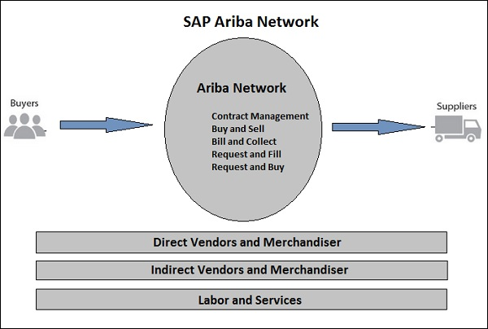

SAP Ariba is a cloud-based Procurement solution, which help buyers and suppliers to meet at one single network. SAP Ariba Partner program enables you with tools, resources, and benefits to help build, run, and grow your business.

Following are the key benefits of using SAP Ariba −

* One of the key advantages of using Ariba solution is that it simplifies procurement and sourcing process with easy synchronization to SAP SRM and other ERP software.
* It enhances supplier, buyers and user experience by bringing in a digital transformation to the supply chain process.
* With cloud-based solution, SAP Ariba can be accessed from different locations. It requires very low initial capital cost for setting up the solution.
* With SAP Ariba, there is an easy setup of key procurement processes - Procure to pay (integration of purchase department with Accounts payable department), Procure to Order by maintaining shopping carts.
* There is easy transfer of master data. Organization structure, suppliers and GL data can be easily transferred to Ariba solution using optimal way of integration.
* SAP Ariba enables easy transfer of transactional data. Invoice details, goods receipt, PO details can be easily transferred to Ariba solution with optimum integration.
* We can use integration toolkit to connect ERP system with Ariba solution.

The following illustration shows Ariba as the world's largest B2B trading platform

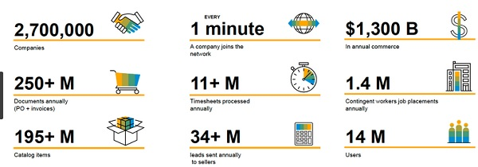

In SAP Ariba, you can access and configure new accounts, set email notifications, electronic order and invoice routing and other account related configuration for new suppliers.

* Go to [https://supplier.ariba.com.](https://supplier.ariba.com/)
* To login to your account, enter username and password.

o meet increased demand for enterprise-class security for mobile apps, [SAP](http://www.sap.com/) today announced a partnership with Mocana, one of the fastest-growing global security platform startups, to resell the leading mobile security product Mocana Mobile App Protection (MAP). The SAP Mobile App Protection solution by Mocana, part of the SAP Mobile Secure portfolio, provides secure mobile app management capabilities. The solution is intended to enable customers to benefit from the ability to quickly add fine-grained usage and security policies to iOS and Android apps without having to write any code. The partnership is forecasted to also help customers expedite deployment of secure mobile apps, especially in highly regulated industries such as financial services, retail, healthcare and government. The announcement was made at [SAPPHIRE NOW](http://www.sapphirenow.com/), being held May 14–16 in Orlando, Florida.

To meet increased demand for enterprise-class security for mobile apps, SAP AG has announced a partnership with Mocana, one of the fastest-growing global security platform startups, to resell the mobile security product Mocana Mobile App Protection (MAP). The SAP Mobile App Protection solution by Mocana, part of the SAP Mobile Secure portfolio, provides secure mobile app management capabilities. The solution is intended to enable customers to benefit from the ability to quickly add fine-grained usage and security policies to iOS and Android apps without having to write any code. The partnership is forecasted to also help customers expedite deployment of secure mobile apps, especially in highly regulated industries such as financial services, retail, healthcare and government.

“SAP is leading the way in partnering with some of the most successful startup companies in the mobile market today,” said Sanjay Poonen, President, Mobile Division, SAP. “In working with Mocana, one of the fastest-growing privately-held security platform providers in the world, we plan to bring a new, innovative best-of-breed solution to our customers. This announcement helps reaffirm our commitment to be at the forefront of enterprise mobile app security and to provide customers with the highest level of viability, management and security available today.”

SAP is focused on comprehensively addressing and simplifying all aspects of enterprise mobility for its customers. The SAP Mobile Secure portfolio addresses the many complexities experienced by any enterprise deploying a mobile solution or strategy. Adding SAP Mobile App Protection to this portfolio helps organisations speed mobile initiatives by automating app security without having to write any code. Once an application is wrapped, SAP Afaria is designed to deploy and manage the application, ensuring corporate data in an app is protected, even outside of the enterprise. Customers may also customise a range of policies including authentication, FIPS 140-2 encryption and per-app VPN to help comprehensively protect data for different users and contexts.

|  |
| --- |
| **What is SAP Mobile Place?** |
| SAP Mobile Place, a brandable, localizable and secure enterprise mobile app store that makes it easy for companies to get their apps into the hands of employees, business partners and consumers. This mobile app management (MAM) solution offers a superior experience for all users on both MDM-managed and unmanaged devices. In addition, Mobile Place is compatible with any MDM solution and is now included with SAP Mobile Secure. |

For IT admins, it's the single destination to publish, manage and analyze mobile and desktop apps, content, and profiles. For end users, it's the place to easily discover and download relevant apps and set up related services such as network access, email, identity and more.

Watch the video to see how your employees can benefit from a central App Store for Enterprise and Consumer Apps.

# SAP Mobile Device Management

Manage and secure devices with Mobile Device Management (MDM) solutions by preconfiguring a range of settings and enforcing security and compliance policies. Centralized Mobile Device Management capabilities by Mobolutions give companies access to safeguard the data stored on mobile devices. Enterprises can opt to leverage MDM solutions both on-premise or on the cloud with both options providing robust security and flexibility that is cost-effective with limited internal talent support.

# SAP Mobile Device Management (Value-Add)

* Remote wipe functionality that allows IT administrators to instantly wipe business data stored on mobile devices
* Password protection to safeguard unauthorized users from accessing business data stored on SAP mobile devices
* End-to-end mobile app security
* Asset management at device level to ensure that access is restricted to authorized devices
* Security insights and reports on data and device usage

## **Go beyond securing and managing your company's mobile devices, apps and content. SAP Mobile Secure is an integrated, cloud-based enterprise mobility management portfolio with superior user experiences for all. The use of this application is specific to Windows 10.**

By default, SAP Mobile Secure works with Azure AD. To get started, sign up for SAP Mobile Secure using an account in your instance of Azure AD.

* Enterprise Single Sign-On - Azure Active Directory supports rich enterprise-class single sign-on with SAP Mobile Secure out of the box. Users sign in using their organizational accounts hosted in Active Directory.

* Easy Configuration - Azure Active Directory provides a simple step-by-step user interface for connecting SAP Mobile Secure to Azure AD.

A relay is a service that allows you to send email. It is usually a full fledged mail server, or can be a specialized SMTP Service. Some examples of a mail server include Microsoft Exchange, IMail by IPSwitch, or Mail Enable by Mail Enable. An example of a SMTP service is the SMTP Service installed that can be installed with IIS. SNM sends email to a relay server, and the relay server is responsible for delivering the email to the final destination. When sending email to a relay server, you must have protocol permissions to use that server. Because of SPAM problems, relay servers are normally locked down, either by IPAddress or by some type of username/password authentication. Relaying errors are the most common problems when programmatically sending emails. If you ever see an exception that reads something like "550 Permission Denied", this is usually a relay error, and you need to talk to your mail server administrator about proper permissions.

# Using Relay Server with SAP Mobile Platform

Components necessary to install Relay Server in IIS on a Windows server or Apache on a Linux server are installed automatically with SAP Mobile Platform Server. You must install those components on Web servers before SAP Mobile Platform can work with Relay Server .

The Relay Server enables secure, load-balanced communication between mobile devices and backend servers through a web server. Supported backend servers include SAP Afaria, SAP Mobile Office, MobiLink, SAP SQL Anywhere, SQL Remote, SAP Mobile Server, and SAP Mobile Platform. The Relay Server provides the following: ● A common communication architecture for mobile devices communicating with backend servers. ● A mechanism to enable a load-balanced and fault-tolerant environment for backend servers. ● Communication between mobile devices and backend servers in a way that integrates easily with existing corporate firewall configurations and policies.

A typical Relay Server deployment is comprised of mobile devices, one or more Relay Servers, and one or more backend servers.

A typical Relay Server deployment is comprised of mobile devices, one or more Relay Servers, and one or more backend servers. A Relay Server deployment consists of the following components: ● Mobile devices running client applications and services that communicate with backend servers running in a corporate LAN. ● An optional load balancer to direct requests from the mobile devices to a group of Relay Servers. ● One or more Relay Servers running in the corporate DMZ. ● At least one backend server running in a corporate LAN that services client requests. The following backend servers are supported for use with the Relay Server: ○ SAP Afaria ○ SAP Mobile Office ○ MobiLink ○ SAP Mobile Platform ○ SAP SQL Anywhere ○ SQL Remote ○ SAP Mobile Server

Agentry SAP framework is a set of pre-built mobile applications that are used for:

* Increasing productivity by eliminating paperwork and reducing foot traffic
* Improving decision-making by giving mobile workers easy data access at the point of performance
* Gaining the maximum value from enterprise applications with timely and accurate data collection
* Lowering operating costs by reducing overhead and getting more from existing resources

With mobile solutions from SAP, organizations can create a seamless flow of information between business units that improve efficiency and move operations closer to real-time.

By deploying multiple products, organizations ensure that real-time data updates to one application can drive another action or transaction in a parallel business unit. Using Mobile add-on for ERP, organizations eliminate delays traditionally caused by paperwork backlogs and communication flaws, thereby streamlining workflow and delivering benefits to multiple business units.

The SAP Mobile Platform makes it simple and cost-effective to deploy and manage multiple Mobile add-on for ERP products. Built on the SAP platform, all Mobile add-on for ERP products are 100% configurable and centrally administered through application updates that automatically flow to users' devices while deployed in the field. The SAP Mobile Platform provides the flexibility, scalability and features that ensure Mobile add-on for ERP mobile applications are future-proof and remain on the cutting-edge of mobile technology.

In addition to the ability to deploy on a wide range of mobile devices and utilize an array of communications methods, the SAP Mobile Platform provides out-of-the-box integration with more than 25 popular mobile peripherals, including bar codes, RFID, GPS, and GIS, as well as support for multiple international languages.

Businesses can lower the total cost of ownership for their collective mobile projects by deploying on a single mobile platform. The addition of new Mobile add-on for ERP products does not add an additional burden to your IT team because they are pre-packaged proven applications built on the same underlying technology. Solutions can be integrated to feed multiple back end systems, improving communications across the enterprise.

The SAP Inventory Manager For Maximo application is an Agentry application deployed within the SAP Mobile Platform runtime environment. For those familiar with older releases of this application, which were deployed on the Agentry Mobile Platform, this section provides some transitional information on what has changed and what is the same in the SAP Mobile Platform 3.

In addition to the general information provided here, it is strongly recommended that you review the information available with the SMP runtime environment, as well as the SAP EAM and service mobile app SDK. Many procedures employed in the configuration and deployment of the SAP Inventory Manager For Maximo application are documented in those guides and manuals.

## Agentry Production Server Within the SMP Runtime Environment

The Agentry server within the Agentry mobile platform is now an application type within the SAP Mobile Platform runtime environment. For those familiar with terminology from the Agentry mobile platform, this is the equivalent of the Agentry production server. From a functional standpoint there are no significant changes to the behavior of the Agentry server functionality. Data and business logic are served up to clients just as they were in the Agentry mobile platform. Data synchronization is handled in the same manner.

Differences involve how the settings for the Agentry server are configured. Within SMP it is no longer possible to modify configuration files directly for applications deployed to this environment. Rather, one of two options exist for making these modifications. First, the SAP Cockpit, which is the administration console for SMP, is used to make any changes that would have otherwise been made to the Agentry.ini configuration file. All settings are available within the SAP Cockpit.

Second, copies of the configuration files can be modified directly outside of the SAP Mobile Platform runtime environment, and then deployed to the Agentry application within the environment. This is the required procedure for all configuration files in need of modification other than the Agentry.ini file, as these are not configurable within the SAP Cockpit.

## Agentry Development Components in the SAP EAM and service mobile app SDK

The various development components of the former Agentry mobile platform are now provided as a part of the SAP EAM and service mobile app SDK. This includes:

* The Agentry development server
* The Agentry editor plug-in
* The Agentry test environment
* The Agentry client installers

Each of these components is installed and used in the same manner as they were within the Agentry mobile platform.

## SAP Cockpit Replaces Agentry Administration Client

Almost all functions of the Agentry administration client are now handled by the SAP Cockpit. In addition to configuration settings for runtime behaviors of the application itself, this also includes the following functional areas:

* Server logging and log file management
* Creating and managing clustered server environments
* Backup and restore of former server-side resources

As mentioned previously, it is important for you to review the information provided with the SAP Mobile Platform , including guides and manuals, as well as any other publications, for information on these procedures and functional areas.

Amazon Simple Email Service (Amazon SES) is a cloud-based email sending service designed to help digital marketers and application developers send marketing, notification, and transactional emails. It is a reliable, cost-effective service for businesses of all sizes that use email to keep in contact with their customers.

You can use our SMTP interface or one of the AWS SDKs to integrate Amazon SES directly into your existing applications. You can also integrate the email sending capabilities of Amazon SES into the software you already use, such as ticketing systems and email clients.

The **Simple Mail Transfer Protocol** (**SMTP**) is a [communication protocol](https://en.wikipedia.org/wiki/Communication_protocol) for [electronic mail](https://en.wikipedia.org/wiki/Email) transmission. As an [Internet standard](https://en.wikipedia.org/wiki/Internet_standard), SMTP was first defined in 1982 by [RFC](https://en.wikipedia.org/wiki/Request_for_Comments) [821](https://tools.ietf.org/html/rfc821), and updated in 2008 by [RFC](https://en.wikipedia.org/wiki/Request_for_Comments) [5321](https://tools.ietf.org/html/rfc5321) to [Extended SMTP](https://en.wikipedia.org/wiki/Extended_SMTP) additions, which is the protocol variety in widespread use today. Mail servers and other [message transfer agents](https://en.wikipedia.org/wiki/Message_transfer_agent) use SMTP to send and receive mail messages. Proprietary systems such as [Microsoft Exchange](https://en.wikipedia.org/wiki/Microsoft_Exchange_Server) and [IBM Notes](https://en.wikipedia.org/wiki/IBM_Notes) and [webmail](https://en.wikipedia.org/wiki/Webmail) systems such as [Outlook.com](https://en.wikipedia.org/wiki/Outlook.com), [Gmail](https://en.wikipedia.org/wiki/Gmail) and [Yahoo! Mail](https://en.wikipedia.org/wiki/Yahoo!_Mail) may use non-standard protocols internally, but all use SMTP when sending to or receiving email from outside their own systems. SMTP servers commonly use the [Transmission Control Protocol](https://en.wikipedia.org/wiki/Transmission_Control_Protocol) on [port number](https://en.wikipedia.org/wiki/Port_number) 25.

User-level [email clients](https://en.wikipedia.org/wiki/Email_client) typically use SMTP only for sending messages to a mail server for relaying, and typically submit outgoing email to the mail server on port 587 or 465 as per [RFC 8314](https://tools.ietf.org/html/rfc8314). For retrieving messages, [IMAP](https://en.wikipedia.org/wiki/Internet_Message_Access_Protocol) and [POP3](https://en.wikipedia.org/wiki/Post_Office_Protocol) are standard, but proprietary servers also often implement proprietary protocols, e.g., [Exchange ActiveSync](https://en.wikipedia.org/wiki/Exchange_ActiveSync).

***S***imple ***M***ail ***T***ransfer ***P***rotocol, a [protocol](https://www.webopedia.com/TERM/P/protocol.html) for sending [e-mail](https://www.webopedia.com/TERM/E/e_mail.html) messages between [servers](https://www.webopedia.com/TERM/S/server.html). Most e-mail systems that send mail over the [Internet](https://www.webopedia.com/TERM/I/Internet.html) use SMTP to send messages from one server to another; the messages can then be retrieved with an [e-mail client](https://www.webopedia.com/TERM/E/e_mail_client.html) using either [POP](https://www.webopedia.com/TERM/P/POP2.html) or [IMAP](https://www.webopedia.com/TERM/I/IMAP.html). In addition, SMTP is generally used to send messages from a mail client to a mail server. This is why you need to specify both the POP or IMAP server and the SMTP server when you [configure](https://www.webopedia.com/TERM/C/configure.html) your e-mail [application](https://www.webopedia.com/TERM/A/application.html).

SAP Fiori is a new user experience (UX) for SAP software and applications. It provides a set of applications that are used in regular business functions like work approvals, financial apps, calculation apps and various self-service apps. SAP Fiori provides 300+ role-based applications like HR, Manufacturing, Finance, etc. SAP Fiori enables multiple device applications that allow users to start a process on their desktop/laptops and to continue that process on a smartphone or on a tablet. SAP has developed Fiori Apps based on User Interface UI5.

SAP Fiori is a new user experience (UX) for SAP software and applications. It provides a set of applications that are used in regular business functions like work approvals, financial apps, calculation apps and various self-service apps.

SAP Fiori provides 300+ role-based applications like HR, Manufacturing, finance, etc. When you open the SAP Fiori home page application, you will see a picture of the flowers. It is because Fiori means ‘flowers’ in Italian.

**SAP UI5** is a Java script based framework that is used to design multi-platform business applications. It supports various data models and views do desktop and mobile applications. SAP UI5 compiles on open Ajax and can be combined with java script libraries.

**SAP UI5** was initially named phoenix that was later changed to **SAP UI5** in 2011.

## **Key UI Technologies**

* Web Dynpro ABAP and Floorplan manager tool can be used for creating new applications.
* SAP UI5 and UI5 application development tools to change adapt or develop new applications.
* SAP Dynpro is used to include Screen Personas for GUI optimization

## **Characteristics of SAP UI5**

The characteristics of SAP UI5 are as follows −

* Well Designed models, easy to consume.
* Performance optimized with compliant of SAP standards
* Support Ajax open source
* Includes JavaScript library
* Extensible UI component model
* Based on open standards like Ajax, JavaScript, CSS, and HTML 5.

### **Key Components – Client and Server SAP UI5 −**

**Client**

* JavaScript library, Image files
* Core JavaScript files
* Test suite HTML and JavaScript files

**Server**

* Application development tools
* Theming Generator
* Resource handler in Java
* Control Development tools

**UI5 Browser Support**

SAP UI5 supports all the key web browsers and latest versions like IE, Mozilla Firefox, Google Chrome and Safari.

OData is used to define best practices that are required to build and consume RESTful APIs. It helps you to find out changes, defining functions for reusable procedures and sending batch requests etc.

Some of the important features are −

* OData provides facility for extension to fulfill any custom needs of your RESTful APIs.
* REST stands for Representational State Transfer and it is sometimes spelled as "ReST".
* It relies on a stateless, client-server, cacheable communication protocol. In virtually all cases, the HTTP protocol is used.
* REST is defined as an architecture style for designing network applications.
* OData helps you focus on your business logic while building RESTful APIs without having to worry about the approaches to define request and response headers, status codes, HTTP methods, URL conventions, media types, payload formats and query options etc.
* OData RESTful APIs are easy to consume.

## **OData Service Life Cycle**

The OData service life cycle includes span of an OData service. Given below are the key steps to be considered in an OData Service Life Cycle.

* Activation of OData service.
* Maintaining OData service.
* Maintaining of models and services, up to the cleanup of the metadata cache.
* RESTful applications use HTTP requests to post data to create or update, read data and delete data. REST uses HTTP for all four CRUD (Create/Read/Update/Delete) operations.
* REST is a lightweight alternative to mechanisms like RPC (Remote Procedure Calls) and Web Services.

## **REST**

REST is defined as an option for web services and Remote Procedure calls. It is used for designing network applications.

REST services like a web services and supports below features −

* Work with firewalls
* Language-independent
* Standards-based
* Not Platform dependent

## **REST Architecture**

Given below are the components of the REST Architecture.

### **Resources**

In REST, both the state and the functionality are presented as resources. Resources are the key element of a RESTful design, as opposed to "methods" or "services" used in RPC and SOAP Web Services.

RPC calls like "**getProductName**" and "**getProductPrice**" are not used in REST. You view the product data as a resource and this resource should contain all the required information.

### **Web of Resources**

It means that a single resource should not contain detailed data and it contains links to additional web pages.

### **Client-Server**

In REST client–server model, one component server can be other component client.

### **No Connection State**

Each request should contain details about the connection to each client and should not reply on the previous connections to the same client.

### **Cachable**

The protocol must allow the server to explicitly specify which resources may be cached, and for how long.

### **Proxy Servers**

To improve performance and scalability, Proxy servers can be used. Any standard HTTP proxy can be used.

SAP Cloud Platform is an open platform-as-a-service,[[4]](https://en.wikipedia.org/wiki/SAP_Cloud_Platform#cite_note-4) which includes the in-memory [SAP HANA](https://en.wikipedia.org/wiki/SAP_HANA) database management system, connects to both [on premises](https://en.wikipedia.org/wiki/On_premises) and cloud-based systems running SAP or other third-party software and relies on open standards,[[5]](https://en.wikipedia.org/wiki/SAP_Cloud_Platform#cite_note-5) like [Java](https://en.wikipedia.org/wiki/Java_(programming_language)), [JavaScript](https://en.wikipedia.org/wiki/JavaScript), [Node.js](https://en.wikipedia.org/wiki/Node.js) and [Cloud Foundry](https://en.wikipedia.org/wiki/Cloud_Foundry)[[6]](https://en.wikipedia.org/wiki/SAP_Cloud_Platform#cite_note-6) for integration options.

## **SAP HANA Cloud Platform as an Application Service**

As an application service it offers the following features:

* **Mobile services**: It acts as a mobile platform in the cloud through which mobile applications that are similar to the SAP mobile platform can be availed.
* **Analytics**: The HCP analytic feature enables users to analyze and present data visually. This feature is easy to use and provides insight on the data available in the cloud platform.
* **Portal**: The HCP portal enables for creating and taking live mobile friendly websites. The HCP portal serves as an intranet that brings together in-house and cloud solutions in a centralized environment for employees to access.
* **Collaboration**: It enables sharing of information among users with the SAP functionality feature. It can be set up for employees working on a specific project to facilitate communication, cooperation and operational efficiency.
* **Security**: It enables data security through functionalities such as creating user accounts, integrating the entire system to ensure data protection while providing easy access to authorized persons.
* **Integration**: It allows for easy integration of on-premise systems and other cloud environments.

PostgreSQL is a powerful, open source object-relational database system. It has more than 15 years of active development and a proven architecture that has earned it a strong reputation for reliability, data integrity, and correctness.

SAP Mobile Platform: (previously Sybase Unwired Platform) is a mobile enterprise application platform designed to simplify the task of creating applications that connect business data to mobile devices for workflow management and back-office integration. Sybase Unwired Platform provides a layer of middleware between heterogeneous back-end data sources, such as relational databases, enterprise applications and files, and the mobile devices that need to read and write back-end data.

**SAP** Mobile Platform (**SMP**) is the company's development platform for mobile apps, with a focus on business-to-business (B2B) and business-to-customer (B2C) applications.

SAP FI stands for Financial Accounting and it is one of important modules of SAP ERP. It is used to store the financial data of an organization. SAP FI helps to analyze the financial conditions of a company in the market. It can integrate with other SAP modules like SAP SD, SAP PP, SAP MM, SAP SCM, etc.

SAP FI comprises of the following sub-components −

* Finance Accounting General Ledger.
* Finance Accounting Accounts Receivable and Payable.
* Finance Accounting Asset Accounting.
* Finance Accounting Bank Accounting.
* Finance Accounting Travel Management.
* Finance Accounting Fund Management.
* Finance Accounting Legal Consolidation.

## **Where Do We Use SAP FI?**

SAP FI module enables you to manage financial accounting data within an international framework of multiple companies, currencies, and languages. SAP FI module mainly deals with the following financial components −

* Fixed asset
* Accrual
* Cash journal
* Accounts receivable and payable
* Inventory
* Tax accounting
* General ledger
* Fast close functions
* Financial statements
* Parallel valuations
* Master data governance

SAP FI consultants are mainly responsible for implementing Financial Accounting and Cost Accounting with SAP ERP Financials.

SAP Controlling (CO) is another important SAP module offered to an organization. It supports coordination, monitoring, and optimization of all the processes in an organization. SAP CO involves recording both the consumption of production factors and the services provided by an organization.

SAP CO includes managing and configuring master data that covers cost and profit centers, internal orders, and other cost elements and functional areas.

The main purpose of SAP controlling module is planning. It enables you to determine variances by comparing actual data with plan data and thus enables you to control business flows in your organization.

## **SAP CO Integration with Financial Accounting**

Both SAP CO and SAP FI modules are independent components in a SAP system. The data flow between these components takes place on a regular basis.

Data flows relevant to cost flows to Controlling from Financial Accounting. At the same time, the system assigns the costs and revenues to different CO account assignment objects, such as cost centers, business processes, projects or orders.

SAP solutions include a number of functional modules, which support transactions to execute key business processes, such as −

* Financial Accounting (FI)
* Financial Supply Chain Management (FSCM)
* Controlling (CO)
* Materials Management (MM)
* Sales and Distribution (SD)
* Logistics Execution (LE)
* Production Planning (PP)
* Quality Management (QM)
* Plant Maintenance (PM)
* Project System (PS)
* Human Resources (HR)

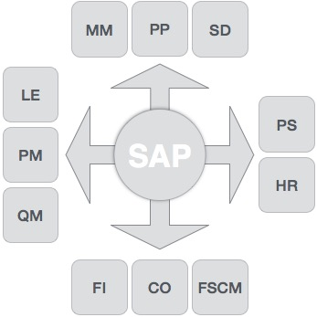

## **Finance and Controlling (FICO)**

SAP FICO is a combination of two ERP modules, i.e., Finance Accounting (FI) and Controlling (CO). Under Finance in SAP and at an enterprise level, the following modules take part −

* FI − Finance
* CO − Controlling
* IM − Investment Management
* TR − Treasury
* EC − Enterprise Controlling

**SAP FI** (Financial Accounting) is accountable for tracking the flow of financial data across the organization in a controlled manner and integrating all the information for effective strategic decision-making.

## **Activities Involved in SAP FI**

* Creation of Organizational Structure (Defining Company, Company Codes, business Areas, Functional Areas, Credit Control, Assignment of Company Codes to Credit Controls)
* Financial Accounting Global Settings (Maintenance of Fiscal Year, Posting Periods, defining Document types, posting keys, Number ranges for documents)
* General Ledger Accounting (Creation of Chart of Accounts, Account groups, defining data transfer rules, creation of General Ledger Account)
* Tax Configuration & Creation and Maintenance of House of Banks
* Account Payables (Creation of Vendor Master data and vendor-related finance attributes like account groups and payment terms)
* Account Receivables (Creation of Customer Master data and customer-related finance attributes like account groups and payment terms
* Asset Accounting
* Integration with SD and MM

**SAP CO** (Controlling) module facilitates coordinating, monitoring, and optimizing all the processes in an organization. It controls the business flow in an organization. This module helps in analyzing the actual figures with the planned data and in planning business strategies.

Two kinds of elements are managed in CO −

* Cost elements
* Revenue elements

These elements are stored in the FI module.

## **Activities Involved in SAP CO**

* Cost Element Accounting (Overview of the costs and revenues that occur in an organization)
* Cost Center Accounting
* Activity-Based-Accounting (Analyzes cross-departmental business processes)
* Internal Orders
* Product Cost Controlling (Calculates the costs that occur during the manufacture of a product or provision of a service)
* Profitability Analysis (Analyzes the profit or loss of an organization by individual market segments)
* Profit Center Accounting (Evaluates the profit or loss of individual, independent areas within an organization)

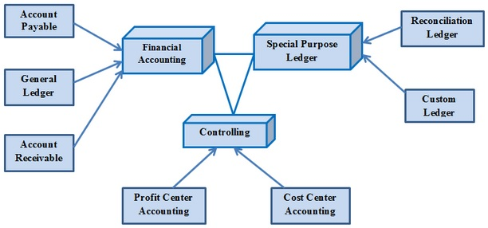

## **Sales & Distribution Management (SD)**

SAP SD is one of the most important modules in SAP. It has a high level of integration complexity. SAP SD is used by organizations to support sales and distribution activities of products and services, starting from enquiry to order and then ending with delivery.

SAP SD can monitor a plethora of activities that take place in an organization such as products enquires, quotation (pre-sales activities), placing order, pricing, scheduling deliveries (sales activity), picking, packing, goods issue, shipment of products to customers, delivery of products and billings.

In all these processes, multiple modules are involved such as FI (Finance Accounting), CO (Controlling), MM (Material Management), PP (Production Planning), LE (Logistics Execution), etc., which shows the complexity of the integration involved.

## **Activities Involved in SAP SD**

* Setting up Organization Structure (creation of new company, company codes, sales organization, distribution channels, divisions, business area, plants, sales area, maintaining sales offices, storage location)
* Assigning Organizational Units (Assignment of individual components created in the above activities with each other according to design like company code to company, sales organization to company code, distribution channel to sales organization, etc.)
* Defining Pricing Components (Defining condition tables, condition types, condition sequences)
* Setting up sales document types, billing types, and tax-related components
* Setting up Customer master data records and configuration

## **Material Management (MM)**

Material Management deals with movement of materials via other modules like logistics, supply chain management, sales and delivery, warehouse management, production and planning.

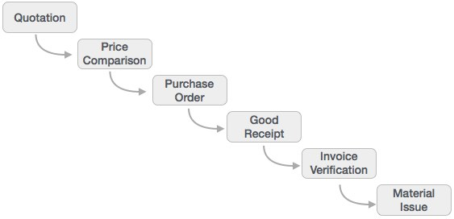

## **Logistic Execution (LE)**

Logistic Execution can be divided into two sub-modules, i.e., shipment of goods (purchase to procurement process) and warehouse management (storage of goods). These two modules are integrated with sale and distribution, material management, and production and planning.

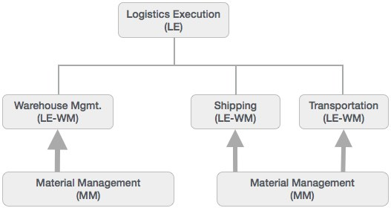

## **Supplier Relationship Management (SRM)**

As the name SRM suggests, this module deals with the effective and efficient transition of products and services between an organization and its suppliers. The main process covered in this section is procurement of products like direct materials, indirect materials, and services. This module can effectively integrate with planning, accounting, and inventory system.

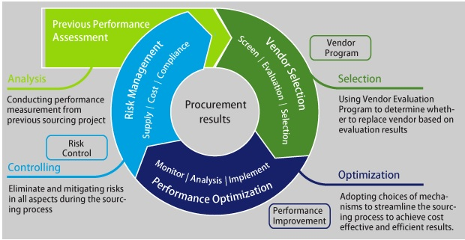

**End-to-End Procurement Cycle**

**Procurement process** with SAP Enterprise Buyer comprises of the following major steps −

* Shopping Carts
* Approval of Shopping Cart
* Sourcing of Requirements
* Purchase Orders
* Purchase Order Approval
* Confirm Goods/Services
* Confirmation Approval
* Process Invoice
* Invoice Approval

## **Customer Relationship Management (CRM)**

CRM deals with end-to-end customer related processes. CRM is designed to centralize the data related to all the customers associated with an organization. It helps an organization −

* Maintain its sales, services, and build marketing strategies according the market demand and customer data analysis.
* Remain focused on its customers and via information analysis, help the business to know more about its customers.
* Improve sales and services and building better relationships with customers.

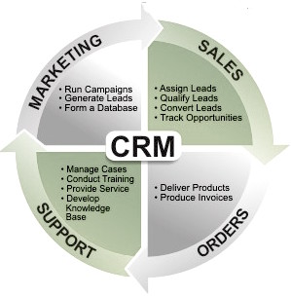

## **Human Resource (HR)**

The most important objective of master data administration in Human Resources is to enter employee-related data for administrative, time-recording, and payroll purposes.

A new employee can be hired without using Recruitment. Instead you can hire someone by running a personnel action in Personnel Administration, thereby creating the necessary data for the employee to be hired.

Employee data must be kept current. After an employee is hired, circumstances can always arise which necessitate either the entry of new data or the correction of current data. For instance −

* An employee moves to his or her new address must be stored in the system.
* An employee gets a pay hike at the start of the year. The new salary must be stored for the relevant date.
* An employee changes jobs within the organization. His or her organizational assignment, working time, and salary also change.
* Data can be stored for the past, present, or future.

**Note** − Entering payroll-relevant data in the past triggers retroactive accounting.

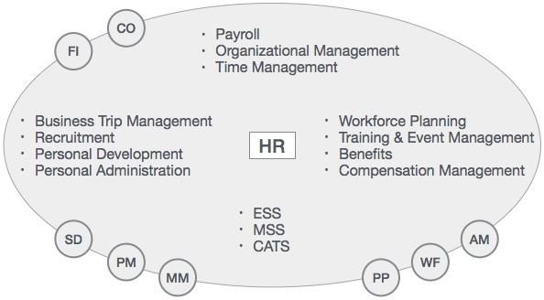

The HR module is comprised of major areas of functionality known as sub-modules. The HR module is a true demonstration of the strength of the SAP product in Enterprise Resource Planning.

The HR system has very strong integration points (where data is passed back and forth without human intervention) with just about all of the other SAP modules. In addition, there is very tight integration amongst the HR sub-modules.

The above illustration highlights some of the basic SAP HR terms as listed below.

* Business trip management
* Recruitment
* Payroll
* Personal development
* Organizational Management
* Time Management
* Workforce Planning
* ESS
* MSS
* Training and event management
* CATS
* Benefits
* Compensation management
* Personal Administration

SAP Human Capital Management (SAP HCM) is one of the key modules in SAP and is also called SAP Human Resource (HR) or SAP Human Resource Management System (SAP HRMS). This introductory tutorial gives a brief overview of the features of SAP HR and how to use it in a systematic manner.

# Audience

Human capital management products from SAP can help your organization hire and retain the right people, manage the work environment, streamline HR processes, ensure legal compliance, and create a people-centric organization. This tutorial is designed to configure the HR module of SAP in an easy and systematic way. Packed with plenty of screenshots, it will be useful for consultants as well as end-users.

# Prerequisites

Before you start proceeding with this tutorial, we are assuming that you are already aware of the basics of SAP. It will be helpful if you have some exposure to the HR functions normally conducted in an organization.

SAP Human Capital Management (SAP HCM) is one of the key modules in SAP and is also called SAP Human Resource (HR) or SAP Human Resource Management System (SAP HRMS). SAP HCM contains many submodules and all these modules are integrated with each other.

The key modules are as follows −

* **Organizational Management** − Organizational Management includes Personnel development, Personnel cost planning and event management.
* **Time Management** − Time management includes time recording, attendance, time schedule, shift management, etc.
* **Personnel Administration** − Personnel Administration includes personal and organizational structure, Infotypes, integration with time and payroll, etc.
* **Payroll** − Payroll deals with payroll types, payroll group configuration, primary and secondary wages, gross pay, bonus, etc.
* **Recruitment** − Recruitment includes hiring an employee, maintaining HR master data, etc.
* **Training and Event Management** − Training and Event Management deals with identifying training needs, scheduling training, training cost management, etc.
* **Travel Management** − Travel Management includes managing official trips, cost management for travel, travel expenses, etc.

## **Organization Management**

Organization Management allows you to manage the enterprise structure and analyze organization plans.

The key features are −

* In organization management, you can configure system settings that is required for enterprise structure, personnel cost planning, etc.
* You can define plan version to configure various organization plans at the same time.
* Only one plan version defines your organizational current plan.
* You can edit, change or compare different organization plans using plan version.
* You can have two different plan versions, one for marketing and other one for sales hierarchy.
* You can compare or edit both the plans but only one plan can be used at a time.

SAP Quality Management is a part of SAP R/3 system and is integrated with other SAP modules like SAP Material Management (MM), Production Planning (PP), and Plant Maintenance (PM). QM is an integral part of logistic management and it is used to perform quality functions such as quality planning, quality assurance, and quality control, at various stages such as incoming material stage, in-process manufacturing process stage, and after production as well. This tutorial will walk you through the different features of SAP QM.

SAP Quality Management is a part of SAP R/3 system and is integrated with other SAP modules like SAP Material Management (MM), Production Planning (PP), and Plant Maintenance (PM). QM is an integral part of logistic management and it is used to perform quality functions such as quality planning, quality assurance, and quality control, at various stages such as incoming material stage, in-process manufacturing process stage, and after production as well.

With Quality Management module, you can implement the key modules of QM system as defined in manufacturing standards like ISO 9000.

As SAP Quality Management is an integral part of SAP R/3 system, it performs the following key functions in manufacturing of goods −

* **Quality Planning** − Quality planning allows to plan the inspection of goods from the vendor, raw material, work-in-process, and final product.
* **Quality Notifications** − Quality notification includes the defect identification and steps to be taken by quality department.
* **Quality Inspection** − Here, quality results are captured and decision is taken as to whether an inspection lot is to be accepted or rejected.

In the following diagram, you can see the key components that are involved in SAP Quality Management process.

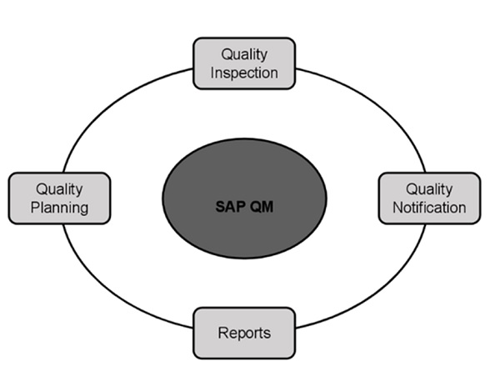

SAP is an enterprise resource planning software that was basically designed to manage resources, information and activities that are required to complete business processes such as procurement and managing orders, billing of orders and management of human resources. SAP applications work with real-time data. It has the ability to be configured according to the needs of the business. It allows a business to make rapid changes in its requirements through a common set of programs. This tutorial adopts a step-by-step approach to acquaint the readers with the SAP MM environment and how to make good use of its features. It will also help learners to perform procurement of stock materials in SAP.

SAP ERP (Enterprise Resource Planning) is a commercial software that integrates all the information in a single software, considering various factors such as time and cost. Organizations can easily meet their business demands with the help of SAP.

## **SAP Business Process**

SAP MM is the short form for SAP Material Management system. The roles of SAP MM in a business process are as follows −

* A business process in SAP is termed as a “module”.
* SAP MM is a part of logistics functions and it helps in managing the procurement activities of an organization.
* It supports all aspects of material management (planning, control, etc.).
* It is the backbone of logistics that incorporates modules such as Sales and Distribution, Production Planning, Plant Maintenance, Project Systems, and Warehouse Management.

## **Features of SAP MM**

The features of a SAP MM system are as follows −

* SAP MM is one of the modules of SAP that deals with material management and inventory management.
* Material Management as a process ensures no shortage of materials or any gaps in the supply chain process of the organization. SAP MM speeds up the procurement and material management activities, making the business run smoothly with complete time and cost efficiency.
* It deals with managing the materials (products and/or services) and resources of an organization with the aim of accelerating productivity and reducing costs. At the same time, SAP MM is quite versatile to accommodate changes that are frequent in any business environment.
* It deals with the Procurement Process, Master Data (Material & Vendor Master), Account Determination & Valuation of Material, Inventory Management, Invoice Verification, Material Requirement Planning, etc.

SAP SD (Sales and Distribution) is one of the significant modules of SAP ERP. It is used to store the customer and product data of an organization. SAP SD helps to manage the shipping, billing, selling and transportation of products and services of a company.

The SAP Logistics module manages customer relationship starting from raising a quotation to sales order and billing of the product or service. This module is closely integrated with other modules like SAP Material Management and PP.

This is an introductory tutorial that covers the basics of SAP SD and how to deal with its various modules and sub-modules.

SAP Sales and Distribution is one of the key components of SAP ERP system and is used to manage shipping, billing, selling and transportation of products and services in an organization.

SAP Sales and Distribution module is a part of SAP Logistics module that manages customer relationship starting from raising a quotation to sales order and billing of the product or service. This module is closely integrated with other modules like SAP Material Management and PP.

### **Key Components in SAP SD**

The key components in SAP Sales and Distribution module are −

* Customer and Vendor Master Data
* Sales Support
* Shipping of Material
* Sales Activities
* Billing related
* Transportation of products
* Credit Management
* Contract Handling and Management
* Foreign Trade
* Information System

### **SAP Sales and Distribution Cycle**

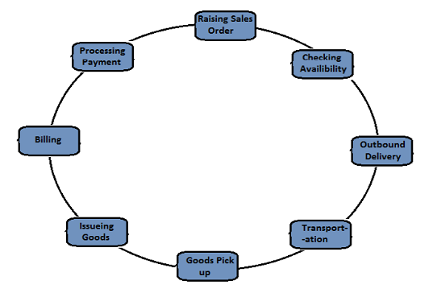

## **SAP SD - Organizational Structure**

SAP provides many components to complete SAP Sales and Distribution organizational structure like Sales Areas, Distribution Channels, Divisions, etc. The SAP SD organization structure majorly consists of two steps −

* Creation of Organization elements in SAP system, and
* second is to link each element as per requirement.

On top of this organization structure in the SD module, sales organization is at highest level and is responsible for distribution of goods and services. SAP recommends to keep the number of sales organization in an organizational structure to be minimum. This will help in making the reporting process easy and ideally it should have a single sales organization.

The next level is distribution channel, which tells the medium by which the products and services are distributed by an organization to its end users. Division in an organizational structure, which represents a product or service line in a single organization.

A sales area is known as entity, which is required to process an order in a company. It comprises of sales organization, distribution channel and a division.

In SAP SD organizational structure, each sales organization is assigned to a company code. Then the distribution channel and divisions are assigned to sales organization and all of these comprise to make a sales area.

In the first step of an SD organizational structure, sales organization is assigned to a company code and then is to define a distribution channel and then division to a sales organization.

The following diagram shows the organizational structure of a Sales and Distribution module −

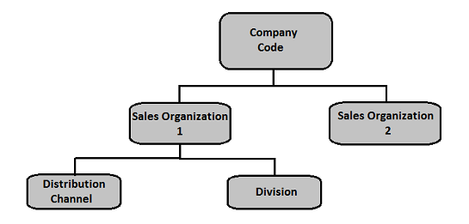

## **Material management**

Material Management is one of the key modules in SAP ERP System and covers the day to day business operations related to inventory and procurement. This module is closely integrated with other modules of R/3 systems like Finance Accounting and Controlling, Sales and Distribution, Quality Management, Product Planning.

### **Integration with Sales and Distribution SD Module**

Consider an example of creating a sales order in SAP SD, it involves copying the details of items from Material Management. Availability check of the item and price details are also taken from MM, but this can be controlled in the SD module. To create inbound and outbound delivery of goods for a sales order, shipping details, loading point etc. also comes from the Material Master.

The item that is placed using a Sales order must be extended to the sales area of an organization to sales order/customer, otherwise it won’t be possible to transact with this material. This confirms that there is a link between SAP SD and MM module, when a sales order is created and fulfilled. Similarly, there are many other links between two modules.

## **Finance and Accounting**

SAP FI stands for Financial Accounting and it is one of the important modules of SAP ERP. It is used to store the financial data of an organization. SAP FI helps to analyze the financial condition of a company in the market. It can integrate with other SAP modules like SD, PP, SAP MM, SAP SCM etc.

SAP EWM is part of SAP Supply Chain Management like Warehouse Management System, but it provides more robust and advanced features to manage key activities in a warehouse.

SAP EWM is used to efficiently manage inventory in a Warehouse and for supporting processing of goods movement. It allows any company to control their Warehouse’s inbound and outbound processes and movement of goods in the Warehouse.

This is a fundamental tutorial that covers the basics of SAP EWM and how to deal with its various components and sub-components.

SAP Extended Warehouse Management (EWM) is used to efficiently manage inventory in the Warehouse and for supporting processing of goods movement. It allows the company to control their Warehouse inbound and outbound processes and movement of goods in the Warehouse.

The main process in a Warehouse is incoming and outgoing materials, goods receipt and goods issue, fulfil customer orders, and distribution of goods. When a company doesn’t store any goods, then there is no need of Warehouse management to manage goods.

Inbound process involves storage of goods in warehouse and their location and Outbound process involves picking up the goods. Whenever a material is stored in a warehouse, it is stored in the storage bin and you can find its current location.

With the help of SAP EWM all the goods movement are controlled by a warehouse management system and provides you the tools to monitor warehouse activities. You can also manage additional functions in the Warehouse like creating a serial number, batch number, vendor management inventory, resource optimization and value added services. SAP Extended Warehouse Management allows you to not only monitor the quantity of goods in Warehouse but to manage other critical functions and delivery of goods efficiently.

SAP Warehouse Management is opposite to Inventory management. Inventory management tells the count of goods in the storage location and its physical location is unknown. Warehouse management deals with goods movement and monitoring the physical location of the goods recorded with specific documents.

### **SAP EWM is different from SAP Warehouse Management**

SAP EWM is a part of SAP Supply Chain Management like Warehouse management system but provides more robust and advanced features to manage key activities in the Warehouse.

SAP Extended Warehouse Management is similar to Warehouse management but it provides more features like picking, put away, RF framework, Warehouse structure and more flexible options to manage the warehouse functions.

You can create new elements like an activity area, resources, labor management and work centers in SAP EWM which were not available in WM.

SAP EWM provides more a robust solution to manage warehouse functions in an organization. It is also a part of SAP Supply Chain Management and also supports all the processes within logistics and supply chain.

## **SAP EWM ─ Key Features**

The following are the key features in SAP EWM −

* Using SAP EWM, you can control the warehouse activities like picking, posting and managing storage bin and good receipts.
* You can set alert for changed data before goods receipt from EWM to the ERP system, reversal or correction of the goods receipt from EWM to the ERP system and an inbound delivery split from EWM to the ERP system.
* You can perform deconsolidation of handling units which contain different products before putting them away in different storage sections.
* You can determine storage concepts using slotting for products and optimize arrangement of goods warehouse automatically.
* It allows you to perform executable tasks like work packages, consisting of warehouse tasks warehouse employees should perform as part of warehouse management activities.
* It allows you to manage and track vehicles as well as other transportation units from the yard check-in to yard check-out, including movements and other tasks within the yard.
* SAP EWM also includes storage and handling of hazardous substances and their transportation in accordance with the regulations from SAP Environmental Health & Safety EHS.
* In SAP EWM, you can also plan labor times and resources more effectively and hence you can make your Warehouse efficient by managing key resource management tasks effectively.
* In SAP EWM, you can use Warehouse cockpit that allows you to display warehouse key figures graphically and to evaluate or monitor activities using defined chart types.
* You can use cross-docking that allows you to perform transportation of handling units across different distribution centers or warehouses till they reach final location in the Warehouse.

## **Deployed Options in SAP EWM**

SAP EWM can be considered as deployed in an ERP server or you can also consider it as an application in the Supply Chain Management landscape.

SAP Extended Warehouse Management is integrated with ERP to access transaction and master data and use of features like slotting, availability check also requires its integration with CRM.

It is considered as a separate application and shares the same server with the SCM applications. You can also run SAP EWM in its own SCM environment which is suitable to get improved performance.

### **EWM Deployment Options**

The following image shows the deployment options for SAP EWM −

* Figure 1 shows SAP EWM on SCM Server.
* Figure 2 shows SAP EWM as Standalone.

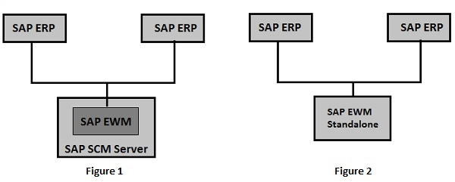

## **Communication Method**

SAP ERP and EWM are closely integrated with each other for transfer of transaction and master data. There are two different ways of communication.

**Core Interface (CIF)** − Core interface is one of the common method for communication between SAP SCM system and SAP Advanced Planning and Optimization APO. Master data maintained in ERP system like customer, material and vendor which are available in ERP system are transferred to EWM system use Core Interface CIF communication.

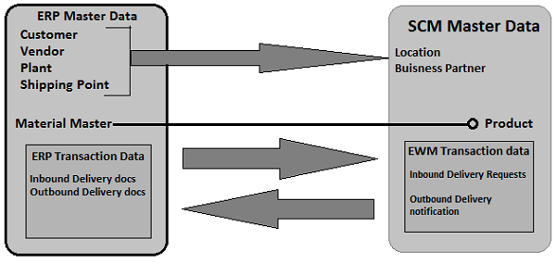

For transaction data (inbound/outbound delivery docs), a separate integration model is used for communication. This model uses iDocs or queued remote function call RFC.

### **How to check various menu structure of EWM system?**

Login to the SCM system and navigate to the Extended Warehouse management node in the SAP menu. You can use various transactions to manage basic functions in Warehouse management −

|  |  |
| --- | --- |
| Warehouse Monitor | /SCWM/MON |
| Maintain Inbound Delivery | /SCWM/PRDI |
| Maintain Outbound Delivery | /SCWM/PRDO |
| RF Environment | /SCWM/RFUI |
| Creating Storage Bin | /SCWM/LS01 |
| Confirm Warehouse Task | /SCWM/TO_CONF |
| Warehouse product Maintenance | /SCWM/MAT1 |

SAP Plant Maintenance (SAP PM) is a software product that manages all maintenance activities in an organization. Plant Maintenance module consists of key activities to include inspection, notifications, corrective and preventive maintenance, repairs, and other measures to maintain an ideal technical system.

SAP Plant Maintenance (SAP PM) application component provides an organization with a tool for all maintenance activities to be performed. All the activities that are performed under maintenance are interconnected and hence this module is closely integrated with other modules - Production Planning, Material Management, and Sales and Distribution.

Using SAP PM, you can perform automatic repairs and facilitate maintenance requests in an organization. It allows you to record problems in SAP system, plan labor and material activities, and to record and settle the cost.

In an organization, you can identify, document, manage problems and perform enterprise asset management for any required assets.

To perform these activities, Plant Maintenance contains the following submodules −

* Management of technical objects and equipment master record.
* Planning of maintenance task.
* Manage workflow notifications and work orders under maintenance order management.

## **Key Functions of Plant Maintenance**

Following activities are performed under Plant Maintenance −

### **Inspection**

Inspection is done to check the actual condition of a technical system.

### **Preventive Maintenance**

Preventive maintenance is used to maintain high availability of the technical system. It includes maintenance planning and work scheduling activities for technical objects.

### **Repair**

Repair involves all measures that can be performed to restore the ideal condition. Repair process can be performed at many planning stages - like work scheduling, resource planning and initial costing, etc. You can respond immediately w.r.t to a damage events causing production shutdown. You can create required purchase requisition and processed work orders to reduce the downtime.

## **Integration with Other Modules**

In SAP PM, you can integrate with other modules such as Material Management, Production Planning, Personnel Management, and Sales and Distribution. These modules are used to keep the current data as per the requirement in Plant Maintenance and are initiated automatically to maintain the current data in the system.

Following are the key modules in which integration is performed with Plant Maintenance −

* Material Management
* Sales and Distribution
* Personnel Management
* Controlling
* Production Planning

The following figure depicts a work order notification process and shows how it is executed under Plant Maintenance.

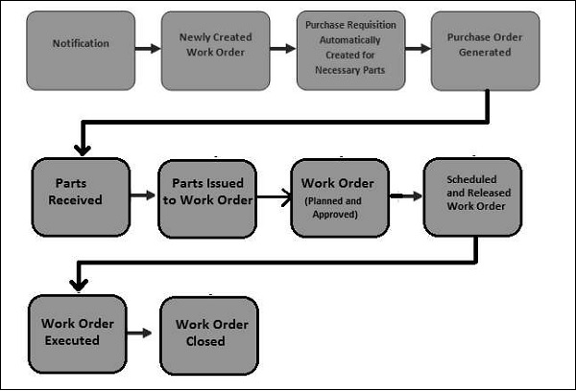

The key steps involved are −

* Notification
* Newly Created Work Order
* Creation of Purchase request for work orders
* Purchase Order created and parts Received
* Parts issues to Work Order
* Approval and Planning of Work Order
* Scheduling and Releasing Work Order
* Work Order Execution
* Closing a Work Order

SAP Simple Finance (S/4 HANA Finance) is one of the important modules to manage SAP Finance and Accounting powered by SAP HANA. It is used to perform financial operations and accounting in real time and reporting using BI tools. SAP Simple Finance helps to analyze the financial conditions of an organization in the market. This is an introductory tutorial that covers the basics of SAP Simple Finance and how to deal with its various modules and sub-modules.

In traditional SAP applications, all the data is stored at the database level and calculations are performed. The results are displayed at the application layer. Most of the query processing time involves calculations and aggregations. It is recommended that all application logic should be pushed at the database level to improve the performance of query execution.

SAP HANA based applications provide best application performance by pushing the execution into the database as possible. All the data is stored in in-memory database so the reading data is much faster as compared to a conventional database.

SAP HANA supports real-time data replication and hence removes unnecessary latency and complexity of data load.

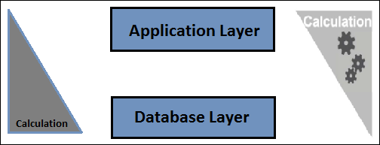

### **Advantages of Using SAP HANA**

Following are the advantages of using SAP HANA as underlying database.

* Real-time data analysis
* Elimination of unnecessary complexity of hardware
* No latency in database due to nightly ETL jobs
* In-memory database
* Column store supports calculations on the run
* Parallel processing
* Data compression

## **SAP HANA Roadmap to S/4 HANA**

SAP HANA developed interest by mid-2011 and various Fortune 500 organizations started considering it as an option to maintain their Business Warehouse needs. In 2012, SAP Business Warehouse powered by HANA was introduced to support real-time analysis and real-time reporting was introduced.

In 2013, SAP Business Suite powered by SAP HANA was introduced that supported realtime business, OLAP, and Transaction on the same system.

In 2014, SAP Simple Finance powered by SAP HANA was introduced for instant financial insight, no aggregates, and single source of data for reporting.

In 2015, SAP S/4 HANA was introduced that provided a simplified data model, new user experience, advance processing, and multitenancy.

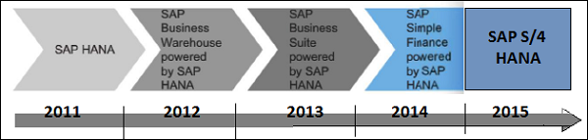

## **S/4 HANA ─ Overview**

S/4 HANA Business suite is based on the native HANA platform to support simplified data models, no aggregates, no indices, etc. It has an integrated Fiori-based user interface and role-based access for different purposes.

S/4 HANA is based on advanced in-memory platform and offers a personalized Fiori-based user experience to access role-based solution. It can be deployed over cloud environment or on-premise solution. There are many customers which are moving from SAP Business Suite to S/4 HANA and for 75% customers, it takes an average 6 months for migration project.

SAP also offers SAP rapid deployment project to perform a fast migration to HANA platform and to SAP Simple Finance solution. Various SAP partners provide fixed price integration for few clients.

Customers can use the customization even after migration of the system. Migration of SAP Business Suite to S/4 HANA is done via implementation package in the form of SAP Simple Finance and Simple Logistics, and many more.

With SAP S/4 HANA, SAP is providing a new product and a next generation of business applications – simple enterprise software for big data and is designed to help you run simple in the digital economy.

SAP Basis refers to the administration of SAP system that includes activities like installation and configuration, load balancing, and performance of SAP applications running on Java stack and SAP ABAP. This includes the maintenance of different services related to database, operating system, application and web servers in SAP system landscape and stopping and starting the system.

The key responsibilities of SAP Basis Administrator include −

* System installation and Configuration
* Load balancing on servers
* Performance management of different components
* Managing interfaces and integration with servers
* Managing servers and different services

With the help of SAP Basis, different SAP modules like Finance Accounting, Production Planning, Sales and Distribution, SAP EWM and other modules can integrate and communicate with each other.

SAP Basis supports the installation and configuration of SAP applications on different operating systems like Windows, Unix, AS/400, etc. and different databases like SQL Server, Oracle, IBM DB2 for back end database.

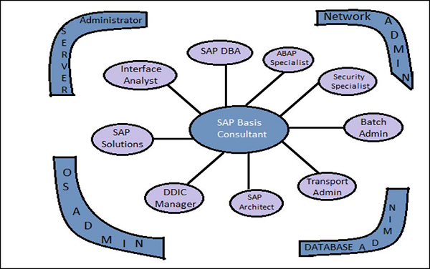

This picture defines the key activities that involve the role of SAP Basis Consultant. The roles of the SAP Basis Consultant are divided into the following categories −

### **Solution Specialist**

The Solution Specialist is responsible for −

* Upgrading the SAP version of system landscape
* SAP Data backup archive
* Migration of Operating system and Database
* Installation of AP/Add On

### **Interface Analyst**

The Interface Analyst is responsible for −

* Configuration and set up of interface between different modules

### **System Administrator**

The System Administrator is responsible for −

* Monitoring the performance of SAP system and modules
* Maintaining SAP system health and performing health checkup

### **SAP Database Administrator**

The SAP Database Administrator is responsible for −

* Backup and restoring the database of SAP system
* Managing database objects

## **Transport and Batch Job Administrator**

The Transport and Batch Job Administrator is responsible for −

* Managing batch job scheduling and replication
* Managing SAP Control access in system landscape

### **DDIC Manager**

The DDIC Manager is responsible for −

* Managing changes to Data Dictionary

### **SAP Architect**

The SAP Architect is responsible for −

* Designing work and data flow in the SAP system
* Managing SAP sizing

### **SAP ABAP Specialist**

The SAP ABAP Specialist is responsible for −

* Troubleshooting and tuning of ABAP Programs
* Applying correction to Programs as per SAP
* Coding and customization of ABAP program as per requirement

## **Transaction Codes**

There are various Transaction Codes (T-codes) that a SAP Basis Administrator uses to perform the assigned tasks. The following is a list of important SAP Basis T-codes −

**SM02** − To send messages to users who are logged in and new users logging to the client.

**SM01** − To take control of transaction codes. In case, the business requires that the users who are authorized to carry the transactions are to be stopped temporarily.

**SM04** − To check the number of users who are logged into the system and in which client and how many sessions each user is generated and in each session what transaction is being executed.

**SM13** − To keep track of the status of the Update service is Active, in case it is not active then we activate from the Update Administrator

**SM37** − To monitor the status of the jobs that are created by a user and for specific dates.

**PFCG** − This is used to maintain roles in SAP system.

**SM21** − SAP system log is displayed for the values inputted in the initial screen. The values that can be maintained is the From Date.

**RZ20** − This is used for cross system monitoring. In this transaction, we have a tree structure that performs a set of transactions and also keeps a track of all the alerts that were captured during the operation of the system

##### What is BASIS?

Basis is a set of programs and tools that act as an interface with Database, Operating system, Communication protocols and business applications (such as FI, CO, MM,etc). Full form of BASIS is "Business Application Software Integrated solution"  
  
SAP applications such as FI,CO,PP etc. can run and communicate with each other across different Operating systems and Databases with the help of BASIS.

ABAP (Advanced Business Application Programming), is a fourth-generation programming language, used for development and customization purposes in the SAP software. Currently positioned along with Java, as the main language for SAP application server programming, most of the programs are executed under the control of the run-time system. This tutorial explains the key concepts of SAP ABAP.

ABAP stands for Advanced Business Application Programming, a 4GL (4th generation) language. Currently it is positioned, along with Java, as the main language for SAP application server programming.

Let's start with the high level architecture of SAP system. The 3-tier Client/Server architecture of a typical SAP system is depicted as follows.

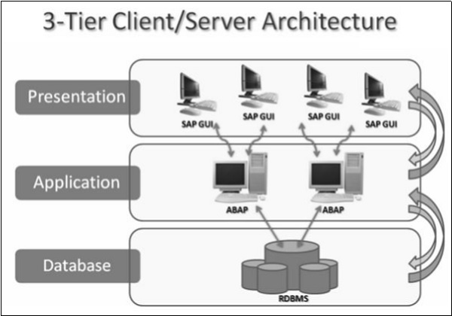

The **Presentation layer** consists of any input device that can be used to control SAP system. This could be a web browser, a mobile device and so on. All the central processing takes place in **Application server**. The Application server is not just one system in itself, but it can be multiple instances of the processing system. The server communicates with the **Database layer** that is usually kept on a separate server, mainly for performance reasons and also for security. Communication happens between each layer of the system, from the Presentation layer to the Database and then back up the chain.

**Note** − ABAP programs run at the application server level. Technical distribution of software is independent of its physical location. It means basically all three levels can be installed on top of each other on one computer or each level can be installed on a different computer or a server.

ABAP programs reside inside the SAP database. They execute under the control of the runtime system that is a part of the SAP kernel. The run-time system processes all ABAP statements, controlling the flow logic and responding to user events.

So, unlike C++ and Java, ABAP programs are not stored in separate external files. Inside the database, ABAP code exists in two forms −

* **Source** code that can be viewed and edited with the ABAP workbench tools.
* **Generated code**, which is a binary representation. If you are familiar with Java, this generated code is somewhat comparable with Java byte code.

The run-time system can be considered as a virtual machine, just similar to Java virtual machine. A key component of the ABAP run-time system is the database interface that turns database independent statements (Open SQL) into the statements understood by the underlying database (Native SQL). SAP can work with a wide variety of databases and the same ABAP program can run on all of those.