Major Project Report

ON

***“BOOK E-SHOPPING”***

SUBMITTED BY:

***MOHIT ARORA***

***1502866***

*UNDER THE GUIDANCE OF TRAINER MR. ABHINANDAN*

***COGNIZANT TECHNICAL SOLUTIONS, CDC***

PLOT No. #26 RAJIV GANDHI TECHNOLOGY PARK,

HINJEWADI PHASE-3, PUNE, MAHARASHTRA-411057

**FEB 2019-MAY 2019**

**CERTIFICATE**

This is to certify that the project report entitled **“Book E-Shopping” by Mohit Arora (1502866)** of Chandigarh Engineering College, Landran (Mohali) affiliated to Punjab Technical University during the academic year 2019, in partial fulfillment of the requirements for the award of the degree of Bachelor of Technology (Computer Science and Engineering) is a bonafide record of the work carried out under our guidance and supervision at **Cognizant Technology Solutions CDC, Pune.**

Shilpa Mahajani

(Project Manager)

Cognizant Technology Solutions

CDC, Pune

**ACKNOWLEDGEMENT**

We feel immense pleasure and feel privileged in expressing our deepest and most sincere gratitude to our supervisor **Mr. Abhinandan**, for his excellent guidance throughout our project work. His kindness, dedication, hard work and attention to detail have been a great inspiration to us. Our heartfelt thanks to you sir for the unlimited support and patience shown to us. We would particularly like to thank him for all her help in patiently and carefully correcting all our manuscripts. We acknowledge the support received from Cognizant Technical Solutions CDC, Pune. We are also very thankful to **Mrs. Shilpa** and **Ms. Komal** for their support and suggestions during our course of the project work in the final year of our undergraduate course.

**Mohit Arora**

**(1502866)**

**ABSTRACT**

Cognizant is an American multinational corporation that provides IT services, including digital, technology, consulting, and operations services. It is headquartered in Teaneck, New Jersey, United States of America. Cognizant is included in the NASDAQ-100 and the S&P 500 indices. It is also one of the fastest growing Fortune 500 companies. It was founded as an in-house technology unit of DUN & BRADSTREEIN in 1994, and started serving external clients in 1996.

Cognizant had a period of fast growth during the 2000s, becoming a Fortune 500 company in 2011. In 2015, the FORTUNE Magazine named it as the world's fourth most admired IT Services company. In 2017, Cognizant was named in Fortune’s Future 50 list.

Cognizant provides information technology, information security, consulting, ITO and BPO services. These include business & technology consulting, system integration, application development & maintenance, IT infrastructure services, analytics, business intelligence data warehousing, customer relationship management, supply chain management, engineering & manufacturing solutions, enterprise resource planning, research and development, outsourcing, and testing solutions.

Cognizant has three key practice areas that span its business — Digital Business, Digital Operations, and Digital Systems & Technology.

**CHAPTER 1**

**1.0 INTRODUCTION**

**1.1 PURPOSE OF THIS PROJECT**

This document is aimed at:

• Providing the necessary inputs to the detailed requirements gathering phase and further on for the SDLC processes.

• This document also serves to establish the traceability between the Business Objectives and the requirements identified in the proposed solution and how they satisfy the stated objectives.

• Provide expectation traceability in terms of the requirements and the user expectation

• Serves as a formal template for documenting the Business Requirements, which also includes statutory and regulatory requirements.

The purpose of this document is to systematically capture the requirements of the project and the system to be developed. The document also captures the Functional requirements and serves as an input for the scope of project.

**1.2 OBJECTIVES**

BES is a system used to perform various tasks related to online shopping of books. The following are the few important modules in the system:

a) Customer Registration and Login.

b) Searching and Add to Cart.

c) View/Edit and Remove from the cart.

d) Payment and Order processing.

e) Order Cancellation.

**1.2.0 BUSINESS CASE**

The transformation from any product from being physical to digital is a common occurrence in each corner of the world – be it purchase of a product or a book. Conversion of a physical store to a digital store is fast shaping the way a business is running. The digital transformation allows the organization to run a business efficiently and in a cost-effective manner. Physical bookstore as such is consuming more floor space to display the 1000s of books from the inventory. The solution developed will address the objective in a holistic manner and will have all the features and functionalities, which shall let a web portal to allow customers to enroll, browse the available books, add books to the cart, perform online payments, perform order cancellation & monitor delivery progress. Digital book stores shall allow the customer to view based on the genres of his interest, which cannot be possible in a physical store without moving around.

**1.2.1 TECHNOLOGIES RECOMMENDED**

|  |  |
| --- | --- |
| **Front End** | Java (HTML5,CSS3, JavaScript) |
| **Middleware** | Java (Spring, Spring MVC, Hibernate MVC , WEB API2) |
| **Backend** | Oracle/SQL Server |

**HARDWARE AND SOFTWARE REQUIREMENTS**

|  |  |
| --- | --- |
| **Technology** | Java |
| **Hardware** | Desktop PC with 8GB RAM |
| **Software** | 1. Node.js 10.15.1  2. Visual Studio Code 1.30  3. Eclipse IDE for Java EE Developers (Oxygen)  4. Maven 3.6.0  5. Tomcat 9  6. MySQL Community Server 8.0  7. MySQL Workbench  8. Oracle 11g express version |

**PRODUCT SCOPE**

This product is a powerful web aggregation engine is a core enabling technology of Cognizant solutions and is a fundamental tool for improving the management of collections and deductions. This product is a great start to an efficiency initiative.

**1.3 INTENDED AUDIENCE**

Interns/Project Team

Mentors and SME’s

Delivery assurance/excellence group

**CHAPTER 2**

**2.0 PROCESS ARCHITECTURE**

Below is the overall functional flow of the project including the components of interaction.

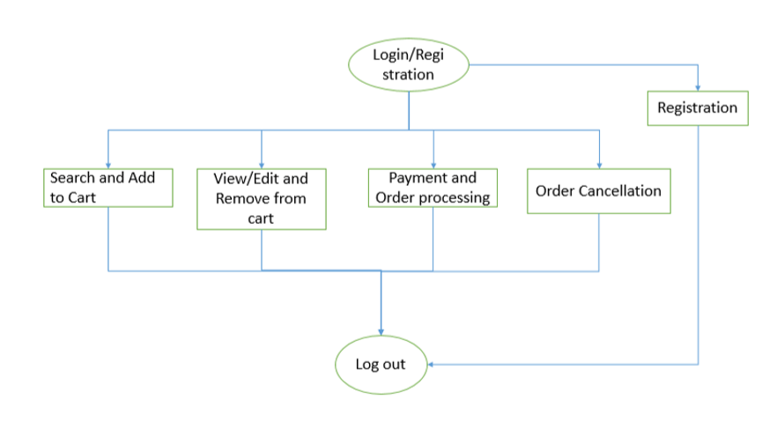

**CHAPTER 3**

3.1 DETAILED BUSINESS REQUIREMENTS

3.1.0 FUNCTIONAL REQUIREMENTS

The functional requirements are projected below, for each of the high-level requirements called out in the earlier section. Additionally, the following elements are captured for each business requirement in the table provided below:-

* Req. Type = (F Core Functionality, E Exception, UI User Interface, R Reporting)

** Priority of Requirement = (1=Base Functionality, 2=Advanced Functionality, 3=Additional Opportunities)

** Originator = (Name of the business process of the system/ department or function name in the customer organization)

The requirements in this document are prioritized as follows:

|  |  |  |
| --- | --- | --- |
| **Value** | **Rating** | **Description** |
| 1 | Critical | This requirement is critical to the success of the project. The project will not be possible without this requirement. |
| 2 | High | This requirement is high priority, but the project can be implemented at a bare minimum without this requirement. |
| 3 | Medium | This requirement is somewhat important, as it provides some value but the project can proceed without it. |
| 4 | Low | This is a low priority requirement or a “nice to have” feature, if time and cost allow it. |
| 5 | Future | This requirement is out of scope for this project, and has been included here for a possible future release. |

|  |  |  |  |  |  |  |
| --- | --- | --- | --- | --- | --- | --- |
|  | **Rationale Categorization** | **Business Requirement** | **Req. Type** | **Priority** | **Originator** | **BR Traced to Business Requirement / Use case ID** |
| Req_ 1.1 | User Registration | User needs to fill some of the basic attributes/  fields as mentioned below in requirement: First Name, Last Name, Age, Gender, Contact Number, Email id, Password | UI | Critical | NA | Req_1 |
| Req_ 1.2 | User Registration | Clicking ‘Submit’ should validate the datatype constraints for each field | F | Critical | NA | Req_1 |
| Req_ 1.3 | User Registration | User failing to provide information on the mandatory fields be provided with an alert message – ‘Please update the highlighted mandatory field(s).’ Also, highlight the missed out field in red | E | Medium | NA | Req_1 |
| Req_ 1.4 | User Registration | Post-successful field level validation, save the information in the database | F | Critical | NA | Req_1 |
| Req_ 1.5 | User Registration | Upon saving the information in the database, display the message ‘Your details are submitted successfully’. | E | Medium | NA | Req_1 |
| Req_ 2.1 | Credential Authentication | A registered user – is able click ‘Login’ link, after keying in ‘Email ID’ & ‘Password’ field and get his credentials authenticated with the existing database entry. | F | Critical | NA | Req_2 |
| Req_ 3.1 | Search and Add to Cart | On searching for the books , the list of books should be displayed along with provision for the user to select the book & also the quantity of the each Item. | Ui | Critical | NA | Req_3 |
| Req_ 3.2 | Search and Add to Cart | The customer can select the book needed; mention the quantity needed for each of the book displayed. | F | Medium | NA | Req_3 |
| Req_ 3.3 | Search and Add to Cart | The quantity needed cannot exceed the quantity available for each book | F | Medium | NA | Req_3 |
| Req_ 3.4 | Search and Add to Cart | Display an error message if no book is selected and the user has added the item to the cart. | E | Medium | NA | Req_3 |
| Req_ 4.1 | View/Edit and Remove from cart | While viewing the cart it should display the list of books one after the other along with the preselected quantity requested for each item. | UI | Critical | NA | Req_4 |
| Req_ 4.2 | View/Edit and Remove from cart | If in case there is no book added in the cart it should display “No items in cart” | UI | Medium | NA | Req_4 |
| Req_ 4.3 | View/Edit and Remove from cart | The customer can unselect the book to be removed; | F | Medium | NA | Req_4 |
| Req_ 4.4 | View/Edit and Remove from cart | The customer can also change the quantity needed for each of the book displayed. | F | Medium | NA | Req_4 |
| Req_ 4.5 | View/Edit and Remove from cart | The modified quantity and removed books should be updated to the database for the customer. | F | Medium | NA | Req_4 |
| Req_ 5.1 | Payment and Order processing | The items added to the cart are displayed in while making the payment. Otherwise display a message, “You have not placed any order”. | F | Medium | NA | Req_5 |
| Req_ 5.2 | Payment and Order processing | The total payment amount is calculated and displayed while making the payment. Price for a specific book = Price of one book * Quantity required Calculate the Total cost by adding up the price for all the books selected. | F | Critical | NA | Req_5 |
| Req_ 5.3 | Payment and Order processing | The customer enters the payment details and proceed for the payment. | F | Critical | NA | Req_5 |
| Req_ 5.4 | Payment and Order processing | Once done, the payment is accepted and the order is placed in the database with the booking status updated to ‘ORD PLACED’ updated to the database for the customer. | F | Critical | NA | Req_5 |
| Req_ 5.5 | Payment and Order processing | Order Id ORD_XXXX, where XXXX is a unique number should be generated and stored. | F | Critical | NA | Req_5 |
| Req_ 6.1 | Order Cancellation | The order details should be displayed. | UI | Medium | NA | Req_6 |
| Req_ 6.2 | Order Cancellation | If no order is available for the customer, display a message “No orders have been placed” | F | Medium | NA | Req_6 |
| Req_ 6.3 | Order Cancellation | On order cancellation, the books details selected for the order by the customer  should be deleted. | F | Medium | NA | Req_6 |
| Req_ 6.4 | Order Cancellation | The order details should be deleted from the database. | F | Medium | NA | Req_6 |

**3.2 REFERENCES**

**3.2.1 TABLE 1.0**

|  |  |  |
| --- | --- | --- |
| Field Name | Field Type | Data Type |
| CAT ID | Text(5) | Numeric |
| CAT NAME | Text(50) | AlphaNumeric |

**3.2.2 TABLE 2.0**

|  |  |  |  |
| --- | --- | --- | --- |
| **Field Name** | **Field Type** | **Data Type** | **Possible Values** |
| CAT ID | Text(5) | Numeric |  |
| Book ID | Text(15) | AlphaNumeric |  |
| Book Name | Text(50) | AlphaNumeric |  |
| Price | Text(5) | Numeric |  |
| Availability | Text(1) | Alphabetic | Y/N |
| Binding | Dropdown | Alphabetic | HardCover/Paperback/others |
| Language | Text(10) | Alphabetic |  |
| Author Name | Text(50) | Alphabetic |  |
| Publisher Name | Text(50) | Alphabetic |  |
| Delivery date | Text(8) | Date |  |

# Introduction

## Purpose & Scope of the document

The purpose of this Use case document is to systematically capture requirements for the project and the system to be developed in terms of use cases. Functional use cases are captured in this document. It also serves as the input for the project scoping.

The scope of this document is limited to addressing the use cases from a user, quality, and non-functional perspective.

## Intended Audience

Each member of the project team

## Use case ‘User Registration’

### Use case attributes

**Use Case Description:**

This use case deals with the capture of user details. The ‘user’ here will be the operator of the system and will be keying in the user details.

**Scope:**

* User registration

**Actors:**

* User – the operator

**Trigger:**

Click ‘Create Account’ button in the ‘User Registration’ page

**Pre-Condition:**

User get redirected to the ‘User Registration’ page upon click of ‘Create Account’ link on the login page.

**Post Condition:**

User is in the registration page & submit details.

**Flow of Events:**

User at login page 🡪 Click ‘Create Account’ link 🡪 User is in the registration page 🡪 User details are submitted and added to the database.

**Primary Scenario:**

A new user – is able to click ‘Create Account’ link and able to provide his details and get registered in the system.

### Business Rules

Business rules should be defined using the following attributes: -

* When the user clicks on the ‘Create Account’ link, it should re-direct to registration form.
  + - User needs to fill some of the basic attributes/fields as mentioned below in requirement: First Name, Last Name, Age, Gender, Contact Number, E-Mail Id, Password.
* Clicking ‘Create Account’ should validate the datatype constraints for each field.
* Post-successful field level validation, save the information in the database
* Upon saving the information in the database, redirect to login page.

### UI Requirements

Here is a prototype on how the ‘User Registration’ page should look like.

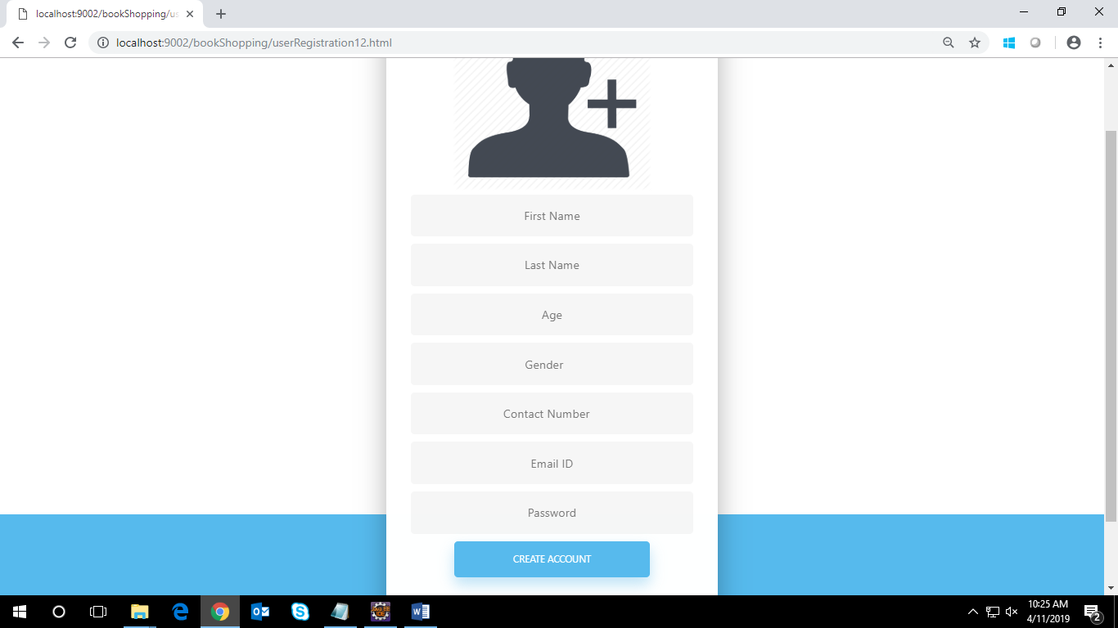

### UI Field Validations

Please refer to the below requirements for field level validations:

* All fields are mandatory.
* The Email ID format must be checked.
* Gender should be chosen from the dropdown options.

## Use case ‘Login Page’

### Use case attributes

**Use Case Description:**

This use case deals with the authentication of the user/admin credentials. The ‘user’/ ‘admin’ here will be the operator of the system and will be keying in the user/admin information into the system.

**Scope:**

* User/admin credentials authentication

**Actors:**

User – the operator/ Admin – the operator

**Trigger:**

Click ‘Login’ link, after keying in ‘Username’ & ‘Password’ field.

**Pre-Condition:**

User/Admin being able to access the login page.

**Post Condition:**

User/Admin is in the respective user/admin home page.

**Flow of Events:**

User at login page 🡪 Key in ‘Username’ & ‘Password’ field 🡪 User credentials are validated 🡪 Respective user/admin home page is displayed.

**Primary Scenario:**

A registered user/admin is able to click ‘Login’ link, after keying in ‘Username’ & ‘Password’ field and get his credentials authenticated with the existing database entry.

**Alternative Scenario:**

A registered user/admin is able to click ‘Login’ link, after keying in ‘Username’ & ‘Password’ field and unable to get his credentials authenticated. The user is redirected to login page for an invalid username or password.

### Business Rules

Business rules should be defined using the following attributes: -

* A registered user/admin is able to click ‘Login’ link, after keying in ‘Username’’ & ‘Password’ field and get his credentials authenticated with the existing database entry.

### UI Requirements

Here is a prototype on how the Login Page should look like.

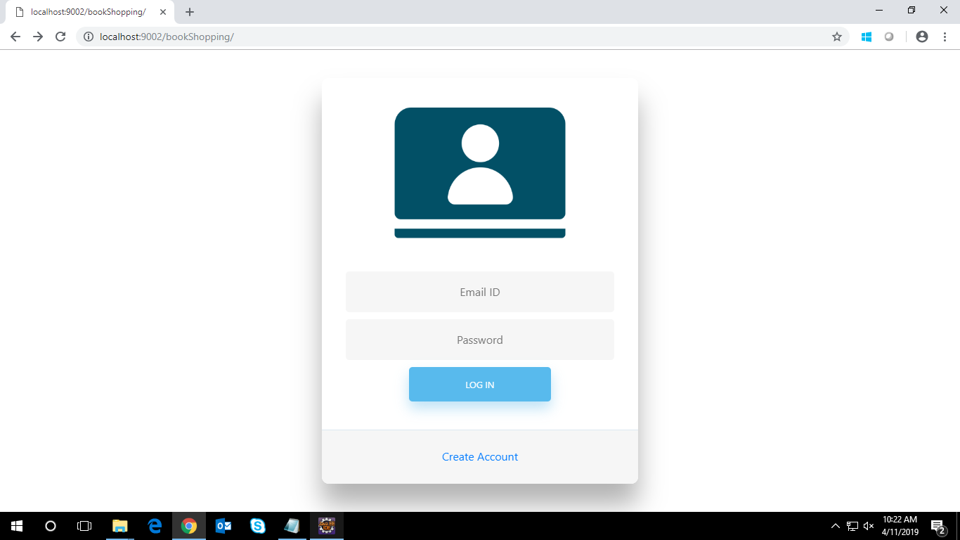

### UI Field Validations

Please refer to the below requirements for field level validations:

* All fields are mandatory.
* The Email ID format must be checked.

## Use case ‘User Home Page’

### Use case attributes

**Use Case Description:**

This use case deals with the display of books and their details. The ‘user’ here will be the operator of the system and will be either searching a particular book or adding required number of books to the cart.

**Scope:**

* Adding book to the cart for purchase.

**Actors:**

* User – the operator

**Trigger:**

User should get redirected to the Cart Page upon clicking on the cart icon in user

homepage.

**Pre-Condition:**

User should be able to get redirected to the ‘User Home Page’ upon clicking the login button on the login page.

**Post Condition:**

User is in the User home page & add book to the cart.

**Flow of Events:**

User at Login Page🡪click ‘Login’ button🡪User at user homepage 🡪click book name 🡪book details will be displayed 🡪 Click ‘Add to cart’ button for required book🡪 added to database🡪’book added’ message will appear 🡪 Click ‘cart’ icon

**Primary Scenario:**

User is able to see details of book and able to add required number of books in the shopping cart by clicking ‘Add to cart’ button. User is also able to search for particular required book.

### Business Rules

Business rules should be defined using the following attributes: -

* When the user clicks on the book name, it should re-direct to page showing full details of book.
* Details of book is mentioned below in requirement: CAT Name, Book Id, Book Name, Book Price, Availability, Binding, Language, Author Name, Publisher Name, Delivery Date.
* User is able to search the required book in home page using search button.
* Clicking ‘Add to cart’ should add the book to the cart page and ‘book added’ message is displayed.
* Post-successful addition of book to cart, save the information in the database.

### UI Requirements

Here is a prototype on how the user home page should look like.

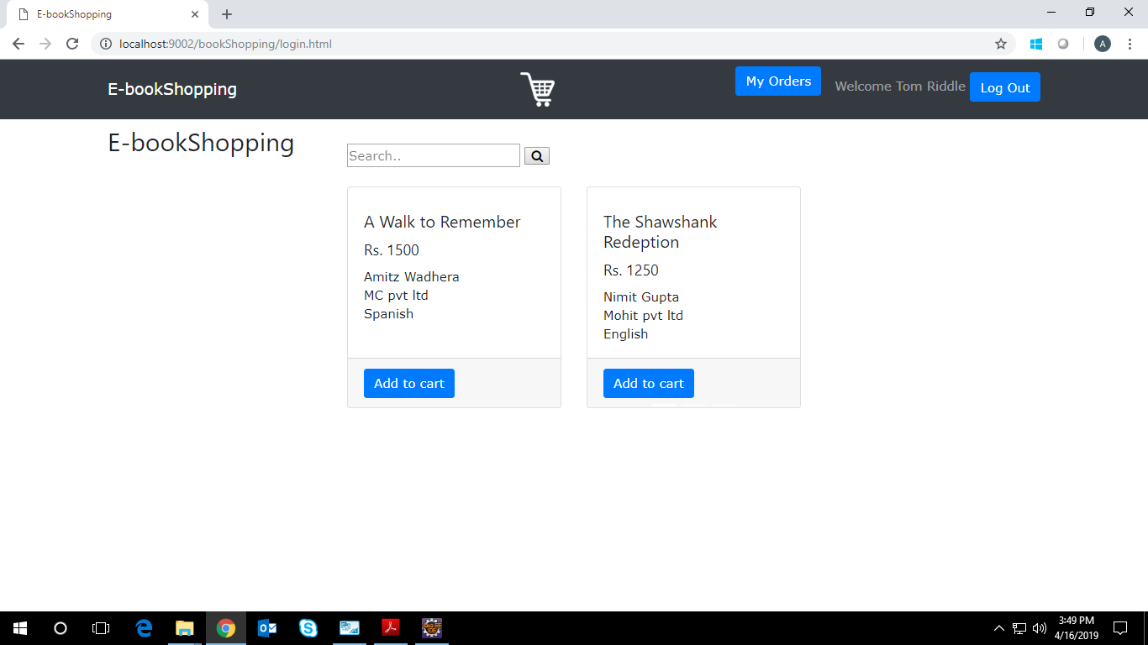

## Use case ‘Cart Page’

### Use case attributes

**Use Case Description:**

This use case deals with the ability to display books of ‘User Home Page’ selected by user to be purchased. The ‘user’ here shall be the operator of the system and will be managing the quantity of books that are added to the cart and display the price according to it. The ‘User’ can remove added books if required and finally checkout with final price.

**Scope:**

View, remove and checkout books added in the cart**.**

**Actors:**

* User – the operator

**Trigger:**

Click ‘Checkout’ button in the ‘Cart’ page

**Pre-Condition:**

User should be able to get redirected to the ‘Cart’ upon clicking the cart icon on the user home page.

**Post Condition:**

User is displayed a page showing all the added books and after checking out with required quantities and final price, it will redirect to ‘Payment Page’.

**Flow of Events:**

User at login page 🡪 Click ‘Login’ button 🡪 User at homepage ->Books are added to cart 🡪 Click the cart icon 🡪 Page is displayed with added books🡪quantity and price is managed🡪click ‘checkout’ button🡪User is redirected to ‘Payment’ page.

**Primary Scenario:**

A user – is able to view added books in the cart and manage their price according to required quantity. User can also remove any book if not required. The final bill will be generated and user will checkout and redirect to payment page

### Business Rules

Business rules should be defined using the following attributes: -

* When the user clicks on added book image, it will show remove option and can be removed from cart if not required.
  + - User can manage the quantity of books and will display the price according to it.
    - User will get final price and on clicking ‘checkout’ will redirect to ‘payment page’.

### UI Requirements

Here is a prototype on how the ‘Cart” page should look like.

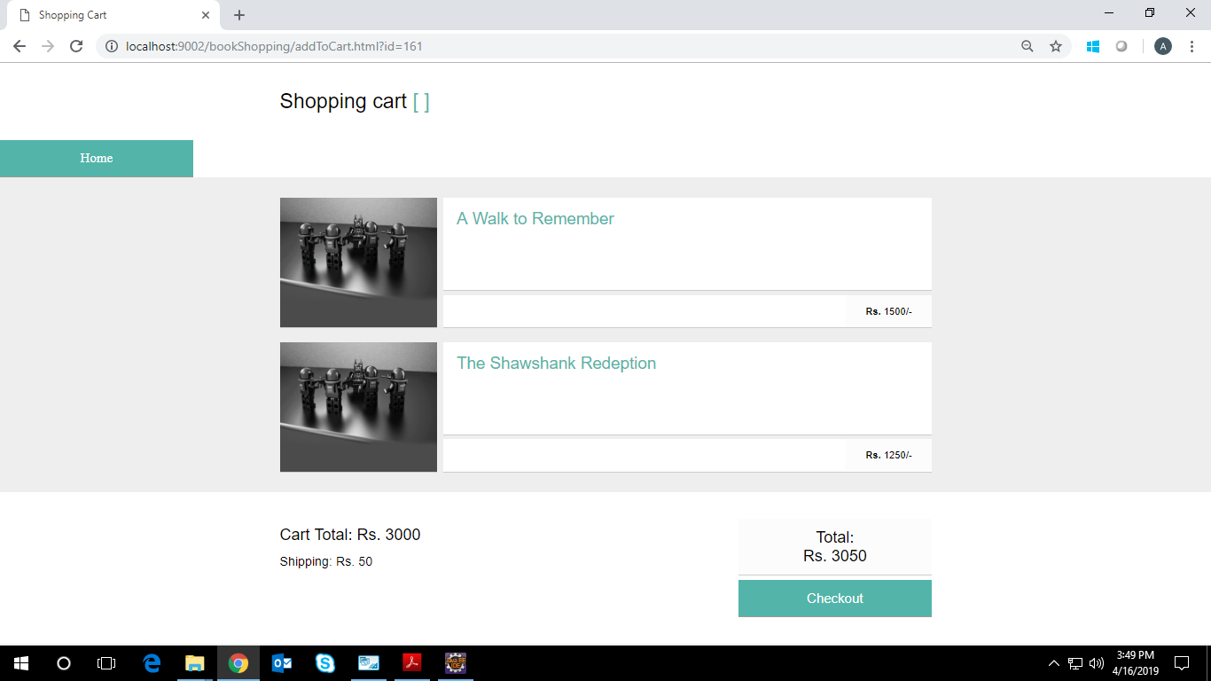

## Use case ‘Payment Page’

### Use case attributes

**Use Case Description:**

This use case deals with the ability of the user to pay the bill listed against the order. The ‘user’ here shall be the operator of the system and will be keying in the bill payment details.

**Scope:** Bill Payment

**Actors:**

* User – the operator

**Trigger:**

Click ‘Checkout’ button in the page.

**Pre-Condition:**

User being able to access the cart & get redirected to the ‘payment’ page upon clicking against ‘checkout’ button.

**Post Condition:**

User is in the payment page & after filling payment credentials, pays the bill by clicking on ‘checkout’ button.

**Flow of Events:**

User at login page 🡪 Click ‘login’ button 🡪 User at home page->books added to cart

🡪manage quantity and price of book🡪 Click ‘checkout’ button->User at payment page🡪 fill payment credentials🡪Click ‘checkout’ button 🡪 Message of successful or unsuccessful order is displayed.

**Primary Scenario:**

A user – is able to fill all valid payment credentials and click ‘checkout’ button for successful order.

**Business Rules:**

Business rules should be defined using the following attributes: -

* + - User needs to fill all valid payment credentials.
* Details of payment is mentioned below in requirement: Full Name, Email, Address, City, State, Zip Code, Accepted cards, Name on Card, Card Number, Exp month, Exp year and CVV.
* Post-successful payment, the corresponding entries are saved to the database.
* Thereafter message of successful or unsuccessful order will be displayed.

### UI Requirements

Here is a prototype of Payment Page with checkout button -

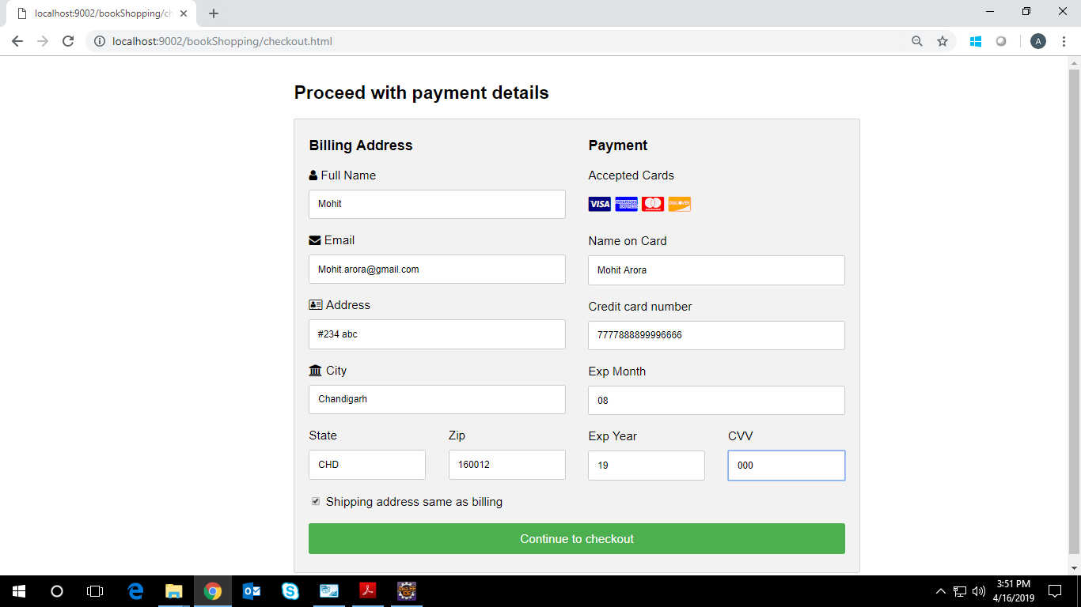

### UI Field Validations

Please refer to the below requirements for field level validations:

* All fields are mandatory.
* The Email ID format must be checked.
* Credit Card Number should not be more than 16 digits.

## Use case ‘Admin Home Page’

### Use case attributes

**Use Case Description:**

This use case deals with the management of books available. The ‘admin’ here will be the operator of the system and will be either adding the book or viewing or removing the book.

**Scope:**

* Adding new books to the database for user as well as view and removal of books.

**Actors:**

* Admin– the operator

**Trigger:**

Click ‘add book’ or ‘view/remove’ in Admin home page.

**Pre-Condition:**

User should be able to get redirected to the ‘Admin Home Page’ upon clicking the login button on the admin login page.

**Post Condition:**

Admin is in the Admin home page & add or view or remove book to the database.

**Flow of Events:**

Admin at admin login page🡪click ‘login’ button🡪admin redirected to admin home page🡪

Click ‘add book’ link🡪fill all book details🡪click ‘add book’ button to add new book.

Admin at admin login page🡪click ‘login’ button🡪admin redirected to admin home page🡪

Click ‘view/remove’ link🡪view or delete book details🡪redirected to admin home page again.

**Primary Scenario:**

Admin – is able to add details of book as well as view or remove book from the available list.

Here is a prototype on how the admin home page should look like.

### Business Rules

Business rules should be defined using the following attributes: -

* When the user clicks on the ‘add book’ link, it should re-direct to page where details to be filled.
* Details of book to be filled as below in requirement: Category, Book Id, Book Name, Book Price, Availability, Binding, Language, Author Name, Publisher Name, Delivery Date.
* Clicking ‘add book’ button should add that book to the database which is accessed by user later.
* User is able to view details of book or remove book details from the database.
* Post-successful addition or deletion of book, save the information in the database.

### UI Requirements

Here is a prototype on how the admin home page should look like.

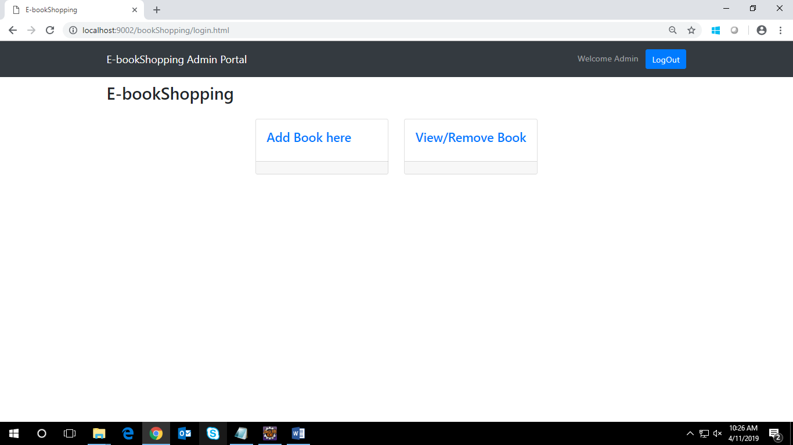

### UI Field Validations

Please refer to the below requirements for field level validations:

* All fields are mandatory.
* The price format must be checked.
* The availability format should be checked

# Database Design

## Tables Structure

**User Registration Details:**

|  |  |  |  |
| --- | --- | --- | --- |
| **Column Name** | **Data Type** | **Length** | **Nulls** |
| firstName | varchar | 255 | N |
| lastName | varchar | 255 | N |
| age | varchar | 255 | N |
| gender | varchar | 255 | N |
| conatctNumber | varchar | 255 | N |
| emailId | varchar | 255 | N |
| password | varchar | 255 | N |

**User/Admin Login Details:**

|  |  |  |  |
| --- | --- | --- | --- |
| **Column Name** | **Data Type** | **Length** | **Nulls** |
| emailId | varchar | 255 | N |
| password | varchar | 255 | N |

**Book Details:**

|  |  |  |  |
| --- | --- | --- | --- |
| **Column Name** | **Data Type** | **Length** | **Nulls** |
| bookId | varchar | 255 | N |
| bookName | varchar | 255 | N |
| authorName | varchar | 255 | N |
| availability | varchar | 255 | N |
| binding | varchar | 255 | N |
| catName | varchar | 255 | N |
| DeliveryDate | datetime | - | N |

**Book Add to Cart Details:**

|  |  |  |  |
| --- | --- | --- | --- |
| **Column Name** | **Data Type** | **Length** | **Nulls** |
| cartId | int | 11 | - |
| bookName | varchar | 255 | N |
| price | varchar | 255 | N |
| userId | varchar | 255 | N |