**TVS** 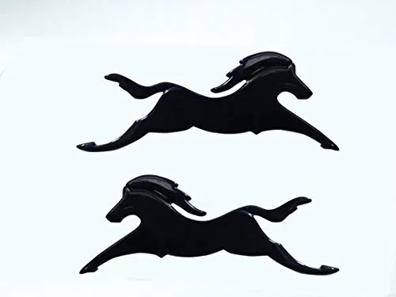K.D.AUTOMOBILES

Trust Value & Service

|  |
| --- |
| ShopNo.4,5,9,10, Nayanakash Tower, Ward No.1,  Deep Nagar Hoshangbad Road Mandideep,  Distt Raisen (M.P.)  Mob.: 8962627453  Authorized Dealer of Tvs Two Wheelers |

To: {{ name }}

Phone: {{ phone }}

|  |  |  |  |  |
| --- | --- | --- | --- | --- |
| Qty | Part Number | Description | Unit Price | Line Total |
| {{%tr for item in invoice_list %}} |  |  |  |  |
| {{item[0]}} | {{item[1]}} | {{item[2]}} | {{item[3]}} | {{item[4]}} |
| {{%tr endfor %}} |  |  |  |  |
|  |  |  |  | |  | | --- | | Sub total : {{ subtotal }} | | Gst-IN:{{ salestax }} | | Discount :{{ dis }} | | **Total** : {{ **total** }} | |