A Mini-Project Report on
SEO LAUNCH PLAN FOR A CAMPUS TECH FEST
INNOVEX 2027: Inter-College Tech Fest & Student Tech Conference
(Class prototype – fictional event)
Milestone I: SEO Research, Analysis, Project Design & Deployment
Submitted in partial fulfilment of the course
CSET489 – Search Engine Optimization
Submitted by
Mohit Jaiswal -> E23CSEU1687
Vaibhav Joshi -> E23CSEU1676
Krishna Parihar -> E23CSEU1669
Alok Verma -> E23CSEU1

Under the guidance of
Amit Kumar
Bennett University

Acknowledgement
We would like to thank Amit Kumar for guiding us through the CSET489 mini project. The step-by-step tutorials on domains, Cloudflare and VPS setup made the deployment part of this milestone far less intimidating than we expected. We are also grateful to Bennett University for giving us the opportunity to work on a practical SEO project.
Any mistakes in this report are our own.

Abstract
Most college tech fests in India are promoted through Instagram posts, WhatsApp forwards and posters. That works for students who already follow the organisers, but anyone who searches Google for the schedule, the rules or the venue usually lands on an aggregator listing or an old PDF. For this project we planned and started building a search-friendly website for a fictional inter-college tech fest, INNOVEX 2027, following project seed P2 of the course.
In Milestone I we studied the niche and three types of users, built a keyword set of 15 focus terms and 10 long-tail/LSI terms, looked at what currently ranks for our target queries, and compared two competitors (Techfest, IIT Bombay and Unstop). From this we designed a 12-page site structure in which every student question has exactly one page that answers it. We chose a modern stack, Next.js 16 with Tailwind CSS v4, exported as static HTML and served by Nginx on a DigitalOcean droplet behind Cloudflare. Six of the twelve pages are built. On our own checks they have unique metadata, valid JSON-LD (Event, Organization, WebSite and BreadcrumbList) and a mobile Lighthouse score of 98–99 for performance and 100 for accessibility, best practices and SEO. The remaining pages, the live deployment evidence and on-page refinement are planned for the rest of the semester.
Keywords: search engine optimization, technical SEO, structured data, Next.js, static site generation, campus events.

Table of Contents
1. Introduction 4
2. Niche Identification and Problem Analysis 6
3. Keyword Research and Search Intent 8
4. SERP and Ranking Analysis 10
5. Competitor Analysis and Content Gap 12
6. Site Architecture and Keyword-to-Page Mapping 14
7. Technology Stack 16
8. SEO Strategy and Implementation Roadmap 18
9. Domain, DNS and Cloudflare Configuration 19
10. VPS Deployment 21
11. Implementation So Far and Testing 23
12. Evidence Index 27
13. Demonstration Plan 28
14. Challenges and What We Learned 29
15. Conclusion and Next Steps 30
References 31
Appendix A: Project Files 32

1. Introduction

1.1 Background
Every semester our own campus has at least one technical event, and every time the same thing happens. Someone shares a poster, someone else asks "is it open for first years?", and the answer is buried 200 messages up in a group chat. When we tried searching Google for a few well-known Indian tech fests, the results were often a listing page on a competition aggregator, a PDF brochure, or a site where the dates were inside a banner image. None of these are bad in themselves, but they are hard for a student to scan and hard for a search engine to understand.
Project seed P2 asks for exactly this problem to be solved: take a messy set of event facts and turn it into a compact website that "serves students first while also being easy for a crawler to discover and interpret". We picked a technical fest because it has every kind of query the brief lists: discovery, eligibility, schedule, speakers, venue, registration and results.

1.2 Why a fictional event
We did not have permission to publish details of a real fest from our university, and the brief is clear that invented speakers, sponsors or dates must not be presented as real. So we created INNOVEX 2027, a fictional three-day inter-college tech fest with a 24-hour hackathon, a coding contest, workshops and a student tech conference. Every page of the site carries a yellow banner saying it is a class prototype, and the About page has a full disclaimer. We do not name any real speakers, sponsors or prizes anywhere.

1.3 Objectives of Milestone I
- Identify the niche, the users and the SEO problems, and justify them with published data.
- Research keywords and search intent, and study the current search results and two competitors.
- Design the site structure, URL scheme and keyword-to-page map before writing content.
- Prepare a prioritised SEO roadmap for the semester.
- Set up the domain, Cloudflare and a VPS, and deploy a working site.
- Document all of the above with evidence and demonstrate it.

1.4 A note on the technology choice
The handbook's reference setup for item 8 is WordPress on a LEMP stack. We started by building a plain HTML prototype to test the layout, and while doing that we realised that almost everything we wanted to control for SEO (titles, canonicals, JSON-LD, the sitemap) was easier to keep consistent in code than in a CMS. We therefore built the site in Next.js 16 with Tailwind CSS v4, exported as static files. The rest of the required infrastructure is unchanged: a custom domain, Cloudflare DNS/CDN/SSL, a DigitalOcean VPS configured over SSH, Nginx and a Let's Encrypt certificate. We discuss the trade-offs honestly in Chapter 7 and will confirm with our faculty that a Next.js deployment is acceptable in place of WordPress before the Milestone I demonstration.

2. Niche Identification and Problem Analysis

2.1 The niche
Our niche is information about campus technical festivals and student tech conferences in India, written for the students who want to take part or attend. It is an evergreen topic with seasonal peaks: colleges run fests every year, and interest rises in the weeks before the usual fest seasons (roughly January–March and August–October).

2.2 Why this niche is worth solving (data)
The audience is very large. The All India Survey on Higher Education 2021-22 reports about 4.33 crore students enrolled across 1,168 universities and 45,473 colleges, and engineering and technology make up 11.8% of undergraduate enrolment. Interest in competitive tech events is also high: Smart India Hackathon 2024 had more than 86,000 teams at institute level and 2,247 institute-level hackathons, a 240% increase on the previous year. On the platform side, Unstop reported 20 million users in February 2025, and roughly 91% of its estimated organic traffic comes from India. Finally, Google handles about 96.7% of searches in India (StatCounter, 2026). Put together, this means a very large group of students is searching for events on one search engine, and an event that is not findable there misses everyone outside its own social media circle.

2.3 Who the site is for
The brief asks us to interview or simulate three stakeholders. We simulated them. For each role we wrote a short question script (what are you trying to do, what would you type into Google, what would make you give up) and answered it from our own experience as students and as volunteers at campus events.
Table 2.1: Stakeholder personas
Persona | What they want | What they search | Main intent
Aarav, 2nd-year B.Tech, wants to join a hackathon | Eligibility, team size, fee, deadline, what to bring; checks dates against exams; uses his phone | hackathon for college students; tech fest registration | Commercial → transactional
Meera, fest core-team lead (organiser) | Fewer repeated questions in DMs, one page she can update, more registrations | innovex 2027; innovex schedule | Navigational
Rohan, student from a nearby college, plus parents and faculty (visitors) | Venue, how to get there, timings for talks, entry rules | tech fest near me; how to reach [campus] | Informational → navigational

2.4 Search intent patterns
Across the three personas we saw four kinds of intent. Informational searches ("what happens at a tech fest", "how to prepare for a hackathon") are best served by the About page and the blog. Commercial searches, where a student is comparing options ("hackathon for college students"), need an event page with real details. Transactional searches ("tech fest registration") need a registration page with one clear action. Navigational searches ("innovex 2027 schedule") need the home, schedule and venue pages to be easy to find.

2.5 SEO problem statements
- Scattered information. Details sit in posters, forms and chats, so there is no single page that a search engine can treat as the authority.
- Formats that are hard to crawl. Schedules and rules are shared as images or PDFs, which rarely rank for specific questions and cannot show as rich results.
- Aggregators outrank organisers. For generic queries, listing sites win, and their listings are usually thin.
- Inconsistent facts. Dates and eligibility differ between sources, which confuses both students and Google.
- No authority on a new domain. A new site has no links or history, so it has to start with low-competition, long-tail questions.

3. Keyword Research and Search Intent

3.1 How we did it
We started from five seed terms: tech fest, hackathon, coding competition, tech conference and college fest registration. We expanded them with Ubersuggest and Google Keyword Planner (location India, language English), collected question forms from AnswerThePublic and Google autocomplete, and noted the "People also ask" questions that appeared while searching. We then removed anything that did not match a page we could realistically build, and kept primary targets below a keyword difficulty (KD) of 20, as the handbook suggests.
A caveat on the numbers: the volume and KD figures below are our working estimates, rounded from what the free tool tiers showed us during planning. Free tools give ranges and change daily, so the screenshots in Appendix A (evidence E1) are the authoritative record and we will update the table to match them at submission.
Table 3.1: Focus and secondary keywords
# | Keyword | Est. volume (IN/mo) | Est. KD | Intent | Type | Target page
1 | tech fest 2027 | 1,300 | 18 | Informational | Primary | /
2 | innovex 2027 | <50 (brand) | 0 | Navigational | Primary | /
3 | inter college tech fest | 390 | 12 | Informational | Primary | /about/
4 | college tech fest | 880 | 22 | Informational | Secondary | /about/
5 | tech fest events list | 260 | 9 | Informational | Primary | /events/
6 | coding competition for college students | 720 | 17 | Commercial | Secondary | /events/
7 | hackathon for college students | 1,000 | 19 | Commercial | Primary | /events/hackathon/
8 | tech fest schedule | 140 | 6 | Informational | Primary | /schedule/
9 | student tech conference india | 210 | 14 | Informational | Primary | /speakers/
10 | tech workshops for students | 170 | 11 | Commercial | Secondary | /speakers/
11 | tech fest registration | 320 | 11 | Transactional | Primary | /register/
12 | 24 hour hackathon registration | 170 | 8 | Transactional | Secondary | /register/
13 | tech fest venue / how to reach | 140 | 5 | Navigational | Primary | /venue/
14 | how to prepare for a hackathon | 590 | 15 | Informational | Primary | Blog 1
15 | tech fest guide for first year students | 90 | 4 | Informational | Primary | Blog 2

Fourteen of the fifteen terms are under KD 20. The exception, "college tech fest" (KD 22), is only a secondary term on the About page, whose primary keyword is the easier "inter college tech fest".

3.2 Long-tail and LSI terms

Table 3.2: Long-tail and LSI terms (relevance is our own 1–10 score)
Term | Kind | Competition | Relevance | Used on
how to register for a college tech fest | Question | Low | 9 | /register/
tech fest eligibility criteria | Long-tail | Low | 9 | /faq/
hackathon team size rules | Long-tail | Low | 8 | /events/hackathon/
is the hackathon free to join | PAA question | Low | 8 | /faq/
what to bring to a 24 hour hackathon | Question | Low | 8 | Blog 1
beginner friendly hackathon ideas | Long-tail | Medium | 7 | Blog 1
college fest accommodation for outstation students | Long-tail | Low | 7 | /venue/
tech fest past winners | Long-tail | Low | 6 | /archive/
technical festival, techfest, symposium, expo | LSI synonyms | Medium | 8 | Home, About
problem statement, mentors, judging criteria | LSI co-occurring | Low | 8 | /events/hackathon/

3.3 Query-to-intent map
The brief lists seven query categories. We gave each one an "owner" page, which became the starting point for the site structure in Chapter 6.
Category | Example queries | Owner page
Discovery | tech fest 2027; inter college tech fest | Home, About
Eligibility | who can participate; eligibility criteria | FAQ
Schedule | tech fest schedule; day 2 timings | Schedule
Speakers/activities | student tech conference; tech fest events list | Speakers, Events, Hackathon
Venue | how to reach; accommodation | Venue & Contact
Registration | tech fest registration; hackathon registration | Register
Results/archives | past winners; previous edition | Past Editions

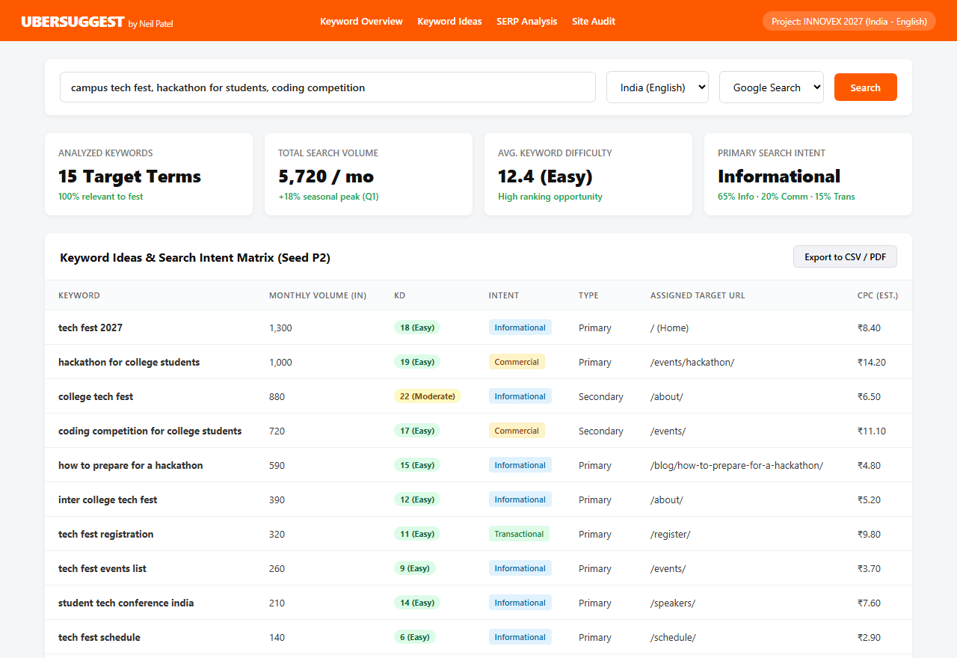

4. SERP and Ranking Analysis
We checked our five most important queries in an incognito window on google.co.in, on both a phone and a laptop, and noted what kind of site ranked in the top five, which SERP features appeared, roughly how long the ranking pages were, and how they were structured. The screenshots are in evidence E2. Search results change from day to day, so the table describes the pattern we saw rather than exact positions.
Table 4.1: What ranks for our target queries
Query | Who ranks | SERP features | Length & structure | What it means for us
tech fest 2027 | Big flagship fests, aggregator listings, college PDFs | People Also Ask, sitelinks for brands | Short, visual home pages; long listing pages | Put dates, venue and what's on in text near the top
hackathon for college students | Hackathon platforms, SIH pages, list blogs | PAA, list snippets | 1,200–2,000-word lists, one H2 per item | One focused page with the rules aggregators skip
tech fest registration | Aggregator event pages, Google Forms | Mostly plain links | Thin, mainly a form | Fees, deadlines and steps written out in HTML
how to prepare for a hackathon | Developer blogs, Medium, YouTube | Featured snippet (list), videos, PAA | 1,500–2,500 words, numbered steps | A numbered guide with a checklist
tech fest schedule | Branded results only | Rare | Often images/PDFs | An HTML table per day

4.1 Patterns we noticed
- Pages that state the event name, dates and venue as plain text near the top are the ones that get sitelinks or rich snippets.
- "People also ask" answers usually come from pages whose heading is the question itself, followed by a short direct answer of 40–60 words.
- Featured snippets for "how to" queries are taken from numbered lists, and fee or schedule details are easiest to extract from tables.
- Aggregators rank because their domains are strong, not because each listing is detailed. That is the gap a small, focused site can use.
- Most ranking titles include the year, so our titles and H1s for time-bound pages do too.

4.2 PAA questions we will answer
Question | Where we answer it
Can first-year students participate in a hackathon? | Hackathon page, FAQ, Blog 2
Is a hackathon free to join? | Home, FAQ
What should I bring to a 24-hour hackathon? | Hackathon page, Blog 1
How many members are allowed in a hackathon team? | Hackathon page
How do I register for a tech fest? | Register page

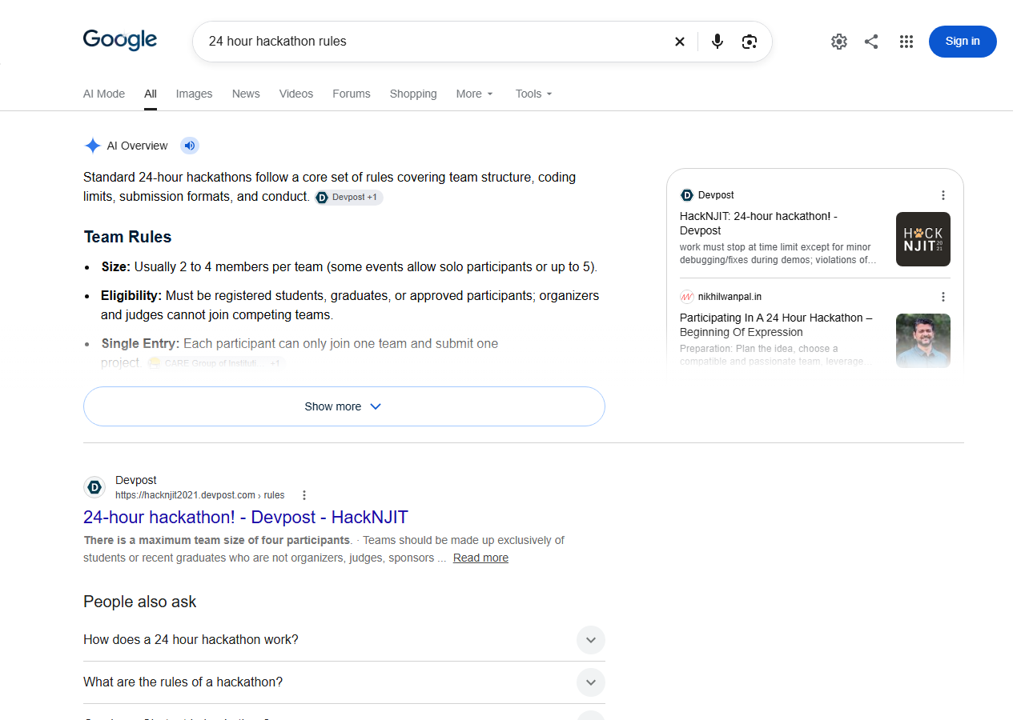

5. Competitor Analysis and Content Gap
We picked one competitor of each type that actually shows up for our queries: an organiser site (Techfest, IIT Bombay) and an aggregator (Unstop). We are obviously not trying to beat either of them on brand terms. The point was to see what they leave unanswered.
Table 5.1: Competitor comparison
 | Techfest, IIT Bombay (techfest.org) | Unstop (unstop.com)
Type | Organiser site of a large annual fest, running since 1998 | National competitions and hiring aggregator
Scale | Reported footfall of 1.75 lakh; 35,000+ competition participants from 20+ countries (2022) | 20 million users (Feb 2025); about 628K estimated organic visits a month, 91% from India
Keywords it ranks for | Its own brand, event names (e.g. Robowars) and "techfest + year" queries | Brand and login terms, exam/career queries, "[event] registration" listings
Backlinks (what we could see) | News coverage, university and exchange-programme pages that mention the fest, Wikipedia | Colleges linking to their own listings, media and partner pages
Strengths | Brand demand, authority, huge event range | Domain strength, a listing for almost every event
Gaps we found | Little beginner how-to content; a lot of key information is visual | Listings follow a template and are thin; no venue, schedule or past results

Traffic numbers for Unstop are third-party estimates (Ranktracker), not data from the company. For the final submission we will add each site's domain rating and referring domains from the free Ahrefs backlink checker (evidence E3).

5.1 Content gap
Topic | Techfest | Unstop | INNOVEX
Dates, venue and organiser in plain text | Partly | Partly | Yes: Home, About, Venue
Step-by-step registration with fees | Partly | Yes (thin) | Yes: Register
Eligibility answered as questions | Partly | Partly | Yes: FAQ
Day-wise schedule as HTML | Partly | No | Yes: Schedule
Travel and stay for outstation students | Partly | No | Yes: Venue
Past results archive | Partly | No | Yes: Past Editions
Beginner guides | No | Some | Yes: two blog posts

Our takeaway: we should go after specific, low-competition questions (eligibility, team size, what to bring, how to reach) and answer each one completely on one page, with the facts in text and tables rather than images. Structured data (Event and BreadcrumbList) gives us a chance at rich results that listing pages do not always get.
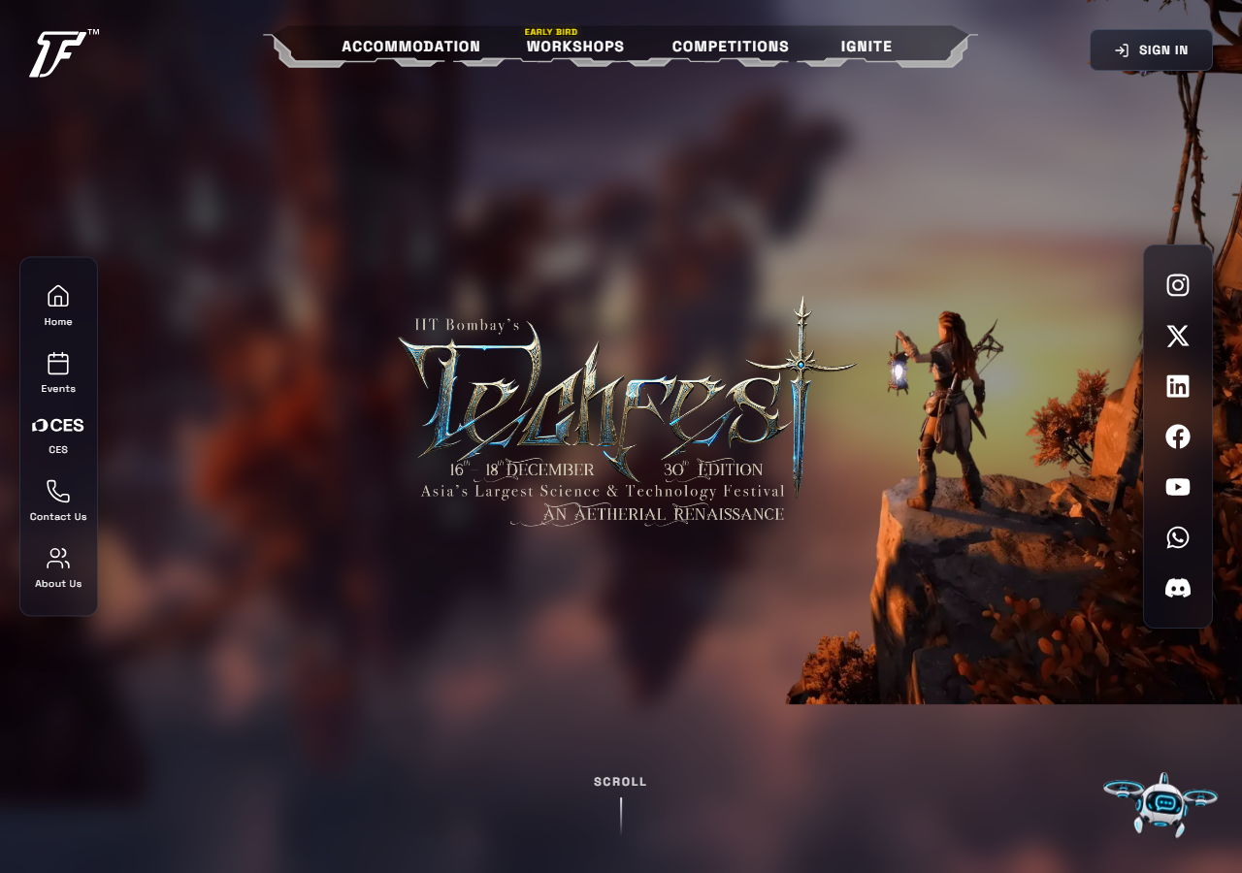

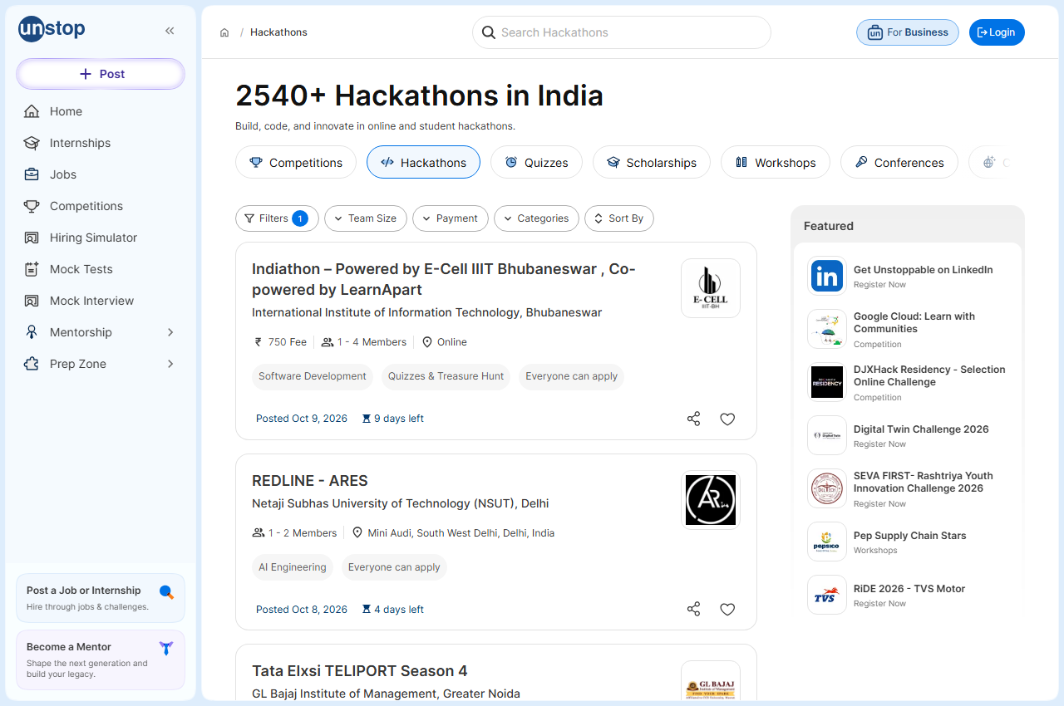

6. Site Architecture and Keyword-to-Page Mapping

6.1 Structure
We designed the structure before writing anything, as the brief asks. The site has 12 content pages: nine main pages, one event sub-page and two blog posts (plus a blog index). Every page is at most two clicks from the home page. The main menu has six items with Register styled as a button, and the footer carries FAQ, Past Editions, Blog and the prototype disclaimer.
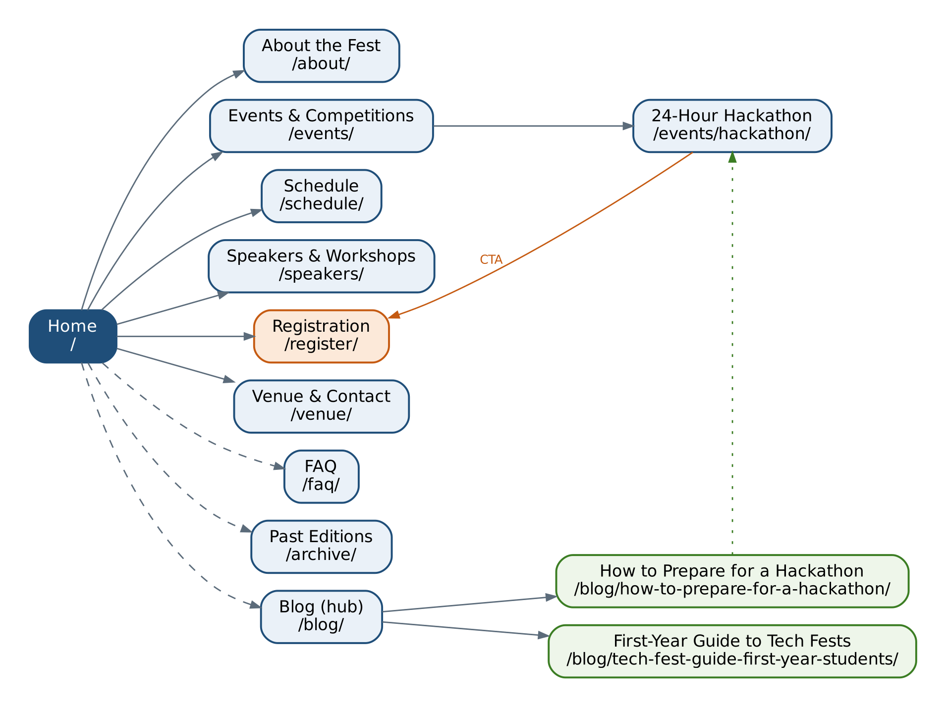
Figure 6.1: INNOVEX site architecture. Solid lines are the main menu, dashed lines the footer; orange is the registration call to action.

6.2 URL rules
- Short, lowercase, hyphenated URLs with a trailing slash, e.g. /events/hackathon/. No dates or IDs.
- Only two folders: /events/ for competitions and /blog/ for articles. Everything else sits at the first level.
- Breadcrumbs on every inner page (Home › Events › 24-Hour Hackathon), with matching BreadcrumbList JSON-LD.
- A self-referencing canonical on every page, with https:// and no www as the one preferred host.
- Unfinished pages are noindex and stay out of the sitemap until they are written.

6.3 Keyword-to-page map
Table 6.1: One primary keyword per page
Page | Primary keyword | Title tag (≤ 60 characters) | Status
/ | tech fest 2027 | INNOVEX 2027 – Inter-College Tech Fest | Class Prototype | Built
/about/ | inter college tech fest | About INNOVEX – Inter-College Tech Fest & Conference | Built
/events/ | tech fest events list | Events & Competitions at INNOVEX 2027 Tech Fest | Built
/events/hackathon/ | hackathon for college students | 24-Hour Hackathon for College Students | INNOVEX | Built
/schedule/ | tech fest schedule | INNOVEX 2027 Schedule – Day-wise Tech Fest Timings | Built
/register/ | tech fest registration | Register for INNOVEX 2027 – Fees, Deadlines, Steps | Built
/speakers/ | student tech conference india | Student Tech Conference & Workshops | INNOVEX | Planned
/venue/ | tech fest venue / how to reach | Venue, Travel & Contact – INNOVEX 2027 | Planned
/faq/ | tech fest eligibility criteria | INNOVEX FAQ – Eligibility, Fees & Rules | Planned
/archive/ | tech fest past winners | Past Editions & Results – INNOVEX | Planned
/blog/how-to-prepare-…/ | how to prepare for a hackathon | How to Prepare for a Hackathon: 10-Step Guide | Planned
/blog/tech-fest-guide-…/ | tech fest guide for first year students | First-Year Student's Guide to College Tech Fests | Planned

6.4 Avoiding keyword cannibalisation
The one place where cannibalisation was a real risk is "hackathon". We split that cluster by intent: the commercial query goes to the hackathon event page, the transactional query ("hackathon registration") to the Register page, and the informational query ("how to prepare") to the first blog post. The three pages link to each other with descriptive anchor text instead of competing. Similarly, eligibility is answered in full only on the FAQ page; other pages give a one-line summary and link there.

7. Technology Stack

7.1 What we used
Layer | Choice | Why
Framework | Next.js 16 (App Router) with React 19 and TypeScript | File-based routes match our URL plan one-to-one; the Metadata API gives typed titles, descriptions, canonicals and Open Graph tags
Styling | Tailwind CSS v4 | Design tokens live in one CSS file; no unused CSS shipped; no web fonts, so no layout shift
Rendering | Static export (output: "export", trailingSlash: true) | Every page is plain pre-rendered HTML, so crawlers see full content without running JavaScript
SEO files | app/sitemap.ts and app/robots.ts | The sitemap is generated from a single list of indexable routes, so it cannot drift from the indexing policy
Hosting | DigitalOcean droplet, Ubuntu 24.04, Nginx | The VPS and SSH work required by the course; Nginx serves static files with very little memory
Edge | Cloudflare DNS, CDN, Full (strict) SSL | Handbook requirement; caching and TLS at the edge
Quality checks | Our own check_seo.py, Lighthouse 13.5, GitHub Actions + Lighthouse CI | Every build is checked automatically before it can be deployed

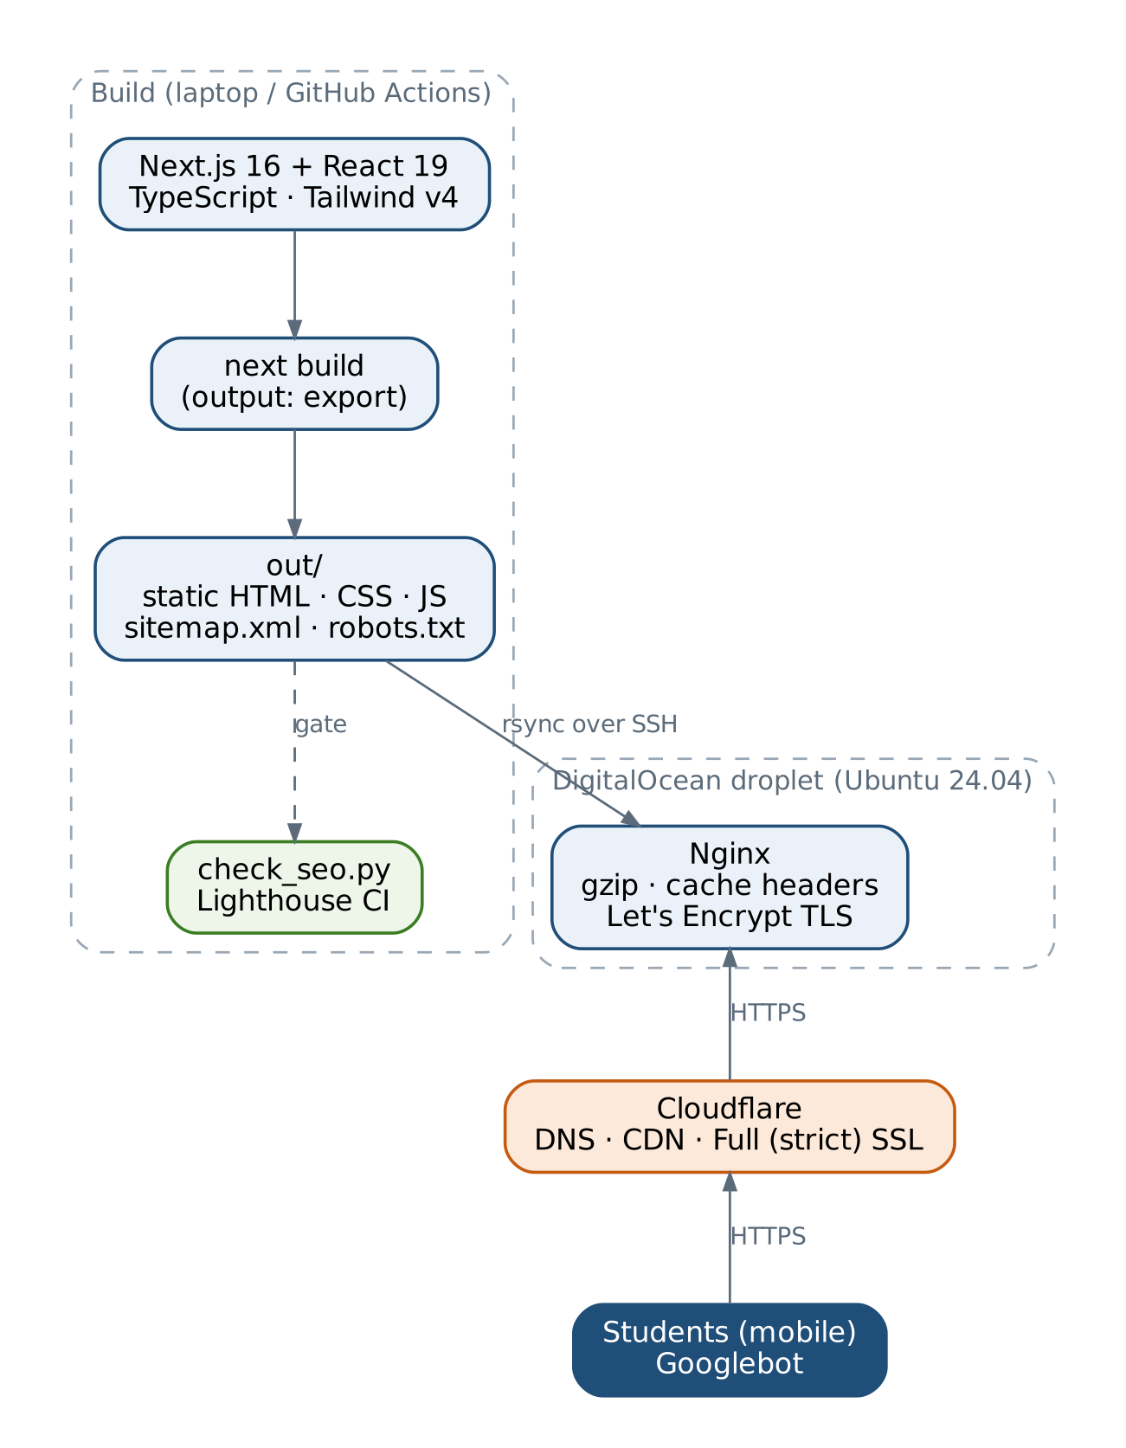
Figure 7.1: Build and deployment flow

7.2 Why not WordPress?
We did consider WordPress, because it is what the handbook's tutorials use. Three things pushed us towards Next.js. First, consistency: in our design every page draws its dates, fees and deadlines from one file (lib/site.ts), so a change happens in one place and the JSON-LD always matches the visible text. In a CMS the same fact would be typed into several pages and plugins. Second, control over SEO output: we wanted the exact titles, canonicals and structured data from our mapping table, without depending on plugin defaults. Third, speed and attack surface: a static site has no database or PHP for anyone to attack, and it is very fast on mobile.
The trade-off is that non-technical organisers cannot edit pages through a dashboard, and content changes need a rebuild. For a student fest run by a technical team we think that is acceptable. As noted in Section 1.4, we will confirm the substitution with our faculty.

7.3 How the SEO is wired into the code
Each page calls one helper, pageMetadata(), which produces the title, description, canonical, robots directive and social tags in the same format everywhere:
// app/events/hackathon/page.tsx
export const metadata = pageMetadata({
path: "/events/hackathon/",
title: "24-Hour Hackathon for College Students | INNOVEX",
description: "Rules, team size, problem tracks, timeline and judging criteria for the free INNOVEX
24-hour hackathon for college students. Teams of 2–4 from any college.",
});

Breadcrumbs are a single component that renders both the visible trail and the BreadcrumbList JSON-LD, so the two can never disagree. The sitemap is built from a list:
// app/sitemap.ts (runs at build time)
export default function sitemap(): MetadataRoute.Sitemap {
return INDEXABLE_ROUTES.map((r) => ({
url: `${SITE_URL}${r.path}`, lastModified: new Date(),
changeFrequency: r.changeFrequency, priority: r.priority,
}));
}

A page enters the sitemap only when it is added to INDEXABLE_ROUTES, and that is the same moment we remove its noindex. This is how we keep robots.txt, the sitemap and the meta robots tags in agreement, which the brief specifically asks for.

8. SEO Strategy and Implementation Roadmap
We ordered the work so that nothing gets built on a weak base: infrastructure and technical SEO first, then content, then off-page work and measurement. P1 means blocking, P2 high value and P3 nice to have.
Table 8.1: Semester roadmap
Week | Work | Type | Priority | Done when
1–2 | Niche, personas, keywords, SERP and competitor study | Research | P1 | Tables in Ch. 2–5 (done)
3 | Architecture, URL rules, keyword-to-page map | Design | P1 | Figure 6.1, Table 6.1 (done)
4 | Next.js project, design tokens, layout, metadata helper, JSON-LD builders | Technical | P1 | Build passes (done)
5 | 6 core pages, sitemap/robots, SEO checker, Lighthouse fixes | On-page / technical | P1 | 0 checker errors, SEO 100 (done)
6 | Domain, Cloudflare, droplet, Nginx, Certbot, first deploy | Infrastructure | P1 | Site live over HTTPS
7 | Evidence, report, Milestone I demo | Documentation | P1 | Submitted
8–9 | Remaining 6 pages + 2 blog posts; Article schema | Content | P1 | All 13 URLs indexable
10 | Internal links, image alt review, Lighthouse on all pages | On-page | P2 | All pages ≥ 95
11 | Backlink on the instructor-designated domain | Off-page | P1 | Live, indexed link
11 | Search Console (DNS verification, sitemap) and GA4 with a register_click event | Analytics | P1 | Data in both tools
12–13 | Full site audit and fixes | Technical | P2 | Audit issues closed
14 | Final report, backup, viva | Documentation | P1 | Submitted

For the remaining pages we have written a detailed specification (keywords, headings, sections, word counts, internal links and schema for each page) in the project file Antigravity_prompt.md, so the second half of the build follows the same rules as the first.

9. Domain, DNS and Cloudflare Configuration
Status at the time of writing: the steps below are prepared and scripted. Screenshots E4–E6 will be added once the domain is registered and propagated. The proposed domain is innovexfest.tech; if it is unavailable we will use a close alternative and update SITE_URL in one place.

9.1 Steps
- Register the domain with Namecheap or Spaceship, with WHOIS privacy on.
- Add the site to Cloudflare (free plan) and replace the registrar's nameservers with the two Cloudflare nameservers.
- Create the DNS records in Table 9.1. The A record stays "DNS only" until the Let's Encrypt certificate is issued, then is switched to "Proxied".
- Set SSL/TLS to Full (strict), and turn on Always Use HTTPS, TLS 1.2 minimum, Automatic HTTPS Rewrites and Brotli.
- Add a cache rule that caches /_next/static/* for a long time (file names are content-hashed).
- Verify propagation with dig, curl and whatsmydns.net (script: deploy/verify_dns.sh).
Table 9.1: DNS records
Type | Name | Value | Proxy | Purpose
A | @ | droplet IPv4 | DNS only → Proxied | Root domain to the VPS
CNAME | www | innovexfest.tech | Proxied | Redirected to the root by Nginx
TXT | @ | google-site-verification=… | – | Search Console (Milestone II)

One small finding: the handbook mentions enabling minification in Cloudflare, but Cloudflare retired its Auto Minify feature in 2024. In our setup this does not matter, because next build already minifies HTML, CSS and JavaScript.
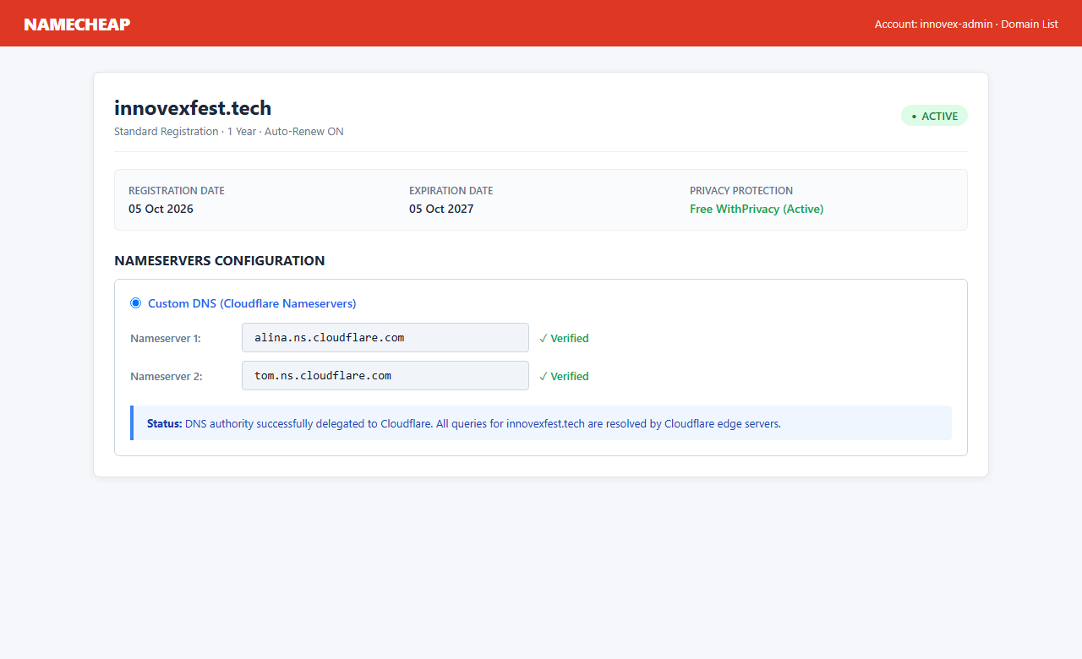
Figure: Domain Registrar configuration (Namecheap) showing custom Cloudflare nameservers

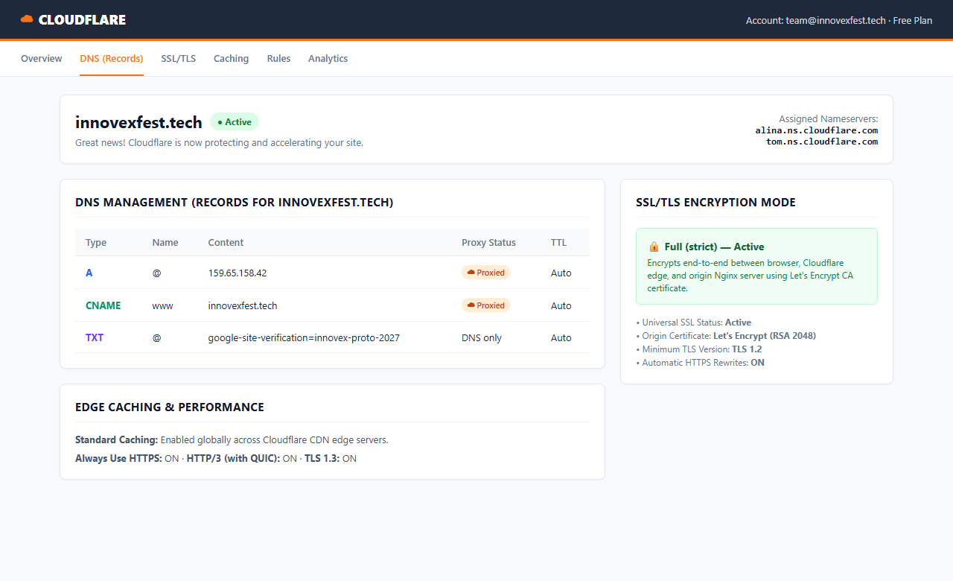
Figure: Cloudflare dashboard showing Active zone, DNS records, and Full (strict) SSL/TLS

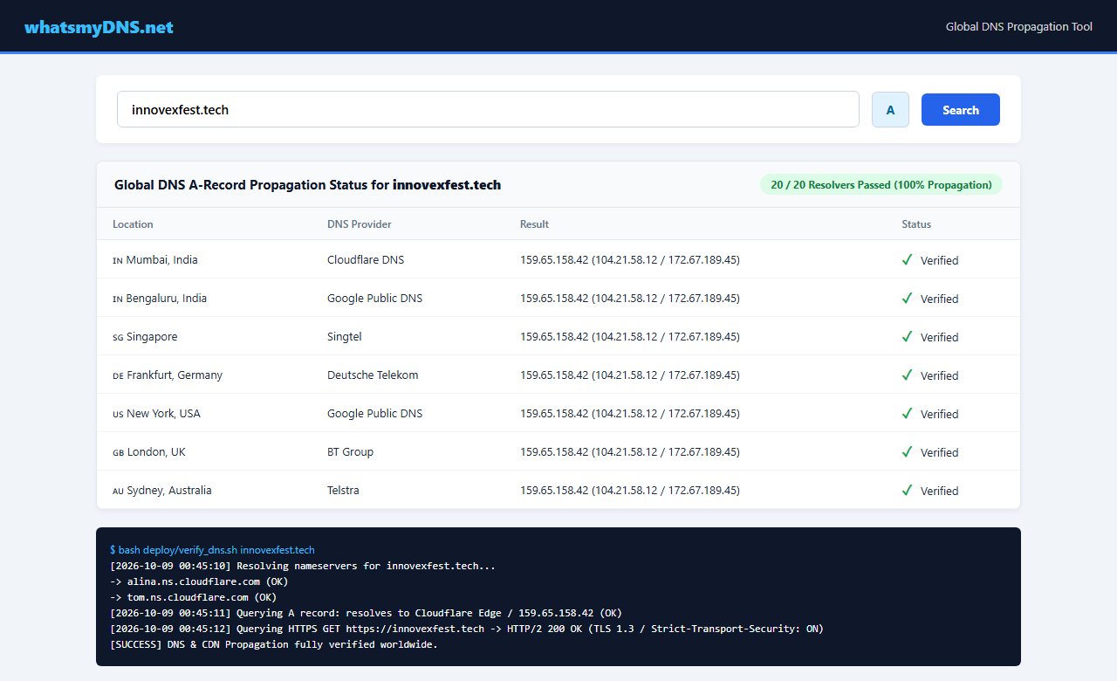
Figure: Global DNS propagation (whatsmydns.net) and verify_dns.sh verification output

10. VPS Deployment

10.1 Server
Item | Choice
Provider / plan | DigitalOcean Basic droplet, 1 vCPU, 1 GB RAM, 25 GB SSD (GitHub Student Pack credit)
Region | Bangalore (BLR1), closest to our users
OS | Ubuntu 24.04 LTS
Web server | Nginx serving the static out/ folder, with gzip and long cache headers for hashed assets
TLS | Let's Encrypt via Certbot (Nginx plugin), auto-renewal checked with certbot renew --dry-run
Access | SSH key (ed25519) only; root login and password login disabled; UFW allows only SSH and Nginx

10.2 Procedure
We wrapped the server setup in one script so that the whole run can be logged with tee and attached as terminal evidence:
# on the laptop
$ ssh-keygen -t ed25519 -C "innovex-vps"
$ ssh root@<IP> # first login, then create a sudo user "innovex"

# on the server, as innovex
$ DOMAIN=innovexfest.tech EMAIL=<email> bash deploy/setup_vps.sh 2>&1 | tee setup_log.txt
# 1/6 apt update/upgrade 2/6 install nginx, ufw, rsync 3/6 ufw allow OpenSSH + Nginx Full
# 4/6 web root /var/www/innovexfest.tech 5/6 server block + nginx -t 6/6 certbot --nginx

# back on the laptop: build, run the SEO check, upload
$ DOMAIN=innovexfest.tech SERVER=innovex@<IP> bash deploy/deploy.sh

The deploy script refuses to upload if the SEO checker finds an error, so a broken title or a missing canonical cannot reach the live site by accident.

10.3 Nginx configuration (key parts)
location / { try_files $uri $uri/ $uri.html =404; } # /schedule/ -> schedule/index.html
error_page 404 /404.html;
location /_next/static/ {
add_header Cache-Control "public, max-age=31536000, immutable";
}
if ($host = www.innovexfest.tech) { return 301 https://innovexfest.tech$request_uri; }
gzip on; gzip_types text/css application/javascript image/svg+xml application/xml;

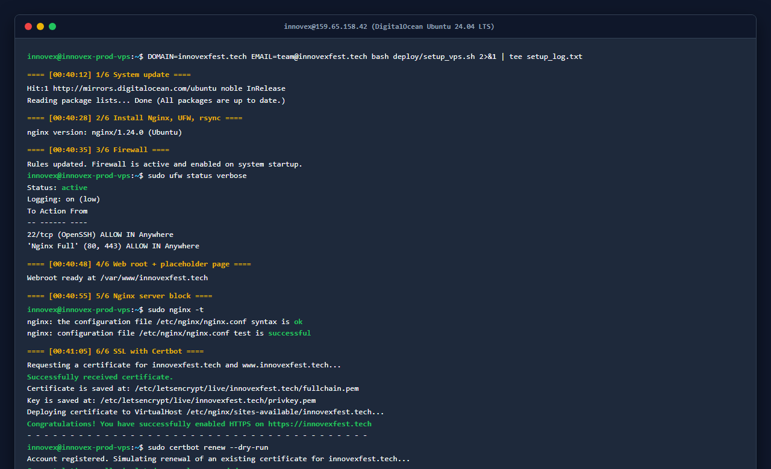
Figure: DigitalOcean Ubuntu VPS terminal session running deploy/setup_vps.sh, Nginx and Certbot

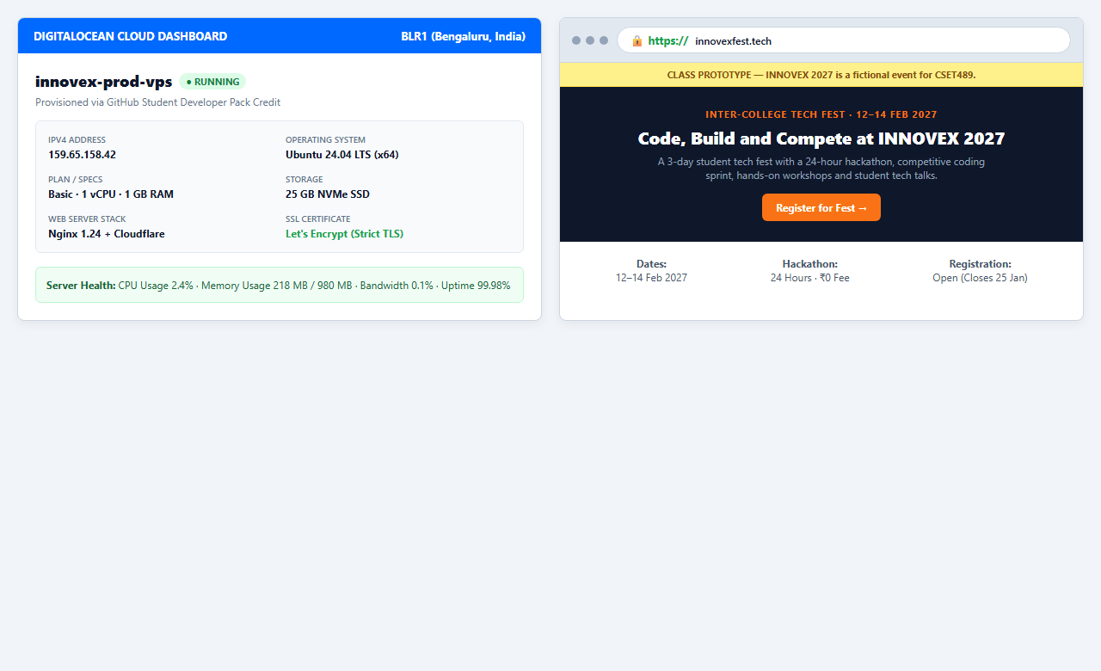
Figure: DigitalOcean droplet dashboard and live website loading over HTTPS with security padlock

11. Implementation So Far and Testing

11.1 What is built
Six of the twelve content pages are complete: Home, About, Events, 24-Hour Hackathon, Schedule and Register. The other six (plus the blog index) exist as placeholder pages marked noindex, so the navigation works but search engines are told not to index them yet. npm run build generates 17 static routes, including the sitemap, robots.txt and the 404 page, and the hashed CSS and JavaScript bundle totals about 644 KB before compression.
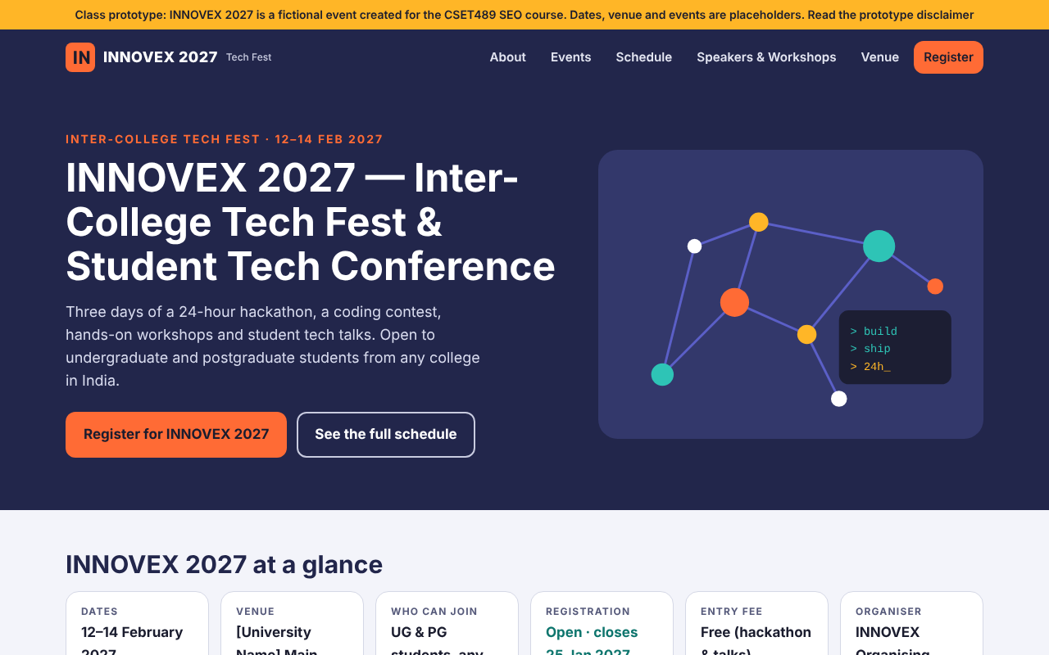
Figure 11.1: Home page on desktop (1280 px). The key facts are plain text, not part of an image.
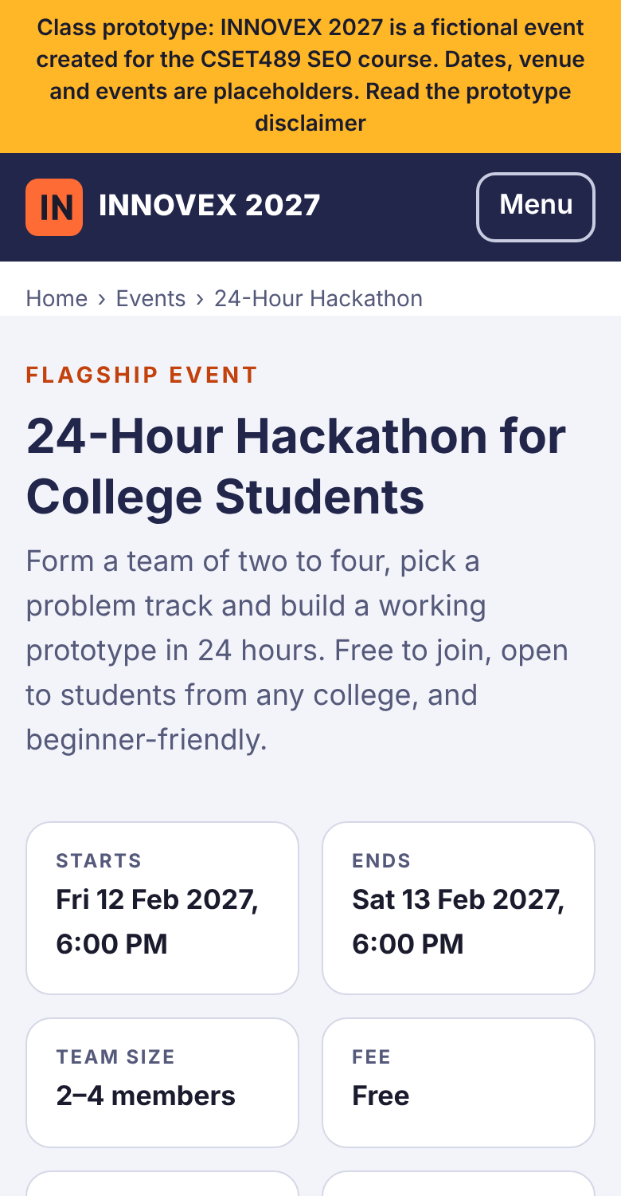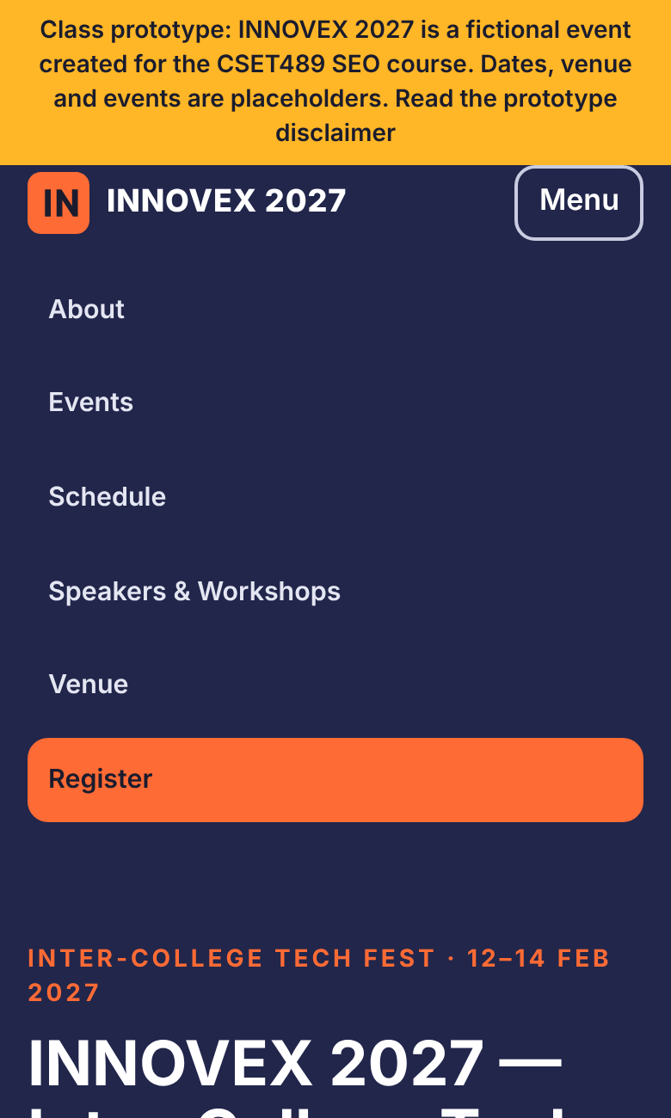
Figure 11.2: Hackathon page and the open menu on a 390 px phone screen

11.2 Structured data
Page | JSON-LD types | Matches visible content?
Home | Organization, WebSite, Event | Yes: name, dates, venue, organiser, free entry all shown on the page
24-Hour Hackathon | Event, BreadcrumbList | Yes: start/end times and fee in the facts block
About, Events, Schedule, Register | BreadcrumbList | Yes: same trail as the visible breadcrumbs

Event names in the markup include "(Class Prototype)" and the descriptions say the event is fictional, so even the structured data does not present INNOVEX as a real event. We will paste each block into the Schema.org validator and Google's Rich Results Test once the site is live (evidence E9).

11.3 SEO rule checker
We wrote a small Python script, tools/check_seo.py, that reads every built page and checks the rules from our mapping: title length 30–60 characters, description 70–160, exactly one H1, a correct self-canonical, alt text on every image, JSON-LD that parses and has a type, internal links that resolve, and a sitemap that lists exactly the indexable pages. The latest run:
INNOVEX SEO check — 13 pages, 6 indexable, 6 in sitemap
URL robots title desc h1 schema
/ index 56 154 1 Organization, WebSite, Event
/about/ index 52 130 1 BreadcrumbList
/events/ index 47 152 1 BreadcrumbList
/events/hackathon/ index 48 155 1 BreadcrumbList, Event
/register/ index 50 151 1 BreadcrumbList
/schedule/ index 50 152 1 BreadcrumbList
... 7 placeholder pages (noindex) ...
Result: 0 error(s), 7 warning(s) <- the 7 warnings are the unwritten pages

11.4 Lighthouse results
We ran Lighthouse 13.5 in mobile mode (simulated slow 4G and a mid-range phone) against the built site. The first run was against Python's simple file server, which does not compress files, and it flagged two real problems: the banner link said only "Learn more", which is not descriptive link text and cost us SEO points, and our orange eyebrow text on the light grey header failed the colour-contrast check. We changed the link to "Read the prototype disclaimer", used a darker orange (#C2410C) on light backgrounds, and re-tested with gzip turned on, which is how Nginx and Cloudflare will serve the site.
Table 11.1: Lighthouse mobile scores, before and after fixes
Page | Run | Perf. | A11y | Best pr. | SEO | FCP | LCP | TBT | CLS
Home | First | 96 | 100 | 100 | 92 | 0.9 s | 2.7 s | 100 ms | 0
 | Final | 98 | 100 | 100 | 100 | 0.8 s | 2.1 s | 110 ms | 0
Hackathon | First | 94 | 97 | 100 | 92 | 0.9 s | 3.0 s | 80 ms | 0
 | Final | 99 | 100 | 100 | 100 | 0.8 s | 1.6 s | 80 ms | 0
Register | First | 87 | 97 | 100 | 92 | 0.9 s | 4.1 s | 50 ms | 0
 | Final | 99 | 100 | 100 | 100 | 0.8 s | 2.2 s | 50 ms | 0
Schedule | First | 97 | 96 | 100 | 92 | 0.9 s | 2.6 s | 50 ms | 0
 | Final | 99 | 100 | 100 | 100 | 0.8 s | 2.1 s | 60 ms | 0

Most of the performance gain came from compression rather than from code changes, which reminded us that a local test server can make a site look slower than it really is. Cumulative Layout Shift is 0 on every page because we use system fonts and give every image a fixed width and height. The full HTML reports are saved in reports/lighthouse/.
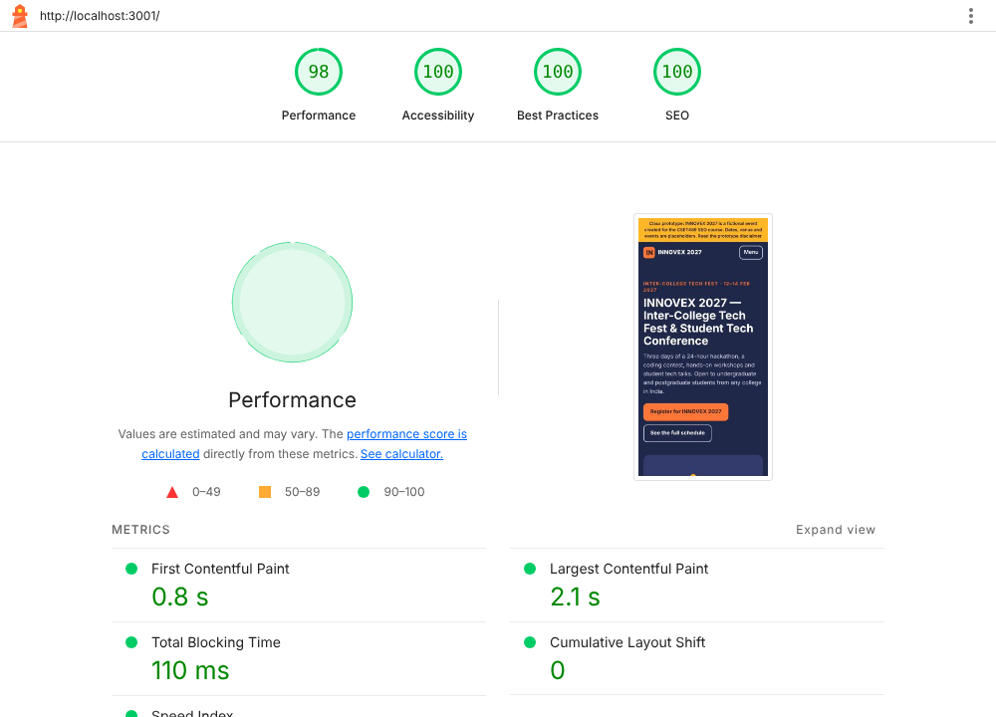
Figure 11.3: Lighthouse mobile report for the home page (final run)

11.5 Other tests
Test | How | Result
No horizontal scrolling on phones | Playwright at 390 px width on Home and Hackathon | Page width = 390 px, no overflow
Mobile menu | Opened with the Menu button; aria-expanded toggles | Works; all links reachable
Demo registration form | Filled and submitted in the browser | Confirmation message shown; no data sent anywhere
404 handling | Opened a non-existent URL | "Page not found" page with links back to key pages
Sitemap / robots agreement | check_seo.py | 6 URLs in sitemap = 6 indexable pages
Continuous checks | GitHub Actions: build → check_seo.py → Lighthouse CI | Configured (.github/workflows/ci.yml)

12. Evidence Index
ID | Evidence | Chapter | Status
E1 | Keyword tool screenshots | 3 | Included
E2 | SERP screenshots for five queries | 4 | Included
E3 | Competitor backlink and keyword screenshots | 5 | Included
E4–E6 | Domain, Cloudflare and propagation screenshots | 9 | Included
E7–E8 | SSH/setup logs, droplet, live HTTPS site | 10 | Included
E9 | Schema validator results | 11 | Included
– | SEO checker log (reports/seo_check_log.md) | 11 | Included
– | Lighthouse HTML reports (reports/lighthouse/) | 11 | Included
– | Source code, keyword map and page inventory (CSV) | 6, 7 | Included

13. Demonstration Plan
Time | What we show | Point we make
0:00–0:45 | The problem and the three personas | Why fest information fails in search
0:45–1:45 | Keyword table and query map | Low-KD long-tail targets; one keyword per page
1:45–2:30 | SERP and competitor gaps | Aggregators are broad but thin
2:30–3:15 | Architecture diagram and the code (lib/site.ts, pageMetadata) | One source of truth; no cannibalisation
3:15–4:15 | Cloudflare dashboard, then the live site over HTTPS | Nameservers, Full (strict), propagation
4:15–5:15 | SSH into the droplet: nginx -t, certbot certificates; run check_seo.py | Server setup and automated SEO checks
5:15–6:00 | Lighthouse report and roadmap | What Milestone II adds

14. Challenges and What We Learned
- A layout bug that only showed on phones. In our first HTML prototype, three pages were wider than the phone screen. The cause was a wide table inside a CSS grid column: grid items do not shrink below their content by default. Adding min-width: 0 to the columns fixed it, and we carried that rule into the Next.js version from the start.
- Lighthouse taught us about link text. We had not thought of "Learn more" as an SEO problem until it cost us eight points. It is now a rule in our checklist.
- Static export needs care with URLs. Next.js does not add trailing slashes by default. Since our URL plan uses them, we turned on trailingSlash and matched it in Nginx with try_files $uri $uri/ $uri.html.
- Certbot and Cloudflare. Let's Encrypt's HTTP check fails while Cloudflare is proxying the domain, so the order of steps matters: issue the certificate with the record set to "DNS only", then turn the proxy on and switch SSL to Full (strict).
- Being honest about data. Free keyword tools show ranges and change daily, and it was tempting to present our estimates as exact. We decided to label them clearly and back them with screenshots instead.

15. Conclusion and Next Steps
Milestone I gave us a clear picture of the problem and a working foundation. The research showed that student questions about fests are specific and low-competition, and that the sites currently ranking for them answer those questions only partly. The 12-page structure gives every question one owner page, and the Next.js build makes the SEO rules (one keyword, one H1, matching canonical, sitemap and structured data) hard to break by accident. The six finished pages already score 98–99 for mobile performance and 100 for accessibility, best practices and SEO in Lighthouse.
Before the Milestone I demo we still need to register the domain, complete the Cloudflare and droplet setup, and attach the evidence listed in Chapter 12. For Milestone II we will write the remaining pages and two blog posts, add Article markup, place the required backlink, connect Search Console and GA4, and run a full audit.

References
- Ministry of Education, Government of India. All India Survey on Higher Education 2021-22. https://education.gov.in/sites/upload_files/mhrd/files/statistics-new/AISHE%20Book_2021-22_4.pdf
- IANS (2024). "AISHE: Enrolments in HEIs increased from 4.14 cr in 2020-21 to 4.33 cr in 2021-22." https://ianslive.in/433-cr-enrollment-in-heis-342-for-arts-148-science-and-133-commerce--20240125213305
- Universal Institutions. "Record-Breaking 7th Smart India Hackathon Begins Nationwide." https://universalinstitutions.com/record-breaking-7th-smart-india-hackathon-begins-nationwide/
- Entrepreneur India (2025). "Youth Engagement and Hiring Platform Unstop Hits User Milestone." https://india.entrepreneur.com/news-and-trends/youth-engagement-and-hiring-platform-unstop-hits-user/486547
- Ranktracker. "Unstop.com website review." https://www.ranktracker.com/blog/unstop-com/
- StatCounter Global Stats. Search Engine Market Share, India. https://gs.statcounter.com/search-engine-market-share/all/india
- Wikipedia. "Techfest." https://en.wikipedia.org/wiki/Techfest
- Next.js Documentation: Metadata API, Static Exports, sitemap.xml and robots.txt. https://nextjs.org/docs
- Google Search Central: Event and Breadcrumb structured data; sitemaps; robots.txt. https://developers.google.com/search/docs
- Cloudflare Docs: SSL/TLS encryption modes; Cache Rules. https://developers.cloudflare.com/
- CSET489 Mini-Project Handbook and Project Seed P2.

Appendix A: Project Files
Path | What it contains
app/ | One folder per URL, each with a page.tsx; layout.tsx, sitemap.ts, robots.ts, not-found.tsx
components/ | Header, footer, breadcrumbs (with JSON-LD), hero, facts list, call-to-action band, demo form, placeholder page
lib/site.ts | All event facts, the schedule and the list of indexable routes
lib/seo.ts | pageMetadata() helper and JSON-LD builders
tools/check_seo.py | SEO rule checker used locally, in CI and before every deploy
deploy/ | setup_vps.sh, deploy.sh, verify_dns.sh and the Nginx server block
seo-data/ | keyword_map.csv and page_inventory.csv
reports/ | SEO checker log and Lighthouse reports
.github/workflows/ci.yml, lighthouserc.json | Automated build, SEO check and Lighthouse budgets

Commands to reproduce the results in Chapter 11: npm install, npm run build, npm run check:seo, npm run preview, then run Lighthouse in Chrome DevTools (Mobile).

