Trust-Aware Explainable Federated Learning for
Personalized Healthcare Risk Prediction
Dr H R Ravikumar
Asst. Prof. Lalitha K
Sahil Kumar
Mohit Khajuria
Manjunath K R
Prem Kumar S
Computer Science and Engineering, Sai Vidya Institute of Technology, Bengaluru, India
ravikumar.hr@saividya.ac.in, lalitha.k@saividya.ac.in, sahil.kumar.23.cs@gmail.com, iammohitkhajuria@gmail.com, manjunathkr14379@gmail.com, premkumarsprem234@gmail.com
Federated learning (FL) enables several hospitals to train a shared clinical risk model without exchanging patient records, but standard aggregation such as FedAvg assumes every participant is honest. A single institution that submits poisoned updates can degrade the global model for all participants, and conventional defences based only on update geometry become unreliable when client data are strongly non-independent and identically distributed (non-IID). This paper presents TA-EFL, a trust-aware and explainable federated framework in which the server derives a per-client trust score from the extrapolated attribution signature of each submitted parameter vector, evaluated on a shared public reference set, and aggregates updates in proportion to $n_{k}T_{k}^{γ}$. Because the signature is recomputed server-side from the weights a client actually submits, it cannot be spoofed by reporting fabricated explanations. The framework is implemented on the Flower FL framework with a logistic-regression risk model whose exact closed-form SHAP values yield a personalized attribution for every individual prediction rather than a single global feature ranking. Across five tabular clinical prediction tasks and six experiments, trust-weighted aggregation retains an area under the ROC curve (AUC) of $0.810±0.018$ with two of six clients malicious, where FedAvg falls to $0.769±0.067$; an extrapolation factor of $κ=4$ raises the honest/attacker separation margin to $+0.807$ from $+0.066$ at $κ=1$. A sensitivity sweep over the trust-weighting parameter $α$ shows that, in this experimental configuration, relying on explanation consistency alone ($α=0$) gives the largest separation margin, while AUC varies little across the sweep. All datasets are public or synthetic and all hospitals are simulated; the system is a research prototype and its outputs are risk estimates, not medical diagnoses.
Index Terms— Federated learning, trust-aware aggregation, model poisoning, explainable artificial intelligence, SHAP, healthcare risk prediction, non-IID data.

I. INTRODUCTION
Clinical risk prediction models are most useful when they are trained on data from many institutions, because a single hospital rarely observes a patient population that is broad enough to support a model that generalises. Patient records, however, are among the most tightly regulated categories of personal data, and centralising them across institutional boundaries is often legally and practically infeasible. Even where federation removes the need to pool data, a recent scoping review finds that governance obligations do not disappear but are redistributed across the participating institutions [1].
Federated learning (FL) addresses this tension by moving computation to the data. Each participating hospital trains on its own records and transmits only model parameters; a coordinating server aggregates those parameters into a global model. FL has attracted sustained interest in healthcare precisely because it offers multi-institution scale without a central data repository. A recent systematic review of 612 studies confirms both the breadth of this activity and how little of it has reached deployment: only 5.2% of the surveyed work reports a real-world application [2].
Two problems limit the direct application of FL to clinical settings.
First, aggregation is trusting by construction. FedAvg computes a sample-size weighted mean of client parameters and therefore grants an adversarial participant influence in proportion to its claimed dataset size. Label flipping, additive noise and scaled model poisoning are all straightforward to implement by a participating institution, and recent surveys catalogue the resulting attack surface in detail [3]. Byzantine-robust aggregation rules such as Krum and the coordinate-wise median reduce this exposure by treating outlying updates as suspicious, but they infer malice from the geometry of the update alone. In healthcare, client distributions genuinely differ—a tertiary cardiac centre and a rural clinic legitimately produce dissimilar updates—so geometry-based outlier rejection risks penalising honest heterogeneity.
Second, a model that influences clinical thinking must be interpretable. Post hoc attribution methods, particularly SHAP, grounded in the Shapley value, are now standard for explaining individual predictions, and the wider explainable AI literature argues that high-stakes decisions require faithful explanations rather than plausible narratives. In federated settings, explanations are usually treated purely as an output artefact presented to clinicians after training has finished.
Research gap. These two concerns are typically addressed separately: robustness work examines parameter geometry, and explainability work examines the final model. The explanation signal is not used as evidence about whether a client is behaving honestly. This is a missed opportunity, because a poisoned model frequently attributes risk to the wrong features, or with inverted sign, even when the norm and direction of its update look unremarkable. A further difficulty is that a client cannot simply be asked to report its own explanations, since a malicious participant would report whatever explanation best conceals its behaviour.
Contributions. This paper makes the following contributions.
- A trust-aware federated aggregation scheme in which per-client trust is derived from explanation consistency in addition to update geometry, combined through an exponential moving average and applied as aggregation weights $p_{k}∝n_{k}T_{k}^{γ}$ with a hard exclusion threshold $τ$.
- An extrapolated attribution signature, computed entirely server-side by amplifying each client’s update direction by a factor $κ$ before taking the signed attribution vector on a shared public reference set. Because it is derived from the submitted weights, it cannot be forged, and the amplification makes an inverted-attribution client detectable well before its update norm becomes anomalous.
- An implementation on the Flower framework with a desktop application that presents per-patient risk estimates together with both human-readable and technical SHAP explanations.
- An empirical study of six experiments spanning attack fraction, trust-component ablation, extrapolation sensitivity, heterogeneity false positives, cross-dataset generalisation, and sensitivity to the trust-weighting parameter, reported with per-seed variability and with negative results retained.

II. RELATED WORK

Federated learning and aggregation
The standard federated training loop—broadcast the global model, train locally for several epochs, and average the returned parameters weighted by local sample count—is known as federated averaging, or FedAvg. Its convergence behaviour and its sensitivity to statistical heterogeneity are well documented, and the non-IID setting in particular is recognised as the regime in which averaging assumptions weaken. The Flower framework provides a framework-agnostic implementation with pluggable server-side strategies, which is the mechanism this work extends.

Trustworthiness in federated learning
Surveys of trustworthy FL organise the field along axes of robustness, privacy, fairness and explainability, and observe that these properties are usually pursued in isolation [4]. FederatedTrust [5] operationalises this view, computing a trustworthiness score for an FL deployment from more than thirty metrics spanning privacy, robustness, fairness, explainability, accountability and federation. That score characterises the deployment as a whole; the mechanism proposed here instead assigns trust to individual participants during training, and couples two of those pillars directly by using explainability as the evidence on which robustness decisions are made.

Poisoning and Byzantine-robust aggregation
Model poisoning in FL has been demonstrated through adversarial-lens analysis, backdoor insertion, and attacks crafted specifically against robust aggregators. Established defences include Krum, which selects the update closest to its neighbours, and the coordinate-wise median or trimmed mean, which bound the influence of extreme coordinates. These rules share an assumption: that a malicious update is geometrically atypical. That assumption can itself be attacked, and the recent taxonomy in [3] organises such attacks by adversary knowledge, target and stage of the training pipeline. A systematisation of the area [6] notes that defences are frequently evaluated against a narrow set of attacks and proposes a unified benchmark—a caution the present study shares, since three attack types are evaluated here rather than an exhaustive set. More recent defences acknowledge the same limitation from the opposite direction: Molina-Coronado [7] reports that defences which perform well on independent and identically distributed client data often degrade once that assumption is relaxed, and proposes layered aggregation in response.

Explainable AI
SHAP unifies additive attribution methods under the Shapley value from cooperative game theory and, for linear models, admits an exact closed form. Local surrogate methods such as LIME provide an alternative route to per-instance explanation. A recurring argument in the interpretability literature is that inherently interpretable models are preferable for high-stakes decisions, rather than opaque models explained after the fact—an argument that motivates the choice of a linear risk model in this work.

Federated learning in healthcare
Teo et al. [2] systematically review clinical FL applications and technical architectures, and a complementary review [8] focuses specifically on model misconduct and security in healthcare deployments. Earlier work established the case for FL in digital health, demonstrated multi-institutional training without data sharing, and reported large multi-national federated studies for clinical outcome prediction. Privacy analyses of gradient leakage show that transmitting parameters is not by itself sufficient for privacy. On the engineering side, Fed-BioMed [9] argues that moving FL from simulation into hospital practice is as much a software, networking and governance problem as a modelling one—a gap that separates the present prototype from clinical deployment.

Gap addressed here
A scoping review of the intersection between FL and explainable AI [10] finds that the two are usually combined so that explanations are produced from a federated model, rather than used within the federated protocol itself. Where explanations have been brought inside the protocol, the form differs from the mechanism proposed here: LR-XFL [11] has clients upload logic rules alongside model updates and weights aggregation by the quality of those rules, and subsequent work attaches uncertainty estimates to federated explanations [12]. Both rely on clients reporting explanatory artefacts, which an adversarial participant could craft. Consistent with the scoping review’s finding, existing trust or reputation mechanisms for FL otherwise score clients using update statistics, validation loss on held-out data, or historical behaviour, and treat explanations as a downstream artefact. This work instead makes the attribution pattern of a submitted model a first-class trust signal, computes it server-side so that it cannot be spoofed, and amplifies it by extrapolation so that inverted attributions become separable early in training.

III. PROPOSED METHODOLOGY

System Architecture
Fig. 1 shows the architecture. $K$ simulated hospitals hold disjoint, non-IID shards of a tabular clinical dataset. Each round, the Flower server broadcasts the global parameter vector, each client performs local training and returns parameters, and the server computes trust scores, aggregates, and evaluates the global model on a held-out test set. The desktop application consumes the resulting model to produce per-patient risk estimates and explanations.
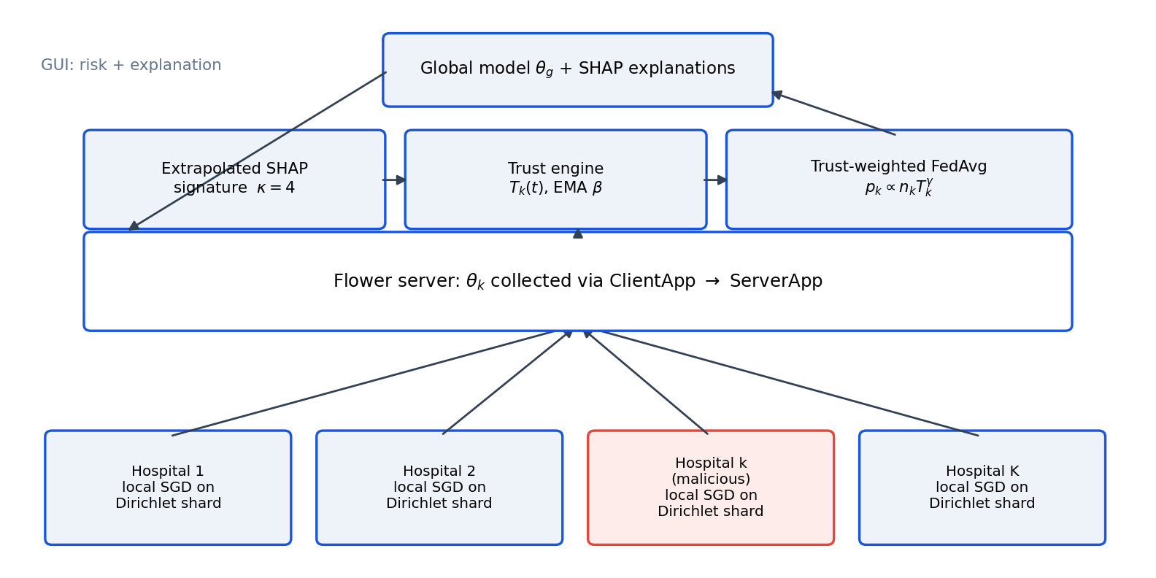
TA-EFL architecture. Clients return only parameters; the server derives the extrapolated attribution signature, the trust score and the aggregation weights.

Federated Learning Framework
The system is implemented against the Flower APIs: each hospital is a NumPyClient exposed through a ClientApp, and trust-weighted aggregation is a custom server-side Strategy within a ServerApp. Two execution backends are provided. The first is Flower’s own simulation runtime. The second advances the identical strategy object a single round per invocation, which keeps experimental runs deterministic and allows the interface to report progress while training is still in flight.
The local model is a binary logistic regression trained by mini-batch stochastic gradient descent. For parameters $θ=(w,b)$,
$$\hat{p}(x)=σ(w^{⊤}x+b), σ(z)=\frac{1}{1+e^{−z}}.$$
A linear model is chosen deliberately: it admits exact SHAP values in closed form, so explanations introduce no approximation error of their own, in line with the argument for interpretable models in high-stakes settings.
The classical FedAvg baseline aggregates as
θg(t+1)=k=1Knkj​nj θk(t),
where $n_{k}$ is the number of local training samples at client $k$. The coordinate-wise median baseline replaces this with an elementwise median over $\{θ_{k}^{(t)}\}$.

Non-IID Client Partitioning
Training indices are divided using a Dirichlet partition. For each class $c$, proportions over clients are drawn as
$$(q_{1,c},…,q_{K,c})∼Dir(α_{nIID}1_{K}),$$
and class-$c$ indices are split accordingly, with resampling until every client holds at least a minimum shard size. Smaller $α_{nIID}$ yields more heterogeneous client populations. The partition is a deterministic function of the dataset, client count, $α_{nIID}$ and seed, so every simulated node reconstructs its own shard without patient data being transferred between processes.

Threat Model
A subset $M⊂\{1,…,K\}$ of hospitals is malicious. They participate in the protocol correctly at the message level—returning well-formed parameter vectors and truthful sample counts—but corrupt what they return in one of three ways:
- Label flipping: local labels are inverted, $y↦1−y$, before training.
- Additive noise: $θ_{k}↦θ_{k}+ε$, $ε∼N(0,σ^{2}I)$ with $σ=1.0$.
- Scaled model poisoning: $θ_{k}↦θ_{g}+s(θ_{k}−θ_{g})$ with $s=8.0$.
The server is honest, observes only submitted parameters and sample counts, and holds a small public reference set $X_{ref}$ containing no private records. Clients never transmit explanations, gradients on private data, or raw features.

Trust Computation
Let $u_{k}=θ_{k}−θ_{g}$ be client $k$’s update and $\tilde{u}={median}_{k}(u_{k})$ the coordinate-wise median update. Two similarity terms are computed. The update-similarity term is the cosine similarity to the median update, attenuated by a magnitude penalty that detects norm inflation:
$$s_{k}^{upd}=\text{max}​\left(0,\frac{u_{k}^{⊤}\tilde{u}}{∥u_{k}∥ ∥\tilde{u}∥}\right)⋅\text{min}​\left(1,\frac{{median}_{j}∥u_{j}∥}{∥u_{k}∥}\right).$$
The explanation-consistency term compares attribution signatures (Section 3.7):
$$s_{k}^{exp}=\text{max}​\left(0,\frac{ϕ_{k}^{⊤}\tilde{ϕ}}{∥ϕ_{k}∥ ∥\tilde{ϕ}∥}\right), \tilde{ϕ}={median}_{k}(ϕ_{k}).$$
The two are mixed by $α$ and smoothed by an exponential moving average with memory $β$:
$$T_{k}(t)=β T_{k}(t−1)+(1−β)\left[αs_{k}^{upd}+(1−α)s_{k}^{exp}\right].$$
Thus $α=1$ reduces trust to update geometry alone and $α=0$ to explanation consistency alone.

Trust-Aware Aggregation
Aggregation weights sharpen trust by an exponent $γ$ and exclude clients below a threshold $τ$:
pk=nk Tkγj​njTjγ, Tk=Tk,Tk≥τ0,Tk<τ
with θg(t+1)=k​pkθk(t). If every client falls below $τ$, the scheme falls back to uniform weighting rather than producing an undefined update. Setting $T_{k}$ constant recovers ([eq:fedavg]).

Explanation-Based Trust
For a linear model, the exact SHAP value of feature $j$ at input $x$ in log-odds space is
$$φ_{j}(x)=w_{j}\left(x_{j}−E[x_{j}]\right).$$
Aggregating over the shared reference set gives a per-client signature, an $L_{2}$-normalised signed vector,
$$ϕ_{k}=\frac{w_{k}⊙sd(X_{ref})}{∥w_{k}⊙sd(X_{ref})∥}.$$
The signature is signed rather than absolute, so a label-flipped model, whose attributions point the wrong way, is anomalous even when its magnitude profile is ordinary. Crucially, $ϕ_{k}$ is computed by the server from the submitted $θ_{k}$, so a malicious client cannot report a favourable explanation.

$κ$ Extrapolation
Early in training, individual updates are small and their signatures are dominated by the shared global model, which compresses the difference between honest and malicious clients. The server therefore extrapolates each client’s update before taking the signature:
$$θ_{k}^{κ}=θ_{g}+κ (θ_{k}−θ_{g}), ϕ_{k}=sig​\left(θ_{k}^{κ},X_{ref}\right).$$
This amplifies the direction in which a client is pushing the model without altering the aggregation itself. Detection quality is quantified by the detection margin
$$Δ=\underset{k∉M}{\text{min}}T_{k}−\underset{k∈M}{\text{max}}T_{k},$$
which is positive only when every honest client is trusted more than every attacker.

SHAP Explainability
Equation ([eq:shap]) provides per-patient attributions at no approximation cost. The application renders them twice: as a signed bar chart over all features, and as a ranked plain-language summary that separates factors increasing from factors decreasing the predicted risk, annotated with the patient’s own feature values in clinical units.

Prediction and Graphical Interface
A PyQt6 desktop application exposes federated training configuration, live per-round trust diagnostics, model evaluation, per-patient explanation and tabular reporting. Personalization here is at the level of the individual patient record: the same global model is applied to every patient, but both the risk estimate and the attribution breakdown are computed from that patient’s own feature vector, so two patients with the same predicted risk may receive entirely different explanations. Predictions are presented as calibrated probabilities with an explicit statement that they are risk estimates rather than diagnoses.

IV. EXPERIMENTAL SETUP

Datasets
Five binary-outcome tabular clinical tasks are used (Table 1). The Breast Cancer Wisconsin (Diagnostic) data are the real measurements distributed with scikit-learn. For the remaining four tasks, the repository supports loading the corresponding public CSV files; when those files are absent—as in the runs reported here—the framework generates a calibrated synthetic cohort with realistic marginal distributions, correlations and outcome prevalence. All reported results for those four tasks are therefore obtained on synthetic data, and this is a limitation rather than a claim of clinical validity (Section 7).
Datasets used in the experiments
Dataset | $n$ | Feat. | Pos. | Source
Heart Disease | 1500 | 13 | 52.6% | Synthetic
Pima Diabetes | 1500 | 8 | 33.9% | Synthetic
Breast Cancer Wisc. | 569 | 10 | 37.3% | Real (sklearn)
Framingham CHD | 2000 | 14 | 15.0% | Synthetic
Stroke Prediction | 2500 | 10 | 9.8% | Synthetic

Preprocessing and Missing Values
Each dataset is split 75/25 into training and test partitions, stratified by outcome. Features are standardised to zero mean and unit variance using training-set statistics only, and the same statistics are applied to the test partition and to any patient entered through the interface. For datasets loaded from real CSV files, physiologically impossible zero entries in the Pima data are treated as missing and imputed with the column median, and categorical fields in the stroke data are integer-encoded; rows with residual missing values are dropped. The synthetic generators do not produce missing values.

Federated Configuration
Table 2 lists the configuration used for all reported experiments. The public reference set for attribution signatures contains $\text{min}(200,|X_{test}|)$ samples drawn from the test pool; in a deployment this would be a synthetic or public cohort rather than patient records.
Experimental configuration
Parameter | Value
Clients (hospitals) $K$ | 6 (experiments); 5 (interface default)
Federated rounds | 30
Local epochs / round | 3
Learning rate, batch, $L_{2}$ | 0.15, 32, ${10}^{−3}$
Model | Logistic regression, mini-batch SGD
Partition | Dirichlet, $α_{nIID}=0.5$
Train/test split | 75% / 25%, stratified
Trust weighting $α$ | 0.0 (final, from E6)
Extrapolation $κ$ | 4.0
EMA memory $β$ | 0.6
Weight exponent $γ$ | 2.0
Exclusion threshold $τ$ | 0.25
Seeds | 42, 43, 44
Framework | Flower

Attacks, Baselines and Metrics
Malicious clients are assigned by index so that the attacked configuration is identical across strategies and seeds: one attacker is client 2 (label flipping); two attackers add client 4 (noise); three attackers add client 1 (scaled poisoning). Trust-weighted aggregation is compared against FedAvg ([eq:fedavg]) and the coordinate-wise median. Performance is reported as test-set ROC-AUC of the final global model, averaged over three seeds with standard deviation; robustness of detection is reported as the margin $Δ$ in ([eq:margin]).

Selection of $α$ and $κ$
$κ$ was selected from the sweep in Section 5.3 and $α$ from the sweep in Section 5.6. Neither was tuned on a separate criterion, and no other hyperparameter was adjusted while these sweeps were performed.

V. RESULTS AND DISCUSSION
Unless stated otherwise, results use the Heart Disease task with $K=6$, 30 rounds, and three seeds; means are reported with standard deviation. Sections 5.1, 5.3 and 5.5 use the final $α=0$ configuration.

E1: Malicious-Client Fraction
Table 3 and Fig. 2 report final AUC as the fraction of malicious clients increases. With no attacker, all three aggregation rules are equivalent, as expected: trust weighting does not help when there is nothing to defend against. The strategies separate once attackers are present. At two of six malicious clients, FedAvg falls to $0.769±0.067$ while trust weighting holds $0.810±0.018$; the increased standard deviation of FedAvg indicates that the damage depends strongly on the particular partition. The coordinate-wise median remains competitive throughout, which is consistent with its design: it is a robust estimator, and the attacks used here are not tailored to defeat it.
E1: final AUC vs. malicious fraction (mean $±$ sd, 3 seeds)
Malicious | Trust-Aware | FedAvg | Median
0/6 | $0.808±0.015$ | $0.808±0.014$ | $0.807±0.018$
1/6 | $0.807±0.016$ | $0.806±0.015$ | $0.796±0.019$
2/6 | $0.810±0.018$ | $0.769±0.067$ | $0.802±0.013$
3/6 | $0.806±0.020$ | $0.775±0.059$ | $0.789±0.036$
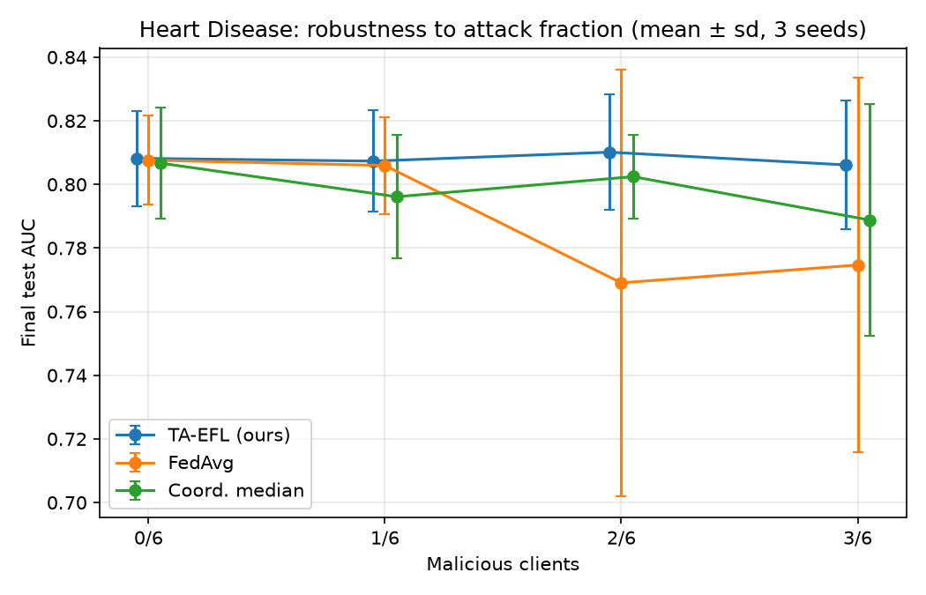
E1: robustness to increasing attack fraction, $α=0$.

E2: Trust-Component Ablation
Table 4 isolates the two trust signals at two of six malicious clients. Using update similarity alone ($α=1$) yields a negative margin, $−0.095±0.127$: at least one attacker is trusted more than at least one honest client, so the ordering is not usable for exclusion. Adding explanation consistency reverses this, and using explanation consistency alone gives the largest margin, $+0.513±0.296$. AUC differences among the three settings are small relative to seed variance. This experiment sets $α$ explicitly and is therefore unaffected by the choice of default.
E2: trust-component ablation, 2/6 malicious (3 seeds)
Trust signal | AUC | Detection margin $Δ$
Update only ($α=1$) | $0.800±0.017$ | $−0.095±0.127$
Both ($α=0.5$) | $0.805±0.013$ | $+0.243±0.111$
Explanation only ($α=0$) | $0.810±0.018$ | $+0.513±0.296$
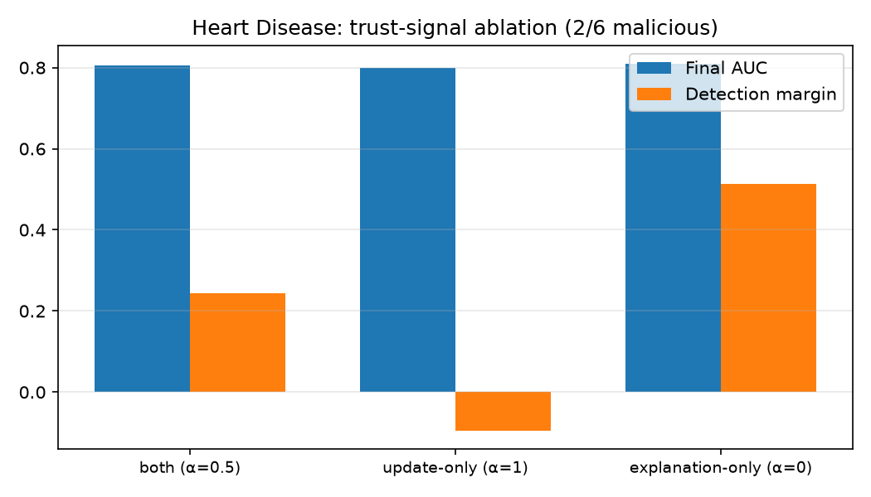
E2: contribution of the two trust signals.

E3: Extrapolation Sensitivity
Table 5 and Fig. 4 sweep $κ$ with a single label-flipping client. Without meaningful extrapolation ($κ=1$) the margin is $+0.066±0.048$, close to the point at which honest and malicious clients are indistinguishable. The margin peaks at $κ=4$ ($+0.807±0.080$) and declines for larger values, where extrapolation begins to amplify noise as well as signal. This supports the central claim that amplifying the update direction, rather than inspecting the raw update, is what exposes inverted attribution. Note that $κ$ affects only trust scoring; the aggregation in ([eq:weights]) uses unmodified parameters.
E3: detection margin vs. $κ$, one label flipper (3 seeds)
Extrapolation $κ$ | Detection margin $Δ$
1 | $+0.066±0.048$
2 | $+0.674±0.399$
4 | $+0.807±0.080$
8 | $+0.495±0.190$
16 | $+0.139±0.073$
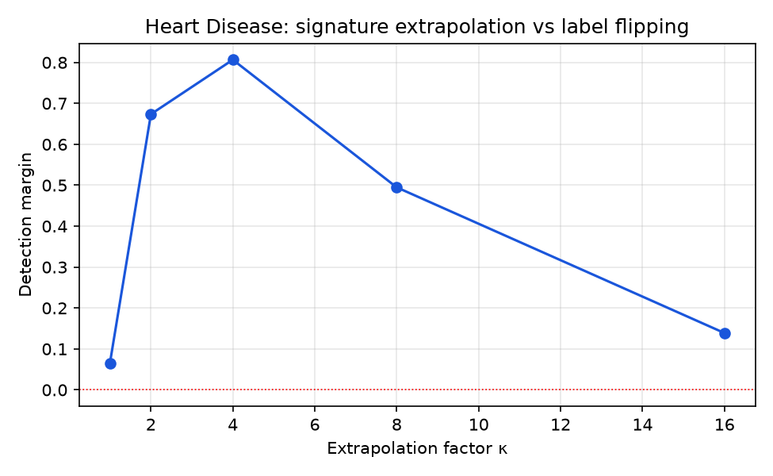
E3: detection margin as a function of $κ$, $α=0$.

E4: Heterogeneity False Positives
A robustness mechanism is only usable if it does not penalise honest institutions whose patient populations differ. E4 runs with no attackers and varies $α_{nIID}$, recording the minimum trust assigned to any honest client (Table 6). Across the range tested, the minimum honest trust remains between $0.384$ and $0.456$, above the exclusion threshold $τ=0.25$, so no honest client is excluded even at $α_{nIID}=0.1$. These values were measured under the earlier $α=0.5$ configuration and have not been re-measured at $α=0$; they should therefore be read as evidence for the mixed-signal setting.
E4: minimum honest-client trust, no attackers (3 seeds)
Dirichlet $α_{nIID}$ | Min. honest trust
0.1 | $0.432±0.023$
0.5 | $0.411±0.025$
1.0 | $0.384±0.065$
5.0 | $0.456±0.013$

E5: Cross-Dataset Generalisation
Table 7 repeats the two-of-six attack configuration on all five tasks. Trust weighting attains the highest or joint-highest AUC on every dataset. The largest gap appears on Breast Cancer Wisconsin, where FedAvg collapses to $0.657$: the label-flipping client inverts a model that is otherwise highly separable, and sample-size weighting propagates that inversion. Detection margins are positive on all five tasks, though smallest on Stroke Prediction ($+0.199$), the most imbalanced task, where honest clients disagree most and the explanation signal is correspondingly weaker.
E5: cross-dataset AUC and detection margin, 2/6 malicious
Dataset | Trust | FedAvg | Median | $Δ$
Heart Disease | $0.810$ | 0.769 | 0.802 | $+0.513$
Pima Diabetes | $0.895$ | 0.874 | 0.891 | $+0.688$
Breast Cancer Wisc. | $0.977$ | 0.657 | $0.977$ | $+0.707$
Framingham CHD | $0.796$ | 0.720 | 0.785 | $+0.484$
Stroke Prediction | $0.909$ | 0.828 | 0.891 | $+0.199$
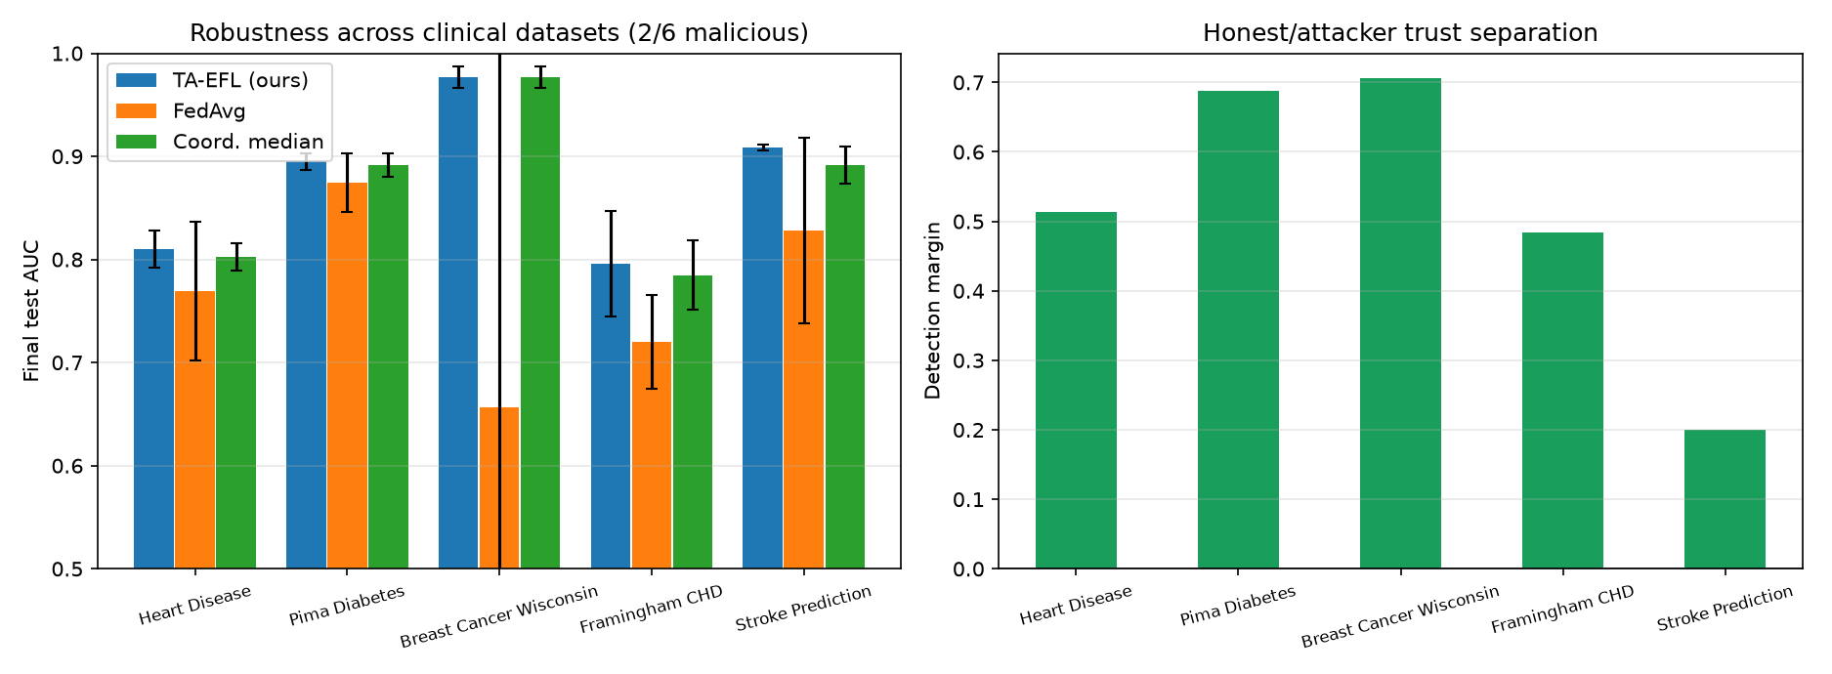
E5: cross-dataset robustness and honest/attacker separation.

E6: Sensitivity to the Trust Weighting $α$
Table 8 and Fig. 6 sweep $α$ over $\{0,0.25,0.5,0.75,1\}$ under the E2 protocol: same dataset, attack configuration, partitions, seeds, $κ$ and evaluation, with $α$ the only variable.
Three observations follow. First, the detection margin decreases monotonically as the update-similarity contribution grows, from $+0.514±0.296$ at $α=0$ to $−0.095±0.127$ at $α=1$, where separation is lost entirely. Second, AUC varies comparatively little across the sweep—from $0.800$ to $0.810$, a range of the same order as the per-seed standard deviation—so AUC alone does not discriminate strongly between settings. Third, $α=0$ attains both the largest margin and the highest mean AUC in this experimental environment.
$α=0$ was therefore adopted for the final configuration primarily on the basis of malicious-client separation. This should not be read as a claim that $α=0$ is universally optimal. The result is specific to these datasets, this attack set, this model family and this partitioning; the update-similarity term retains a clear purpose against attacks that preserve attribution structure while inflating magnitude, and a different attack mixture could favour a non-zero $α$. What the sweep does establish is that, here, explanation consistency carries the discriminative signal and adding update similarity dilutes it.
E6: sensitivity to trust weighting $α$, 2/6 malicious (3 seeds)
$α$ | AUC | Detection margin $Δ$
0.00 | $0.810±0.018$ | $+0.514±0.296$
0.25 | $0.810±0.018$ | $+0.413±0.187$
0.50 | $0.805±0.013$ | $+0.243±0.111$
0.75 | $0.805±0.014$ | $+0.061±0.111$
1.00 | $0.800±0.017$ | $−0.095±0.127$
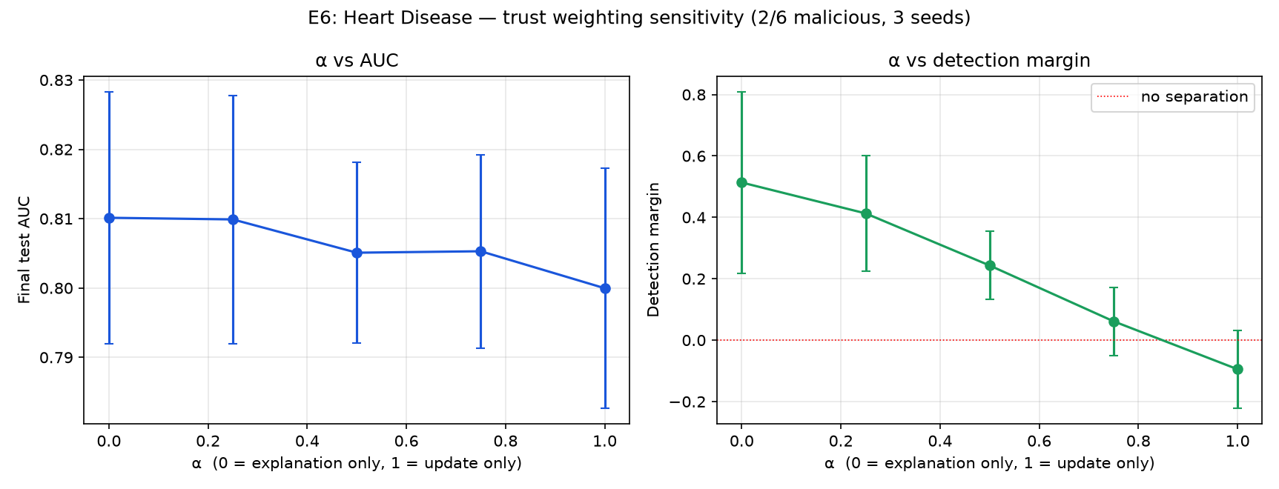
E6: $α$ against AUC (left) and detection margin (right).

VI. EXPLAINABILITY AND GRAPHICAL INTERFACE
The application presents the prediction before any explanation. For a selected patient it reports a risk category and the estimated probability, followed by a ranked breakdown of the factors that increased and decreased that estimate, each annotated with the patient’s own value in clinical units and a qualitative strength. A plain-language summary names the strongest contributor on each side. Below this, the technical view shows the signed SHAP attribution over all features (Fig. 7), with the axis labelled as impact on the prediction rather than as a clinical effect.
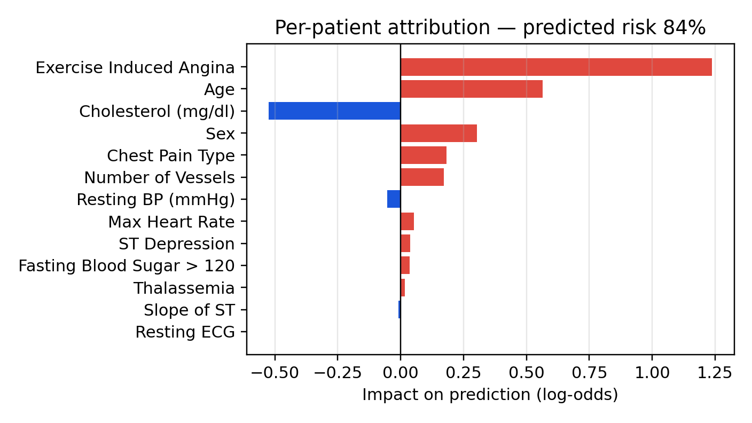
Per-patient attribution from ([eq:shap]) for one test patient. Positive values increase the predicted risk. Illustrative example produced by the project’s explainability module on the synthetic Heart Disease cohort.
Categorical inputs are presented by name rather than by code—sex as female/male, chest pain type, resting ECG, ST slope and thalassemia by their category labels—while the numeric code required by the model is retained internally, so the vector reaching the model is unchanged. The same interface can explain either a held-out test patient or the patient just entered on the prediction screen; in the latter case the explanation and the prediction refer to the same input by construction.
The reporting screen presents model performance, attack robustness, per-client trust decomposition, the E1–E6 summary and cross-dataset results as tables, reading from the stored experiment outputs rather than recomputing them, and supports CSV export.
Two framing decisions are deliberate. Attributions are described as contributions of features to the model’s output, not as causal or clinical statements, following the caution urged in the explainability literature. Every prediction view carries an explicit notice that the output is an AI-generated risk estimate and not a medical diagnosis.

VII. LIMITATIONS
The following limitations bound the claims made here.
Simulated federation. All hospitals are simulated processes on one machine. Real deployments face stragglers, dropout, heterogeneous compute and communication failures, none of which are modelled. They also face governance questions—consent, liability, auditability and data stewardship across institutions—that a technical mechanism does not resolve [1].
Data provenance. Only the Breast Cancer Wisconsin task uses real measurements in the reported runs. The other four use calibrated synthetic cohorts, which reproduce plausible marginals and correlations but not the messiness, coding drift or site-specific bias of hospital records. Results on those four tasks characterise the method’s behaviour, not clinical performance.
Dataset scale. Cohorts of 569–2500 records split across six clients leave some shards small, which inflates seed-to-seed variance; several reported standard deviations are large relative to the differences discussed.
Attack scope. Three attack types are evaluated. Adaptive adversaries that optimise against the trust rule itself—for example, by matching the cohort attribution signature while poisoning slowly—are not evaluated, and shows such attacks are practical against robust aggregators.
Explanation fidelity. Exact SHAP values are available only because the model is linear. The signature in ([eq:signature]) summarises a model by its weight profile on a reference set, so two models with different behaviour but similar weight direction would be scored alike. SHAP values also describe association within the model, not causation.
No clinical validation. The system has not been evaluated prospectively, on real patient cohorts, or in any care setting; no clinical utility, safety or equity claim is made. Its outputs are risk estimates from a research prototype and must not be used for diagnosis or treatment decisions.
Environment sensitivity. Absolute values depend on the numerical environment: the split implementation and metric library affect partitioning and hence results. All figures reported here come from a single consistent environment and configuration.

VIII. CONCLUSION AND FUTURE WORK
This paper presented TA-EFL, a federated learning framework in which explanation consistency is used as a trust signal rather than only as an output. By recomputing an extrapolated attribution signature server-side from each submitted parameter vector, the method detects clients whose models attribute risk in the wrong direction without requiring clients to report anything beyond parameters. Across six experiments, trust-weighted aggregation preserved AUC under attack where FedAvg degraded, extrapolation at $κ=4$ produced the strongest honest/attacker separation, and no honest client was excluded under the heterogeneity levels tested. A sensitivity sweep led to $α=0$ for this configuration, selected on separation rather than on accuracy, and reported as configuration-specific rather than universal.
Future work follows directly from the limitations. The most important step is evaluation on real multi-institutional data with a clinical partner. Beyond that: adaptive attacks that target the attribution signature itself; non-linear models, where exact SHAP is unavailable and approximate attributions would introduce their own error; formal privacy guarantees for the reference set and the signatures, given known gradient-leakage risks; re-measurement of E4 under the final configuration; and calibration analysis, since a risk score intended to inform clinicians must be well calibrated and not merely well ranked.

IX. REPRODUCIBILITY
All experiments are reproducible from the accompanying repository with fixed seeds $\{42,43,44\}$. Experiments E1, E3 and E5 in the final configuration are produced by run_study.py –only e1,e3,e5 –label final_alpha0; E2 and E4 by run_study.py; E6 by run_study.py –only e6. Per-seed values are stored as CSV files alongside the figures reproduced in this paper.

REFERENCES
- R. Eden, I. Chukwudi, C. Bain, S. Barbieri, L. Callaway, S. de Jersey, Y. George, A.-D. Gorse, M. Lawley, P. Marendy, S. M. McPhail, A. Nguyen, and M. Samadbeik, “A scoping review of the governance of federated learning in healthcare,” npj Digital Medicine, vol. 8, no. 427, 2025.
- Z. L. Teo, L. Jin, N. Liu, S. Li, D. Miao, X. Zhang, W. Y. Ng, T. F. Tan, D. M. Lee, K. J. Chua, J. Heng, Y. Liu, R. S. M. Goh, and D. S. W. Ting, “Federated machine learning in healthcare: A systematic review on clinical applications and technical architecture,” Cell Reports Medicine, vol. 5, no. 2, 2024.
- S. Sagar, C.-S. Li, S. W. Loke, and J. Choi, “Poisoning attacks and defenses in federated learning: A survey,” arXiv preprint arXiv:2301.05795, 2023.
- A. Tariq, M. A. Serhani, F. Sallabi, T. Qayyum, E. S. Barka, and K. A. Shuaib, “Trustworthy federated learning: A survey,” arXiv preprint arXiv:2305.11537, 2023.
- P. M. Sánchez Sánchez, A. Huertas Celdrán, N. Xie, G. Bovet, G. Martínez Pérez, and B. Stiller, “FederatedTrust: A solution for trustworthy federated learning,” Future Generation Computer Systems, vol. 152, pp. 83–98, 2023.
- H. Zhang, Y. Liu, X. He, J. Wu, T. Cong, and X. Huang, “SoK: Benchmarking poisoning attacks and defenses in federated learning,” arXiv preprint arXiv:2502.03801, 2025.
- B. Molina-Coronado, “Celtibero: Robust layered aggregation for federated learning,” arXiv preprint arXiv:2408.14240, 2024.
- M. S. Ali et al., “Federated learning in healthcare: Model misconducts, security, challenges, applications, and future research directions—a systematic review,” arXiv preprint arXiv:2405.13832, 2024.
- F. Cremonesi, M. Vesin, S. Cansiz, Y. Bouillard, I. Balelli, L. Innocenti, S. Silva, S.-S. Ayed, R. Taiello, L. Kameni, R. Vidal, and M. Lorenzi, “Fed-BioMed: Open, transparent and trusted federated learning for real-world healthcare applications,” arXiv preprint arXiv:2304.12012, 2023.
- L. M. Lopez-Ramos, F. Leiser, A. Rastogi, S. Hicks, I. Strümke, V. I. Madai, T. Budig, A. Sunyaev, and A. Hilbert, “Interplay between federated learning and explainable artificial intelligence: A scoping review,” arXiv preprint arXiv:2411.05874, 2024.
- Y. Zhang and H. Yu, “LR-XFL: Logical reasoning-based explainable federated learning,” in Proc. AAAI Conf. Artificial Intelligence, vol. 38, pp. 21788–21796, 2024.
- Y. Zhang and H. Yu, “Uncertainty-aware explainable federated learning,” arXiv preprint arXiv:2503.05194, 2025.

