Introduction of JDBC (30 Minutes)

JDBC stands for **J**ava **D**ata**b**ase **C**onnectivity, which is a standard Java API for database-independent connectivity between the Java programming language and a wide range of databases.

JDBC (Java Database Connectivity) 

The JDBC library includes APIs for each of the tasks mentioned below that are commonly associated with database usage.

* Making a connection to a database.
* Creating SQL or MySQL statements.
* Executing SQL or MySQL queries in the database.
* Viewing & Modifying the resulting records.

Fundamentally, JDBC is a specification that provides a complete set of interfaces that allows for portable access to an underlying database. Java can be used to write different types of executables, such as −

* Java Applications
* Java Applets
* Java Servlets
* Java ServerPages (JSPs)
* Enterprise JavaBeans (EJBs).

All of these different executables are able to use a JDBC driver to access a database, and take advantage of the stored data.

JDBC provides the same capabilities as ODBC, allowing Java programs to contain database-independent code.

## JDBC Architecture

The JDBC API supports both two-tier and three-tier processing models for database access but in general, JDBC Architecture consists of two layers −

* **JDBC API:** This provides the application-to-JDBC Manager connection.
* **JDBC Driver API:** This supports the JDBC Manager-to-Driver Connection.

The JDBC API uses a driver manager and database-specific drivers to provide transparent connectivity to heterogeneous databases.

The JDBC driver manager ensures that the correct driver is used to access each data source. The driver manager is capable of supporting multiple concurrent drivers connected to multiple heterogeneous databases.

Following is the architectural diagram, which shows the location of the driver manager with respect to the JDBC drivers and the Java application −

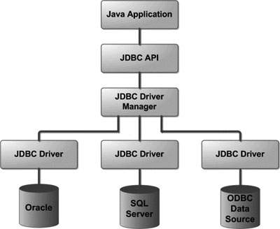

**Activity: (10 Minutes)**

* **Question and answer in group.**

## Lesson -2

## Common JDBC Components

The JDBC API provides the following interfaces and classes −

**DriverManager:**

This class manages a list of database drivers.

* Matches connection requests from the java application with the proper database driver using communication sub protocol.
* The first driver that recognizes a certain subprotocol under JDBC will be used to establish a database Connection.
* **Driver:** This interface handles the communications with the database server. You will interact directly with Driver objects very rarely. Instead, you use DriverManager objects, which manages objects of this type. It also abstracts the details associated with working with Driver objects.
* **Connection:** This interface with all methods for contacting a database. The connection object represents communication context, i.e., all communication with database is through connection object only.
* **Statement:** You use objects created from this interface to submit the SQL statements to the database. Some derived interfaces accept parameters in addition to executing stored procedures.
* **ResultSet:** These objects hold data retrieved from a database after you execute an SQL query using Statement objects. It acts as an iterator to allow you to move through its data.
* **SQLException:** This class handles any errors that occur in a database application.

**Why use JDBC**

Before JDBC, ODBC API was the database API to connect and execute query with the database. But, ODBC API uses ODBC driver which is written in C language (i.e. platform dependent and unsecured). That is why Java has defined its own API (JDBC API) that uses JDBC drivers

Discuss types of drivers

JDBC drivers implement the defined interfaces in the JDBC API, for interacting with your database server.

For example, using JDBC drivers enable you to open database connections and to interact with it by sending SQL or database commands then receiving results with Java.

## JDBC Drivers Types

JDBC driver implementations vary because of the wide variety of operating systems and hardware platforms in which Java operates. Sun has divided the implementation types into four categories, Types 1, 2, 3, and 4, which is explained below –

## Type 1: JDBC-ODBC Bridge Driver

* It is also known as JDBC type -1 driver.
* It is database driver that utilize the ODBC driver to connect to database.
* Acts as a bridge between JDBC and another database connectivity mechanism such as ODBC
* Translates the JDBC API calls to ODBC API calls and sends them via native API calls directly to the ODBC driver.
* The driver is implemented in the sun.jdbc.odbc.JdbcOdbcDriver class.

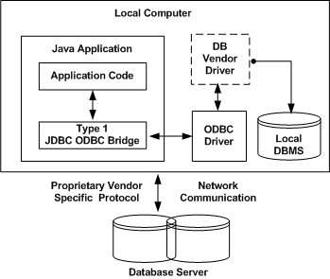

**Advantages**

The JDBC-ODBC Bridge allows access to almost any database, since the database’s ODBC drivers are already available.

**Disadvantages**

1. Since the Bridge driver is not written fully in Java, Type 1 drivers are not portable.  
2. A performance issue is seen as a JDBC call goes through the bridge to the ODBC driver, then

to the database, and this applies even in the reverse process. They are the slowest of all driver

types.  
3. The client system requires the ODBC Installation to use the driver.  
4. Not good for the Web.

## Type 2: JDBC-Native API

In a Type 2 driver, JDBC API calls are converted into native C/C++ API calls, which are unique to the database. These drivers are typically provided by the database vendors and used in the same manner as the JDBC-ODBC Bridge. The vendor-specific driver must be installed on each client machine.

If we change the Database, we have to change the native API, as it is specific to a database and they are mostly obsolete now, but you may realize some speed increase with a Type 2 driver, because it eliminates ODBC's overhead.

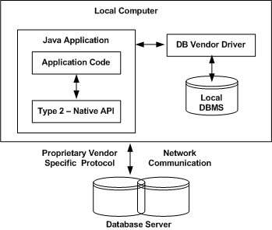

The Oracle Call Interface (OCI) driver is an example of a Type 2 driver.

## Type 3: JDBC-Net pure Java

In a Type 3 driver, a three-tier approach is used to access databases. The JDBC clients use standard network sockets to communicate with a middleware application server. The socket information is then translated by the middleware application server into the call format required by the DBMS, and forwarded to the database server.

This kind of driver is extremely flexible, since it requires no code installed on the client and a single driver can actually provide access to multiple databases.

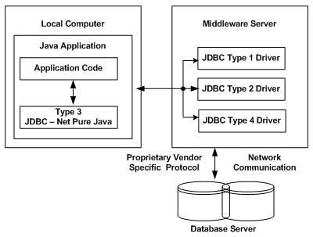

You can think of the application server as a JDBC "proxy," meaning that it makes calls for the client application. As a result, you need some knowledge of the application server's configuration in order to effectively use this driver type.

Your application server might use a Type 1, 2, or 4 driver to communicate with the database, understanding the nuances will prove helpful.

## Type 4: 100% Pure Java

In a Type 4 driver, a pure Java-based driver communicates directly with the vendor's database through socket connection. This is the highest performance driver available for the database and is usually provided by the vendor itself.

This kind of driver is extremely flexible, you don't need to install special software on the client or server. Further, these drivers can be downloaded dynamically.

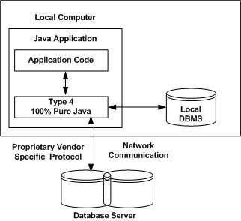

MySQL's Connector/J driver is a Type 4 driver. Because of the proprietary nature of their network protocols, database vendors usually supply type 4 drivers.

## Which Driver should be Used?

If you are accessing one type of database, such as Oracle, Sybase, or IBM, the preferred driver type is 4.

If your Java application is accessing multiple types of databases at the same time, type 3 is the preferred driver.

Type 2 drivers are useful in situations, where a type 3 or type 4 driver is not available yet for your database.

The type 1 driver is not considered a deployment-level driver, and is typically used for development and testing purposes only.