**LIBRARY CASE STUDY**

1. **NEW_MEMBER**: A procedure that adds a new member to the MEMBER table. For the join date, use CURDATE(). Pass all other values to be inserted into a new row as parameters.

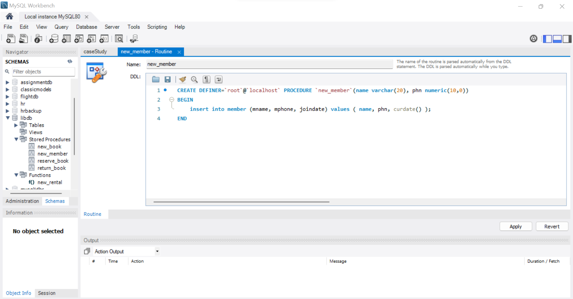

1. **NEW_BOOK**: A procedure that adds a new book to the book table. columns pass as parameter.

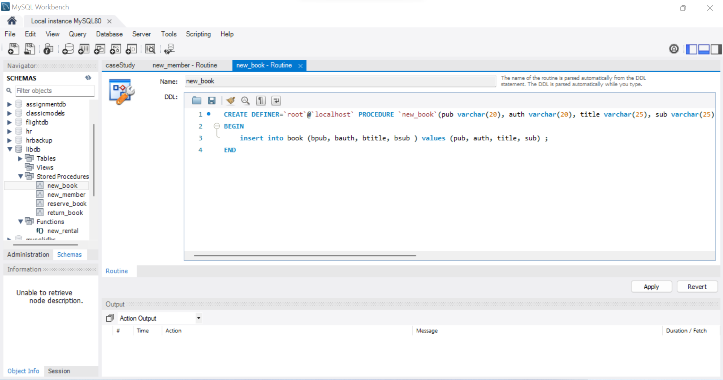

Create a **trigger** to insert into bcopy table whenever insert happens on new_book.

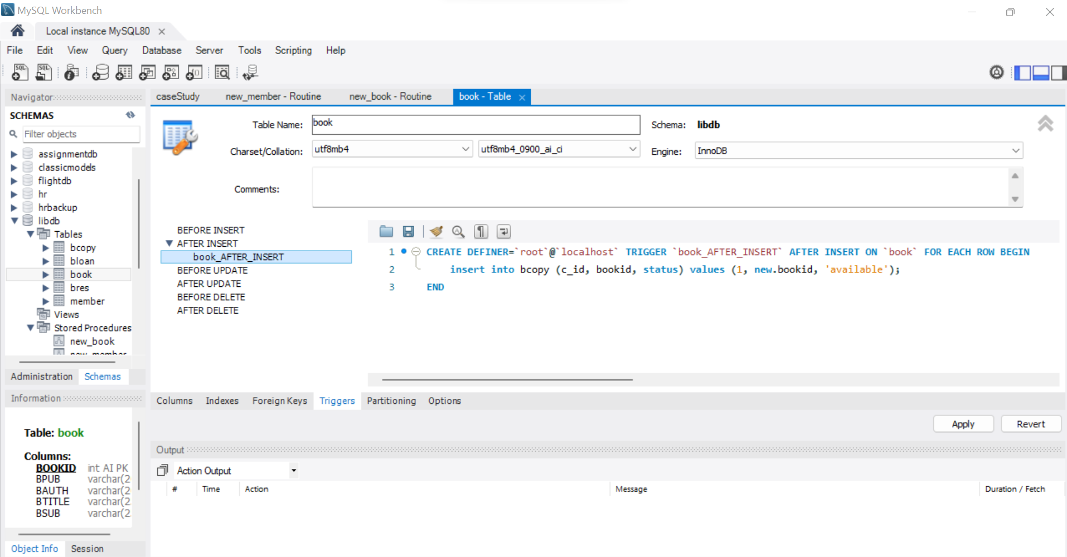

(Here multiple copies can be entered manually)

1. **NEW_RENTAL**: Function to record a new rental. Pass the bID number for the book that is to be rented, pass ID number into the function. The function should return the due date for the book. Due dates are three days from the date the book is rented. If the status for a book requested is listed as AVAILABLE in the bCOPY table for one copy of this title, then update this b_COPY table and set the status to RENTED. If there is no copy available, the function must return NULL. Then, insert a new record into the BLOAN table identifying the booked date as today's date, the copy ID number, the member ID number, the BOOKID number and the expected return date.

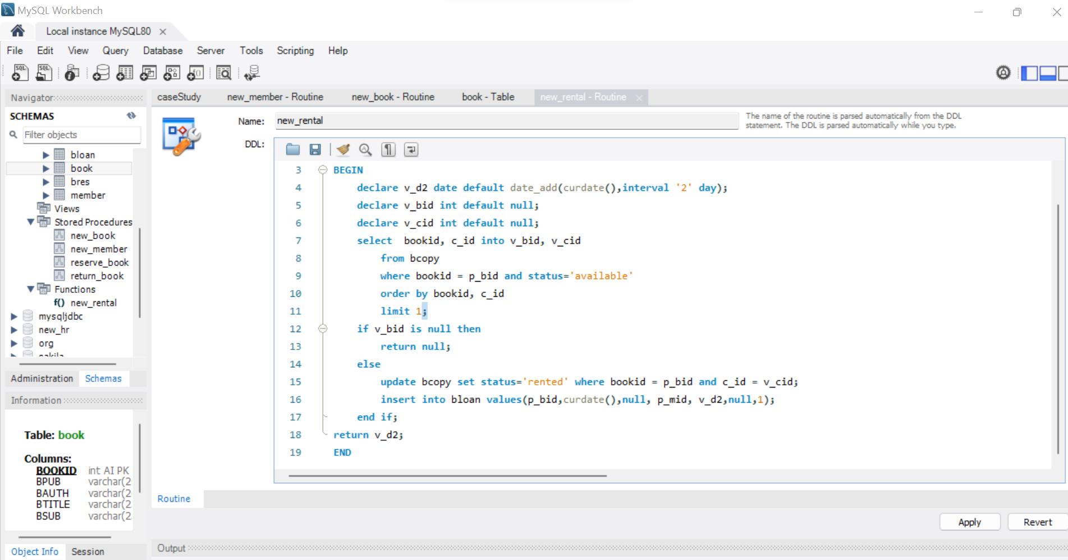

1. **RETURN_book**: A procedure that updates the status of a book (available, rented, or reserved) and sets the return date. Pass the book ID, the copyID and the status to this procedure. Check whether there are reservations for that title, and display a message if it is reserved. Update the RENTAL table and set the actual return date to today’s date. Update the status in the BCOPY table based on the status parameter passed into the procedure.

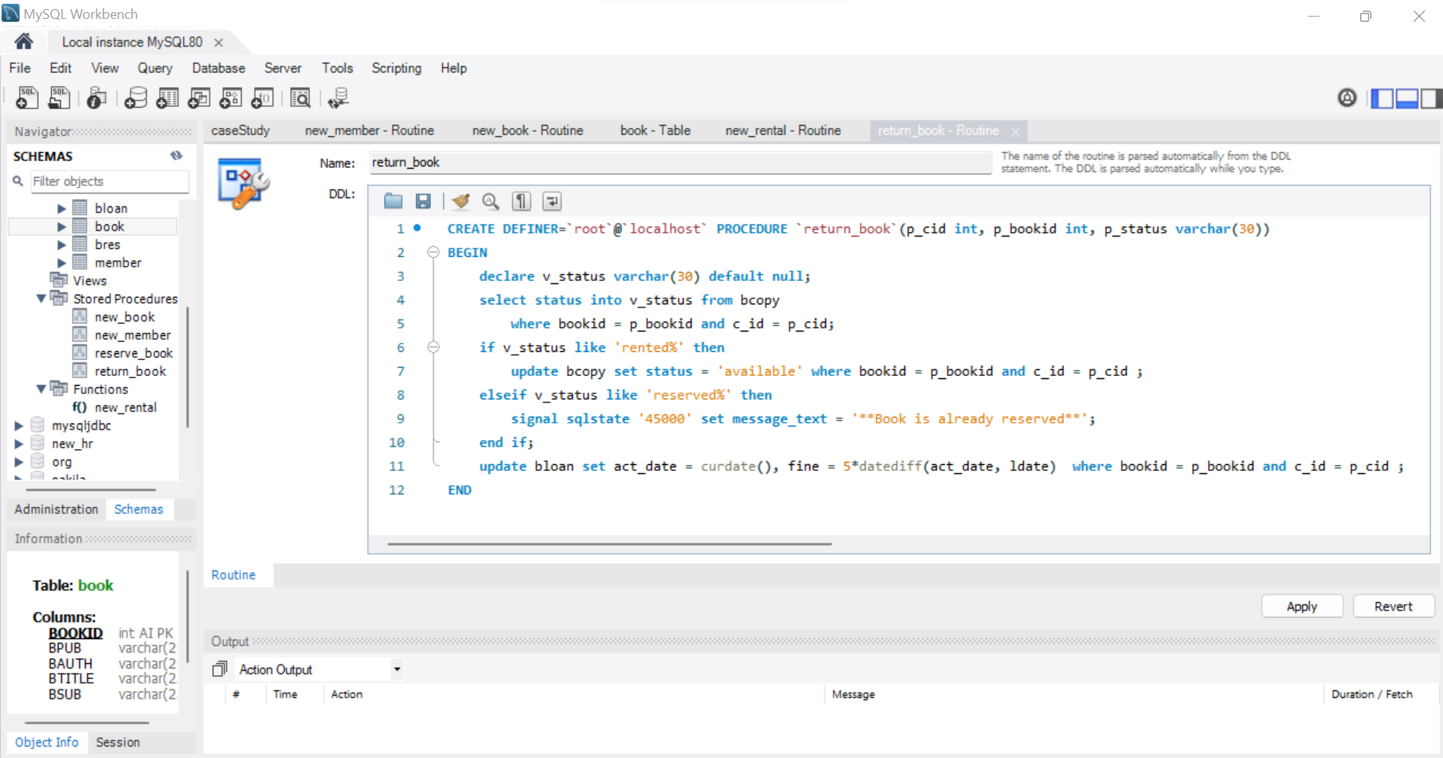

1. **RESERVE_BOOK**: A procedure that executes only if all of the book copies requested in the NEW_RENTAL procedure have a status of RENTED. Pass the member ID number and the book ID number to this procedure. Insert a new record into the BRES table and record the reservation date, member ID number, and BID number. Print out a message indicating that a BOOK is reserved and its expected date of return.

