**Weather – by pyspark rdd dataframe**

* Reading the data from text file

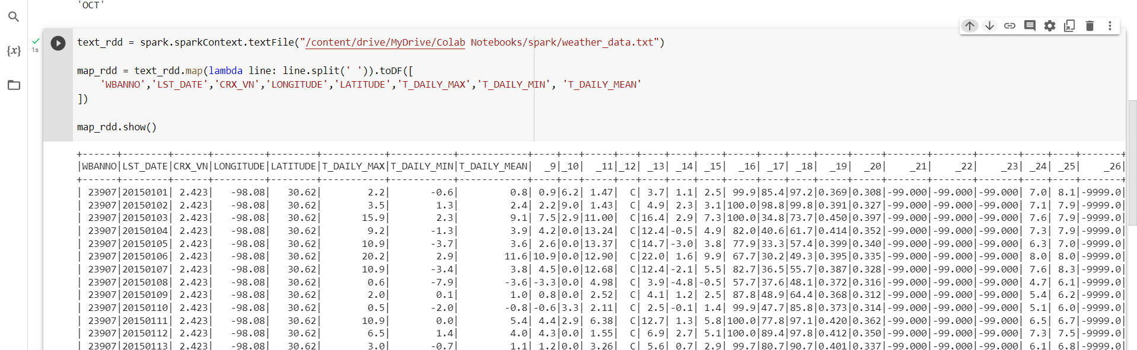

* Over-all maximum and minimum tempreture

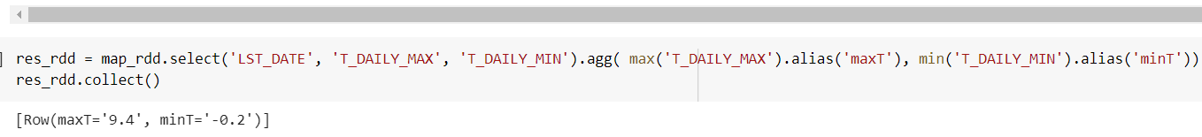

* Month-wise maximum and minimum tempreture

