OM ADVERTISING
AGENT-READY SOFTWARE REQUIREMENTS SPECIFICATION
Showcase / Marketing Website — V1
Purpose: Provide a single source of truth that an AI coding agent can use to design, implement, validate and finish the complete website without requiring product-level clarification.
Field | Value
Document status | Implementation-ready baseline — Squarespace reference locked
Version | 1.3
Product | OM Advertising website
Business type | Advertising, signage, printing and physical brand-visibility services
Primary location | Near Power House, Renwal Road, Chomu, Jaipur
Primary phone | 9799852206
Secondary phone | 9829537889
Email | omadvertisingchomu@gmail.com
Authentication | Not required
Database | Not required for V1
Checkout / ecommerce | Not required
Primary conversion | Phone / WhatsApp / quote inquiry

0. EXECUTIVE INSTRUCTION TO THE CODING AGENT
READ THIS SECTION FIRST. Treat this document as the authoritative product specification for V1. Implement the complete website end-to-end in one pass. Do not stop after scaffolding, do not create placeholder pages, and do not introduce backend systems that are explicitly out of scope.
- Build a polished, production-quality, responsive marketing/showcase website for OM Advertising.
- The website must communicate that OM Advertising is an all-in-one physical branding partner, not merely a printing or sign-board vendor.
- The experience should be premium, dark, image-led, cinematic and modern. It must behave like an immersive digital showroom: large visual moments, full-bleed imagery/video, editorial typography, controlled motion, interactive storytelling and strong conversion CTAs. MANDATORY DESIGN REFERENCE: use Squarespace.com (https://www.squarespace.com/) as the primary external reference for visual restraint, section composition, media-as-environment, editorial scale, spacing, storytelling rhythm, portfolio presentation and premium interaction patterns. When a visual or interaction decision is uncertain, the working/coding agent should open and inspect Squarespace.com for reference before inventing a pattern. Use its current design language as inspiration, not as a source to copy. Do NOT clone Squarespace, copy its layouts, branding, wording, navigation or UI.
- Do not copy the supplied poster layouts literally. Extract their brand identity, service information and messaging, then elevate it into a modern web experience.
- Use the supplied images as visual references/assets where appropriate. Do not invent factual claims such as years of experience, number of clients, certifications, awards or project counts.
- No login, signup, user accounts, admin dashboard, database, shopping cart, payment system or complex backend is required.
- All content that may change should be centralized in a configuration/content data layer so the client or developer can update it without editing component structure.
- All navigation links must work. No dead buttons. If a feature is not implemented, remove the corresponding UI rather than leaving a fake interaction.
- The final implementation must be mobile-first and fully usable on desktop, tablet and mobile.
- Before declaring completion, perform a visual/functional QA pass against every acceptance criterion in this document.

0.1 Agent Decision Rules
- Prefer the simplest architecture that fully satisfies the requirements.
- Prefer reusable components and data-driven content over duplicated markup.
- Use semantic HTML, accessible controls and meaningful alt text.
- Use optimized responsive images; avoid loading unnecessarily large originals when smaller variants are sufficient.
- Use CSS effects sparingly. Avoid excessive gradients, rainbow UI, neon glow, ornamental gears, ribbons and poster-like decoration.
- Use the OM logo's multicolor spectrum as a controlled brand accent; do not turn the whole interface into a multicolor/rainbow theme.
- When a requirement is ambiguous, choose the option that preserves the premium showcase positioning and minimizes technical complexity.
MANDATORY REFERENCE RULE: Squarespace.com is the designated design-language reference for this project. When the agent needs to decide how a section should be composed, how media should behave, how spacing/typography should feel, how a portfolio should be presented, or how a visual interaction should be paced, inspect https://www.squarespace.com/ and use the observed principle as a reference. Do not guess when the reference can clarify the intended quality bar. Always adapt the principle to OM Advertising rather than reproducing Squarespace literally.
- Never fabricate business facts. Mark any unverified item as configurable content or omit it.

1. PRODUCT DEFINITION

1.1 Product Vision
Create a high-conversion digital storefront for OM Advertising that shows prospective business owners what the company can create, demonstrates the transformation it can deliver, establishes trust, and gives the visitor an immediate path to contact the business.

1.2 Core Positioning
Recommended primary positioning: “Make Your Brand Impossible to Miss.” Supporting concept: “Signage. Printing. Complete Brand Visibility.”
The website narrative must frame the customer's desired outcome—visibility, recognition, professionalism and identity—rather than focusing only on the physical products.

1.3 Target Audience
- Local shops and retail businesses.
- Cafés, restaurants and hotels.
- Offices and professional businesses.
- Showrooms and commercial properties.
- New businesses requiring complete physical branding.
- Businesses renovating or upgrading their storefront/interior.
- Businesses needing recurring printed promotional materials.

1.4 Primary Conversion Goals
- Primary: visitor initiates a phone call or WhatsApp conversation.
- Secondary: visitor requests a quote / project discussion.
- Tertiary: visitor explores services and portfolio and gains enough confidence to contact OM Advertising.

2. SCOPE

2.1 In Scope
- Responsive landing page.
- Services page.
- Our Work / portfolio page.
- About Us page.
- Contact page.
- Global responsive navbar and footer.
- Service category and service detail presentation.
- Portfolio/gallery presentation.
- Call, WhatsApp and email CTAs.
- Quote/contact inquiry UI if feasible without a database.
- SEO metadata and social sharing metadata.
- Accessible, semantic and responsive implementation.
- Centralized configuration for business information, navigation, services, portfolio items, copy and theme tokens.

2.2 Explicitly Out of Scope
- Authentication and authorization.
- Customer accounts.
- Database.
- Admin CMS.
- Online checkout.
- Payment gateway.
- E-commerce cart.
- Order tracking.
- Customer dashboards.
- Complex booking/scheduling.
- User-generated reviews unless later supplied by the client.
- Blog/news system unless separately requested.

3. INFORMATION ARCHITECTURE & SITEMAP
Route | Purpose | Navbar | Footer
/ | Primary conversion-oriented landing page | Yes | Yes
/services | Complete categorized service catalogue | Yes | Yes
/work | Visual portfolio / examples | Yes | Yes
/about | Company positioning and story | Yes | Yes
/contact | Contact details and conversion | Yes | Yes

3.1 Navbar
- Logo: OM Advertising.
- Links: Home, Services, Our Work, About Us, Contact.
- Primary CTA: Get a Quote.
- Desktop: persistent/sticky navbar may be used if visually appropriate.
- Mobile: hamburger menu with all links and CTA.
- Navbar should visually transition on scroll if a sticky treatment is used.
- Active route/state must be visually identifiable.

4. VISUAL DESIGN SYSTEM

4.1 Design Direction
Premium dark-mode brand presentation. The interface should feel like a modern signage/branding studio. Photography and signage illumination provide most of the visual drama; UI decoration remains restrained.
Token | Recommended value | Usage
Background | #0B0B0C | Primary page background
Surface | #151517 | Cards, panels, navigation surfaces
Surface elevated | #1D1D20 | Hover/active/elevated components
Primary text | #F5F2EA | Headings and important copy
Secondary text | #A8A5A0 | Supporting copy
Brand gold | #D6A84F | Primary accent, highlights, CTA details
Brand gold light | #E7C77A | Hover/highlight
Border | #343438 | Subtle separation
Success/positive | #6FBF8A | Only where semantic status is needed
Error | #E07171 | Only where semantic error is needed

4.2 Color Rules
- Do not use pink or magenta as a primary UI color.
- Do not use rainbow gradients as backgrounds.
- The logo's multicolor ring/mark may appear in the logo and selected visual accents.
- Gold should be the dominant brand accent for typography details, borders, icons and CTA emphasis.
- Maintain strong contrast for accessibility.

4.3 Typography
- Use a modern, highly legible sans-serif family.
- Headings: strong geometric/modern sans-serif weight 600–800.
- Body: regular/medium weight with generous line height.
- Avoid condensed poster fonts for core UI text.
- Use script/decorative typography only as a rare accent, never for functional navigation or long text.

4.4 UI Language
- Rounded corners should be moderate, not overly playful.
- Borders should be subtle and purposeful.
- Buttons should have clear hierarchy and large enough touch targets.
- Use restrained hover elevation, image zoom and glow effects.
- Use generous whitespace to separate the premium UI from the dense supplied posters.

5. HOME / LANDING PAGE SPECIFICATION
The home page contains exactly eight major content sections in the following narrative order.
ID | Section | Primary job
H01 | Hero | Capture attention and immediately communicate the outcome.
H02 | Complete Branding Solutions | Explain the four high-level capabilities.
H03 | Core Services | Show the most commercially important services.
H04 | From Space to Brand | Use transformation/before-after storytelling.
H05 | Why OM Advertising | Establish trust through four clear principles.
H06 | Our Work | Provide visual proof and aspiration.
H07 | How It Works | Remove friction and explain the process.
H08 | Final CTA | Convert high-intent visitors.

5.1 H01 — Hero
H01.1 — Headline [MUST]
Display the primary message: “Make Your Brand Impossible to Miss.”
H01.2 — Supporting copy [MUST]
Use concise copy communicating signage, printing and complete physical brand visibility.
H01.3 — Primary CTA [MUST]
“Get a Quote” must lead to /contact or an equivalent quote interaction.
H01.4 — Secondary CTA [MUST]
“Explore Our Services” must lead to /services.
H01.5 — Hero visual [MUST]
Use a high-quality finished storefront/signage visual. Prefer real client work when the client supplies it; otherwise use supplied approved imagery.
H01.6 — Brand cue [MUST]
OM Advertising logo must be visible without competing with the headline.
H01.7 — Mobile [MUST]
Hero must stack cleanly; CTA buttons remain easy to tap and the visual must not obscure the message.

5.2 H02 — Complete Branding Solutions
Present four high-level categories instead of exposing every individual service immediately.
Category | Examples | Intent
Signage | Acrylic 3D Letters, LED Sign Boards, Retro/Reflective Signs, Name Boards | Physical visibility
Space Branding | ACP Cladding, PVC Panels, Glass Branding, Wall Graphics | Turn spaces into branded environments
Printing | Eco-Solvent, Flex, Vinyl, One Vision, 12×18 Digital | Printed brand communication
Business & Promotional | Cards, Brochures, Pamphlets, Stickers, Standees | Everyday marketing collateral

H02.1 — Category cards [MUST]
Each category should have a strong visual, short description and link to the relevant Services content.
H02.2 — Hierarchy [MUST]
Avoid presenting 15–20 equal cards above the fold; category-level grouping is mandatory.

5.3 H03 — Core Services
Highlight six recurring/core offerings identified across the supplied creatives:
- Acrylic 3D Letter Signs
- LED Sign Boards
- ACP Cladding
- PVC Panel Interior & Exterior
- Professional Printing
- Retro Sign Boards
H03.1 — Service cards [MUST]
Each service card must include image, name, concise benefit-led description and optional “View service” link.
H03.2 — Image-first [MUST]
The product should be visually understandable before the visitor reads detailed text.

5.4 H04 — From Space to Brand
H04.1 — Heading [MUST]
Use the concept: “From an Empty Space to a Recognizable Brand.”
H04.2 — Before/after [MUST]
Present the supplied before/after concept as a visual transformation where suitable.
H04.3 — Message [MUST]
Explain that storefront/exterior/interior branding changes first impressions and visibility.
H04.4 — CTA [MUST]
Provide a contextual CTA such as “Transform My Space” leading to /contact.

5.5 H05 — Why OM Advertising
Principle | Website expression
Designed to Stand Out | Creative signage built around the business identity.
Quality Materials | Professional materials selected for appearance and durability.
Complete Branding | Signage, printing and space branding under one roof.
Timely Delivery | Clear process from requirement to production and delivery/installation.

H05.1 — No unsupported proof [MUST]
Do not attach numerical claims, awards or certifications unless later provided by the client.

5.6 H06 — Our Work
H06.1 — Portfolio [MUST]
Use an image-led grid or masonry-like responsive layout.
H06.2 — Categories [MUST]
Support filtering or grouping by Signage, Printing, Exterior, Interior and Branding if enough assets exist.
H06.3 — Lightbox [MUST]
A lightweight image lightbox is optional but recommended for portfolio usability.
H06.4 — CTA [MUST]
Link to the full /work page.

5.7 H07 — How It Works
Step | Name | Description
01 | Tell Us What You Need | Share business type, space, dimensions and requirements.
02 | We Design | Develop a visual direction around the brand and space.
03 | We Make It | Produce the signage, printing or branding materials.
04 | We Deliver / Install | Complete the project and make the brand ready to be seen.

5.8 H08 — Final CTA
H08.1 — Heading [MUST]
Use the concept: “Ready to Make Your Brand More Visible?”
H08.2 — Actions [MUST]
Show Get a Quote, Call and WhatsApp actions.
H08.3 — Contact [MUST]
Repeat verified phone, email and location details.
H08.4 — No friction [MUST]
A visitor must not need an account or multi-step form to contact the business.

6. SERVICES PAGE SPECIFICATION
Services are data-driven and grouped into four categories.

SIGNAGE
- Acrylic 3D Letters
- LED Sign Boards
- Retro Sign Boards
- Retro Reflective Sign Boards
- LED Board Manufacturing
- Name Boards

BRANDING & CLADDING
- ACP Cladding
- PVC Panel Interior
- PVC Panel Exterior
- Glass Branding (Frosted/Vinyl)
- Wall Graphics
- Wall Branding
- Office Branding
- Shop Branding

PRINTING
- Eco-Solvent Printing
- Flex Printing
- Vinyl Printing
- One Vision Printing
- 12×18 Digital Printing
- Sunboard Printing
- Canvas Printing
- Printing on ACP
- Printing on PVC
- Printing on 12 mm Toughened Material

BUSINESS & PROMOTIONAL
- Visiting Cards
- Business Cards
- Brochures
- Pamphlets
- Leaflets
- Sticker Printing
- Promotional Standees
SVC.1 — Service detail [MUST]
Every service must have enough content for a visitor to understand what it is and why it may be useful.
SVC.2 — Service CTA [MUST]
Every service category/detail presentation must offer a direct quote/contact action.
SVC.3 — No false specifications [MUST]
Do not add dimensions, material grades, warranties, machine models or technical specifications unless confirmed by the client.
SVC.4 — Data-driven [MUST]
Services must be defined in a centralized content/config structure.

7. OUR WORK / PORTFOLIO PAGE
- Primary purpose: visual proof.
- Use supplied project/product imagery as the initial gallery where licensing/usage is approved by the client.
- Each portfolio item should support: title, category, short description, image(s) and optional location/client field if verified.
- Do not invent client names. Some supplied creatives contain fictional-looking business signage; treat such text as visual mockup content unless confirmed as an actual project.
- Provide responsive image cards and optional lightbox.
- If there are too few assets for category filters, do not show empty filters; use a simple gallery.

8. ABOUT US PAGE
Keep the About page concise and factual. The supplied creatives establish the company's location and service positioning, but do not provide sufficient evidence for detailed history or quantitative achievements.
- OM Advertising — Chomu, Jaipur.
- Position as a signage, printing and physical branding partner.
- Explain the all-in-one approach.
- Explain the focus on creativity, quality materials and timely execution as stated in the supplied marketing material.
- Include the owner's/contact names only where the client confirms they should be publicly displayed.
ABT.1 — Avoid invented history [MUST]
Do not claim founding year, years of experience, team size, client count, certifications or awards without explicit client confirmation.

9. CONTACT PAGE & CONVERSION
Field | Verified supplied value | Configurable
Business | OM Advertising | Yes
Location | Near Power House, Renwal Road, Chomu, Jaipur | Yes
Phone 1 | 9799852206 | Yes
Phone 2 | 9829537889 | Yes
Email | omadvertisingchomu@gmail.com | Yes

CON.1 — Phone CTA [MUST]
Use tel: links with the configured phone number.
CON.2 — WhatsApp CTA [MUST]
Provide a WhatsApp CTA using the configured primary/approved WhatsApp number only after client confirmation. Do not guess which number is WhatsApp-enabled.
CON.3 — Email CTA [MUST]
Use mailto: for the configured email.
CON.4 — Map [MUST]
An embedded map is optional. If implemented, use the verified business location and avoid exposing a false precise address.
CON.5 — Inquiry form [MUST]
A simple form is optional. If included, it must either use a configured external form/email endpoint or clearly state that it opens an email/WhatsApp flow. Do not build a custom database-backed submission system.

10. FOOTER SPECIFICATION
Column | Links/content
OM Advertising | Short positioning statement + logo
Services | Signage, Space Branding, Printing, Business & Promotional
Company | Home, About Us, Services, Our Work, Contact
Get in Touch | Phone, WhatsApp, Email, Location

- Bottom bar: © OM Advertising. All rights reserved.
- Privacy Policy and Terms & Conditions may be included as lightweight static pages if the deployment/business context requires them.
- Do not create empty legal pages merely for decoration.

11. CONFIGURATION & CONTENT MODEL
The implementation must separate content/configuration from UI components. A single configuration module/file should contain business identity, contact information, navigation, service groups, portfolio entries, SEO defaults and theme tokens.
Recommended conceptual structure (exact language/framework syntax is implementation-dependent):
siteConfig = {
brand: {
name: "OM Advertising",
tagline: "Make Your Brand Impossible to Miss.",
subTagline: "Signage. Printing. Complete Brand Visibility.",
logo: "/assets/brand/logo.png"
},
contact: {
phonePrimary: "9799852206",
phoneSecondary: "9829537889",
email: "omadvertisingchomu@gmail.com",
address: "Near Power House, Renwal Road, Chomu, Jaipur",
whatsappNumber: "", // fill only after client confirms
mapUrl: "" // optional; fill only with verified location
},
navigation: [...],
services: [...],
portfolio: [...],
seo: {...},
theme: {...}
}

11.1 Configurable Fields
- Business name and logo.
- Tagline and supporting hero copy.
- Phone numbers.
- WhatsApp number.
- Email.
- Address/location.
- Navigation labels/routes.
- Service categories and service items.
- Portfolio items and categories.
- CTA labels.
- Social links, if provided.
- SEO title, description and Open Graph image.
- Theme tokens and optional accent values.

12. ASSET & IMAGE REQUIREMENTS
The supplied creatives are reference material. The coding agent should create an assets directory and map approved images through configuration rather than hardcoding them throughout components.
- Preserve the original logo where possible as the brand mark.
- Prefer clean product/project crops over using entire poster graphics as website backgrounds.
- If a poster contains text-heavy layout, crop/extract the useful product image rather than rendering the entire poster as UI content.
- Use descriptive filenames such as acrylic-3d-letters.webp, led-sign-board.webp, acp-cladding.webp.
- Generate responsive image sizes when tooling allows.
- Use lazy loading below the fold.
- Use meaningful alt text describing the visible product/context, not keyword stuffing.

12.1 Supplied Reference Images
Reference Creative 1: 805cb109-042f-4dd8-968b-991628fd363d.png
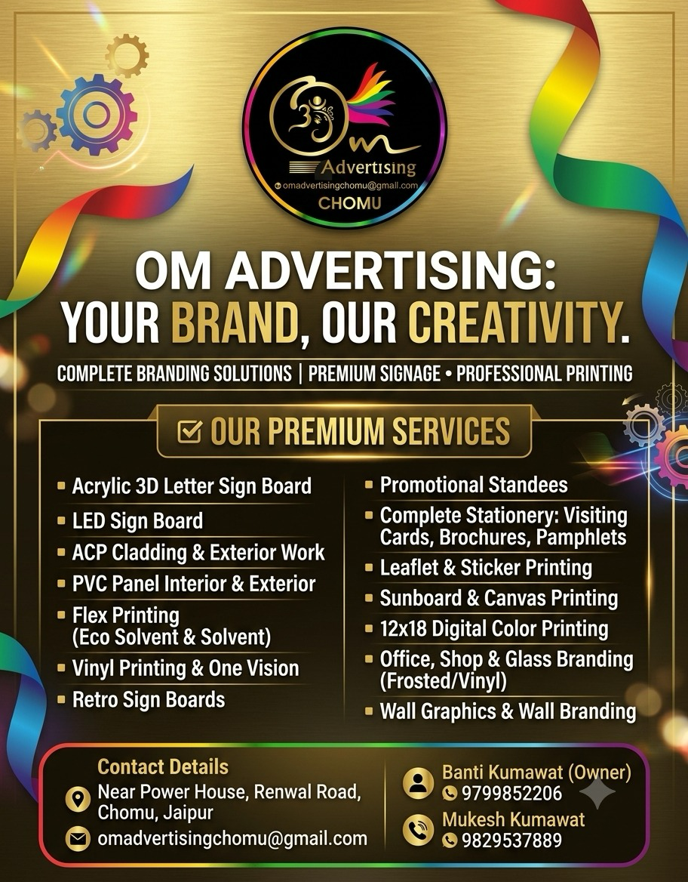
Reference Creative 2: 403c5577-284c-4ae6-b7f8-e59337cf6d15.png
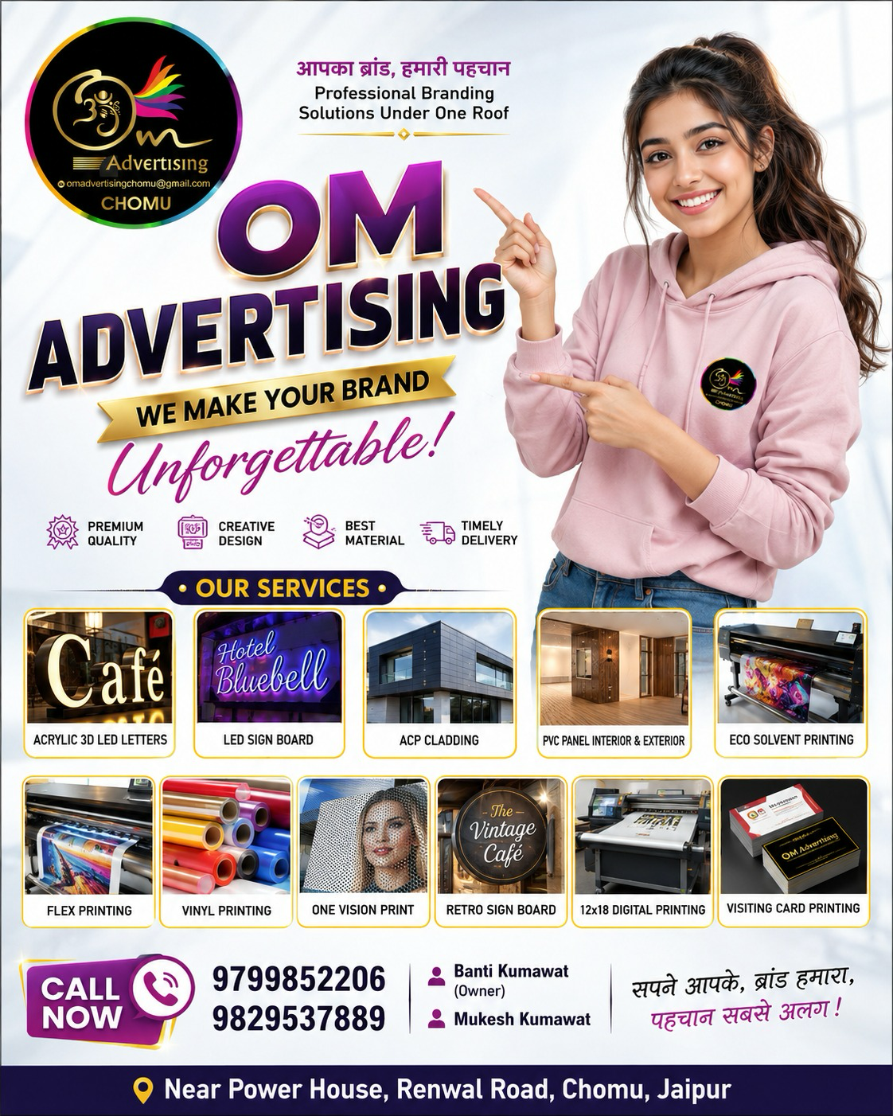
Reference Creative 3: 0bd9b4db-d560-4f89-a1e6-034469dca0fd.png
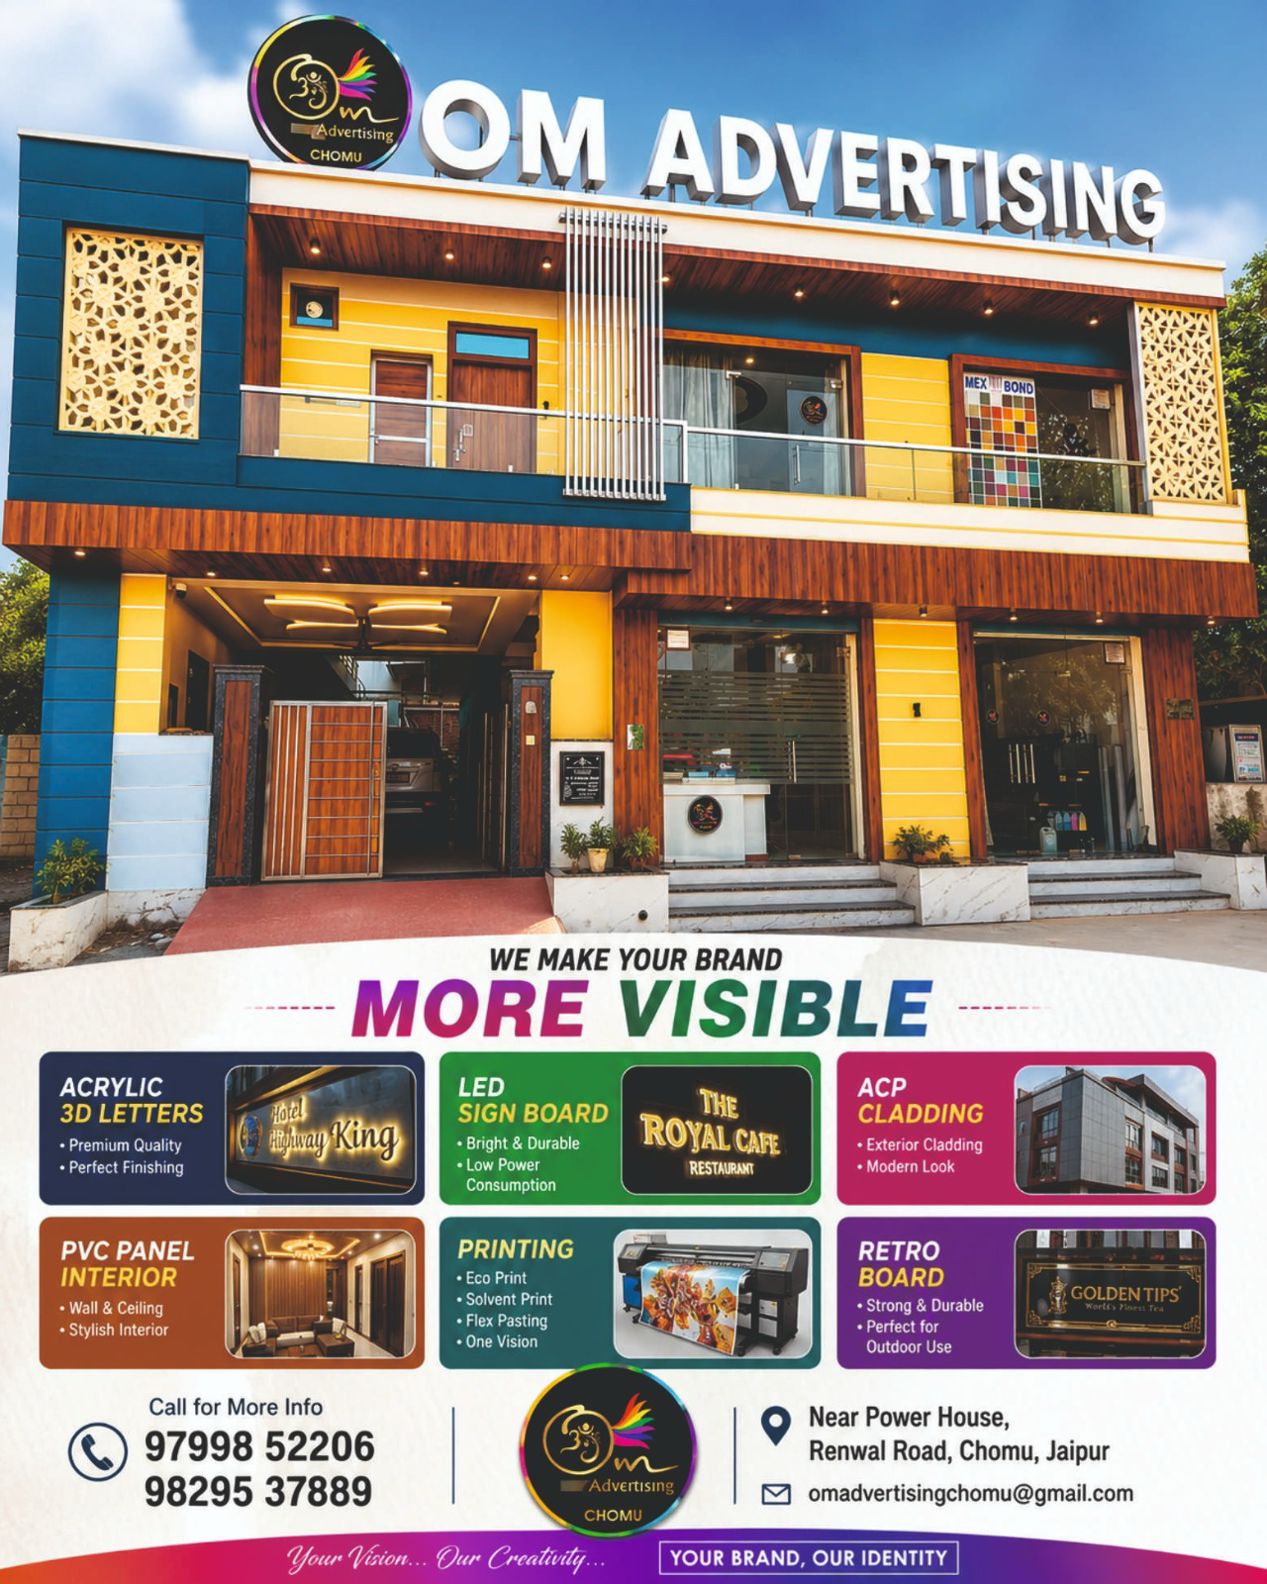
Reference Creative 4: f46b5b51-9ad1-471a-a8cc-14bb47fff90a.png
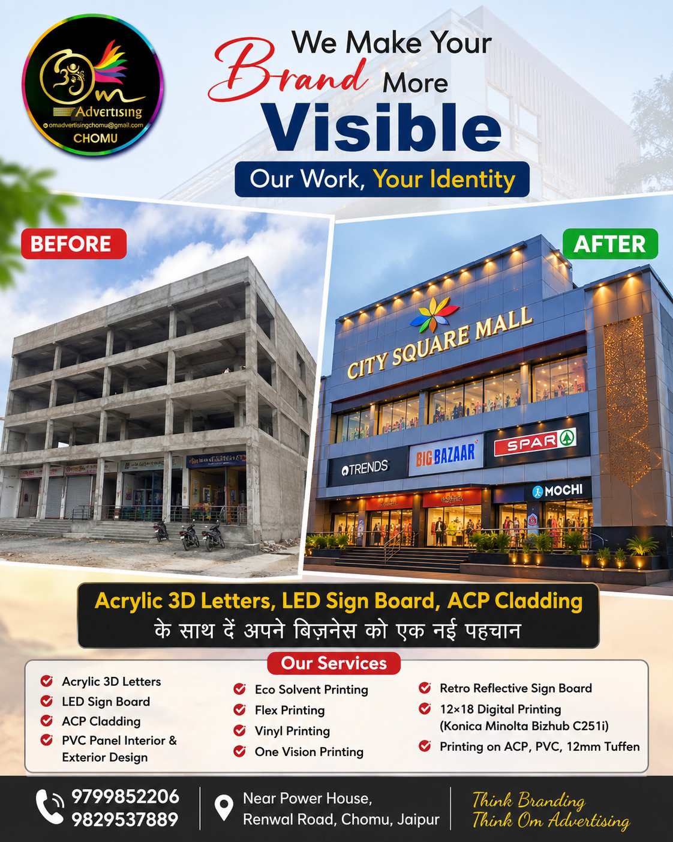
Reference Creative 5: ce2ed953-2b7e-42dd-9b0d-1d2c4ff0d969.png
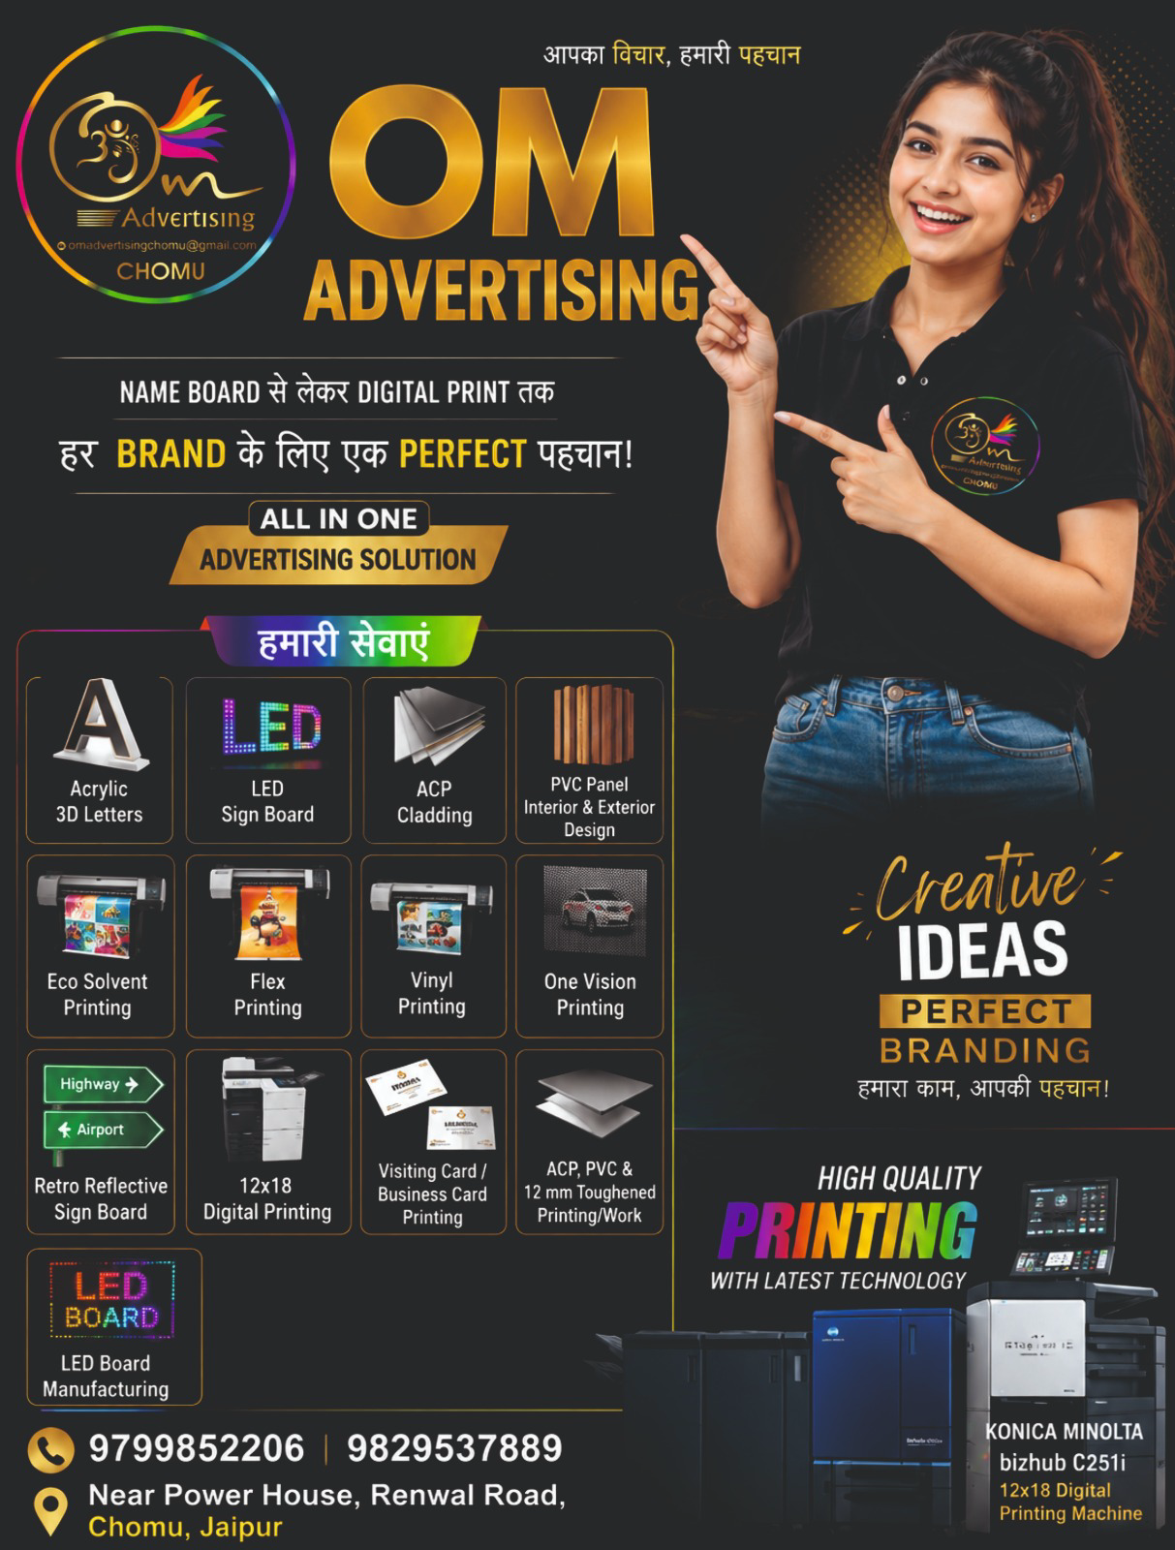

13. FUNCTIONAL REQUIREMENTS
ID | Area | Requirement
FR-01 | Routing | All five primary routes must resolve without broken links.
FR-02 | Navbar | All navbar links must work on desktop and mobile.
FR-03 | CTA | Every major CTA must lead to a real action: route, call, email or configured WhatsApp.
FR-04 | Responsive | Layout must adapt to mobile, tablet and desktop.
FR-05 | Portfolio | Portfolio items must render from data/configuration.
FR-06 | Services | Service categories and items must render from data/configuration.
FR-07 | Contact | Contact details must be centrally configured and reused consistently.
FR-08 | Accessibility | Keyboard navigation, focus states, semantic landmarks and image alt text must be implemented.
FR-09 | External links | External/social links, if any, must open safely and only if configured.
FR-10 | Error-free | No console errors, broken image references or dead interactive controls in the final build.

14. NON-FUNCTIONAL REQUIREMENTS
Area | Requirement
Performance | Optimize images, avoid unnecessary dependencies and keep initial page load lightweight.
Responsive | Support common mobile, tablet and desktop widths; no horizontal scrolling.
Accessibility | Target WCAG 2.1 AA principles where practical; visible focus and adequate contrast.
SEO | Unique title/description per route; semantic headings; canonical URLs if supported by framework.
Security | No secrets in client code; no backend credentials; sanitize any form input if an external submission flow is added.
Maintainability | Reusable components and centralized content/configuration.
Browser support | Current Chrome, Safari, Firefox and Edge; modern mobile browsers.
Deployment | Should be deployable as a static or frontend-only application without a database.

15. SEO & DISCOVERABILITY
Route | Recommended title | Description intent
/ | OM Advertising | Signage, Printing & Branding in Chomu, Jaipur | Complete physical branding and visibility solutions.
/services | Services | OM Advertising | Signage, printing, cladding and branding services.
/work | Our Work | OM Advertising | Portfolio of signage, printing and branding work.
/about | About OM Advertising | Chomu, Jaipur | Company positioning and all-in-one branding approach.
/contact | Contact OM Advertising | Chomu, Jaipur | Phone, email, location and quote CTA.

- Use one H1 per route.
- Use logical H2/H3 hierarchy.
- Add Open Graph/Twitter metadata.
- Add favicon using the approved OM brand mark.
- If business address/service area is confirmed, consider LocalBusiness structured data.
- Do not add fabricated schema properties.

16. UX / INTERACTION REQUIREMENTS
- Hero CTA should be visible without scrolling on desktop and mobile.
- Sticky mobile CTA may be used for Call / WhatsApp if it does not obscure content.
- Service cards should have clear hover/focus states.
- Portfolio images may subtly zoom on hover; disable or reduce motion for prefers-reduced-motion.
- Use smooth scrolling only where it improves navigation; never interfere with standard browser behavior.
- Buttons must communicate whether they navigate, call, email or open an external service.
- Do not use autoplay audio/video.
- Avoid excessive animation. Motion should support hierarchy rather than become the product.

17. RESPONSIVE LAYOUT RULES
Viewport | Rules
Mobile | Single-column sections, large touch targets, compact navbar, stacked CTAs, carefully cropped imagery.
Tablet | Two-column cards/grids where appropriate; preserve generous spacing.
Desktop | Wide editorial layout, strong hero visual, 3–4 column grids where content permits.
Large desktop | Constrain content width so text lines remain readable; do not stretch UI indefinitely.

18. RECOMMENDED TECHNICAL ARCHITECTURE
The SRS intentionally does not force a specific framework. If the project already has a framework, use it. If starting from scratch, prefer a modern frontend stack capable of static generation/deployment.
- Component-based frontend.
- File-based/static routing.
- Centralized TypeScript/JavaScript content configuration.
- CSS variables/design tokens for theme values.
- Reusable Button, Container, SectionHeading, ServiceCard, PortfolioCard, CTA and Contact components.
- Image optimization supported by the chosen framework/build tooling.
- No database layer.
- No authentication provider.
- No server API unless required solely by an external form submission integration.

18.1 Suggested Component Tree
App
├── Layout
│ ├── Navbar
│ └── Footer
├── Shared
│ ├── Button
│ ├── Container
│ ├── SectionHeading
│ ├── ServiceCard
│ ├── PortfolioCard
│ └── ContactActions
├── Home
│ ├── Hero
│ ├── SolutionCategories
│ ├── CoreServices
│ ├── Transformation
│ ├── WhyUs
│ ├── WorkPreview
│ ├── Process
│ └── FinalCTA
├── Services
├── Work
├── About
└── Contact

19. CONTENT & BRAND VOICE
- Confident, professional and visually expressive.
- Customer-focused rather than equipment-focused.
- Short paragraphs and strong headings.
- Use Hindi/Hinglish only if the client later requests bilingual content; V1 default UI should be English unless otherwise specified.
- Do not overpromise outcomes such as guaranteed sales, guaranteed footfall or guaranteed customer growth.
- Prefer benefit language: visibility, recognition, professional appearance, brand identity, standout storefront.

19.1 Approved Conceptual Messaging
- Make Your Brand Impossible to Miss.
- Signage. Printing. Complete Brand Visibility.
- Your Brand. Our Creativity.
- We Make Your Brand More Visible.
- From an Empty Space to a Recognizable Brand.
- Ready to Make Your Brand More Visible?
These are positioning concepts derived from the supplied marketing creatives. Final copy can be adjusted for clarity and conversion without changing the meaning.

20. SOURCE-OF-TRUTH & CONTENT VALIDATION
The supplied promotional creatives contain repeated information but also contain marketing/mockup imagery. The agent must distinguish between verified business facts and illustrative visuals.
Item | Status | Implementation rule
Business name | Consistent | Use OM Advertising.
Location | Consistent | Use the supplied Chomu, Jaipur location; keep configurable.
Phone numbers | Consistent | Use both supplied numbers; keep configurable.
Email | Consistent | Use supplied email; keep configurable.
Service list | Repeated with minor variation | Normalize into four categories; preserve items without inventing new ones.
Owner/contact names | Appears in creatives | Treat as configurable/public-contact content; do not expose unless client confirms.
Project/client names shown inside images | Unverified/mockup | Do not present as actual clients/projects unless confirmed.
Quantitative claims | Not supplied | Do not invent.
Machine model references | Appears in one creative | Do not elevate to a website claim unless client confirms relevance.

21. DEFINITION OF DONE / ACCEPTANCE CRITERIA
- The website builds successfully with no build errors.
- All primary routes are implemented and navigable.
- Navbar and footer are present and functional across breakpoints.
- Home page contains the eight specified sections in the specified narrative order.
- The visual style is premium dark, gold-accented and image-led.
- The design does not resemble a pasted promotional poster.
- The site clearly communicates signage + printing + complete branding/visibility.
- Core services and full service categories are represented.
- Portfolio/work section is visually prominent.
- Before/after transformation storytelling is represented where suitable imagery exists.
- Phone, email and location are consistent everywhere because they are sourced from one configuration object.
- WhatsApp is only enabled once a verified WhatsApp number is configured.
- No database/authentication/backend is introduced unless required for an explicitly configured external form integration.
- No fabricated testimonials, awards, years of experience, client counts or certifications appear.
- Images are responsive and below-the-fold images are lazy-loaded.
- Interactive elements have hover/focus states and keyboard accessibility.
- No horizontal overflow on common mobile widths.
- No broken images, missing icons, dead buttons or console errors.
- SEO metadata exists for all primary routes.
- Reduced-motion preferences are respected where animations are present.
- The final website is production-ready and deployable as a frontend/static site.

22. FINAL AGENT QA CHECKLIST
Check | Pass condition
Desktop visual QA | No overlapping, awkward whitespace or broken grids at desktop widths.
Mobile visual QA | Navbar, hero, cards, gallery and CTA remain usable without horizontal scroll.
Navigation QA | Every navbar/footer link resolves correctly.
CTA QA | Call/email/quote/WhatsApp actions behave exactly as labeled.
Content QA | No unsupported factual claims.
Image QA | No stretched, pixelated or missing images where approved assets are available.
Accessibility QA | Keyboard focus visible; images have alt text; contrast is readable.
Performance QA | No unnecessary large dependencies/assets; images optimized.
SEO QA | Titles, descriptions, headings and social metadata present.
Code QA | No dead code, duplicated content structures or avoidable hardcoded business data.
Build QA | Production build completes successfully.

23. FUTURE-READY EXTENSION POINTS (DO NOT IMPLEMENT IN V1)
- WhatsApp lead workflow.
- External form provider integration.
- Headless CMS/admin content editing.
- Project case studies.
- Testimonials/reviews.
- Service-specific landing pages.
- Lead tracking/analytics dashboard.
- Google Business/Profile integration.
These should be considered future extension points only. V1 should remain a lightweight showcase website.

24. FINAL HANDOFF INSTRUCTION
The coding agent should execute the following sequence without waiting for additional product clarification:
- Inspect the existing repository and identify the current frontend stack, if any.
- Preserve useful existing project conventions unless they conflict with this SRS.
- Create the centralized content/configuration model.
- Create the design tokens and global responsive styles.
- Create reusable layout/shared components.
- Implement the navbar and footer.
- Implement all five routes.
- Build the eight home-page sections in the specified narrative order.
- Populate services from the normalized service data.
- Populate portfolio from approved supplied imagery.
- Wire all phone/email/navigation CTAs.
- Implement optional WhatsApp CTA only if a verified number is supplied in configuration.
- Add SEO metadata and accessibility features.
- Optimize images and loading behavior.
- Run build/lint/type checks available in the repository.
- Perform responsive/visual QA and fix all discovered issues.
- Remove placeholders, dead interactions and unsupported claims.
- Deliver the complete production-ready website, not merely a prototype or scaffold.

25. VERSIONING / CHANGE CONTROL
Version | Date | Change
1.0 | 2026-09-02 | Initial implementation-ready SRS based on supplied OM Advertising creatives and website strategy.

For future revisions, increment the version and record changes here. The latest approved version is the authoritative implementation source.

25. PREMIUM RESPONSIVE & INTERACTIVE EXPERIENCE
V1.1 adds a critical visual/UX requirement: the website must not behave like a desktop page that is merely compressed into a narrow viewport. Mobile is a first-class composition. The site must remain premium, interactive and visually rich without becoming an excessively long stack of cards.

25.1 Core Mobile Principle
- Do NOT convert every desktop card/grid into a one-column list on mobile.
- When a desktop section contains 6–8 or more visual cards, mobile must use a space-efficient interaction pattern such as a horizontal carousel, snap-scrolling rail, marquee, accordion, tabbed selector, progressive reveal or compact dynamically changing feature.
- The visitor must be able to discover all important content without an unnecessarily enormous page height.
- Horizontal carousels must be touch-friendly, show a visual hint that more content exists, and avoid accidental page-level horizontal scrolling.
- Use CSS scroll-snap or equivalent for natural touch browsing where appropriate.
- Do not hide essential information merely to shorten the page; recompose it into an interaction pattern.

25.2 Desktop-to-Mobile Composition Rules
Content pattern | Desktop | Mobile
Service/category cards | 2–4 column editorial grid | Horizontal swipe carousel or compact active-card pattern; never blindly stack 8 cards
Core service cards | 3-column/asymmetric grid | Swipe carousel showing one strong card plus a partial next-card preview
Portfolio | Responsive gallery/masonry-like grid | Featured carousel + compact category rail; optional lightbox
Why Us | 4-principle grid | Animated horizontal rail or rotating active-card presentation
Process | 4-step horizontal sequence | Progressive step reveal or horizontal timeline
Text-heavy sections | Wide editorial composition | Progressive disclosure, accordion or active-card content
CTA | Wide split composition | Compact stacked CTA with optional persistent contact action

25.3 Interactive 3D / Motion Direction
The visual goal is a premium, dimensional, animated brand experience—not a flat collection of cards. Motion should reinforce the physical nature of signage, lighting, printing and transformation.
- Use layered depth, subtle perspective and controlled 3D transforms for selected cards and hero imagery.
- Use gentle pointer/mouse parallax on desktop where performance permits.
- Use touch-aware motion or tilt only where it remains comfortable on mobile; never require device-motion permissions.
- Use scroll-triggered reveal animations such as fade + translate + scale, staggered entrances, masked image reveals and section transitions.
- Use subtle hover lift, perspective rotation and image zoom on desktop.
- Use active-card emphasis in mobile carousels instead of trying to show every card simultaneously.
- Use animated light sweeps/glows around selected signage imagery to echo illuminated sign boards.
- Use animated gradient/light accents sparingly and within the dark + gold visual system.
- Use a layered hero visual rather than a static poster.
- Use section transitions that make scrolling feel intentional while keeping content readable and fast.

25.4 Marquee / Infinite Motion
- A restrained marquee may be used for service keywords or short brand statements such as “SIGNAGE • PRINTING • BRANDING • VISIBILITY”.
- Marquees must pause on hover/focus where appropriate and respect prefers-reduced-motion.
- Do not use a marquee for important body copy or contact information.
- Do not place continuous motion in every section; motion density should vary so the page remains sophisticated rather than noisy.

25.5 Dynamic Section Techniques
- Hero: the supporting phrase or secondary visual may rotate slowly while the primary message remains stable.
- Services: an active category can change its supporting image/content while preserving a stable heading and CTA.
- Portfolio: a featured project may transition slowly with manual controls and swipe support.
- Why Us: one principle can become the active large card while the remaining principles become compact selectors.
- Transformation: use a before/after comparison slider when suitable imagery exists.
- Process: the active step can update explanatory copy as the user progresses.
- Dynamic content must never make navigation or reading difficult.

25.6 Animation Performance & Accessibility
- Prefer transform and opacity animations over layout-affecting properties.
- Use IntersectionObserver or the framework equivalent for viewport-triggered animations.
- Avoid expensive continuous JavaScript animation loops unless genuinely necessary.
- Respect prefers-reduced-motion: reduce or disable non-essential parallax, auto-rotation, marquee and elaborate entrance animations.
- Animations must never delay access to content.
- No animation should cause cumulative layout shift.
- No flashing or rapidly strobing effects.
- Interactive controls must remain keyboard accessible with visible focus states.

25.7 Mobile Page-Length Budget
The landing page intentionally contains eight major sections, but its mobile implementation must not become an eight-section × many-card vertical catalogue. The agent must actively compress repeated visual content through interaction and progressive disclosure.
- Each major section should communicate its primary idea within roughly one to two mobile viewport heights before the next major section begins, unless the content genuinely requires more space.
- A section may internally scroll horizontally rather than adding multiple vertical card rows.
- Use partial-card peeking, pagination dots, compact tabs or progress indicators to make hidden content discoverable.
- Do not force users to open every card to understand the overall service offering.
- The dedicated Services and Our Work pages may contain more content because they are browsing destinations; the home page should remain curated.

25.8 Desktop Experience Must Also Be Premium
- Do not design desktop as a static grid. Use depth, hover states, visual hierarchy, transitions and large editorial compositions.
- Use large imagery and negative space to create a premium studio/showroom feel.
- Avoid excessive card borders. Not every content item needs a boxed container.
- Use layered sections, overlapping imagery, floating accents and subtle depth where they improve composition.
- The desktop page should feel like a crafted brand experience rather than a generic template.

25.9 Motion System
Motion type | Recommended behavior | Priority
Page entrance | Short fade/translate sequence for hero and initial navigation | Recommended
Scroll reveal | Staggered reveal for sections/cards | Must
Card hover | Subtle lift + perspective + image scale | Recommended
Image reveal | Masked/clip-path reveal or scale-in | Recommended
Carousel | Swipe/drag + snap + pagination | Must on mobile when card count is high
Marquee | Slow continuous keyword strip | Optional
Parallax | Very subtle layered movement | Optional
3D tilt | Low-amplitude pointer/touch-aware tilt | Optional
Auto-rotation | Slow and user-controllable; never essential for comprehension | Optional
CTA emphasis | Subtle glow/pulse when entering viewport | Recommended

25.10 Interaction Safety Rules
- Never sacrifice readability for animation.
- Never make critical information appear only after hover; hover does not exist on many touch devices.
- Never trap a user inside a carousel.
- Every carousel must allow manual navigation.
- If auto-advancing, use a slow interval and pause when the user interacts.
- Do not use full-screen loading animations for a simple marketing site.
- Do not use heavy WebGL/Three.js unless a clearly justified effect cannot be achieved with performant CSS/DOM techniques.

26. UPDATED DEFINITION OF DONE / VISUAL ACCEPTANCE
- Mobile is treated as a separately composed experience, not merely a desktop grid collapsed to one column.
- No major home-page section creates an unnecessarily long vertical sequence of 6–8+ cards on mobile.
- High-card-count sections use carousels, horizontal rails, progressive disclosure, active-card systems or another space-efficient pattern.
- Mobile carousels support natural swipe/drag, scroll-snap or equivalent touch interaction.
- Desktop and mobile both feel premium, dimensional and intentionally designed.
- The landing page includes meaningful animation/motion without becoming distracting or slow.
- At minimum, the hero, service/category browsing and scroll reveals have polished motion treatment.
- 3D/depth effects are subtle and performance-conscious.
- The website respects prefers-reduced-motion.
- No horizontal page overflow is introduced by carousels or animations.
- The page remains usable with keyboard navigation.
- Animations do not produce layout jumps or obscure CTAs.
- The mobile landing page feels compact enough to encourage exploration rather than endless scrolling.

27. FINAL AGENT HANDOFF — UPDATED
In addition to all previous implementation instructions, the agent must explicitly treat responsive composition and motion design as first-class requirements.
- Audit every home-page section for card count and vertical height at mobile widths.
- For sections containing many cards, choose a carousel, horizontal rail, progressive reveal, active-card system, accordion or another compact interaction instead of blindly stacking cards.
- Implement responsive motion and interaction behavior independently where desktop and mobile require different composition.
- Test touch interactions on narrow mobile widths and confirm there is no page-level horizontal overflow.
- Test prefers-reduced-motion and ensure the experience remains complete without decorative animation.
- Verify animation does not interfere with CTAs, reading order, navigation or accessibility.
- Complete the full website rather than stopping at a design prototype.

28. CINEMATIC DIGITAL SHOWROOM DIRECTION — SQUARESPACE-INSPIRED REFERENCE
This section is an authoritative implementation layer for the visual experience. If any earlier generic guidance conflicts with this section, this section takes precedence for visual composition, media usage, interaction style and storytelling. The goal is not to reproduce Squarespace. The goal is to apply the design principles that make Squarespace feel premium and compelling to the OM Advertising context.

28.1 What We Are Actually Building
Do not think of the website as a normal local-business website made of a hero followed by rows of service cards. Think of it as a digital showroom for physical branding work. A visitor should feel as though they are moving through an exhibition of signage, lighting, materials, storefront transformations and finished branding environments.
The website must answer three questions visually and quickly:
- What can OM Advertising create for my business?
- What difference will professional branding make to my space?
- How do I start a project with OM Advertising?
The experience should use a claim → visual proof → explanation → CTA rhythm. Whenever the website makes a strong statement, follow it with an image, video, transformation or portfolio example that makes the statement believable.

28.2 Reference Principles Taken From Squarespace
The current Squarespace homepage demonstrates a strong use of large media, oversized headings, clear section hierarchy, repeated calls to action, visual examples and progressive storytelling. Its homepage moves through distinct content chapters rather than presenting everything as one dense interface. This is the design language to learn from, not the exact UI.
- Media should sometimes be the environment of a section, not a small image sitting inside a card.
- Large typography should communicate the idea before supporting copy explains it.
- Sections should feel visually distinct so the page has a rhythm and sense of progression.
- Use whitespace and composition to make individual visual moments feel important.
- Use examples and portfolio imagery as proof, not merely decoration.
- Repeat contextual CTAs at meaningful decision points instead of forcing the user to return to the navbar.
- Use horizontal or carousel-like exploration when multiple examples exist, instead of stacking every item vertically.
- Keep the interface itself quiet so the actual branding work remains the visual hero.
Reference: Squarespace homepage — https://www.squarespace.com/. The reference is for interaction and visual principles only; OM must retain its own brand identity, content and business purpose.

28.3 Visual Experience: The Page Should Feel Like Chapters
Each major homepage section is a visual chapter. Avoid making all eight sections look like the same dark container with a heading and cards. The background, scale, media treatment and layout should change deliberately between chapters while remaining within the OM visual system.
- Chapter 01 — CINEMATIC / DARK: hero video, logo, oversized headline, CTA.
- Chapter 02 — EDITORIAL / LIGHT OR WARM: oversized statement about visibility and brand identity, supported by strong imagery.
- Chapter 03 — PRODUCT SHOWCASE / DARK: interactive services presented through large media rather than a card grid.
- Chapter 04 — TRANSFORMATION / FULL-BLEED: before/after building or storefront transformation with interactive comparison.
- Chapter 05 — TRUST / CHARCOAL + GOLD: why OM, process quality and capability principles with restrained motion.
- Chapter 06 — GALLERY / IMAGE-LED: portfolio presented as an immersive gallery or horizontal rail.
- Chapter 07 — MINIMAL / DARK: process journey with active step and subtle progress motion.
- Chapter 08 — CINEMATIC CTA: final visual environment, large closing statement and direct contact actions.
The page should have breathing room. Do not fill every region with UI. Empty space is an intentional part of the premium experience.

28.4 HERO — BACKGROUND VIDEO IS A CORE REQUIREMENT
The hero must support a full-bleed background video and should use it when suitable media is available. The video is an atmospheric backdrop, not a video-player component. It must sit behind the content and make the finished physical work feel alive.
Preferred hero footage: illuminated acrylic letters at night, LED sign boards switching on, close-ups of fabricated lettering/materials, storefront signage, printing/fabrication activity, installation moments, or a finished branded storefront. The exact footage is configurable and must never be fabricated.
- Video is muted, autoplay, loop and playsinline when technically supported.
- Use a dark overlay/gradient so white text and gold accents remain readable.
- Provide an explicit poster/fallback image for mobile, slow networks and unsupported playback.
- Do not show video controls for a background video.
- Do not allow the video to compete with the headline; the content layer remains the primary interaction surface.
- Never use autoplay audio.
- Use responsive cropping so the important visual subject remains visible on narrow screens.
- If no suitable hero video exists, use a high-quality still image with cinematic motion treatment rather than inventing stock footage.
Recommended hero composition: small OM Advertising label/logo → oversized headline “MAKE YOUR BRAND IMPOSSIBLE TO MISS.” → concise supporting line “Signage. Printing. Complete Brand Visibility.” → primary CTA “Get a Quote” → secondary CTA “Explore Our Work”.

28.5 MEDIA SYSTEM — VIDEO, IMAGE AND FALLBACKS
Treat media as a first-class content system. Every major visual section should be able to specify its media independently rather than hard-coding images inside components.
- heroVideo: desktop/background hero video source.
- heroPoster: fallback image for hero video.
- sectionVideo: optional background/ambient video for a section.
- sectionPoster: fallback for section video.
- backgroundImage: full-bleed section image.
- productImage: service/product detail visual.
- portfolioImage: portfolio gallery asset.
- beforeImage / afterImage: interactive transformation pair.
- mobileMedia: optional mobile-specific crop or alternate asset.
- ambientVideo: optional short atmospheric loop used sparingly.
Media loading rules: preload only the hero media when justified; lazy-load below-the-fold media; use responsive image sizes; use compressed modern formats where supported; avoid shipping a 4K video to a phone; and avoid loading hidden carousel slides unnecessarily when the chosen framework supports deferred loading.

28.6 HOME SECTION BEHAVIOUR — IMPLEMENTATION INTENT
H01 — Hero: full-screen or near-full-screen cinematic media. Text should occupy a controlled portion of the frame, not a centered card over the video. Use subtle entrance animation and a clear CTA.
H02 — Brand Visibility: use oversized editorial typography and one dominant visual. Example direction: “YOUR BRAND DESERVES TO BE SEEN.” The exact copy remains configurable.
H03 — What We Create: replace a conventional six/eight-card grid with an interactive category experience. Desktop can use a large visual panel with a category list/selector; selecting Signage, Branding & Cladding, Printing or Promotional changes the visual and supporting details. Mobile should become a swipeable horizontal experience or one-active-category-at-a-time pattern.
H04 — From Space to Brand: make the before/after transformation a hero moment. Use a draggable comparison divider when assets are available. The interaction must work by mouse, touch and keyboard where feasible, and have a static fallback.
H05 — Why OM: avoid generic icon-card repetition. Use large statements, short principles and one supporting image/ambient visual. An active principle may subtly change as the visitor scrolls.
H06 — Our Work: treat the portfolio as a gallery. Prefer one large featured project/visual with navigation, count and supporting caption, or a horizontal rail of large images. Avoid a wall of small equal-sized cards.
H07 — How It Works: use a compact process journey such as Discover → Design → Produce → Install → Deliver. The active step can update the supporting visual or copy while scrolling/interaction occurs.
H08 — Final CTA: return to a cinematic visual environment and a decisive action. Use a short closing message and direct Call / WhatsApp / Get a Quote actions.

28.7 OVERSIZED TYPOGRAPHY AND EDITORIAL COMPOSITION
Typography is a major visual element, not merely a text container. Use large display headings with strong line breaks and generous spacing. Avoid filling the page with paragraphs.
- Use 1–2 major display statements per visual chapter.
- Keep supporting copy concise, ideally 1–3 short sentences.
- Use intentional line breaks where they improve composition; do not create awkward wrapping at smaller widths.
- Allow headings to overlap or sit partially over imagery only when readability remains strong.
- Use small uppercase labels, section numbers or microcopy as secondary navigation cues, not as decoration everywhere.
- Do not use condensed poster typography for body copy.

28.8 HORIZONTAL STORYTELLING AND INTERACTION
When the content naturally contains multiple categories or examples, prefer horizontal exploration over vertical repetition. The user should feel that they are browsing a collection, not scrolling through a spreadsheet of services.
- Desktop: horizontal rail, large active visual, or split layout with category selector.
- Mobile: touch-friendly horizontal scroll-snap or one-active-item carousel.
- Show a clear active state and a visible way to move forward/back.
- Use partial next-card visibility where appropriate to teach the user that more content exists.
- Do not introduce page-level horizontal scrolling.
- Keyboard users must be able to reach and operate carousel controls.

28.9 SCROLL-BASED STORYTELLING
Use scroll as a storytelling mechanism, not as an excuse for decorative animation. Good examples include a background image slowly scaling while text enters, a service visual changing as its corresponding category becomes active, a portfolio image revealing as it enters the viewport, or a process step becoming active as the user progresses.
- Use IntersectionObserver or equivalent viewport-aware techniques rather than expensive continuous JavaScript loops.
- Prefer transform and opacity for animation.
- Avoid scroll-jacking. Native scrolling must remain natural.
- Do not pin content for so long that the visitor feels trapped.
- Animation must never hide the CTA or delay access to important information.

28.10 MOTION LANGUAGE
Motion should feel like light moving across physical materials: smooth, deliberate and slightly dimensional. Avoid bouncy app-like animation.
- Hero: subtle fade/translate/scale entrance.
- Images: gentle reveal, crop or scale on entry.
- Portfolio: restrained hover zoom or image shift.
- Cards/panels: subtle depth/tilt only where it adds value.
- Buttons: clear hover/focus response; no excessive glow.
- Transitions: consistent easing and duration system.
- Marquee: optional and slow; never use it for essential information.
Respect prefers-reduced-motion. In reduced-motion mode, preserve content order and interaction but remove nonessential transforms, parallax, autoplay decorative motion and complex transitions.

28.11 VISUAL DEPTH WITHOUT A HEAVY 3D ENGINE
The site should feel dimensional, but a heavy WebGL/Three.js implementation is not required. Prefer CSS/DOM techniques: layered imagery, shadows, masked crops, subtle perspective, glass-like overlays used sparingly, depth through spacing, and small pointer-responsive movement.
- Do not turn the website into a gaming-style 3D interface.
- Do not use spinning 3D objects simply because they are technically possible.
- Do not sacrifice mobile performance for decorative depth.

28.12 COLOR AND BRAND ADAPTATION
Do not copy Squarespace colors. Borrow its restraint and editorial confidence, then express OM Advertising through the existing dark/gold system and controlled use of the OM multicolor logo spectrum.
- Primary environment: #0B0B0C / charcoal.
- Surfaces: #151517 and #1D1D20.
- Text: warm white #F5F2EA with muted #A8A5A0 supporting text.
- Accent: gold #D6A84F / #E7C77A.
- Use the logo spectrum only as a brand accent, image reflection, small gradient detail or controlled highlight.
- Avoid pink/magenta-heavy gradients, rainbow backgrounds, neon panels and generic “AI startup” visual language.
Warm/off-white editorial sections may be introduced between dark chapters to create contrast. These are allowed only when they improve the visual rhythm and do not break brand continuity.

28.13 PORTFOLIO AS PROOF, NOT A DATABASE
The portfolio is the strongest proof available. Make it visually dominant. Each portfolio item should support a media-first presentation with optional title, service category, short description and location/project metadata only when verified.
- Large featured visual first; text second.
- Use image count/navigation such as “01 / 06” when useful.
- Allow swipe/drag and arrow navigation.
- Use full-bleed or edge-to-edge images where appropriate.
- Avoid putting every image inside identical bordered cards.
- Do not label an unverified business visible in a supplied creative as an OM client/project.

28.14 MOBILE IS A COMPOSED EXPERIENCE
Mobile must not be treated as desktop squeezed into one column. Recompose the story for thumb interaction and limited vertical space.
- Hero video may use a mobile-specific crop or poster image.
- Service categories use swipe/active-item interaction instead of 4–8 stacked cards.
- Portfolio uses swipeable large images rather than a long grid.
- Before/after remains directly touch-operable.
- Keep primary CTA accessible without requiring long scrolling.
- Use compact sticky Call/WhatsApp CTA only if it does not obscure content.
- Do not introduce horizontal overflow outside intentionally scrollable components.
- Touch targets should be comfortably tappable and controls should not sit too close together.

28.15 PERFORMANCE, ACCESSIBILITY AND FALLBACKS
- Hero media must have a poster fallback.
- All video must be muted and never require sound to understand the page.
- Respect reduced-motion preferences.
- Use semantic HTML and accessible headings.
- Provide meaningful alt text for informative images; decorative media may use empty alt text where appropriate.
- Ensure text over media meets contrast requirements.
- Ensure every interactive element has visible keyboard focus.
- Avoid cumulative layout shift when images/video load.
- Lazy-load below-fold media and use responsive sizes.
- Do not use a full-screen loader for ordinary page loading.
- Test slow-network behavior. The page must remain understandable if videos are delayed or unavailable.

28.16 CONTENT CONFIGURATION — MEDIA-AWARE MODEL
Extend the existing centralized content/configuration model so the visual story can be changed without changing component logic. At minimum, support fields equivalent to:
- site.brand, site.contact, site.socials
- hero.label, hero.heading, hero.supportingText, hero.primaryCta, hero.secondaryCta, hero.video, hero.poster, hero.mobileMedia
- brandStatement.heading, brandStatement.body, brandStatement.media
- serviceCategories[].title, description, image, video, accent, items[]
- transformation.beforeImage, transformation.afterImage, transformation.heading, transformation.body
- whyUs[].title, body, media
- portfolio[].title, category, image, mobileImage, description, verifiedMetadata
- process[].step, title, body, media
- finalCta.heading, body, backgroundVideo, poster
The implementation may use different exact field names, but the separation of content from presentation is mandatory.

28.17 WHAT NOT TO BUILD
- Do not build a generic template with a hero, six identical cards and a footer.
- Do not make every section the same height, same background and same component pattern.
- Do not use a large number of tiny icons to represent every service.
- Do not fill the page with dense paragraphs.
- Do not copy Squarespace navigation, branding, wording or layouts.
- Do not use random stock photos that do not represent signage, fabrication, printing or physical branding.
- Do not use heavy WebGL, giant JS animation libraries or expensive effects without measurable value.
- Do not make video mandatory for the visitor to understand the site; still-image fallbacks must work.
- Do not sacrifice speed, accessibility or mobile usability for visual spectacle.

28.18 IMPLEMENTATION PRIORITY
If time or asset availability requires prioritization, implement in this order:
- Hero cinematic media + fallback + typography + CTA.
- Distinct visual chapter composition across the homepage.
- Interactive service/category presentation.
- Portfolio gallery/carousel with large imagery.
- Before/after transformation interaction.
- Scroll reveals and active-step storytelling.
- Secondary depth/tilt/parallax details.
- Optional marquee/ambient decorative motion.
Never implement lower-priority decorative effects by weakening higher-priority content, performance, accessibility or conversion behaviour.

28.19 AGENT VISUAL SELF-CHECK
Before declaring the website complete, the working/coding agent should be able to answer “yes” to all of the following:
- Does the homepage immediately feel like a premium digital showroom rather than a local business template?
- Does the hero use strong environmental media and make the OM message immediately clear?
- Do different sections feel like different visual chapters while still belonging to one brand?
- Are the actual signage/branding/printing outputs visually dominant?
- Can a visitor understand the main service categories without reading a long list?
- Does the portfolio feel like a gallery of work rather than a grid of database records?
- Does the transformation section visually prove the value OM creates?
- Does mobile feel intentionally designed and interactive rather than vertically stacked?
- Can every major visual feature gracefully fall back when media or motion is unavailable?
- Does the design remain recognizably OM Advertising rather than looking like a Squarespace clone?
The purpose of this rule is to ensure that future agents, developers and reviewers understand the intended design language without requiring the user to restate it. Squarespace.com should be treated as a reference to return to throughout the build, not merely as inspiration mentioned once during project kickoff.
Reference priority: when this SRS contains a generic design suggestion that is less specific than the Squarespace reference principles, use the Squarespace-inspired direction already defined in Section 28 as the visual quality bar. When business requirements, accessibility, performance or conversion requirements conflict with a decorative reference pattern, those functional requirements take precedence.
If the current Squarespace website changes over time, the agent should use the current site as the live reference for the quality and design principles requested by this SRS. Do not depend on a screenshot or a one-time interpretation of the reference site.
The reference is about DESIGN LANGUAGE, not copying. The OM website must remain unmistakably OM Advertising: use OM content, OM logo, OM dark/gold palette, OM imagery, OM messaging and OM business context. Never copy Squarespace text, navigation, logo, brand assets, exact layouts, proprietary illustrations, or distinctive page structures.
Consult Squarespace.com when deciding: section composition and visual hierarchy; use of full-bleed images/video; background media treatment; typography scale and line breaks; whitespace and pacing; portfolio/gallery presentation; horizontal browsing patterns; CTA placement; transitions and motion restraint; mobile composition; and the balance between content and empty space.
Reference website: https://www.squarespace.com/
Squarespace.com is an explicit and permanent design reference for the OM Advertising website. The agent must treat it as a visual quality benchmark and consult it whenever design direction is uncertain, especially during implementation and visual QA.

28.20 MANDATORY SQUARESPACE REFERENCE RULE

29. VERSION EDIT LOG
This log is the authoritative record of SRS revisions. Every future approved modification must add a new row. Do not delete historical entries. The highest version number is the current authoritative specification.
Version | Date | Change summary | Implementation impact
1.0 | 2026-09-02 | Initial implementation-ready SRS based on supplied OM Advertising creatives and website strategy. | Established sitemap, content architecture, design system, requirements and V1 scope.
1.1 | 2026-09-02 | Added premium responsive/mobile composition requirements, card-density rules, carousel/marquee/dynamic-section guidance, 3D/depth motion direction, animation performance/accessibility rules, mobile page-length budget, and updated Definition of Done. | Agent must treat mobile composition and motion as first-class requirements; high-card-count sections must not blindly stack vertically.
1.2 | 2026-09-02 | Integrated a Squarespace-inspired cinematic digital-showroom direction: background video, media-first sections, editorial typography, visual chapters, horizontal storytelling, immersive portfolio, transformation interaction, scroll storytelling, media-aware configuration, mobile recomposition, performance/fallback rules and explicit anti-patterns. | Coding agent must implement the website as an immersive visual journey rather than a conventional card-based local-business template. New visual/media requirements are authoritative for the experience.
1.3 | 2026-09-02 | Made Squarespace.com an explicit, mandatory design-language reference and added a live-reference rule requiring agents to consult the site when design/interaction decisions are uncertain. | Working/coding agents must use Squarespace.com as the visual quality benchmark throughout implementation and QA, while adapting principles to OM Advertising and never cloning Squarespace.

29.1 Future Revision Rules
- Increment the version for every approved SRS change.
- Record the date of the change.
- Describe what changed in plain language.
- State the implementation impact so the coding agent can identify which requirements need review.
- Keep all previous version rows.

