* 1. Check the API URL if it's a server name and is added in Azure DNS?
  2. Try putting in the IP address in place of the server name?
  3. Check if cert has been attached to the backend API URL?
  4. Check if it's working fine with the Postman?
  5. Check the API logs, Screenshot below:
  6. Check if the logs are getting created on the backend server?
  7. Is there any other app on the server and is that being called?
  8. Check the certs on the jboss correctly installed with the root cert?
  9. Check for network traffic
  10. For the slowness of a function which is normally working fine on postman, check if **Debug mode** is enabled or disabled on jboss at the server level

**500 Error checks**

* 1. Check server/jboss for errors, If a call is going through postman and not from connector, check API logs, Most probably a cert issue (root cert or intermediate cert is missing).
  2. Check jboss certs, all 3 are in place and are valid
  3. Check if the cert is attached to the backend API call in APIM
  4. Check the validity for the certs uploaded on APIM
  5. **Check the appgateway certificate for its validity (fix for the below issue on dev)**

Call with MS for "message": "The underlying connection was closed: Could not establish trust relationship for the SSL/TLS secure channel."," <https://stmicroelectronics-my.sharepoint.com/:v:/g/personal/mohit_sharma_st_com/EX8rLSh_waNPrzlfQQbGXf8BLACj6KwlTp6bNTfC4h3ZaA>

Machine generated alternative text:
Home apim-platform-qa 
apim-platform-qa I Logs 
API Management service 
Tables 
P Search (Ctrl+/) 
OAuth 2.0 + OpenlD Connect 
Issues (deprecated) 
Monitoring 
Analytics 
Application Insights 
Alerts 
Metrics 
Diagnostic settings 
Logs 
Workbooks 
Deployment + infrastructure 
Pricing tier 
Locations 
Queries 
Functions 
4 
6 
7 
8 
AplManagement(SatewayLogs 
I where TimeGenerated ago(ld) 
I where IsRequestSuccess 
false 
I where isnu11(BackendResponseCode) or BackendResponseCode 40 
I where ResponseCode 4ea 
x 
p Search 
Collapse all 
Alerts 
Diagnostics 
Errors 
Reg 
we 
Group columns 
E 73 records 
Group by: Topic v 
Get failed requests due to issues not related to the 
backend 
Run Load to editor 
Description 
Get the logs of failed requests due to issues not related to the backend (e.g., 
API Mangement policies configuration, rate limit exceeded, client 
disconnection). 
Information 
Tags 
orrelation•d 
7f054d-70a2-4e70-bde2-78630721... 
085c6745-oe13-4996-91be-3c28d5c 
bcb09117-d21a-457b-b769-f3191e3f1 
85f79b90-6749-4e8e-b493-e45b8c 
aa35be37-2298-4d3b-90af-d5e41 
Error reasons breakdown 
Get failed requests due to 
issues not related to the... 
Get failed requests due to 
issues related to the backend 
Last 100 failed requests 
Example query - Created by Microsoft 
Resource type: API Management services 
Latency 
Performance 
Category: Azure Resources 
items per page 
1 - 20 of 20 tems 

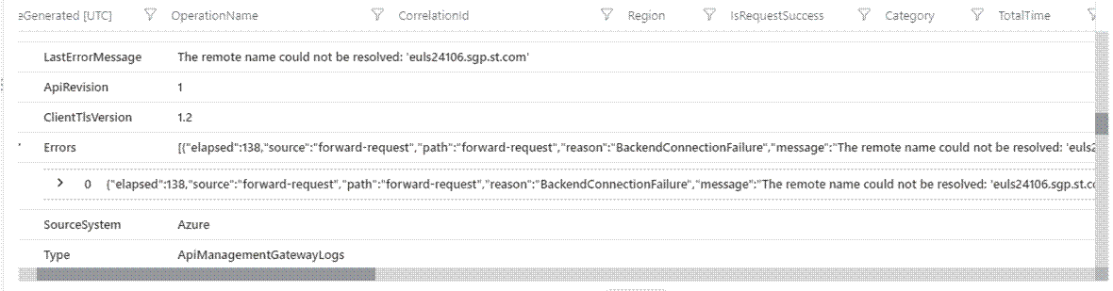

**Events and functions call errors: Check function calls are working fine:**

Machine generated alternative text:
Home Function App 
Function App 
nc-genesys-leave-pr 
-genesys-leave-pr I Configuration 
CD Refresh Save X Discard Leave Feedback 
x 
Ill azfunc 
1.1 
8unction App 
P Search (Ctrl+/) 
Functions 
Functions 
App keys 
App files 
proxies 
Deployment 
STMicroeIectronics (stmicroelectronics.onmicrosof... 
+ Create Manage view v 
Filter for any field... 
Name 
(.9 azfunc-genesys-cmdm-pr 
azfunc-genesys-cmdm-qa 
azfunc-genesys-leave-pr 
(.9 azfunc-genesys-leave-qa 
(.9 azfunc-genesys-prappraval-pr 
(.9 azfunc-genesys-prappraval-qa 
(.9 azfunction-spanline 
(.9 azfunction-spanline-qa 
mailtestapp 
Application settings 
Application settings 
Function runtime settings 
General settings 
Application settings are encrypted at rest and transmitted over an encrypted channel. You can choose to display 
them in plain text in your browser by using the controls below. Application Settings are exposed as environment 
variables for access by your application at runtime. Learn more 
+ New application setting Show values Advanced edit 
@ Key vault Reference 
@ Key vault Reference 
App Service Config 
Deployment slots 
Deployment Center 
Settings 
Configuration 
Authentication 
Applic.tion Insights 
Identity 
Filter application settings 
Name 
AAD CLIENT 
AAD CLIENT SECRET 
APPINSIGHTS INSTRUMENTATIONKEY 
APPLICATIONINSIGHTS CONNECTION STRIN 
Value 
Hidden value. Click to show value 
Hidden value. Click to show value 
Hidden value. Click to show value 
Hidden value. Click to show value 
of 1 
Pace 
v 

Machine generated alternative text:
appinsights-genesys-prod I Transaction search 
p 
z," 0/2022.6:07;" PM 
Nodata is this 
Z," "2022. 6707;" AM 

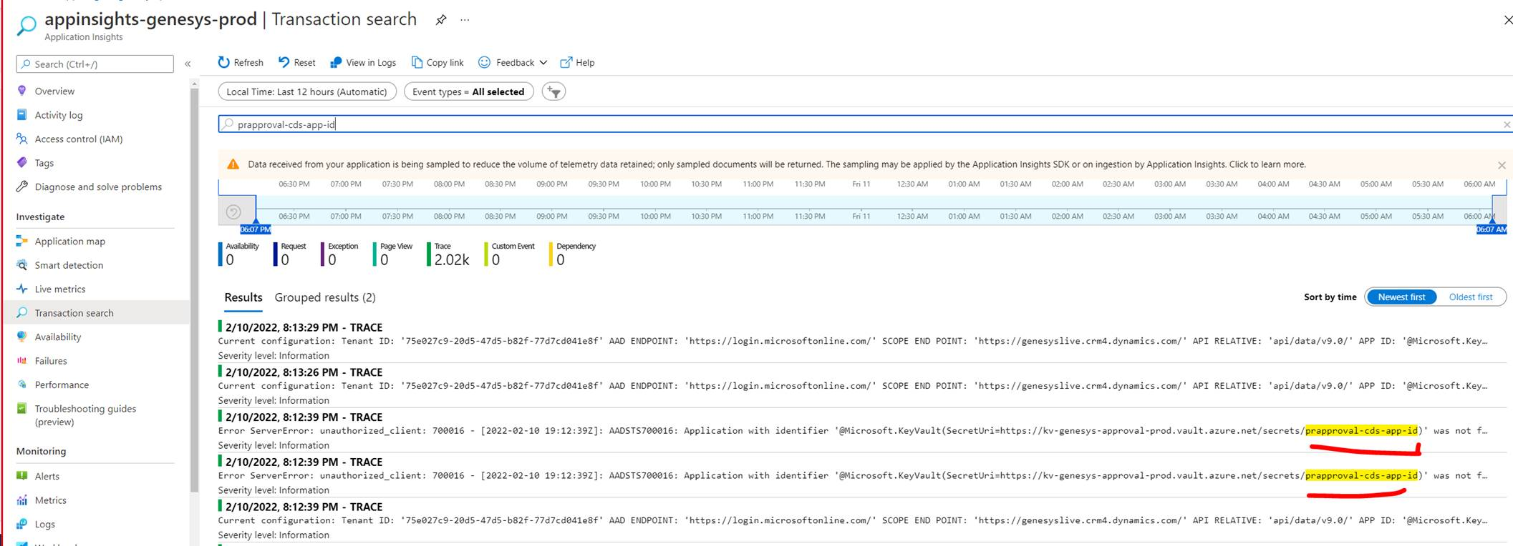

Machine generated alternative text:
Home Log Analytics workspaces la-prod-genesys100 
la-prod-genesys100 1 Logs 
Run 
Time range : Last 24 hours 
sort by TimeGenerated desc 
Save v 
e Share v 
+ New alert rule 
by time (latest logs 
e, _ Resourceld I sort by... 
p 
Log Analytics workspace 
Search (Ctrl+/) 
Agents configuration 
Custom logs 
Computer Groups 
Data Export 
Linked storage accounts 
Neftvork Isolation 
la-prod-genesysl 00 Select scope 
Tables Queries 
Functions 
p function 
Group by. Category v 
Collapse all 
Applications 
Function activity over time 
Function Error rate 
Function results 
Show application logs from 
Function Apps 
Show application logs from Function Apps 
Run Load to editor 
Description 
A list of application logs, sorted by time (latest logs shown first). 
General 
Workspace summary 
Workbooks 
Logs 
Solutions 
Information 
Example query 
- Created by Microsoft 

QA:

[https://api-genesys-qa.st.com](https://api-genesys-qa.st.com/) (F5)

23000 ==> AHLR

<https://api-genesys-qa.st.com/ahlr>

<https://server1.st.com:23000/ahlr>

<https://server2.st.com:23000/ahlr>

23000 ==> AHLR

<https://api-genesys-qa.st.com/ahlr>

<https://server1.st.com:23000/ahlr>

<https://server2.st.com:23000/ahlr>

10000 ==> LDAP / USERMNG

<https://api-genesys-qa.st.com/ldap> or

<https://api-genesys-qa.st.com/usermng>

<https://server1.st.com:10000/ldap>

<https://server2.st.com:10000/ldap>

and

<https://server1.st.com:10000/usermng>

[https://server2.st.com:100](https://server2.st.com:10000/usermng)QA:

[https://api-genesys-qa.st.com](https://api-genesys-qa.st.com/) (F5)

10000 ==> LDAP / USERMNG

<https://api-genesys-qa.st.com/ldap> or

<https://api-genesys-qa.st.com/usermng>

<https://server1.st.com:10000/ldap>

<https://server2.st.com:10000/ldap>

and

<https://server1.st.com:10000/usermng>

<https://server2.st.com:10000/usermng>

[00/usermng](https://server2.st.com:10000/usermng)