Que 9 :

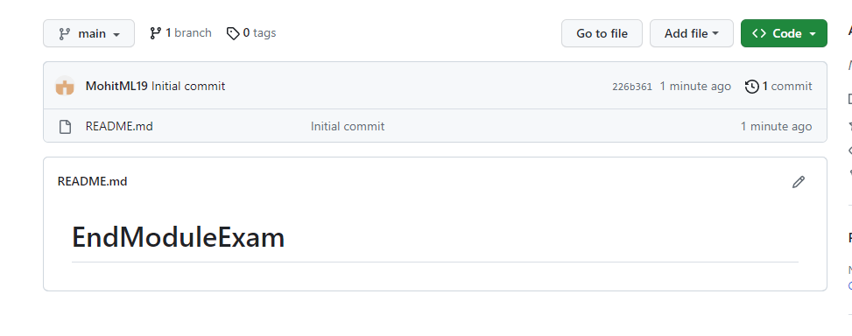

Que 10

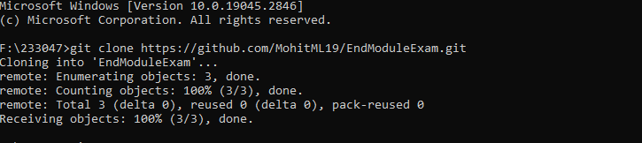

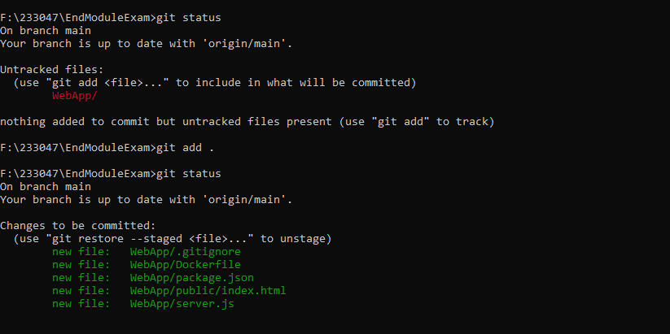

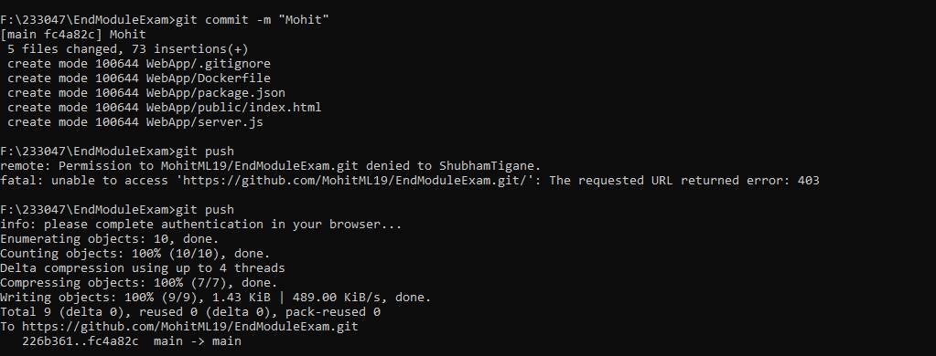

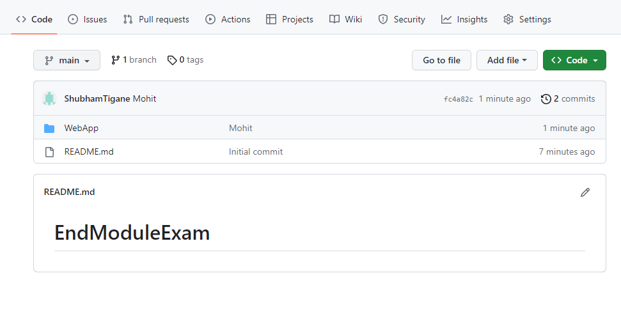

Que 11

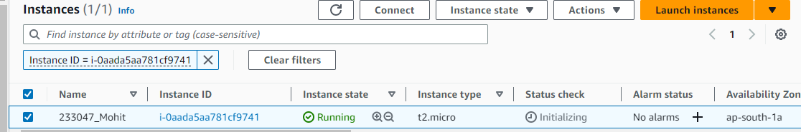

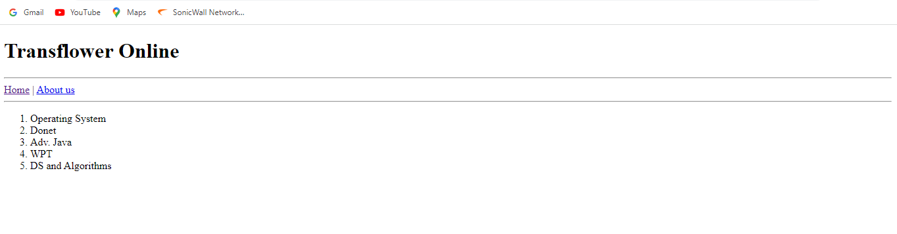

Que 13,14,15,16,17,18,19

Using username "ubuntu".

Authenticating with public key "mml"

Welcome to Ubuntu 22.04.2 LTS (GNU/Linux 5.15.0-1031-aws x86_64)

* Documentation: https://help.ubuntu.com

* Management: https://landscape.canonical.com

* Support: https://ubuntu.com/advantage

System information as of Wed May 17 05:55:30 UTC 2023

System load: 0.39990234375 Processes: 103

Usage of /: 20.1% of 7.57GB Users logged in: 0

Memory usage: 20% IPv4 address for eth0: 172.31.43.121

Swap usage: 0%

Expanded Security Maintenance for Applications is not enabled.

0 updates can be applied immediately.

Enable ESM Apps to receive additional future security updates.

See https://ubuntu.com/esm or run: sudo pro status

The list of available updates is more than a week old.

To check for new updates run: sudo apt update

The programs included with the Ubuntu system are free software;

the exact distribution terms for each program are described in the

individual files in /usr/share/doc/*/copyright.

Ubuntu comes with ABSOLUTELY NO WARRANTY, to the extent permitted by

applicable law.

To run a command as administrator (user "root"), use "sudo <command>".

See "man sudo_root" for details.

ubuntu@ip-172-31-43-121:~$ sudo apt update

Hit:1 http://ap-south-1.ec2.archive.ubuntu.com/ubuntu jammy InRelease

Get:2 http://ap-south-1.ec2.archive.ubuntu.com/ubuntu jammy-updates InRelease [119 kB]

Get:3 http://ap-south-1.ec2.archive.ubuntu.com/ubuntu jammy-backports InRelease [108 kB]

Get:4 http://security.ubuntu.com/ubuntu jammy-security InRelease [110 kB]

Get:5 http://ap-south-1.ec2.archive.ubuntu.com/ubuntu jammy/universe amd64 Packages [14.1 MB]

Get:6 http://ap-south-1.ec2.archive.ubuntu.com/ubuntu jammy/universe Translation-en [5652 kB]

Get:7 http://ap-south-1.ec2.archive.ubuntu.com/ubuntu jammy/universe amd64 c-n-f Metadata [286 kB]

Get:8 http://ap-south-1.ec2.archive.ubuntu.com/ubuntu jammy/multiverse amd64 Packages [217 kB]

Get:9 http://ap-south-1.ec2.archive.ubuntu.com/ubuntu jammy/multiverse Translation-en [112 kB]

Get:10 http://ap-south-1.ec2.archive.ubuntu.com/ubuntu jammy/multiverse amd64 c-n-f Metadata [8372 B]

Get:11 http://ap-south-1.ec2.archive.ubuntu.com/ubuntu jammy-updates/main amd64 Packages [604 kB]

Get:12 http://ap-south-1.ec2.archive.ubuntu.com/ubuntu jammy-updates/main Translation-en [170 kB]

Get:13 http://ap-south-1.ec2.archive.ubuntu.com/ubuntu jammy-updates/main amd64 c-n-f Metadata [14.4 kB]

Get:14 http://ap-south-1.ec2.archive.ubuntu.com/ubuntu jammy-updates/restricted amd64 Packages [271 kB]

Get:15 http://ap-south-1.ec2.archive.ubuntu.com/ubuntu jammy-updates/restricted Translation-en [41.3 kB]

Get:16 http://ap-south-1.ec2.archive.ubuntu.com/ubuntu jammy-updates/restricted amd64 c-n-f Metadata [604 B]

Get:17 http://ap-south-1.ec2.archive.ubuntu.com/ubuntu jammy-updates/universe amd64 Packages [898 kB]

Get:18 http://ap-south-1.ec2.archive.ubuntu.com/ubuntu jammy-updates/universe Translation-en [184 kB]

Get:19 http://ap-south-1.ec2.archive.ubuntu.com/ubuntu jammy-updates/universe amd64 c-n-f Metadata [18.8 kB]

Get:20 http://ap-south-1.ec2.archive.ubuntu.com/ubuntu jammy-updates/multiverse amd64 Packages [35.3 kB]

Get:21 http://ap-south-1.ec2.archive.ubuntu.com/ubuntu jammy-updates/multiverse Translation-en [8452 B]

Get:22 http://ap-south-1.ec2.archive.ubuntu.com/ubuntu jammy-updates/multiverse amd64 c-n-f Metadata [468 B]

Get:23 http://ap-south-1.ec2.archive.ubuntu.com/ubuntu jammy-backports/main amd64 Packages [40.9 kB]

Get:24 http://ap-south-1.ec2.archive.ubuntu.com/ubuntu jammy-backports/main Translation-en [10.2 kB]

Get:25 http://ap-south-1.ec2.archive.ubuntu.com/ubuntu jammy-backports/main amd64 c-n-f Metadata [388 B]

Get:26 http://ap-south-1.ec2.archive.ubuntu.com/ubuntu jammy-backports/restricted amd64 c-n-f Metadata [116 B]

Get:27 http://ap-south-1.ec2.archive.ubuntu.com/ubuntu jammy-backports/universe amd64 Packages [22.2 kB]

Get:28 http://ap-south-1.ec2.archive.ubuntu.com/ubuntu jammy-backports/universe Translation-en [15.0 kB]

Get:29 http://security.ubuntu.com/ubuntu jammy-security/main amd64 Packages [388 kB]

Get:30 http://ap-south-1.ec2.archive.ubuntu.com/ubuntu jammy-backports/universe amd64 c-n-f Metadata [548 B]

Get:31 http://ap-south-1.ec2.archive.ubuntu.com/ubuntu jammy-backports/multiverse amd64 c-n-f Metadata [116 B]

Get:32 http://security.ubuntu.com/ubuntu jammy-security/main Translation-en [111 kB]

Get:33 http://security.ubuntu.com/ubuntu jammy-security/main amd64 c-n-f Metadata [9744 B]

Get:34 http://security.ubuntu.com/ubuntu jammy-security/restricted amd64 Packages [270 kB]

Get:35 http://security.ubuntu.com/ubuntu jammy-security/restricted Translation-en [41.0 kB]

Get:36 http://security.ubuntu.com/ubuntu jammy-security/restricted amd64 c-n-f Metadata [604 B]

Get:37 http://security.ubuntu.com/ubuntu jammy-security/universe amd64 Packages [709 kB]

Get:38 http://security.ubuntu.com/ubuntu jammy-security/universe Translation-en [123 kB]

Get:39 http://security.ubuntu.com/ubuntu jammy-security/universe amd64 c-n-f Metadata [14.4 kB]

Get:40 http://security.ubuntu.com/ubuntu jammy-security/multiverse amd64 Packages [30.2 kB]

Get:41 http://security.ubuntu.com/ubuntu jammy-security/multiverse Translation-en [5828 B]

Get:42 http://security.ubuntu.com/ubuntu jammy-security/multiverse amd64 c-n-f Metadata [252 B]

Fetched 24.7 MB in 9s (2777 kB/s)

Reading package lists... Done

Building dependency tree... Done

Reading state information... Done

45 packages can be upgraded. Run 'apt list --upgradable' to see them.

ubuntu@ip-172-31-43-121:~$ sudo apt install

Reading package lists... Done

Building dependency tree... Done

Reading state information... Done

0 upgraded, 0 newly installed, 0 to remove and 45 not upgraded.

ubuntu@ip-172-31-43-121:~$ sudo apt install docker.io

Reading package lists... Done

Building dependency tree... Done

Reading state information... Done

The following additional packages will be installed:

bridge-utils containerd dns-root-data dnsmasq-base pigz runc ubuntu-fan

Suggested packages:

ifupdown aufs-tools cgroupfs-mount | cgroup-lite debootstrap docker-doc rinse zfs-fuse | zfsutils

The following NEW packages will be installed:

bridge-utils containerd dns-root-data dnsmasq-base docker.io pigz runc ubuntu-fan

0 upgraded, 8 newly installed, 0 to remove and 45 not upgraded.

Need to get 72.4 MB of archives.

After this operation, 287 MB of additional disk space will be used.

Do you want to continue? [Y/n] y

Get:1 http://ap-south-1.ec2.archive.ubuntu.com/ubuntu jammy/universe amd64 pigz amd64 2.6-1 [63.6 kB]

Get:2 http://ap-south-1.ec2.archive.ubuntu.com/ubuntu jammy/main amd64 bridge-utils amd64 1.7-1ubuntu3 [34.4 kB]

Get:3 http://ap-south-1.ec2.archive.ubuntu.com/ubuntu jammy-updates/main amd64 runc amd64 1.1.4-0ubuntu1~22.04.2 [4242 kB]

Get:4 http://ap-south-1.ec2.archive.ubuntu.com/ubuntu jammy-updates/main amd64 containerd amd64 1.6.12-0ubuntu1~22.04.1 [34.4 MB]

Get:5 http://ap-south-1.ec2.archive.ubuntu.com/ubuntu jammy/main amd64 dns-root-data all 2021011101 [5256 B]

Get:6 http://ap-south-1.ec2.archive.ubuntu.com/ubuntu jammy-updates/main amd64 dnsmasq-base amd64 2.86-1.1ubuntu0.3 [354 kB]

Get:7 http://ap-south-1.ec2.archive.ubuntu.com/ubuntu jammy-updates/universe amd64 docker.io amd64 20.10.21-0ubuntu1~22.04.3 [33.3 MB]

Get:8 http://ap-south-1.ec2.archive.ubuntu.com/ubuntu jammy/universe amd64 ubuntu-fan all 0.12.16 [35.2 kB]

Fetched 72.4 MB in 4s (16.4 MB/s)

Preconfiguring packages ...

Selecting previously unselected package pigz.

(Reading database ... 63657 files and directories currently installed.)

Preparing to unpack .../0-pigz_2.6-1_amd64.deb ...

Unpacking pigz (2.6-1) ...

Selecting previously unselected package bridge-utils.

Preparing to unpack .../1-bridge-utils_1.7-1ubuntu3_amd64.deb ...

Unpacking bridge-utils (1.7-1ubuntu3) ...

Selecting previously unselected package runc.

Preparing to unpack .../2-runc_1.1.4-0ubuntu1~22.04.2_amd64.deb ...

Unpacking runc (1.1.4-0ubuntu1~22.04.2) ...

Selecting previously unselected package containerd.

Preparing to unpack .../3-containerd_1.6.12-0ubuntu1~22.04.1_amd64.deb ...

Unpacking containerd (1.6.12-0ubuntu1~22.04.1) ...

Selecting previously unselected package dns-root-data.

Preparing to unpack .../4-dns-root-data_2021011101_all.deb ...

Unpacking dns-root-data (2021011101) ...

Selecting previously unselected package dnsmasq-base.

Preparing to unpack .../5-dnsmasq-base_2.86-1.1ubuntu0.3_amd64.deb ...

Unpacking dnsmasq-base (2.86-1.1ubuntu0.3) ...

Selecting previously unselected package docker.io.

Preparing to unpack .../6-docker.io_20.10.21-0ubuntu1~22.04.3_amd64.deb ...

Unpacking docker.io (20.10.21-0ubuntu1~22.04.3) ...

Selecting previously unselected package ubuntu-fan.

Preparing to unpack .../7-ubuntu-fan_0.12.16_all.deb ...

Unpacking ubuntu-fan (0.12.16) ...

Setting up dnsmasq-base (2.86-1.1ubuntu0.3) ...

Setting up runc (1.1.4-0ubuntu1~22.04.2) ...

Setting up dns-root-data (2021011101) ...

Setting up bridge-utils (1.7-1ubuntu3) ...

Setting up pigz (2.6-1) ...

Setting up containerd (1.6.12-0ubuntu1~22.04.1) ...

Created symlink /etc/systemd/system/multi-user.target.wants/containerd.service → /lib/systemd/system/containerd.service.

Setting up ubuntu-fan (0.12.16) ...

Created symlink /etc/systemd/system/multi-user.target.wants/ubuntu-fan.service → /lib/systemd/system/ubuntu-fan.service.

Setting up docker.io (20.10.21-0ubuntu1~22.04.3) ...

Adding group `docker' (GID 122) ...

Done.

Created symlink /etc/systemd/system/multi-user.target.wants/docker.service → /lib/systemd/system/docker.service.

Created symlink /etc/systemd/system/sockets.target.wants/docker.socket → /lib/systemd/system/docker.socket.

Processing triggers for dbus (1.12.20-2ubuntu4.1) ...

Processing triggers for man-db (2.10.2-1) ...

Scanning processes...

Scanning linux images...

Running kernel seems to be up-to-date.

No services need to be restarted.

No containers need to be restarted.

No user sessions are running outdated binaries.

No VM guests are running outdated hypervisor (qemu) binaries on this host.

ubuntu@ip-172-31-43-121:~$ git clone https://github.com/MohitML19/EndModuleExam.git

Cloning into 'EndModuleExam'...

remote: Enumerating objects: 12, done.

remote: Counting objects: 100% (12/12), done.

remote: Compressing objects: 100% (8/8), done.

remote: Total 12 (delta 0), reused 9 (delta 0), pack-reused 0

Receiving objects: 100% (12/12), done.

ubuntu@ip-172-31-43-121:~$ sudo docker run -d -p practice .

docker: Invalid containerPort: practice.

See 'docker run --help'.

ubuntu@ip-172-31-43-121:~$ sudo docker build -t practice .

unable to prepare context: unable to evaluate symlinks in Dockerfile path: lstat /home/ubuntu/Dockerfile: no such file or directory

ubuntu@ip-172-31-43-121:~$ ls

EndModuleExam

ubuntu@ip-172-31-43-121:~$ cd EndModuleExam/

ubuntu@ip-172-31-43-121:~/EndModuleExam$ cd WebApp/

ubuntu@ip-172-31-43-121:~/EndModuleExam/WebApp$ sudo docker build -t practice .

Sending build context to Docker daemon 7.68kB

Step 1/7 : FROM node:18

18: Pulling from library/node

918547b94326: Pull complete

5d79063a01c5: Pull complete

4eedd9c5abf7: Pull complete

9cdadd40055f: Pull complete

b58a51cba8a5: Pull complete

5779d144b348: Pull complete

0ebc6b9148c5: Pull complete

0c858c110602: Pull complete

Digest: sha256:3f567a26b6b6d601fb2b168d4f987b50697617ead15bfc0e0152e600ac48d0fe

Status: Downloaded newer image for node:18

---> acb969b80f38

Step 2/7 : WORKDIR /app

---> Running in cd242fc8da92

Removing intermediate container cd242fc8da92

---> 2f67b8a437ef

Step 3/7 : COPY package.json /app

---> df91b078e595

Step 4/7 : RUN npm install

---> Running in b06801848f21

added 58 packages, and audited 59 packages in 2s

8 packages are looking for funding

run `npm fund` for details

found 0 vulnerabilities

npm notice

npm notice New minor version of npm available! 9.5.1 -> 9.6.6

npm notice Changelog: <https://github.com/npm/cli/releases/tag/v9.6.6>

npm notice Run `npm install -g npm@9.6.6` to update!

npm notice

Removing intermediate container b06801848f21

---> dcf3c2008fd1

Step 5/7 : COPY . /app

---> ea4a858fbc2b

Step 6/7 : CMD node server.js

---> Running in 84c41bbdaa06

Removing intermediate container 84c41bbdaa06

---> 7d86ca6ca844

Step 7/7 : EXPOSE 7667

---> Running in f937d2ce15b3

Removing intermediate container f937d2ce15b3

---> 284d4c857a33

Successfully built 284d4c857a33

Successfully tagged practice:latest

ubuntu@ip-172-31-43-121:~/EndModuleExam/WebApp$ sudo docker run -d -p 1234:7667 practice

1b11b21e0f51ddee5582ee075bfcd60dc58cd50cff4a1f0c934ed3f94b2bfe09

ubuntu@ip-172-31-43-121:~/EndModuleExam/WebApp$