**CHAPTER : 1 | INTRODUCTION**

1.1 *Motivation………………………………………………………….*

Facial emotion detection systems are developed with the aim of improving various aspects of human-computer interaction and understanding human emotions. Here are some motivations behind creating such systems:

1. **Enhancing User Experience:** By accurately detecting facial expressions, systems can better understand user emotions, leading to more personalized and responsive interactions. This can improve user satisfaction in applications ranging from gaming to customer service.
2. **Human-Computer Interaction:** Facial emotion detection enables computers to interpret human emotions, making interactions more intuitive and natural. This is particularly valuable in applications like virtual assistants, where understanding emotional context can enhance communication.
3. **Psychological Research:** Researchers use facial emotion detection systems to study human emotions and behaviour. These systems provide quantitative data on emotional responses, aiding studies in psychology, sociology, and human-computer interaction.
4. **Medical Applications:** Facial emotion detection can be used in healthcare to assess patients' emotional states, aiding in diagnosis and treatment. For example, it can help detect signs of depression or anxiety in patients.
5. **Security and Surveillance:** In security applications, facial emotion detection can help identify suspicious behaviour or individuals exhibiting signs of distress. This can be valuable in public safety and surveillance systems.
6. **Education and Learning:** In educational settings, facial emotion detection can be used to gauge students' engagement and emotional responses during lessons. This information can help educators tailor their teaching methods to individual students' needs.

1.2 *Scope………………………………………………………………..*

The scope of facial emotion detection systems is broad and encompasses various domains and applications. Here are some key areas where these systems can be applied:

1. **Human-Computer Interaction (HCI):** Facial emotion detection enhances HCI by enabling computers to interpret human emotions, leading to more intuitive and personalized interactions. This is applicable in areas such as virtual assistants, gaming, and user interfaces.
2. **Healthcare:** In healthcare, facial emotion detection systems can assist in assessing patients' emotional states, aiding in diagnosis, treatment, and therapy for conditions like depression, anxiety, and autism spectrum disorders.
3. **Education:** These systems can be used in educational settings to gauge students' emotional responses and engagement during lessons, helping educators tailor teaching methods to individual needs and improve learning outcomes.
4. **Market Research and Advertising:** Companies use facial emotion detection to analyse consumers' emotional responses to products, advertisements, and marketing campaigns, informing the design of more effective strategies.
5. **Security and Surveillance:** Facial emotion detection can aid in security and surveillance applications by identifying suspicious behaviour or individuals exhibiting signs of distress, enhancing public safety measures.
6. **Psychological Research:** Researchers use facial emotion detection systems to study human emotions and behaviour, providing quantitative data for studies in psychology, sociology, and human-computer interaction.
7. **Accessibility:** For individuals with disabilities, facial emotion detection systems provide alternative means of communication and interaction, assisting those with conditions like autism spectrum disorders in understanding and expressing emotions.
8. **Emotionally Intelligent Systems:** Facial emotion detection contributes to the development of emotionally intelligent systems that can understand and respond to human emotions in a more nuanced and empathetic manner.
9. **Cultural Analysis:** These systems can be used to analyse cultural differences in emotional expressions, contributing to cross-cultural research and understanding.

1.3 *Objective…...………………………………………………............*

The objective of a facial emotion detection system is to accurately recognize and interpret human emotions from facial expressions captured in images or videos. The primary goals of such systems include:

1. **Emotion Recognition:** The system should accurately identify and classify facial expressions into different emotional categories such as happiness, sadness, anger, fear, surprise, disgust, and neutrality.
2. **Real-time Processing:** For applications requiring real-time interaction, such as virtual assistants or gaming, the system should process facial expressions quickly and efficiently to provide timely responses.
3. **Robustness:** The system should be robust to variations in lighting conditions, facial orientations, facial occlusions, and individual differences in facial appearances to ensure reliable performance in diverse settings.
4. **Accuracy:** Achieving high accuracy in emotion detection is crucial to ensure that the system can reliably interpret subtle facial cues and accurately infer the underlying emotional states of individuals.
5. **Adaptability:** The system should be adaptable to different demographic groups, cultural contexts, and application scenarios, allowing for generalization across diverse populations and environments.
6. **User Experience Enhancement:** By accurately detecting and responding to user emotions, the system aims to enhance user experience in various human-computer interaction applications, making interactions more intuitive, engaging, and personalized.
7. **Insight Generation:** In research and psychological applications, the system aims to generate insights into human emotions and behaviour by analysing large datasets of facial expressions and correlating them with contextual information.
8. **Integration:** Depending on the application, the system may need to integrate with other technologies such as natural language processing, gesture recognition, or physiological sensors to provide a comprehensive understanding of users' emotional states.
9. **Privacy and Ethical Considerations:** Ensuring user privacy and handling sensitive facial data ethically are important objectives for facial emotion detection systems. Robust privacy measures and ethical guidelines should be incorporated into the design and deployment of such systems.

1.4 *Application…………………………………………………………*

Facial emotion detection systems have a wide range of applications across various domains. Here are some common applications:

1. Human-Computer Interaction (HCI):

* **Virtual Assistants:** Facial emotion detection can be used to enhance the interaction between users and virtual assistants by enabling the system to recognize and respond to users' emotions, creating a more personalized and engaging experience.
* **Gaming:** In gaming, facial emotion detection can be used to create more immersive experiences by allowing game characters to react to the player's facial expressions in real-time.

1. Healthcare:

* **Mental Health Monitoring:** Facial emotion detection systems can assist healthcare professionals in monitoring patients' emotional states, especially in conditions like depression, anxiety, and autism spectrum disorders.
* **Pain Assessment:** These systems can be used to assess pain levels in patients who may have difficulty communicating verbally, such as infants or individuals with cognitive impairments.

1. Education:

* **Student Engagement:** Facial emotion detection can help educators gauge students' engagement levels during lessons, allowing for more personalized teaching approaches and interventions.
* **Special Education:** In special education, these systems can aid in understanding and supporting students with emotional or developmental challenges.

1. Marketing and Advertising:

* **Consumer Research:** Facial emotion detection can be used in market research to analyse consumers' emotional responses to products, advertisements, and marketing campaigns, providing valuable insights for product development and advertising strategies.

1. Security and Surveillance:

* **Public Safety:** Facial emotion detection systems can be deployed in security cameras to identify suspicious behaviour or individuals displaying signs of distress, enhancing public safety measures in public spaces.
* **Access Control:** In access control systems, facial emotion detection can supplement traditional biometric authentication methods by detecting emotional states, helping to prevent unauthorized access.

CHAPTER : 2 | SURVEY

2.1 *Literature Survey…………………………………………………..*

A comprehensive literature survey on facial emotion detection systems would involve exploring research articles, conference papers, and academic publications across various disciplines such as computer vision, machine learning, psychology, and human-computer interaction. Here's a structured approach to conducting a literature review on this topic:

1. **Database Search:** Begin by searching academic databases such as IEEE Xplore, PubMed, Google Scholar, and ACM Digital Library using relevant keywords such as "facial emotion detection," "facial expression recognition," "emotion recognition," and "computer vision."
2. **Filtering and Selection:** Narrow down the search results based on relevance, publication date, and citation count. Focus on peer-reviewed articles, conference papers, and seminal works in the field.
3. **Review of Key Concepts:** Familiarize yourself with the fundamental concepts and techniques used in facial emotion detection, including facial feature extraction, machine learning algorithms, dataset creation, and evaluation metrics.
4. **Historical Overview:** Explore early works and foundational papers in facial emotion detection, tracing the evolution of techniques and methodologies over time.
5. **State-of-the-Art Methods:** Identify recent advancements and state-of-the-art methods in facial emotion detection. Pay attention to novel approaches, architectures, and algorithms that have demonstrated superior performance in benchmark datasets.
6. **Challenges and Limitations:** Analyse the challenges and limitations associated with existing facial emotion detection systems, such as robustness to variations in lighting, occlusions, pose, and cultural differences.
7. **Applications and Use Cases:** Examine the diverse applications and use cases of facial emotion detection systems across different domains, including healthcare, education, entertainment, marketing, security, and human-computer interaction.
8. **Datasets and Benchmarks:** Investigate popular datasets and benchmarks used for training and evaluating facial emotion detection models, such as the CK+ dataset, MMI dataset, and Affect Net dataset.

*2.2 Conclusion………………………………………………………….*

The literature survey on facial emotion detection systems provides a comprehensive understanding of the current state, challenges, and future directions of this field. Here's a concise conclusion drawn from the survey:

Facial emotion detection systems have undergone significant advancement, driven primarily by developments in deep learning techniques and the availability of large-scale annotated datasets. These systems play a crucial role in various applications, including human-computer interaction, healthcare, education, marketing, security, and entertainment.

Key findings from the literature survey include:

1. **Technological Evolution**: The evolution of facial emotion detection techniques from handcrafted features to deep learning architectures has resulted in substantial improvements in accuracy and robustness.
2. **Challenges and Limitations:** Despite progress, challenges such as robustness to variations in lighting, pose, occlusions, and cultural differences persist. Addressing these challenges is essential for deploying reliable systems in real-world scenarios.
3. **Applications:** Facial emotion detection systems find applications in diverse domains, ranging from personalized user experiences to mental health monitoring and security surveillance.
4. **Datasets and Benchmarks:** The availability of annotated datasets and standardized benchmarks facilitates research and evaluation in facial emotion detection. However, there is a need for more diverse and culturally inclusive datasets.
5. **Evaluation Metrics:** Researchers commonly use metrics such as accuracy, precision, recall, and F1-score to evaluate system performance. However, comprehensive evaluation frameworks are necessary to capture the system's performance accurately.

CHAPTER : 3 | PROBLEM STATEMENT

*3.1 Problem Statement…………………………………….................*

Facial emotion recognition (FER) technology plays a crucial role in various applications, including human-computer interaction, affective computing, and mental health monitoring. However, existing FER systems face several challenges related to accuracy, robustness, real-time processing, and generalizability across diverse demographic groups and cultural backgrounds.

The primary objective of this project is to design and implement a facial emotion recognition system that addresses the following key challenges:

1. **Accuracy:** Develop advanced machine learning algorithms and deep learning models capable of accurately detecting and classifying a wide range of facial expressions, including subtle nuances and variations in emotional states.
2. **Robustness**: Enhance the robustness of the system to environmental factors such as changes in lighting conditions, facial occlusions, head movements, and variations in facial appearance due to factors like age, gender, and ethnicity.
3. **Real-time Processing:** Design efficient algorithms and optimization techniques to enable real-time processing of facial emotion recognition tasks, ensuring low latency and high responsiveness for interactive applications.
4. **Cross-dataset Generalization:** Address the challenge of generalizing the FER model across diverse datasets representing different demographic groups, cultural backgrounds, and environmental conditions, to ensure the system's effectiveness in real-world scenarios.
5. **Multi-modal Integration:** Explore the integration of multiple modalities (e.g., facial expressions, voice, body language) to improve the accuracy and robustness of emotion recognition, enabling a more holistic understanding of human affective states.

CHAPTER : 4 | MINIMUM REQUIREMENTS

*4.1 Software Requirement……………………………………………*

Software requirements for a facial emotion recognition system typically encompass a range of components, including libraries, frameworks, and tools for image processing, machine learning, and user interface development. Here's a list of software requirements commonly needed for developing such a system:

1. **Programming Language:**

Choose a programming language suitable for implementing machine learning algorithms, image processing, and user interface development. Popular choices include Python, C++, and Java.

1. **Machine Learning Libraries:**TensorFlow: An open-source machine learning framework developed by Google for building and training deep neural networks.PyTorch: Another popular deep learning library known for its flexibility and ease of use.scikit-learn: A machine learning library in Python that provides simple and efficient tools for data mining and data analysis.Keras: High-level neural networks API, capable of running on top of TensorFlow, Theano, or Microsoft Cognitive Toolkit.
2. **Computer Vision Libraries:**OpenCV (Open Source Computer Vision Library): A library of programming functions mainly aimed at real-time computer vision.Dlib: A toolkit for machine learning and computer vision tasks, including facial landmark detection and face recognition.
3. **Facial Emotion Datasets:**

Access to datasets containing labeled facial images expressing various emotions is crucial for training and testing the emotion recognition model. Examples include CK+, FER2013, and AffectNet.

1. **IDE (Integrated Development Environment):**

Choose an IDE for coding, debugging, and testing the system. Options include:PyCharmVisual Studio CodeJupyter Notebook (for interactive data exploration and prototyping)

*4.2 Hardware Requirement……………………………….................*

The hardware requirements for a facial emotion recognition system depend on various factors, including the complexity of the algorithms, the scale of deployment, and the desired performance metrics. Here's a generalized list of hardware components and specifications typically needed for developing and deploying such a system:

1. **Processor (CPU):**A multi-core processor with sufficient processing power is essential for real-time facial emotion recognition tasks.For small-scale applications or prototyping, a modern quad-core CPU (e.g., Intel Core i5 or AMD Ryzen 5) should suffice.For larger-scale deployments or applications requiring higher processing power, consider using server-grade CPUs or high-performance computing (HPC) clusters.
2. **Graphics Processing Unit (GPU):**GPUs are crucial for accelerating the training and inference processes of deep learning models, which are commonly used in facial emotion recognition systems.NVIDIA GPUs are widely preferred due to their excellent support for deep learning frameworks like TensorFlow and PyTorch.For development and experimentation, a mid-range GPU (e.g., NVIDIA GeForce GTX 1060 or higher) is sufficient.For production deployments or applications with high computational demands, consider using high-end GPUs like NVIDIA Tesla or Quadro series.
3. **Memory (RAM):**Adequate RAM is necessary for storing and manipulating image data, intermediate results, and model parameters.For development purposes, a minimum of 8 GB RAM is recommended.For larger datasets and more complex models, consider 16 GB or higher RAM configurations.
4. **Storage (HDD/SSD):**SSDs (Solid State Drives) offer faster read/write speeds compared to traditional HDDs, which can improve overall system performance, especially during data loading and model training.For development purposes, a minimum of 256 GB SSD or HDD is recommended.For production deployments and storing large datasets, consider higher-capacity SSDs or HDDs, or utilize cloud-based storage solutions.
5. **Camera:**A high-resolution camera capable of capturing clear and detailed facial images is essential for input to the facial emotion recognition system.For desktop applications or prototype development, a standard webcam with HD (720p).

CHAPTER : 5 | METHODOLOGIES

*5.1 Methods………………..……………………………….................*

1. **Facial Landmark Detection:** Facial emotion recognition systems often begin by detecting and localizing facial landmarks such as the eyes, nose, mouth, and eyebrows. This feature extraction step helps identify regions of interest for further analysis.
2. **Feature Extraction:** After detecting facial landmarks, these systems extract features from the face that are indicative of different emotions. Features may include the shape of the mouth, the position of the eyebrows, wrinkles around the eyes, and overall facial expressions.
3. **Machine Learning Algorithms:** Facial emotion recognition systems employ machine learning algorithms to analyze extracted facial features and classify them into different emotional states. Commonly used algorithms include neural networks, and deep learning models such as convolutional neural networks (CNNs).
4. **Emotion Classification:** The core feature of these systems is their ability to classify facial expressions into discrete emotional categories such as happiness, sadness, anger, surprise, fear, disgust, and neutrality. Each emotional state is assigned a probability score indicating the likelihood of the detected emotion.
5. **Real-time Processing:** Many facial emotion recognition systems are designed to process facial expressions in real-time, enabling immediate responses or interventions based on detected emotions. Real-time processing is essential for applications such as interactive interfaces, virtual reality environments, and surveillance systems.

CHAPTER : 6 | DESIGH FRAMEWORK

6.1 *Data Flow Diagram…..………………………………................*

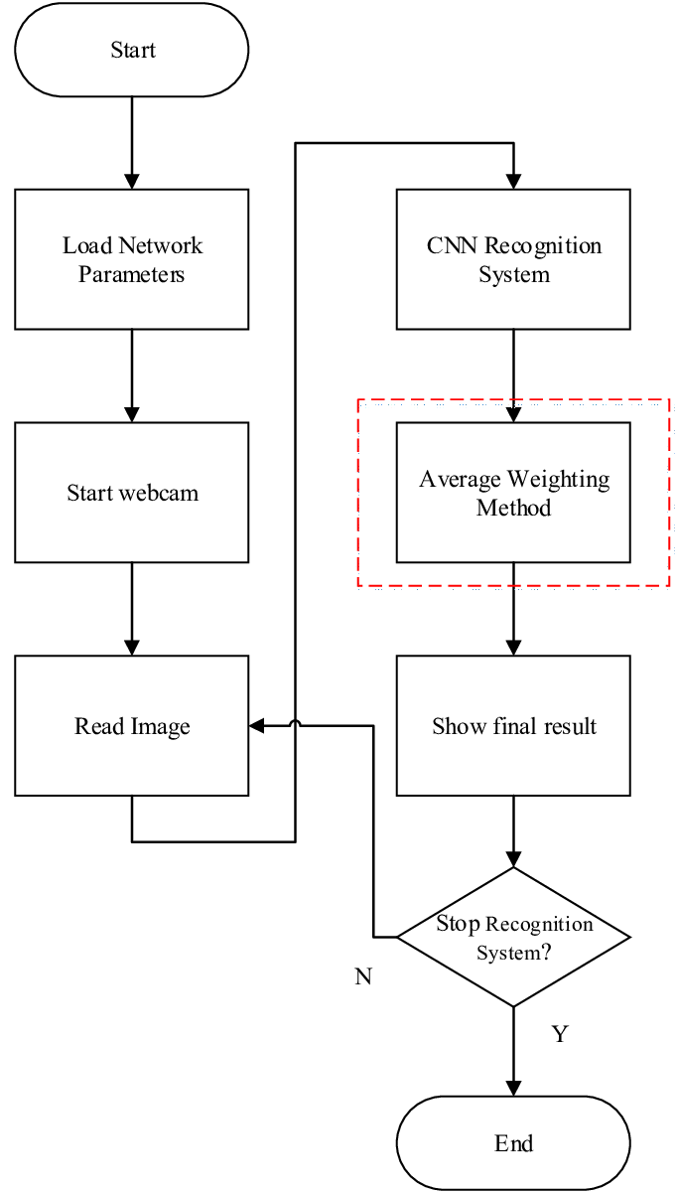

Fig 1 : Data Flow Diagram of Facial Emotion Recognition System

CHAPTER : 8 | CONCLUSION

*8.1 Conclusion…..…………………………………………................*

Facial emotion detection systems represent a significant advancement in human computer interaction, with far-reaching implications across various domains. While these systems have demonstrated remarkable accuracy and utility in recognizing and interpreting human emotions from facial expressions, they also come with ethical considerations and societal implications that must be carefully addressed. As we continue to innovate and refine facial emotion detection technology, it is imperative to prioritize ethical considerations such as privacy, fairness, transparency, and accountability. Proactive measures to mitigate biases, protect user privacy, and ensure responsible deployment are essential for fostering trust and acceptance among users.

*8.2 Future Scope..…………………………………………................*

1. **Human-Computer Interaction (HCI):**
   * Facial emotion recognition systems play a crucial role in HCI by enabling more natural and intuitive interactions between humans and computers.
   * Applications include virtual assistants, chatbots, and interactive systems in gaming and entertainment.
2. **Healthcare and Mental Health:**
   * These systems have significant potential in healthcare for diagnosing and monitoring mental health conditions such as depression, anxiety, and autism spectrum disorders.
   * They can assist therapists and healthcare professionals in assessing patients' emotional states and progress during therapy sessions.
3. **Market Research and Consumer Behavior:**
   * In marketing and consumer research, facial emotion recognition systems are used to analyze consumer reactions to products, advertisements, and user interfaces.
   * They help companies understand consumer preferences, improve product design, and tailor marketing strategies.
4. **Security and Surveillance:**
   * Facial emotion recognition systems contribute to security and surveillance efforts by identifying individuals displaying suspicious behavior or signs of distress in public spaces, airports, and other high-security areas.

REFRENCES :

* Internet Research
* Research Papers
* Prof. Satish Choudhary
* Prof. Reeta Bourasi

CHAPTER : 7 | IMPLEMENTATION

*7.1 Implementation…..………………………………........................*

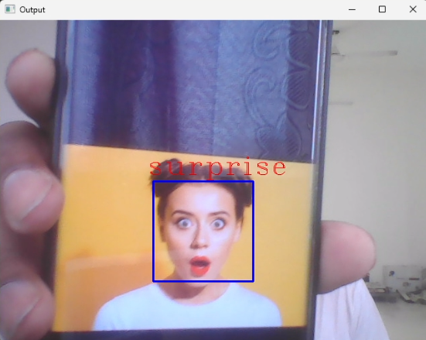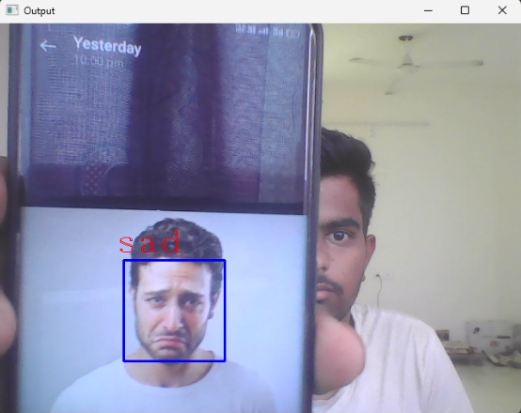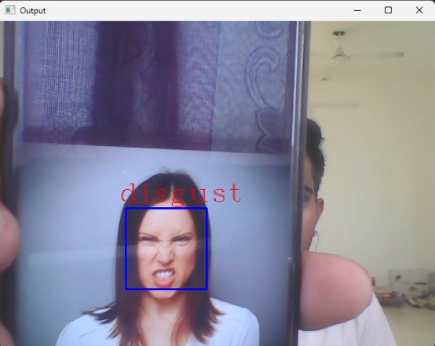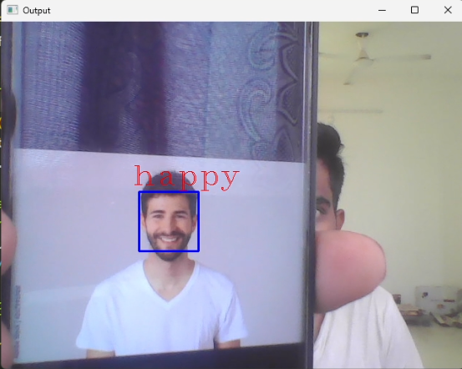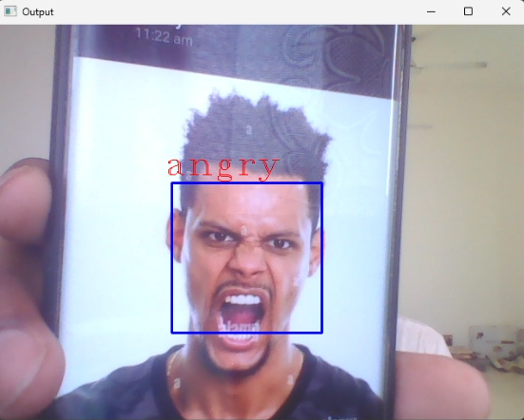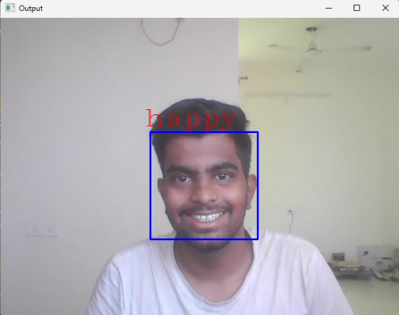

Fig 2 : Input and Output of the Code