Project Assignment
- An idea to Start a Brand?
- A lifestyle brand dedicated to zero waste living the brand sells environmentally friendly alternatives for everyday use such as bamboo toothbrushes reusable metal straws biodegradable bags and refillable products to encourage a low waste lifestyle.

- Name of the Brand?
- Greenest blends green for sustainability and nest for home representing a secure ecofriendly living that begins where we reside the name embodies the brand purpose of encouraging zero waste living through the provision of environmentally friendly products that enable people to construct a greener more accountable way of life.
03. Logo Explorations and Final Logo?

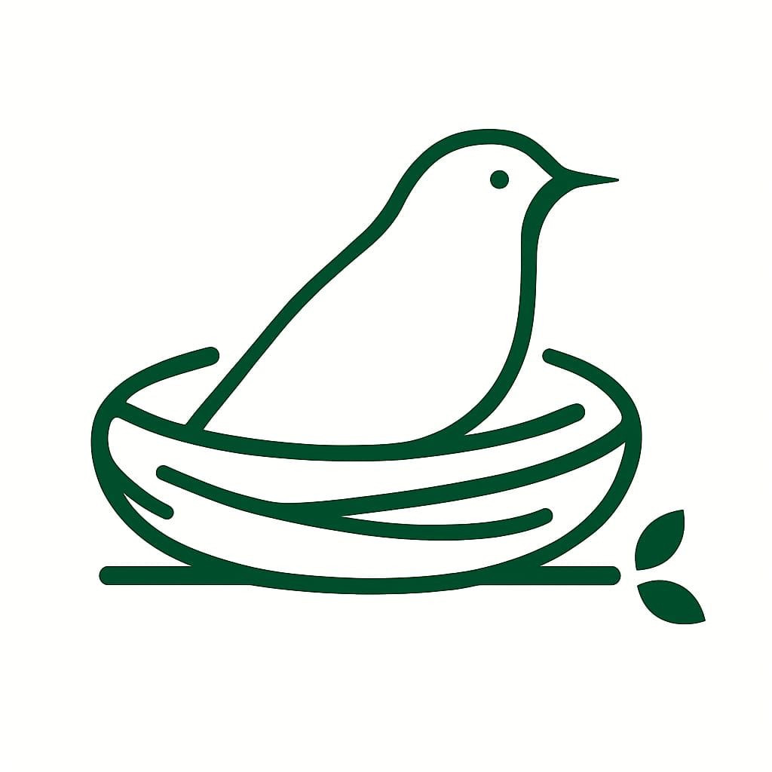

04. Colour Palette?
This colour creates a calming and natural balance fresh beige provides a clean and ecofriendly base and natural green and brown highlight greenness showing the organic and zero waste idea in a nice way.
05. Target Audience?
- Environmentally conscious individuals aged 20–45.

- Urban residents looking to reduce their carbon footprint.

- Students and professionals interested in sustainability.

- Households aiming to adopt eco-friendly lifestyles.

06 - Few screens of app to show how it works?

