Stock Market Program Project
- Explain Different types of trading based on time period. Also explain which one is most suitable for you and why?
- Scalping: Holding positions for seconds to minutes.

- Intraday Trading: Holding positions for same trading day.

- BTST/STBT (Buy Today Sell Tomorrow / Sell Today Buy Tomorrow): holding positions for 2 days.

- Swing Trading: holding positions for more than 2 days & less than a month.

- Positional Trading: Holding positions for more than 1 month & less than 6 months

- Long-Term Trading: Holding positions from 6 month to 1 year.
- According to me long-term trading is the most appropriate trading strategy for me since it fits my financial objectives, risk appetite, and time horizon. In contrast to short-term trading, which necessitates constant market watching and fast decision-making, long-term trading emphasizes patience, fundamental analysis, and long-lasting wealth generation.
- Find Out and attach the Snapshot of 5 Stocks/Shares which are currently in Up-Trend along with the entry point
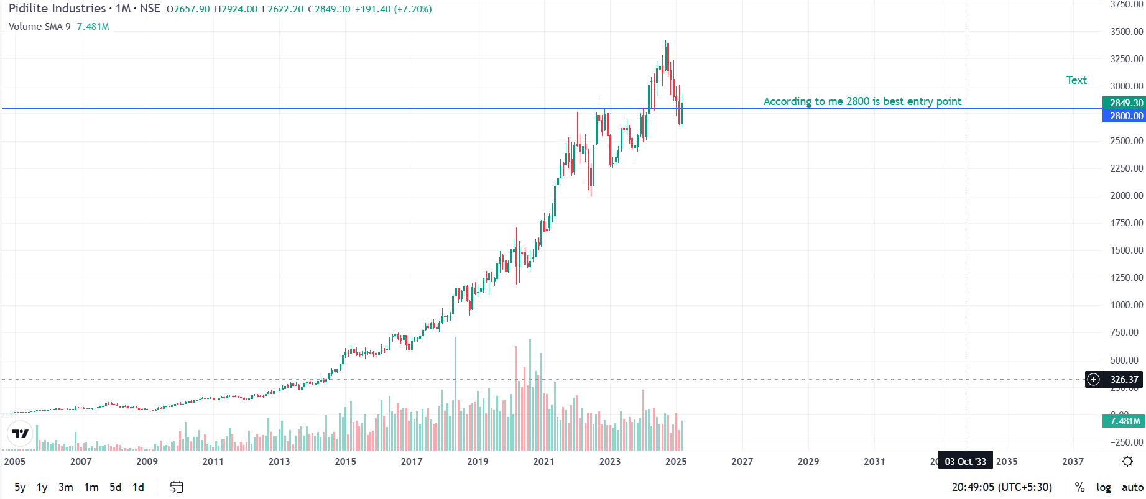
Pidilite Industries Ltd. Current price: ₹2849.30
Entry price :2800
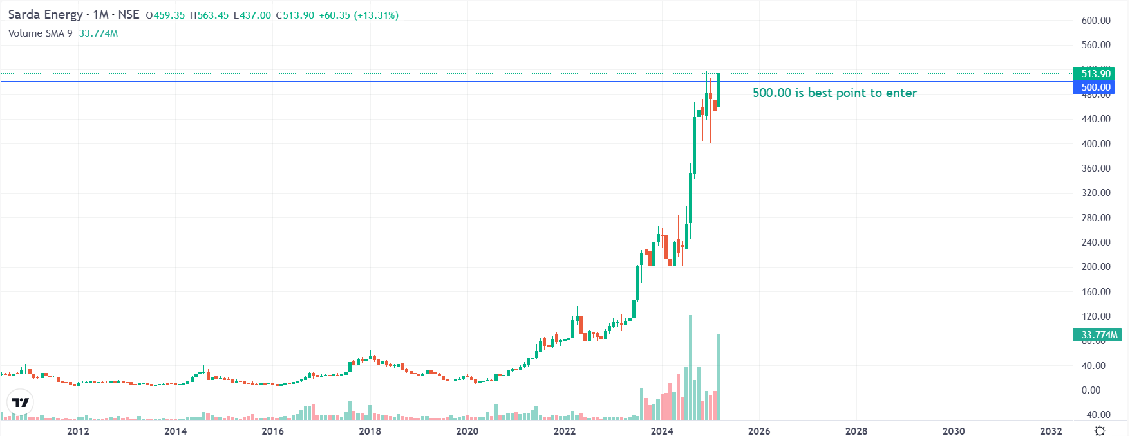
Sarda Energy & Minerals Ltd. Current price:513.90
Entry price: 500
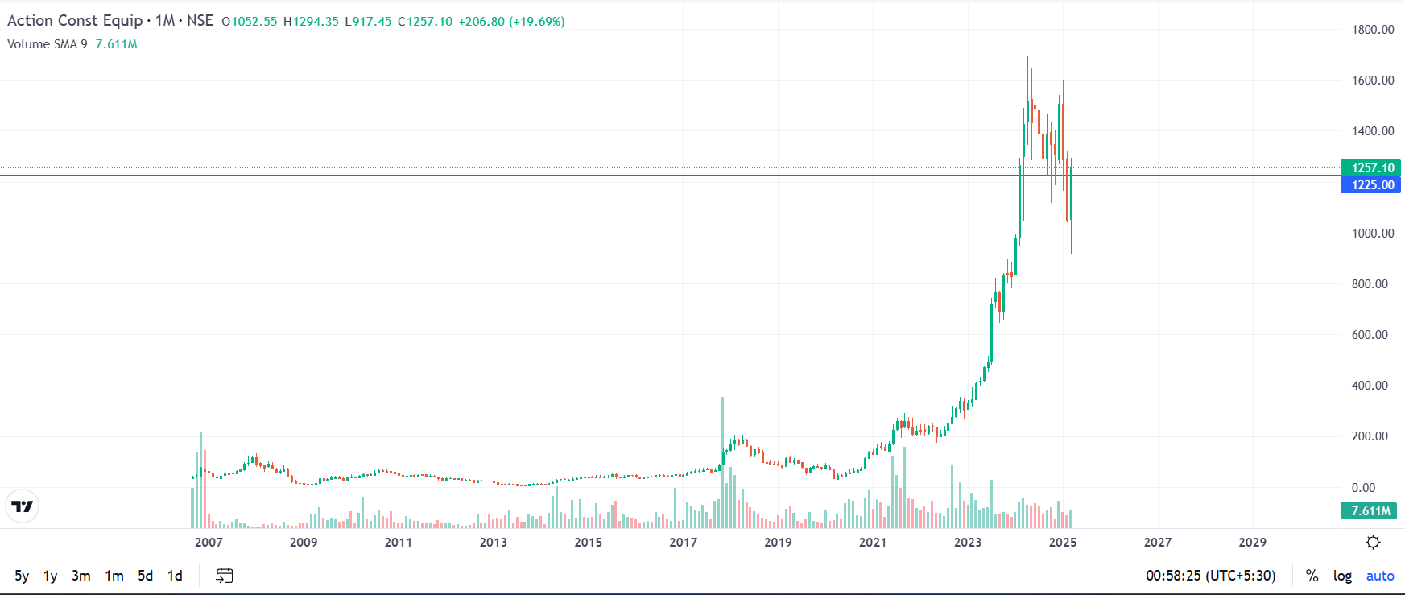
Action Construction Equipment Ltd. Current price:1257.10
Entry price :1225
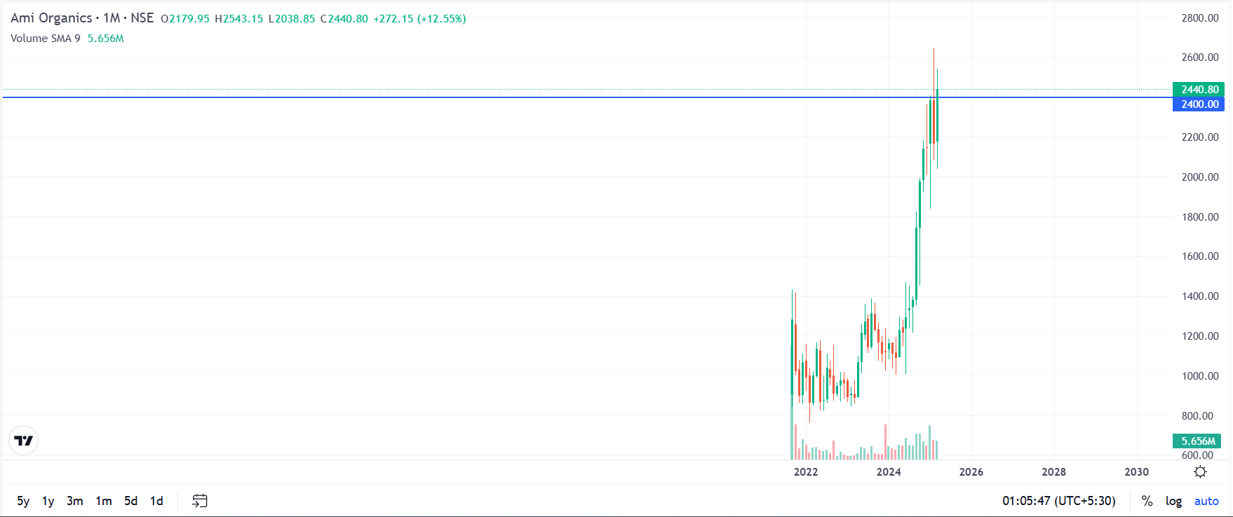
Ami Organics Ltd. Current price:2440.80
Entry price :2400
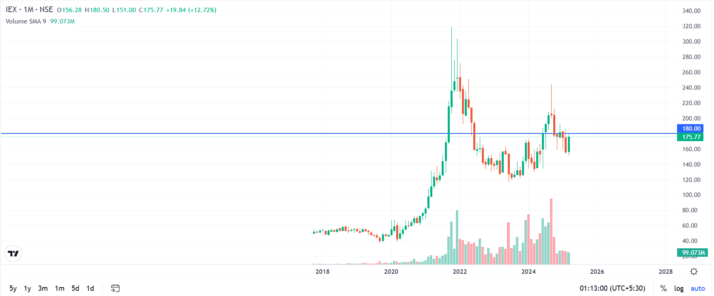
Indian Energy Exchange. current price:175.77
Entry price: 180
- Discuss 4 types of Support and Resistance and attach snapshot of 1 example for each

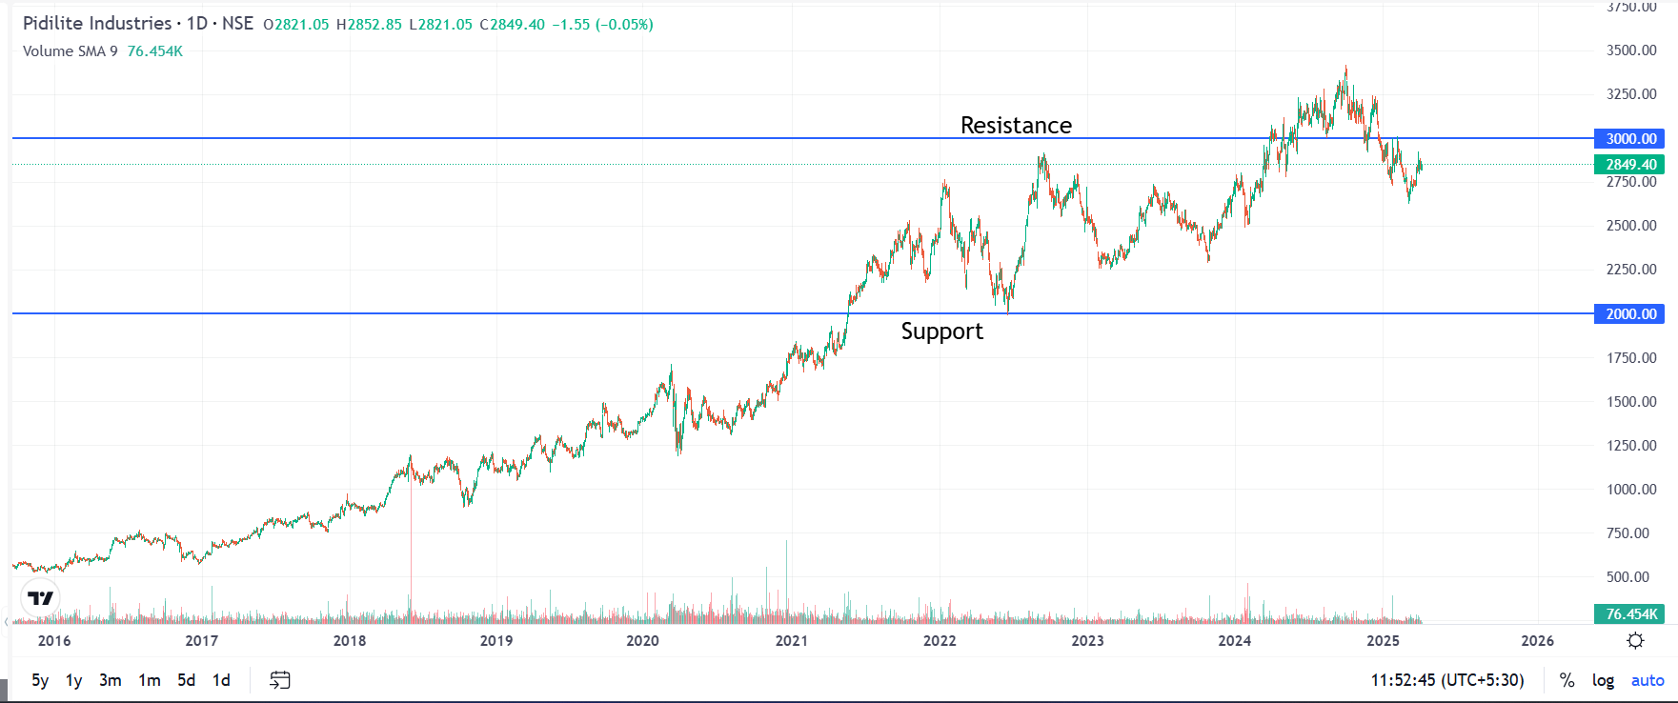
Round Number: psychological Impact People naturally see round numbers because Human brain is so tuned to think in terms multiple of 5,10 & 2.
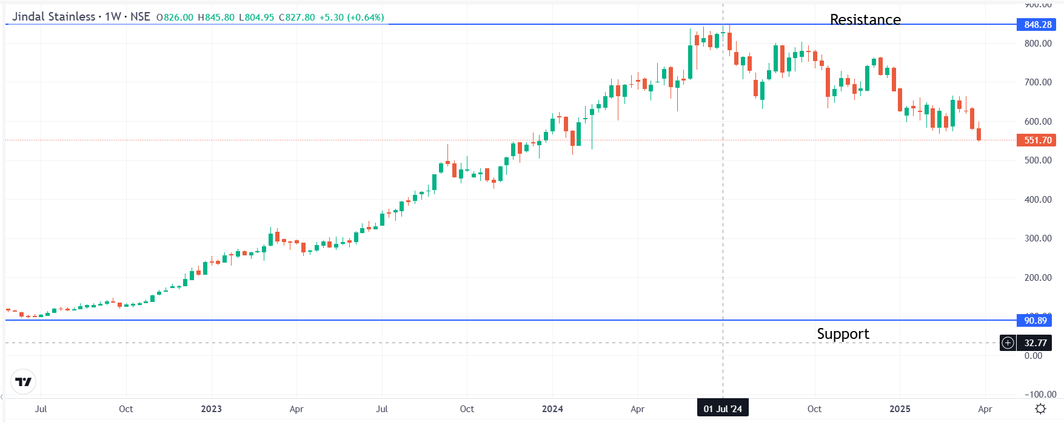
All-Time High/Low: The All-Time High is the highest price an asset has ever reached in its entire trading history.

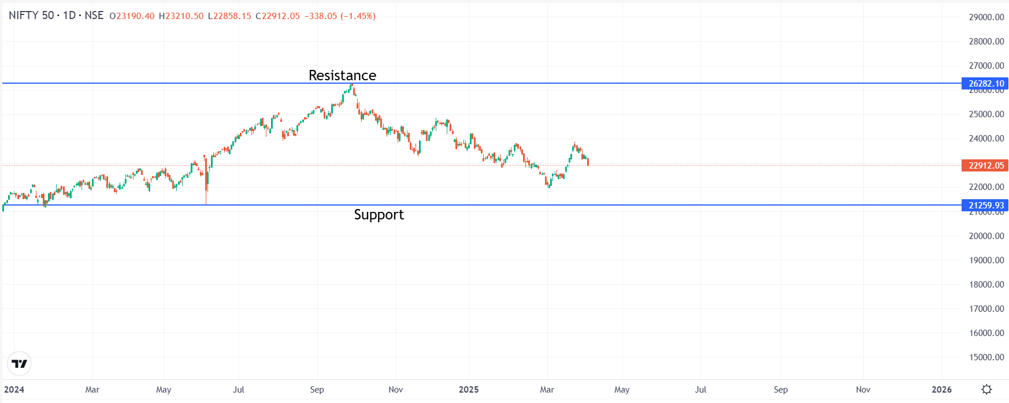

Previous Peaks and Pits: These are points on a price chart where the price rises reach a high and then reverses downward.

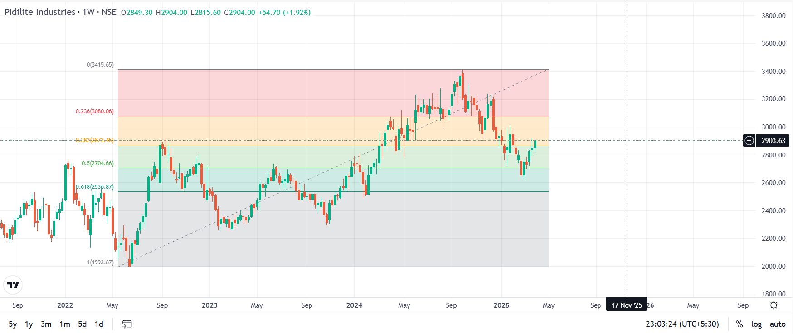

Fibonacci Ratios: Fibonacci ratios come from the Fibonacci sequence each number is the sum of the two before it.
- Find out 5 examples of 61% Fibonacci Retracement and attach the snapshot
Fibonacci Ratios: Fibonacci ratios come from the Fibonacci sequence each number is the sum of the two before it. If Fibonacci ratio dropped less than 61% (or golden ratio) then it will be known as market crash.
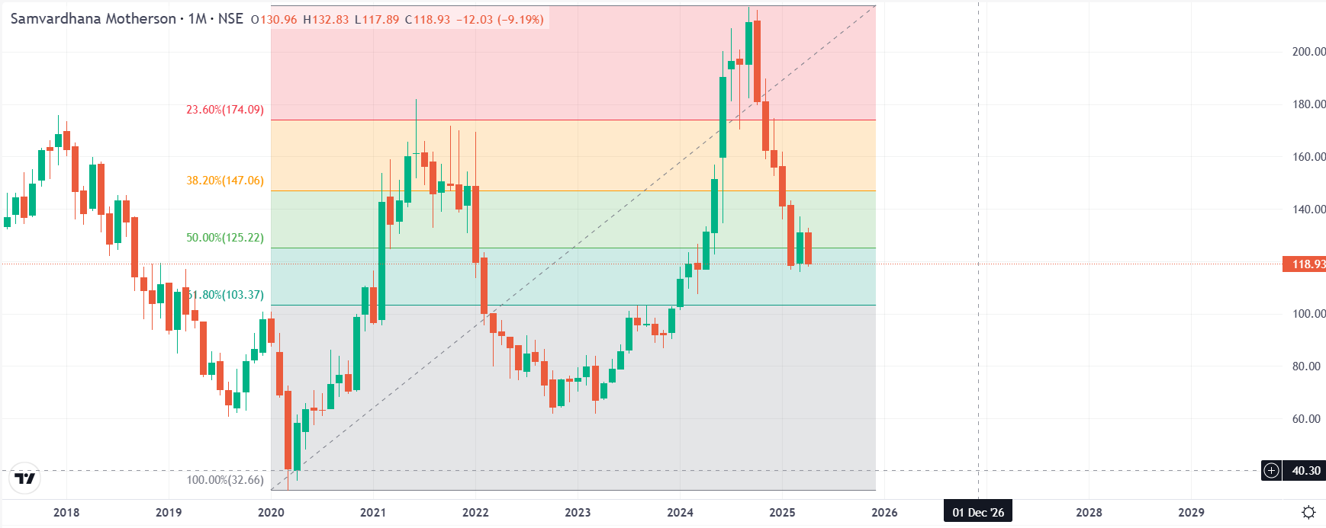
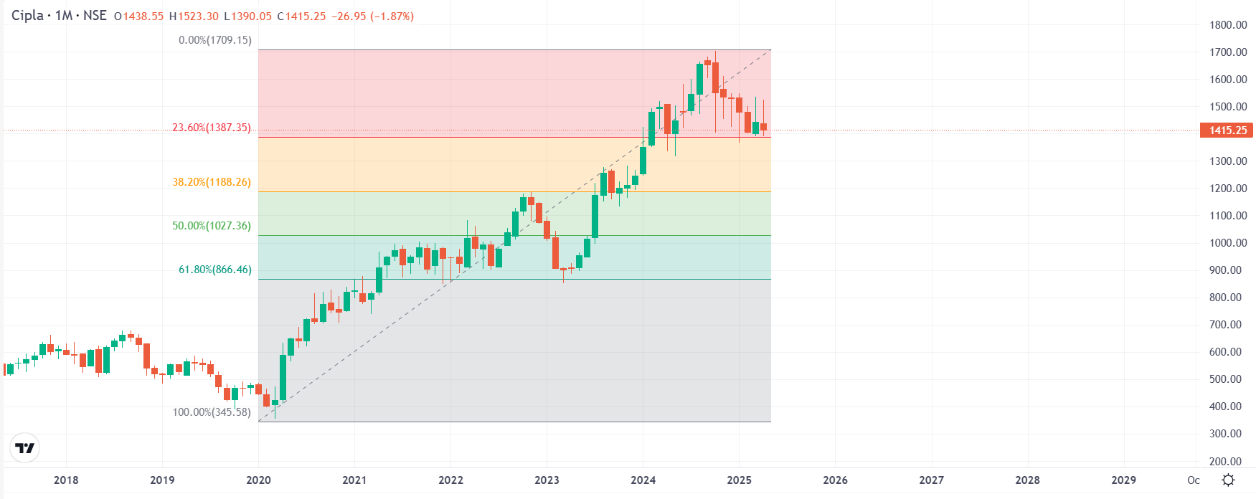
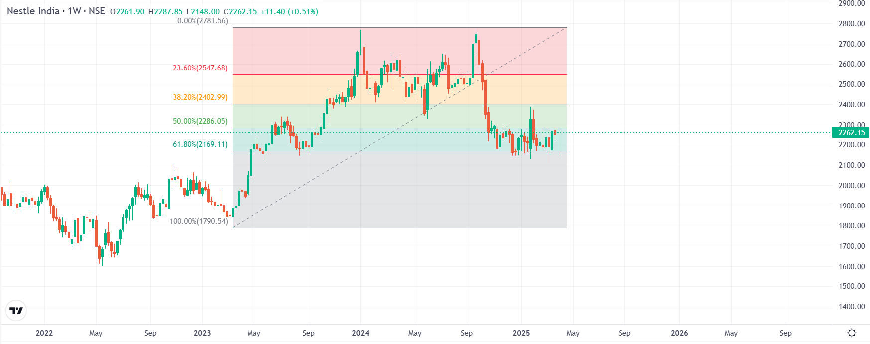
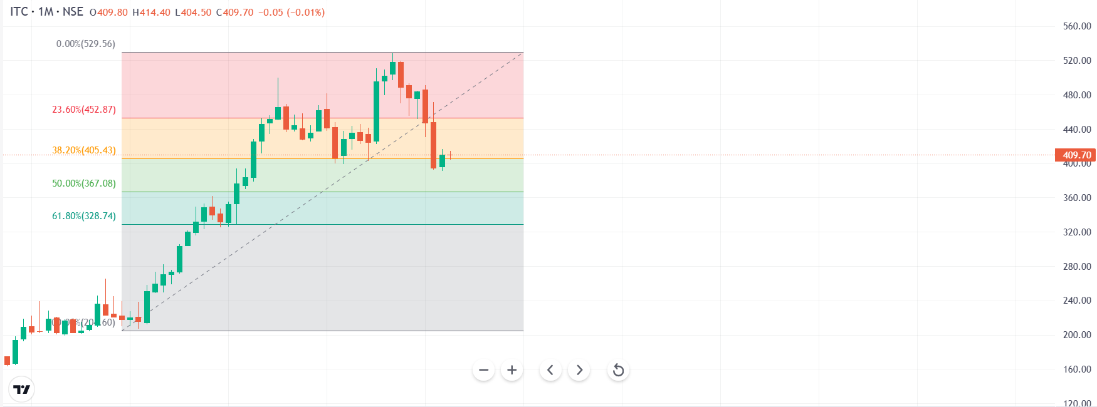
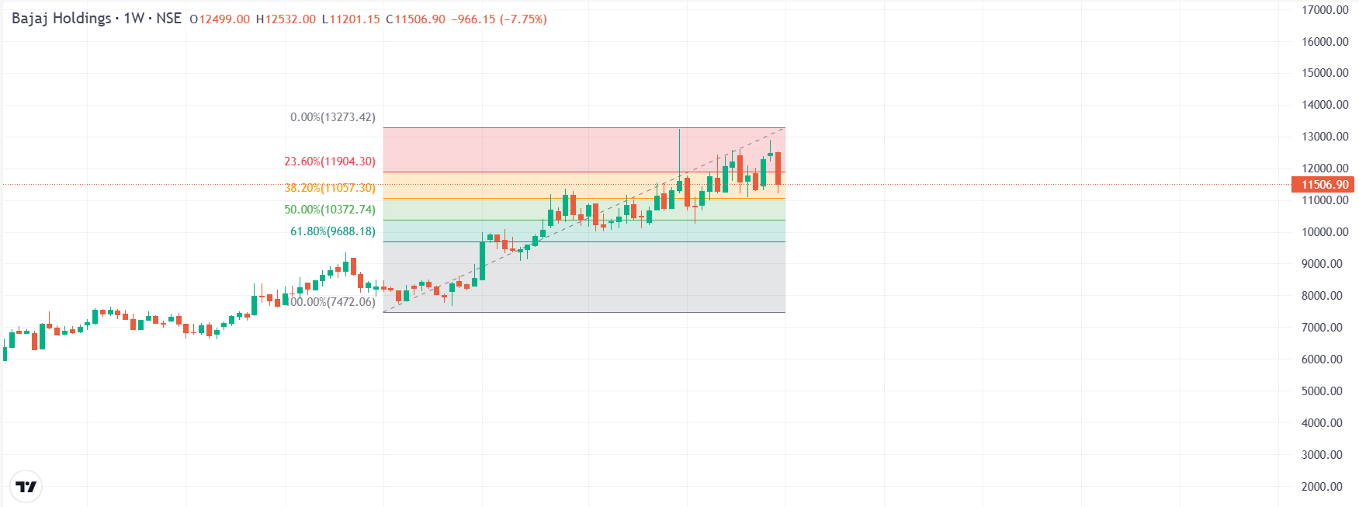
- Find out 4 examples of each pattern and submit snapshots
(Eastern Patterns)
- Tweezer top
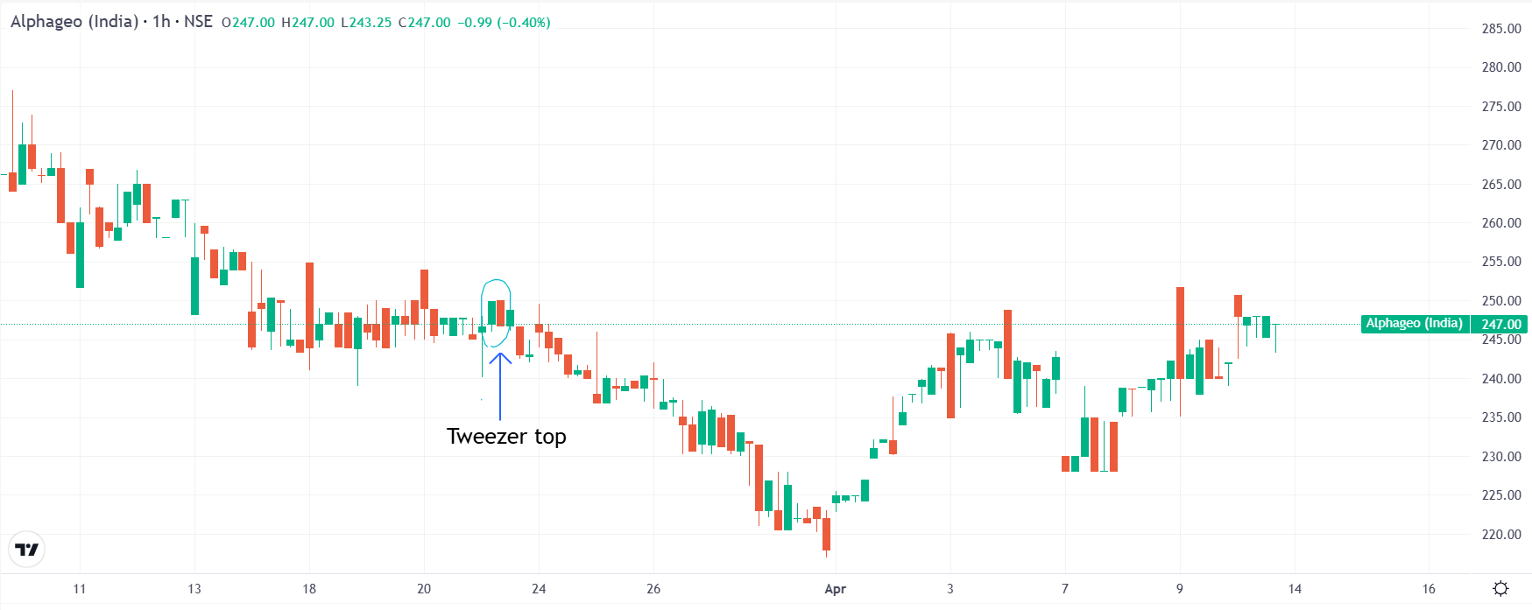
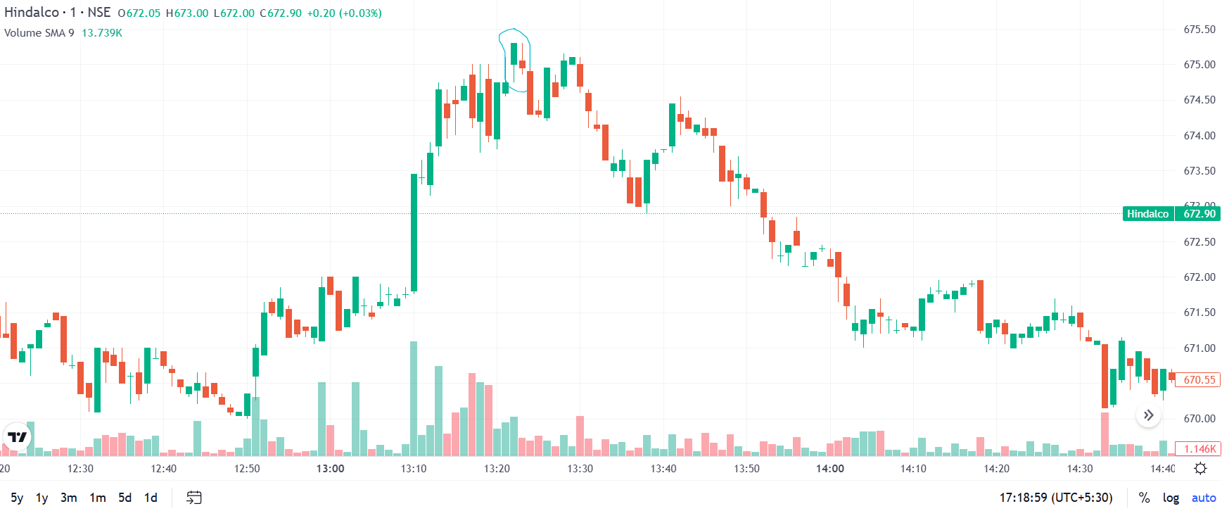
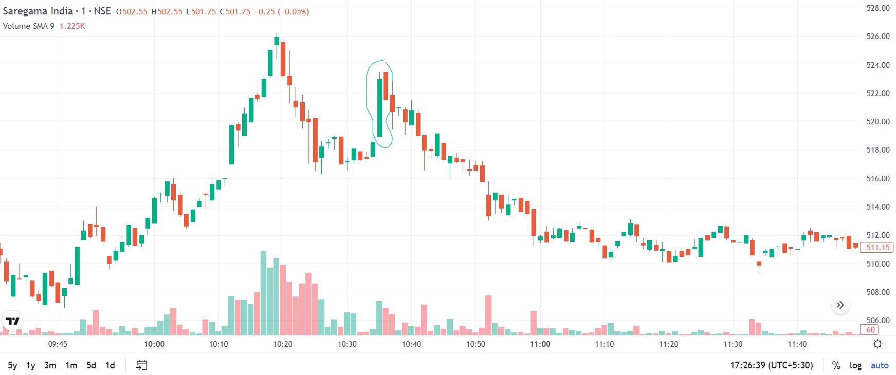
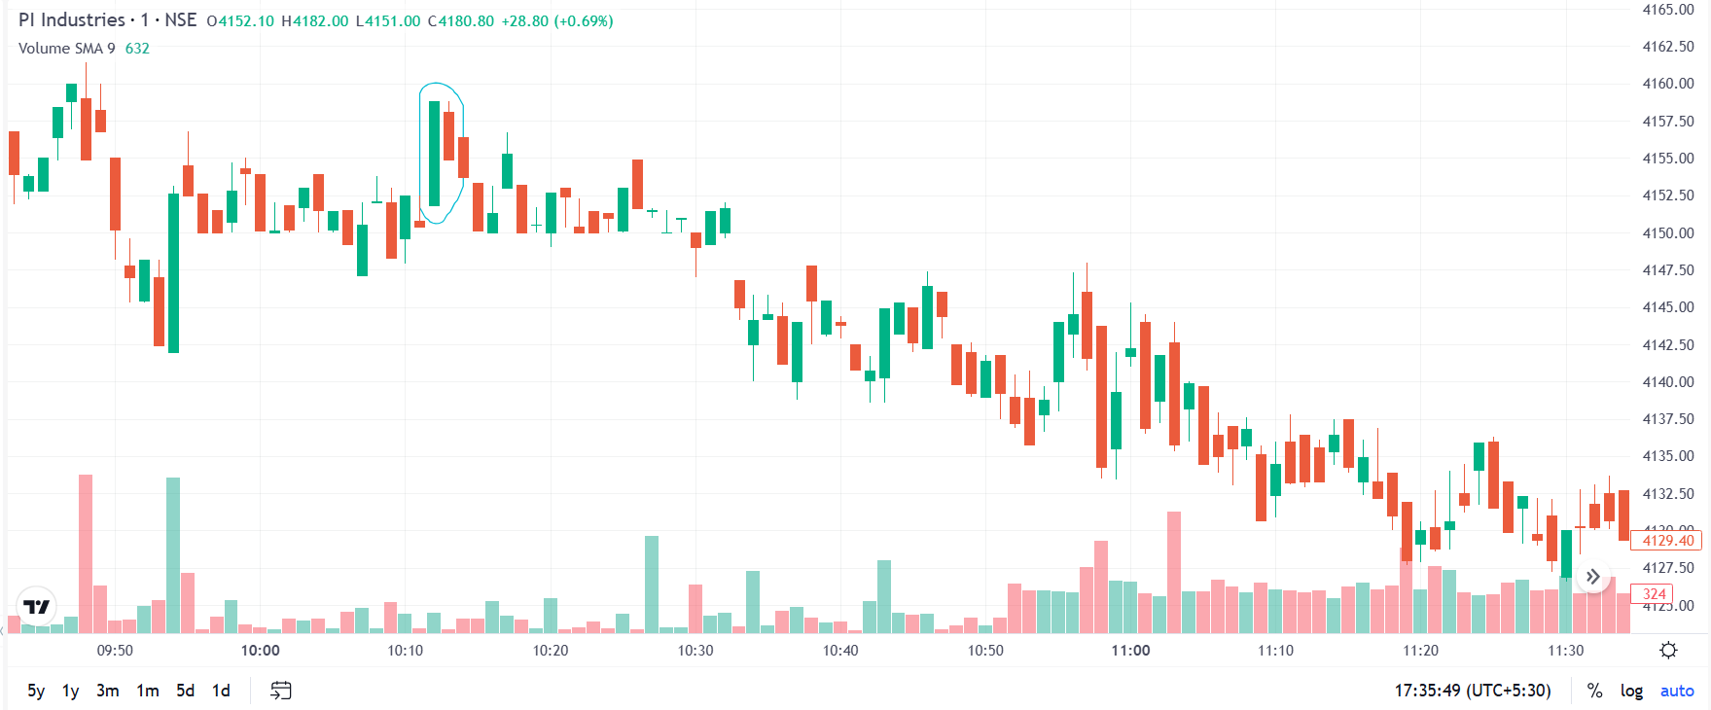

- Evening Star

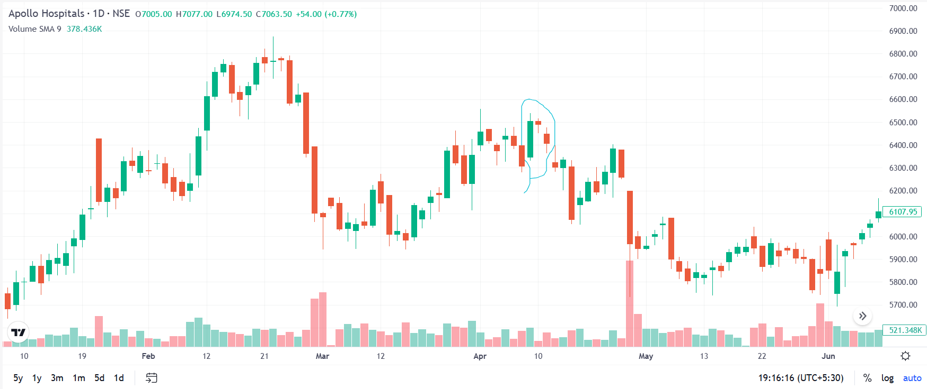

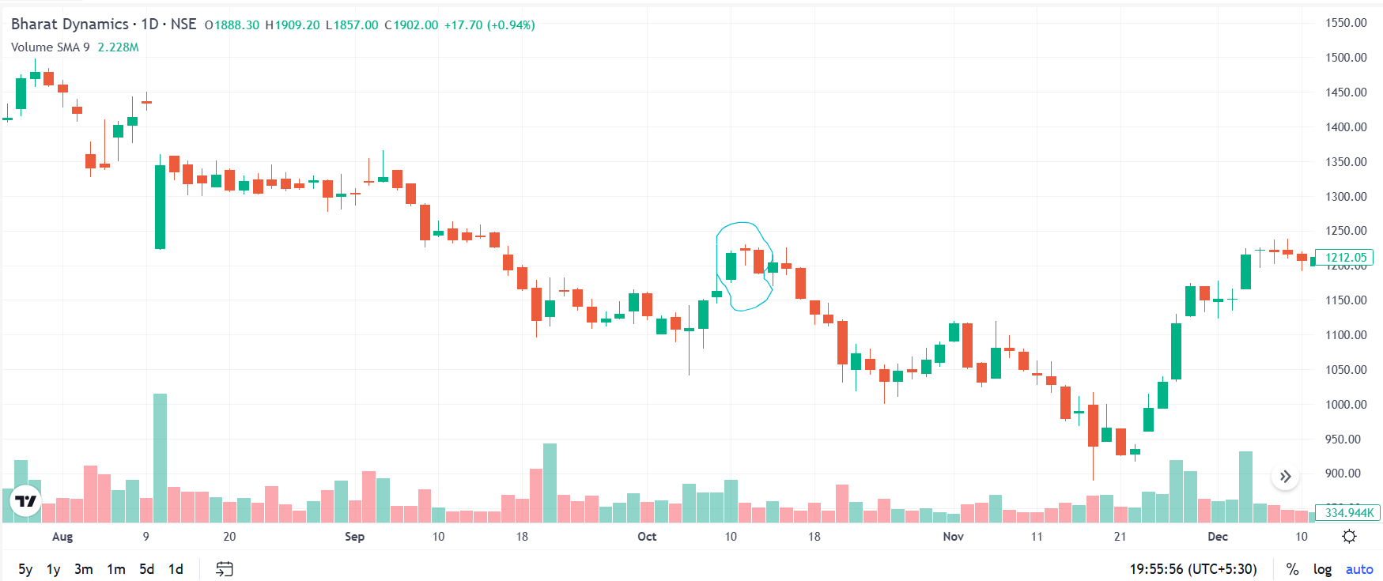
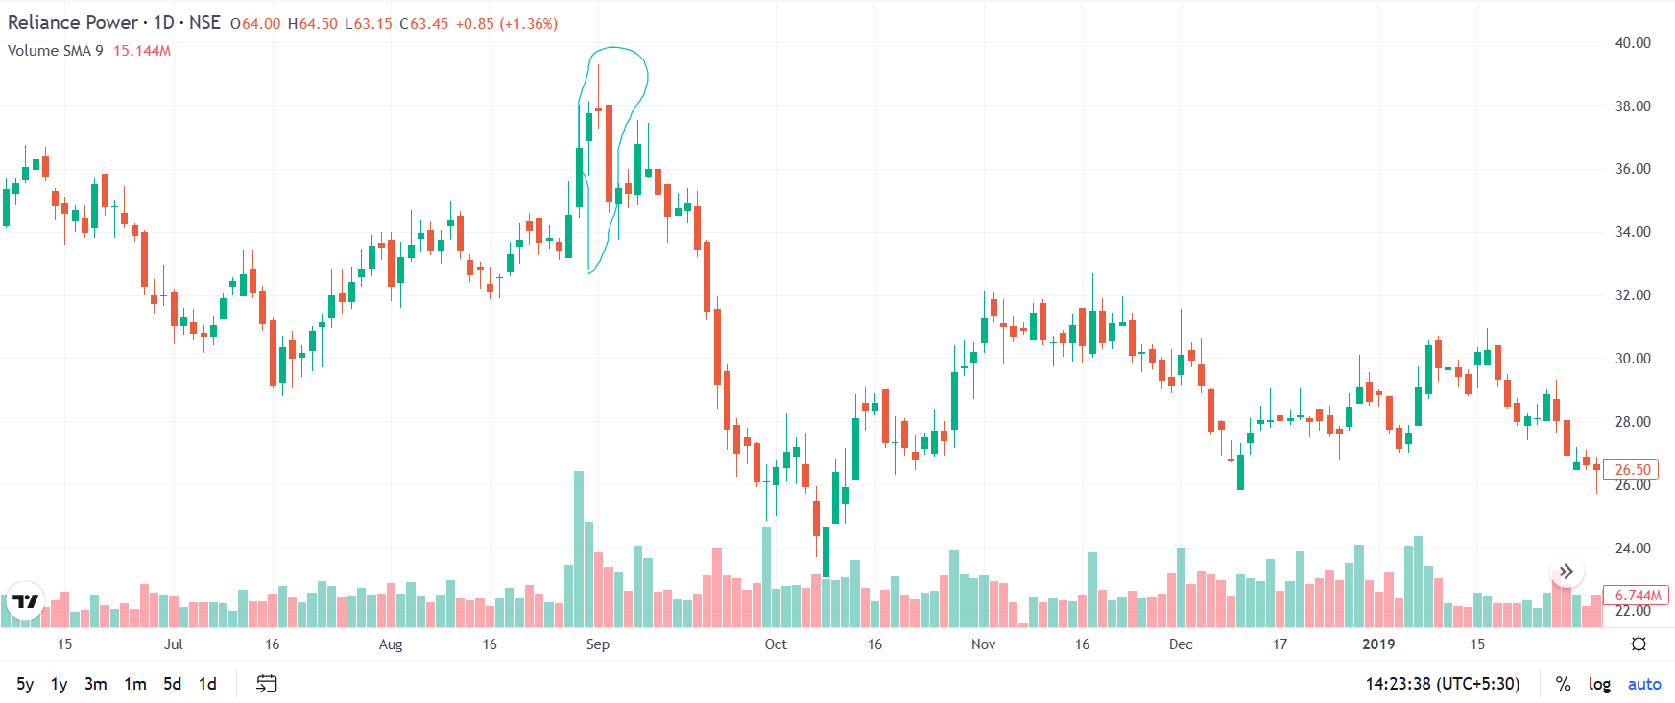
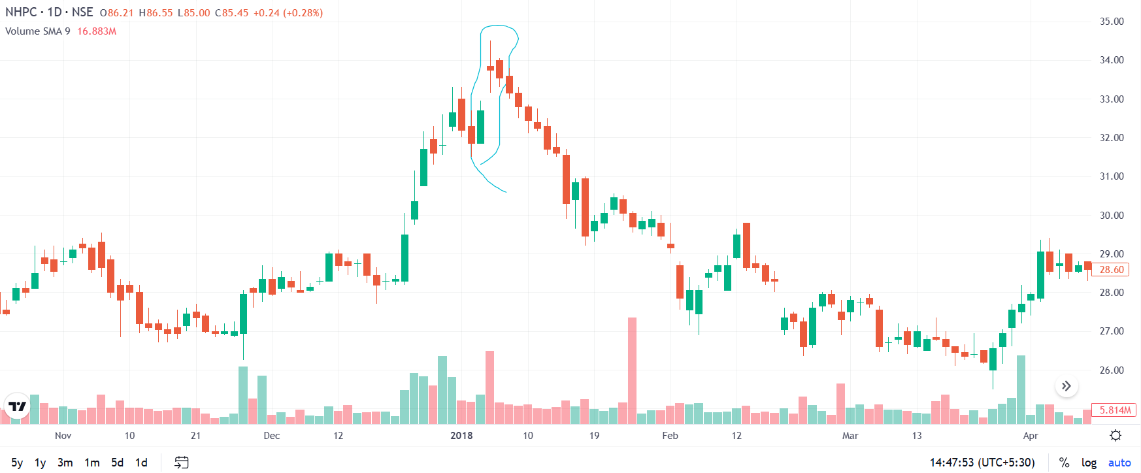
- Bullish Harami
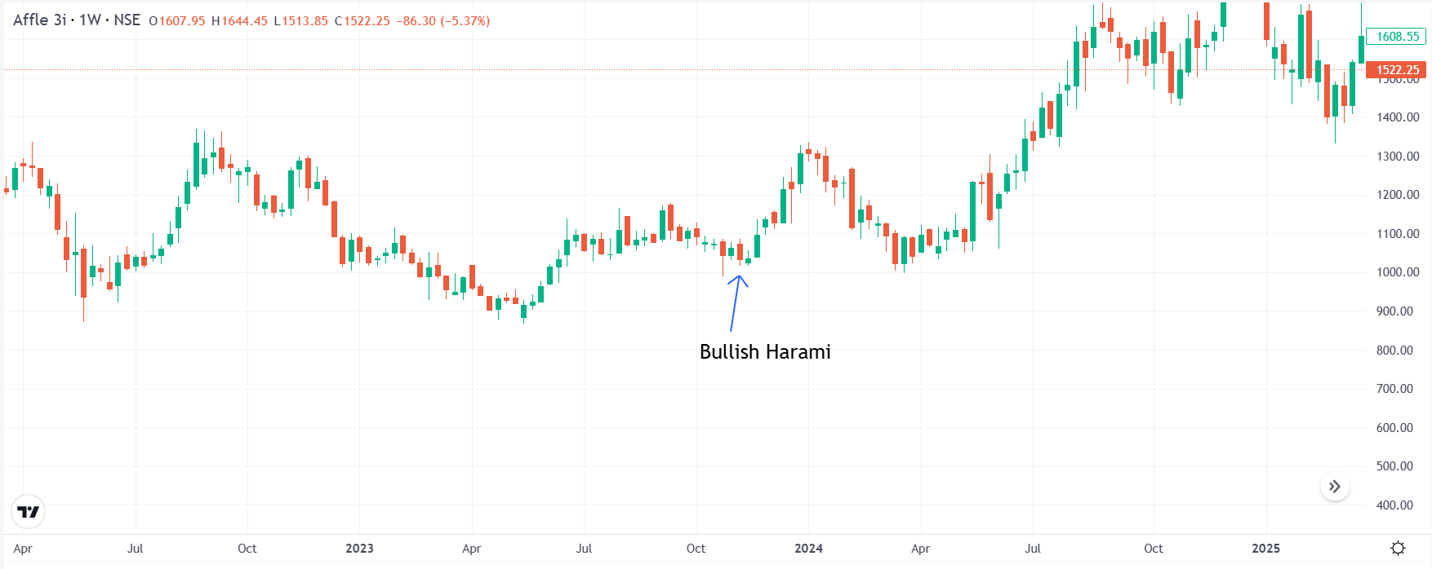
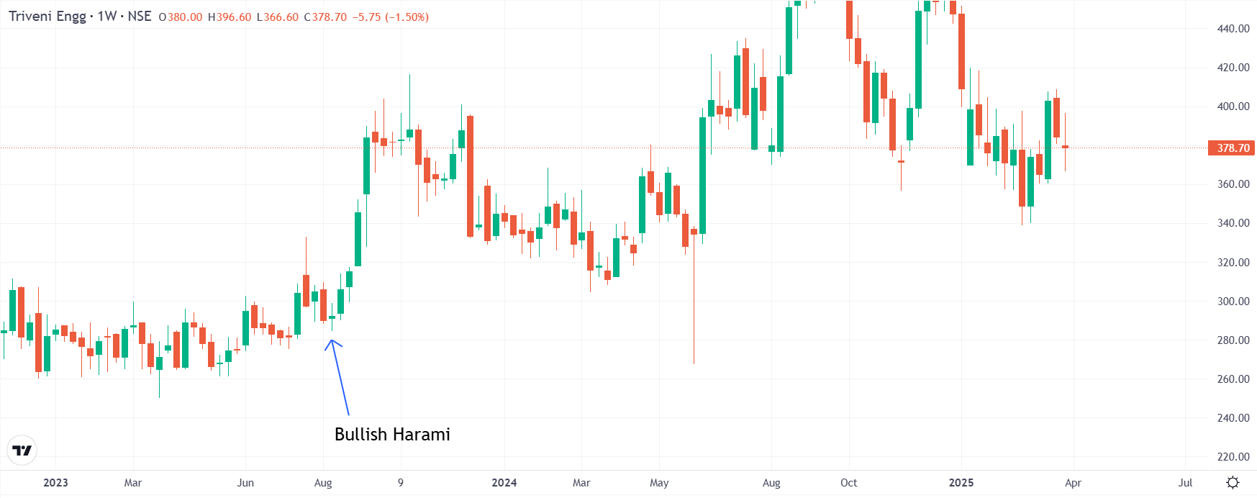
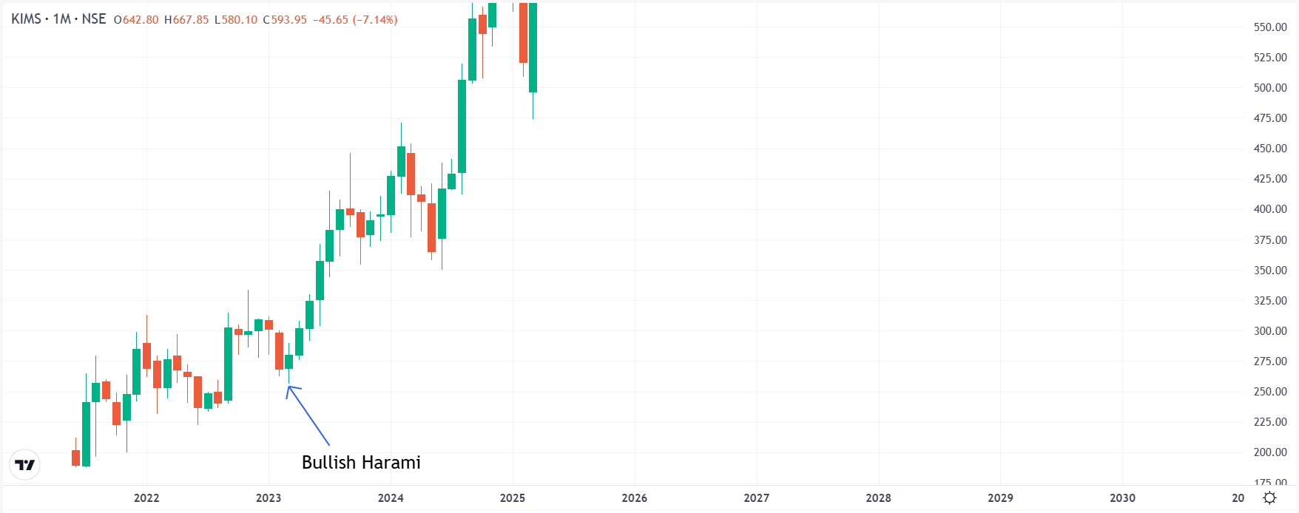
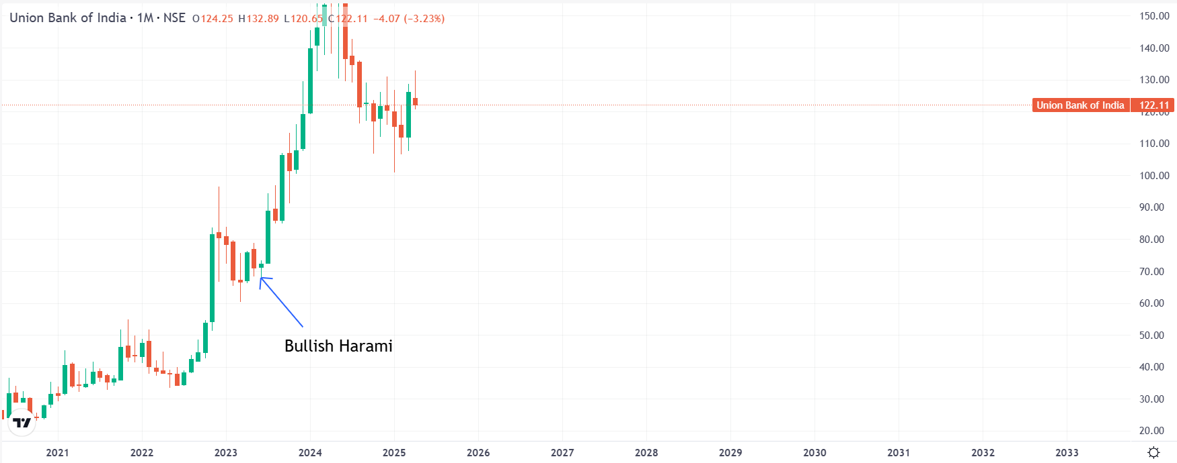
- Bullish/Bearish Engulfing
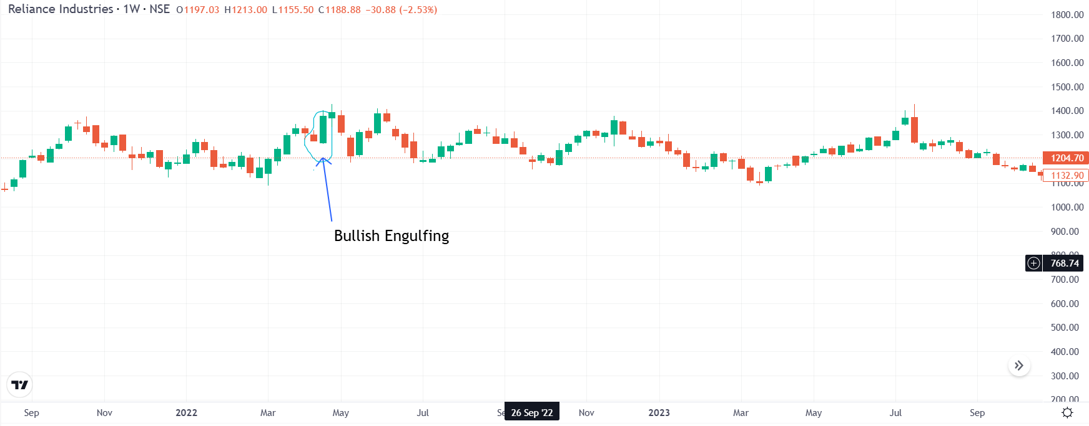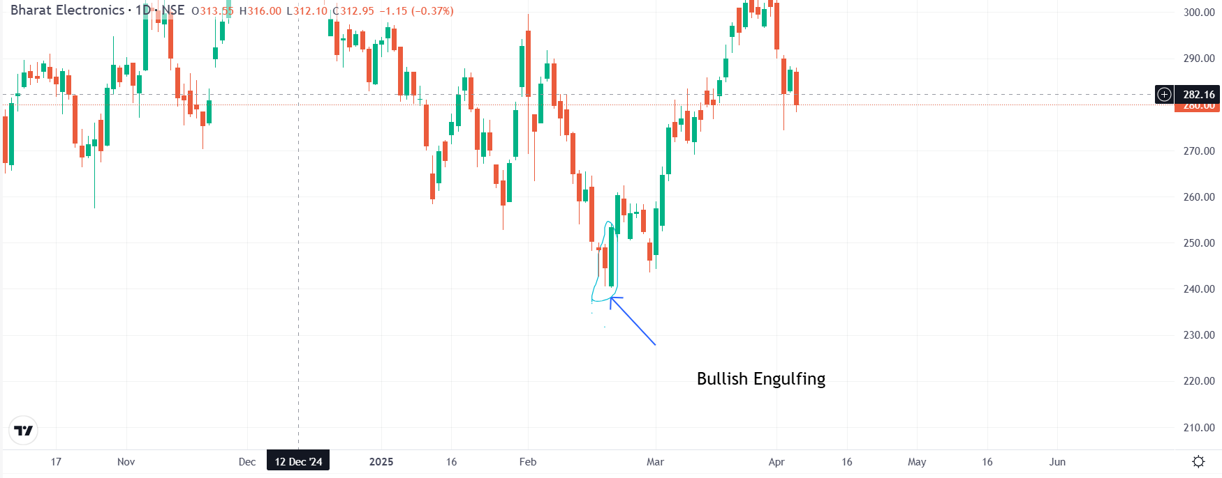
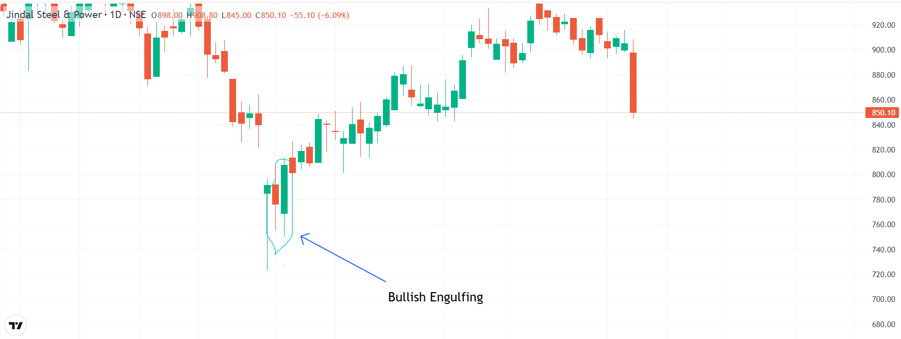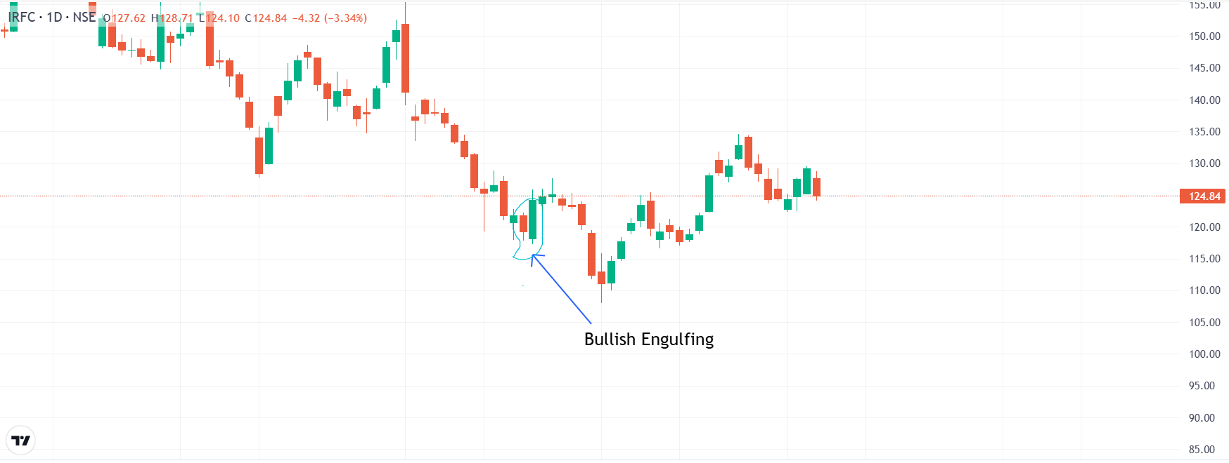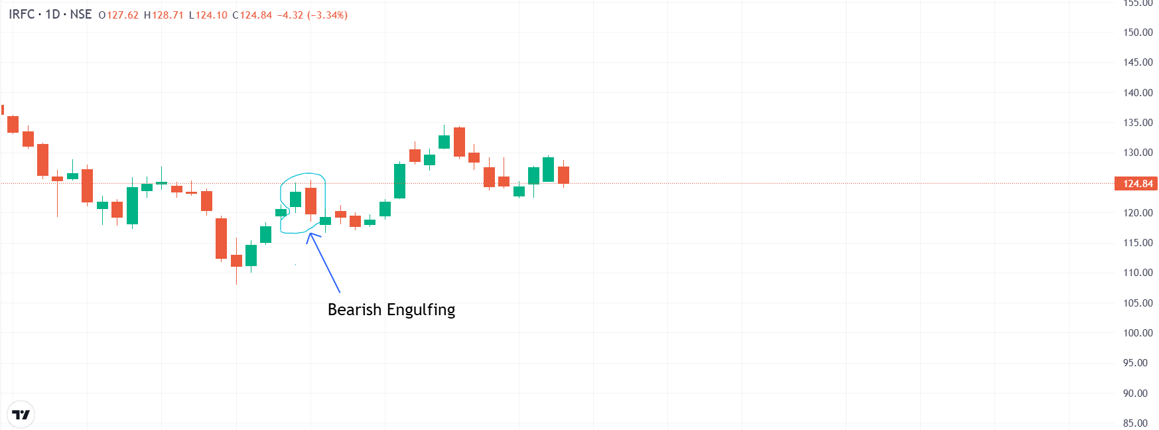
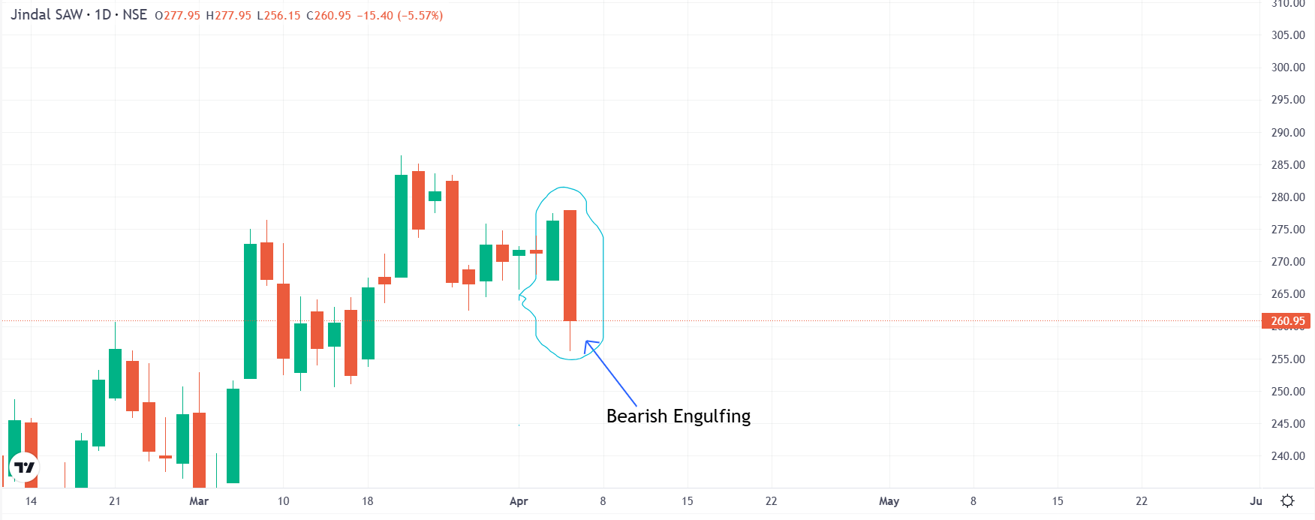

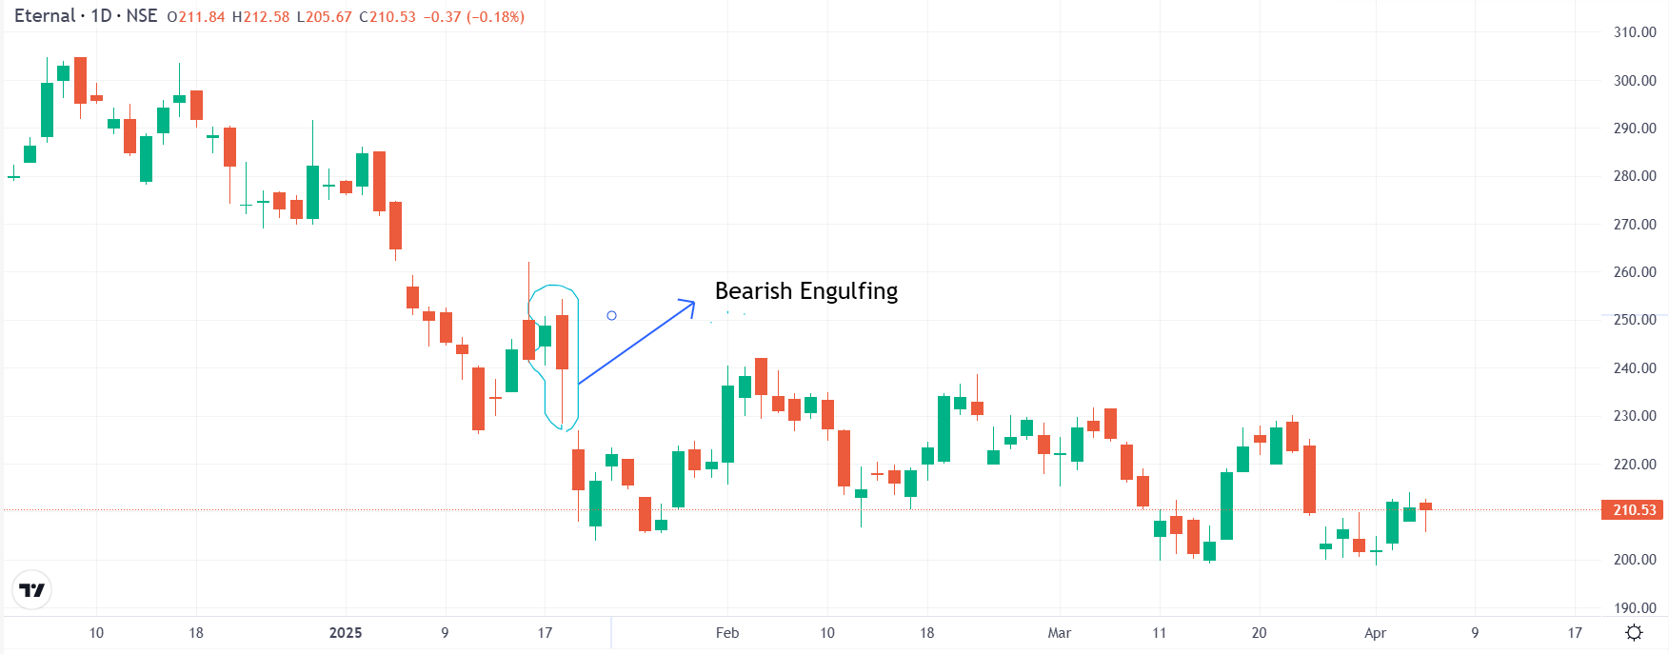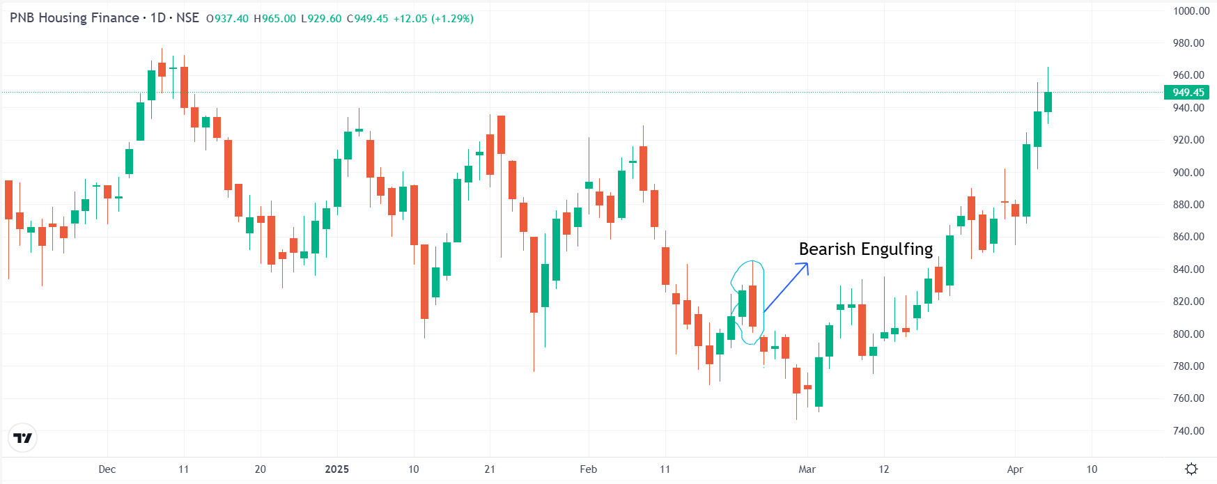

(Western Patterns)
- Double top
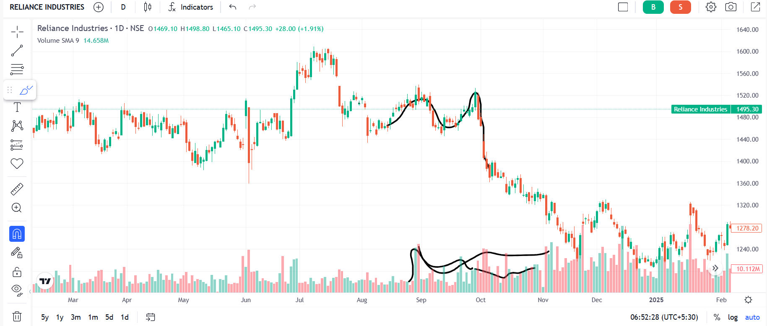
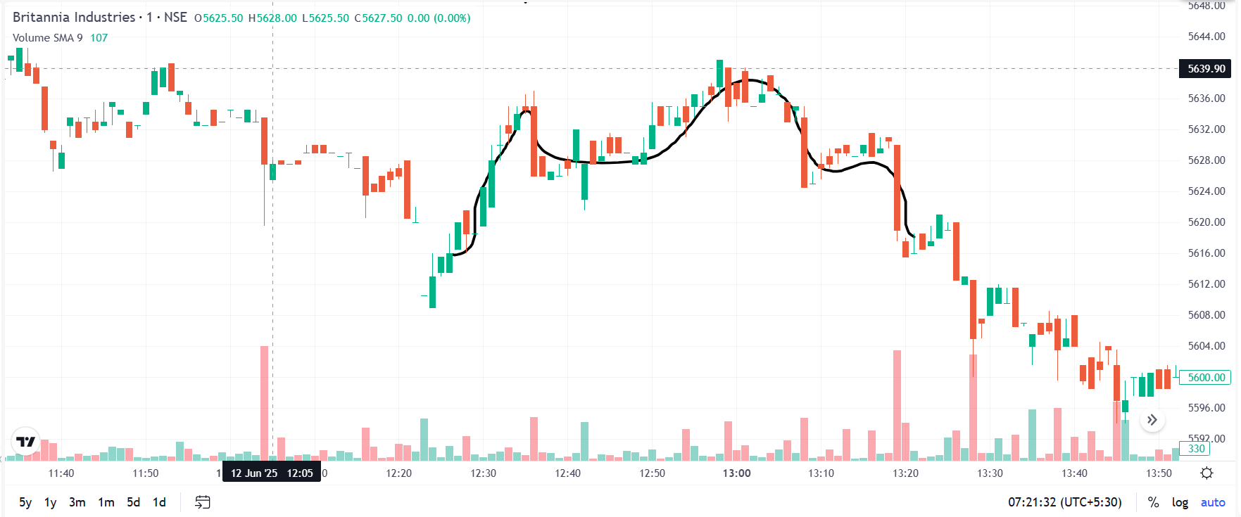
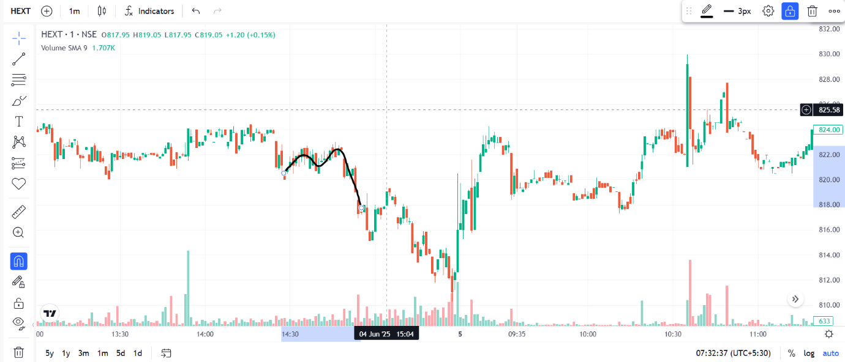
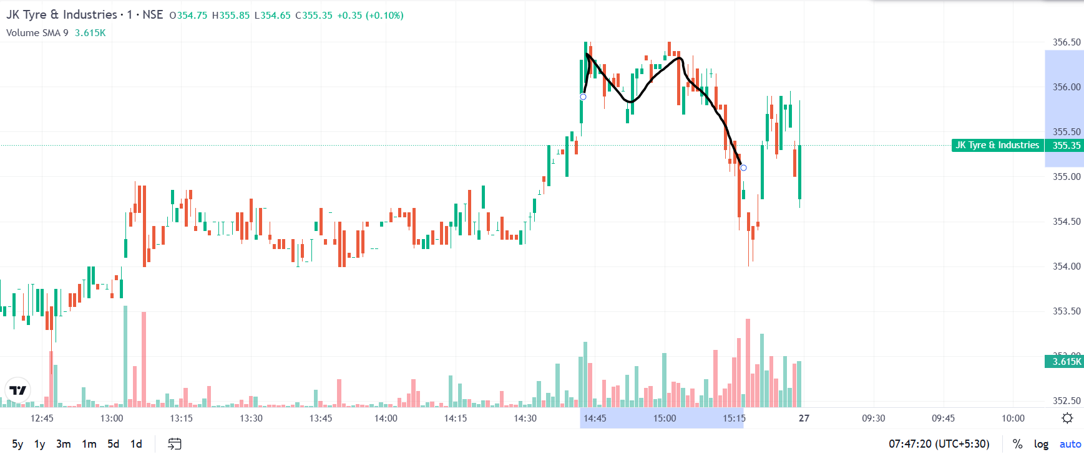

- Head & Shoulder

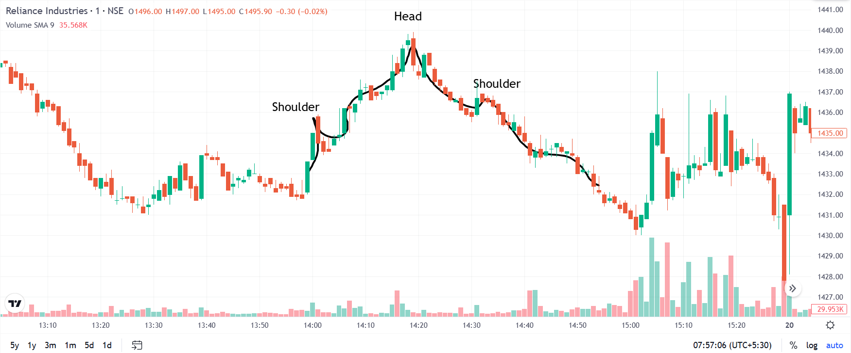

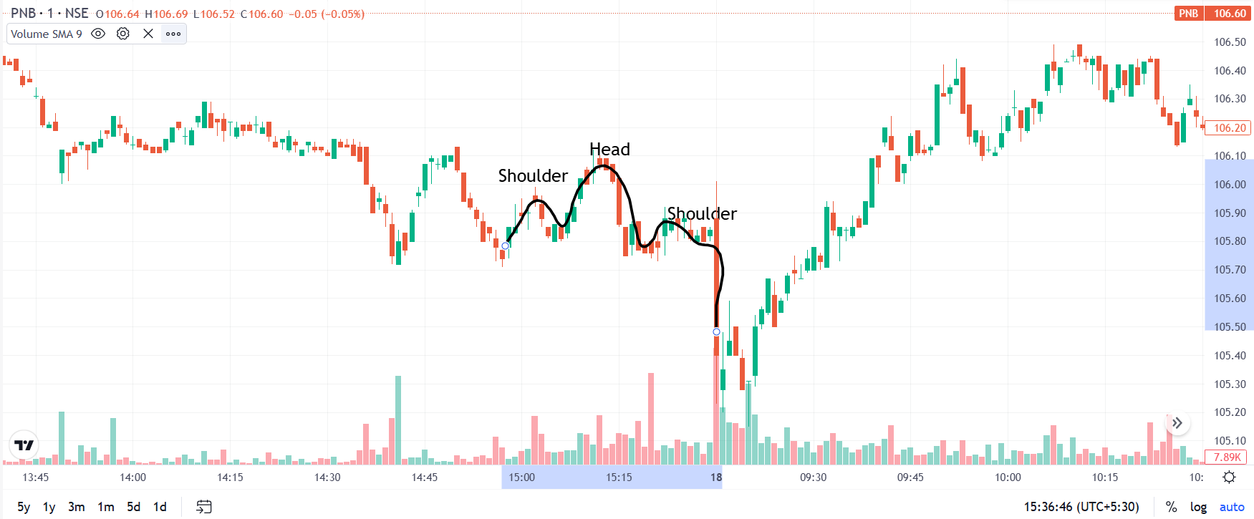

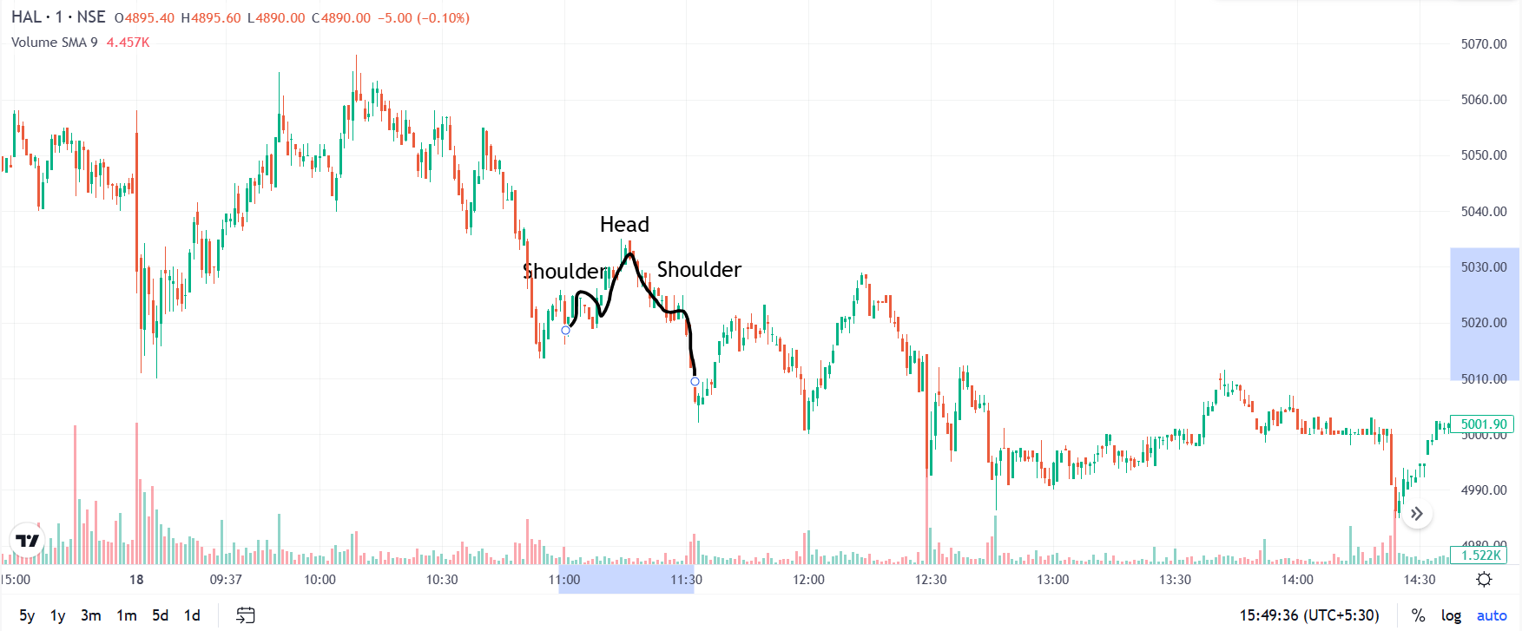

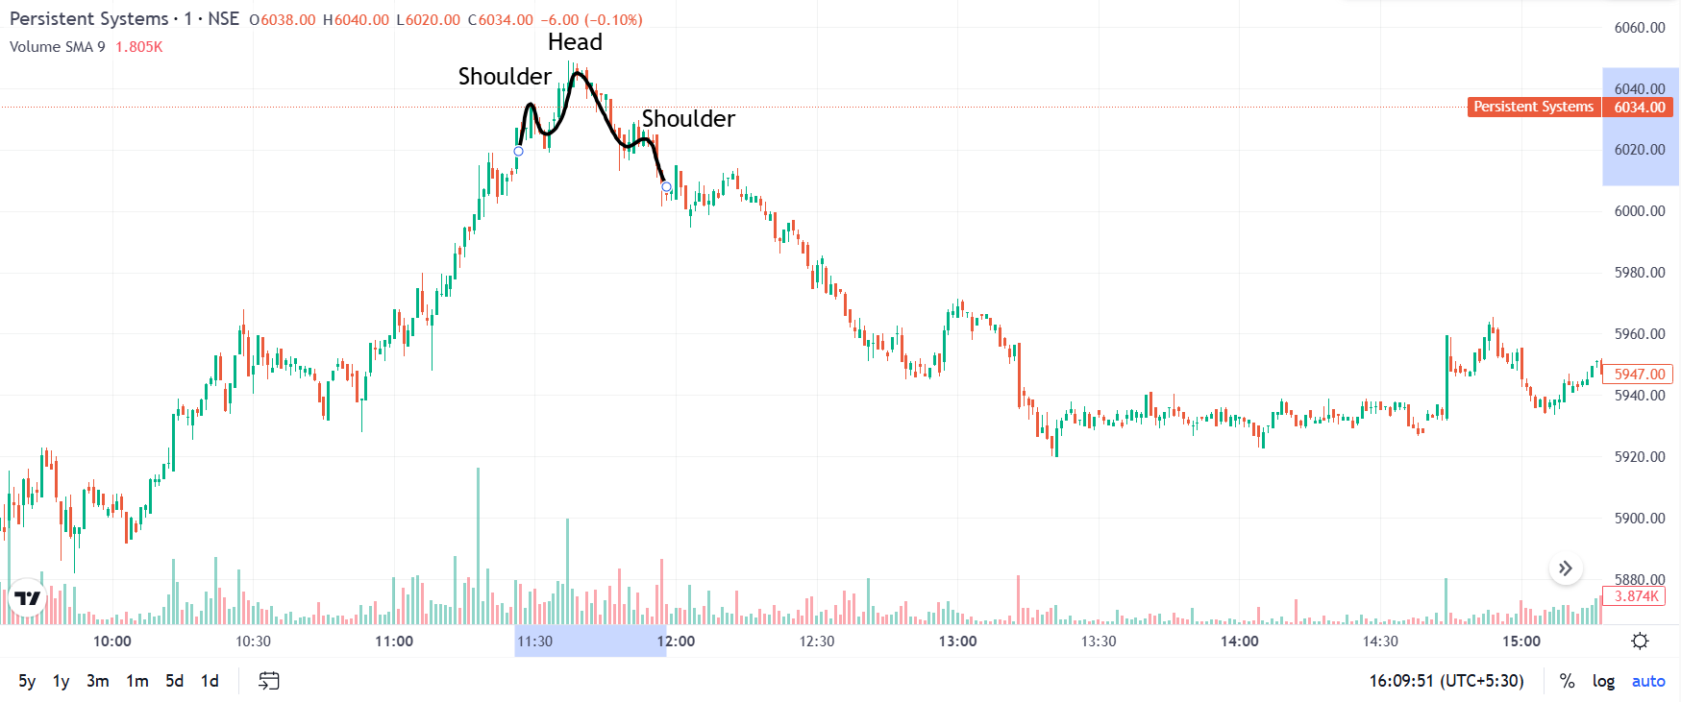

- Cup Pattern

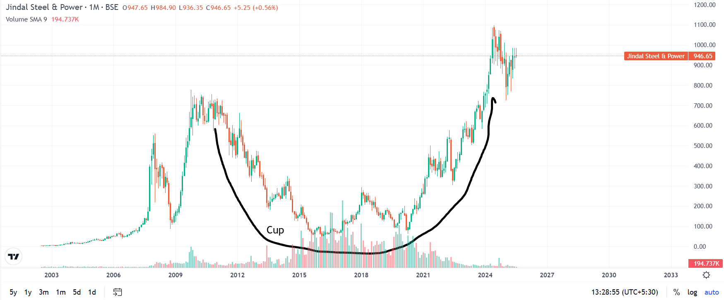

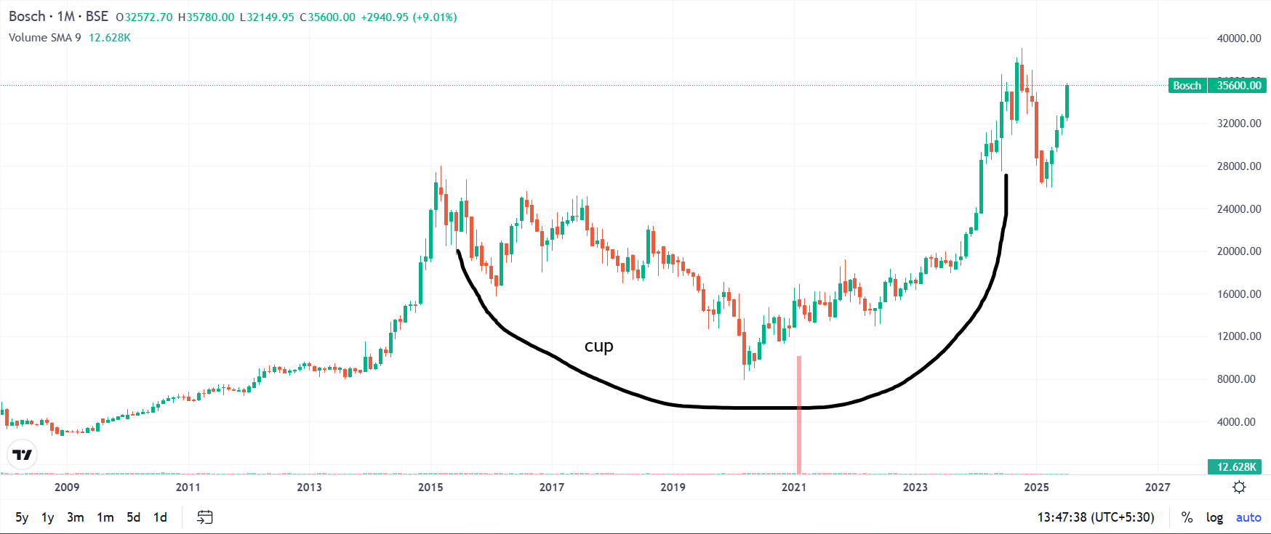

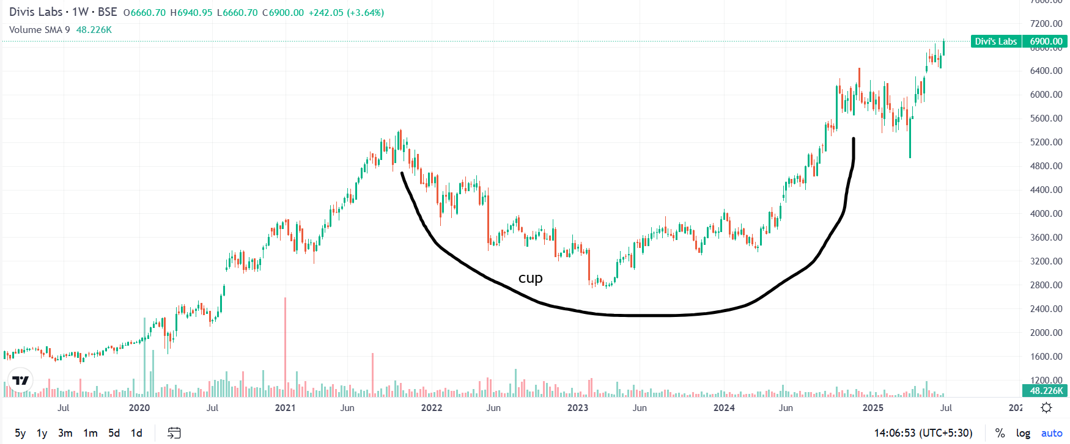

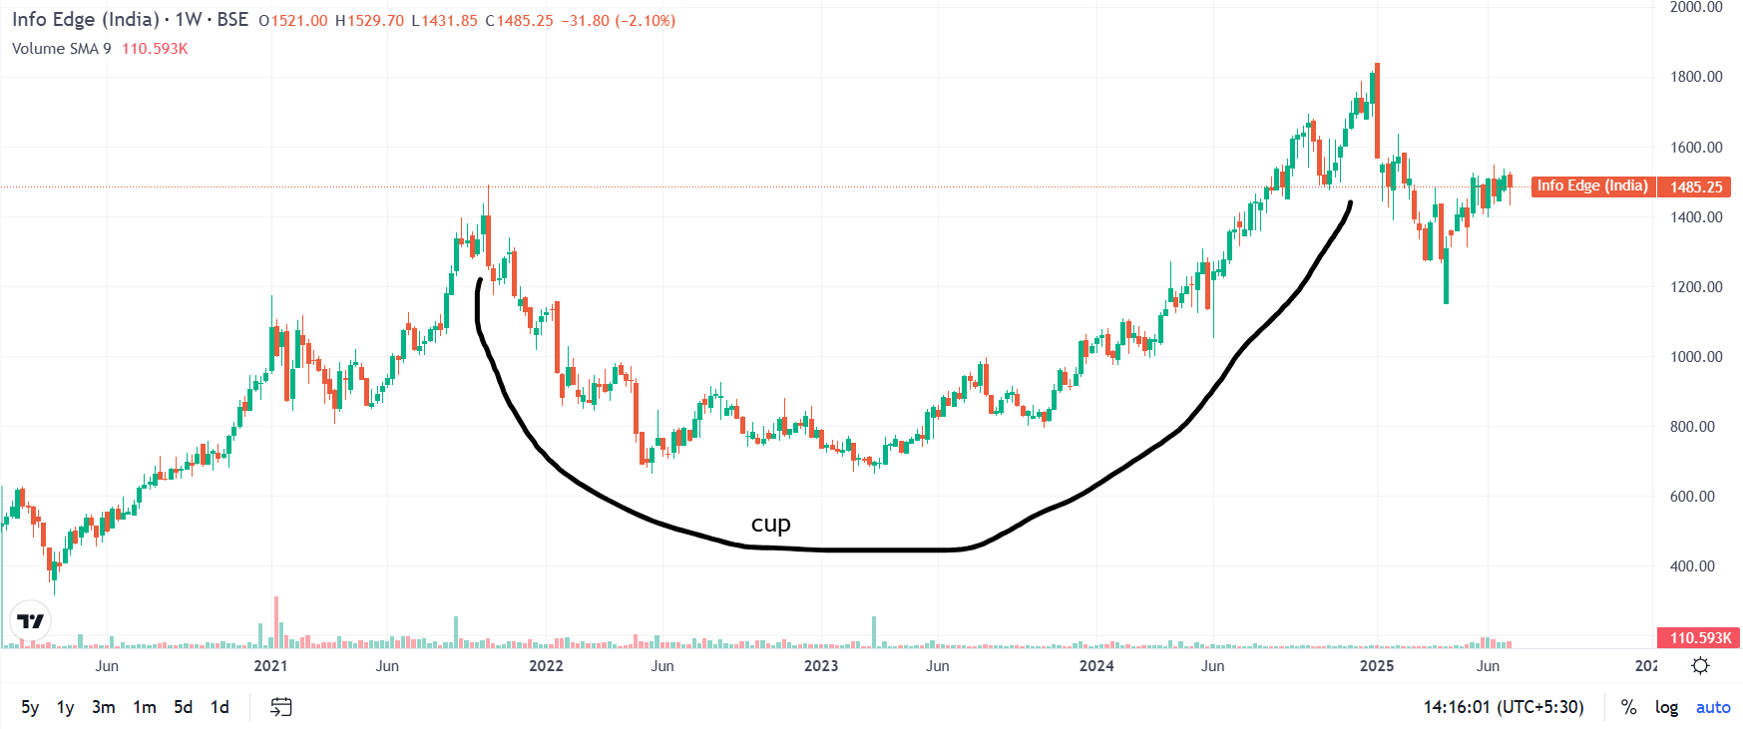

- Flag Pattern
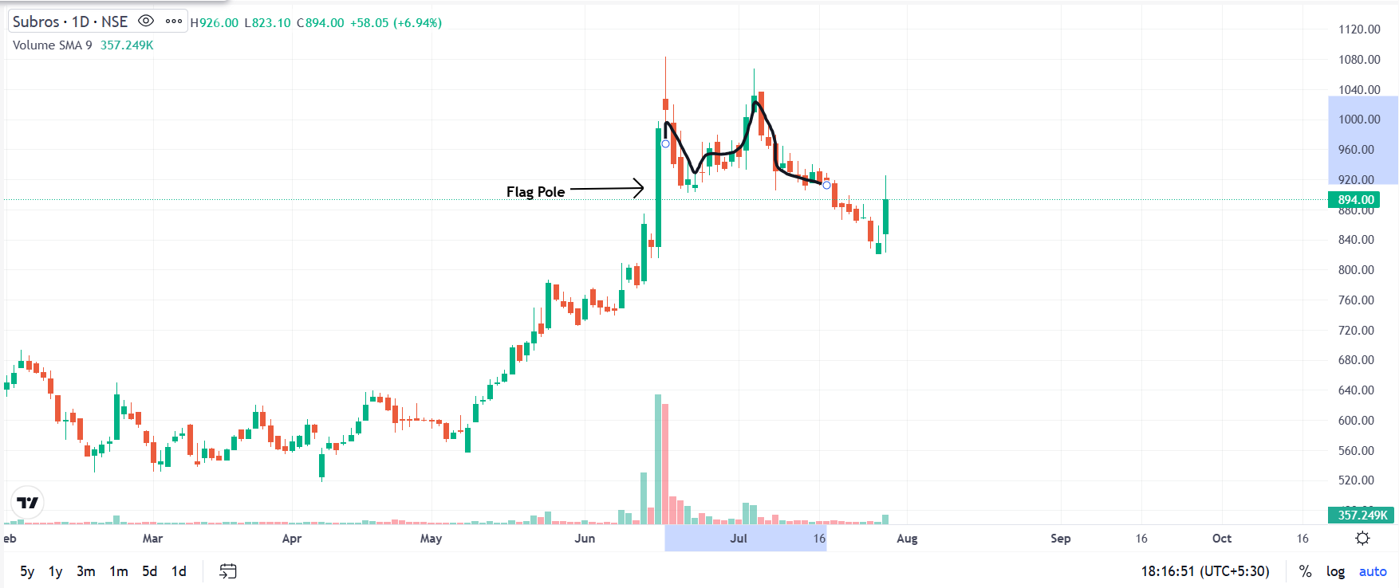

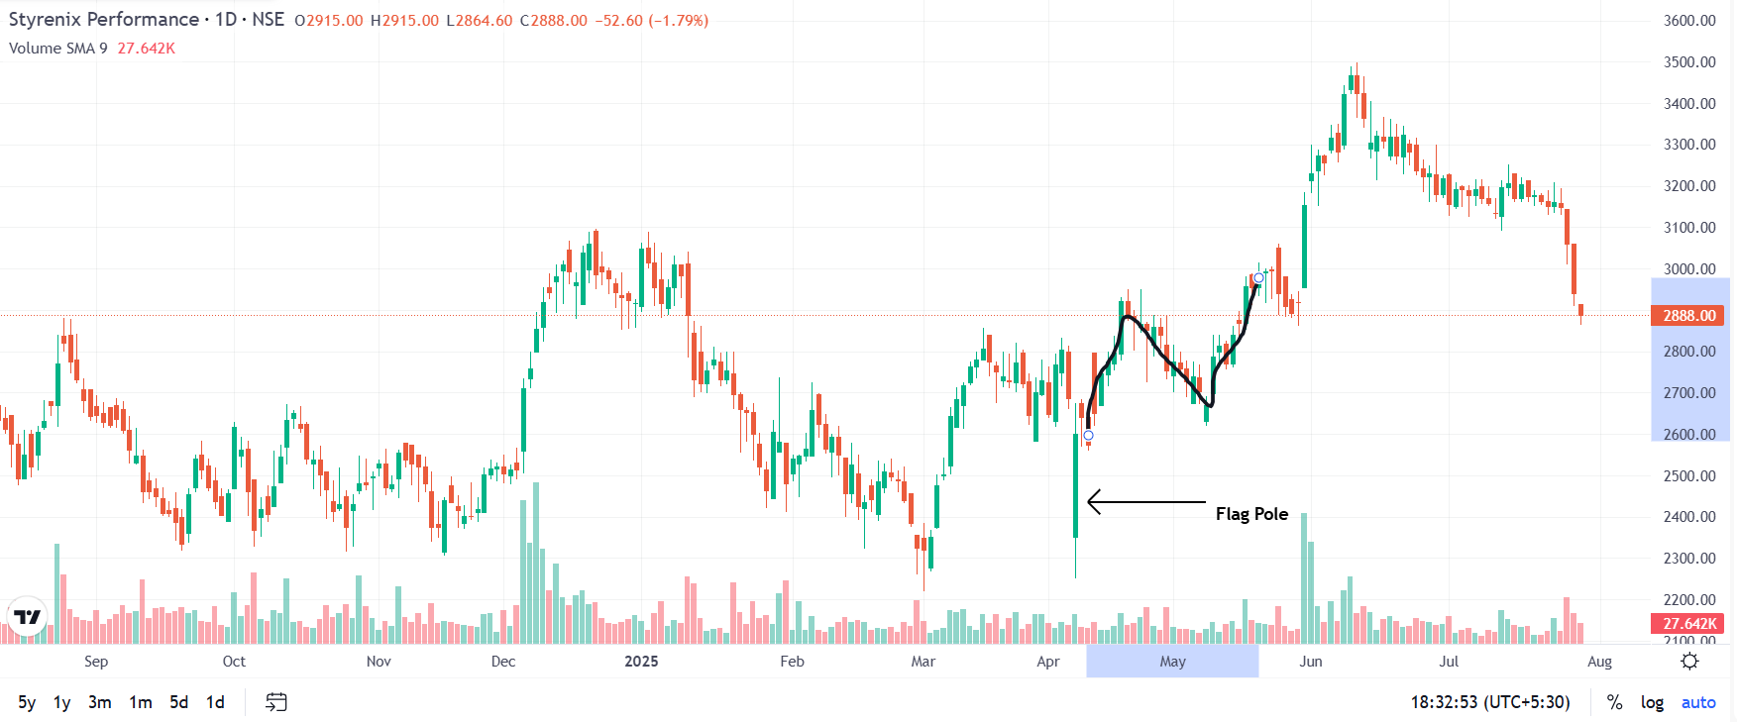
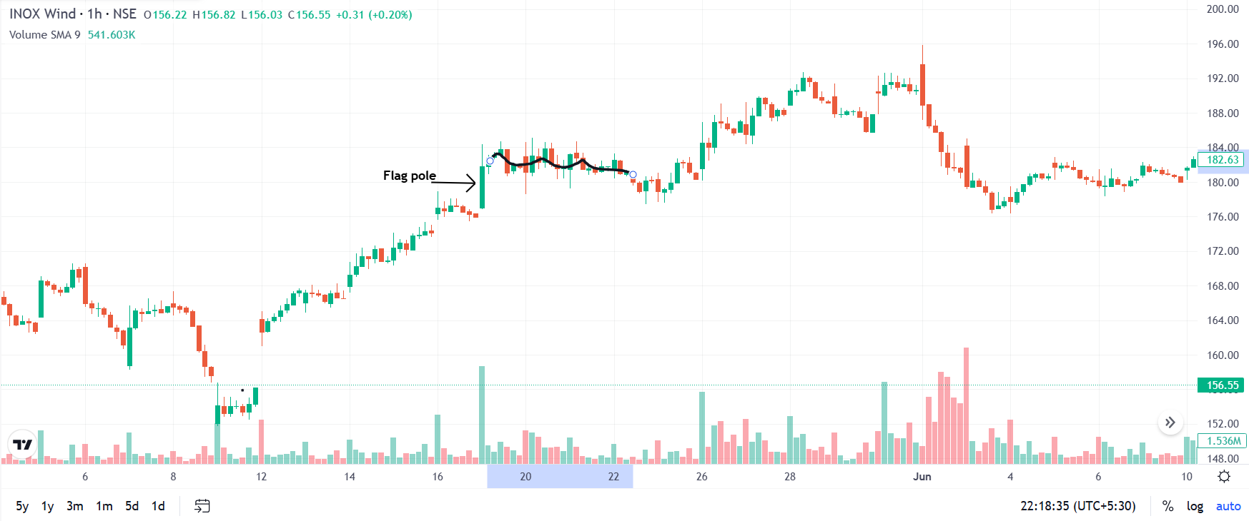

- Find out a Company which is looking good for Buying at this point of time using Technical Analysis. Mention the point of entry, Reason of Entry, Stop Loss, Target and time period of trade. Also write all the logics/reasons of your recommendation.

According to my analysis, Asian Paints Ltd is good for buying at this point of time.

The trade setup: -
Entry point: 2,285
Stop Loss point: 2,190
Target point: 2,600
Time period: 6 month – 1 Years

Reason for Entry & logics/reasons of your recommendation: -

- Critical Support Zone

At the moment, the stock is close to the Fibonacci retracement level of 61.8% from the last significant uptrend.

The price is stabilizing at about ₹2,250, which is also in line with a historically high demand zone.

This zone has acted as a base for previous rallies

- Oversold Momentum Indicators
The Daily RSI is getting close to the oversold level (about 30 to 35), which suggests that selling pressure may have peaked.

Early indications of flattening and a potential reversal from negative territory are being seen in the weekly MACD.

The called irregular RSI is in inflated territory.

- Fibonacci Confluence Zone

The ₹2,250–2,285 range corresponds to:

Fibonacci retracement of the previous bull run at 61.8%

Long-term trendline support from the lows of 2020

Historically, the 50-month moving average has rarely been broken.

- Volume Accumulation
Lower volumes coincided with price drops over the past month, suggesting selling fatigue.

Accumulation volumes are increasing on the recent green candles close to support, which indicates institutional buying.

- Macro Tailwinds
Indian housing, infrastructure and rural markets are expected to grow.
Increasing urbanisation, premiumisation of paints, and focus on home aesthetics will continue to drive demand.

