Beyond FAQs
Combining RPA Workflow with Conversational AI
for customer service that resolves, not just replies
Team members: ______________________________
Registration numbers: ______________________
Course / Slot: _____________________________
Guide: _____________________________________
Submitted: 03 November 2026
Fill in the blanks above before submitting.

1. Overview
Conversational AI understands language but stops at retrieving an answer; RPA executes backend tasks but cannot interpret a free-text request. This project joins the two, so a customer's message is understood, acted on, and either resolved automatically or handed to a person with the reasoning already done.
The domain is scoped to five appliance categories - Television, Washing Machine, Mixer Grinder, Refrigerator and Air Conditioner - over a mock CRM of 21 orders, so the system can be finished and evaluated rather than left broadly half-built.

Key results
- 88% intent-classification accuracy on a held-out validation set
- Confidence threshold of 0.55, derived by sweeping a stated safety policy rather than assumed
- Five intents handled end to end; three automated, two escalated by policy
- 40 automated tests, one per claim the project makes
- Offline throughout: no network needed for speech, classification, routing or execution

2. System architecture
Four layers. Each is swappable without touching the others - the NLU layer already demonstrates this, with a cloud engine and an offline one behind one contract.
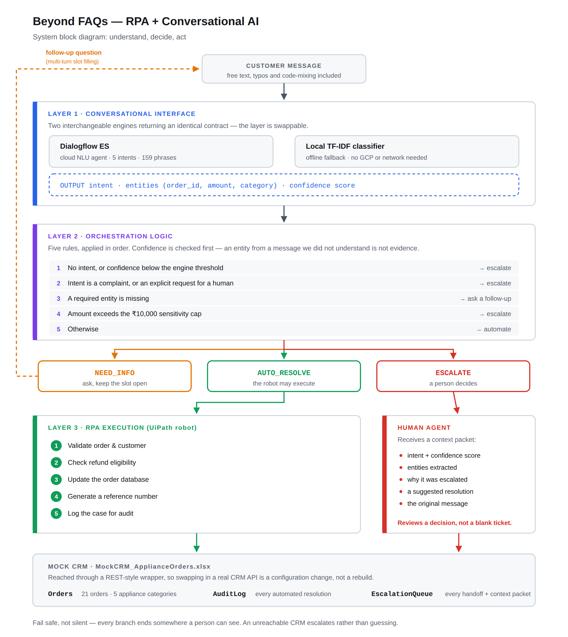
Figure A: System block diagram - understand, decide, act.

Routing rules
Applied in this order. Confidence is checked first on purpose: an entity extracted from a message the system did not understand is not evidence.
- No intent, or confidence below the engine's threshold -> escalate
- Intent is a complaint, or an explicit request for a human -> escalate
- A required entity is missing -> ask a follow-up question
- Amount exceeds the Rs 10,000 sensitivity cap -> escalate
- Otherwise -> automate

3. The UiPath robot
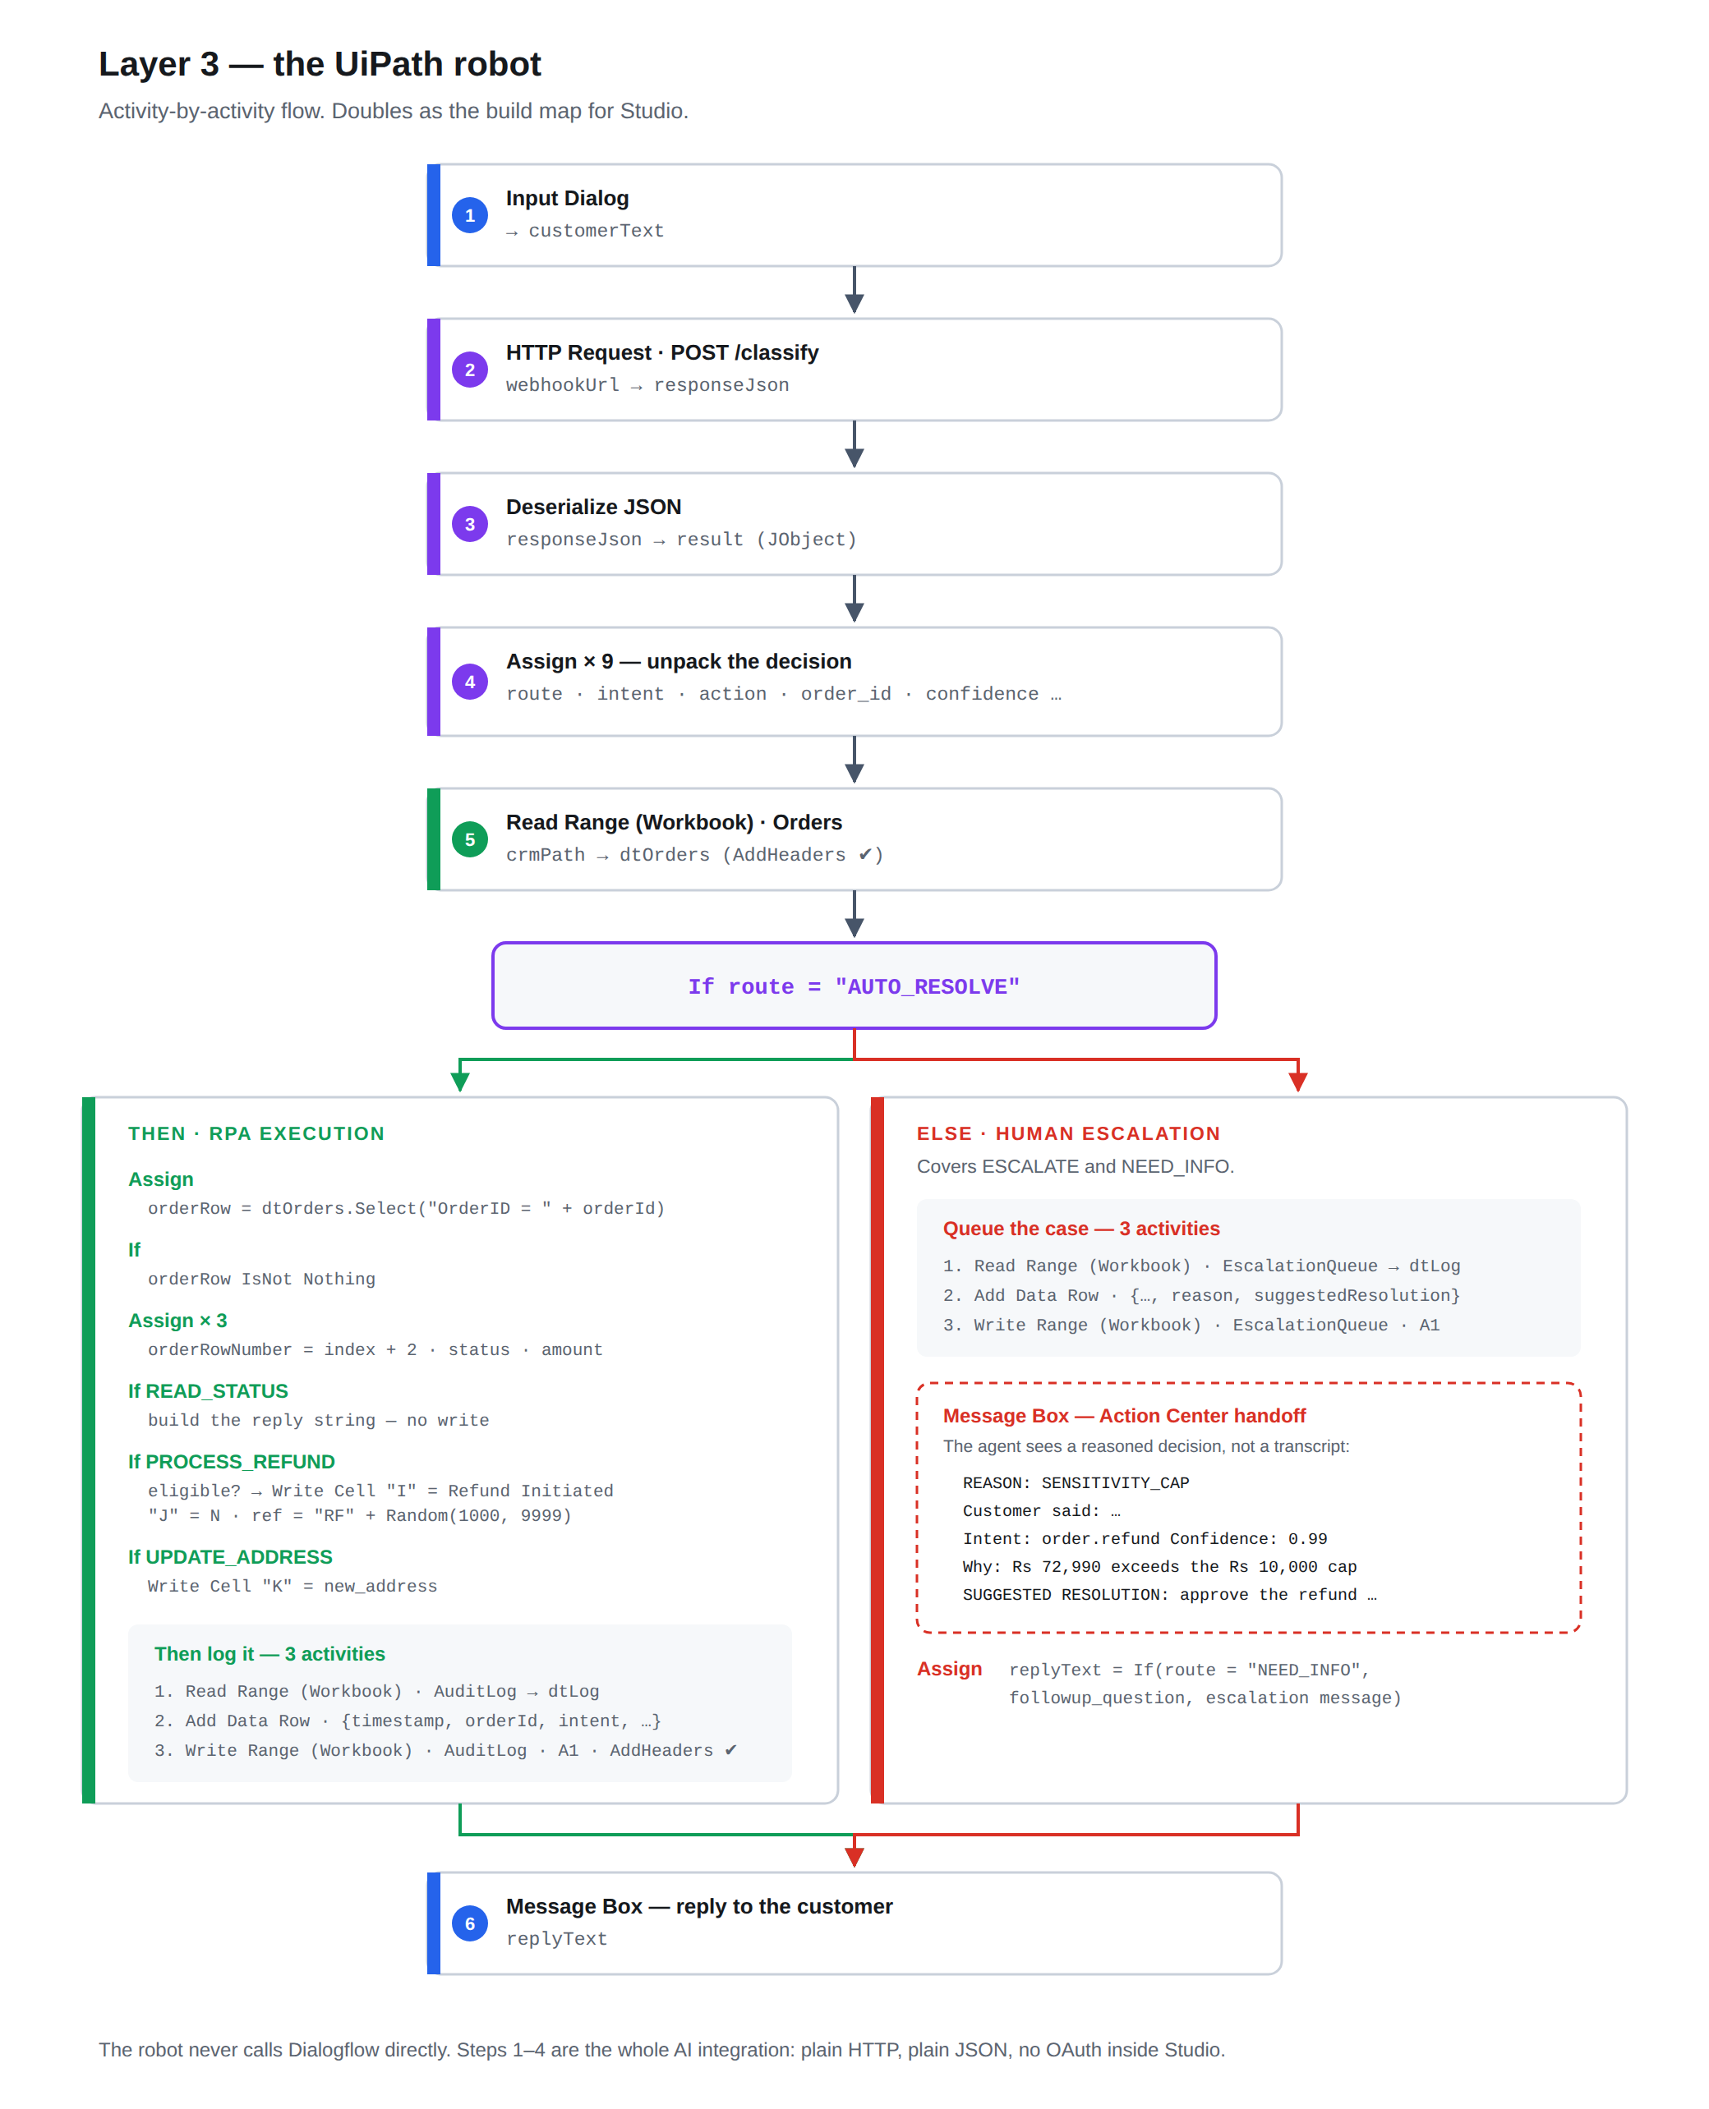
Figure B: The robot, activity by activity.

4. What to install and how to run
Full instructions are in README.md. The essentials:

Requirements
Python 3.9 or newer
pip install -r requirements.txt (Flask, openpyxl)
Optional - voice input:
pip install vosk sounddevice
python scripts/download_vosk_model.py
Optional - the UiPath robot:
UiPath Studio, with UiPath.System.Activities
and UiPath.WebAPI.Activities installed

Running it
python scripts/build_mock_crm.py Create the mock CRM workbook (once)
python demo.py The six scripted scenarios
python demo.py --queue The escalation queue, as an agent sees it
python demo.py --interactive Type your own messages
python demo.py --voice Speak instead of typing
python demo.py --reset Restore the CRM to its starting state
python -m unittest discover -s tests Run the 40 tests
python -m nlu.evaluate Threshold sweep and accuracy
python -m orchestrator.webhook_service Start Layer 2 (needed by UiPath)
Close the workbook in Excel before running anything - Excel holds an exclusive lock and every write will fail.

5. Results

5.1 Classifier evaluation
The threshold is measured, not assumed. Every candidate value is swept against a held-out set under a stated policy: maximise automation subject to at least 95% precision and zero out-of-scope messages automated.
==========================================================================
LAYER 1 EVALUATION - held-out validation set
==========================================================================
Training phrases : 159
Validation phrases : 50 in-scope, 15 out-of-scope
Raw accuracy : 44/50 (88.0%) [ignoring confidence]
thresh automated auto rate precision false auto
--------------------------------------------------------------------------
0.00 50/50 100.0% 88.0% 15/15 <-- FAILS POLICY
0.05 50/50 100.0% 88.0% 11/15 <-- FAILS POLICY
0.10 50/50 100.0% 88.0% 7/15 <-- FAILS POLICY
0.15 48/50 96.0% 89.6% 6/15 <-- FAILS POLICY
0.20 45/50 90.0% 88.9% 2/15 <-- FAILS POLICY
0.25 44/50 88.0% 88.6% 1/15 <-- FAILS POLICY
0.30 42/50 84.0% 90.5% 0/15 <-- FAILS POLICY
0.35 41/50 82.0% 92.7% 0/15 <-- FAILS POLICY
0.40 38/50 76.0% 92.1% 0/15 <-- FAILS POLICY
0.45 37/50 74.0% 94.6% 0/15 <-- FAILS POLICY
0.50 36/50 72.0% 94.4% 0/15 <-- FAILS POLICY
0.55 31/50 62.0% 96.8% 0/15
0.60 26/50 52.0% 100.0% 0/15
0.65 22/50 44.0% 100.0% 0/15
0.70 22/50 44.0% 100.0% 0/15
0.75 21/50 42.0% 100.0% 0/15
0.80 20/50 40.0% 100.0% 0/15
0.85 17/50 34.0% 100.0% 0/15
0.90 11/50 22.0% 100.0% 0/15
0.95 8/50 16.0% 100.0% 0/15
1.00 0/50 0.0% 100.0% 0/15
==========================================================================
RECOMMENDED THRESHOLD: 0.55
==========================================================================
Policy : maximise automation subject to precision >= 95% and zero false automations
Automates : 62.0% of in-scope requests (31/50)
Precision : 96.8% of those classified correctly
Escalates : 38.0% to a human, including all 15 out-of-scope messages
config.py currently uses CONFIDENCE_THRESHOLD_LOCAL = 0.55
-> Matches. Nothing to change.
Misclassified in-scope phrases (what to add training data for):
0.11 expected order.refund got order.address_update "can you reverse the charge on 4514"
0.30 expected order.address_update got order.status "i typed my flat number wrong on order 4518"
0.28 expected order.address_update got order.status "can the courier deliver 4513 somewhere else"
0.58 expected order.address_update got order.status "relocate delivery of order 4505"
0.54 expected order.address_update got order.status "my street name is wrong on order 4514"
0.41 expected order.complaint got order.status "im furious about the condition of my order"

5.2 Test suite
........................................
----------------------------------------------------------------------
Ran 40 tests in 1.675s
OK

5.3 End-to-end run
Captured from `python demo.py`. Each scenario shows the decision made at every layer, so the routing can be followed rather than taken on trust.
==============================================================================
RPA + Conversational AI - customer service that resolves
==============================================================================
NLU engine : local classifier (auto; Dialogflow unavailable: the google-cloud-dialogflow package is not installed (pip install google-cloud-dialogflow))
Threshold : 0.55 (derived in nlu/evaluate.py, not guessed)
Sensitivity cap : Rs 10,000
Mock CRM : MockCRM_ApplianceOrders.xlsx
==============================================================================
------------------------------------------------------------------------------
SCENARIO 1: Straightforward request, handled start to finish
------------------------------------------------------------------------------
The classifier is confident and the request is routine, so the robot reads the order and answers. No human involved.
Customer Where is my order #4521?
Layer 1 NLU intent=order.status confidence=0.96 engine=local
entities order_id=4521
Layer 2 Routing AUTO_RESOLVE (WITHIN_POLICY)
because Confidence 0.96 >= 0.55 and the request is within automation policy.
Layer 3 Robot READ_STATUS -> Status read: Delivered
Bot Hi Ananya - your Prestige Iris 750W (order 4521) was delivered.
If something's wrong with it, I can start a return or raise it with our product team - just tell me what the problem is.
Ordered on 10 Sep.
------------------------------------------------------------------------------
SCENARIO 2: Vague message - the system knows that it does not know
------------------------------------------------------------------------------
Nothing here identifies a request. Rather than guessing at an intent, confidence falls below the threshold and it goes to a person.
Customer Something's wrong with my stuff
Layer 1 NLU intent=order.complaint confidence=0.19 engine=local
Layer 2 Routing ESCALATE (LOW_CONFIDENCE)
because Confidence 0.19 is below the 0.55 automation threshold for the local engine.
Layer 3 Robot queued in EscalationQueue for a human
packet agent sees: The message could not be classified confidently (best guess: order.complaint at 0.19). Entities detected: none. Read the customer's message, confirm w...
Bot I want to get this right rather than guess, and I'm not confident enough that I've understood what you need.
I've passed your message to one of our agents exactly as you wrote it, along with what I was able to work out.
Reference: ESC8169
Someone will come back to you within 4 working hours. If you have your order number to hand, sharing it now will help them get straight to it.
------------------------------------------------------------------------------
SCENARIO 3: Confident AND still escalated - the sensitivity cap
------------------------------------------------------------------------------
The classifier is sure this is a refund. It is escalated anyway, because the amount is above the authorisation cap. Confidence alone never decides.
Customer I want a refund for order 4516
Layer 1 NLU intent=order.refund confidence=0.99 engine=local
entities order_id=4516, amount=72990.0
Layer 2 Routing ESCALATE (SENSITIVITY_CAP)
because Refund of Rs 72,990.00 exceeds the Rs 10,000.00 sensitivity cap. Escalated despite 0.99 confidence.
Layer 3 Robot queued in EscalationQueue for a human
packet agent sees: The order IS marked refund-eligible and all automated checks pass. Recommended action: approve the Rs 72,990.00 refund. This case is above the cap for...
Bot Hi Lakshmi - I've reviewed your refund request for Haier 596L Side by Side (order 4516), and everything on my side checks out - the order is eligible and within policy.
Because Rs 72,990.00 is above my approval limit of Rs 10,000.00, it needs a supervisor's sign-off. I've passed it on with my recommendation to approve.
Reference: ESC6480
A member of the team will confirm within 4 working hours. You don't need to do anything else.
------------------------------------------------------------------------------
SCENARIO 4: A refund the robot can complete
------------------------------------------------------------------------------
Same intent as the previous case, but within the cap and eligible, so the robot updates the database and issues a reference number.
Customer i want my money back for order 4521
Layer 1 NLU intent=order.refund confidence=0.89 engine=local
entities order_id=4521, amount=2499.0
Layer 2 Routing AUTO_RESOLVE (WITHIN_POLICY)
because Confidence 0.89 >= 0.55 and the request is within automation policy.
Layer 3 Robot PROCESS_REFUND -> Refund of Rs 2,499.00 initiated.
reference RF4720
Bot That's done, Ananya. I've approved a refund of Rs 2,499.00 for your Prestige Iris 750W (order 4521).
Reference: RF4720
The amount will be returned to your original payment method within 5-7 working days, and you'll get an SMS once your bank has processed it. Nothing further is needed from you.
------------------------------------------------------------------------------
SCENARIO 5: Missing information - ask, do not fail
------------------------------------------------------------------------------
No order number, so the system asks for one and then completes the original request with the answer.
Customer i want a refund
Layer 1 NLU intent=order.refund confidence=0.99 engine=local
Layer 2 Routing NEED_INFO (MISSING_ORDER_ID)
because Intent 'order.refund' needs 'order_id' before it can be actioned.
Bot Sure - could you tell me your order number? It's the 4-digit number on your confirmation email.
Customer 4509
Layer 1 NLU intent=order.refund confidence=0.99 engine=local
entities order_id=4509, amount=4299.0
Layer 2 Routing AUTO_RESOLVE (WITHIN_POLICY)
because Confidence 0.99 >= 0.55 and the request is within automation policy.
Layer 3 Robot PROCESS_REFUND -> Refund of Rs 4,299.00 initiated.
reference RF4035
Bot That's done, Rohit. I've approved a refund of Rs 4,299.00 for your Philips HL7756 750W (order 4509).
Reference: RF4035
The amount will be returned to your original payment method within 5-7 working days, and you'll get an SMS once your bank has processed it. Nothing further is needed from you.
------------------------------------------------------------------------------
SCENARIO 6: A complaint - escalated on policy, not on confidence
------------------------------------------------------------------------------
The classifier is confident this is a complaint. Complaints are never automated, whatever the score.
Customer my washing machine arrived broken and it wont start
... (29 more lines)

5.4 The escalation context packet
What a human agent receives. This is the project's central claim made concrete: the agent reviews a decision that has already been reasoned through, with the evidence attached.
==============================================================================
ESCALATION QUEUE - what the human agent picks up
==============================================================================
------------------------------------------------------------------------------
CASE ESC8169 Pending · Unassigned
------------------------------------------------------------------------------
Raised 2026-11-03 13:29:55
Order none identified
CUSTOMER SAID
"Something's wrong with my stuff"
WHAT THE CLASSIFIER MADE OF IT
Intent order.complaint
Confidence 0.1908
Entities none
WHY IT WAS ESCALATED
LOW_CONFIDENCE
SUGGESTED RESOLUTION
The message could not be classified confidently (best guess:
order.complaint at 0.19). Entities detected: none. Read the customer's
message, confirm what they need, and if this phrasing is a common one,
add it to the training data so the classifier handles it next time.
------------------------------------------------------------------------------
CASE ESC6480 Pending · Unassigned
------------------------------------------------------------------------------
Raised 2026-11-03 13:29:55
Order 4516 · Haier 596L Side by Side · Rs 72,990.00
Customer Lakshmi Subramanian · 9840556677
Order status Delivered · refund-eligible: Y
CUSTOMER SAID
"I want a refund for order 4516"
WHAT THE CLASSIFIER MADE OF IT
Intent order.refund
Confidence 0.99
Entities order_id=4516; amount=72990.0
... (39 more lines)

6. Screenshots
Paste each screenshot into the marked space below its heading. The captions are already written.

Figure 1: The orchestration webhook running
[ PASTE SCREENSHOT HERE ]
Terminal 1, after `python -m orchestrator.webhook_service`. This is Layer 2 serving the routing decisions the robot acts on.

Figure 2: Scenario 1 - resolved automatically
[ PASTE SCREENSHOT HERE ]
`python demo.py`. High confidence and a routine request, so the robot reads the order and answers with no human involved.

Figure 3: Scenario 3 - confident, and still escalated
[ PASTE SCREENSHOT HERE ]
The classifier is 0.99 sure this is a refund. It escalates anyway, because Rs 72,990 is above the Rs 10,000 sensitivity cap. Confidence alone never decides.

Figure 4: The escalation queue as an agent receives it
[ PASTE SCREENSHOT HERE ]
`python demo.py --queue`. The agent is handed intent, confidence, the reason for escalation and a recommended action - a decision to review, not a transcript to investigate.

Figure 5: Live, unscripted input
[ PASTE SCREENSHOT HERE ]
`python demo.py --interactive`, with messages typed during the demonstration rather than from the script.

Figure 6: Voice input and digit recovery
[ PASTE SCREENSHOT HERE ]
`python demo.py --voice`. The recogniser returns words; the line beneath shows the spoken digits converted back to the order number the CRM needs.

Figure 7: The UiPath workflow in Studio
[ PASTE SCREENSHOT HERE ]
uipath/Main.xaml. The robot asks for the message, calls the orchestration webhook, reads the decision and branches on it.

Figure 8: UiPath - the AI decision received by the robot
[ PASTE SCREENSHOT HERE ]
The message box raised by the running robot, showing the intent, confidence, route and reason returned by Layer 2.

Figure 9: UiPath - the escalation branch
[ PASTE SCREENSHOT HERE ]
The same workflow taking the other path, with the suggested resolution the human agent will receive.

Figure 10: The order database after the run
[ PASTE SCREENSHOT HERE ]
data/MockCRM_ApplianceOrders.xlsx, Orders sheet. The refunded order now reads 'Refund Initiated' and its refund eligibility has been cleared, so the same refund cannot be run twice.

Figure 11: The audit log
[ PASTE SCREENSHOT HERE ]
AuditLog sheet. One row per automated resolution, recording the confidence that produced it.

Figure 12: The escalation queue
[ PASTE SCREENSHOT HERE ]
EscalationQueue sheet. One row per handoff, carrying the context packet and the case reference given to the customer.

7. Honest status and limitations
Stated plainly, because a prototype that overstates itself is harder to defend than one that does not.
- The Dialogflow agent is implemented but not provisioned; nlu/dialogflow_setup.py creates it from the same training data in one command. The offline classifier runs in its place, and both return an identical contract.
- The UiPath robot receives the routing decision and acts on it, but is triggered by a Studio run rather than an Orchestrator job - a deployment difference, not an architectural one.
- The CRM is an Excel workbook behind a REST-style wrapper, so pointing the system at a real CRM API is a configuration change rather than a rebuild.
- Speech recognition accuracy depends on the microphone and the room. Recognition is constrained to the project's vocabulary to protect order numbers, which are the field everything downstream depends on.

