WEEK 2 REPORT
Exploratory Data Analysis and Dataset Quality Review
Prepared for Internship Submission
Project: Employee Attrition Prediction using Python
Evidence basis: the supplied Jupyter notebooks and their recorded outputs.

1. Executive Summary
The EDA notebook was run against the supplied HR analytics CSV. The dataset contains 1,470 rows and 35 columns. The target label is imbalanced: 237 records (16.12%) are Attrition = Yes and 1,233 (83.88%) are Attrition = No. The recorded column checks show 1,470 non-null values for each of the 35 columns in the inspected dataset.

2. Dataset Overview
Check | Observed result | Interpretation
Dataset dimensions | 1,470 rows × 35 columns | A compact tabular classification dataset
Target values | Yes and No | Binary classification target
Attrition = Yes | 237 (16.12%) | Minority class
Attrition = No | 1,233 (83.88%) | Majority class
Missing values | 0 reported in the inspected columns | No nulls detected by the notebook’s missing-value check
Exact duplicate rows | 0 removed in preprocessing notebook | No exact duplicate rows were found by that check

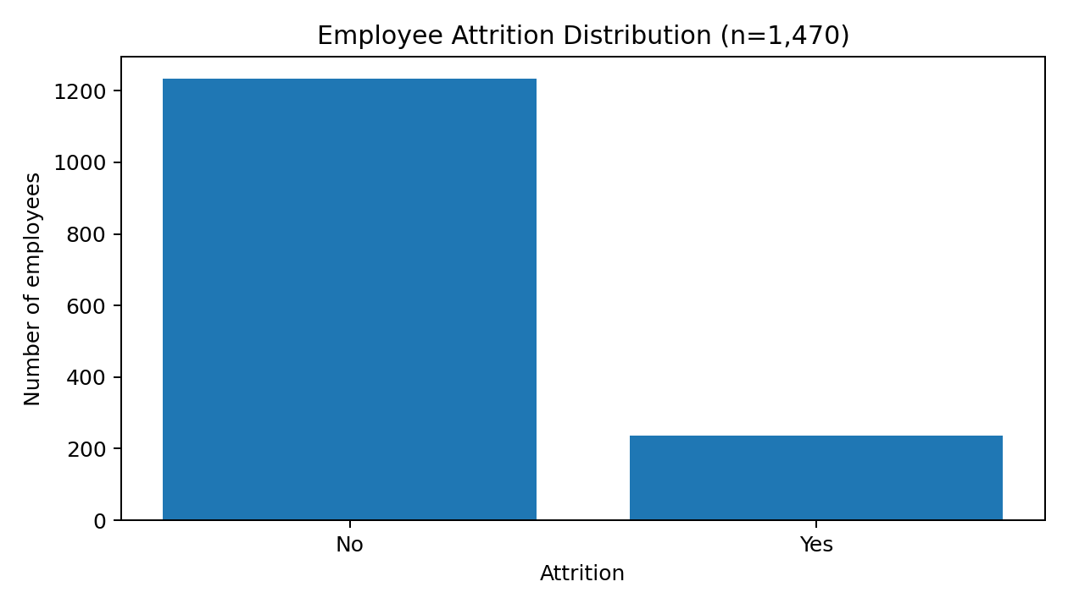
Figure 1. Counts for the Attrition target in the supplied dataset.

3. Data Types and Features
The dataset includes numeric fields such as Age, DailyRate, DistanceFromHome, MonthlyIncome, TotalWorkingYears, YearsAtCompany and satisfaction/involvement scores. Categorical fields include BusinessTravel, Department, EducationField, Gender, JobRole, MaritalStatus and OverTime. The modeling preparation identifies 23 numeric features and 7 categorical features after removing identifier/constant columns and the target.

4. EDA Activities Completed
- Loaded the CSV and inspected the dataset dimensions and sample records.
- Reviewed data types, descriptive summaries and missing-value counts.
- Counted and calculated percentages for Attrition = Yes and Attrition = No.
- Generated an attrition distribution chart.
- Generated numeric feature comparisons for selected fields, including Age, MonthlyIncome, YearsAtCompany and DistanceFromHome, where available in the notebook.

5. Key Observations
- The majority of records are labelled No; the attrition class is a minority at 16.12%.
- No missing values were reported in the notebook’s inspected missing-value output.
- The dataset contains a mix of numeric and categorical variables, so preprocessing needs to handle the two feature types differently.
- The class imbalance means a model can appear accurate while failing to identify employees labelled Yes.
- The exploratory charts are descriptive; they do not demonstrate that any feature causes attrition.

6. Limitations
This dataset is a sample HR analytics dataset, not a live HR system. The notebook checks establish the visible data structure and target balance but do not establish that the data is representative of any particular organization. The analysis is cross-sectional and should not be interpreted as a validated forecast of future departures.

7. Week 2 Conclusion
EDA established the dataset structure, basic completeness checks and the imbalance in the Attrition target. These observations justify a preprocessing pipeline and evaluation approach that considers minority-class recall, precision and F1-score alongside accuracy.

