WEEK 3 REPORT
Data Preprocessing, Model Training and Evaluation
Prepared for Internship Submission
Project: Employee Attrition Prediction using Python
Evidence basis: the supplied Jupyter notebooks and their recorded outputs.

1. Executive Summary
The preprocessing and model-training notebooks were executed on the 1,470-row dataset. No exact duplicate rows were removed. Three constant columns—EmployeeCount, Over18 and StandardHours—were removed. The data was split using a stratified 80/20 train-test split with random_state=42. Three models were evaluated: a majority-class dummy baseline, logistic regression and random forest.

2. Preprocessing Steps
Step | Recorded implementation / result
Duplicate check | 0 exact duplicate rows removed
Constant columns | EmployeeCount, Over18 and StandardHours removed
Target | Attrition mapped to binary labels for classification
Identifier | EmployeeNumber excluded from predictive features
Train/test split | 1,176 train rows and 294 test rows; stratified; test_size=0.20; random_state=42
Train attrition rate | Approximately 16.16%
Test attrition rate | Approximately 15.99%
Feature groups | 23 numeric and 7 categorical features identified
Preprocessing | Numeric imputation/scaling and categorical imputation/one-hot encoding are handled within the modeling pipeline

3. Models Compared
Model | Role
Dummy baseline | Predicts the majority class; reference point for judging whether machine learning adds value
Logistic Regression | Interpretable baseline with class weighting
Random Forest | Tree-based model that can capture nonlinear relationships

4. Test-Set Results
Model | Accuracy | Precision | Recall | F1-score | ROC-AUC
Dummy baseline | 0.840 | 0.000 | 0.000 | 0.000 | 0.500
Logistic Regression | 0.752 | 0.349 | 0.638 | 0.451 | 0.803
Random Forest | 0.840 | 0.500 | 0.170 | 0.254 | 0.798

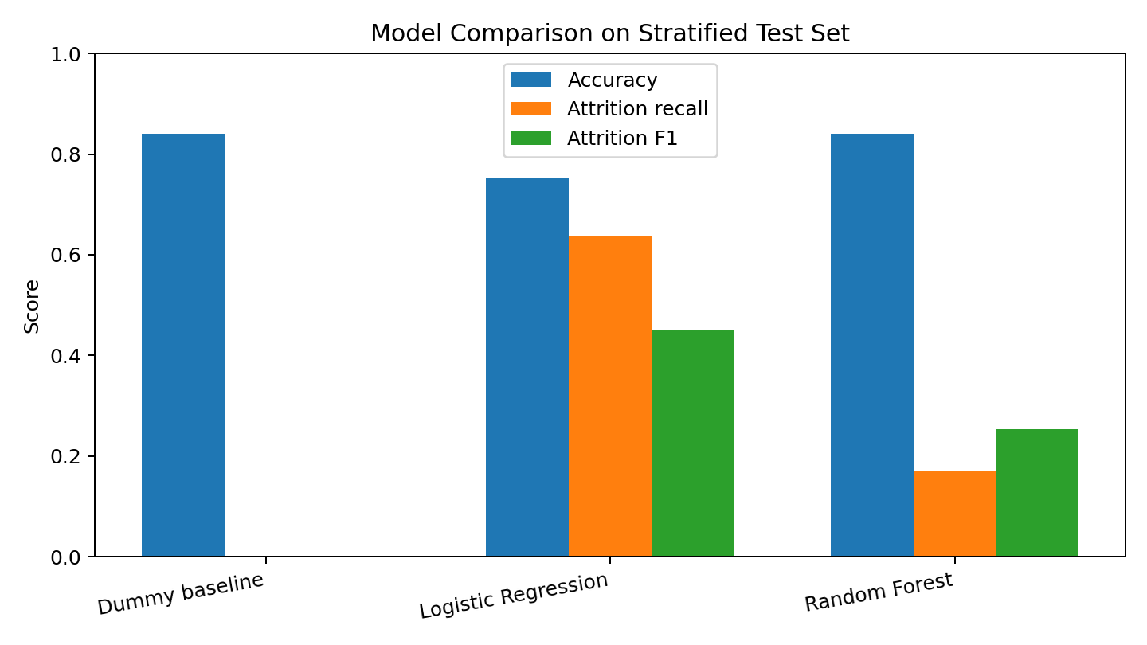
Figure 1. Model metrics recorded by the model-training notebook. Recall and F1 refer to the Attrition = Yes class.

5. Interpretation of Results
- The dummy baseline achieved 84.0% accuracy by predicting the majority class, but it had zero recall for Attrition = Yes. This demonstrates why accuracy alone is insufficient.
- Logistic regression achieved the highest attrition recall (0.638) and F1-score (0.451) among the evaluated models. It identified a larger share of attrition cases, but its precision was 0.349 and overall accuracy was lower.
- Random forest achieved 84.0% accuracy and 0.500 precision, but its attrition recall was only 0.170, meaning it missed many positive cases at the default threshold.
- The notebook selected logistic regression by F1-score for the confusion-matrix demonstration. This is a teaching selection rule, not proof that it is the best operational model.

6. Evaluation Limitations
- Evaluation uses a single stratified holdout split rather than temporal validation or cross-validation.
- The target reflects the supplied dataset’s Attrition label; the notebook does not define a future six-month prediction window.
- The results are dataset-specific and may not generalize to another organization or time period.
- Threshold selection, calibration, fairness/subgroup evaluation and PR-AUC analysis would be useful additions before any real-world use.

7. Week 3 Conclusion
The executed notebooks demonstrate an end-to-end baseline workflow. Logistic regression provides the strongest balance of recall and F1 among these three runs, while the dummy baseline confirms that high accuracy can hide complete failure to detect attrition cases. Further validation would be required before drawing operational conclusions.

