WEEK 4 REPORT
Final Findings, Business Interpretation and Recommendations
Prepared for Internship Submission
Project: Employee Attrition Prediction using Python
Evidence basis: the supplied Jupyter notebooks and their recorded outputs.

1. Executive Summary
The project completed a basic Python workflow for employee attrition analysis: EDA, preprocessing, a stratified holdout split, and comparison of a dummy baseline, logistic regression and random forest. The dataset has 1,470 records, with 16.12% labelled Attrition = Yes. Logistic regression produced the highest recall and F1-score for the positive class in the recorded comparison. The results are exploratory and should not be treated as a validated workforce risk system.

2. Main Findings
Finding | Evidence from notebook | Meaning
Attrition is the minority class | 237 Yes (16.12%) vs 1,233 No (83.88%) | Evaluation should focus on positive-class metrics, not accuracy alone.
Basic completeness checks passed | No nulls reported by the inspected missing-value output | No nulls were detected by this check; this does not rule out invalid or semantically missing values.
Dummy accuracy is misleading | 84.0% accuracy but 0.000 recall and 0.000 F1 for Attrition = Yes | A majority-class predictor can score well on accuracy without finding attrition cases.
Logistic regression found more positive cases | Recall 0.638; F1 0.451; precision 0.349 | It detects more labelled attrition cases but produces false positives.
Random forest missed many positive cases | Recall 0.170; F1 0.254 | At the evaluated threshold, it is less effective at identifying the positive class.

3. Model Comparison
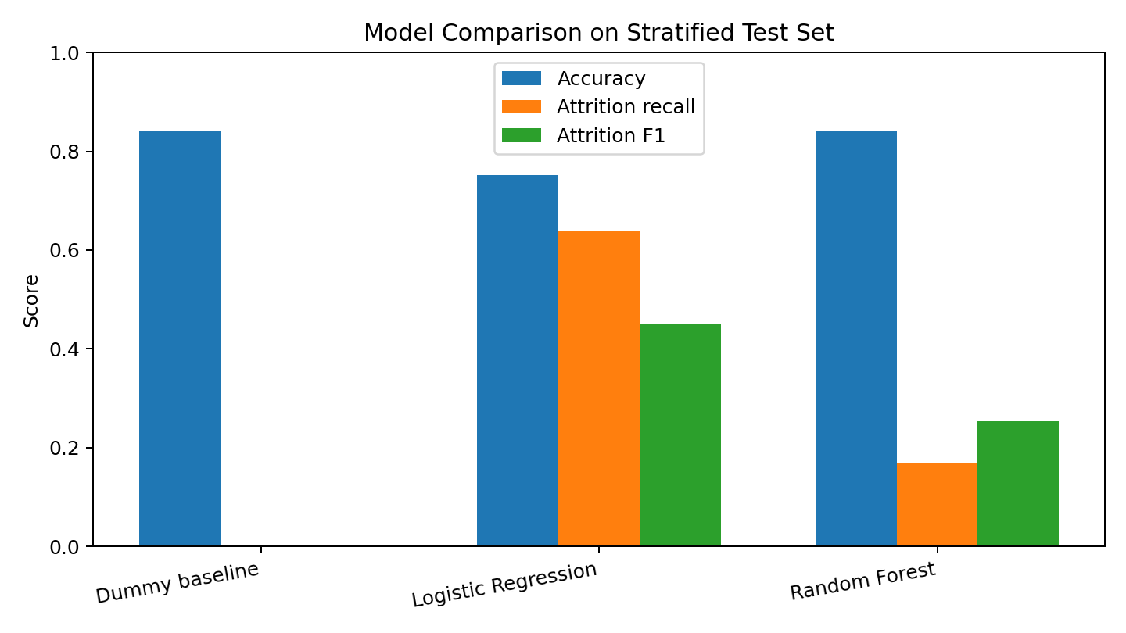
Figure 1. Accuracy, positive-class recall and F1-score on the 294-row test set.
Logistic regression was selected by the notebook’s F1-based rule for confusion-matrix review. It had ROC-AUC 0.803, compared with 0.798 for random forest and 0.500 for the dummy baseline. ROC-AUC values are close for the two trained models; the choice depends on the cost of missed attrition cases versus unnecessary interventions, and should not be made from one metric alone.

4. Business Recommendations
- Use the results as a learning prototype only. Do not assign individual employee risk labels or make automated employment decisions.
- If an organization conducts a separate authorized retention study, begin with aggregate patterns and supportive options such as onboarding check-ins, workload discussions and career-development conversations.
- Before considering any real use, define the target and prediction horizon with HR, confirm lawful data access, and assess data quality and representativeness.
- Evaluate precision-recall trade-offs and decision thresholds with stakeholders; false positives may create unnecessary interventions, while false negatives may miss employees who need support.
- Perform cross-validation or temporal validation, subgroup error checks, calibration review and monitoring before making stronger claims.

5. Project Limitations
- The dataset is a public sample and is not evidence about a specific employer’s current workforce.
- The target is the dataset’s existing Attrition label, not a newly constructed future-period outcome.
- The evaluation uses one stratified 80/20 split with random_state=42; performance uncertainty across different splits was not estimated.
- The recorded notebooks compare three models and do not report PR-AUC, calibration or subgroup fairness metrics.
- Associations and model predictions do not establish causality.

6. Final Conclusion
The project successfully demonstrates how to inspect a tabular HR dataset, prepare mixed feature types and compare simple classification models. The most important technical lesson is that class imbalance makes accuracy an incomplete measure. Logistic regression found more positive cases than random forest in this run, but its precision shows that predictions would require careful review. The project is suitable as an educational portfolio exercise; further validation and governance would be required for any real workforce application.

