Abstract
Long-horizon failure is reported as one number, which confounds two failures with opposite remedies: the model has lost track of the world, or it holds the world and chooses badly. We separate them where an exact state oracle exists, chess from move notation with no search at inference, in models of result@paramsSmall ?? result@paramsSmall to result@paramsLarge ?? result@paramsLarge parameters, reading linear probes against the true position at every token.
Aggregate state fidelity, the quantity usually reported, is the weaker predictor of an illegal next move within a fixed depth, at AUC result@aucAggMin ?? result@aucAggMin to result@aucAggMax ?? result@aucAggMax against result@aucActMin ?? result@aucActMin to result@aucActMax ?? result@aucActMax for the same representation restricted to the squares the move touches. And the errors are coherent. Reconstructing the position the model appears to believe, result@belIllAttn ?? result@belIllAttn of its illegal moves are legal there, against result@belMisAttn ?? result@belMisAttn for the same move under another position’s belief and result@belRandAttn ?? result@belRandAttn for an arbitrary illegal move. Editing the probe direction encoding an occupied square removes result@patchCutAttn ?? result@patchCutAttn of the probability mass on moves from it, a norm-matched random edit result@patchRandCutAttn ?? result@patchRandCutAttn, so the representation is read and not merely present. Belief consistency rises monotonically across six model sizes, though the causal edit is not measured at every size. A substantial identified subset of long-horizon error is coherent with a degraded state the policy demonstrably reads.
We report failures too: a backwards layer profile, a degenerate pre-registered metric, an auxiliary objective improving the measurement of state more than its consequences, and a second domain needing seven designs to become measurable.
Keywords: state tracking, world models, probing, model diagnostics, chess, long-horizon reasoning

Introduction
A model that reasons over many steps has to keep track of something, and an attention-only decoder has no explicit bounded mutable state in which to keep it. Each token’s representation is rebuilt from the whole prefix through attention , so any quantity the task requires, a board position, the value of a variable, which sub-goal remains open, exists only because the network re-derives it at every layer and position. That re-derivation is dependable over short spans and unreliable over long ones. Anyone who has watched a model reason for forty steps knows the symptom: it stays fluent and quietly stops being right about its own earlier commitments.
The usual remedies sit outside the model: tree search grafts deliberation onto the policy , process reward models supervise intermediate steps , and self-consistency samples several chains and votes . Each raises end-task accuracy and leaves the original question untouched: what fails inside the network as the chain lengthens? The two candidate failures recommend opposite purchases. If the model has forgotten the world, a verifier that rescores outputs pays repeatedly to repair something the architecture gave away. If it remembers the world and reasons badly over it, a verifier is exactly right.
Answering that requires reading an intermediate representation against a known-correct intermediate state, and on open-ended text no such state exists. The intermediate “state” of an argument in prose is not well defined, which is why claims about it are hard to falsify. We move the measurement to a domain where the state is exact, cheap, and external, and are explicit about what that does and does not license.

What we find.
Working with search-free autoregressive models trained only on chess move notation, we measure the internal state against a rules engine at every token and compare it with what the model actually does. Three results carry the argument, and the rest of the paper tests how far they reach.
- The errors are coherent. We reconstruct the board the model appears to believe and ask whether its illegal move is legal there. It is, for result@belIllAttn ?? result@belIllAttn of illegal moves, with a bootstrap interval of [ result@belIllLoAttn ?? result@belIllLoAttn, result@belIllHiAttn ?? result@belIllHiAttn]. The same move scored against another position’s believed board at equal depth is legal result@belMisAttn ?? result@belMisAttn of the time, and an arbitrary illegal move scored against the model’s own believed board is legal result@belRandAttn ?? result@belRandAttn of the time. Lossy decoding caps what is detectable at result@belLegAttn ?? result@belLegAttn, the rate for moves that were genuinely legal.
- The representation is read, not merely present. Editing the probe direction that encodes an occupied square removes result@patchCutAttn ?? result@patchCutAttn of the probability mass on moves from that square, while a norm-matched random edit removes result@patchRandCutAttn ?? result@patchRandCutAttn and shifts the mass at chance. The edit strength is calibrated rather than chosen.
- Where the world model is measured matters, increasingly with depth. Whole-board probe accuracy predicts an illegal next move with an AUC of result@aucAggMin ?? result@aucAggMin to result@aucAggMax ?? result@aucAggMax. The same representation restricted to the squares the move uses reaches result@aucActMin ?? result@aucActMin to result@aucActMax ?? result@aucActMax. In the opening the two are almost indistinguishable; the gap opens as reasoning deepens, and in a joint fit the move-touched term carries a standardised weight of result@betaAct ?? result@betaAct against result@betaAgg ?? result@betaAgg.
The first two are the ones we would defend hardest, and they belong together: the errors are coherent with a decayed state, and that state is causally load-bearing rather than an epiphenomenon. Failure here is not noise breaking through as the context grows. A substantial share of it is action admissible under a world that has drifted, which suggests why fluency outlives correctness: the model acts coherently with respect to a position it no longer holds.

Why chess.
Chess presented purely as move notation, with no tree search at inference, gives what prose does not. The true state after any prefix is computable by a rules engine, so probing has a per-token label; legality is decidable, so a state-tracking failure has an unambiguous observable rather than a judgement call; move quality is separately scoreable by an engine, so the second failure mode can be measured conditional on the first being absent; depth is uniformly scaled, unlike “number of reasoning steps” in prose; and the domain is combinatorial, so surface heuristics do not substitute for computation. Chess is our instrument, not our subject, and Section 8 is explicit about the reach that buys.

Contributions.
Alongside those results we contribute a per-token diagnostic stratification into state mismatch, belief-consistent error, conditional planning loss, and unresolved failure, measured against an exact oracle rather than a learned verifier, with the conditioning analysis that shows how far the strata can be told apart; a horizon defined on state fidelity directly, which avoids a failure mode of behavioural horizons that we document; and an account of what failed, including a degenerate metric, a prediction that ran backwards, an intervention that improved the measurement more than the behaviour, and seven task designs before a second domain became measurable. Each changed a decision.

Related Work

Inference-time search.
Deliberation over candidates , process supervision , and sampling with a vote , built on chain-of-thought prompting , buy accuracy with inference compute and take the base policy as given. Our concern is the base policy: a verifier that spends its budget repairing state-tracking errors compensates for a representational defect at a recurring cost. We diagnose which defect is present before recommending a remedy.

Long-context evaluation.
Position-dependent retrieval failure and effective-context measurement show usable context is shorter than advertised context. Both measure retrieval of material present in the prefix. Long-horizon reasoning failure is different: the needed quantity was never written down, only implied, and has to be maintained through composition. A model can attend to every token of a sixty-ply game and still not know where the pieces are.

World models and probing.
Linear probes recover board state from game transcripts with linear structure ; chess serves as a state-tracking testbed ; and causal editing of internal associations changes behaviour . Closest to our setting, probes board state and estimated player skill in a chess-playing language model and intervenes on those representations, and the same probes are later used as ground truth for evaluating dictionary learning . That the representation exists and is manipulable in this domain is our premise rather than our result. We ask instead how its fidelity varies with reasoning depth, and whether its failures explain behavioural failures at the level of individual actions. Probe design follows the control-task discipline of .

Concurrent work, and what is actually new here.
The measurement at the centre of this paper is not new. report the fraction of illegal chess moves that are legal on a probe-reconstructed board and reach a conclusion close to the opposite of ours: for models trained on large datasets that fraction is small, and the gradient of their board-state probe is nearly orthogonal to that of the next-token head, which they read as the probe lacking a causal role in generation. separate state tracking from decision quality in searchless chess transformers; benchmark exact state tracking across architectures over a parameter range close to ours; show world-state representations decaying during generation in frontier reasoning models, with a causal restoration experiment; and document loss of coherent internal state over long sequences. State decay with depth, chess state tracking, and scaling this measurement are therefore not novel contributions of ours, and we do not claim them.
What differs is the conditions and the conclusion. Their illegal moves are adversarially induced; ours arise on ordinary held-out trajectories, which is a different population and may have a different mechanism. We add same-depth mismatched-belief and random-move controls, which bound how much of the effect a merely plausible board would produce; we compare aggregate against action-conditioned predictors on equal footing; and where their gradient-orthogonality analysis finds the probe weakly coupled to generation, our calibrated residual-stream intervention finds a strong effect on the action. Those results are not strictly contradictory, since a direction can be causally load-bearing at one layer while its gradient is near-orthogonal to the output head, but the tension is real and we flag it as the most useful open question this paper raises.

Expressivity, recurrence, and search-free play.
Theory bounds what these architectures can track: state-space models are weaker than their recurrent form suggests , and intermediate tokens change what a Transformer can express . That work asks what is representable in principle; we ask what a trained model actually maintains, and where it stops. Structured state-space models give constant per-token state, usually motivated by throughput and context length; we use a small supervised recurrent channel not as a contribution in itself but as a test case for whether the diagnostic discriminates between architectures. Policies that reach strong play by distilling engine evaluations without a tree show the task is learnable without search. Their objective is strength; ours is measurement, so we deliberately study models weak enough to fail.

Problem Formalisation
Let a task be a token sequence $x_{1:L}$ generated left to right, and $s_{t}=Φ(x_{1:t})$ the exact state after the prefix, from an external oracle $Φ$. For chess $s_{t}=(b_{t},τ_{t},c_{t},e_{t})$: piece placement, side to move, castling rights, and the en-passant target.
Our probe decodes only the first component. Write ${\hat{b}}_{t}^{(ℓ)}=g^{(ℓ)}(h_{t}^{(ℓ)})$ for decoded piece placement, and let the pseudo-state used by the belief test be ${\tilde{s}}_{t}=({\hat{b}}_{t},τ_{t},⌀,⌀)$, with side to move taken from ply parity and castling and en-passant disabled so that nothing is licensed by an assumption we did not decode. Claims below concern ${\hat{b}}_{t}$ and ${\tilde{s}}_{t}$, not $s_{t}$. The state space is large, but the description length of any $s_{t}$ is constant in $t$: a position occupies a few hundred bits however many plies produced it.
Let $h_{t}^{(ℓ)}$ be the residual-stream activation at position $t$, layer $ℓ$, and $g^{(ℓ)}$ a linear decoder trained to recover $s_{t}$ from it. Write ${\hat{s}}_{t}^{(ℓ)}=g^{(ℓ)}(h_{t}^{(ℓ)})$ for the decoded, or believed, state.
Definition 1 (Board-placement fidelity). $F^{(ℓ)}(t)=Pr[{\hat{b}}_{t}^{(ℓ)}=b_{t}]$, the probability that piece placement is linearly decodable at depth $t$. We name it for placement rather than for state because side to move, castling rights and the en-passant target are not decoded.
Definition 2 (Move-touched fidelity). The probability that ${\hat{s}}_{t}$ and $s_{t}$ agree on the origin and destination squares of the selected move. We name it for what it measures rather than calling it action-relevant, because it is a deliberately local proxy. The state an action actually depends on is larger: legality can turn on intermediate path squares for sliding pieces, the king’s square and post-move attack status, pins and discovered attacks, castling rights and transit squares, the en-passant target, side to move, and promotion. A fuller treatment would define $R_{legal}(a,s)$, the complete set of components legality depends on, and report a progression from whole-board through move-touched to path-aware and fully legality-aware fidelity. We report the local proxy and the controls that bound it, and leave that progression to future work.
Definition 3 (Behavioural error and its stratification). Let $Y_{t}=1$ when the action selected at depth $t$ is behaviourally invalid, and let $M_{t}=1$ when the decoded state disagrees with the oracle on the components the selected action reads. By the law of total probability, $$Pr(Y_{t}=1)=Pr(M_{t}=1)Pr(Y_{t}=1∣M_{t}=1)+Pr(M_{t}=0)Pr(Y_{t}=1∣M_{t}=0).$$ This is an observational stratification and not a causal decomposition. The first term is not by itself memory-caused error and the second is not by itself policy-caused error.
Definition 4 (Belief-consistent error). Write $A(s)$ for the actions valid in state $s$ and $\tilde{A}(\hat{s})$ for those admitted by the decoded state. An error is belief-consistent when $B_{t}=1[ a_{t}∉A(s_{t})∧a_{t}∈\tilde{A}({\hat{s}}_{t}) ]$, and we report $Pr(B_{t}=1∣a_{t}∉A(s_{t}))$.
Two consequences of this framing are worth stating plainly, because an earlier version of this paper got them wrong. A state mismatch need not produce a behavioural error: our own measurements show the probe wrong on the squares a move touches for a substantial fraction of legal moves, so $M_{t}=1$ does not imply $Y_{t}=1$. And because the probe is an incomplete and lossy read of the state, belief consistency identifies a subset of errors rather than partitioning all of them. The errors it does not identify are unresolved: they may be genuine policy failures, state errors the probe did not capture, information the probe cannot read linearly, or reconstruction failures. We do not call them planning errors.

The State-Space Bottleneck
Proposition 1 (Cost mismatch). Under full attention each new token reads an $O(t)$ key-value history and retains $O(t)$ cached memory, while the task state has description length $O(1)$. A key-value cache amortises the computation of earlier activations, so the cost is not recomputation from scratch; what the architecture lacks is a bounded mutable state that could carry $s_{t}$ forward and be updated in place. This is a motivating cost mismatch, not a proof that fidelity must decay.
Two consequences were testable. Fidelity should fall with depth even well inside the context window, because the re-derivation circuit must compose more updates within a fixed layer budget; it does (Section 6.1). We also predicted fidelity would peak at intermediate layers and fall toward the output, the state being a means rather than an end. That prediction is wrong. Decodability rises through the stack and is maximal at the final block, from result@layerProfFirst ?? result@layerProfFirst at the first layer to result@layerProfLast ?? result@layerProfLast at the last. For this task the state sits close to the target: the next legal move is a direct function of the position, so a representation making the position linearly available is also a good representation for the output head. We keep the failed prediction because it constrains where a state carrier should be inserted, and our spacing was chosen before we knew.
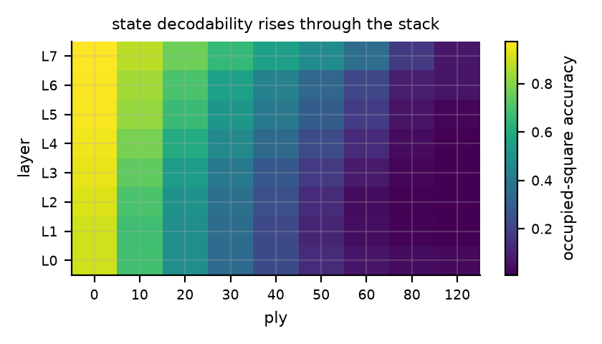
State decodability by layer and depth. Contrary to our prediction, the position is most linearly available at the final block rather than in the middle of the stack.

Diagnostic Protocol

Data.
Public game records above a rating floor, deduplicated by move-sequence hash, split by game, so no position from a given game appears in more than one split. Splitting by game does not make the splits prefix-disjoint, since distinct games share openings, and we do not claim it does. The corpus holds result@nGames ?? result@nGames games: result@ntrainlm ?? result@ntrainlm for training, result@ntrainprobe ?? result@ntrainprobe for probes, result@neval ?? result@neval for evaluation, mean length result@meanPly ?? result@meanPly plies, move vocabulary result@nVocab ?? result@nVocab.

Oracle.
A rules engine replays every game and emits the exact state after every token, verified complete before any model is measured.

Probes.
One linear head per layer, fitted on the probe split and reported on the evaluation split. Because most squares are empty, raw per-square accuracy is misleadingly high, so we report accuracy on occupied squares against a per-square, per-depth majority predictor.

Controls.
A majority predictor; a label-permutation control pairing activations with another game’s state at equal depth, preserving marginals while destroying the relation to the input; and a randomised-weight model of identical architecture, bounding what probe capacity alone extracts.

Behavioural measures.
Illegal top-1 move rate against depth, and the probability mass on legal continuations, both read against the oracle.

Results

State and behaviour both decay with depth
State decodability against every trivial explanation, for the baseline model. Occupied-square accuracy at the most decodable layer, beside a per-square per-depth majority predictor, a label-permutation control, and a randomised-weight model of identical architecture. The gap is what training put there.
Ply | model | majority | label perm. | random weights | illegal rate
0–10 | 0.975 | 0.867 | 0.879 | 0.898 | 0.0004
10–20 | 0.876 | 0.599 | 0.673 | 0.641 | 0.0115
20–30 | 0.761 | 0.444 | 0.487 | 0.439 | 0.0439
30–40 | 0.655 | 0.359 | 0.315 | 0.297 | 0.0982
40–50 | 0.557 | 0.261 | 0.166 | 0.195 | 0.1766
50–60 | 0.475 | 0.073 | 0.072 | 0.141 | 0.2347
60–80 | 0.353 | 0.000 | 0.019 | 0.071 | 0.2920
80–120 | 0.173 | 0.000 | 0.001 | 0.038 | 0.3231
120–161 | 0.066 | 0.000 | 0.000 | 0.030 | 0.3192

Aggregate and move-touched state error compared like for like, as predictors of the same binary outcome on the same samples: whether the model’s top-1 move is illegal. AUC is computed within each depth bucket so neither predictor can simply be tracking depth. The standardised coefficients come from a logistic fit containing both predictors. The aggregate measure is informative and it is the weaker of the two, and the gap widens with depth.
Ply | AUC aggregate | AUC move-touched | $β$ aggregate | $β$ move-touched | $n$​
10–20 | 0.671 | 0.687 | +0.065 | +0.153 | 15,000
20–30 | 0.627 | 0.681 | +0.120 | +0.332 | 15,000
30–40 | 0.584 | 0.662 | +0.100 | +0.506 | 14,511
40–50 | 0.548 | 0.643 | +0.057 | +0.573 | 13,176
50–60 | 0.551 | 0.617 | +0.114 | +0.500 | 11,262
60–80 | 0.538 | 0.592 | +0.076 | +0.431 | 16,426
pooled, depth as covariate | n/a | n/a | +0.118 | +0.504 | 85,375

Does state loss explain behaviour? The aggregate column is the within-depth AUC of whole-board probe error as a predictor of an illegal move, reported as a range over depth buckets. Move-touched error is the probability the probe is wrong on the origin or destination square. Belief consistency is the share of illegal moves admissible under the model’s own decoded board, beside the same move under another position’s belief, an arbitrary illegal move, and the legal-move recovery reference.
 |  | aggregate | move-touched |  | belief consistency
4-5(lr)6-9 Model | Params | AUC | illegal | legal | own | mismatch | random | recovery
Attention-only | 7,345,920 | 0.54 to 0.67 | 0.806 | 0.384 | 0.355 | 0.050 | 0.007 | 0.654
Attention-only, parameter-matched | 7,505,976 | n/a | 0.804 | 0.391 | 0.350 | 0.051 | 0.007 | 0.650
Recurrent channel ($λ=0$) | 7,508,416 | n/a | 0.801 | 0.384 | 0.358 | 0.053 | 0.007 | 0.658
Recurrent channel ($λ=1$) | 7,508,416 | n/a | 0.806 | 0.399 | 0.366 | 0.093 | 0.021 | 0.656
6L/192 | 3,440,064 | 0.52 to 0.70 | 0.831 | 0.447 | 0.266 | 0.049 | 0.006 | 0.581
12L/384 | 22,835,328 | 0.53 to 0.71 | 0.747 | 0.327 | 0.412 | 0.056 | 0.009 | 0.713
12L/512 | 39,884,288 | 0.53 to 0.74 | 0.711 | 0.297 | 0.439 | 0.059 | 0.009 | 0.745

Causal intervention at the calibrated edit strength. Editing the state direction removes probability mass from moves out of the affected square; a norm-matched random direction does not. The manipulation check reports how often the edit actually changed the decoded belief.
Model | $n$​ | belief flipped | mass before | mass after | random edit after
Attention-only | 700 | 1.000 | 0.071 | 0.005 | 0.065
Attention-only, parameter-matched | 600 | 1.000 | 0.074 | 0.004 | 0.066
Recurrent channel ($λ=0$) | 600 | 1.000 | 0.070 | 0.004 | 0.064
Recurrent channel ($λ=1$) | 600 | 1.000 | 0.067 | 0.004 | 0.062

Horizon and state fidelity by condition. $H_{ill}(.05)$ is the ply at which the illegal-move rate first crosses five percent, interpolated between bucket midpoints because the bucketed read-off returns the same bucket for every condition and so discriminates nothing. Mean $±$ s.d. over seeds where more than one was run.
Model | Params | seeds | occ. acc. @40–50 | illegal @40–50 | $H_{ill}(.05)$​
Attention-only | 7,345,920 | 3 | 0.555 $±$ 0.003 | 0.176 $±$ 0.002 | 26.1 $±$ 0.0
Attention-only, parameter-matched | 7,505,976 | 3 | 0.554 $±$ 0.002 | 0.172 $±$ 0.003 | 26.0 $±$ 0.1
Recurrent channel ($λ=0$) | 7,508,416 | 3 | 0.556 $±$ 0.003 | 0.169 $±$ 0.002 | 26.2 $±$ 0.3
Recurrent channel ($λ=1$) | 7,508,416 | 3 | 0.632 $±$ 0.003 | 0.166 $±$ 0.002 | 26.5 $±$ 0.2
read-out ablated at test | n/a | 3 | 0.559 $±$ 0.005 | 0.149 $±$ 0.005 | 27.2 $±$ 0.4
6L/192 | 3,440,064 | 3 | 0.468 $±$ 0.006 | 0.245 $±$ 0.003 | 21.4 $±$ 0.1
8L/256 | 7,345,920 | 3 | 0.555 $±$ 0.003 | 0.176 $±$ 0.002 | 26.1 $±$ 0.0
12L/256 | 10,504,960 | 3 | 0.577 $±$ 0.005 | 0.149 $±$ 0.001 | 27.8 $±$ 0.2
8L/384 | 15,737,472 | 3 | 0.632 $±$ 0.006 | 0.134 $±$ 0.004 | 29.5 $±$ 0.2
12L/384 | 22,835,328 | 3 | 0.656 $±$ 0.001 | 0.112 $±$ 0.002 | 31.7 $±$ 0.3
12L/512 | 39,884,288 | 3 | 0.694 $±$ 0.003 | 0.101 $±$ 0.001 | 33.8 $±$ 0.1

The scale ladder, three seeds per rung. $H_{ill}$ is read off behaviour, the ply at which the illegal-move rate crosses five percent. $H_{fid}$ is read off the representation, the depth at which the probe first fails on the squares the chosen move touches more than half the time, and so cannot be moved by hedging. Belief consistency is normalised by each model’s own legal-move recovery reference, because that reference rises with size. Mean $±$ s.d. over seeds.
Model | Params | seeds | $H_{ill}(.05)$​ | $H_{fid}(.5)$​ | belief / reference | mismatch
6L/192 | 3,440,064 | 3 | 21.4 $±$ 0.1 | 33.8 $±$ 0.2 | 0.476 $±$ 0.017 | 0.051 $±$ 0.002
8L/256 | 7,345,920 | 3 | 26.1 $±$ 0.0 | 40.8 $±$ 0.5 | 0.534 $±$ 0.008 | 0.052 $±$ 0.002
12L/256 | 10,504,960 | 3 | 27.8 $±$ 0.2 | 42.1 $±$ 0.3 | 0.552 $±$ 0.007 | 0.051 $±$ 0.002
8L/384 | 15,737,472 | 3 | 29.5 $±$ 0.2 | 50.0 $±$ 0.4 | 0.568 $±$ 0.008 | 0.053 $±$ 0.001
12L/384 | 22,835,328 | 3 | 31.7 $±$ 0.3 | 52.5 $±$ 0.5 | 0.577 $±$ 0.005 | 0.053 $±$ 0.003
12L/512 | 39,884,288 | 3 | 33.8 $±$ 0.1 | 59.1 $±$ 0.5 | 0.587 $±$ 0.011 | 0.056 $±$ 0.004

Planning error against how strictly we condition on state. Each cell gives the median engine centipawn loss, the blunder rate, and the sample size, over legal moves whose touched squares the probe recovers and with at most the stated number of other squares wrong. Tightening the conditioning lowers the loss, so part of what looks like degraded judgement is state loss elsewhere on the board. Loss still grows with depth at fixed conditioning, so part of it is not. Cells with fewer than thirty scored positions are reported as n/a, and that scarcity is itself the finding: at depth a nearly intact board is rare.
Ply | $≤0$​ | $≤2$​ | $≤4$​ | $≤8$​ | $≤16$​ | any
20–30 | n/a | 24 / 0.18 (115) | 24 / 0.21 (300) | 31 / 0.22 (300) | 44 / 0.31 (300) | 58 / 0.34 (300)
30–40 | n/a | n/a | 38 / 0.25 (85) | 62 / 0.36 (300) | 75 / 0.41 (300) | 91 / 0.47 (300)
40–50 | n/a | n/a | n/a | 67 / 0.41 (300) | 120 / 0.53 (300) | 111 / 0.52 (300)

Domain 2, permutation tracking. Answer accuracy at the shallowest and deepest depths against a chance rate of one in four, the probe’s recovery of the queried object at depth, and belief consistency beside its mismatched control. The attention-only model solves the task well above chance while its state stays at chance under the probe, so it is not maintaining a linearly decodable assignment. The supervised channel is, and its errors are coherent with it.
Model | seeds | acc. shallow | acc. deep | probe deep | belief / control
Attention-only | 3 | 1.000 $±$ 0.000 | 0.589 $±$ 0.010 | 0.263 $±$ 0.010 | 0.256 $±$ 0.005 / 0.249 $±$ 0.003
Recurrent channel ($λ=1$) | 3 | 1.000 $±$ 0.000 | 0.989 $±$ 0.001 | 0.983 $±$ 0.001 | 0.701 $±$ 0.017 / 0.254 $±$ 0.009
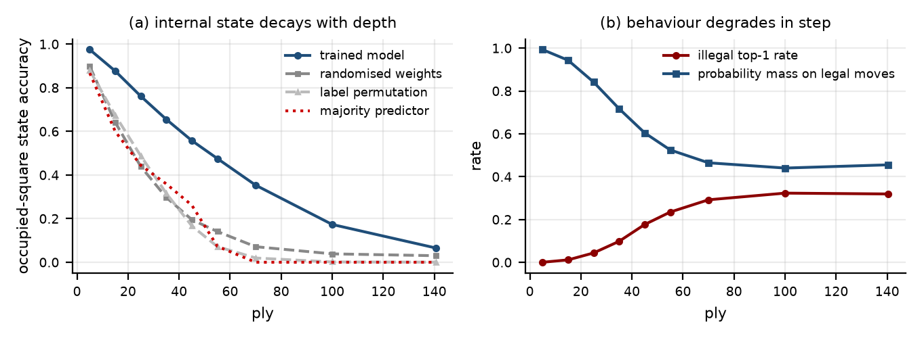
Internal state and external behaviour decay together. (a) Occupied-square state accuracy at the most decodable layer, against a majority predictor, a label-permutation control, and a randomised-weight model of identical architecture. (b) The illegal top-1 move rate and the probability mass the model places on legal continuations.
Occupied-square decodability falls from result@occFirst ?? result@occFirst in the opening to result@occLast ?? result@occLast in the deepest bucket, while the illegal top-1 rate rises from result@illFirst ?? result@illFirst to result@illLast ?? result@illLast and the probability mass on legal moves falls from result@massFirst ?? result@massFirst to result@massLast ?? result@massLast. At mid-game the trained model is well clear of every trivial explanation, reaching result@occ40Attn ?? result@occ40Attn against result@ctlMaj40 ?? result@ctlMaj40 for the majority predictor and lower still for the label-permutation and randomised-weight controls, which Table 1 reports in full at every depth. There is a real state representation, and it becomes progressively less recoverable by a linear decoder. Section 6.3 tests whether that reflects loss or a moving basis.

Aggregate fidelity is the weaker signal
The two curves fall together, but the relationship is weaker than that suggests, and measuring it carelessly overstates it.
An earlier version of this analysis compared a point-biserial correlation for the aggregate predictor against a conditional probability for the move-touched one. Those are different statistics, and the contrast flattered the conclusion: a correlation against a heavily skewed binary outcome is attenuated, so the aggregate measure looked uninformative when it was merely differently scaled. We now score both the same way, as predictors of the same binary outcome on the same samples, within depth so that neither can simply be tracking depth.
Aggregate board fidelity predicts an illegal next move with an AUC between result@aucAggMin ?? result@aucAggMin and result@aucAggMax ?? result@aucAggMax. That is above chance and not negligible. The same representation restricted to the two squares the move touches reaches result@aucActMin ?? result@aucActMin to result@aucActMax ?? result@aucActMax, and the two are closest in the opening and furthest apart at depth: at ply 40 to 50 the aggregate reaches result@aucAgg40to50 ?? result@aucAgg40to50 against result@aucAct40to50 ?? result@aucAct40to50. Fitted jointly with depth as a covariate, the move-touched term takes a standardised weight of result@betaAct ?? result@betaAct against result@betaAgg ?? result@betaAgg for the aggregate.
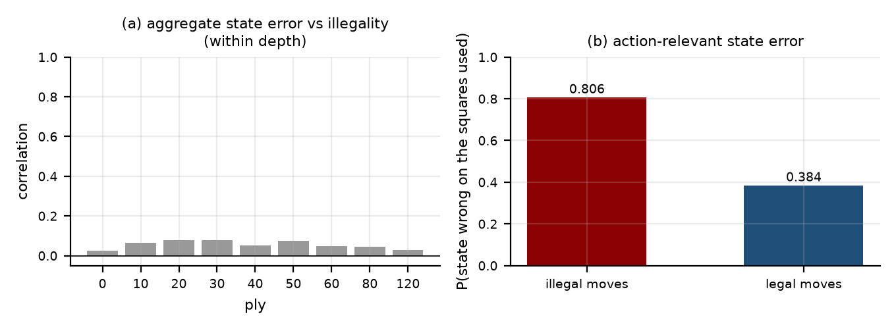
(a) Within a fixed depth, the correlation between the number of misremembered squares and playing an illegal move is small. (b) The same representation, scored only on the squares the move actually uses, separates illegal from legal moves sharply. Table 2 compares the two on equal footing, as predictors of the same outcome.
The claim we can defend is therefore narrower than the one we first wrote, and it is still a claim about a standard practice. Whole-board probe accuracy is a usable but weak proxy for whether a world model is load-bearing, it degrades as a proxy exactly where long-horizon behaviour matters most, and a measurement restricted to the state an action consumes is several times more informative from the same probe and the same activations. Stated as a conditional rather than a ranking, the probe is wrong on the squares a move touches for result@locIllAttn ?? result@locIllAttn of illegal moves against result@locLegAttn ?? result@locLegAttn of legal ones. The relevant question is not how much of the world the model has lost, but whether it has lost the part it is about to use.

Lost, or merely moved? Depth-local probes
Every fidelity number so far comes from one decoder fitted across all depths, and a falling number has been read as the state becoming less available. A single global decoder cannot distinguish that from an alternative: the state might stay equally present while its linear basis moves with depth, so that one fixed decoder simply transfers badly. The reversible-cycle experiment holds the position fixed but still uses the global probe, so it inherits the same ambiguity.
We fit a separate linear probe inside each depth bucket and evaluate every probe on every bucket.
Is the state lost, or is the representation rotating? Each row is a linear probe fitted inside one depth bucket and evaluated on every bucket; the pooled row is a probe fitted across all depths, as used elsewhere in the paper. Depth-local probes do not hold up at depth either, so the decline is not explained by a fixed decoder failing to transfer. Local probes see roughly a sixth of the pooled training data, which makes this a conservative test of the drift account.
Probe fitted at | ply 10 | ply 20 | ply 30 | ply 40 | ply 50 | ply 60
ply 10 | 0.910 | 0.776 | 0.521 | 0.307 | 0.203 | 0.151
ply 20 | 0.835 | 0.789 | 0.695 | 0.540 | 0.348 | 0.201
ply 30 | 0.640 | 0.736 | 0.671 | 0.610 | 0.546 | 0.412
ply 40 | 0.253 | 0.591 | 0.636 | 0.553 | 0.486 | 0.416
ply 50 | 0.106 | 0.341 | 0.527 | 0.514 | 0.430 | 0.346
ply 60 | 0.097 | 0.241 | 0.415 | 0.497 | 0.447 | 0.340
pooled across depths | 0.907 | 0.804 | 0.694 | 0.591 | 0.506 | 0.409
The diagonal answers the question. A probe fitted for the deepest bucket and tested there reaches result@drDiagLast ?? result@drDiagLast, against result@drDiagFirst ?? result@drDiagFirst for the shallowest bucket tested on itself. Depth-local probes collapse in almost the same way the global probe does, result@drPoolFirst ?? result@drPoolFirst to result@drPoolLast ?? result@drPoolLast, so the decline is not an artifact of a fixed decoder failing to keep up. If the representation merely rotated, a probe fitted at the relevant depth would recover what a global probe misses, and it does not.
Basis change is nonetheless present in the off-diagonal. A probe fitted on the shallowest positions reaches only result@drFarOff ?? result@drFarOff on the deepest ones, far below what a probe fitted there achieves, so the encoding does move with depth. It moves and it also thins, and the thinning is what the paper’s curves track.
One caveat cuts in our favour rather than against. Each depth-local probe sees roughly a sixth of the data the pooled probe sees, which is why the pooled probe edges the diagonal at depth. More data would help the local probes, so this is a conservative test of the drift account: it would have to overturn a gap that already runs the wrong way for it.

Which squares, not how many
Move-touched fidelity scores two squares where the aggregate averages sixty-four, and a statistic over two concentrated variables can look sharper than one over sixty-four diluted ones for reasons unrelated to relevance. The control that separates those explanations is a random pair.
Which squares carry the signal. Each row scores probe error over a different set of squares as a predictor of an illegal top-1 move, on identical samples. Intervals are bootstrapped over games rather than positions, since positions within a game are not independent. Two random occupied squares are a partial match to a move’s endpoints, the origin being occupied by the mover while the destination is usually empty or held by the opponent, so this control equalises count and occupancy only in part. It performs like the whole board; the squares the move actually touches do not, so the advantage is about which squares rather than how many.
Squares scored | AUC [95% CI]
whole board, 64 squares | 0.629 [0.623, 0.633]
two random squares | 0.539 [0.534, 0.542]
two random occupied squares | 0.631 [0.627, 0.636]
origin square only | 0.664 [0.660, 0.668]
destination square only | 0.637 [0.633, 0.642]
move-touched, origin and destination | 0.696 [0.693, 0.700]
Two randomly chosen squares predict an illegal move at an AUC of result@sqTwoRandom ?? result@sqTwoRandom, well below the whole board at result@sqWholeBoard ?? result@sqWholeBoard. Two squares drawn at random from those actually occupied reach result@sqTwoRandomOcc ?? result@sqTwoRandomOcc, statistically indistinguishable from the whole board. The squares a move touches reach result@sqMoveTouched ?? result@sqMoveTouched, with a game-clustered interval that does not overlap either control. The advantage is therefore about which squares are read, not how many, and it is not an artifact of averaging fewer variables. That control equalises count and occupancy only in part: a move’s origin is occupied by the side to move, while its destination is usually empty or held by the opponent, so a pair of occupied squares does not reproduce the endpoint profile exactly. A fully matched control would draw one square occupied by the mover and one matching the destination’s true class.
Splitting the pair, the origin square carries more of the signal than the destination, result@sqSourceOnly ?? result@sqSourceOnly against result@sqDestOnly ?? result@sqDestOnly. That ordering is what one would expect if the dominant failure is proposing a move from a square the model has misremembered as occupied.

The errors are coherent
If state loss drives the failure, an invalid action should be valid in the state the model believes it is in. We reconstruct that believed position from the probe and re-score the model’s own move in it, clearing castling rights so nothing is licensed by an assumption we did not decode, and testing pseudo-legality because a decoded board may lack a king.
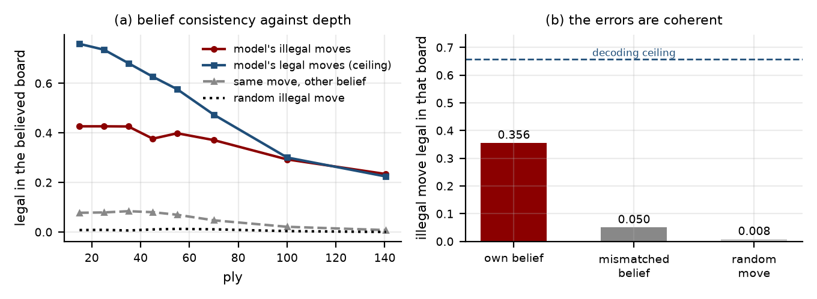
The errors are coherent. (a) Against depth, restricted to buckets with at least thirty illegal cases. (b) Pooled: an illegal move is far more likely to be legal in the model’s own believed board than under another position’s belief at equal depth, or than an arbitrary illegal move is under the model’s own belief. The dashed line is the recovery reference for this test, set by how often genuinely legal moves are recovered as legal.
Of the illegal moves the model plays, result@pcBel ?? result@pcBel are legal in its own believed position, with a game-clustered interval of [ result@pcBelLo ?? result@pcBelLo, result@pcBelHi ?? result@pcBelHi] over result@pcN ?? result@pcN illegal moves from result@pcGames ?? result@pcGames games. Positions within a game are not independent, so the interval resamples whole games. Two controls bound the alternatives. The same move scored against a believed position decoded elsewhere at equal depth is legal result@pcBelMis ?? result@pcBelMisof the time, so the effect is specific to this belief at this position rather than to plausible boards generally. An arbitrary illegal move scored against the model’s own believed position is legal result@pcBelRand ?? result@pcBelRandof the time, so the believed board is not permissive. For reference, genuinely legal moves are recovered as legal in the believed board result@belLegAttn ?? result@belLegAttn of the time, which is below one because probe decoding is lossy. We call this a legal-move recovery reference rather than a decoding reference, and we do not divide by it to estimate an unobserved true rate: that would assume probe sensitivity is the same on legal and illegal cases, which we have not established. What the comparison licenses is that a substantial identified subset of illegal moves is consistent with the decoded state, not that most of them are.
We do not divide by that reference. Doing so would estimate an unobserved true rate only under an assumption we have not tested, that the probe is equally sensitive on legal and illegal cases. What the comparison licenses is narrower and still substantial: a large identified subset of illegal moves is admissible under the board this model appears to hold at this position, at result@belRatioMisAttn ?? result@belRatioMisAttn times the rate of the matched control. It identifies state-consistent failure. It does not assign the remainder.

Inducing a false belief changes the action
Belief consistency is observational. It shows the model errs coherently with a decayed state without showing that the state representation drives the action. We therefore intervene. At a position where the side to move genuinely occupies a square, we push the residual stream along the probe direction encoding "this square is empty" and ask whether the model stops proposing moves from it.
Two safeguards decide whether such an experiment means anything, and both are reported. The manipulation check asks whether the edit changed the decoded belief at all: at the strength we use it does, in result@patchFlipAttn ?? result@patchFlipAttn of cases. The norm-matched control applies a random direction of identical magnitude at the same position, which separates belief from mere perturbation sensitivity.
Edit strength has to be calibrated rather than chosen, because a large enough push degrades the forward pass and will move behaviour for reasons having nothing to do with state. Figure 5 reports the sweep. Below a quarter of the residual-stream magnitude the edit does not reliably flip the belief; above roughly one, the random control also starts destroying the output distribution, so any effect there is damage rather than belief. We report the intervention at result@patchAlphaAttn ?? result@patchAlphaAttn, inside the window where the manipulation succeeds and the control does not.
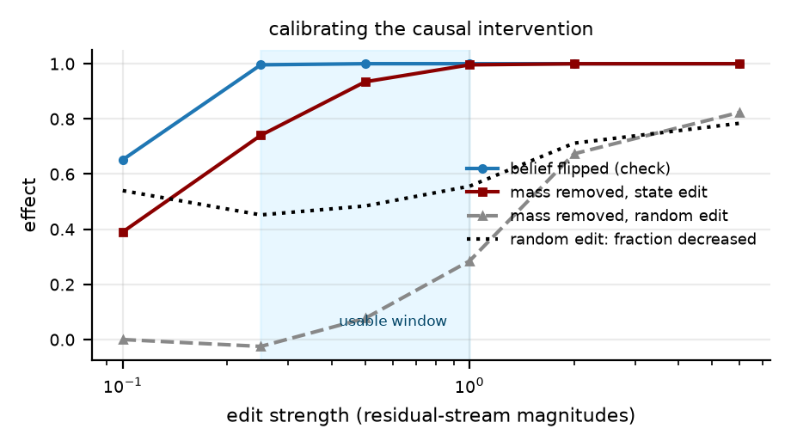
Choosing the edit strength. Too small and the belief does not flip; too large and a norm-matched random direction also destroys the output distribution, so any effect there is damage rather than belief. We report inside the shaded window.
At that strength, editing the state direction removes result@patchCutAttn ?? result@patchCutAttn of the probability mass on moves from the affected square, decreasing it in result@patchDecAttn ?? result@patchDecAttn of result@patchNAttn ?? result@patchNAttn cases. The norm-matched random edit removes result@patchRandCutAttn ?? result@patchRandCutAttn and decreases the mass in result@patchRandDecAttn ?? result@patchRandDecAttn of cases, which is indistinguishable from a coin flip. The state representation is not a decorative correlate of the model’s computation. It is read.

How much of the planning error is really memory
The other half of the decomposition needs care, because the conditioning that would isolate it cleanly is unattainable. Requiring the probe to recover the exact board leaves no samples past the opening; requiring only the squares the move touches leaves samples everywhere but does not constrain the rest of the board, so state loss elsewhere is still counted as a failure of judgement.
We therefore vary the strictness and read the trend (Table 7). Tightening the conditioning lowers the loss substantially: at ply 30 to 40 the median centipawn loss falls from result@epsMed30to40tol64 ?? result@epsMed30to40tol64 with the board unconstrained to result@epsMed30to40tol4 ?? result@epsMed30to40tol4 when at most four other squares may be wrong, and the blunder rate from result@epsBl30to40tol64 ?? result@epsBl30to40tol64 to result@epsBl30to40tol4 ?? result@epsBl30to40tol4. Roughly half of what a naive reading would call degraded judgement is misattributed memory failure. The strictest cells are thinly populated at depth however many games we scan, since a nearly intact board becomes rare exactly where we would most like to condition on one; cells with fewer than thirty scored positions are reported as n/a.
The trend does not go to zero. Holding the conditioning at four wrong squares, the median loss still grows with depth, from result@epsMed20to30tol4 ?? result@epsMed20to30tol4 at ply 20 to 30 to result@epsMed30to40tol4 ?? result@epsMed30to40tol4 at ply 30 to 40. Judgement given intact state is not depth-invariant.
The honest reading is that the identified state-consistent component is substantial, stricter conditioning reduces measured planning loss, and a residual depth-dependent planning component remains. Calling memory dominant would overstate what a lossy probe and small conditioned samples support, and our original framing of H4, a clean separation in which an intervention moves one term and leaves the other untouched, was too tidy. The decomposition still earns its place, because it converts one uninterpretable curve into two quantities with different remedies, but the terms are entangled rather than orthogonal and the conditioning should be reported whenever either is quoted.

Scale
The behavioural horizon is read off the illegal-move curve at the ply where it first crosses five percent, interpolated between bucket midpoints because the bucketed read-off returns the same bucket for every condition and so cannot discriminate between them. A second horizon defined on the representation is introduced in supplementary material, where both are tabulated together.
Across the ladder the behavioural horizon grows with scale and grows slowly, from result@hintRung1 ?? result@hintRung1 ply at result@paramsSmall ?? result@paramsSmall parameters to result@hintRung6 ?? result@hintRung6 at result@paramsLarge ?? result@paramsLarge, three seeds per rung. Roughly an order of magnitude in parameters buys about half again as much depth, which is consistent with H2 and with the cost mismatch of Section 4: scaling helps, and it does not buy back a missing mechanism cheaply.
The question that matters more for the reach of this paper is not whether the horizon moves with scale, which it does, but whether the mechanism does. Figure 6(b) and Table 6 report belief consistency at every rung, three seeds each. The raw rate rises with size, but so does each model’s legal-move recovery reference, so the honest quantity is the ratio of the two. Normalised that way the coherence of errors still rises monotonically, from result@belRatioNRung1 ?? result@belRatioNRung1 at result@paramsSmall ?? result@paramsSmall parameters to result@belRatioNRung6 ?? result@belRatioNRung6 at result@paramsLarge ?? result@paramsLarge, with seed spreads of a few parts in a thousand, while the mismatched control stays flat near result@pcBelMis ?? result@pcBelMis and the random-move control near result@pcBelRand ?? result@pcBelRand. We show the ratio as a descriptive normalisation, since the reference itself rises with size, and not as an estimate of a hidden true proportion. What we have characterised strengthens with scale over the range we can reach rather than washing out, which is evidence against its being an artifact of the smallest models.
Both horizons order the models identically and both grow sublinearly in parameters, the behavioural one from result@hintRung1 ?? result@hintRung1 to result@hintRung6 ?? result@hintRung6 ply and the fidelity one from result@hfidRung1 ?? result@hfidRung1 to result@hfidRung6 ?? result@hfidRung6 (Table 6). Roughly an order of magnitude in parameters buys about half again as much depth, which is consistent with H2 and with the cost mismatch of Section 4: scaling helps, and it does not buy back a missing mechanism cheaply.
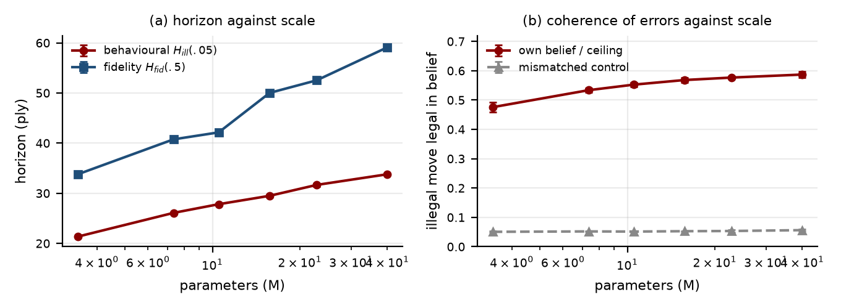
(a) The horizon against model size. (b) Belief consistency and its matched control against model size. The question is whether the mechanism is a property of small models or survives scale.

An intervention, evaluated by the diagnostic
The diagnostic is only useful if it discriminates. We test a fixed-width gated recurrent channel inserted after every $k$-th attention block, carrying $z_{t}∈R^{d_{s}}$ with $d_{s}≪d$:
$$u_{t}=W_{in}h_{t}, α_{t}=σ(W_{g}[h_{t};z_{t−1}]), z_{t}=(1−α_{t})⊙Az_{t−1}+α_{t}⊙ϕ(u_{t}),$$
read back as $h_{t}←h_{t}+W_{out}z_{t}$, with $A$ diagonal so inference-time state is $O(1)$ per token, and an optional auxiliary loss $λL_{state}$ supervising $z_{t}$ to be the state. We separate architecture ($λ=0$), supervision ($λ>0$), and read-out (zeroing $W_{out}$ at test time), against a parameter-matched attention-only control.
With the auxiliary objective active, state decodability rises sharply, from result@occ40Attn ?? result@occ40Attn for the attention-only baseline to result@occ40AlsbOne ?? result@occ40AlsbOne at matched parameters and matched tokens, a difference many times the seed spread. The architecture without the objective, result@occ40AlsbZero ?? result@occ40AlsbZero, is indistinguishable from the baseline, as is the parameter-matched control at result@occ40AttnPM ?? result@occ40AttnPM. The gain comes from supervising the channel, not from adding it, and not from the parameters it costs.
Behaviour barely follows. The illegal-move rate improves from result@ill40Attn ?? result@ill40Attn to result@ill40AlsbOne ?? result@ill40AlsbOne and the horizon from result@hintAttn ?? result@hintAttn to result@hintAlsbOne ?? result@hintAlsbOne ply, while the attention-only model at result@paramsAttnWide ?? result@paramsAttnWide parameters reaches almost exactly the same decodability, result@occ40AttnWide ?? result@occ40AttnWide, and converts it into a much larger behavioural gain, result@ill40AttnWide ?? result@ill40AttnWide and result@hintAttnWide ?? result@hintAttnWide ply. Two models with the same measured world model, then, and very different behaviour. In Section 6.2 aggregate decodability predicted behaviour weakly across positions within a model; here it fails to predict behaviour across models. An auxiliary loss makes the state linearly available, and being available is not the same as being used.

An ablation that improves behaviour.
Zeroing the read-out at test time lowers the illegal-move rate, from result@ill40AlsbOne ?? result@ill40AlsbOne to result@ill40Zab ?? result@ill40Zab, and lengthens the horizon, from result@hintAlsbOne ?? result@hintAlsbOne to result@hintZab ?? result@hintZab ply. Removing a component the model was trained with should not help, so we measured what else it does. Language-model loss rises, from result@lmIntact ?? result@lmIntact to result@lmAblated ?? result@lmAblated across seeds, and the read-out is not vestigial: it injects a vector of result@injRatio ?? result@injRatio of the residual stream’s own norm. The ablated model is worse at predicting the continuation and simultaneously better at staying legal, because it places more mass on legal moves, result@massAblated ?? result@massAblated against result@massIntact ?? result@massIntact, while committing less confidently to any particular one.
The lesson is about our own observable rather than about the artifact. A model can lower its illegal-move rate by hedging toward the legal-move prior, so the illegal rate is not a monotone proxy for the quality of state maintenance and should be read alongside a likelihood. This does not disturb the coupling, belief-consistency, or causal results, which are computed per position rather than from a rate, but it qualifies the intervention comparison and the horizon metric. We therefore report H3 as supported only in its weakest form and H4 as not supported in the form we predicted: the intervention improves the measurement of state tracking far more than it improves state tracking’s consequences. Anyone using auxiliary state supervision as a training signal, or probe accuracy as a progress metric, should treat that gap as the default expectation.
Positions within a game are not independent, so every interval in this paper is bootstrapped over games rather than positions, and the population-averaged fits behind the coupling claim are reported in supplementary material.

A constructive edit: moving a piece in the model’s belief
Suppressing a square’s occupancy removes the mass on moves from it, which is consistent with a causal belief state and equally consistent with generic damage to source-square features. A constructive edit separates the two. We take a square $A$ the mover genuinely occupies and an empty square $B$, and edit toward “$A$ is empty” and “$B$ holds the piece that was on $A$” together. Generic damage predicts that mass leaves $A$; only a belief the policy reads predicts that mass arrives at $B$.
Both happen. Across result@trN ?? result@trN positions at the calibrated strength, mass on moves out of $A$ changes by result@trOutA ?? result@trOutAwhile a norm-matched random edit gives result@trOutARand ?? result@trOutARand. Mass on moves out of $B$, which are illegal in the true position, changes by result@trOutB ?? result@trOutBagainst result@trOutBRand ?? result@trOutBRandfor the random edit. Intervals are bootstrapped over games.
Splitting the edit budget across two directions makes the manipulation less reliable than the single-square version: $A$ decodes as empty in result@trFlipA ?? result@trFlipA of cases and $B$ as the transferred piece in result@trFlipB ?? result@trFlipB. Restricting to the result@trBothN ?? result@trBothN cases where both flips demonstrably succeeded, the constructive effect strengthens, to result@trOutBBoth ?? result@trOutBBoth, while the random control on $A$ becomes indistinguishable from zero. We read this as the policy consulting a joined-up occupancy representation rather than a single feature, while noting it establishes this for occupancy and not for the whole position.

Off distribution: uniformly random legal play
Every measurement so far uses held-out human games, which are in distribution. report that a uniformly-random-legal-play split stays discriminative where in-distribution performance saturates, making it a fair test of whether our findings lean on familiar opening theory.
They do not. On result@rpGames ?? result@rpGames games of uniformly random legal play, occupied-square accuracy falls from result@rpOccFirst ?? result@rpOccFirst to result@rpOccLast ?? result@rpOccLast and the illegal rate rises from result@rpIllFirst ?? result@rpIllFirst to result@rpIllLast ?? result@rpIllLast, both steeper than on human games as expected for an unfamiliar distribution. Belief consistency is result@rpBelief ?? result@rpBelief over result@rpBelN ?? result@rpBelN illegal moves against a random-move control of result@rpRand ?? result@rpRand, slightly higher than the in-distribution rate rather than lower. Coherent error is not an artifact of familiar ground.
A policy-conditioned horizon, defined on the state the action consumes rather than on the whole board, is reported in supplementary material.

A degenerate metric, declared
Our horizon was pre-registered on exact-position fidelity, the probability that all sixty-four squares are simultaneously recovered. That criterion is already below its threshold in the first bucket, so the pre-registered horizon evaluates to zero ply for every condition and cannot discriminate between them. The underlying quantity falls to result@exactFirst ?? result@exactFirst in the opening and to result@exactMid ?? result@exactMid by ply 20 to 30, after which exact states essentially do not occur, which is also why conditioning on them yields no samples at depth. We therefore report horizons on occupied-square accuracy and on the illegal-move rate. The revision was made after inspecting baseline data and before evaluating any intervention, and every definition is applied unchanged across conditions. Anyone measuring state tracking with an all-or-nothing criterion will obtain an unusable number for the same reason.

What the predictions came to
Pre-registration is only worth the words if the verdicts are stated, including the ones that went against us.
State fidelity declines with depth, from result@occFirst ?? result@occFirst to result@occLast ?? result@occLast occupied-square accuracy, clear of a majority predictor, a label-permutation control, and a randomised-weight model (Table 1, Figure 2).
The horizon grows slowly with scale across six rungs at three seeds each, from result@hintRung1 ?? result@hintRung1 ply at result@paramsSmall ?? result@paramsSmall parameters to result@hintRung6 ?? result@hintRung6 at result@paramsLarge ?? result@paramsLarge (Section 6.8).
The supervised recurrent channel raises state decodability substantially and the horizon by result@hintAlsbOne ?? result@hintAlsbOne against result@hintAttn ?? result@hintAttn ply; the architecture without supervision changes neither.
We expected an intervention that improved state tracking to improve behaviour through it. Instead it improved the measurement far more than its consequences, matching a model twice its size on decodability while capturing a fraction of the behavioural gain (Section 6.9). We designed H4 to be able to fail and it failed, in a direction that supports the paper’s main claim rather than undermining it.
The natural-language transfer test our protocol specifies was not run and is absent rather than approximated (Section 8). A second oracle-bearing domain, reached only after several failed designs, tests the weaker claim and is reported in supplementary material.
Three results were not predicted at all. The layer profile ran opposite to our expectation (Section 4). Ablating the recurrent read-out improved behaviour while worsening prediction, which turned out to say something about our own observable rather than about the artifact (Section 6.9). And the standard whole-board measure of a world model proved a weaker predictor of behaviour than the same measure restricted to the state an action consumes, by a margin that grows with depth (Section 6.2).
If we could keep only one result it would be belief consistency together with the causal edit, which say that these models act coherently on a state they are losing.

Discussion
The practical content of this paper is a change in what to measure. That a probe recovers a world model at some aggregate accuracy is weak evidence that the model is load-bearing: aggregate accuracy predicts the validity of the next action poorly, and worse with depth. Measuring the same representation on the components an action depends on is substantially more informative from the same activations. Any team instrumenting a system for long-horizon reliability should condition on the state the action uses.
The belief-consistency result reframes the failure. A model that plays a coherent move in a misremembered position is not behaving erratically, and treatments that assume erratic behaviour are aimed at the wrong target. Sampling several chains and voting may offer limited benefit when independently sampled continuations share the same state distortion, though we did not test repeated sampling or how far drift is correlated across samples. A verifier that scores outputs is well placed to catch the error and badly placed to prevent it, at a cost paid on every query.
The protocol generalises past chess. Anywhere an external checker can reconstruct the intended intermediate state, program execution traces, spreadsheet recalculation, structured database updates, ledger reconciliation, the same measurements are available. The requirement is not a game; it is an oracle.
We also treat the negative results as part of the contribution. A predicted layer profile came out backwards, a pre-registered metric turned out to be degenerate, and a first design of a second domain turned out to be unlearnable for a reason diagnosable from the loss curve. Each changed a decision, and each is reported where it did so.

Limitations
Scale. Our models are small and trained on a modest corpus, far below the chess-specific literature and any frontier system. Undertrained models fail within a measurable range, which is what makes the instrument work, but the horizon values describe these models. Section 6.8 estimates the trend rather than assuming it away.
One domain family. Chess carries an exact oracle by construction, which is what makes it measurable and also what makes it unrepresentative of open-ended reasoning. The second domain reaches a measurable regime (supplementary material), but only its supervised condition maintains a decodable state, so the attention-only replication we wanted is not available there. The central findings rest on one instrument.
Probe decoding is lossy. The believed board is an approximation, which is why we report the legal-move recovery rate as an explicit reference rather than treating the decoded state as ground truth.
Pseudo-legality. Belief consistency is tested with pseudo-legal moves, since a decoded board may lack a king and make check tests ill-defined. This is permissive, which the random-move control is designed to bound.
Scope of the causal claim. The intervention establishes that the decoded state direction is read by the policy at the layer tested. It does not establish which downstream computation consumes it, and a single-direction edit is a coarse instrument.
A metric was revised after seeing data. Declared in Section 6, applied uniformly, reported alongside the original.
No natural-language transfer test. Establishing that these findings hold for mathematical or textual reasoning needs matched general-corpus pre-training, which our compute did not cover. It is absent rather than approximated.

Avenues of Future Research
The most useful next steps are to extend the scale ladder far enough to estimate how the horizon grows with parameters and data, and to test whether the belief-consistency rate is scale-invariant where the horizon moves; to replicate the measurements in domains that were not designed as benchmarks, such as program execution or ledger reconciliation, where an oracle exists but the data is not constructed; to run the natural-language transfer test with matched pre-training, the experiment that decides whether this line of work reaches practice; and to develop state supervision that does not require an oracle, for example from execution traces or agreement between sampled continuations. Move-touched fidelity is also a candidate live confidence signal, for abstaining or escalating when the state an action depends on is poorly determined.

Conclusion
Long-horizon behavioural failure can arise from degradation of the task state, from poor action selection given the state that is available, or from failures that remain unresolved under a lossy decoder. These are not cleanly separable with the instruments we have, and we have not separated them.
What we can report is narrower and, we think, still worth having. In search-free chess models, whole-board probe fidelity is a weaker predictor of an invalid next action than fidelity on the endpoints of the move actually selected, and the gap widens with depth. A substantial identified subset of invalid actions is admissible under the board that model appears to hold at that position, at many times the rate of a mismatched-belief control and of an arbitrary invalid move. Targeted suppression and transfer edits show that the corresponding occupancy representation influences the policy rather than merely accompanying it. The identified share grows across the range of model sizes we can train, and survives a shift to uniformly random legal play.
These measurements identify state-consistent failure. They do not partition all failures, and the errors they leave unidentified are unresolved rather than attributed to reasoning. The practical consequence is a change in what to measure: a world model reported as an aggregate accuracy tells a practitioner less than the same representation scored on the state the next action will consume, and the difference matters most exactly where long-horizon behaviour is hardest to check.

Declarations

Disclosure statement.
The authors report no conflict of interest.

Funding.
This research received no specific grant from any funding agency in the public, commercial, or not-for-profit sectors.

Data availability statement.
The training and evaluation code, the measurement pipeline, and the result files from which every reported value is generated are available at https://github.com/MohitPratapSinghRathore/derived-total.

AI usage declaration.
During the preparation of this manuscript the authors used a generative AI tool to assist with language editing and refinement of the text. The authors reviewed and edited all output and take full responsibility for the content of the paper. Generative AI was not used to generate or analyse the study’s data, which were produced entirely by the evaluation pipeline described in the paper.

Experimental detail
Model configurations, probe fitting, engine scoring, intervention hyper-parameters, and the second-domain setup are reported in supplementary material.

Deviations from the pre-registration
We record every deviation rather than presenting the final protocol as the original one.
- The horizon was pre-registered on exact-position fidelity, which proved degenerate. Horizons on occupied-square accuracy and on the illegal-move rate were added after inspecting baseline data and before evaluating any intervention, and applied unchanged to all conditions.
- The bucketed horizon was replaced by an interpolated crossing point, because the bucketed read-off returned the same bucket for every condition.
- Planning error was pre-registered as conditional on exact state recovery, which yields no samples past the opening. It is reported conditional on move-touched recovery, with a strictness ladder showing what the choice costs.
- The aggregate and move-touched comparison was first made with incommensurable statistics, a correlation against a conditional probability. Both are now scored as predictors of the same outcome.
- The layer-profile prediction was falsified and is retained as such.
- The second domain required seven designs. All are reported.

