**Practical 6**

**Aim:** 1) Write program to demonstrate use of CSS-Link Properties.

2) Write program to demonstrate use of CSS-list Properties. (Also include

- Make list as an image).

3) Write program to demonstrate use of CSS-Table Properties.

**Code 1**:

<!DOCTYPE html>

<html lang="en">

<head>

<meta charset="UTF-8" />

<meta name="viewport" content="width=device-width, initial-scale=1.0" />

<title>CSS-Link Properties</title>

<link rel="preconnect" href="https://fonts.googleapis.com" />

<link rel="preconnect" href="https://fonts.gstatic.com" crossorigin />

<link href="https://fonts.googleapis.com/css2?family=Lobster&display=swap" rel="stylesheet" />

<style>

body {

background-color: rgb(234, 226, 226);

}

.lobster-regular {

font-family: "Lobster", sans-serif;

font-weight: 400;

font-style: normal;

text-align: center;

}

.link {

text-align: center;

}

.link a {

text-decoration: none;

}

.link a:visited {

background-color: red;

}

.link a:link {

color: white;

background-color: antiquewhite;

font-size: 20px;

}

.link a:hover {

/* text-decoration: underline; */

background-color: rgb(126, 117, 255);

}

a:link,

a:visited {

background-color: white;

color: black;

border: 4px solid rgb(126, 117, 255);

border-radius: 0.8rem;

padding: 10px 20px;

text-align: center;

text-decoration: none;

display: inline-block;

}

a:hover, a:active {

background-color: blue;

color: white;

}

h2 {

margin-top: 8rem;

}

</style>

</head>

<body>

<div class="lobster-regular">

<h1>This is an example of Google Fonts</h1>

</div>

<div class="link">

<a href="https://youtube.com" target="_blank">CSS-Link Property</a>

</div>

<h2>Example of Link Button is below</h2>

<a href="https://youtube.com" target="_blank">Link Button for YouTube</a>

</body>

</html>

**Output 1**:

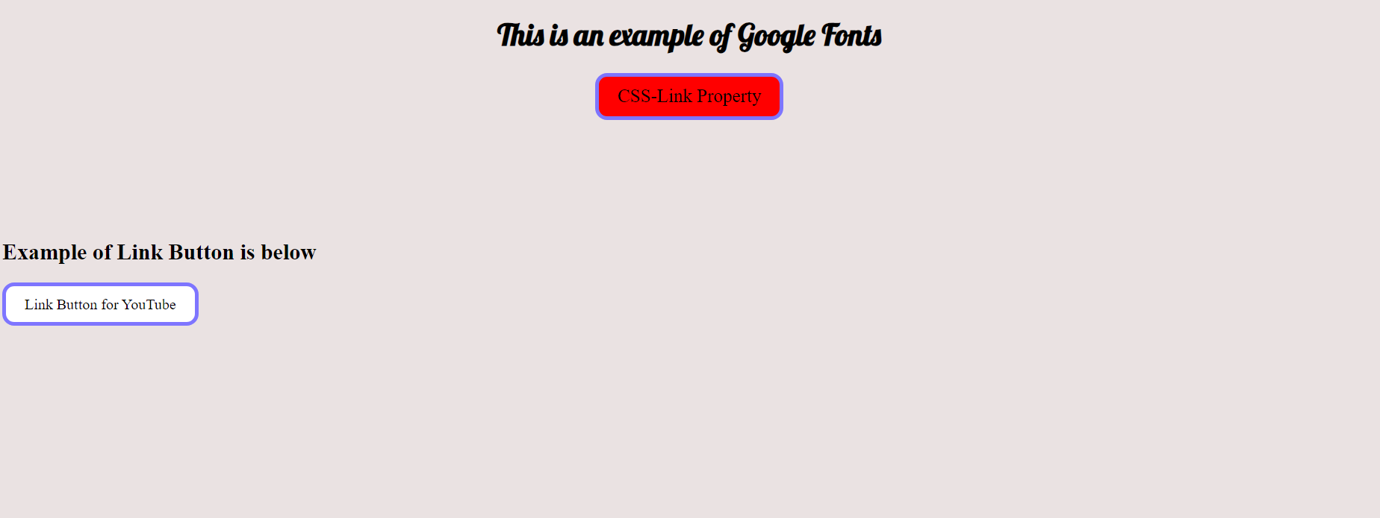

**Code 2:**

<!DOCTYPE html>

<html lang="en">

<head>

<meta charset="UTF-8">

<meta name="viewport" content="width=device-width, initial-scale=1.0">

<title>CSS-List Properties</title>

<style>

body {

font-family: Arial, sans-serif;

margin: 20px;

background-color: rgb(255, 250, 250);

color: rgb(20, 20, 20);

}

ol {

list-style-type: decimal;

color: rgb(209, 123, 123);

font-weight: bold;

margin-left: 40px;

list-style-position: outside;

}

ul {

list-style-type: square;

color: rgb(22, 0, 167);

margin-left: 25px;

list-style-position: inside;

}

li.special {

color: lightgreen;

}

ul.image-list {

list-style-image: url("../images/Adani\ university.png");

list-style-position: inside;

display: flex;

}

</style>

</head>

<body>

<h1>CSS List Properties</h1>

<h2>Ordered List</h2>

<ol>

<li>Item 1</li>

<li>Item 2</li>

<li class="special">Item 3</li>

<li>Item 4</li>

</ol>

<h2>Unordered List</h2>

<ul>

<li>Item 1</li>

<li>Item 2</li>

<li class="special">Item 3</li>

<li>Item 4</li>

</ul>

<h2>List with Custom Image</h2>

<ul class="image-list">

<li>Item 1</li>

<li>Item 2</li>

<li class="special">Item 3</li>

<li>Item 4</li>

</ul>

</body>

</html>

**Output 2:**

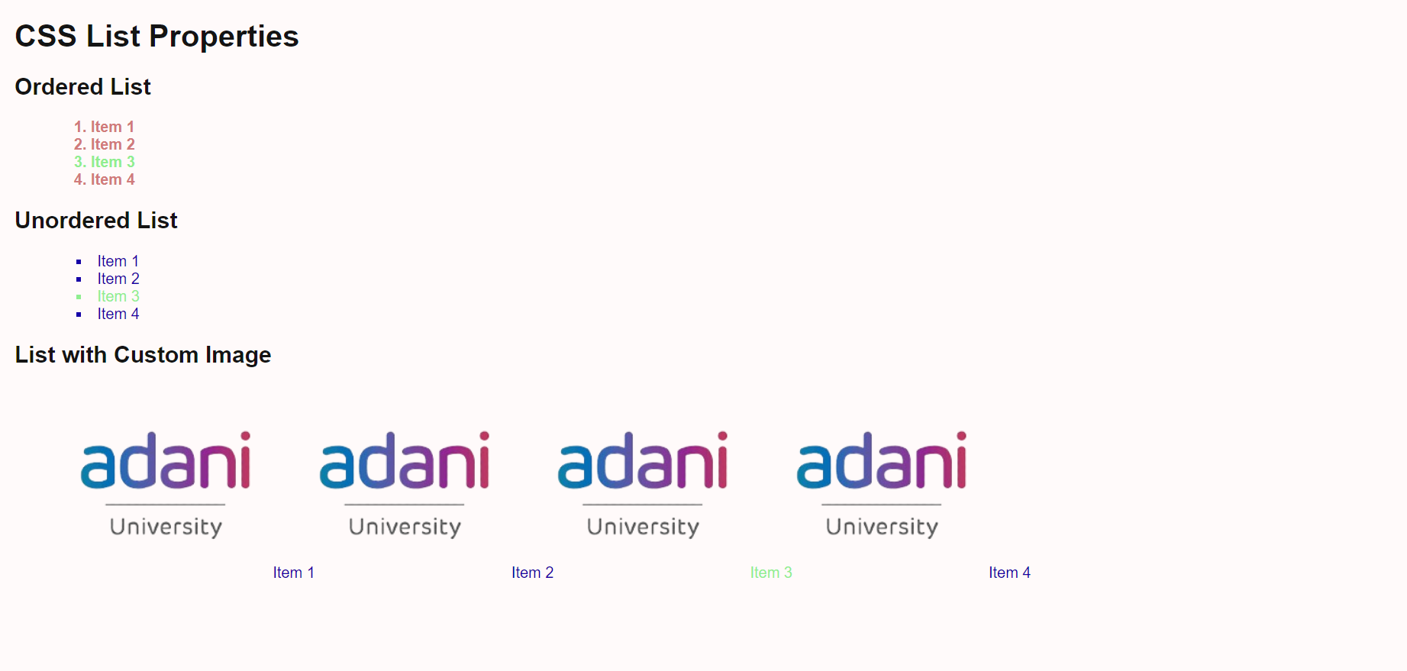

**Code 3:**

<!DOCTYPE html>

<html lang="en">

<head>

<meta charset="UTF-8">

<meta name="viewport" content="width=device-width, initial-scale=1.0">

<title>CSE-C Time Table</title>

<style>

body {

font-size: 1.1rem;

margin: 10px;

color: black;

}

table {

width: 100%;

border-collapse: collapse;

margin-bottom: 40px;

}

th, td {

border: 3px solid rgb(0, 0, 0);

padding: 10px;

text-align: center;

}

th {

background-color: rgb(187, 167, 249);

}

td {

background-color: white;

}

</style>

</head>

<body>

<div class="container">

<table>

<table border="">

<tr>

<th colspan="6">

<center>Faculty of Engineering Science and Technology</center>

</th>

</tr>

<tr>

<th colspan="6">

<center>Semester 2-Computer Science and Engineering(CSE-B)-AIML</center>

</th>

</tr>

<tr>

<td colspan="5">Classroom No: 202</td>

<th colspan="1">w.e.f 18/01/2024</th>

</tr>

<tr>

<th>

<center>TIME</center>

</th>

<th>

<center>MONDAY</center>

</th>

<th>

<center>TUESDAY</center>

</th>

<th>

<center>WEDNESDAY</center>

</th>

<th>

<center>THURSDAY</center>

</th>

<th>

<center>FRIDAY</center>

</th>

</tr>

<tr>

<td>

<center>9.10 to 10.00</center>

</td>

<td>

<center></center>

</td>

<td>

<center></center>

</td>

<td>

<center></center>

</td>

<td>

<center></center>

</td>

<td>

<center></center>

</td>

</tr>

<tr>

<td>

<center>10.00 to 10.50</center>

</td>

<td>

<center>MATHS-2(TB)</center>

</td>

<td>

<center></center>

</td>

<td>

<center></center>

</td>

<td>

<center></center>

</td>

<td>

<center></center>

</td>

</tr>

<tr>

<td colspan="1">10.50 to 11.00</td>

<th colspan="5">BREAK</th>

</tr>

<tr>

<td>

<center>11.00 to 11.50</center>

</td>

<td>

<center>AP(SJ)</center>

</td>

<td>

<center>AP(SJ)</center>

</td>

<td>

<center>MATHS-2(TB)</center>

</td>

<td>

<center>MATHS-2(TB)</center>

</td>

<td rowspan="2">

<center>B1-DS(AT)<BR>B2-FWD(VF)<BR>B3-

AP(JT)<BR>B4-PP(RJ)</center>

</td>

</tr>

<tr>

<td>

<center>11.50 to 12.40</center>

</td>

<td>

<center>PP(RJ)</center>

</td>

<td>

<center>DS(AT)</center>

</td>

<td>

<center>DS(AT)</center>

</td>

<td>

<center>FED(KK)</center>

</td>

</tr>

<tr>

<td colspan="1">12.40 to 13.30</td>

<th colspan="5">LUNCH</th>

</tr>

<tr>

<td>

<center>13.30 to 14.20</center>

</td>

<td>

<center>DS(AT)</center>

</td>

<td rowspan="2">

<center>B1-PP(UG)<BR>B2-DS(AT)<BR>B3-

FWD(VF)<BR>B4-AP(JT)</center>

</td>

<td rowspan="2">

<center>B1-AP(SJ)<BR>B2-PP(UG)<BR>B3-

DS(AT)<BR>B4-FWD(VF)</center>

</td>

<td rowspan="2">

<center>B1-FWD(VF)<BR>B2-AP(JT)<BR>B3-

PP(RJ)<BR>B4-DS(AT)</center>

</td>

<td>

<center>FWD(KK)</center>

</td>

</tr>

<tr>

<td>

<center>14.20 to 15.10</center>

</td>

<td>

<center>FWD(KK)</center>

</td>

<td>

<center>PP(RJ)</center>

</td>

</tr>

<tr>

<td colspan="1">15.10 to 15.30</td>

<th colspan="5">BREAK</th>

</tr>

<tr>

<td>

<center>15.30 to 16.20</center>

</td>

<td rowspan="2">

<center>B1-maths-2(VM)<BR>B4-PP(RJ)</center>

</td>

<td rowspan="2">

<center>B3-PP(RJ)<BR>B4-MATHS2(VM)</center>

</td>

<td>

<center>AP(SJ)</center>

</td>

<td rowspan="2">

<center>B2-PP(UG)<BR>B4-MATHS2(VM)</center>

</td>

<td rowspan="2">

<center>B1-PP(UG)<BR>B4-MATHS2(VM)</center>

</td>

</tr>

<tr>

<td>

<center>16.20 to 17.10</center>

</td>

<td>

<center>HV(PR)</center>

</td>

</tr>

</table>

</body>

</html>

**Output 3:**

