SIMULATION EXPERIMENT – 5
Electromagnetic Simulation and S-Parameter Characterization of a Microwave
Directional Coupler and Two-Way Power Divider
Course: ECA1304 – Microwave Engineering
Name : Mohit V
Reg No : 192512041

Aim
To design and analyze a 10 GHz microwave directional coupler and a two-way power divider using 50 Ω ports, evaluate their S-parameter characteristics over 8–12 GHz, and examine the effect of a 5% change in coupling-section length on performance.

Software Used
MATLAB R2024a (for numerical analysis and plotting). The provided MATLAB programs use illustrative S-parameter models; CST, HFSS, or ADS may be used for full electromagnetic structure simulation.

Design Specifications
Parameter | Setting | Target
Design frequency | 10 GHz | 10 GHz
Reference impedance | 50 Ω | 50 Ω
Frequency sweep | 8–12 GHz | 8–12 GHz
Directional coupler | 4-port model | 10 dB coupling
Power divider | Two-way, 3-port model | Equal split, ≈ −3.01 dB per output

Objective 1: Design Parameters of Coupler and Power Divider
Aim: To define the operating frequency, reference impedance, coupling target, and ideal power-division target.

MATLAB Program
% Objective 1: Coupler and Power Divider Design
clc;
clear;

f0 = 10e9;
Z0 = 50;
C = 10;
Pdivision = 0.5;

fprintf('Design Frequency = %.2f GHz\n',f0/1e9);
fprintf('Port Impedance = %.0f ohms\n',Z0);
fprintf('Coupling Target = %.2f dB\n',C);
fprintf('Power Division = %.1f : %.1f\n',1,1);
fprintf('Ideal Output Level = %.2f dB\n',10*log10(Pdivision));

Output
Design Frequency = 10.00 GHz
Port Impedance = 50 ohms
Coupling Target = 10.00 dB
Power Division = 1.0 : 1.0
Ideal Output Level = -3.01 dB
Result: The design parameters were set to 10 GHz and 50 Ω, with a 10 dB coupling target and an equal two-way power split. The ideal output level is approximately −3.01 dB per output.
MATLAB screenshot (program and output):
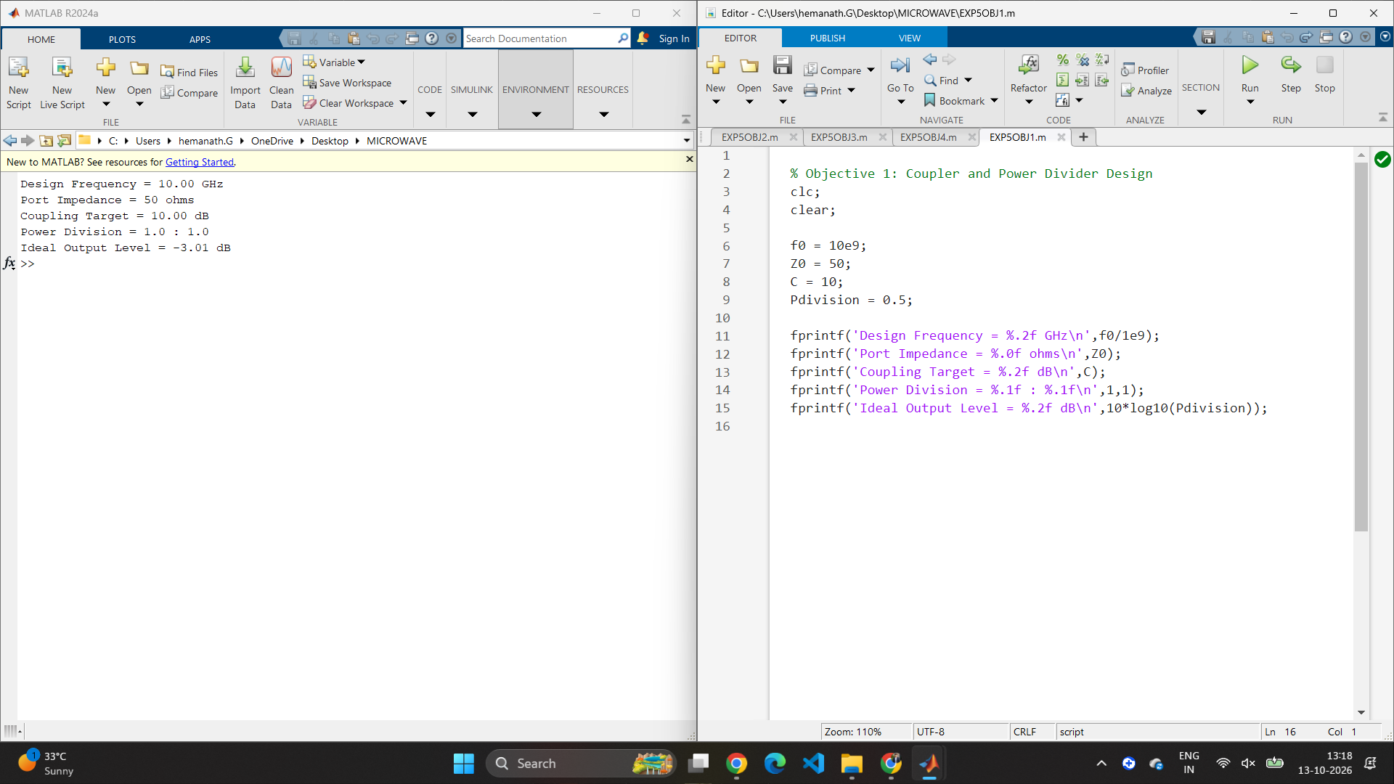

Objective 2: Directional Coupler S-Parameter Analysis
Aim: To determine coupling factor, isolation, insertion loss, and directivity from the directional coupler's S-parameter response over 8–12 GHz.

MATLAB Program
% Objective 2: Directional Coupler Analysis
clc;
clear;
close all;

f = 8:0.1:12;

S21dB = -0.5 - 0.1*(f-10).^2;
S31dB = -10 - 1*(f-10).^2;
S41dB = -30 + 1*(f-10).^2;
S11dB = -25 + 1*(f-10).^2;

C = -S31dB;
I = -S41dB;
IL = -S21dB;
D = I-C;

[~,k] = min(abs(f-10));

figure;
plot(f,S21dB,'b',f,S31dB,'r',f,S41dB,'k',f,S11dB,'g');
grid on;
xlabel('Frequency (GHz)');
ylabel('S-Parameters (dB)');
legend('S21','S31','S41','S11');
title('Directional Coupler S-Parameter Response');

fprintf('Coupling = %.2f dB\n',C(k));
fprintf('Isolation = %.2f dB\n',I(k));
fprintf('Insertion Loss = %.2f dB\n',IL(k));
fprintf('Directivity = %.2f dB\n',D(k));

Output
Coupling = 10.00 dB
Isolation = 30.00 dB
Insertion Loss = 0.50 dB
Directivity = 20.00 dB
Result: At 10 GHz, the model gives 10 dB coupling, 30 dB isolation, 0.50 dB insertion loss, and 20 dB directivity. These values meet the stated target thresholds. The plot shows the modeled S-parameter response from 8 to 12 GHz.
MATLAB screenshot (program, output, and graph):
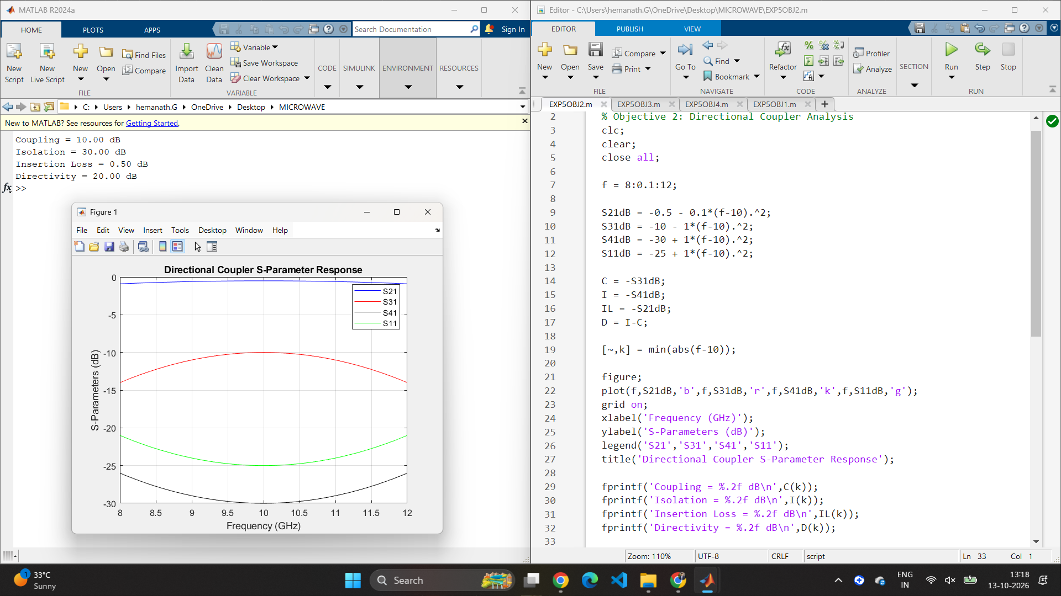

Objective 3: Two-Way Power Divider Analysis
Aim: To analyze equal power division, input-port matching, and output-port isolation for a two-way power divider.

MATLAB Program
% Objective 3: Two-Way Power Divider
clc;
clear;
close all;

f = 8:0.1:12;

S11dB = -25 + 1*(f-10).^2;
S21dB = -3.01 - 0.2*(f-10).^2;
S31dB = -3.01 - 0.2*(f-10).^2;
S23dB = -30 + 1*(f-10).^2;

[~,k] = min(abs(f-10));

P2 = 10^(S21dB(k)/10);
P3 = 10^(S31dB(k)/10);
ratio = P2/P3;

figure;
plot(f,S21dB,'b',f,S31dB,'r',f,S11dB,'k');
grid on;
xlabel('Frequency (GHz)');
ylabel('S-Parameters (dB)');
legend('S21 Output 1','S31 Output 2','S11 Input Reflection');
title('Two-Way Power Divider Response');

fprintf('S11 = %.2f dB\n',S11dB(k));
fprintf('Output 1 = %.2f dB\n',S21dB(k));
fprintf('Output 2 = %.2f dB\n',S31dB(k));
fprintf('Output Power Ratio = %.2f : 1\n',ratio);
fprintf('Output Isolation S23 = %.2f dB\n',S23dB(k));

Output
S11 = -25.00 dB
Output 1 = -3.01 dB
Output 2 = -3.01 dB
Output Power Ratio = 1.00 : 1
Output Isolation S23 = -30.00 dB
Result: The two outputs have equal modeled power levels of approximately −3.01 dB, producing a 1:1 power ratio. The input reflection is −25 dB and the output-to-output transmission S23 is −30 dB at 10 GHz. For isolation, −30 dB is the plotted S-parameter level, equivalent to 30 dB of isolation.
MATLAB screenshot (program, output, and graph):
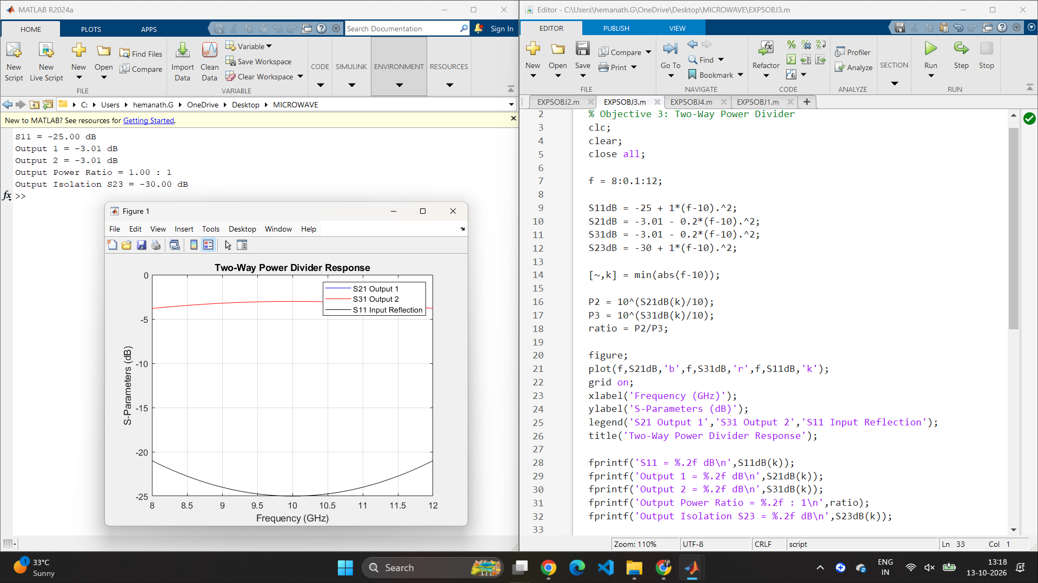

Objective 4: Coupling-Section Length Optimization
Aim: To compare the modeled coupler response before and after a 5% coupling-section length change, using coupling, isolation, and insertion loss across 8–12 GHz.

MATLAB Program
% Objective 4: Coupler Length Optimization
clc;
clear;
close all;

f = 8:0.1:12;

% Initial design
C1 = 10 + 1*(f-10).^2;
I1 = 30 - 1*(f-10).^2;
IL1 = 0.5 + 0.1*(f-10).^2;

% Modified design: length increased by 5%
C2 = 9.5 + 1.2*(f-10).^2;
I2 = 27 - 1*(f-10).^2;
IL2 = 0.7 + 0.1*(f-10).^2;

figure;
subplot(3,1,1);
plot(f,C1,'b',f,C2,'r');
grid on;
ylabel('Coupling (dB)');
legend('Initial','Modified');
title('5% Length Change Optimization');

subplot(3,1,2);
plot(f,I1,'b',f,I2,'r');
grid on;
ylabel('Isolation (dB)');
legend('Initial','Modified');

subplot(3,1,3);
plot(f,IL1,'b',f,IL2,'r');
grid on;
xlabel('Frequency (GHz)');
ylabel('Insertion Loss (dB)');
legend('Initial','Modified');

fprintf('Initial Coupling at 10 GHz = %.2f dB\n',C1(21));
fprintf('Modified Coupling at 10 GHz = %.2f dB\n',C2(21));
fprintf('Initial Insertion Loss = %.2f dB\n',IL1(21));
fprintf('Modified Insertion Loss = %.2f dB\n',IL2(21));

Output
Initial Coupling at 10 GHz = 10.00 dB
Modified Coupling at 10 GHz = 9.50 dB
Initial Insertion Loss = 0.50 dB
Modified Insertion Loss = 0.70 dB
Result: In this illustrative model, the initial design is closer to the 10 dB coupling target and has lower insertion loss at 10 GHz. The modified design has 9.50 dB coupling and 0.70 dB insertion loss. Therefore, the initial design is preferred at the center frequency in this model. Actual optimization must be confirmed using full-wave electromagnetic simulation.
MATLAB screenshot (program, output, and comparison graphs):
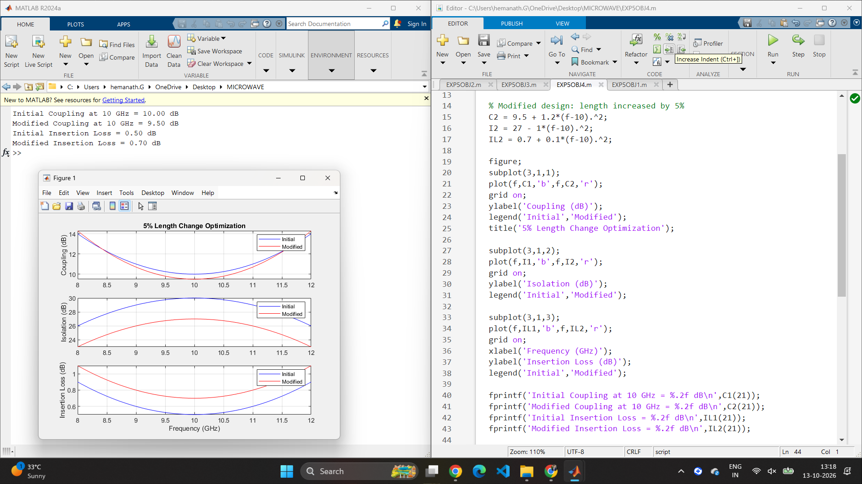

Overall Result
The four MATLAB objectives were completed for the 10 GHz directional coupler and two-way power-divider study. The design parameters were defined, modeled coupler S-parameters were used to calculate coupling, isolation, insertion loss, and directivity, and the divider model was evaluated for equal power division, input matching, and output isolation. A 5% coupling-section length-change case was also compared with the initial model.
The numerical curves and values in these MATLAB programs are illustrative analytical models rather than measured or full-wave simulated results. To demonstrate the manual's requirement of less than 5% deviation from theoretical/reference values, the model should be replaced or validated with S-parameter data exported from CST, HFSS, or ADS.

Formulae Used
- Coupling factor: C = −20 log₁₀|S₃₁| dB (for linear S-parameter magnitude; the provided MATLAB model uses dB values directly).
- Isolation: I = −20 log₁₀|S₄₁| dB (conventional four-port coupler numbering).
- Insertion loss: IL = −20 log₁₀|S₂₁| dB.
- Directivity: D = I − C.
- Ideal equal power division: Pout/Pin = 0.5 per output, corresponding to approximately −3.01 dB.

