ECA 6101 COMPUTER NETWORKS AND CYBERSECURITY
MOHIT V 192512043
EXP 8 Real-time monitoring of traffic in Youtube data streaming using Wireshark
Objectives
1. To capture YouTube streaming traffic using Wireshark and identify the data packets
associated with video transmission.
2. To estimate the maximum bitrate of a YouTube video stream using the captured traffic
statistics and analyze bandwidth utilization.
OBJECTIVE 1:

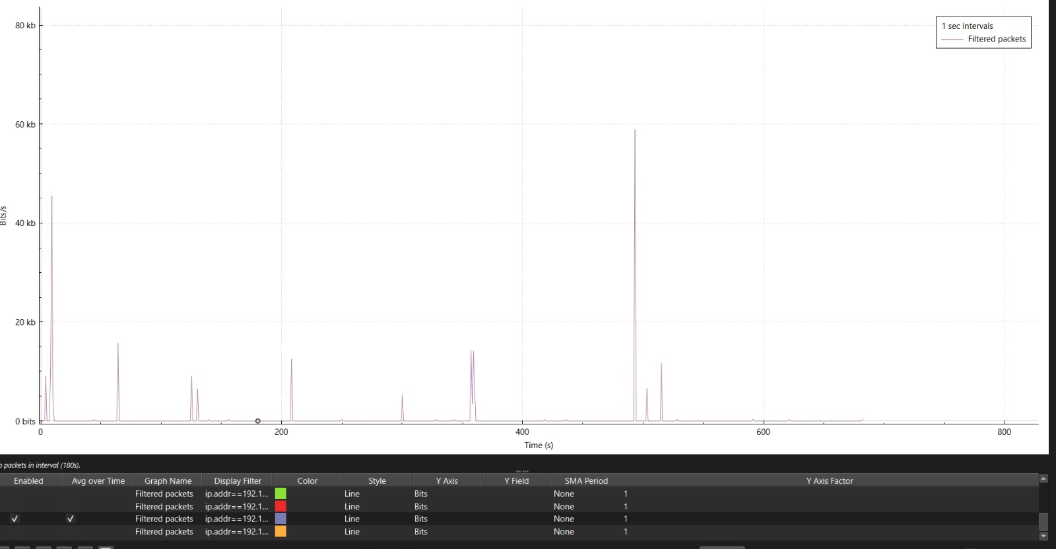

OBJECTIVE 2:
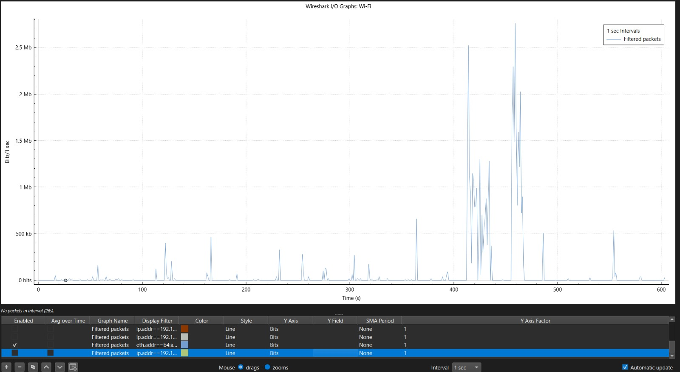

Result 1
The YouTube streaming traffic was successfully captured using Wireshark. The total amount of
data transferred during the video playback session was identified from the captured packets,
enabling analysis of the network resources utilized by the streaming application.
Result 2
The average bitrate of the YouTube video stream was successfully estimated using the captured
traffic statistics and streaming duration. The results demonstrated the relationship between video
quality, data transfer rate, and bandwidth consumption during video streaming.

