

**Tribhuvan University**

**Faculties of Humanities and Social Sciences**

**DNK: A CLOTHING E-COMMERCE SITE**

**A PROJECT REPORT**

**Submitted to Department of Computer Application**

**Ratna RajyaLaxmi Campus**

**Pradarshani Marga, Kathmandu**

***In partial fulfillment of the requirements for the Bachelors in Computer Application***

Submitted by

**Gopal Pokhrel (6-2-40-19-2020)**

**Kiara Raya (6-2-40-24-2020)**

**Anjani Gurung (6-2-40-24-2020)**

**Aasha Khadka (6-2-40-24-2020)**

Under the Supervision of

Mr. Ananda KC



**Tribhuvan University**

**Faculty of Humanities and Social Sciences**

**Ratna RajyaLaxmi Campus**

**SUPERVISOR'S RECOMMENDATION**

I hereby recommend that this project was prepared under my supervision by Gopal Pokhrel, Kiara Raya, Aasha Khadka and Anjani Gurung. "**DNK: A Clothing E-commerce Site**" in partial fulfillment of the requirements for the degree of Bachelor of Computer Application is recommended for the final evaluation.

**SIGNATURE**

Mr. Ananda KC

Lecturer and Project Supervisor

BCA Department,

Ratna RajyaLaxmi Campus, Pradarshani Marga, Kathmandu



**Tribhuvan University**

**Faculty of Humanities and Social Sciences**

**Ratna RajyaLaxmi Campus**

**LETTER OF APPROVAL**

This is to certify that this project was prepared Gopal Pokhrel, Kiara Raya, Aasha Khadka and Anjani Gurung entitled " **DNK: A Clothing E-commerce Site** " in partial fulfillment of the requirements for the degree of Bachelor in Computer Application has been evaluated. In our opinion, it is satisfactory in the scope and quality as a project for the required degree.

|  |  |
| --- | --- |
| **SIGNATURE of Supervisor**        Ananda KC  BCA Department  Ratna Rajya Laxmi Campus  Pradarshani Marga, Kathmandu | **SIGNATURE of HOD/ Coordinator**        Mr. Bhupendra Ram Mishra  Program Coordinator  BCA Department,  Ratna Rajya Laxmi Campus |
| **SIGNATURE OF Internal Examiner**  **__________________________** | **SIGNATURE OF External Examiner**  **___________________________** |

# ABSTRACT

The concept of E-Commerce has been around since the invention of Internet in the 1990s.Our E Commerce store is based on the same concept to encourage online shopping and to implement the learned concepts during the completion of Introduction to MIS & E- Business course in Fifth Semester.

Keywords: Clothing Store, Software, CMS, E-Commerce, B2C,

# ACKNOWLEDGEMENT

We would like to express our sincere gratitude to our instructors for their valuable guidance and support throughout the completion of this lab report. Their knowledge and expertise in the field of MIS & E-Business were invaluable resources and helped us deepen our understanding of the subject. We would also like to thank our classmates for their helpful discussions and feedback during the development of this report. Their insights and perspectives greatly enriched our learning experience. Finally, we would like to acknowledge the support of our families and friends, who provided encouragement and motivation throughout this project. Thank you all for your contributions to the success of this lab report.

# Table of Contents

ABSTRACT iii

ACKNOWLEDGEMENT iv

Table of Contents v

List of Abbreviations vii

List of Figures viii

Chapter 1: Introduction 1

1.1 Introduction to E-Commerce 1

1.2 Classification of E-commerce 1

1.2.1 B2B e-commerce 2

1.2.2 B2C e-commerce 2

1.2.3 C2C e-commerce 2

1.2.4 C2B e-commerce 2

1.2.5 B2G e-commerce 3

1.2.6 G2B e-commerce 3

1.2.7 G2C e-commerce 3

1.3 Objectives 3

Chapter 2: Process of Building a Website 4

2.1 Steps for Building A website 4

2.1.1 Select a Web host: 4

2.1.2 Register a domain name: 4

2.1.3 Create and manage content: 4

2.1.4 Design the website: 4

2.1.5 Construct the website and test: 5

2.1.6 Market and promote the website: 5

2.2 Procedures During Design of Ecommerce Store 5

2.2.1 Adding Products 5

2.2.2 Adding Categories 6

2.2.3 Adding Payments 6

2.3 Steps of Online Shopping 7

2.3.1 Add to Cart 7

2.3.2 Cart Page 7

2.2.5 Billing Address and Delivery Address 8

2.3.5 Confirmation 8

2.4.2 Viewing list of Orders 9

2.4.3 Updating Order 9

Chapter 3: Conclusion and Future Recommendations 10

3.1 Lesson Learnt 10

3.2 Conclusion 10

References 11

Appendices 12

# List of Abbreviations

|  |  |
| --- | --- |
| B | Business |
| C | Consumer |
| CMS | Content Management System |
| DNK | Dress N’ Kicks |
| G | Government |

# List of Figures

Figure 1.1: Ecommerce Process 1

Figure 2.1: Adding products 5

Figure 2.2: Adding categories 6

Figure 2.3 Adding Payments 6

Figure 2.4: Cart page 7

Figure 2.5: Billing address and Order placement 8

Figure 2.6: Order Confirm 8

Figure 2.7: Viewing orders 9

Figure 2.8: Updating Order 9

Figure 2.9: Order Completed 9

# Chapter 1: Introduction

## 1.1 Introduction to E-Commerce

Commerce is a division of trade or production which deals with the exchange of goods and services from producer to final consumer. E-commerce is the purchasing, selling & exchanging goods and services over computer network or internet through which transactions or terms of sale are performed electronically.

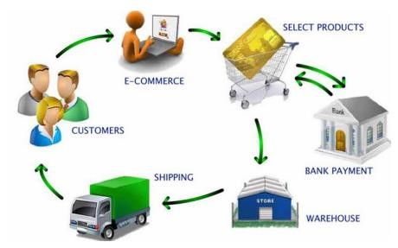

**Figure 1.1: Ecommerce Process**

## 1.2 Classification of E-commerce

E-Commerce business models can be classified as following:

1. Business-to-business (B2B)
2. Business-to-Consumer (B2C)
3. Business-to-government (B2G)
4. Consumer-to-consumer (C2C)
5. Government to consumer (G2C)
6. Government-to-business (G2B)

### 1.2.1 B2B e-commerce

B2B e-commerce is simply defined as ecommerce between companies.

Website following B2B business model sells its product to an intermediate buyer who then sells the product to the final customer.

As an example, a wholesaler places an order from a company's website and after receiving the consignment, sells the end product to final customer who comes to buy the product at wholesaler's retail outlet

Example: Intel selling microprocessor to Dell

### 1.2.2 B2C e-commerce

Website following B2C business model sells its product directly to a customer. A customer can view products shown on the website of business organization. The customer can choose a product and order the same. Website will send a notification to the business organization via email and organization will dispatch the product/goods to the customer.

Examples: amazon.com, daraz.com, gyapu.com, flipcart.com.

### 1.2.3 C2C e-commerce

Website following C2C business model helps consumer to sell their assets like residential property, cars, motorcycles etc. or rent a room by publishing their information on the website. Website may or may not charge the consumer for its services. Another consumer may opt to buy the product of the first customer by viewing the post/advertisement on the website.

Examples: hamrobazar.com, olx.com, quikr.com

### 1.2.4 C2B e-commerce

In this model, a consumer approaches website showing multiple business organizations for a particular service. Consumer places an estimate of amount he/she wants to spend for a particular service. For example, comparison of interest rates of personal loan/ car loan provided by various banks via website.

Business organization who fulfills the consumer's requirement within specified budget approaches the customer and provides its services.

### 1.2.5 B2G e-commerce

B2G model is a variant of B2B model. Such websites are used by government to trade and exchange information with various business organizations. Such websites are accredited by the government and provide a medium to businesses to submit application forms to the government.

### 1.2.6 G2B e-commerce

Government uses B2G model website to approach business organizations. Such websites support auctions, tenders and application submission functionalities.

### 1.2.7 G2C e-commerce

Government uses G2C model website to approach citizen in general. Such websites support auctions of vehicles, machinery or any other material. Such website also provides services like registration for birth, marriage or death certificates. Main objectives of G2C website are to reduce average time for fulfilling people requests for various government services.

## 1.3 Objectives

* To practically implement the knowledge learnt during the completion of MIS & EBusiness.
* To build an E-commerce site
* To sell products online

# Chapter 2: Process of Building a Website

## 2.1 Steps for Building A website

The process to build a successfully ecommerce website is as follows. They are followed in the completion of this project.

### 2.1.1 Select a Web host:

One of the first decisions that an online business will face is where to place its website on the Internet. The website may be included in a virtual shopping mall, such as 3d-berlin.com, the-virtualmall.com, or pointshop.com/mall. Alternatively, a web store can be hosted in a marketplace that is a collection of independent web stores like Yahoo! (smallbusiness.yahoo.com), Amazon.com, Etsy, or eBay However, many medium and large-sized businesses build their own websites with either an independent hosting service or through self-hosting arrangements.Apache Server and MySQL is used in our project.

### 2.1.2 Register a domain name:

In a mall or web store, the business’s name may be an extension of the host’s name. A stand-alone website will need its own domain name, and decisions will have to be made about which top-level domain name to use and whether the domain name includes the business name or only some aspect of branding. Registering domain names is essential to a business.

### 2.1.3 Create and manage content:

The website also needs content – the text, catalog, images, sound, and video – that delivers the information that visitors need and expect. Content can come from a variety of sources, but getting the right content in place, making it easy for viewers to find, delivering it effectively, and managing the content so it remains accurate and up-to-date are critical success factors.

We used WordPress which is a great Content Management System (CMS).

### 2.1.4 Design the website:

This important task is designing the web site. Stores in a mall or those using store builders may have limited options, but the stand-alone websites have many options.

### 2.1.5 Construct the website and test:

Businesses must also decide whether to design and construct the website internally, contract it out to a Web design firm, or a combination of both. When the business owners are satisfied with the website, it is transferred to the website host. At this point, the website is open for business, but it requires final testing to ensure that all the links work and that the processes function as expected (e.g., acceptance of credit cards).

We used Pay on Delivery as it is free, for adding payment through payment platforms such as Khalti, we need Merchant private and public key which we did. We tested insertion of products such as shoes, clothing items, etc.

### 2.1.6 Market and promote the website:

At this stage, the business promotes the location of the website, both online and offline. A business can use any of (online or offline) advertising strategies.

## 2.2 Procedures During Design of Ecommerce Store

### 2.2.1 Adding Products

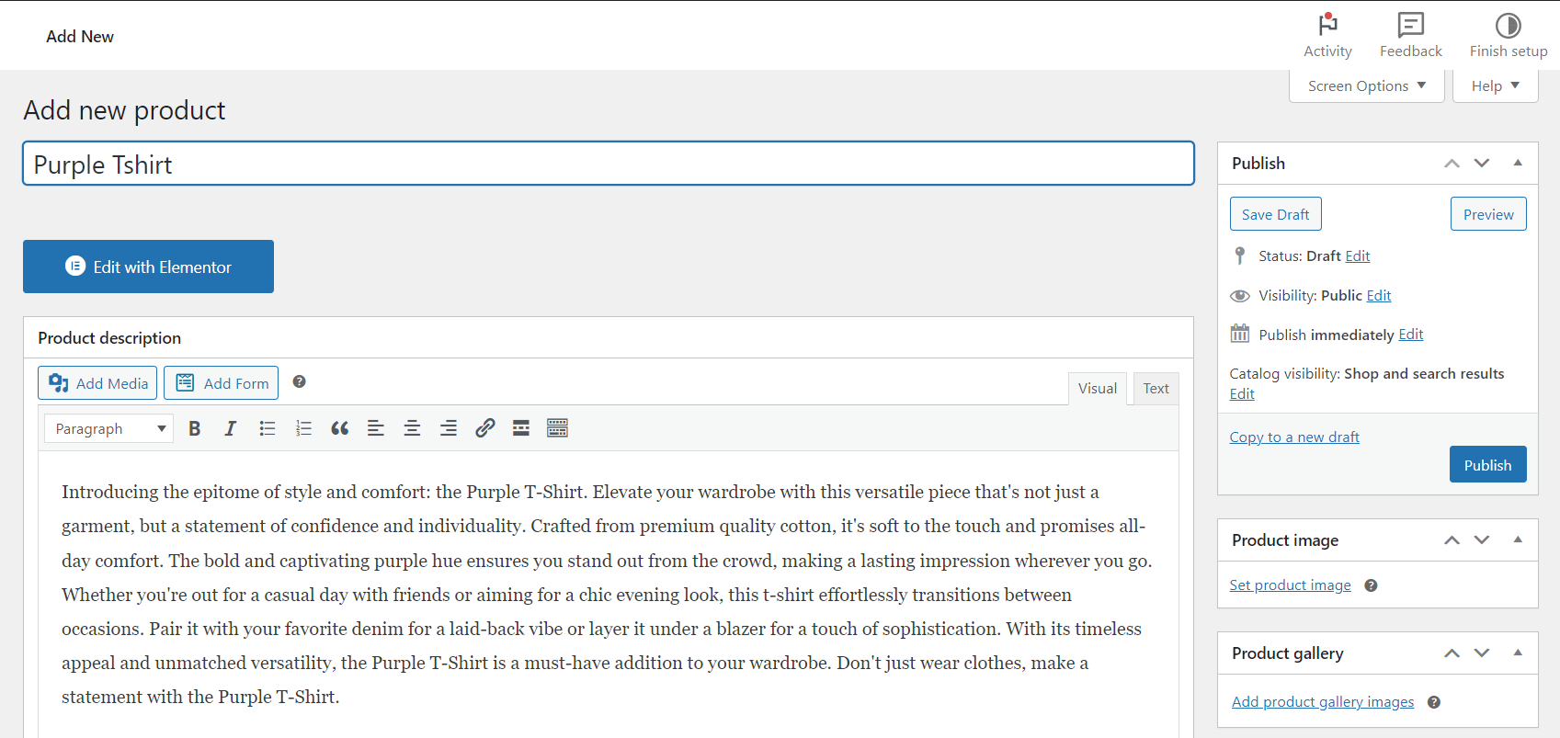

**Figure 2.1: Adding products**

### 2.2.2 Adding Categories

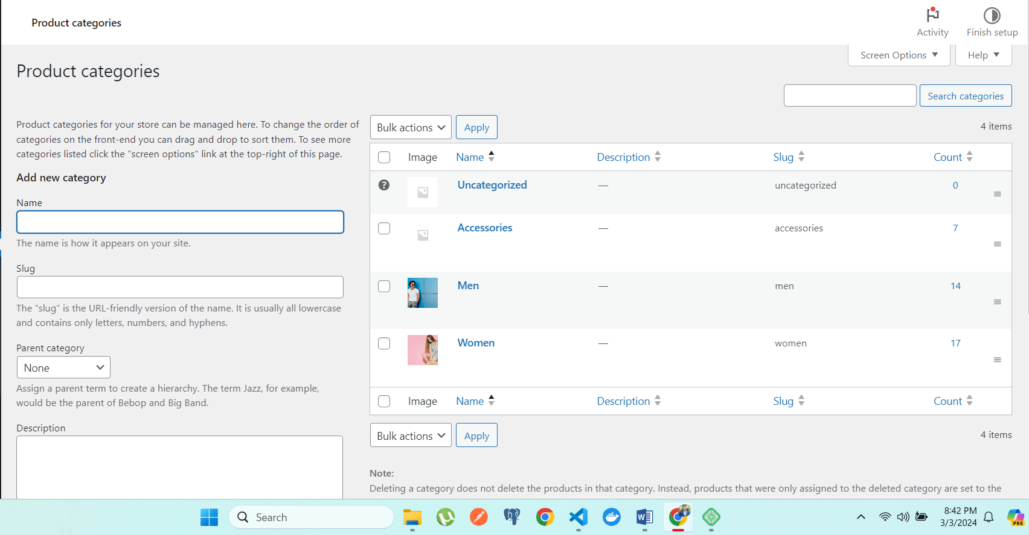

**Figure 2.2: Adding categories**

### 2.2.3 Adding Payments

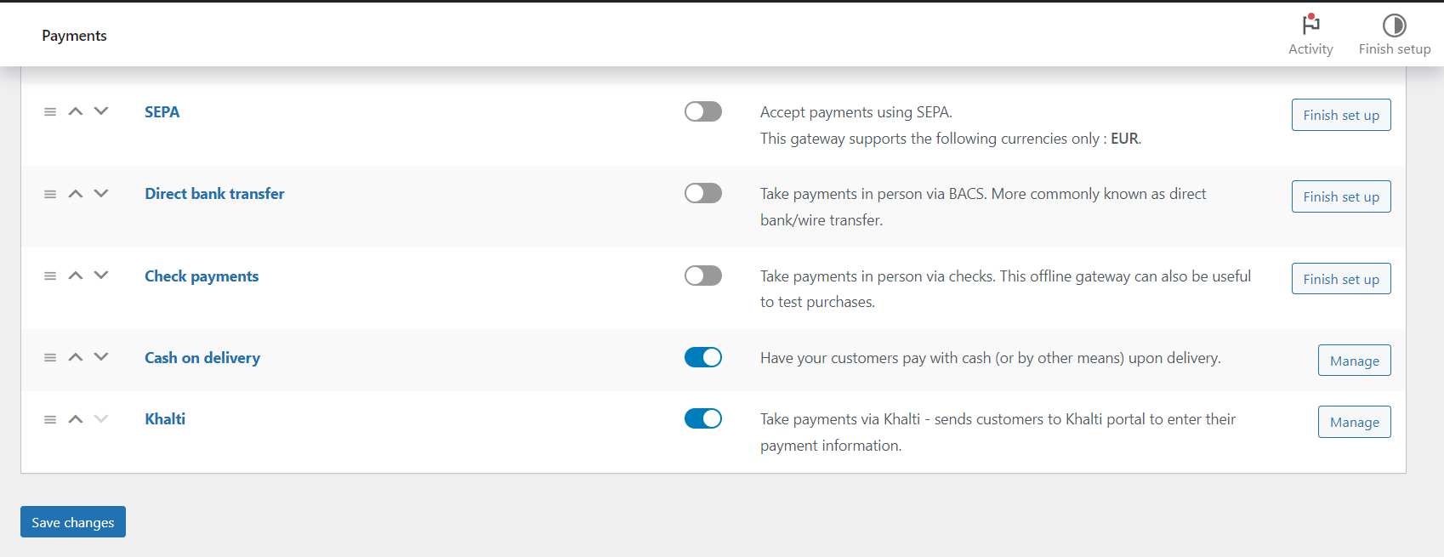

**Figure 2.3 Adding Payments**

## 2.3 Steps of Online Shopping

The steps involved in this process is as follows:

### 2.3.1 Add to Cart

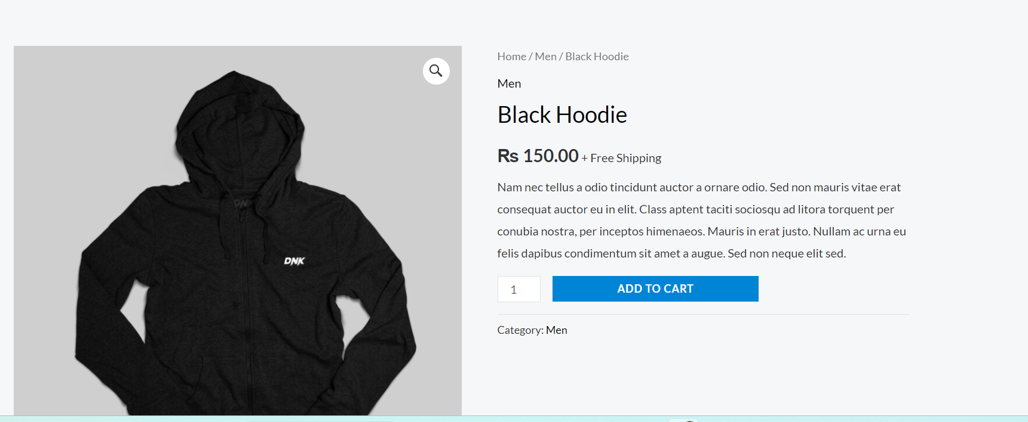

**Figure 2.4 Adding to cart**

### 2.3.2 Cart Page

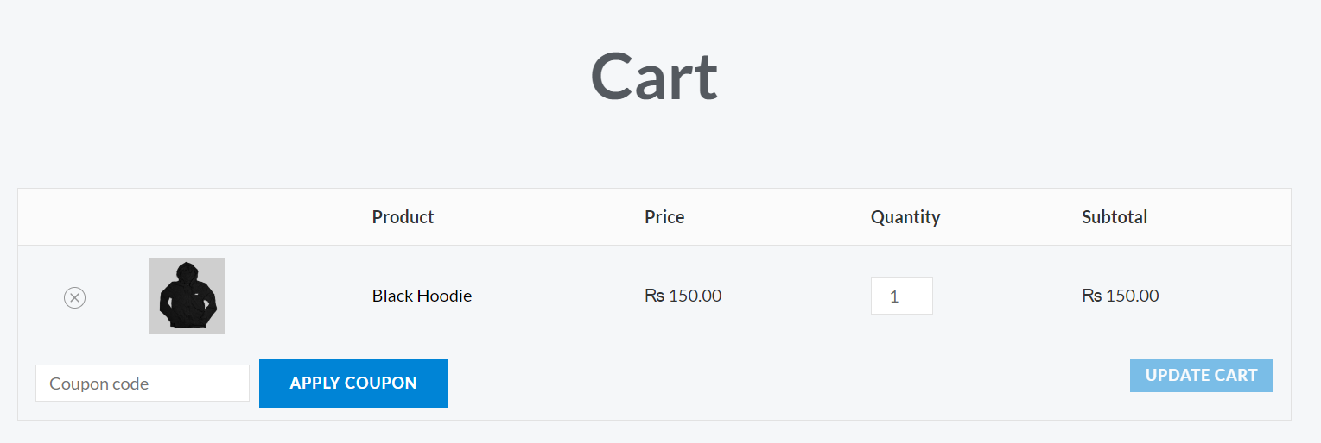

**Figure 2.4: Cart page**

### 2.2.5 Billing Address and Delivery Address

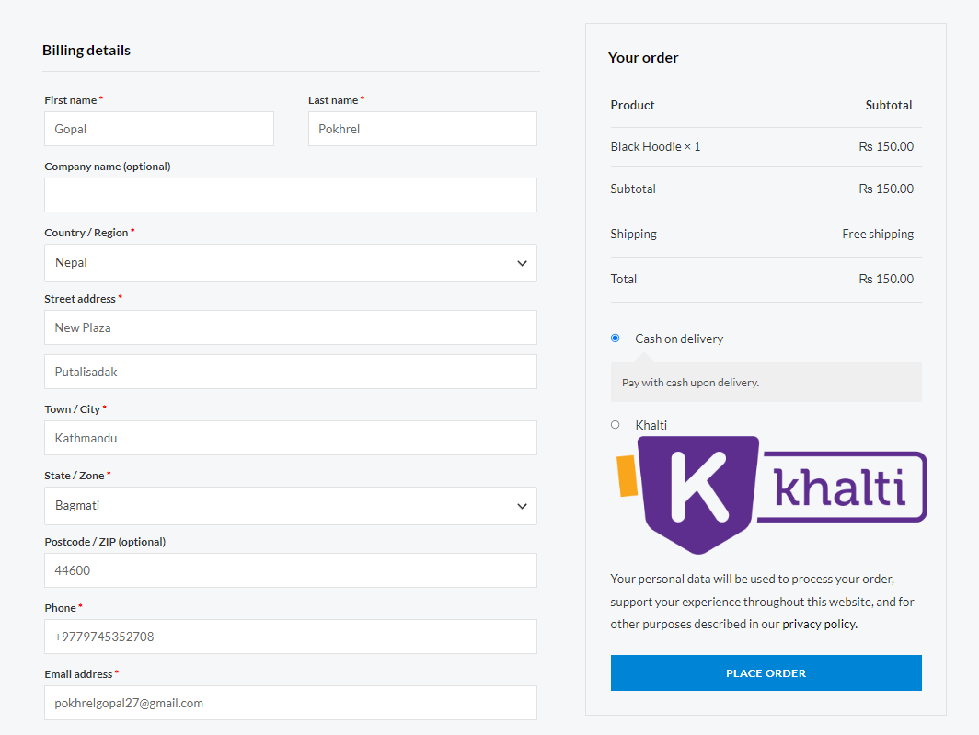

**Figure 2.5: Billing address and Order placement**

### 2.3.5 Confirmation

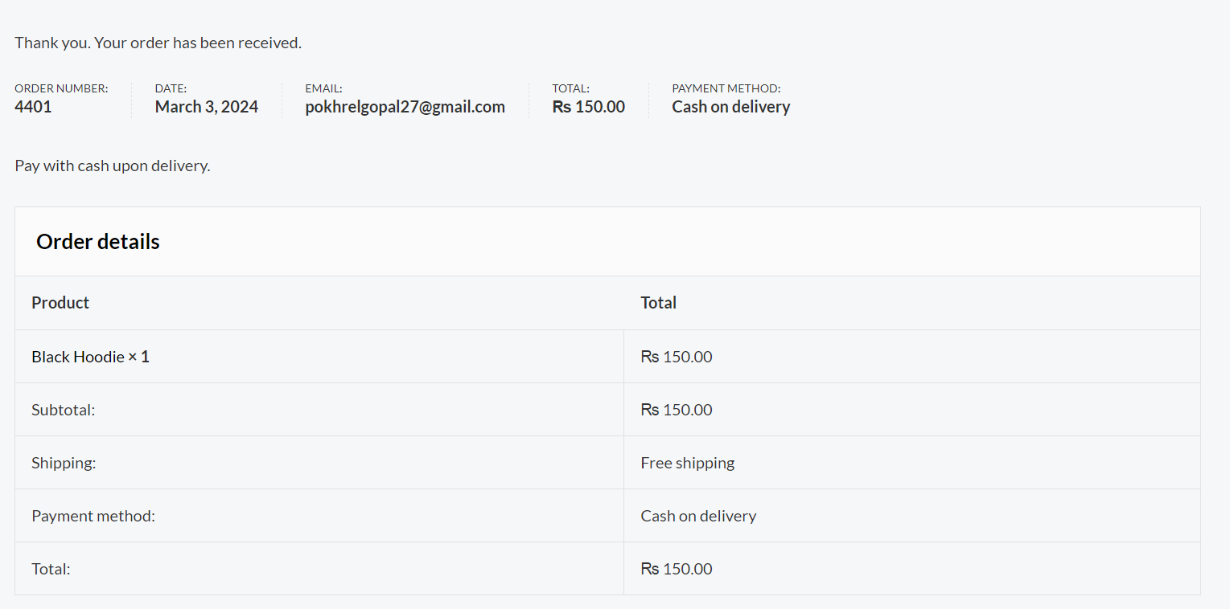

**Figure 2.6: Order Confirm**

### 2.4.2 Viewing list of Orders

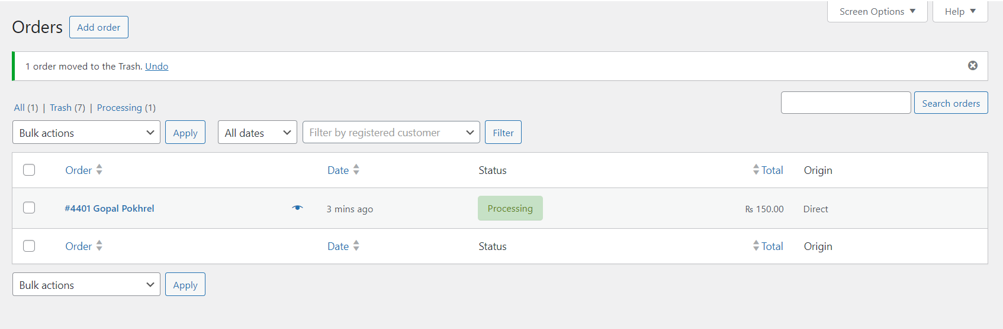

**Figure 2.7: Viewing orders**

### 2.4.3 Updating Order

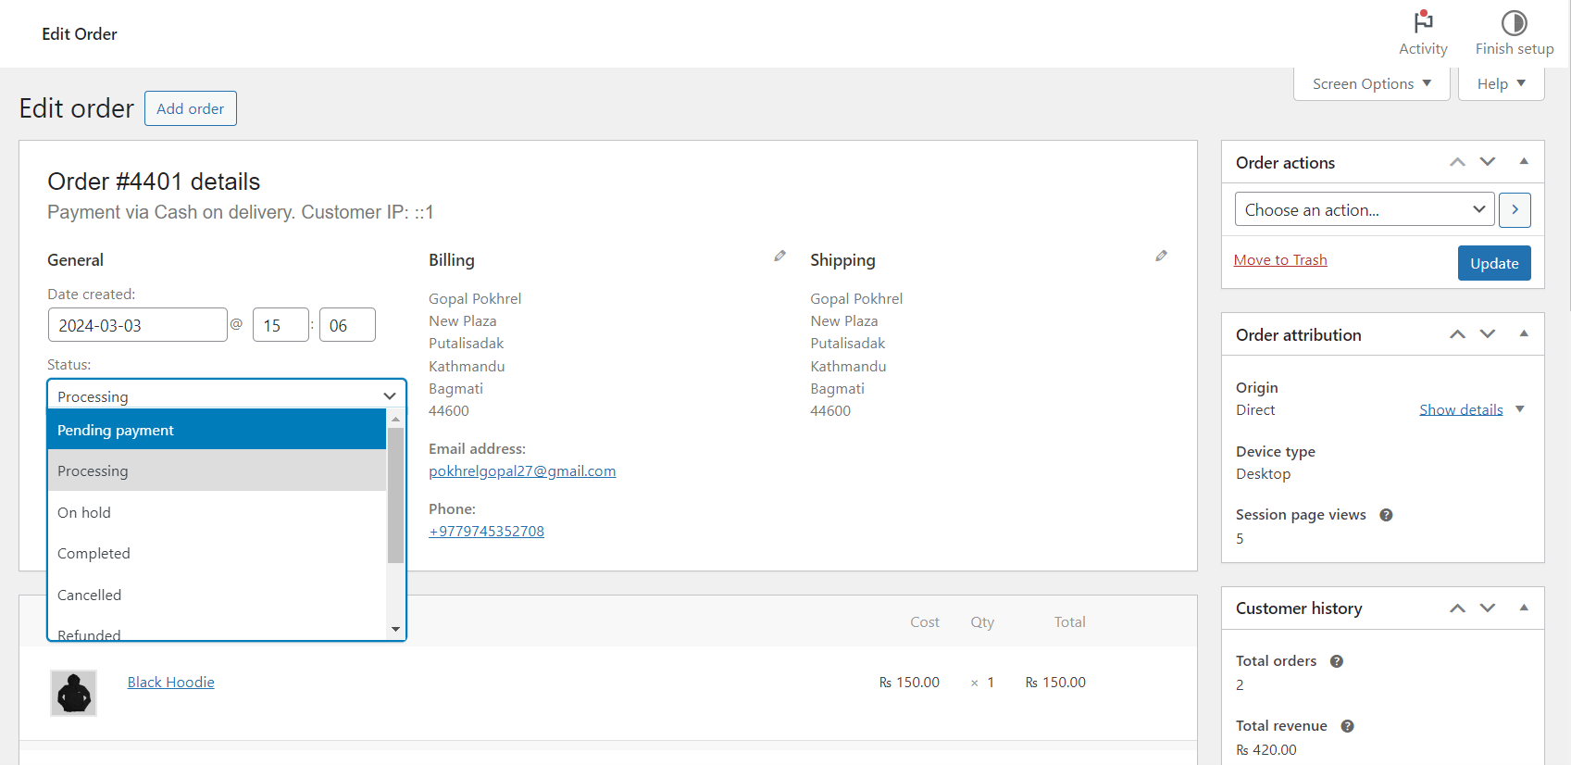

**Figure 2.8: Updating Order**

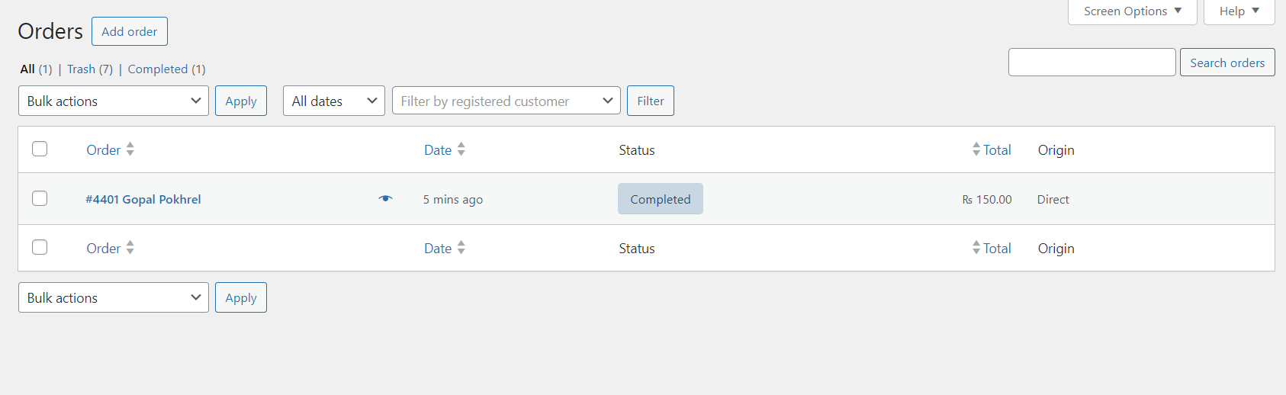

**Figure 2.9: Order Completed**

# Chapter 3: Conclusion and Future Recommendations

## 3.1 Lesson Learnt

After completing our project entitled "DNK: A Clothing Ecommerce Store," we are thrilled to acknowledge the significant understanding we have gained about the actual process of developing an ecommerce site. Initially, we encountered challenges due to a lack of information in certain areas. However, with remarkable support, we ultimately managed to bring our project to fruition. While we acknowledge that our site may not be perfect in every aspect, the invaluable experience gained from completing this project is undeniable.

## 3.2 Conclusion

Based on the facts and on the data gathered, the conclusion is that the website is built on the concepts taught in the MIS & E-business. It is not perfect but with more resources such as Elementor Pro and more payment services it can be improved.

# References

https://daraz.com/

[WordPress.org Documentation](https://wordpress.org/documentation/)

[Elementor: #1 Free WordPress Website Builder | Elementor.com](https://elementor.com/)

[WooCommerce - Open Source eCommerce Platform](https://woocommerce.com/)

[Sydney - WordPress theme | WordPress.org](https://wordpress.org/themes/sydney/)

# Appendices



