1. Prepare specifications for computer, network printer, router, switch and other network accessories for your college.

|  |  |  |  |  |  |  |
| --- | --- | --- | --- | --- | --- | --- |
| **S.N.** | **Particulars** | **Specifications (minimum)** | **Estimated Price per Unit** | **Quantity** | **Total Estimated Cost** | **Remarks** |
| 1 | CPU | 13th Gen Intel® Core™ i5 (24 MB cache, 14 cores, 2.50 GHz to 4.80 GHz Turbo, 65 W) or more | Rs. 85,000/- (Exclusive of VAT) | 35 | Rs. 2,975,000/-  (Exclusive of VAT) |  |
| 2 | RAM | 8 GB DDR5 RAM [3200MHz or more] |
| 3 | Hard Drive | 512 GB, M.2 2230, PCIe NVMe, SSD |
| 4 | Graphics | Integrated Intel Graphics |
| 5 | Motherboard | Intel Chipset |
| 6 | Ports | Headphone and Mic Connector, VGA, HDMI, Serial Port, 2xUSB 3.2 Ports [Front], 2xUSB 3.2 [Rear], Keyboard and Mouse Connectors, RJ-45 Network Connector - GIG, Power Connector, Integrated Wi-Fi (Gig+) and Bluetooth 5.0 or more |
| 7 | Monitor | 18.5-inch LED screen 720p monitor or more |
| 8 | Accessories | USB Keyboard, Optical mouse and all standard accessories, Keyboard and Mouse Part Number must be match with purposed brand |
| 9 | Form Factor | Mini or Tower Business Series |
| 10 | Operating System | Windows 11 Pro. Factory Installed |

Technical Specifications for Branded Desktop Computers

Date: 2080/11/10

|  |  |  |  |  |  |  |
| --- | --- | --- | --- | --- | --- | --- |
| SN | Particulars | Specifications | Estimated Price per Unit | Quantity | Total Estimated Cost | Remarks |
| 1 | Type | Laser Printer | 80000 | 1 | 80000 | Check Epson Eco Tank ET-4760 for reference |
| 2 | Printing Technology | Laser |
| 3 | Print Speed | Up to 15 ppm (black), 8 ppm (color) |
| 4 | Resolution | Up to 4800 x 1200 dpi |
| 5 | Connectivity | Wi-Fi, Ethernet, USB, Bluetooth |
| 6 | Duplex Printing | Automatic |
| 7 | Compatibility | Windows MAC |
| 8 | Paper Handling | 250-sheet input tray, 30-sheet ADF, 150-sheet output tray |

Technical Specifications for Network Printer

|  |  |  |  |  |  |  |
| --- | --- | --- | --- | --- | --- | --- |
| SN | Particulars | Specification | Estimated price per Unit | Quantity | Estimated Total | Remarks |
| 1 | Wireless Standards | 802.11ax (Wi-Fi 6) | Rs.3,600 | 1 | Rs.3,600 |  |
| 2 | Wireless Range | Up to 2,000 to 5,000 square feet (depending on environmental factors) |
| 3 | Number of bands | (2.4 GHz and 5 GHz) |
| 4 | Speed Rating | 300 MBPS or more |
| 5 | Ports | 1x Fast WAN Port + 3x Fast LAN Ports or more |
| 6 | Protocols | IPv4, IPv6 |
| 7 | Access Control | IP Filtering, MAC Filtering, Domain Filtering, IPv6 Filtering or more |
| 8 | Security | Access Control, IP & MAC Binding or more |

Technical Specifications for Router

|  |  |  |  |  |  |  |
| --- | --- | --- | --- | --- | --- | --- |
| SN | Particulars | Specifications | Estimated price per unit | Quantity | Total Estimated | Remarks |
| 1 | Ports | 24 x 10/100/1000 Ethernet ports, 2 x 1G SFP uplink ports | Rs 10800 | 1 | 10800 | Reference: SF-95 AS 24 Port unmanaged Fast Ethernet Switch |
| 2 | Power Over Ethernet (PoE) | Preferred |
| 3 | Security | Basic QoS or more |
| 4 | Unmanaged (Auto detect devices, no need to configure) | Preferred |

Technical Specifications for Switch

|  |  |  |  |  |  |  |
| --- | --- | --- | --- | --- | --- | --- |
| SN | Particulars | Specifications | Estimated Price Per Unit | Quantity | Estimated Total Cost | Remarks |
| 1 | Ethernet Cables | 50m CAT-6 cable bundle | 900 | 1 | Rs 1940 |  |
| 2 | Connectors | RJ 45 set of 100 pcs | 150 | 1 |
| 3 | Cable Managements | Cable Ties and Cable Pins bundle of 100 pcs | 350 | 1 |
| 4 | Crimping Tool | Crimping tool; and wire stripper | 380 | 1 |
| 5 | Labeler | Price roll sticker | 40 | 4 |
| 6 | Tester |  |  |  |  |  |

Technical Specifications for Network Accessories

1. Determine the appropriate placement of networking devices on a network.
   1. Cables
      1. Layer: Physical Layer (Layer 1)
      2. Function: Carry data signals between networking devices.
   2. Layer 2 Switches
      1. Layer: Data Link Layer (Layer 2)
      2. Function: Forward frames between devices within the same network segment using MAC addresses.
   3. Routers
      1. Layer: Network Layer (Layer 3)
      2. Function: Carry data signals between networking devices.
   4. Layer 3 Switches
      1. Layer: Network Layer (Layer 3)
      2. Function: Combine features of switches and routers. Provide routing functions at Layer 3, enabling faster packet forwarding based on IP addresses.
   5. Connectors
      1. Layer: Physical Layer (Layer 1)
      2. Function: Connect cables to networking devices.
2. Identify networking cable standards. Create and test cross over and straight cables.
3. Ethernet Cables:

* Category 5e (Cat5e): Supports Gigabit Ethernet (up to 1000 Mbps) over short distances (up to 100 meters). Cat5e cables are widely used for Ethernet networks.
* Category 6 (Cat6): Offers improved performance and reduced crosstalk compared to Cat5e. It supports 10-Gigabit Ethernet (up to 10 Gbps) over shorter distances.
* Category 6a (Cat6a): Enhanced version of Cat6, capable of supporting 10-Gigabit Ethernet over longer distances (up to 100 meters).

1. Fiber Optic Cables

* Single-mode fiber (SMF): Designed for long-distance, high-speed data transmission. It uses a single strand of glass fiber and offers higher bandwidth and longer transmission distances compared to multimode fiber.
* Multimode fiber (MMF): Suited for shorter distances and lower bandwidth requirements. It uses multiple paths of light transmission within the fiber core.

1. Coaxial Cables

* RG-6: Commonly used for cable television (CATV) and high-speed Internet connections.
* RG-59: Older standard used for analog video transmission, now being replaced by RG-6 for digital signals.

1. Twisted Pair Cables

* Shielded Twisted Pair (STP): Twisted pair cables with additional shielding to reduce electromagnetic interference (EMI) and crosstalk.
* Unshielded Twisted Pair (UTP): Most common type of twisted pair cable used in Ethernet networks. It consists of twisted pairs of insulated copper wires and does not have additional shielding.

Steps in creating Cross-Over Cables:

Tools Needed:

* Ethernet Cables (CAT5e or CAT5)
* Crimping tool
* Two RJ45 plugs

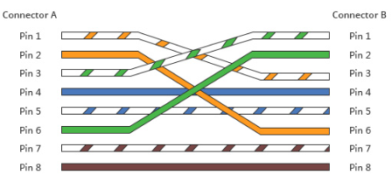

* The cable on Connector A and B should have following color patterns in order.

|  |  |
| --- | --- |
| **Connector A** | **Connector B** |
| Orange-White | Green White |
| Orange | Green |
| Green White | Orange White |
| Blue | Blue |
| Blue White | Blue White |
| Green | Orange |
| Brown White | Brown White |
| Brown | Brown |

Follow these Steps:

* Prepare everything mentioned above
* Strip approximately 2 cm of cable shielding from both ends
* Untangle the wires and make the pattern as written in above table for both sides referred as (A and B)
* Push the arranged cable into RJ45 connector
* Insert it into crimping tool and crimp it.
* Repeat the process for another side as well.

Steps in preparing straight cable:

* Prepare everything same as in cross over cable
* This is how they should look like.  
  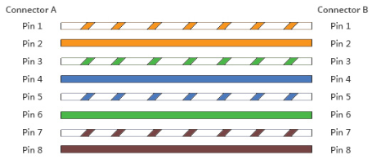

1. After arranging repeat the same process to crimp it as we did in cross over cable.
2. Configure the IP address of your computer

Steps:

1. Go to Run (Win + R).
2. Type ncpa.cpl and press enter.

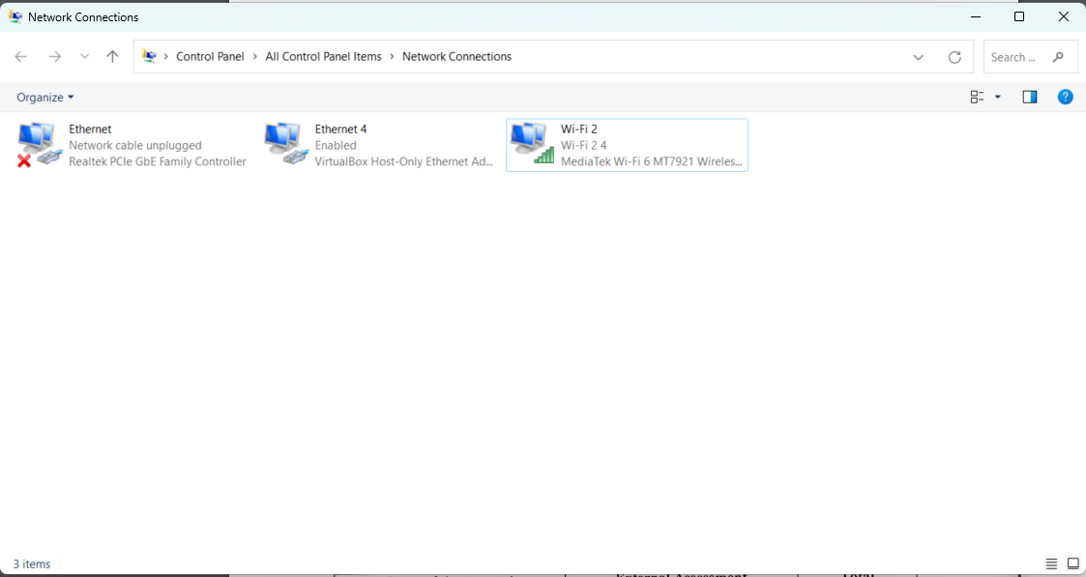

1. Double click on your network  
   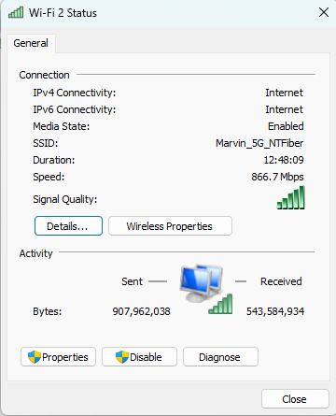
2. Click on Properties.

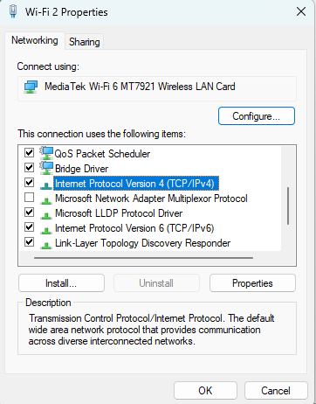

1. Double click on Internet Protocol Version 4 (TCP/IPv4).
2. You will see the following window.

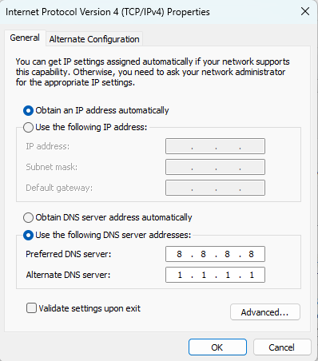

1. Select “Use the following IP address” and enter your preferred IP address and click ok.  
   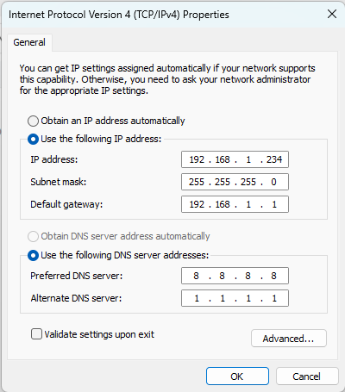

10. Configuring IP address and subnet in Linux Machine

* 1. Press Windows key and search and go to settings.
  2. Click on Network.  
     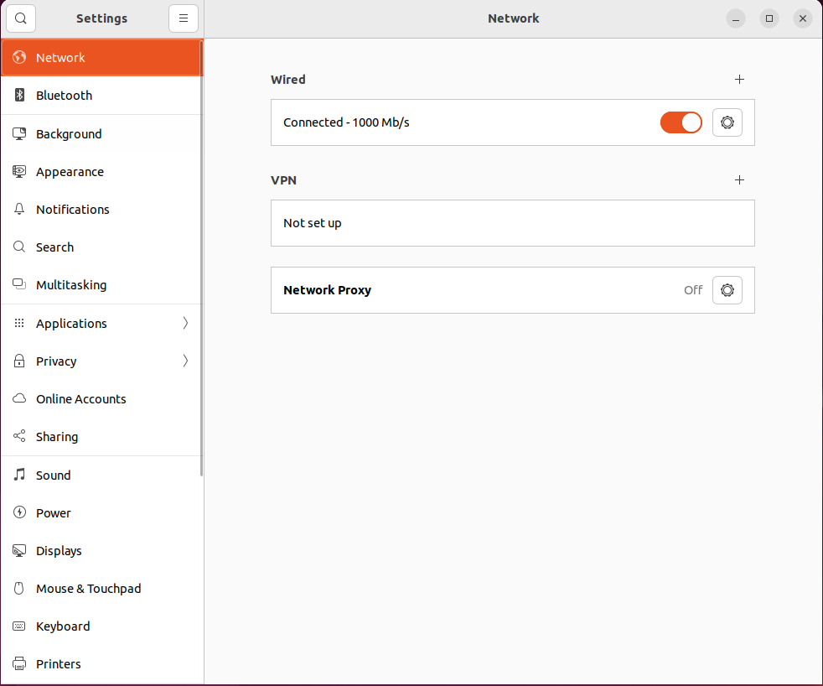
  3. In wired options, click on Setting button.

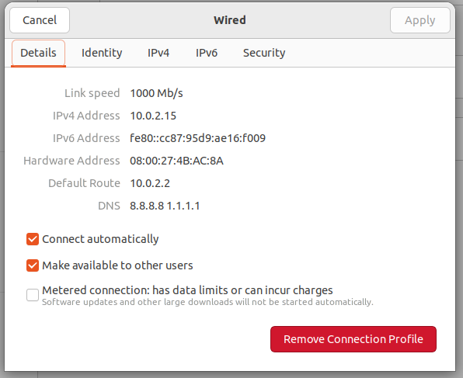

* 1. Click on IPV4 tab.

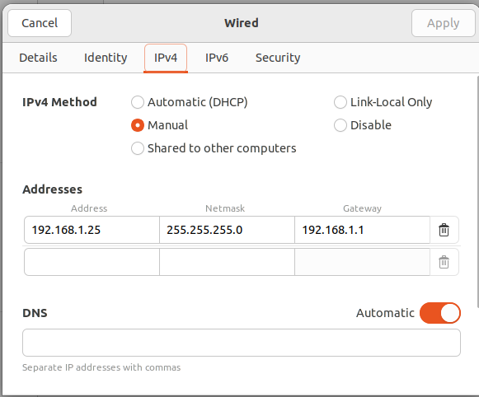

* 1. Select manual in methods.
  2. Put your preferred IP Address, Subnet Mask and Default Gateway.
  3. Click on Apply button on top right side.
  4. Your configuration is all set.

15.

In Linux machine, Go to terminal and type:

sudo nano /etc/resolve.conf

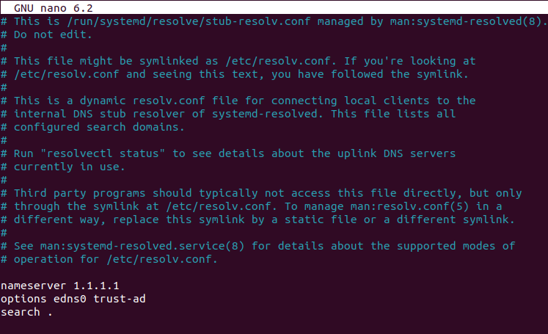

The above window will appear change the nameserver and save the file.

Reopen and check if change persists.

