Entering, Deleting, and Changing Field Values.
1) Write a command that puts the following values, in their given order, into the salespeople table: city – San Jose, name – Blanco, comm – NULL, cnum – 1100.
2) Write a command that removes all orders from customer Clemens from the Orders table.
3) Write a command that increases the rating of all customers in Rome by 100.
4) Salesperson Serres has left the company. Assign her customers to Motika.
OUTPUT:-
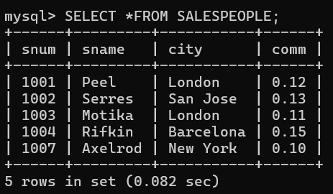
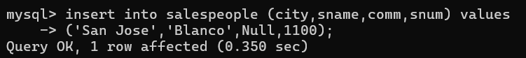
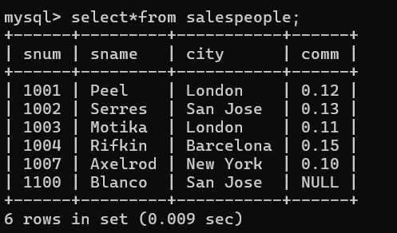

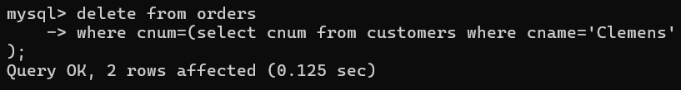
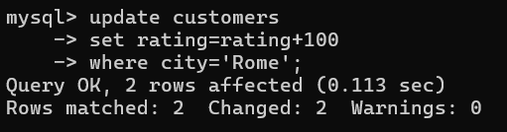
BEFORE:-
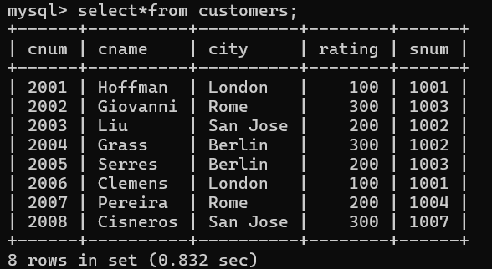
AFTER:-
