Using Subqueries with DML Commands.
1) Assume there is a table called Multicust, with all of the same column definitions as Salespeople. Write a command that inserts all salespeople with more than one customer into this table.
2) Write a command that deletes all customers with no current orders.
3) Write a command that increases by twenty percent the commissions of all salespeople with total orders above Rs. 3,000.
OUTPUT:-
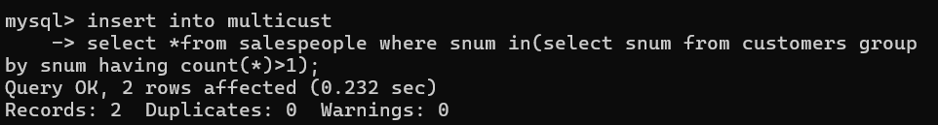
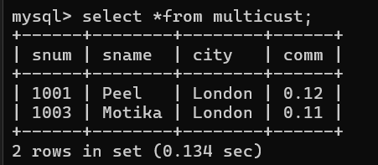
BEFORE:-
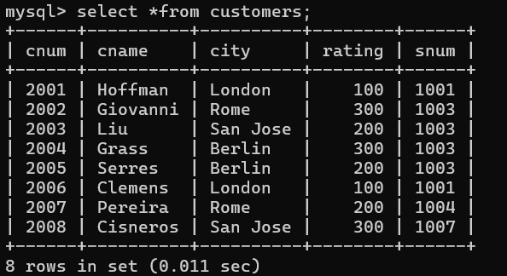

AFTER:-
