LOWERCASE LETTERS

AIM
To write a Lex program that reads an input character and identifies whether it is a lowercase letter (a–z).

ALGORITHM
- Start the program.
- In the definitions section, include the required header files.
- In the rules section, define the pattern [a-z] and print “<character> is lowercase” when it matches.
- Define a rule for the newline character (\n) that returns 0 to stop scanning.
- Define a rule for any other character (.) that does nothing.
- In the user subroutine section, define yywrap() returning 1.
- In main(), print the prompt, call yylex() and return 0.
- Compile with lex and cc, run the program, and enter the input.
- Stop the program.

PSEUDO CODE

START

DEFINE RULES:
Rule 1: If the character is in the range 'a' to 'z', print "<character> is lowercase".
Rule 2: If the character is a newline ('\n'), return 0 to stop scanning.
Rule 3: For any other character, do nothing (ignore).

DEFINE yywrap():
Return 1 to indicate the end of input.

MAIN:
Print "Enter the lexeme:"
Call yylex() to scan the input and apply the rules.
Return 0.

STOP

PROGRAM

%{

#include <stdio.h>

%}

%%

[a-z] { printf("%s is lowercase\n", yytext); }

\n { return 0; }

. { }

%%

int yywrap()

{

return 1;

}

int main()

{

printf("Enter the lexeme: ");

yylex();

return 0;

}

OUTPUT
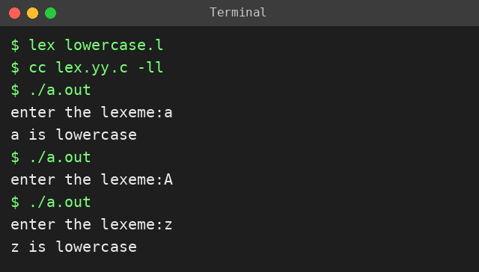

RESULT
Thus the Lex program to identify lowercase letters was executed successfully and the output was verified.

