Vendor Sales Performance Analytics
End-to-End Data Analytics Portfolio Project

Mohith
Senior Test Analyst | Transitioning to Data Analytics • Cognizant

Python | PostgreSQL | Power BI | Domain
pandas · NumPy matplotlib · seaborn scipy | SQL CTEs Window Functions Data Modeling | Live PostgreSQL Connection Interactive Dashboard | Beverage Retail Vendor Analytics Inventory Mgmt

1. Project Overview

This project builds a complete end-to-end data analytics pipeline for a beverage retail business. The dataset spans 5 raw CSV files containing 2.6+ million rows of transactional data across vendor purchases, sales, inventory, and freight invoices. The goal was to consolidate, clean, and analyze this data to uncover vendor performance patterns, pricing inefficiencies, and inventory risks — then surface the findings in an interactive Power BI dashboard.

Dataset & Pipeline Summary

Source File | Rows | Key Columns
purchases.csv | 2,372,474 | VendorNumber, VendorName, Brand, PurchasePrice, Quantity, Dollars, PODate
purchase_prices.csv | 12,261 | Brand, Description, Price (ActualPrice), Volume, PurchasePrice, VendorNumber
vendor_invoice.csv | 5,543 | VendorNumber, InvoiceDate, PONumber, Quantity, Dollars, Freight, Approval
end_inventory.csv | 224,489 | InventoryId, Store, City, Brand, Description, onHand, Price, endDate
begin_inventory.csv | ~224K+ | Opening stock positions — same schema as end_inventory
vendor_sales_summary | Derived | 18 columns including 4 engineered KPIs: GrossProfit, ProfitMargin, StockTurnOver, SalestoPurchaseRatio

Pipeline Flow
Raw CSVs → PostgreSQL (ingestion_db.py) → SQL CTEs + Python cleaning (get_vendor_summary.py) → Jupyter EDA → Jupyter Analysis → Power BI Dashboard

2. Exploratory Data Analysis

In this phase, the vendor_sales_summary table was profiled to understand data distributions, detect outliers, and validate data quality before deeper analysis.

2.1 Distribution of All Numerical Columns
Histograms with KDE were plotted for all 16 numerical columns to understand the shape and spread of each variable.

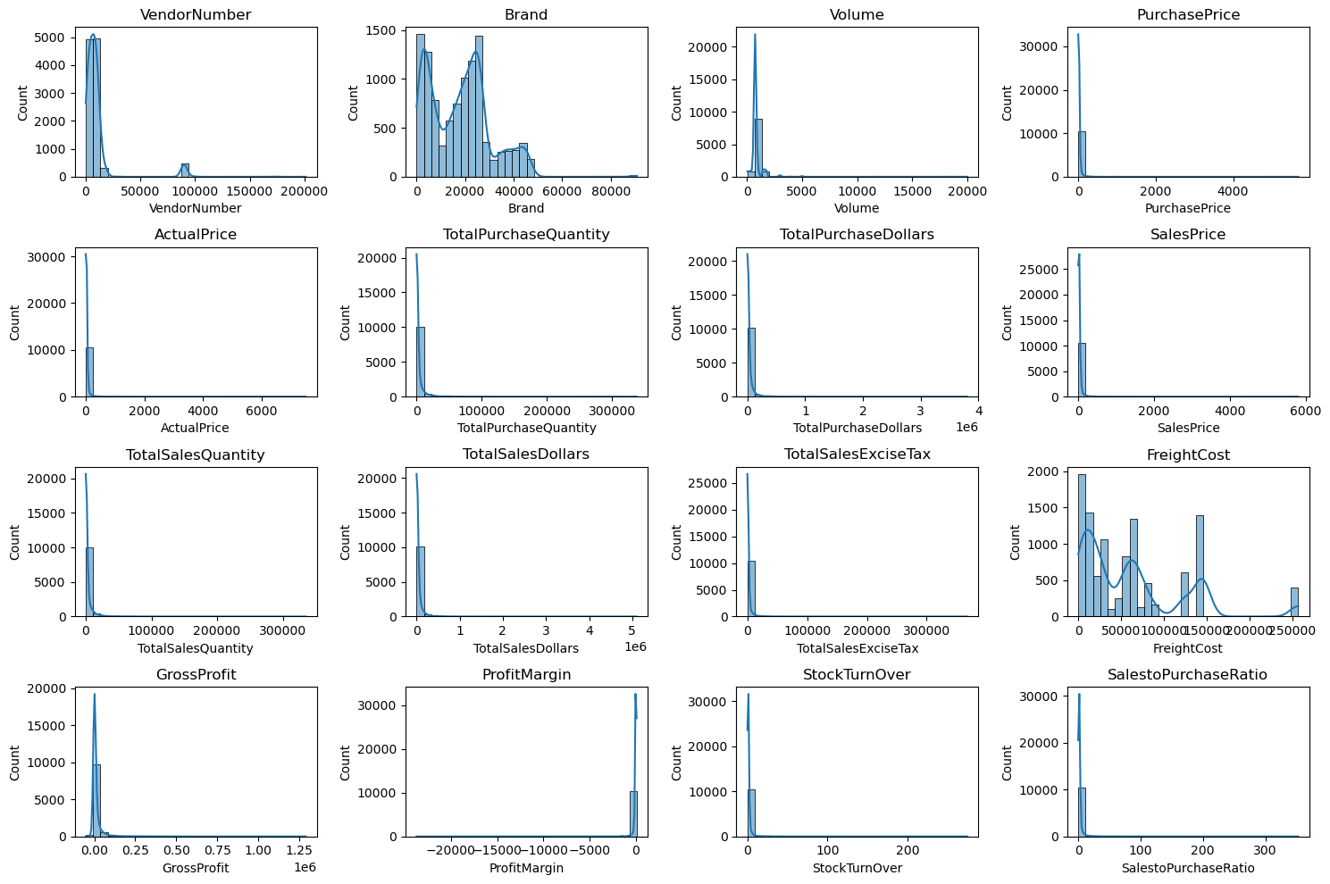
Fig 1: Distribution plots across all numerical columns — raw data (pre-filter)

2.2 Outlier Detection — Box Plots
Box plots were used to detect outliers across all numeric columns.

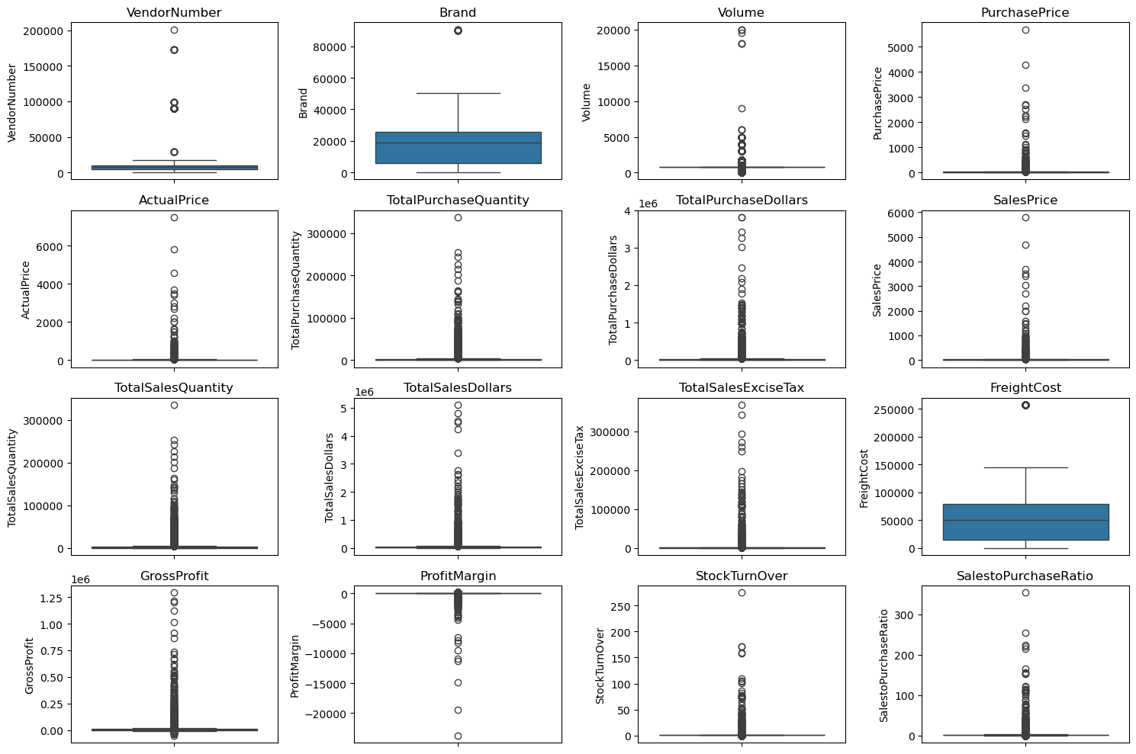
Fig 2: Box plots showing outliers across all numerical columns

Summary Statistics Insights from the Raw Data

- Gross Profit minimum: −$52,002.78 — some products are selling at a loss due to high procurement costs or heavy discounting below purchase price
- Profit Margin minimum: −∞ — occurs where TotalSalesDollars is zero but TotalPurchaseDollars is positive
- TotalSalesQuantity & TotalSalesDollars min: 0 — some products were purchased but never sold, indicating slow-moving or obsolete stock
- PurchasePrice outliers: Max $5,681.81 vs mean $24.39 — premium or specialty products exist in the catalogue
- FreightCost range: $0.09 to $257,032.07 — massive variance indicating logistics inefficiencies or bulk shipments
- StockTurnOver range: 0 to 274.5 — some products sell extremely fast; values > 1 indicate sales being fulfilled from older existing stock

2.3 Distribution After Filtering (Clean Data)
The dataset was filtered to retain only records with GrossProfit > 0, ProfitMargin > 0, and TotalSalesQuantity > 0. This removed loss-making and unsold-inventory records from the analysis dataset.

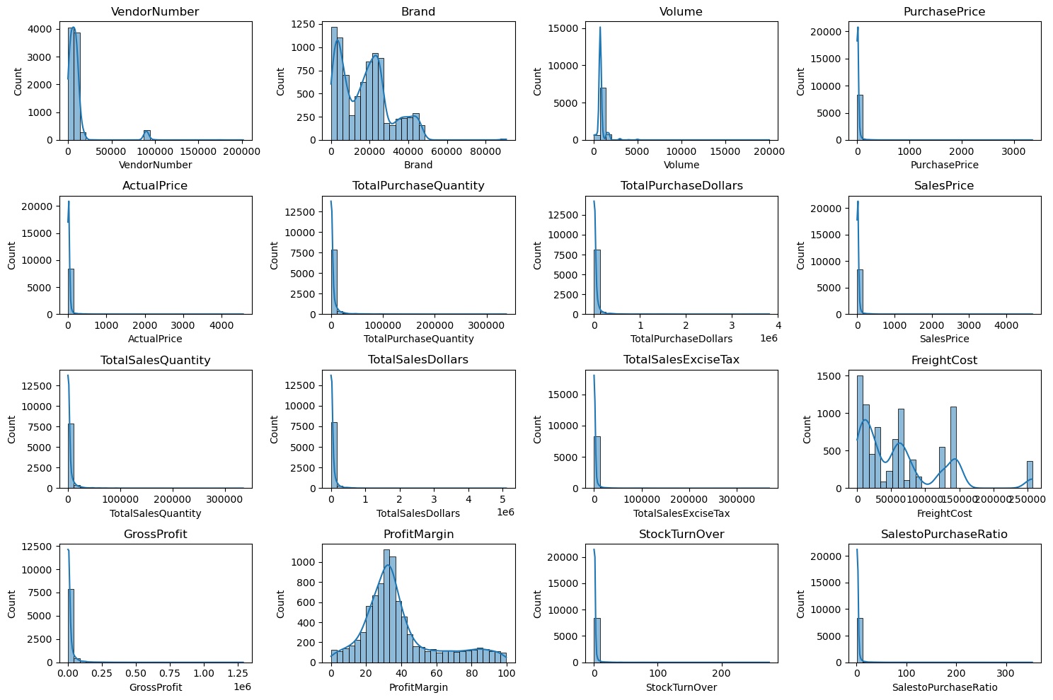
Fig 3: Distribution plots after filtering for valid profitable records

2.4 Categorical Column Distributions
Count plots for VendorName and product Description show the top 10 most frequent entries — confirming the heavy concentration in a small set of vendors and product lines.

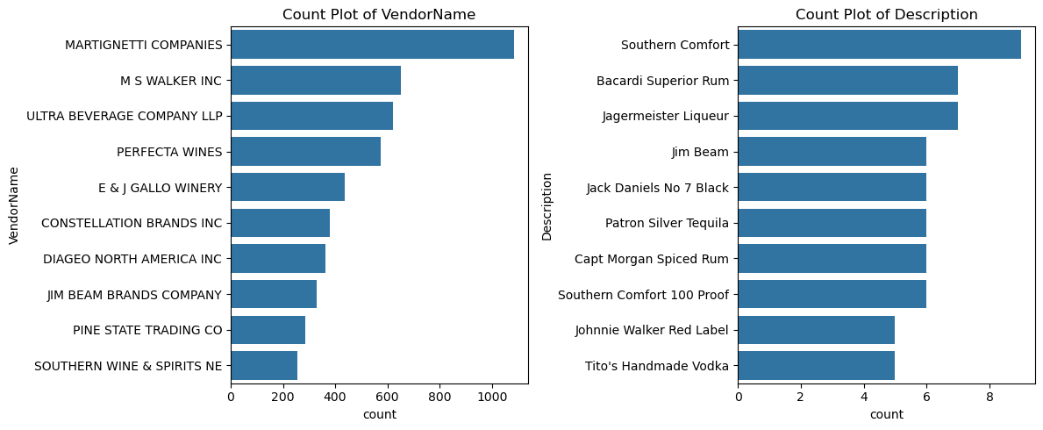
Fig 4: Count plots for top 10 Vendors and Product Descriptions

3. Correlation Analysis

A Pearson correlation heatmap was generated across all numerical columns to identify relationships between purchase activity, sales performance, and profitability metrics.

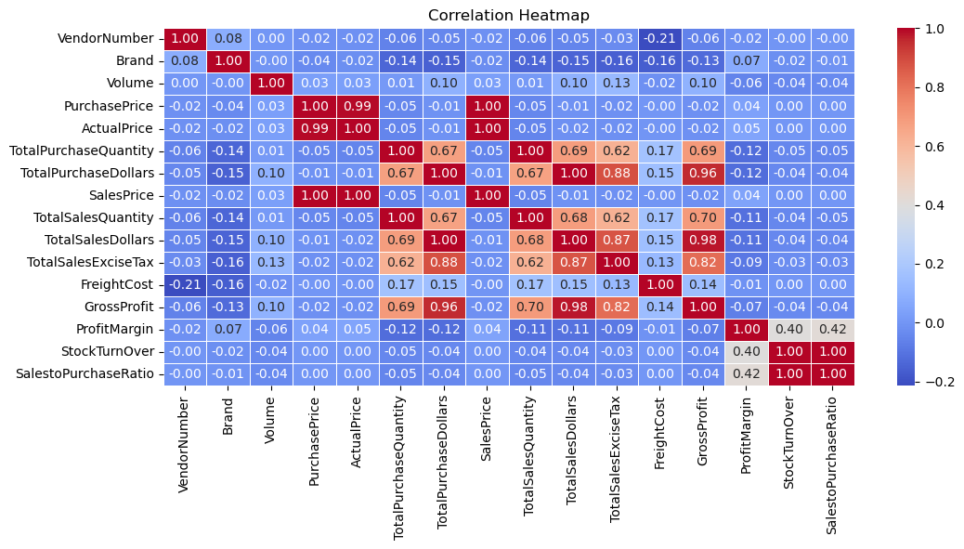
Fig 5: Correlation heatmap — numerical columns

Correlation Insights

- TotalPurchaseQuantity ↔ TotalSalesQuantity: Correlation of 0.999 — confirms highly efficient inventory turnover; almost all purchased stock is being sold
- PurchasePrice ↔ TotalSalesDollars: Weak correlation of −0.012 — price variations do not significantly drive revenue, suggesting volume is the primary revenue lever
- PurchasePrice ↔ GrossProfit: Weak −0.016 — higher-priced products do not automatically yield higher gross profit
- StockTurnover ↔ GrossProfit: Weak negative −0.038 — faster-moving products do not necessarily generate higher profits, indicating margin compression at high velocity
- StockTurnover ↔ ProfitMargin: Weak −0.055 — higher turnover is not correlated with better margins; this challenges the common assumption that faster inventory movement means higher profitability

4. Vendor & Brand Sales Performance

Top 10 vendors and top 10 brands were identified by total sales dollars. These rankings reveal where the majority of revenue is concentrated.

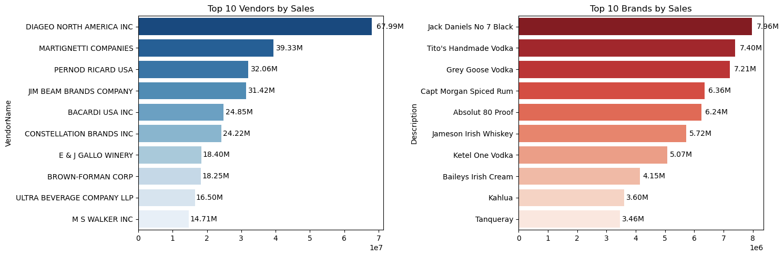
Fig 6: Top 10 Vendors (left) and Top 10 Brands (right) by Total Sales Dollars

4.1 Top 10 Vendors by Sales
Rank | Vendor Name | Total Sales $ | Purchase Contribution
1 | DIAGEO NORTH AMERICA INC | $67.99M | 16.30%
2 | MARTIGNETTI COMPANIES | $39.33M | 8.30%
3 | PERNOD RICARD USA | $32.06M | 7.76%
4 | JIM BEAM BRANDS COMPANY | $31.42M | 7.64%
5 | BACARDI USA INC | $24.85M | 5.67%
6 | CONSTELLATION BRANDS INC | $24.22M | 4.97%
7 | E & J GALLO WINERY | $18.40M | 3.93%
8 | BROWN-FORMAN CORP | $18.25M | 4.31%
9 | ULTRA BEVERAGE COMPANY LLP | $16.50M | 3.63%
10 | M S WALKER INC | $14.71M | 3.18%

4.2 Top 10 Brands by Sales
Rank | Brand / Product | Total Sales $
1 | Jack Daniels No 7 Black | $7.96M
2 | Tito's Handmade Vodka | $7.40M
3 | Grey Goose Vodka | $7.21M
4 | Capt Morgan Spiced Rum | $6.36M
5 | Absolut 80 Proof | $6.24M
6 | Jameson Irish Whiskey | $5.72M
7 | Ketel One Vodka | $5.07M
8 | Baileys Irish Cream | $4.15M
9 | Kahlua | $3.60M
10 | Tanqueray | $3.46M

5. Vendor Purchase Concentration (Pareto Analysis)

A Pareto chart was built to understand procurement concentration. The bars show each vendor's individual purchase contribution %; the red dashed line tracks the cumulative contribution. This reveals how quickly procurement spend concentrates in a few vendors.

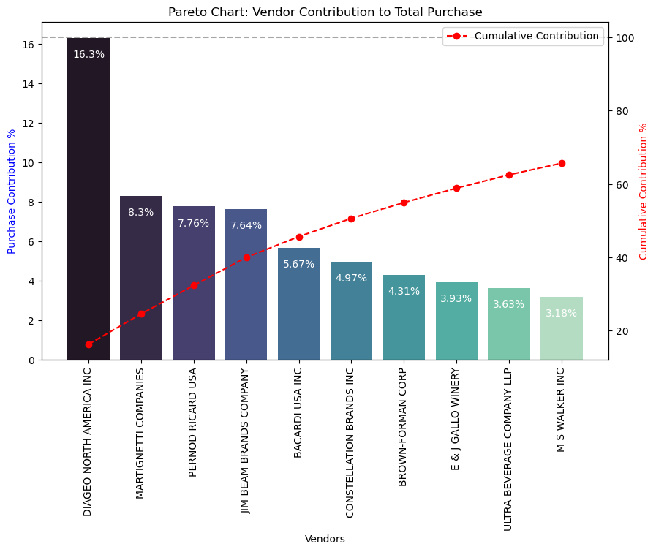
Fig 7: Pareto chart — Vendor Purchase Contribution % with cumulative line

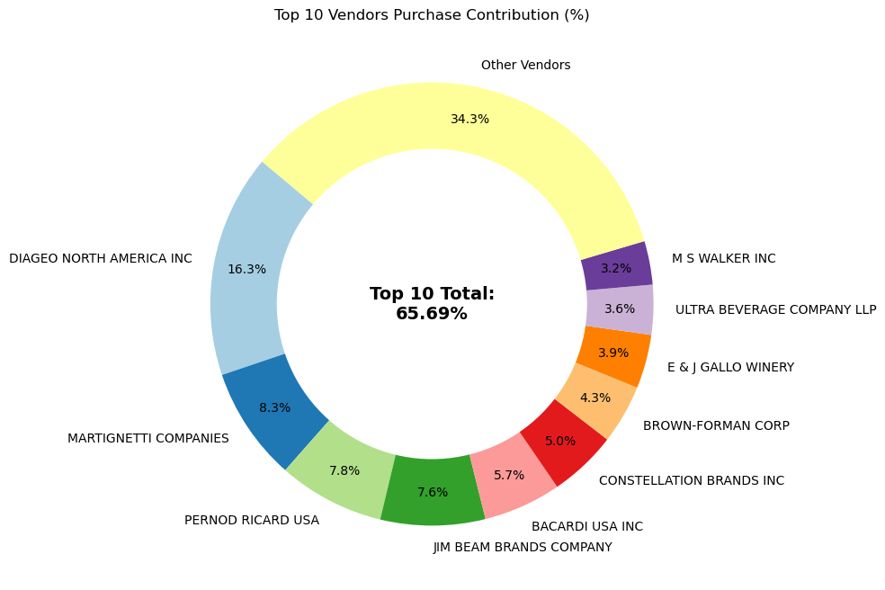
Fig 8: Donut chart — Top 10 vendors vs all others by purchase contribution

Top 10 Vendor Purchase Contribution Table
Vendor Name | Total Purchase $ | Contribution % | Cumulative %
DIAGEO NORTH AMERICA INC | $50.10M | 16.30% | 16.30%
MARTIGNETTI COMPANIES | $25.50M | 8.30% | 24.60%
PERNOD RICARD USA | $23.85M | 7.76% | 32.36%
JIM BEAM BRANDS COMPANY | $23.49M | 7.64% | 40.00%
BACARDI USA INC | $17.43M | 5.67% | 45.67%
CONSTELLATION BRANDS INC | $15.27M | 4.97% | 50.64%
BROWN-FORMAN CORP | $13.24M | 4.31% | 54.95%
E & J GALLO WINERY | $12.07M | 3.93% | 58.88%
ULTRA BEVERAGE COMPANY LLP | $11.17M | 3.63% | 62.51%
M S WALKER INC | $9.76M | 3.18% | 65.69%

Key Finding: Top 10 vendors (out of 119 total) account for 65.69% of all procurement spend

6. Brands Needing Promotional or Pricing Adjustments

Brands were segmented using quantile thresholds to identify the most commercially interesting under-served group: products with low sales volume but high profit margin. These are profitable products that simply lack market exposure.

Thresholds applied:
- Low Sales threshold: ≤ 15th percentile of TotalSalesDollars → ≤ $560.30
- High Margin threshold: ≥ 85th percentile of ProfitMargin → ≥ 64.97%
- Result: 198 brands identified in this quadrant

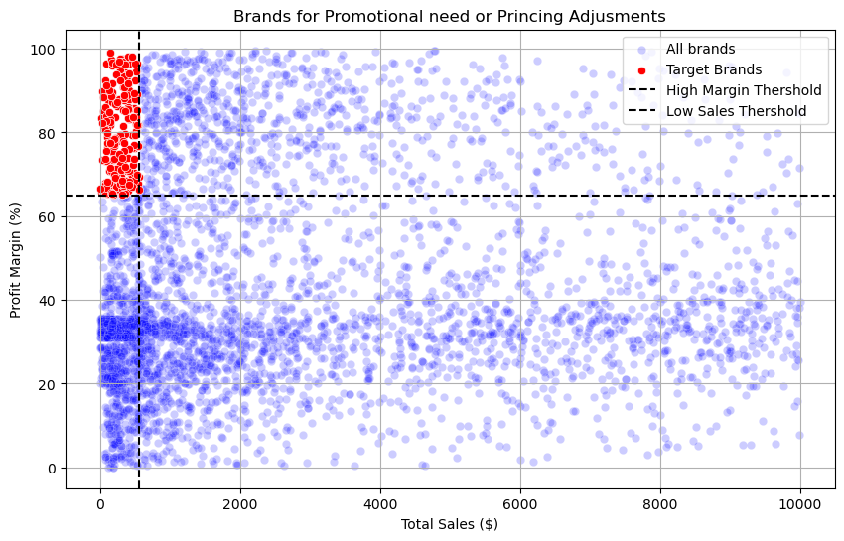
Fig 9: Scatter plot — All brands (blue) vs promotional target brands (red). Threshold lines shown in black dashes.

Sample of Target Brands (Low Sales / High Margin)

Brand Description | Total Sales $ | Profit Margin %
Crown Royal Apple | $27.86 | 89.81%
Concannon Glen Ellen Wh Zin | $15.95 | 83.45%
Sauza Sprklg Wild Berry Marg | $27.96 | 82.15%
Dad's Hat Rye Whiskey | $538.89 | 81.85%
Debauchery Pnt Nr | $11.58 | 65.98%
Nanbu Bijin Southern Beauty | $535.68 | 76.75%
A Bichot Clos Marechaudes | $539.94 | 67.74%
Sbragia Home Ranch Merlot | $549.75 | 66.44%

- 198 brands identified — these need better shelf placement, marketing investment, or promotional bundling
- Despite low volume, margins of 65–90% mean even modest sales uplift creates significant profit impact
- Crown Royal Apple at 89.81% margin is the highest-priority target

7. Bulk Pricing Impact on Unit Cost

Vendors were segmented into Small, Medium, and Large order size categories using quantile-based binning (pd.qcut with q=3 on TotalPurchaseQuantity). The UnitPurchasePrice was then compared across segments to quantify the bulk discount effect.

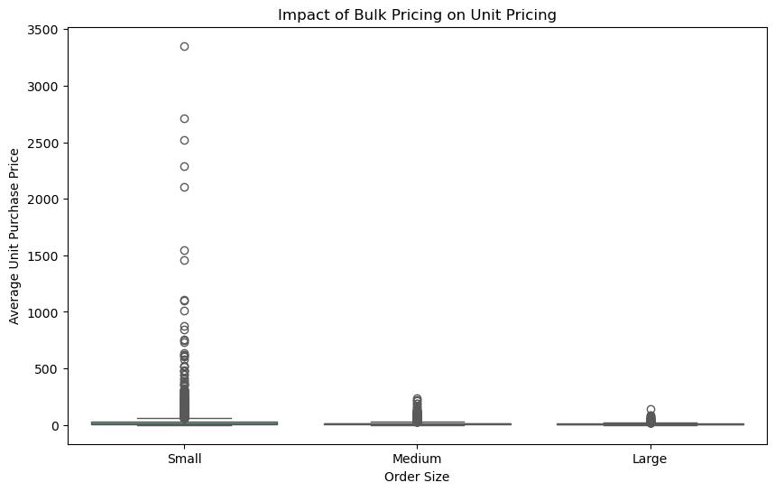
Fig 10: Box plot — Unit Purchase Price by Order Size (Small / Medium / Large)

Average Unit Purchase Price by Order Size

Order Size Segment | Avg. Unit Purchase Price | Price Reduction vs Small
Small | $39.07 | —
Medium | $15.49 | ~60% lower
Large | $10.78 | ~72% lower

- 72% unit cost reduction: Large order vendors pay only $10.78/unit vs $39.07/unit for Small orders — bulk pricing is highly effective
- Volume strategy works: The price differential strongly incentivises vendors to consolidate orders, even at the cost of holding more inventory
- Margin opportunity: Vendors currently in Small or Medium tiers could significantly improve their cost structure by increasing order sizes to unlock Large pricing

8. Unsold Inventory Analysis

Unsold inventory value was calculated for each vendor-brand combination using:
UnsoldInventoryValue = (TotalPurchaseQuantity − TotalSalesQuantity) × PurchasePrice

Total unsold inventory value across all vendors: $2.71M

Top 10 Vendors by Unsold Inventory Value

Rank | Vendor Name | Unsold Inventory Value
1 | DIAGEO NORTH AMERICA INC | $722.21K
2 | JIM BEAM BRANDS COMPANY | $554.67K
3 | PERNOD RICARD USA | $470.63K
4 | WILLIAM GRANT & SONS INC | $401.96K
5 | E & J GALLO WINERY | $228.28K
6 | SAZERAC CO INC | $198.44K
7 | BROWN-FORMAN CORP | $177.73K
8 | CONSTELLATION BRANDS INC | $133.62K
9 | MOET HENNESSY USA INC | $126.48K
10 | REMY COINTREAU USA INC | $118.60K

- DIAGEO leads unsold risk: At $722K, DIAGEO NORTH AMERICA has the highest exposure — review reorder quantities for slow-moving DIAGEO SKUs
- Top 4 vendors: Account for $2.15M of the $2.71M total — concentrated unsold risk mirrors the concentrated procurement risk
- Action needed: Stock-clearance campaigns or vendor buy-back negotiations should be prioritized for these top vendors

9. Statistical Analysis — Confidence Intervals & Hypothesis Testing

9.1 Confidence Intervals for Profit Margins
Vendors were split into two groups based on sales performance quartiles:
- Top-Performing Vendors: TotalSalesDollars ≥ 75th percentile
- Low-Performing Vendors: TotalSalesDollars ≤ 25th percentile
A 95% confidence interval was computed for ProfitMargin in each group using the t-distribution (scipy.stats.t.ppf).

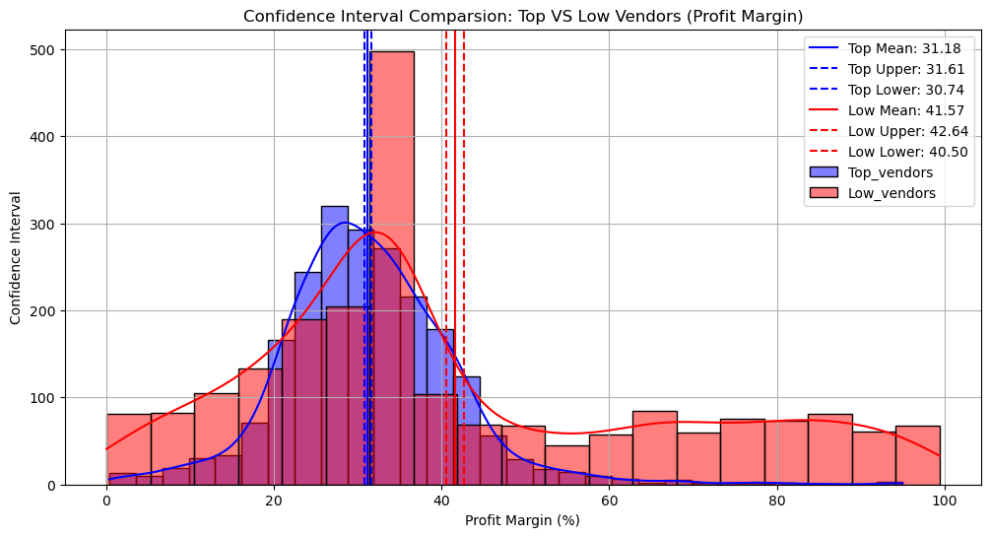
Fig 11: 95% Confidence Interval distributions — Top Vendors (blue) vs Low-Performing Vendors (red)

Segment | Mean Profit Margin | 95% Confidence Interval
Top-Performing Vendors (≥75th pct.) | ~31.2% | 30.74% – 31.61%
Low-Performing Vendors (≤25th pct.) | ~41.6% | 40.48% – 42.62%

9.2 Two-Sample t-Test (Welch's t-Test)
A two-sample independent t-test (Welch's, equal_var=False) was performed to test whether the margin difference is statistically significant.

Hypothesis Test Setup

- H₀ (Null): No significant difference in mean profit margins between top and low-performing vendors
- H₁ (Alternative): A significant difference exists in profit margins between the two groups

Test Result

T-Statistic: -17.6695
P-Value: 0.0000
Conclusion: Reject H₀ — There is a significant difference in profit margins between top and low-performing vendors.

- Counter-intuitive finding: Low-performing vendors (by sales volume) have significantly HIGHER profit margins (40.48%–42.62%) than top-performing vendors (30.74%–31.61%)
- Explanation: High-volume vendors likely compete on price, compressing their margins. Low-volume vendors may sell premium or niche products with less price competition
- Business implication: Top vendors could explore selective price adjustments or cost-optimization strategies to recover 5–10 margin points without significantly impacting volume
- For low performers: Despite higher margins, their low sales volume highlights a need for better marketing, competitive pricing, or improved distribution channels

10. Conclusions & Recommendations

1. Vendor Concentration Risk
- 65.69% of all procurement is concentrated in just 10 out of 119 vendors
- DIAGEO NORTH AMERICA alone drives 16.3% of total procurement spend
- Recommendation: Develop backup vendor relationships; negotiate long-term contracts with top 3 vendors to manage supply risk

2. Volume ≠ Profitability (Statistically Proven)
- t-test result (p=0.0000) confirms low-volume vendors earn significantly higher margins (40–43%) than top-volume vendors (31%)
- Recommendation: Audit pricing strategy for top vendors — targeted price adjustments could recover significant margin dollars at scale

3. Promotional Investment Opportunity
- 198 brands identified with low sales but margins of 65–90%
- Crown Royal Apple (89.81% margin, $27.86 sales) is the highest-priority candidate
- Recommendation: Invest in end-aisle placement, targeted promotions, or digital advertising for these high-margin, low-visibility products

4. Bulk Purchasing Incentive Works
- Large order vendors pay ~72% less per unit ($10.78) vs Small order vendors ($39.07)
- Recommendation: Proactively communicate bulk pricing tiers to Medium-tier vendors to drive order consolidation

5. $2.71M Unsold Inventory Needs Action
- DIAGEO ($722K), JIM BEAM ($555K), and PERNOD RICARD ($471K) carry the highest unsold stock risk
- Recommendation: Run clearance campaigns; renegotiate reorder quantities based on historical sell-through rates

This project demonstrates end-to-end data analytics capability across all stages:
Data Engineering · SQL Modeling · EDA · Statistical Testing · Business Visualization

