

Incentives-Based Design for Onboarding Legal Service Providers for Extending Legal Services to Citizens in India.
Course Code: CSE7101 - Capstone Project, VII Semester (Academic Year 2025-26)
Submission for: Review-2
Batch: CSE_166

Team Members:
Name | Roll Number
YASHAVANTH K S | 20221CSE0363
LANCHAN J | 20221CSE0325
MOHITH GOWDA J P | 20221CSE0328

Under the Supervision of,
Dr.B Chandrashekar
Assistant Professor
School of Computer Science and Engineering
Presidency University

Reviewer
Dr. Saritha K
Professor
School of Information Science and Engineering
Presidency University

Abstract
Access to legal services is challenged in India as a result of lack of transparency, affordability, and difficulty in finding the right professionals available to citizens. This project displays a way to centralize a new type of e-Marketplace that connects citizens to legal service providers that are verified. Legal professionals could include advocates, arbitrators, mediators, notaries, and document writers situated in any city in India. The platform also developed pricing structures for aggregated services that include an incentive program for participation including financial rewards if completed on time, gamified features like badges and leaderboards, discounted platform time for multi-year use and verified services. Providers participate most in an institutional manner through Bar Councils, arbitration boards, and notary authorities. Our system uses an intelligent algorithm that can match all clients with the best legal professional based on case type, area of expertise, and availability. This system is intended to be inclusive, affordable, and available to all citizens, regardless of socio-economic background. This will provide transparency, efficiency, and accountability in the legal profession.

Literature Survey
Building a trustworthy, technology-enabled legal service ecosystem requires understanding how regulation, pedagogy, and digital platforms intersect. Several recent studies illuminate the contours of this landscape.
- Kukrety, Kaushik and Pandey’s 2023 paper in Empirical Economics Letters undertakes a systematic review of blockchain and India’s legal framework for digital assets. Drawing on 43 sources, the authors trace the evolution of distributed ledger technology (DLT) from early cryptographic proposals to present-day cryptocurrency debates. They conclude that India’s fintech momentum necessitates balanced legislation—strong enough to safeguard users and national interests yet flexible enough to foster innovation. Issues such as user protection, AML/KYC compliance, and smart-contract recognition are identified as critical gaps for policymaker.
- Tushaus, Gupta and Kapoor (2015) investigate clinical legal education in India through a nationwide survey of law school legal aid clinics. Published in the Asian Journal of Legal Education, their study shows that clinics simultaneously educate students and expand community access to justice. Yet representation rights and pedagogical credit vary widely, suggesting the need for structured service-learning models, elective credit,,
- and outreach reforms. Their findings underscore that meaningful access is a function not only of law but also of educational infrastructure.
- Balthu, Reid and Clegg (2022) explore the digitalisation of legal service delivery in a EurOMA conference paper. Using a mixed-methods design—a longitudinal case study plus a survey of 250 common-law practitioners—the authors highlight efficiency gains, customer value, and competitiveness when firms adopt workflow automation and AI-enabled knowledge systems. Cultural inertia, perceived risk, and uncertain regulatory guidance remain obstacles, implying that adoption strategies must combine technological and organizational change management.
- Sanchez-Cartas and Leon (2019) provide a broad literature review of multi-sided platforms and markets, synthesising two decades of theory on network effects, pricing asymmetries, and platform governance. Although their work is not limited to law, the indirect network effects and cross-side externalities they describe directly inform the design of legal e-marketplaces, where lawyers and clients represent distinct sides with interdependent participation incentives.
- Islam, Ferdaus, Khan and Habib’s 2018 article, Online Legal Service: The Present and Future, surveys existing digital legal offerings, stressing cost efficiency, transparency, and global reach. They also catalogue persistent hurdles—jurisdictional ambiguity, authentication, and confidentiality—and forecast trends such as AI-driven drafting and blockchain-anchored smart contracts. Their analysis positions user trust and regulatory clarity as prerequisites for mass adoption.
- Upadhyaya, Mohanan and Prasad (2013) empirically examine barriers to adoption of B2B e-marketplaces among Indian MSMEs. Although focused on manufacturing, their findings—trust deficits, cost concerns, infrastructure gaps—mirror the anxieties Indian clients express toward online legal services. They recommend training, vendor vetting, and policy support, lessons equally pertinent to e-legal marketplaces aspiring to mainstream acceptance.
- Collectively, these studies show that effective online legal platforms must couple robust regulatory frameworks (blockchain compliance, user rights) with user-centric design (cost transparency, security, service diversity). Legal education reforms can seed digital literacy and pro-bono outreach, while platform economics research clarifies pricing, incentives, and network growth strategies. Embedding these insights into initiatives like Legal Sahyog Hub promises greater accessibility, trust, and efficiency, aligning with India’s broader push for digital justice and citizen empowerment.

Objectives
- To Onboard and Retain Diverse Legal Professionals: Implement a robust, incentives-based design to attract and retain a wide array of legal service providers, including advocates, arbitrators, mediators, notaries, and document writers, on the platform.
- To Provide a Transparent Marketplace: Develop a transparent platform with a real-time feedback and rating system that allows citizens to evaluate and select legal professionals based on performance and reviews.
- To Enhance Accessibility and User Experience: Design a user-friendly and intuitive interface that simplifies the process of finding legal aid and offers cost-effective, dependable legal options at the user's fingertips.
- To Promote Legal Education and Awareness: Integrate a comprehensive resource center featuring articles, blogs, and podcasts to raise awareness of basic human rights and legal procedures among the general populace.
- To Ensure Secure and Ethical Operations: Implement strong data security protocols and ethical guidelines to safeguard sensitive legal information and ensure the platform operates in compliance with existing and future legal frameworks

Existing Methods and Drawbacks
The existing methods for accessing legal services, both traditional and digital, suffer from several critical drawbacks that our project aims to overcome.
i)Traditional Methods
The conventional approach involves seeking out lawyers in person. This method is often inefficient and prohibitive due to a number of factors.
- Time-Consuming and Expensive: Finding a suitable lawyer requires physical travel and can be costly in terms of both time and money.
- Information Asymmetry: There is a significant information gap, making it difficult to find an experienced lawyer who meets specific requirements.
- Fragmented System: The legal service sector is largely unorganized, with providers operating independently, making it challenging to find a single point of contact for diverse legal needs.
ii) Existing Digital Platforms
While digital platforms exist, they are often rudimentary and fail to address the core issues of trust and quality.
- Limited Functionality: Platforms like "Legal Service India" offer a list of lawyers from various cities, but lack features like a rating system and comprehensive provider profiles to help users make informed decisions.
- Lack of Trust: The absence of authentication and a public review system makes it difficult for users to trust the credibility of listed providers, leading to concerns about fraud and misrepresentation.
- Passive Model: These platforms are largely passive directories. They do not actively incentivize legal professionals to join or improve their service quality, resulting in a low supply of providers relative to demand.
The proposed directly addresses these drawbacks by implementing an active, incentives-based model with robust quality assurance mechanisms and a focus on user trust and education

Proposed Method & Feasibility Study
The proposed system, is an e-marketplace platform designed to be a comprehensive solution for legal service delivery in India. The methodology focuses on a phased, technology-driven approach to ensure its successful implementation and operation.
Proposed Method
- Requirement Analysis: Conduct a thorough analysis by surveying legal service providers, citizens, and administrators to gather detailed requirements for the platform's features and functionality.
- System Architecture Design: Create an advanced system architecture that includes a user-friendly interface, a secure database, and a server-side framework. Data flow diagrams (DFD) and entity-relationship (ER) diagrams will be designed to map the flow of information within the system.
- Incentive System Integration: Develop and integrate an incentive system that rewards legal service providers for their performance. This includes creating a leaderboard and a reputation system based on client ratings and feedback.
- Feasibility Study: A study will be conducted to assess the technical, economic, and operational feasibility of the project. This will include an analysis of the Indian legal services market, evaluation of potential competitors, and a resource-based assessment of technology and cost.

Architecture Diagram & Modules
i) System Architecture
The diagram illustrates the platform's core components:
- User Registration & Profile Setup: The entry point for both users and providers.
- Service Offering Configuration: Where providers detail their services.
- Search & Discovery: The main function for users to find legal services.
- Engagement Request & Provider Acceptance/Rejection: Manages the client-provider interaction workflow.
- Communication & Consultation: The channel for secure client-provider communication.
- Feedback & Ratings: The mechanism for quality assurance and the basis of the incentive system.

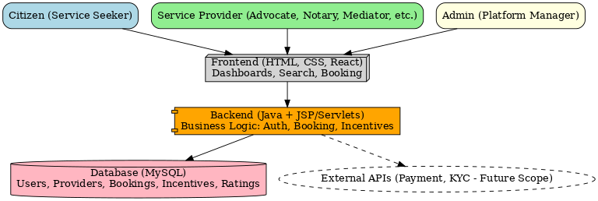

ii)Modules

a)Citizen Module

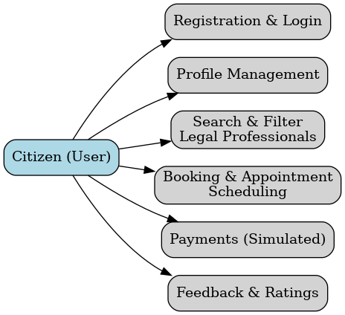

The Citizen Module provides the primary interface for citizens to access legal services. It enables users to:
- Register & Login securely to access the platform.
- Maintain and update their personal profiles.
- Search and filter legal professionals (advocates, notaries, mediators, etc.) based on specialization, location, fees, and ratings.
- Book and schedule appointments with chosen providers.
- Make simulated payments for availing services.
- Provide feedback and ratings to enhance service quality and reliability.
This module is designed for simplicity and user-friendliness, ensuring citizens can easily connect with legal professionals.

b) Service Provider Module
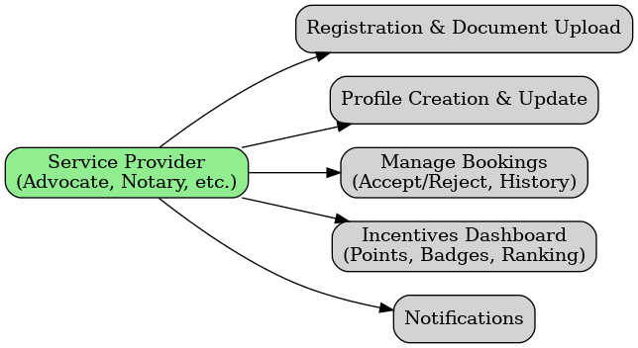
The Service Provider Module is intended for legal professionals such as advocates, arbitrators, notaries, and mediators. It allows them to:
- Complete registration and document upload for verification.
- Create and manage their profiles, including specialization, experience, fees, and availability.
- Manage bookings by accepting, rejecting, or rescheduling citizen requests.
- Access their incentives dashboard, where points, badges, and ranking are displayed.
- Receive notifications and alerts for bookings, feedback, or admin communications.
This module ensures transparency, credibility, and motivation through incentives, thereby encouraging professionals to actively use the platform.

c) Admin Module

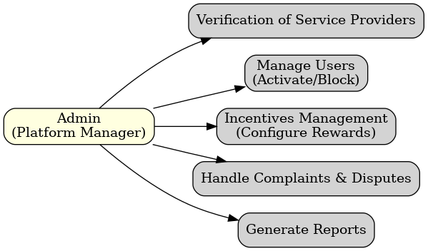
The Admin Module provides oversight and control of the platform. The administrator has the ability to:
- Verify and approve service providers after reviewing documents.
- Manage users (both citizens and providers) by activating, suspending, or blocking accounts.
- Configure and monitor the incentives system to encourage participation and maintain quality.
- Handle complaints and disputes between citizens and providers.
- Generate reports and analytics on bookings, incentives, and platform activity.
This module ensures that the marketplace remains secure, credible, and efficient.

d) Common/Shared Modules
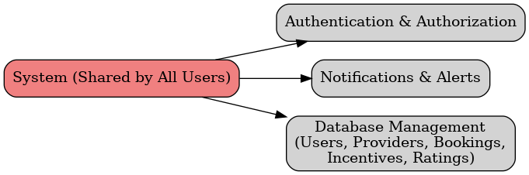
- Authentication & Authorization for secure login and controlled access.
- Notifications and alerts to keep citizens, providers, and admins updated in real time.
- Database management, which securely stores and retrieves all essential data such as user details, provider records, bookings, incentives, and ratings.
These modules act as the backbone of the system, ensuring smooth communication and data consistency across all components.

Hardware and Software Details
Software Requirements | Hardware Requirements
Operating System: Windows 10 | Processor: Intel Core i5 or higher
Backend: Java Spring Boot (v3.x)/JSP | RAM: 8 GB or more
Frontend: HTML,CSS,JS | Storage: 256 GB SSD or higher
Database: MySQL (v8.0+) | Display: 1080p Full HD monitor
Authentication: JWT / Firebase Auth | Network: Stable broadband internet (10 Mbps+)
Web Server: Apache Tomcat 10+ | Peripherals: Keyboard, mouse
Build Tools: Maven / Gradle | Optional: UPS for power backup
Payment Integration: Razor pay

Project Timeline
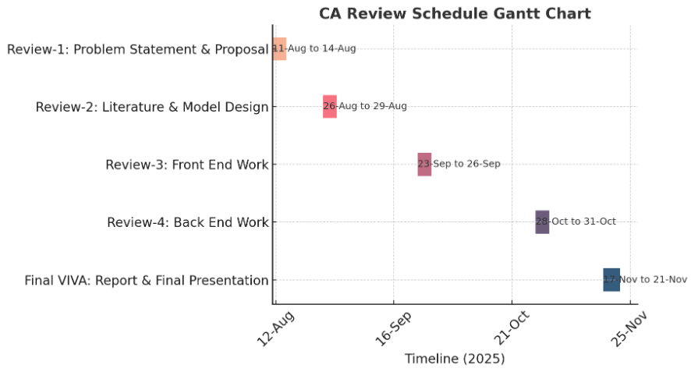

Conclusion
By providing a platform that not only connects citizens with a diverse range of authenticated legal professionals but also fosters accountability through a transparent feedback and rating system, it aims to build public trust and enhance the quality of legal aid. The project's comprehensive approach, which includes an educational component to improve legal literacy, holds the potential to democratize access to justice and contribute to a more informed and equitable society for all Indian citizens.

References:
- Incentives based Design for onboarding Legal Service Providers for Extending Legal Services to Citizens in India by Piyush Karnale, Srishti Chavan, Amulya Chougale, and Ansh Patil .
- Barriers to Adoption of B2B E-marketplaces: An Empirical Study of Indian Manufacturing MSMEs by Pallavi Upadhyaya, Manjunatha Prasad Karantha, and Mohan P. Thayyil .
- India Legal Aid Clinics: Creating Service Learning Research Projects to Study Social Justice by David W. Tushaus, Shailendra Kr. Gupta, and Sumit Kapoor .
- Improving Legal Service Delivery: the approving role of legal technologies by Krishna Chaitanya Balthu, Iain Reid, and Ben Clegg .
- Artificial intelligence (AI) applications for marketing: A literature-based study by Abid Haleem, Mohd Javaid, Mohd Asim Qadri, Ravi Pratap Singh, and Rajiv Suman
- Integrating AI-Based Information Services in Legal Systems: Opportunities and Challenges by Odiljon Nematillaev, Khayitjon Turdiev, Timur Kenjayev, Karamat Kilicheva, I.B. Sapaev, Xosiyatposhsho Axmadaliyeva, Jaloliddin Yusubov, and Umid Menglikulovs .
- Blockchain Technology and Legal Framework in India: A Systematic Review by Neha Kukrety, Pitresh Kaushik, and Shashank Shekhar Pandey .
- Legal Sahyog Hub: An Incentives Based Design For Onboarding Legal Service Providers On E-Market Place For Extending Legal Services To Citizens In India by Dr. Yakuta Tayyebi, Anuj Banke, Anshita Balodiya, Gourav choudhary, and Ananya Dey .
- Multi-sided Platforms and Markets: A Literature Review by Juan Manuel Sánchez-Cartas and Gonzalo León.
- Online Legal Service: The Present and Future by Md Aminur Islam, Jannatul Ferdaus, Md. Abbas Ali Khan, and Md. Tarek Habib .

