**EXP NO:** **3**

**Servlet Program to Display 'Hello, World!' in Browser**

**AIM:**

To write a servlet program that prints **"HelloWorld!"** and displays it in the browser when accessed.

**CODE:**

package com.karthick.servlet;

import java.io.IOException;

import java.io.PrintWriter;

import javax.servlet.ServletException;

import javax.servlet.annotation.WebServlet;

import javax.servlet.http.HttpServlet;

import javax.servlet.http.HttpServletRequest;

import javax.servlet.http.HttpServletResponse;

/**

 * Servlet implementation class HelloWorld

 */

@WebServlet("/HelloWorld")

public class HelloWorld extends HttpServlet {

    private static final long serialVersionUID = 1L;

    /**

     * @see HttpServlet#HttpServlet()

     */

    public HelloWorld() {

        super();

        // TODO Auto-generated constructor stub

    }

    /**

     * @see HttpServlet#doGet(HttpServletRequest request, HttpServletResponse response)

     */

    protected void doGet(HttpServletRequest request, HttpServletResponse response) throws ServletException, IOException {

        PrintWriter p = response.getWriter();

        p.println("Hello World!!!");

    }

    /**

     * @see HttpServlet#doPost(HttpServletRequest request, HttpServletResponse response)

     */

    protected void doPost(HttpServletRequest request, HttpServletResponse response) throws ServletException, IOException {

        // TODO Auto-generated method stub

        doGet(request, response);

    }

}

**OUTPUT:**

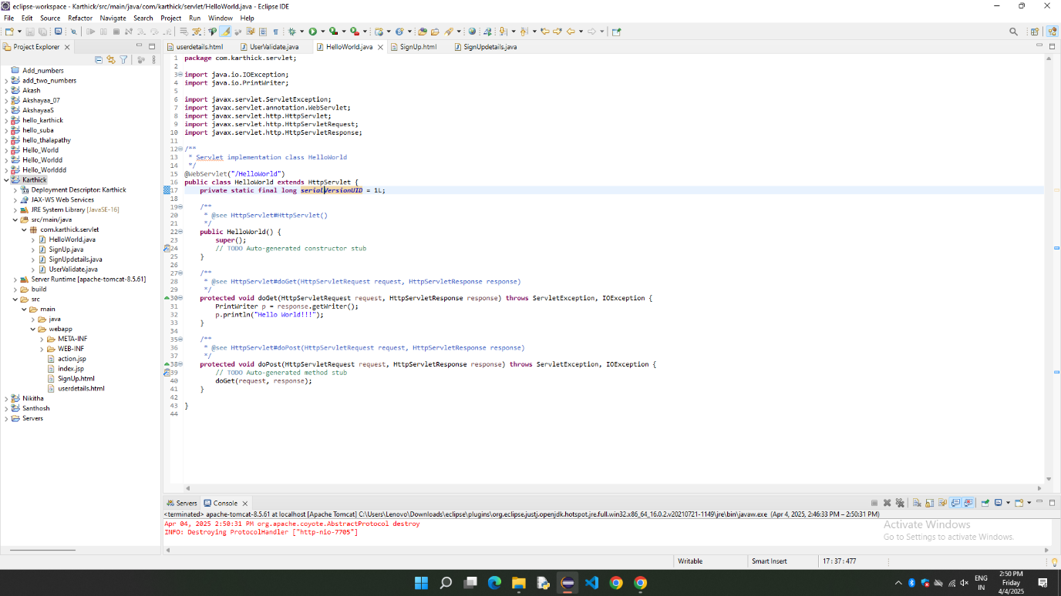

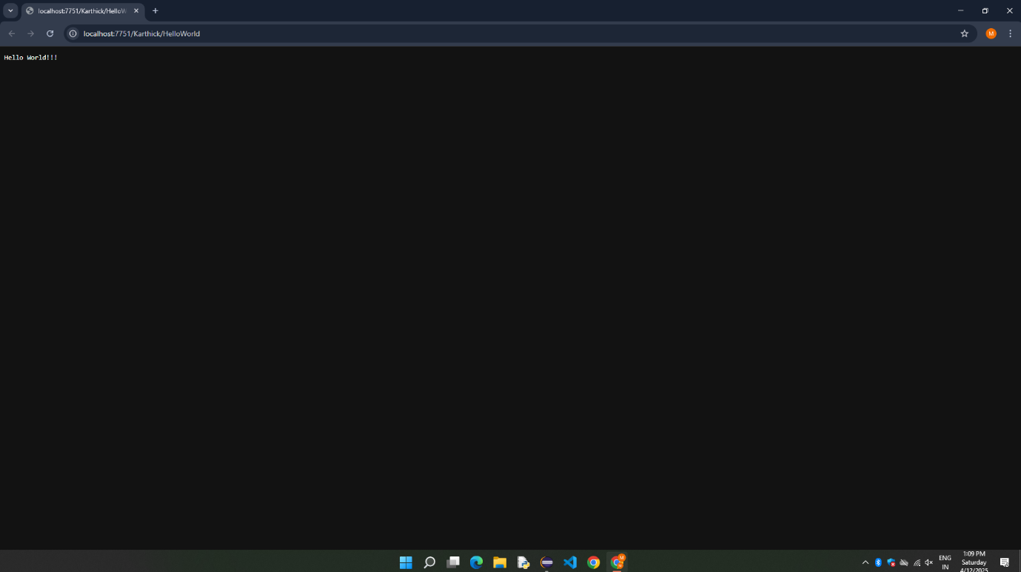

**RESULT:**

Thus, the Servlet Program to print/display Hello World in the web browser is successfully Implemented.