**EXP NO:** **5**

**Servlet Example Demonstrating HTTP GET vs POST Methods with Form Handling**

**AIM:**

Write a Servlet to demonstrate the difference between HTTP GET and POST methods by creating a form and handling requests accordingly.

**CODE:**

**SignUp.html**

<!DOCTYPE html>

<html>

<head>

<meta charset="ISO-8859-1">

<title>Sign_up</title>

</head>

<body>

<form action="./SignUpdetails" method="post">

    <label for="fname">FirstName:</label>

    <input type="text" name="fname" placeholder="Enter Your First Name"><br><br>

    <label for="lname">LastName:</label>

    <input type="text" name="lname" placeholder="Enter Your First Name"><br><br>

    <label for="age">Age:</label>

    <input type="number" name="age" placeholder="Enter Your Age"><br><br>

    <label for="date">Date Of Birth:</label>

    <input type="date" name="datee"><br><br>

    <label for="gender">Male</label>

    <input type="radio" name="gender"><br><br>

    <label for="gender">Female</label>

    <input type="radio" name="gender"><br><br>

    <label for="address">Address:</label>

    <textarea  name="address" ></textarea>

    <input type="submit" value="Sign-Up">

</form>

</body>

</html>

**SignupDetails.java**

package com.karthick.servlet;

import java.io.IOException;

import java.io.PrintWriter;

import javax.servlet.ServletException;

import javax.servlet.annotation.WebServlet;

import javax.servlet.http.HttpServlet;

import javax.servlet.http.HttpServletRequest;

import javax.servlet.http.HttpServletResponse;

/**

 * Servlet implementation class SignUpdetails

 */

@WebServlet("/SignUpdetails")

public class SignUpdetails extends HttpServlet {

    private static final long serialVersionUID = 1L;

    /**

     * @see HttpServlet#HttpServlet()

     */

    public SignUpdetails() {

        super();

        // TODO Auto-generated constructor stub

    }

    protected void doPost(HttpServletRequest request, HttpServletResponse response) throws ServletException, IOException {

        String firstname=request.getParameter("fname");

        String lastname=request.getParameter("lname");

        int age=Integer.parseInt(request.getParameter("age"));

        String date=request.getParameter("date");

        String gender=request.getParameter("gender");

        String address=request.getParameter("address");

       PrintWriter p = response.getWriter();

       p.println("FirstName :"+firstname);

       p.println("LastName :"+lastname);

       p.println("Age  :"+age);

       p.println("Date Of Birth :"+date);

       p.println("Gender :"+gender);

       p.println("Address :"+address);

    }

}

**OUTPUT:**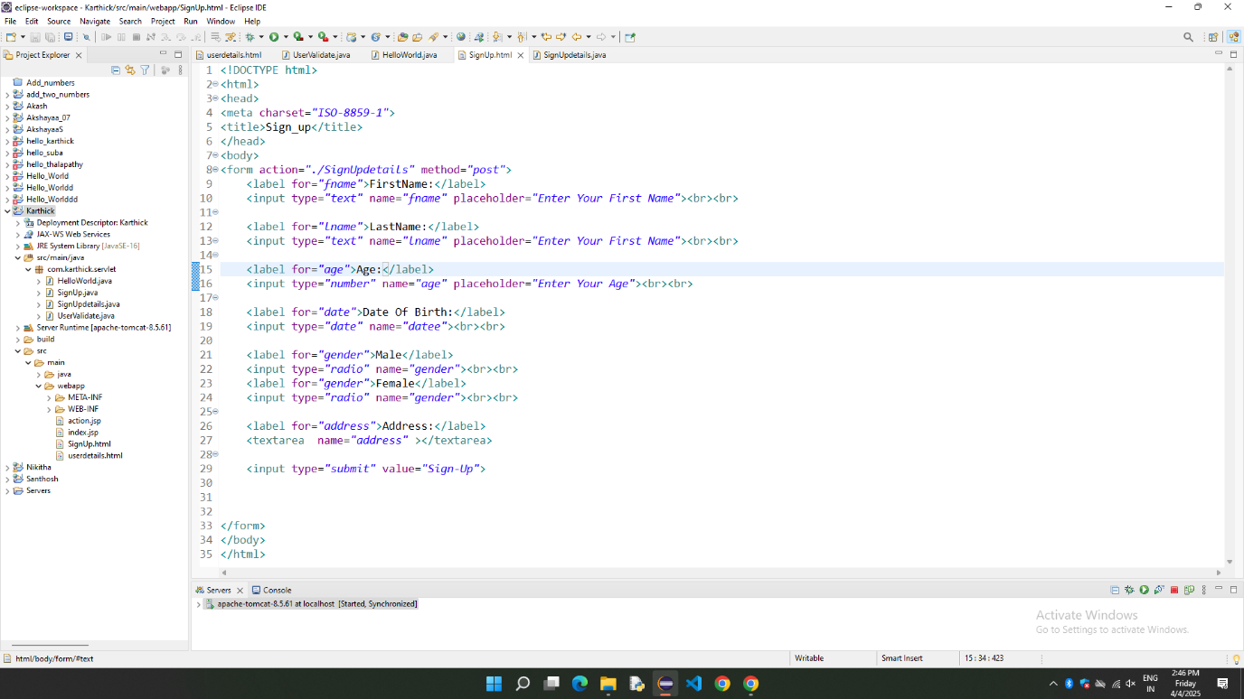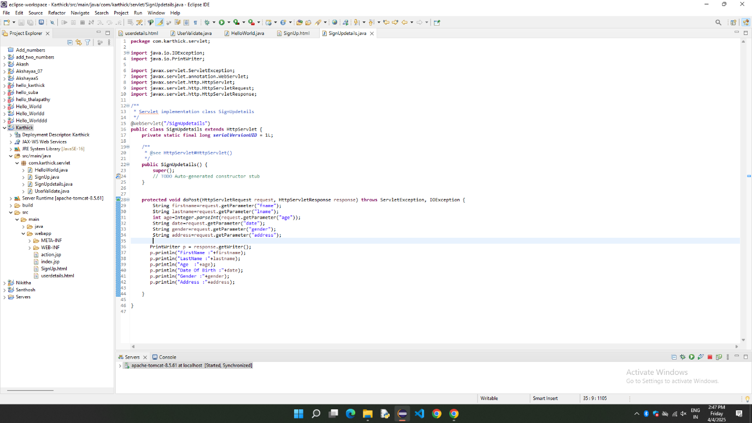



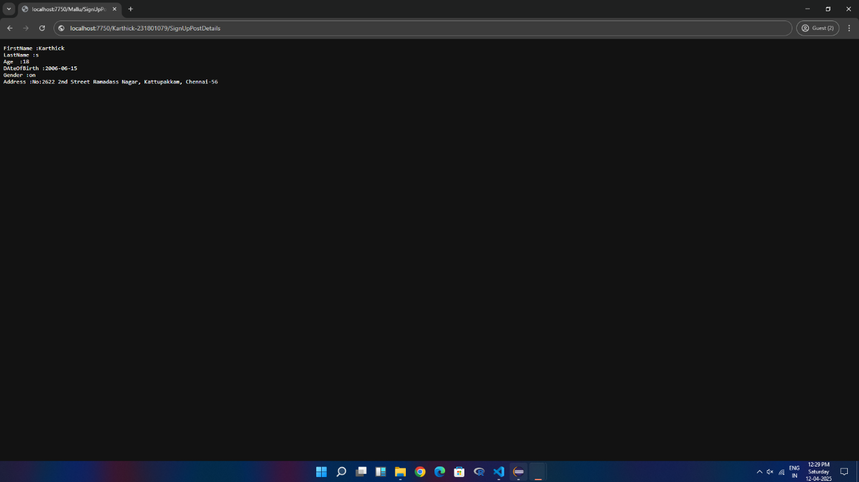

RESULT:

Thus, the difference between HTTP GET and POST Method is Successful demonstrated by creating a form and handling requests.