Name : Mohith Reddy

Batch no. : 123(9 AM)

Mobile no. : 8096411678

Email Address : [mohithmullangi@gmail.com](mailto:mohithmullangi@gmail.com)

TERRAFORM SCRIPT

Terraform.tf :

terraform {

  required_providers {

    aws = {

      source = "hashicorp/aws"

      version = "5.53.0"

    }

  }

}

Provider.tf :

provider "aws" {

profile = "default"

region = "ap-southeast-1"

}

Resource.tf :

resource "aws_vpc" "sai" {

  cidr_block = "10.0.0.0/16"

}

resource "aws_subnet" "sai1" {

  vpc_id     = aws_vpc.sai.id

  cidr_block = "10.0.1.0/24"

}

resource "aws_subnet" "sai2" {

  vpc_id     = aws_vpc.sai.id

  cidr_block = "10.0.2.0/24"

}

resource "aws_internet_gateway" "gw" {

  vpc_id = aws_vpc.sai.id

}

resource "aws_route_table" "routetable" {

  vpc_id = aws_vpc.sai.id

  route {

    cidr_block = "0.0.0.0/0"

    gateway_id = aws_internet_gateway.gw.id

  }

}

resource "aws_vpc" "mohith" {

  cidr_block = "120.0.0.0/16"

}

resource "aws_subnet" "mohith1" {

  vpc_id     = aws_vpc.mohith.id

  cidr_block = "120.0.1.0/24"

}

resource "aws_subnet" "mohith2" {

  vpc_id     = aws_vpc.mohith.id

  cidr_block = "120.0.2.0/24"

}

resource "aws_internet_gateway" "gw2" {

  vpc_id = aws_vpc.mohith.id

}

resource "aws_route_table" "routetable22" {

  vpc_id = aws_vpc.mohith.id

  route {

    cidr_block = "0.0.0.0/0"

    gateway_id = aws_internet_gateway.gw2.id

  }

}

* Executing the command – terraform init :

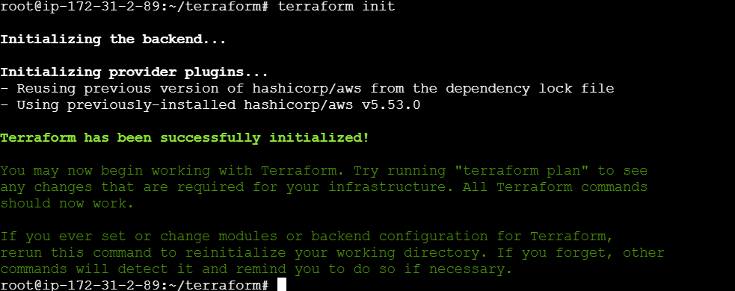

* Executing the command – terraform validate :



* Executing the command – terraform plan :

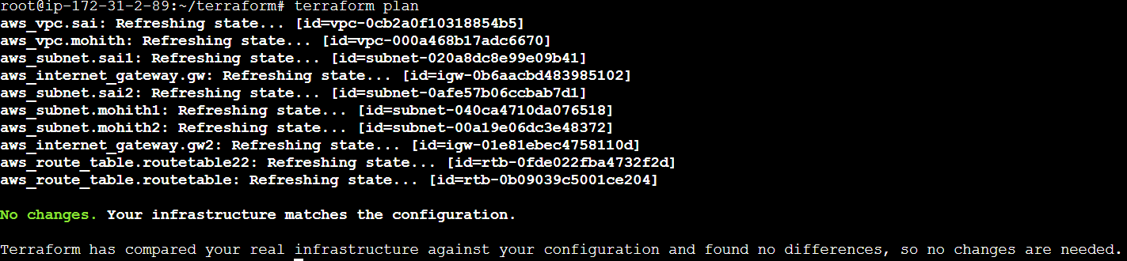

* Now apply this by using the command – terraform apply :

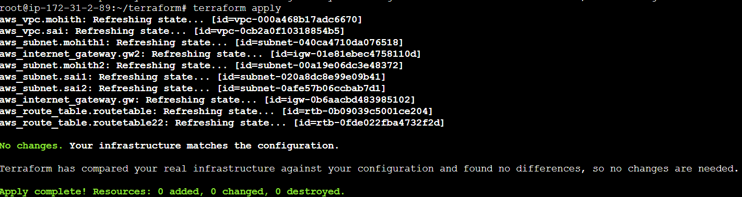

VPC Peering : Add the below code to the existing resource code and follow the same process to create a VPC peering connection.

Resource.tf :

resource "aws_vpc_peering_connection" "sai" {

  peer_vpc_id   = aws_vpc.mohith.id

  vpc_id        = aws_vpc.sai.id

}

Execution :

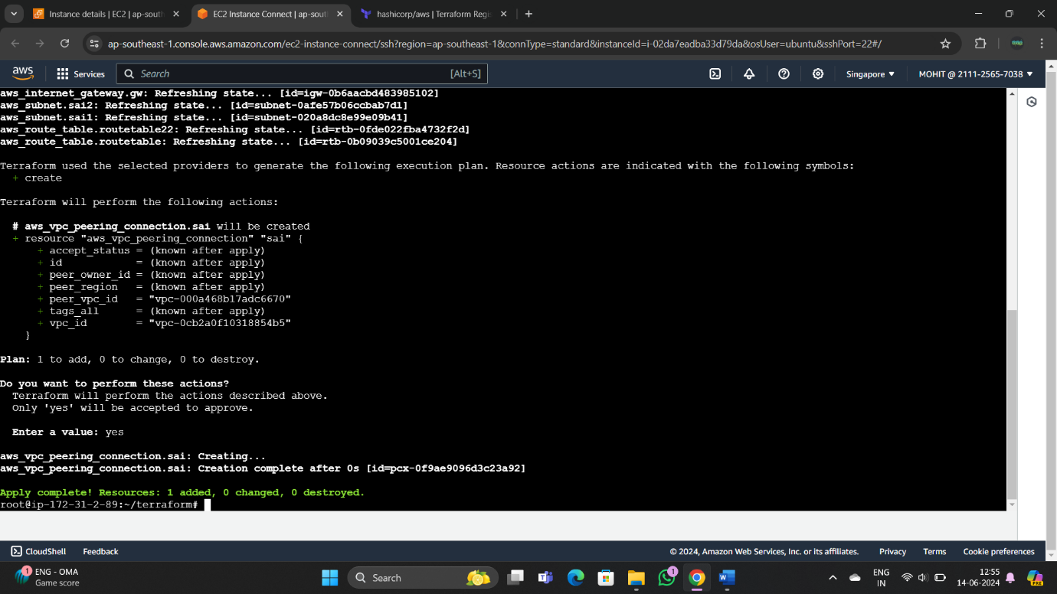

* Hence , the VPC , Subnets , Route tables , and Internet Gateway is created successfully using terraform and also VPC peering connection is also created.

Here is the graphical presentation of the work done :

