Control Flow of the Project Module financialyearinfo
22.03.2017
The control flow of the project module in Enlighten Software Service pvt ltd followed
is as follows
Before going to the control flow let us look at the structure and indentation of the module
Inside P10251accounts there is a file of the module
–> financialyearinfo
1->en
2->logics
3->scripts
1->en :
->financialyear.jsp : contains the entry file for which user has access to and links to the file
financialyear.inc, all the code of declaring tables are not done directly here itself this is
done because errors occurred cant be identified in a mixture of data

->financialyear.inc : contains the declaration of tables with tr and td and all the structure
of the table

->help.jsp : contains all the information regarding the contents to the module differs with
every module and is not similar

->help.inc : contains the structure of the help part

->module.css :all the style,border and alignment etc
Note:all the files here are mandatory
2->logics:

FinancialyearinfoBL.java:It contains all the files of business logic, has the
state ie instance variables and behaviours ie methods
ex of instance variables like kModuleId and behaviour like executeTask()
3->scripts:
1. constants.js :contains all the javascript constants Ex:kInitData

2. main.js : methods of onload(),init() and filling()

3. module.js : used for initialization here the objects needed are initialized however
the objects are predefined in the Enlighten Software service pvt ltd framework

4.msgsen.js : these are the messages to be shown to user ex:”are you sure”

5.params.js : these contains the methods which returns the parameter

6.tstatus.js : these returns the status

7. uievents : consists of all the events except onload

8.uibuilder.js : to display the dynamic web content ex:when we select a option in
dropdown(Company Unit) and hit a search button dynamically a table gets upon where
number of manupulations can be done,ex:showFYearList_102510301()
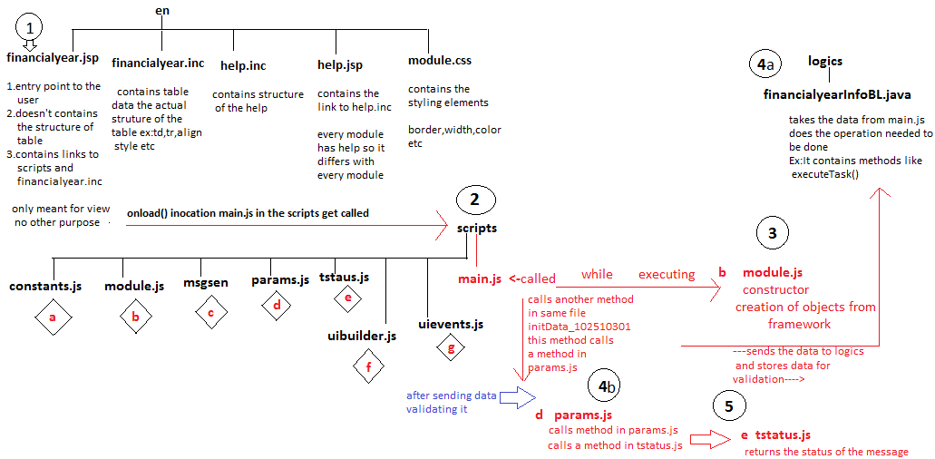
Schematic Representation Fig 1.1
Points to remember
    - Every Module contains the selecting Company Unit so create once and reuse it
instead of duplication

    - There are javascript objects to be used which are predefined in the company
framework the usage should be fulfilled whenever needed

    - All the method must has its project code as well as version number Ex:onload_102510301() ,102:project code,51:version,03:module group,01:task id

    - The constants are predefined and used for the disciplinary approach

------------------------ ******* -----------------------------------

Control Flow …. continued
23.03.2017

So far we have seen the flow from jsp,main,params,module,financialyearinfoBL,tstatus we will
now see the flow from uibuilder to uievents and displaying the message to user if he/she makes
invalid selections below shows the representation of the control flow
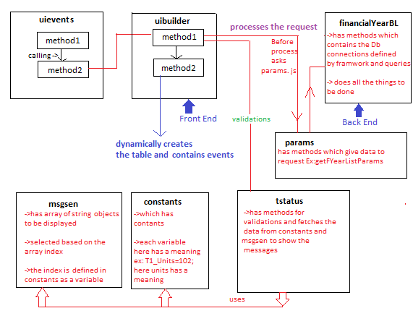
Schematic Representation Fig 1.2
When the user makes a drop down selection and hits search, the operations that are happening
behind are method1 in uievents ie method unitChanged_102510301 calls other method in same file
searchImgClicked_ 102510301 this method again calls method1 in uibuilder ie showFYearList method
before building table the validation staus needs to be done to check for valid request passed so this
method makes a validation call to tstatus if it succeeds then it goes for creating the table
dynamically ie method2 in uibuilder which has BuiltFYearListUI which creates the table dynamically
if it fails then the message from the msgen is accessed and shown to user

Note:the method showFYearList method however can either be declared in main or uibuilder
but the BuiltFYearListUI has to be in uibuilder
Points to Remember
- establishing the connection to db is done just by creating object from the framework
there is no need to send the url,uid,pwd
- kCR:Client row and kSR:Server row
- if any invalid input passed the validation is done and appropriate message is sent
to user by accessing the variables in the msgsen however indexes are stored not in ints
rather than variable to eliminate ambiguity
------------------------ ******* ----------------------------------

Control Flow - ClientRequest
28.03.2017

In FinancialYearinfo Whenever the user enters the details like start,end date and the
isCurrentDate the background happening things are as follows
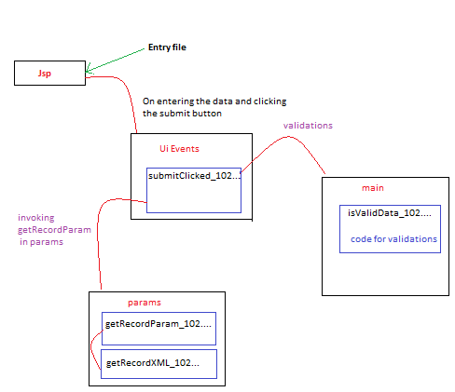
the user enters the info and hits submit button in

Schematic Representation Fig 1.3 :Control Flow
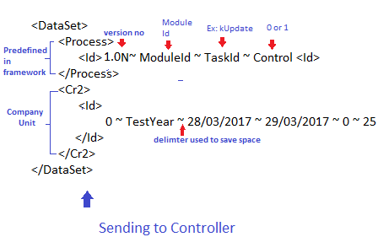
Schematic Representation Fig 1.4 :Client Request- XML

In the Fig 1.3 it shows when the user enters the details in financialyear info and hits
submit button the submitClicked_102510301() method gets picked up and starts up
the execution and for validation of inputs it is send for the method in the main and soon
after that before processing the request the call is made to getRecordParam_102510301()
which in turn calls method getRecordXML_102510301()
In the Fig 1.4 it shows the client request being made up the
the structure is shown in above figure all the elements such as <DataSet>,<Process>,<Id>
and <Cr2> are previously customized accordingly

Inside the Id there are four elements namely

- Version:It represents the version being used
- Module Id:This represents the module id
- Task Id :It is the task Id for ex:kUpdate which has value 10251030105
- Control :It is the control either 0 or 1

Inside the Cr2 there are six elements namely

- Id:it is a number if this is new the value would be 0 and future processing is to be made
based on the value ie equals to zero has a operation in database to be made,greater
than zero a certain operations is to be made,it is unique and is not same.
- Year Name:it represents the financial year name based upon the corresponding values
- startdate:it represents the startdate
- enddate:it represents the enddate
- current-year status:It represents the staus of current-year whether 0 or 1
- unit-Id:It represents the unitId that is company unit number

After all the validation happens and the submitClicked calls method afterSubmitClicked which
then calls the method in ui builder to built the tables

Points to Remember
- Note In <Cr2> we are specifying the exact details we want if we want to access all
the details of the companies we could eliminate the <Cr2> resulting in giving all
the company details

- The “ ~ “ is the delimiter which is used to save memory constraints

- The details of xml is sent to the controller for further processing

Note:The getProcessXml method is used in almost every method so which makes it
compulsory ,constants are stored in the constants file and the messages
to be displayed for user for invalid inputs or any other messages are stored in msgsen
file in an array .

----------------------- ********************** -------------------------

Inside Logics File
30.03.2017
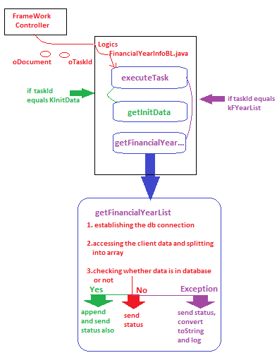
Schematic Representation Figure 1.5 :In FinancialYearInfoBL.java
The controller passes the taskid and odocument to the logic where the taskId is matched with
various elements like kInitData,kFYearList,kUpdate,kDelete based on the values matched
the method gets picked up and executed if the taskId matches with the kFyearList then the
method getFinancialYearList gets executed where connection to the database is done
along with which client row data is splitted into a array and checked whether data is there
or not if the data is present then the data is sent using toXMLString method
and status is sent using getStatusXML where these two methods are defined in
resource file

toXMLString:accepts two parameters
1:ResultSet
2:server row

getStatusXML:accepts three parameters
1:FinancialYear
2:status code: 1-->successful ,-1-->Unsuccessful
3:message whether financialyearList successful or not

the result in xml is stored as
<Result>
<Status>
<Id>
statusID ~ statuscode ~ taskid : message
</Id>
</Status>
<sr1>
<Id>
Id ~ YearName ~ starting date ~ ending date ~ current-year ~ unitID
<Id>
</sr1>
</Result>

in status
in the id the first element is statusId which is an integer for ex: T5_Process=501
second element is the statuscode which is either 1 or -1 indicating the success or
failure followed by a message which is successful or not
in server row
in the id first element is the Id which is an integer followed by the yearname
which is financialyear name and third and fourth is starting and ending dates
and the fifth element is the current-year which indicates whether or not it is
a current year and last element is the company unit id which corresponds to
company number
Points to Remember
- the splitting of the “~” in the string arrays occurs inside the method getParams which
accepts the taskId as a parameter

- the taskId in the status is for developers convenience in order to track the problem
which he/she gets stuck in some issues

-------------------------- ************************ -----------------------------
Tstatus messages
31.03.2017
While validating the information sent by the user, In tstatus the xml is put
into the variable which has the elements like id ,status code and message.
It is validated whether or not it is having contents in it or not if it doesn’t contain
anything it returns false if it has then control comes inside and each of the
values are extracted ie a one variable contain the statusId and another variable
contain messages ,A variable is validated if it is -1 or not ,if it it is -1 it goes
inside and shows the message where it has gone wrong by accessing the messages
from msgsen note:this allows the developer to track down the problem easily where the
problem is coming from , After all the validations succeeds the control goes to building the table
while the table it takes the taskId and puts it into the variable and is checked whether or
not it is empty if not control comes inside and the creation of the table is done
by getting the header row data and needed data
Points to Remember
- the UDModule.GK_DTA_SEP has token “~”. In building the table we use the
method getXMLIndexValue to split all the data
- the UDModule.GkSR_Status has the status

Dynamically Building table
05.04.2017

- The building of the table occurs after the click of the search image

- The method for building the table has various other methods which is responsible
for building the various parts of the table

- For example to get the header of the table there is a method known as
getHeaderRow which has the a predefined set of values to build the
header of the table

- getHeaderRow has 8 columns serial number,info,financialYear,startDate,EndDate,edit
delete and autoId all these values are accessed from the messages file

- There is another condition which has the permission to edit and delete the details
for ex:developer has the authority to edit and not to delete whereas the admin
has the permission for both

- after building the header row we need to build the remaining rows that is datarows
for that we need to iterate over database ,fetch it and display for that we have a
method known as getDataRow.

- getDataRow is the method which accepts the argument as the integer indicating
the row ,it calls various others methods(helping methods)to build the particular column the
helping methods are getIndexCell:which increments the number accepted,getInfoCell:which
returns the information like createdBy,created date,modifiedby,modifiedDate,modifiedTime
create time, getFYearCell:returns the financial year by accesing in the messages
getStartDateCell:returns the startDate, getEndDateCell:which returns the end date
getEditCell:which has the value as edit and is static which is same for all the cases
getDeleteCell:which has the events being called which deletes the corresponding
cell or row,getAutoIdCell:which returns the yearId

Points to Remember
          - The building of table is done either when of two condtions occur
1:Whenever search image is clicked
2:after submit button is clicked
note: replaceDynamicHtml and getNoDataPresent are methods in resource file

------------------- ************************* ----------------------------

