Model View Controller

1->Model View Controller is a design pattern to solve a recurring problem that is separation of
concerns which isolates the presentation layer,control layer and data logic layer. It includes
the advantage of parallel development process and segregation of layer which makes the
application elegant where each of the layer performs its particular job. The schematic representation
is given below Fig 1.0
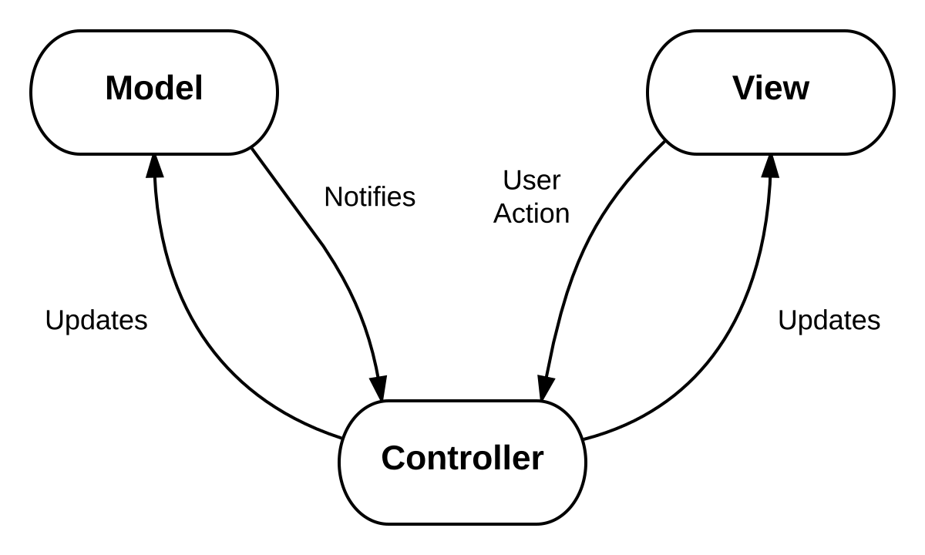Illustration 1: Figure 1.0:Model View Controller Architectural Pattern
2->Model View Controller contains 3 parts
- Model
- View
- Controller

3.View:It is responsible for presenting the User Interface,It may be HTML,JSP's etc. It takes
the input and serves it to the controller,the validations may be done either at the view itself using
java script or in controller,View is responsible for what user views.

Controller:It is responsible for the taking the input from view and maps it to particular model
which is needed based on the input given in the view,Controller is built using the servelet
In controller validations are done. The job of the controller is to act as intermediate between
the view and the controller no other code must be done in controller related to business logic.

Model:Model is responsible for the actual business logic,The model is POJO's(Plain Old Java
-Objects),The POJO's are which state are marked as private and exposed with necessary setters and
getters and contains its business logic. Model is an intermediate between controller and database
it communicates with the database,multiple model can contain multiple views.

Advantages of Model View Controller

- Separation of concerns allows the advantage of re-usability

- Ability to provide multiple views and modification doesn’t affect the whole system

- Includes Parallel development process which makes the development faster

