Flash Sale Prototype Test Evidence
This document records a local 500-unit checkout test, duplicate protection and worker recovery. Each screenshot comes from the live application or an explicitly labelled viewer of actual saved output.
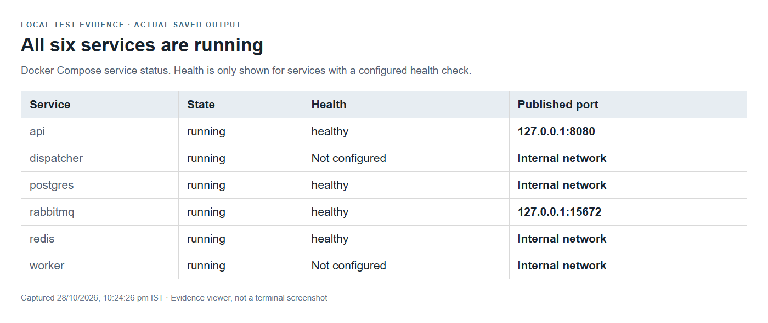

Fresh Sale Before Testing
The isolated demo was reset before the concurrency test. The product page showed all 500 reservation tokens available; no purchase was made in the browser before the test.
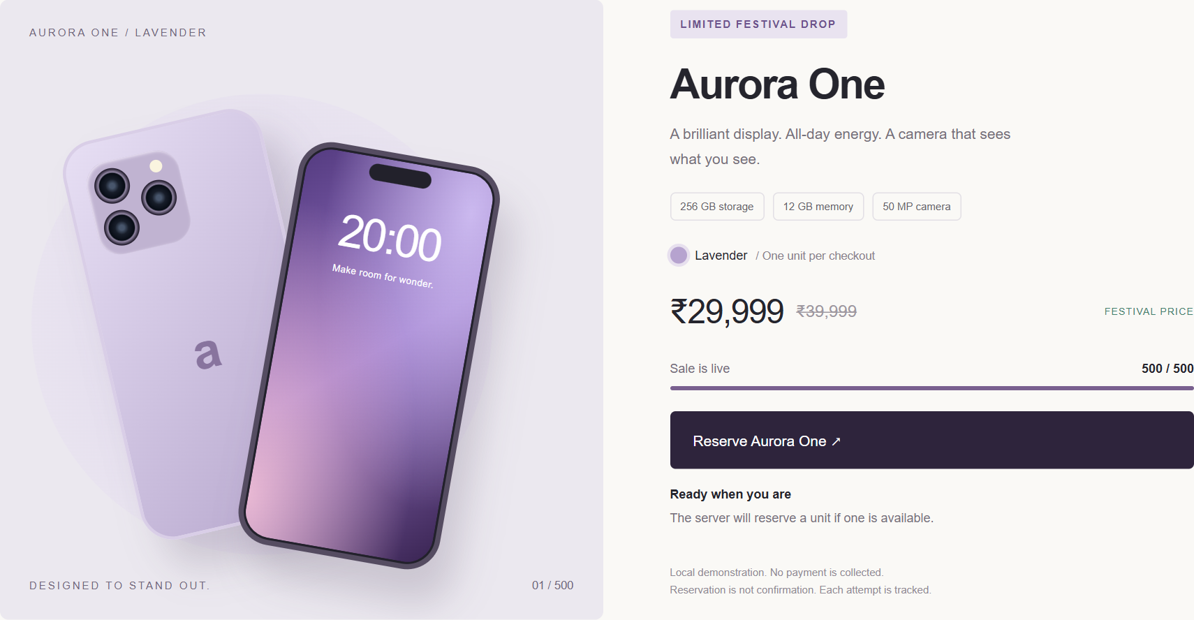
Figure 2. Initial storefront availability. The accompanying fresh-metrics JSON records zero confirmed orders and zero pending attempts.

Concurrent Checkout Results
The test sent 1,000 independent purchase attempts at concurrency 50. It recorded 500 accepted requests, 500 unavailable responses and 0 unexpected errors. Admission latency is distinct from order completion time.
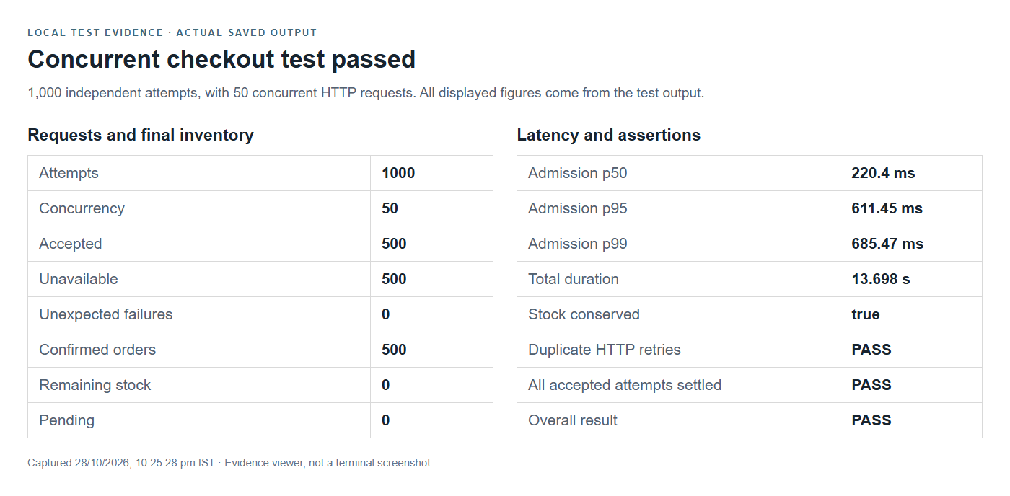

Completed Sale and Inventory Conservation
After workers settled, PostgreSQL contained 500 confirmed orders, with 0 units remaining and 0 attempts pending. The storefront observer panel was refreshed after settlement.
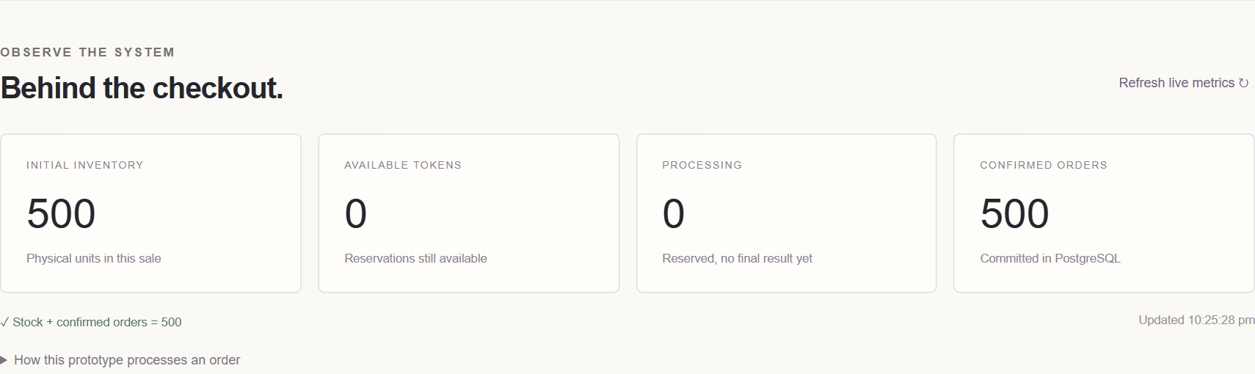

Independent Database Verification
The first SQL query verifies that remaining stock plus confirmed orders equals the initial inventory. The second groups orders by purchase-attempt ID and reports IDs that occur more than once.
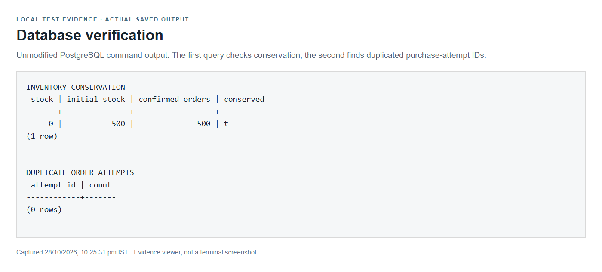

Checkout While the Worker Is Stopped
A fresh sale was started and the worker was stopped. The browser submitted one purchase request. Its reservation was accepted, but no order was confirmed while processing was unavailable.
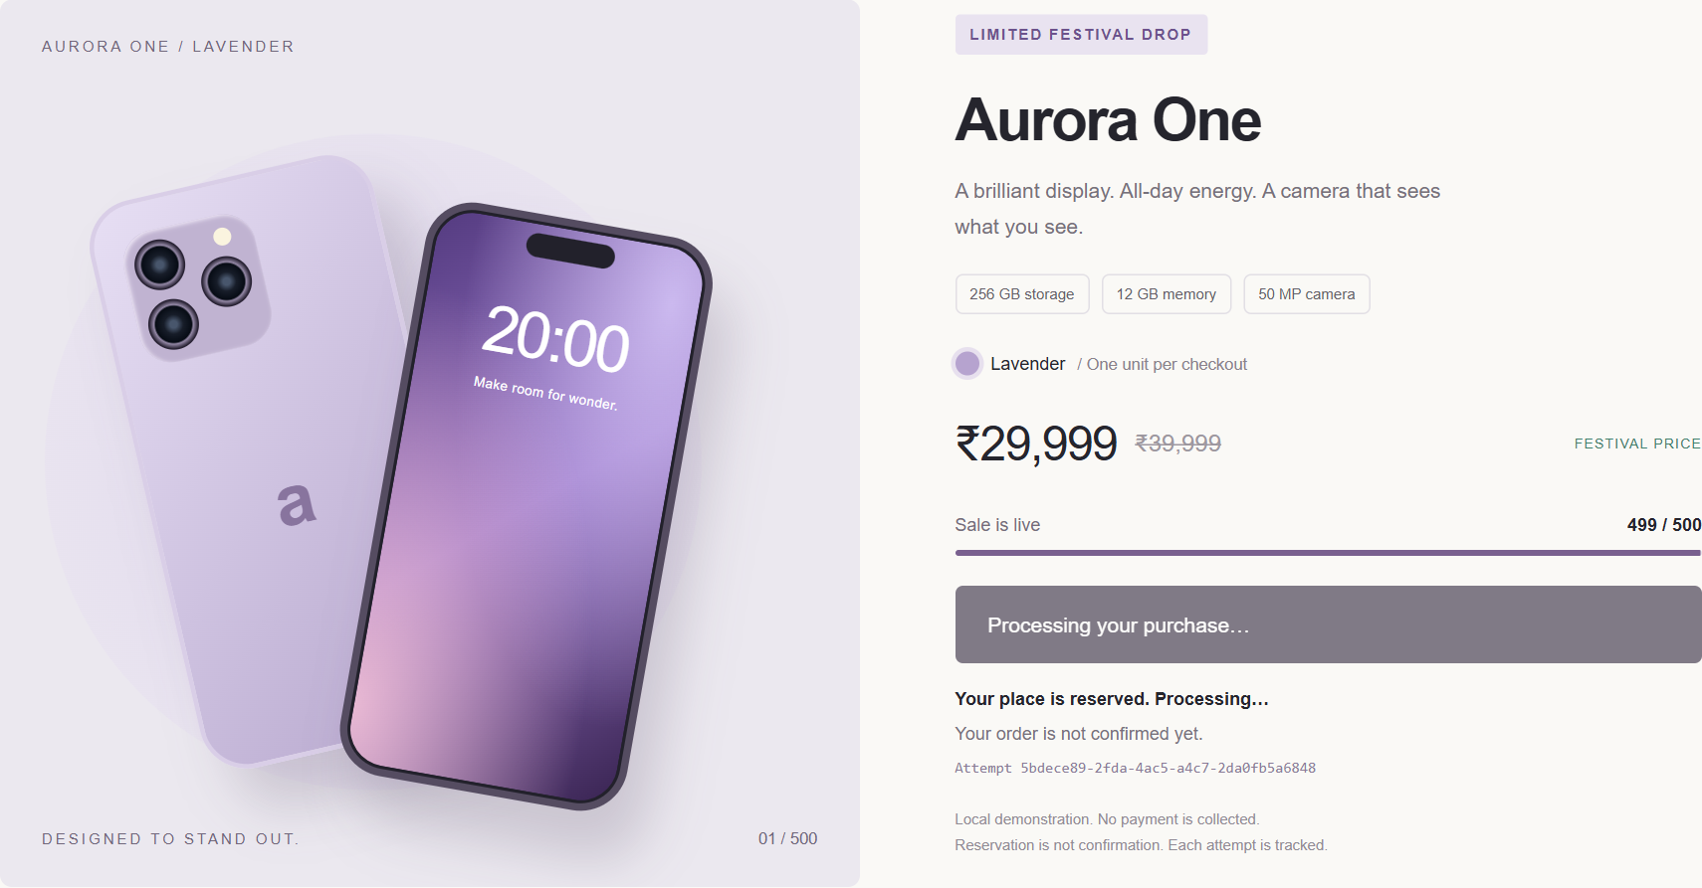

Recovery After Restart and Reload
The worker was restarted. The same purchase attempt became confirmed. The browser was then reloaded and recovered that confirmation using its saved attempt ID.
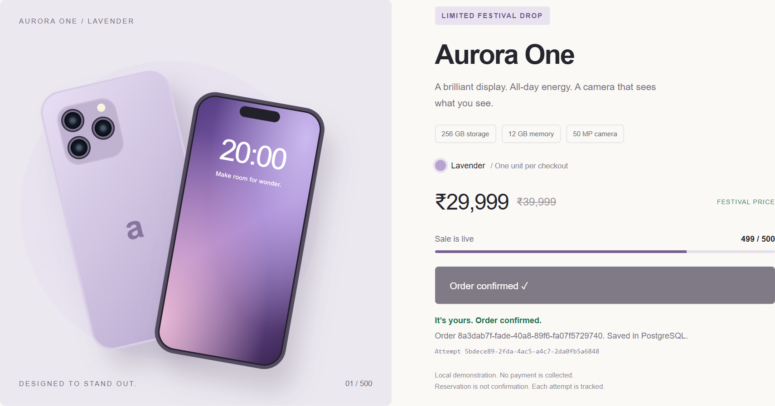

Duplicate Broker Delivery Protection
The test delivered the original purchase message and 5 duplicates. PostgreSQL recorded 6 processed deliveries for the attempt, while retaining exactly 1 order and one inventory decrement.
