GoML - Full Stack Engineer R2 Round
Proposed Architecture Report

-- Kamireddy Mohith Reddy
mohith23110016@snuchennai.edu.in

- Problem Statement : A festive flash sale that is occurring at 8 am with a count of 500 high-demand smartphones and is expected to incur a large traffic of around 100,000 users hitting website’s endpoint in the first 10 seconds of the launch.

During trail runs for this event, website experienced high latency, database row locks, and API request timeouts, and mainly the system oversold 40 of the smartphones causing critical consistency bug.
Task is to re-design both frontend and backend logics ensuring database consistency and preventing overselling under high load.

- Problems - Causes - Impacts :

Current problem | What it means in this scenario | Likely cause or mechanism | Impact
Inventory overselling | The system confirmed 540 checkouts even though only 500 phones were available. | A possible race condition: multiple requests read the same available stock before any of them completes its update. If checking availability and claiming stock are separate, several requests can claim the same remaining unit. | Some confirmed orders cannot be fulfilled, potentially requiring cancellations or refunds.
Database lock contention | Many checkout operations compete to update the same product’s inventory record. | Transactions may hold a lock on the inventory row while other transactions wait. Long transactions or unrelated work inside a transaction can increase the waiting time. | Checkout slows down, database connections remain occupied, and some operations may time out.
High checkout latency | Customers wait too long for a response after attempting to buy. | Possible bottlenecks include waiting for database locks, exhausted connection pools, overloaded application servers, or too much work performed before returning an HTTP response. | Customers experience an unresponsive checkout and may retry or abandon the purchase.
API request timeouts | Some requests do not receive a response within the allowed time. | Work may take longer than the client, gateway, or application timeout because requests are waiting for resources or slow operations. A timeout does not necessarily mean the underlying operation stopped. | Customers may not know whether their order succeeded. Retrying can create further load and, without duplicate protection, duplicate processing.
Sudden traffic pressure | A very large number of requests arrives around the sale opening rather than being spread over time. | The synchronized launch concentrates demand. If incoming work exceeds processing capacity, requests accumulate and compete for limited connections, CPU, memory, and database capacity. | Response times rise and services can become overloaded.
Repeated checkout submissions | One customer may generate several requests by repeatedly clicking Buy or retrying after a delay. | A button that remains active and unclear feedback can encourage repeated clicks. Without backend duplicate-request protection, those requests may be processed independently. | Unnecessary traffic increases, and the same purchase attempt may be processed more than once.
Unclear waiting and failure states | Customers may be unable to tell whether their checkout is pending, successful, failed, or sold out. | Missing status tracking, delayed feedback, or treating request acceptance as final purchase confirmation can create ambiguity. | Customers may retry unnecessarily or believe they have secured stock before confirmation.

- Proposed System Architecture :

- Customer → B)CDN and frontend → C)API gateway/load balancer → D) checkout service → E) inventory reservation and queue → F)background workers → G) database

1. Frontend and static asset delivery
- The customer opens a lightweight product page served through a Content Delivery Network (CDN). The CDN delivers static files such as JavaScript, CSS, and images, reducing the work handled by the application servers.
- When the customer clicks Buy, the interface immediately disables repeated submission and displays a processing state. Each purchase attempt has a unique request identifier that remains the same if that attempt is retried.
- The interface distinguishes between pending, confirmed, sold out, and failed. It displays confirmation only after the backend has committed the order.

2. API gateway and load balancer
- Incoming checkout requests pass through a gateway that applies request validation and rate limits to reduce abusive traffic. A load balancer distributes permitted requests across available checkout-service instances.
- Rate limiting and stock exhaustion produce explicit responses. In your report, interpret the brief’s “0% dropped requests” as a goal of avoiding silently lost requests—not a promise that every request will become an order.

3. Stateless checkout service
- The checkout service validates the purchase attempt and checks its request identifier to prevent duplicate processing. Retrying the same attempt should return its existing status rather than create another purchase.
- The service is stateless: important request and inventory information lives in shared storage, rather than only in one server’s memory. This allows multiple instances to handle requests consistently.
- Its main responsibility is to accept and coordinate checkout work quickly. It does not keep the HTTP connection open while completing all order-processing steps.

4. Inventory reservation using Redis
- Redis acts as a fast admission layer for the limited stock. An atomic operation checks whether inventory tokens remain and reserves one for the purchase attempt.
- The check, decrement, and association with the request identifier must be coordinated atomically. Simply using a separate stock lookup followed by a decrement would recreate the concurrency problem.
- These tokens represent reservations, not completed sales. The database remains the final authority for confirmed orders. If Redis loses state, reservations must be reconciled with persistent records before normal admission resumes.

5. Durable queue for background processing
- Accepted purchase attempts are placed in a durable message queue. Background workers consume these messages at a controlled rate, preventing the initial traffic burst from turning into an equally large burst of simultaneous database writes.
- Once the request has been durably accepted, the API returns 202 Accepted, a request ID, and a status URL.
- There is an important failure boundary here: reserving a Redis token and publishing a queue message are two separate operations. Your design needs a recoverable handoff—for example, a durable reservation record with retry and reconciliation—so a crash between those steps does not permanently strand inventory or lose an accepted request. Do not describe these two operations as one automatic transaction.

6. Workers and transactional database updates
- Workers complete the order in the relational database. Each checkout is processed in a transaction that:
- Checks whether the request has already been completed.
- Decrements stock only if stock is still available.
- Creates the corresponding order.
- Commits the inventory change and order together.
- The worker must verify that the conditional stock update actually succeeded before confirming the order. A unique constraint on the purchase-attempt identifier provides persistent protection against duplicate orders.
- The queue message is acknowledged only after processing has been committed. If a worker crashes and the message is delivered again, duplicate protection allows the worker to recognize the completed operation.

7. Status updates to the customer
- While processing continues, the frontend checks the status endpoint using controlled polling. This is a manageable choice for a prototype; polling frequency should be limited and should stop once a final status is reached.
- The status endpoint returns the actual recorded outcome. A delayed response or browser timeout must not automatically be interpreted as a failed purchase—the same request ID can be used to retrieve the result.

8. Recovery and monitoring
- The system tracks pending requests, queue backlog, processing failures, stock, and confirmed orders. Recovery logic identifies unfinished reservations and retries or resolves them.
- Reservations should not be released merely because a timer expired without checking whether an order committed. Otherwise, the system could make inventory available again for an already completed purchase.

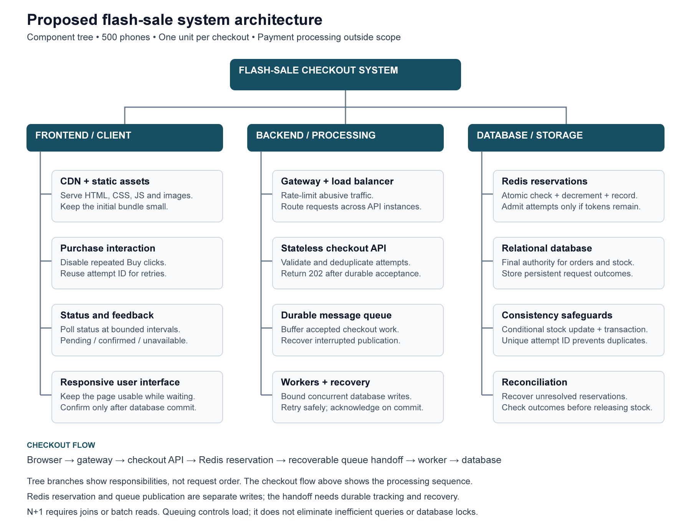
- End to End Checkout Flow :
The checkout flow begins when a customer clicks Buy and ends when the system records a confirmed order or a definite failure. In this design, each purchase attempt is for one phone.
1. Customer submits a purchase request
The frontend immediately disables the Buy button and displays a processing message. It sends the product ID and a unique purchase-attempt ID to the backend. If the request needs to be retried, the frontend reuses the same attempt ID.
2. The gateway checks and routes the request
The gateway applies traffic controls, including rate limits, and forwards permitted requests through the load balancer to an available checkout API instance. Invalid or rate-limited requests receive an explicit response.
3. The checkout API validates the attempt
The API checks the request details and verifies that the sale is open. It also checks whether the attempt has already been processed. A repeated attempt returns its existing status instead of creating another reservation or order. Duplicate protection must also be enforced during reservation and database processing, because duplicate requests can arrive simultaneously.
4. Redis reserves an inventory token
An atomic Redis operation checks for an existing reservation for the attempt. If none exists and a token is available, it reduces the available token count and records the reservation together.
If no tokens remain, the request receives an unavailable response and does not proceed to order processing. A reservation means the request can proceed; it does not yet mean the purchase is confirmed.
5. The request is durably accepted for processing
The reserved attempt is handed over to the message queue through a recoverable publication process. Pending publication must be tracked so that a failure between reservation and queue publication can be resolved without losing the request or permanently holding its token.
After durable acceptance, the API returns 202 Accepted, the attempt ID, and a status URL. The frontend continues to show the request as pending.

6. A background worker processes the request
A worker consumes the queued message. Worker concurrency is limited to avoid overwhelming the database with simultaneous inventory updates. The worker uses the attempt ID to recognize work that has already completed, including messages delivered again after a failure.
7. The database commits the order
The worker performs the inventory update and order creation within one database transaction. Stock is reduced only if sufficient inventory remains, and the worker verifies that the update succeeded before creating a confirmed order.
A unique constraint on the attempt ID prevents duplicate orders. If the transaction fails, its changes are rolled back together. Once the transaction commits, the worker acknowledges the queue message.
8. The frontend retrieves the final outcome
The frontend polls the status endpoint at controlled intervals. The endpoint returns the recorded state of the purchase attempt. Once the order is confirmed, the frontend displays the confirmation and stops polling. A definite failure is shown with an appropriate message.
A network timeout is treated as an unknown outcome rather than proof that the purchase failed. The frontend checks the existing attempt’s status instead of automatically creating a new purchase attempt.
9. Unfinished attempts are recovered
Recovery processing checks unresolved reservations and interrupted work. Temporary failures can be retried using the same attempt ID. Before releasing a reservation, the system verifies that no order committed and ensures that delayed processing cannot subsequently complete the cancelled attempt.
The flow maintains a clear distinction between request submitted, inventory reserved, and order confirmed. Only a committed database transaction produces a confirmed purchase.

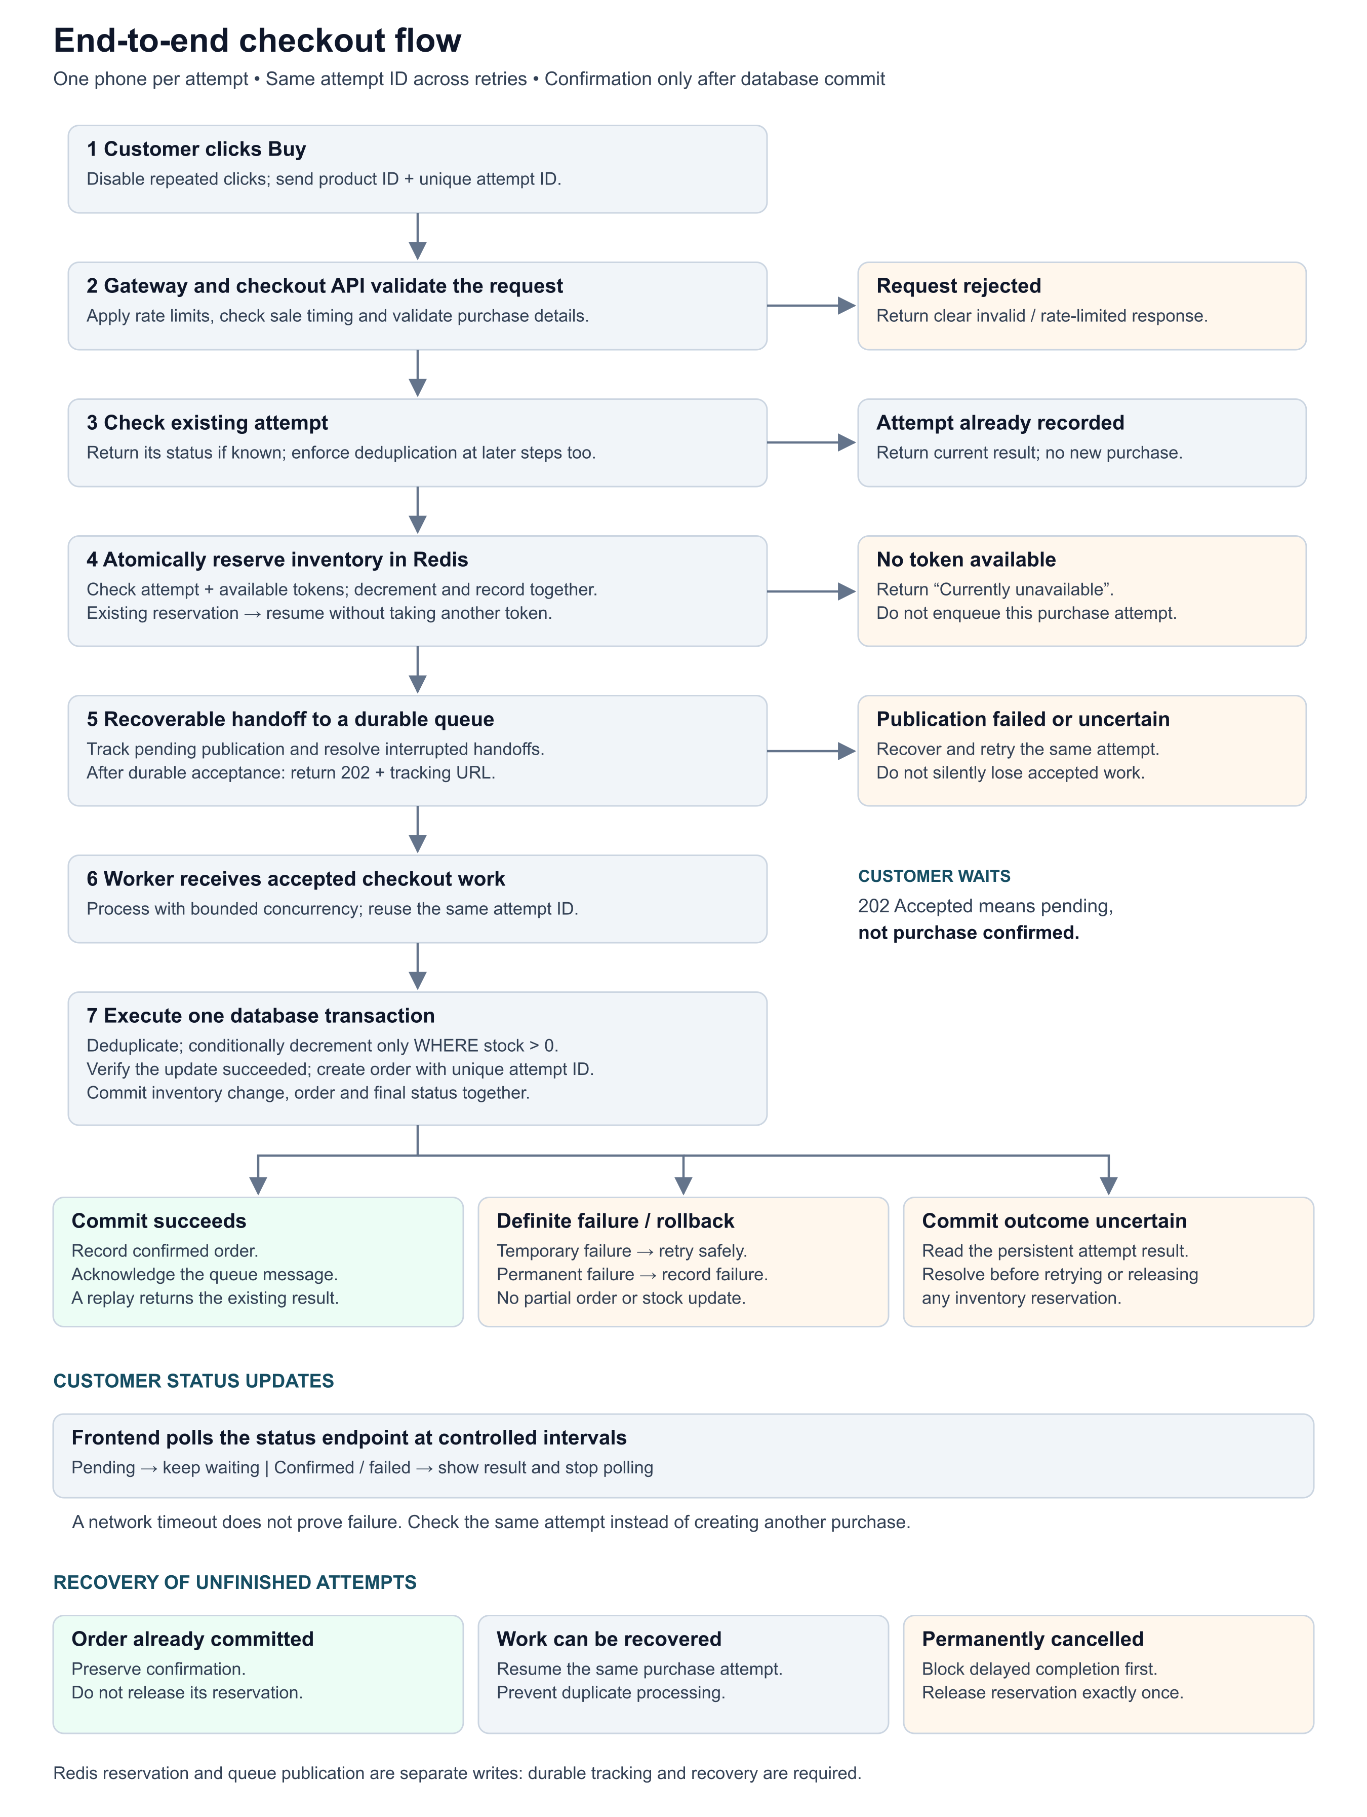

- Frontend Design :

Identified problem | Proposed frontend solution | Technology that can be used for this
Repeated clicks generate duplicate checkout requests | Immediately disable Buy and guard the submission handler while a purchase attempt is active. | Preact useRef for the immediate guard; useReducer for UI state; native button disabled attribute
Retries may create additional purchase attempts | Generate one identifier per purchase attempt and reuse it on retries. Backend duplicate protection must enforce this identifier. | crypto.randomUUID(), Fetch API, backend-supported idempotency key
Customers cannot distinguish processing from confirmation | Display explicit submitting, pending, confirmed, unavailable, failed, and uncertain states. Show success only after backend confirmation. | TypeScript state models, Preact useReducer, status components
Large JavaScript and CSS bundles delay interaction | Minimize dependencies and load nonessential features separately from the initial checkout page. | Preact, Vite production builds, dynamic import(), CSS Modules
Large images and static files slow page loading | Resize and compress images, load below-the-fold images lazily, and deliver static assets through a CDN. | AVIF/WebP, HTML srcset, loading="lazy", Amazon S3 and CloudFront
Frequent status checks increase backend traffic | Poll only active attempts, avoid overlapping requests, apply backoff and jitter, and stop at a final outcome. | Fetch API, recursive setTimeout, Page Visibility API
Network timeouts leave the purchase outcome unclear | Display an uncertain state and retrieve the existing attempt’s status instead of immediately starting another purchase. | Fetch API, AbortController, backend status endpoint
Refreshing the page loses checkout progress | Save the active attempt ID and restore status tracking when the page reloads. | sessionStorage, Preact useEffect, backend status endpoint
Immediate retries worsen rate limiting or temporary overload | Delay retries and follow the server’s Retry-After guidance when supplied. | HTTP 429/503 handling, Fetch response headers, backoff timers
Displayed stock or countdown may be outdated | Treat displayed availability as advisory and let the backend validate stock and sale timing. | Server-provided sale timestamps, Fetch API, optional SSE for availability updates
Unclear or inaccessible loading feedback | Provide readable status messages, keyboard-accessible controls, and announcements for status changes. | Semantic HTML, aria-live, aria-busy, responsive CSS
Performance targets are assumed rather than verified | Measure production asset sizes and browser startup behavior under documented device and network conditions. | Vite build output, Chrome DevTools Network and Performance panels, Playwright

- Backend Design

Identified problem | Proposed backend solution | Technology that can be used for this
Large traffic bursts overload a single server | Distribute requests across multiple stateless API instances. Scale capacity ahead of the scheduled sale rather than relying only on reactive scaling. | NGINX or AWS Application Load Balancer; Amazon ECS with scheduled scaling
Bots and excessive requests consume capacity | Apply rate limits by authenticated customer and IP, validate requests, and reject abusive traffic with explicit responses. | AWS WAF, gateway rate limiting, Redis-backed rate limiter
Heavy checkout processing increases HTTP response time | Move order completion into background processing. Return 202 Accepted with a tracking URL only after durable acceptance. | RabbitMQ durable queues, persistent messages, publisher confirms; Node.js with TypeScript and Fastify
Too many requests compete for limited inventory | Use an atomic operation to check availability, reserve one token, and associate the reservation with the purchase attempt. | Redis Lua scripting
Repeated requests create duplicate reservations or orders | Reuse a purchase-attempt ID, validate that repeated requests have matching details, and enforce duplicate protection in both reservation and order processing. | Idempotency keys, Redis atomic checks, PostgreSQL unique constraints
A crash between inventory reservation and queue publication loses work | Atomically record pending publication alongside the Redis reservation. Use a dispatcher to publish with confirmation, retry unresolved publication, and reconcile after recovery. | Redis Lua with a pending-work record or Redis Stream; RabbitMQ publisher confirms; recovery worker. Redis persistence and failover behavior require explicit configuration.
Uncontrolled workers recreate database contention | Limit worker concurrency and the number of unacknowledged messages. Keep database transactions short. | RabbitMQ consumer prefetch, bounded worker pools, PostgreSQL connection-pool limits
Worker crashes or repeated message delivery cause duplicate processing | Make processing idempotent and acknowledge messages only after the database transaction commits. Redelivered messages check the existing outcome. | RabbitMQ manual acknowledgements, PostgreSQL transactions and unique attempt IDs
Temporary failures cause aggressive retry loops | Retry transient failures with bounded backoff and jitter. Route repeatedly failing work for investigation and recovery. | Retry queues, message TTL and dead-letter exchanges in RabbitMQ, application retry policies
Customers cannot determine their checkout outcome | Provide an authenticated status endpoint returning the recorded pending, confirmed, or failed outcome. Prevent access to another customer’s attempt. | REST endpoint such as GET /checkout-attempts/{id}, Fastify, PostgreSQL; optional Redis status cache
Cancelled or abandoned reservations hold inventory indefinitely | Reconcile unfinished attempts, check for committed orders, and prevent delayed completion before releasing a reservation exactly once. | Recovery workers, persistent attempt states, conditional state transitions, Redis Lua
CPU-heavy work blocks API responsiveness | Keep request handlers lightweight and use asynchronous I/O. Move CPU-intensive work to separate threads or processes. | Node.js asynchronous APIs, worker_threads, separate worker services
Failures and bottlenecks are difficult to diagnose | Track latency, error rates, queue backlog, reservation age, database waits, and order outcomes. Correlate events using the attempt ID. | OpenTelemetry, Prometheus, Grafana, structured application logs

- Database Design :
Identified problem | Proposed database solution | Technology that can be used for this
Concurrent requests oversell inventory | Decrement stock only when stock > 0 and verify that the update succeeded before confirming the order. | PostgreSQL conditional UPDATE, RETURNING
Stock changes but order creation fails | Perform the inventory update and order creation in one transaction so both succeed or both roll back. | PostgreSQL ACID transactions
Database row-lock contention causes delays | Keep transactions short and limit simultaneous worker writes to the inventory row. | PostgreSQL row-level locking, bounded worker concurrency
Retries create duplicate orders | Enforce a unique purchase-attempt ID and return the existing result for duplicate attempts without decrementing stock again. | PostgreSQL UNIQUE constraint, transactional duplicate handling
N+1 queries increase database load | Fetch related records together instead of issuing separate queries for each record. | SQL JOIN, batch queries
Slow order and status lookups | Index frequently queried identifiers to avoid unnecessary full-table scans. | PostgreSQL indexes on attempt IDs and order IDs

