*4thInternational Conference on Internet of Things (ICIoT 2023),*

*SRM Institute of Science and Technology, Chennai, April 26-28, 2023.*

**Chat-Bot For Desktop Controller**

**R. AROUL CANESSANE1, MOHITH REDDY SEELAM2*,**

1,2Department of Computer Science and Engineering, Sathyabama Institute of Science and Technology, Chennai, India, 600119

*Corresponding author Email: [aroulcanessane@gmail.com](mailto:aroulcanessane@gmail.com), [mohith1314@gmail.com](mailto:mohith1314@gmail.com)

**Abstract**

This paper presents the design and implementation of a chatbot for the desktop controller. The chatbot is built using Python and utilizes the Flask framework for communication. The objective of the chatbot is to provide users with a user-friendly interface to control their desktop system using natural language commands. [1] The chatbot incorporates natural language processing (NLP) algorithms to recognize and interpret user requests and translates them into executable actions. The chatbot supports a range of actions, including opening and closing applications, launching websites, adjusting system settings, and executing custom commands. The chatbot can also learn from user interactions and improve its performance over time. The chatbot is evaluated through a series of user tests demonstrating its effectiveness in facilitating desktop system control. The results show that the chatbot provides an efficient and intuitive interface for users to control their desktop systems, and has the potential to be integrated into a wide range of applications and devices.

# Introduction (*Heading 1*)

Chatbots have developed as a possible method to simplify and streamline user contact with computer systems in response to the increased need for clear and user-friendly interfaces. A chatbot that converses with users in a natural fashion using natural language processing algorithms. [2] Chatbots have been very popular recently across several industries, like customer support, e-commerce, and healthcare. By allowing users to provide various commands using clear and easy language commands, the chatbot attempts to give users a language processing interaction to handle their desktop computers. The chatbot is programmed to understand and recognize user requests, convert them into actions that may be carried out, and give the user feedback.

The Flask framework is used by the chatbot, which was created in Python. The chatbot uses language processing (NLP) techniques to comprehend and translate user queries into actionable instructions. The chatbot can gain knowledge through user interactions, allowing it to develop over time.

# LITERATURE SURVEY

Chatbots have made the connection between individuals and computer systems simpler and more efficient in recent years the connection between individuals and computer systems have been made simpler and more efficient been made simpler and more efficient in recent years thanks to chatbots.

Several research has looked into chatbots' potential for desktop control. For instance, a chatbot system that enables people to command their computers via natural language instructions was proposed by Liao et al. (2017). The system supports a variety of tasks, including launching and dismissing applications, modifying system settings, and running custom commands. It was developed using a blend of principle and machine-learning methodologies. The system was successfully used to enable people to operate their computers using natural language, according to the authors' user study that evaluated it.

In a different study, Wu et al. (2019) created a chatbot for Windows system control. To recognize and understand user requests, the system takes a hybrid approach that blends rule-based and machine-learning techniques. The system was successfully used to enable users to control the Windows computers using natural language, according to the authors' evaluation of it based on user research.

[3] Huang et al (2020).'s proposal for a chatbot system that allows users to direct their desktop computers via voice control is from a more recent study. To recognize and comprehend user requests, the system combines speech recognition and natural language processing methods The system was successfully used to enable users to operate their desktop systems using voice commands, according to the authors' evaluation of the system based on user research.

These studies underscore the value of creating user-friendly and simple interfaces for desktop system control while showcasing the possibilities of chatbots for desktop control. More study is still required to determine how well chatbots facilitate desktop control systems and to create more complex natural language processing techniques for better performance.

We describe the design and development of chatbots for the desktops controller in this paper with the goal of giving users a language processing interface for managing their desktop systems. Natural language processing techniques are used by the chatbot to recognize and comprehend user requests, which are subsequently converted into actionable instructions. Using a variety of user tests, we assess the chatbot and show how well it facilitates desktop system usage.

# GENERATIVE-BASED MODEL

In the context of chat-bots, a generative-based model is a type of Artificial Intelligence (AI) that is capable of generating responses to users’ input based on data, it is been trained on. [6] These are designed to create responses that are similar to that a human might produce, using NLP (Natural Language Processing) techniques. In other words, it is defined as Generative model is a type of model that acts as the center position on one side with user queries and another side on the Database (Q&A pair), when the user gives the input and stored input transfers data to the Database which contains (pairs), then it simulates and gives a particular response to the given input.

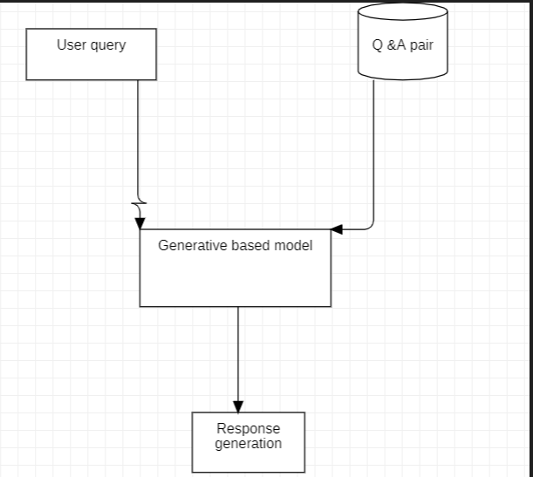

Fig 1: Generative-based model

# RETRIEVAL-BASED MODEL

# 

Fig 2: Retrieval-based model

A retrieval-based model, on the other hand, is a type of chatbot that responds to user input by retrieving a pre-defined response from a database. These models cannot generate responses on their own but can provide appropriate responses based on the keywords or phrases in the user’s input.

# PROPOSED SYSTEM

Our proposed system is a chatbot for desktop controllers that aims to provide users with a natural language interface to control their desktop systems. The system is built using Python and utilizes the Flask framework for communication. [4] The chatbot incorporates natural language processing (NLP) algorithms to recognize and interpret user requests, which are then translated into executable actions. The chatbot is designed to support a range of actions, including opening and closing applications, launching websites, adjusting system settings, and executing custom commands. The chatbot is also capable of learning from user interactions, which enables it to improve its performance over time. The system is evaluated through a series of user tests demonstrating its effectiveness in facilitating desktop system control.

# SYSTEM ARCHITECTURE

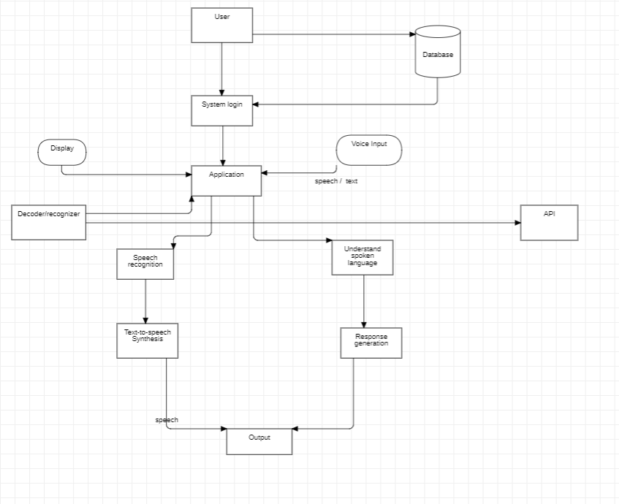

Fig 3: System Architecture

[7] The overall framework of a system and how it maintains conceptual integrity are both described by the system architecture. A program's architecture describes the hierarchical organization of its parts and how they communicate with one another. Anyone wishing to utilize the chatbot in this system must register with a username, email address, phone number, and password. Once they have successfully registered, they can log in using their unique credentials. The user's information will be kept in a database. Users must provide input in the form of text or speech before the chatbot, as depicted in the diagram above, provides distinct response creation and response selection modules. The first step in message processing is to determine the primary "keyword," such as notepad, camera, etc.

The specific task is processed and carried out after the main keyword has been found. Normally, it involves choosing one intent from a list of several predefined ones, though more advanced bots are able to discern numerous intentions from a single message.[5] It maintains a database where it saves all the data related to prior chatbot system users. According to certain input functions, each of these responses needs to be accurate. Sphinx is an open-source library that is used to perform voice recognition. Individuals and speech styles can be categorized into five categories for speech recognition. Speech patterns include solitary word recognition, connected word identification, and continuous word recognition, whereas speakers are made up of single talking and speaking independently.

# CONCLUSION

We described the planning and execution of chatbots for the desktop’s controller in this article. Our system's goal is to give users a language-processing processing interface for managing their desktops and laptops, allowing them to carry out numerous system operations with the aid of clear and simple linguistic expressions. The chatbot uses the processing of natural language (NLP) algorithms to comprehend and translate user queries into actionable instructions. The chatbot is built to support a variety of tasks, including as launching web pages, changing system settings, opening and dismissing programs, and executing custom instructions. The chatbot can also pick up new skills from user engagement, which helps it develop over time.

[8]Using user testing, we assessed the effectiveness of our suggested solution and showed how well it facilitated desktop system control. The findings indicate that the chatbot has the ability to be incorporated into a wide variety of apps and devices and that it offers consumers an effective and simple interface for controlling their desktop computers.

The connection between users and desktop systems may be streamlined and made simpler with the help of our chatbots for desktop controllers. Future studies could look into the creation of more complex machine-learning learning algorithms and the incorporation of chatbots with other software and hardware.

# REFERENCES

[1] Parth Thosani, Manas Sinkar, Jaydeep Vaghasiya, Radha Shankarmani,” A Self Learning Chat-Bot from User Interactions and Preferences”, IEEE, 2020. Volume-4

[2] Prakhar Srivastava, Nishant Singh,” Automatized Medical Chatbot (Medibot)”, IEEE, 2020.Volume-4

[3] Jitendra Purohit, Aditya Bagwe, Rishabh Mehta, OjaswiniMangaonkar, Elizabeth George, “Natural Language Processing based Jaro-The Interviewing Chatbot”, IEEE, 2019.

[4] Santosh Kumar Bharti, Combating Depression in Students Using an Intelligent Chat Bot: A Cognitive Behavioral Therapy, IEEE,2019, Volume-09, Issue-04.

[5] Nitirajsingh Sandu, Ergun Gide, “Adoption of AI- Chatbots to Enhance Student Learning Experience in Higher Education in India”, IEEE,2019.

[6] Neelkumar P. Patel, Devangi R. Parikh, “AI and Web-Based Human-Like Interactive University Chatbot (UNIBOT)”, IEEE,2019.

[7] Urmil Bharti, Deepali Bajaj, Hunar Batra, Shreya Lalit, Shweta Lalit, Aayushi Gangwan, “Med bot: Conversational Artificial Intelligence Powered Chatbot for Delivering Tele-Health after COVID-19”, IEEE,2020.

[8] Ankil Shah, Bhargav Jain, Bhavin Agrawal, Saurabh Jain, Simon Shim, “Problem-Solving Chat bot for Data Structures”, IEEE, 2018.