CineMatch AI: Movie Recommendation System

A Project Report Submitted in the partial fulfillment of the requirements for the award of the degree of

BACHELOR OF TECHNOLOGY
In

DEPARTMENT OF COMPUTER SCIENCE AND ENGINEERING
By
K. Akshitha | 2420030146
K. Sree Vardhan | 2420030711
T. Mohit Sai | 2420030723

Under the Esteemed Guidance of

Dr. N. Sunanda

Associate Professor

Department of CSE

AY- 2026-2027

Semester: ODD SEM




K L (Deemed to be) University DEPARTMENT OF CSE

Declaration

The Project Report entitled “CineMatch AI: Movie Recommendation System”

is a record of Bonafide work of K. Akshitha – 2420030146, K. Sree Vardhan – 2420030711, T. Mohit Sai – 2420030723 submitted in partial fulfillment for the award of B. Tech in K L (Deemed to be) University to the K L University. The results embodied in this report have not been copied from any other departments/University/Institute.

K. Akshitha – 2420030146
K. Sree Vardhan – 2420030711
T. Mohit Sai – 2420030723
K L (Deemed to be) University DEPARTMENT OF CSE

CERTIFICATE

This is certify that the mini project based report entitled “CineMatch AI: Movie Recommendation System” is a bonafide work done and submitted by K. Akshitha – 2420030146, K. Sree Vardhan – 2420030711, T. Mohit Sai – 2420030723 in partial fulfillment of the requirements for the award of the degree of BACHELOR OF TECHNOLOGY in Department of CSE, K L (Deemed to be University), during the academic year 2026-2027.

Signature of the Guide

Signature of the Course Coordinator Signature of the HOD

ACKNOWLEDGEMENT
The success in this project would not have been possible but for the timely help and guidance rendered by many people. Our wish to express my sincere thanks to all those who has assisted us in one way or the other for the completion of my project.

Our greatest appreciation to my Course Coordinator, and my guide Dr. N. Sunanda, Department of COMPUTER SCIENCE ENGINEERING which cannot be expressed in words for his/her tremendous support, encouragement and guidance for this project.

We express our gratitude to Dr. P. Venkateshwar Rao Sir, Head of the Department for computer science engineering for providing us with adequate facilities, ways and means by which we are able to complete this project-based Lab.

We thank all the members of teaching and non-teaching staff members, and also who have assisted me directly or indirectly for successful completion of this project. Finally, I sincerely thank my parents, friends and classmates for their kind help and cooperation during my work.

K. Akshitha – 2420030146
K. Sree Vardhan – 2420030711
T. Mohit Sai – 2420030723
Abstract
The rapid growth of digital entertainment platforms has made it increasingly difficult for users to discover movies that match their interests and preferences. Traditional movie browsing methods often require users to search through a large collection of films, which can be time-consuming and may not provide personalized suggestions. To address this problem, CineMatch AI is proposed as an AI-powered movie recommendation system that helps users discover movies based on their interests, preferences, and interactions.
The system aims to provide personalized movie recommendations by combining content-based filtering, collaborative filtering, and a hybrid recommendation approach. Content-based filtering analyzes movie information such as genres and other available attributes to identify films similar to a user's interests. Collaborative filtering uses user preferences and interaction patterns to identify movies that may be relevant. The system also considers movie popularity and mood-based preferences to improve the recommendation experience. A user-friendly interface allows users to explore movies, view recommendations, and access movie trailers.
The proposed system is designed using React.js for the frontend and Python with FastAPI for backend services, with SQLite considered for prototype data storage. By combining multiple recommendation techniques, CineMatch AI aims to make movie discovery more efficient, personalized, and engaging. The project focuses on improving the overall user experience by reducing search effort and helping users find movies suited to their preferences.

Index
S. No. | Chapters | Topics | Page.no
 |  | Acknowledgement
 |  | Abstract
1 | Introduction | 1.1 Background of the project  1.2 Problem statement  1.3 Scope of the project  1.4 Objective(s)  1.5 Importance of the application  1.6 Target users/audience | 1-10
2 | System Requirements | 2.1 Hardware requirements  2.2 Software requirements  2.3 Development tools and frameworks | 11-20
3 | Technology Stack | 3.1 Front-end (e.g., React.js, Angular, HTML/CSS)  3.2 Back-end (e.g., Node.js, Django, Spring Boot)  3.3 Database (e.g., MongoDB, MySQL, PostgreSQL)  3.4 Version Control (e.g., Git, GitHub)  3.5 APIs or External services (e.g., Firebase, Stripe) | 21-30
4 | System Architecture | 4.1 High-level architecture diagram  4.2 Description of each layer (frontend, backend, database)  4.3 Deployment architecture (e.g., cloud, local, CI/CD pipelines) | 31-35
5 | Design | 5.1 Wireframes or mockups  5.2 ER Diagram / Database schema | 36-42
6 | Implementation | 6.1 Module-wise implementation  6.2 Front-end logic (UI rendering, state management)  6.3 Backend logic (routes, controllers, business logic)  6.4 Database connectivity  6.5 API integration  6.6 Authentication & Authorization | 43-55
7 | Features | 7.1 List of main features  7.2 How each feature works (user perspective + technical description) | 56-60
8 | Testing | 8.1 Postman testing (frontend/backend)  8.2 Integration testing  8.3 Tools used for testing  8.4 Test cases and results | 61-67
9 | Deployment | 9.1 Steps to deploy  9.2 Environment configuration  9.3 Hosting of frontend and backend | 68-73
10 | Challenges & Limitations | 10.1 Issues faced during development  10.2 Solutions applied  10.3 Current limitations or known bugs | 74-80
11 | Future Enhancements | 11.1 Planned features  11.2 Possible integrations or optimizations | 81-88
12 | Conclusion | 12.1 Summary of the project  12.2 What was achieved  12.3 Skills learned during development | 89-100
13 | References | - Books, tutorials, APIs, documentation sites used
14 | Appendices | - Screenshots of the app  - Sample code snippets  - Installation/setup instructions  - User manual or guide  -certifications

CHAPTER 1
Introduction

  - Motivation
The main objective of “CineMatch AI” is to provide users with personalized movie recommendations based on their interests and preferences. Through this system, users can explore movies, view their details, and discover top-rated and relevant films. The system uses AI-based recommendation techniques to suggest movies according to user preferences, genres, and popularity. It also aims to help users discover movies based on their mood and interests. CineMatch AI makes movie selection easier, faster, and more enjoyable.

  - Objective
“CineMatch AI” aims to provide users with information about movies and recommend films based on their interests and preferences. Nowadays, online movie platforms have transformed the way people discover and choose movies. However, finding a suitable movie among thousands of options can be difficult and time-consuming. CineMatch AI helps users explore movies through personalized recommendations based on genres, ratings, popularity, and user interactions. It uses AI-based recommendation techniques to help users discover movies that match their interests and mood.
1.3 What is Web Development?
Web development is the work involved in developing a web site for the Internet (World Wide Web) or an intranet (a private network). Web development can range from developing a simple single static page of plain text to complex web-based internet applications (web apps), electronic businesses, and social network services. A more comprehensive list of tasks to which web development commonly refers, may include web engineering, web design, web content development, client liaison, client-side/server-side scripting, webserver and network configuration
Among web professionals, "web development" usually refers to the main non-design aspects of building web sites: writing markup and coding. Web development may use content management systems (CMS) to make content changes easier and available with basic technical skills.
For larger organizations and businesses, web development teams can consist of hundreds of people (web developers) and follow standard methods like Agile methodologies while developing websites. Smaller organizations may only require a single permanent or contracting developer, or secondary assignment to related job positions such as a graphic designer or information systems technician. Web development may be a collaborative effort between departments rather than the domain of a designated department. There are three kinds of web developer specialization: front-end developer, back-end developer, and full-stack developer.

1.4 What is Website?
A website or web site is a collection of related network web resources, such as web pages, multimedia content, which are typically identified with a common domain name, and published on at least one web server. Notable examples are wikipedia.org, google.com, and amazon.com.
Websites can be accessed via a public Internet Protocol (IP) network, such as the Internet, or a private local area network (LAN), by a uniform resource locator (URL) that identifies the site.
Websites can have many functions and can be used in various fashions; a website can be a personal website, a corporate website for a company, a government website, an organization website, etc. Websites are typically dedicated to a particular topic or purpose, ranging from entertainment and social networking to providing news and education. All publicly accessible websites collectively constitute the World Wide Web, while private websites, such as a company's website for its employees, are typically part of an intranet.

1.5 What is Webpage?
A web page is a document that is suitable to act as a web resource on the World Wide Web. In order to graphically display a web page, a web browser is needed. This is a type of software that can retrieve web pages from the Internet. When accessed by a web browser it may be displayed as a web page on a monitor or mobile device. Typical web pages are hypertext documents which contain hyperlinks, often referred to as links, for browsing to other web pages.
The term web page usually refers to what is visible, but may also refer to the contents of the source code itself, which is usually a text file containing hypertext written in HTML or a comparable markup language. Most current web browsers include the ability to view the source code. Web browsers will frequently have to access multiple web resource elements, such as style sheets, scripts, and images, while presenting each web page.

CHAPTER 2
Software Requirement

2.1 Problem Statement
The rapid growth of digital entertainment platforms has transformed the way people search for and choose movies. Additionally, online movie platforms provide users with ratings, reviews, and recommendations that influence their movie-watching decisions. However, finding a suitable movie among thousands of available options can be difficult and time-consuming. Users may struggle to discover movies that match their interests, preferences, and mood. CineMatch AI aims to solve this problem by providing personalized movie recommendations based on genres, ratings, popularity, and user preferences using AI-based recommendation techniques.
  - Technologies used

- HTML: Hypertext Markup Language (HTML) is the standard markup language for documents designed to be displayed in a web browser. It can be assisted by technologies such as Cascading Style Sheets (CSS) and scripting languages such as JavaScript.
General Syntax of HTML:
<! DOCTYPE html>
<html>
<head>
<title>Page Title</title>
</head>
<body>
<h1>My First Heading</h1>
<p>My first paragraph.</p>
</body>
</html>

- CSS: Cascading Style Sheets (CSS) is a style-sheet language used to describe the presentation of a document written in HTML or XML (including XML dialects such as SVG, Math-ML or XHTML). CSS describes how elements should be rendered on screen, on paper, in speech, or on other media.
CSS is one of the core languages of the open Web and is standardized across Web browsers according to the W3C specification. Developed in levels, CSS1 is now obsolete, CSS2.1 is a recommendation, and CSS3, now split into smaller modules, is progressing on the standardization track.

Types of CSS:
2.1 Inline CSS: It will affect only single elements. In HTML we require that various HTML tag's views are different so then we use inline Cascading Style Sheets. There are disadvantage of inline Cascading Style Sheets. It must be specified on every HTML tag. There is a lot of time consumed by that and it is not the best practice for a good programmer and the code will be quite large and very complex.
2.2 Internal CSS: In internal CSS the style of CSS is specified in the <head> section. This is internal CSS, it affects all the elements in the body section. Internal CSS is used in the condition when we want a style to be used in the complete HTML body. For that we can use style in the head tag.
2.3 External CSS: In External CSS we create a .css file and use it in our HTML page as per our requirements. Generally external Cascading Style Sheets are used whenever we have many HTML attributes and we can use them as required; there is no need to rewrite the CSS style again and again in a complete body of HTML that inherits the property of the CSS file. There are two ways to create a CSS file. The first is to write the CSS code in Notepad and save it as a .css file, the second one is to directly add the style sheet in our Solution Explorer and direct Visual Studio to use it on our HTML page.

- Bootstrap: Bootstrap is a free and open-source CSS framework directed at responsive, mobile-first front-end web development. It contains CSS- and (optionally) JavaScript based design templates for typography, forms, buttons, navigation and other interface components. Bootstrap is the third-most-starred project on Git-Hub, with more than 135,000 stars, behind only free Code Camp (almost 305,000 stars) and marginally behind Vue.js framework. According to Alexa Rank, Bootstrap getbootstrap.com is in the top-2000 in US while vuejs.org is in top-7000 in US. Bootstrap, originally named Twitter Blueprint, was developed by Mark Otto and Jacob Thornton at Twitter as a framework to encourage consistency across internal tools. Before Bootstrap, various libraries were used for interface development, which led to inconsistencies and a high maintenance burden.

  - Software Used
2.3.1 Brackets (text-editor): It is a source code editor with a primary focus on web development. Created by Adobe Systems, it is free and open-source software licensed under the MIT License, and is currently maintained on Git-Hub by Adobe and other open-source developers. It is written in JavaScript, HTML and CSS. Brackets is cross-platform, available for mac-OS, Windows, and most Linux distributions. The main purpose of brackets is its live HTML, CSS and JavaScript editing functionality.
Adobe first started development of a text editor for web development on Edge Code, which was discontinued. This was later transformed into Adobe Brackets. With the release of Brackets 1.0, Adobe announced that the development of an open source software for web development was ready and was not an experimental project anymore. Brackets contains more than 282 community contributors and more than 400 requests for bug fixes and new features. Every version of Brackets has more than 100,000 downloads and stands to be 16th most popular project on Git-Hub.

CHAPTER 3
Software Design

3.1 DFD
A data-flow diagram (DFD) is a way of representing a flow of a data of a process or a system (usually an information system). The DFD also provides information about the outputs and inputs of each entity and the process itself. A data-flow diagram has no control flow, there are no decision rules and no loops. Specific operations based on the data can be represented by a flowchart.
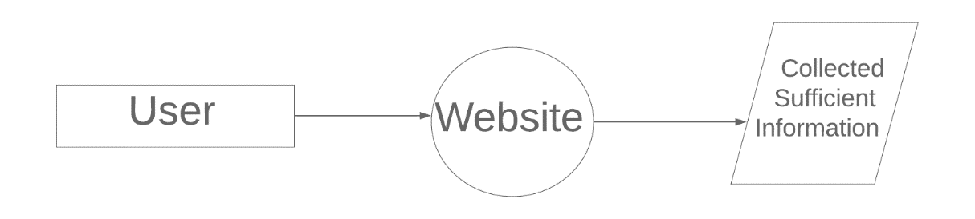
Fig No. 3.1 DFD LEVEL-0

CHAPTER 4
WEB PAGE DETAILS
4.1 Web Page Details
Home Page
About the Project
Movie Discovery Page
Search and Genre Filter Page
Movie Details and Trailer Page
Favorites / Watchlist Page
Sign In and Sign Up Page
4.2 Detailed Description of Pages
1. Home Page
The Home Page is the main entry point of CineMatch AI. It introduces the movie discovery platform through a cinematic banner, navigation links, and options to start exploring or sign in. It explains that the application helps users discover movies that match their interests and preferences.
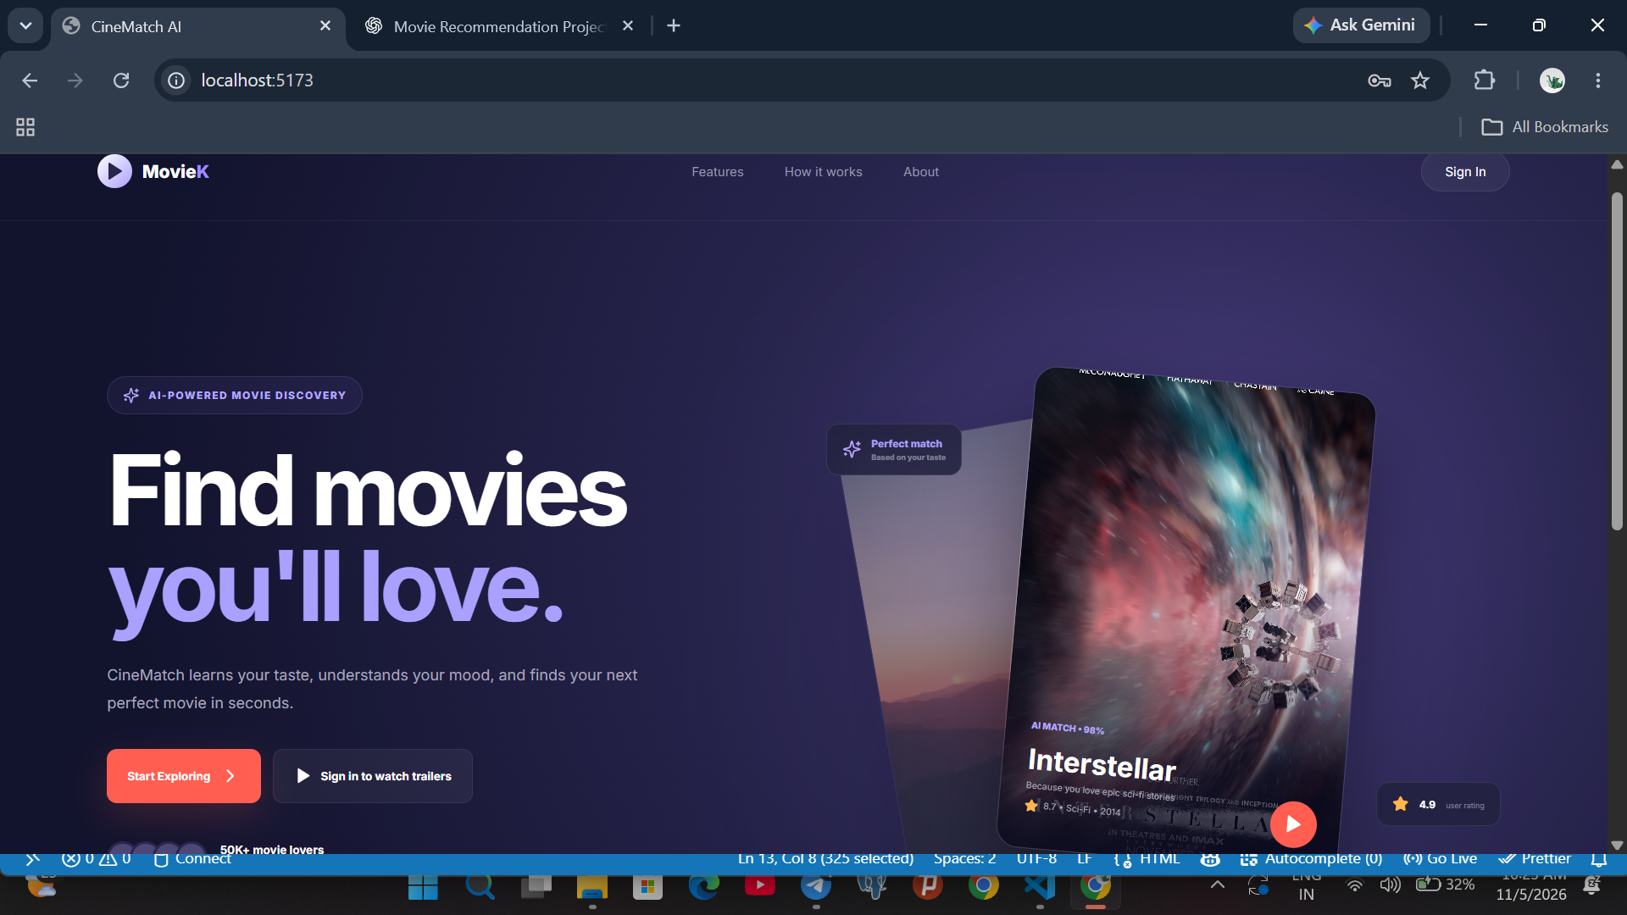
Fig No. 4.1: CineMatch AI Home Page
2. About the Project
The About the Project section explains the purpose of CineMatch AI and introduces its main capabilities. The application brings movie browsing, search, category navigation, movie information, favourites, and trailer previews together in one place. Its goal is to make movie discovery simple and engaging.
Fig No. 4.2: CineMatch AI Project Introduction
3. Movie Discovery Page
The Movie Discovery Page allows users to browse the movie and television catalogue available in the application. The dashboard displays featured titles and movie cards with poster images and basic information. Users can select a title to view more details.
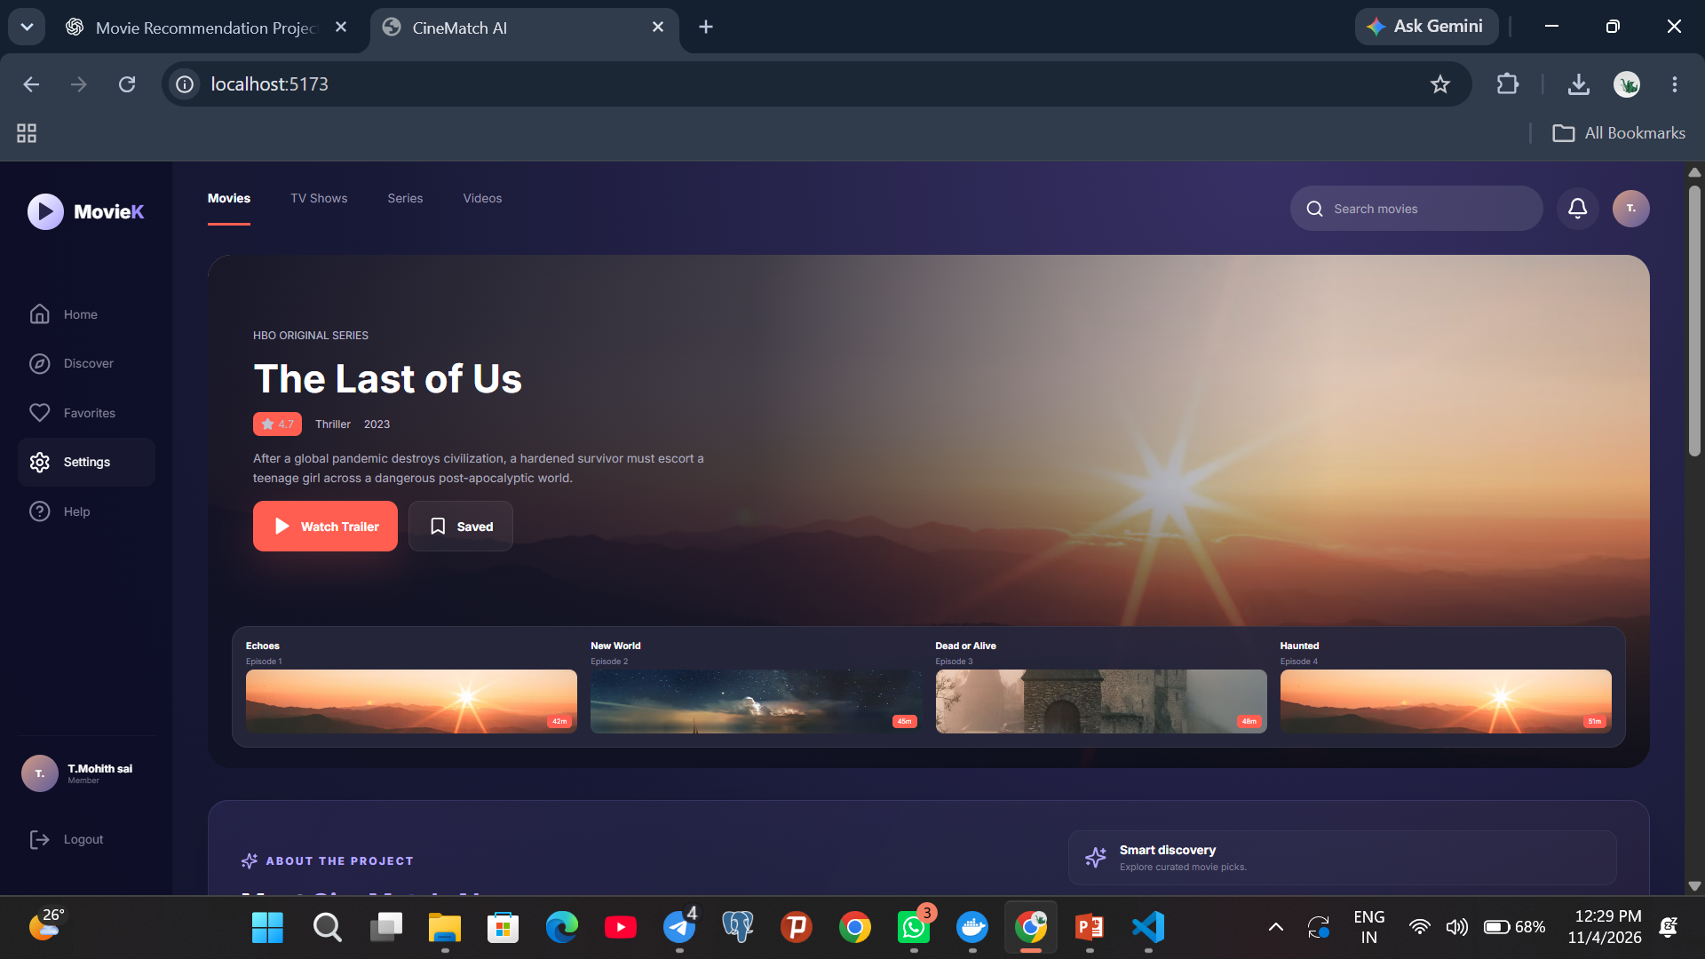
Fig No. 4.3: Movie Discovery Dashboard
4. Search and Genre Filter Page
The search and category navigation features help users locate movies more easily. Users can enter a title or keyword in the search field and browse available media categories, such as Movies, TV Shows, Series, and Videos. The screenshot illustrates the search area and category navigation.
Fig No. 4.4: Search and Category Navigation
5. Movie Details and Trailer Page
When a user selects a movie, CineMatch AI displays a details view containing the title, genre, release year, duration, rating, and a short explanation of why the movie may be relevant. The Watch Trailer option opens a trailer preview using an embedded YouTube player.
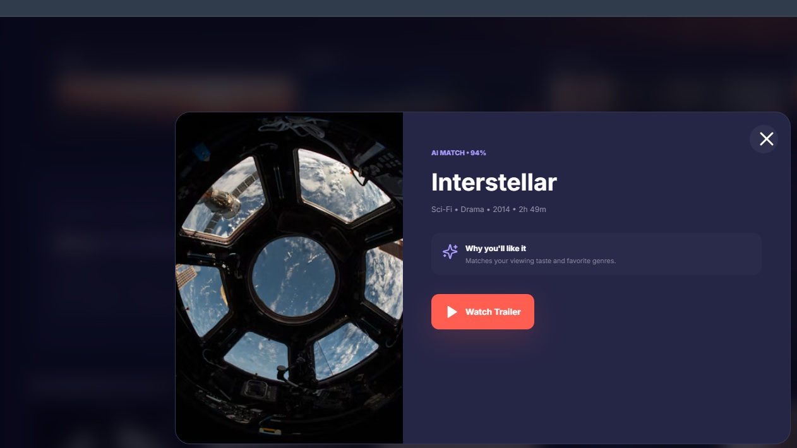
Fig No. 4.5: Movie Details and Trailer Preview
6. Favorites / Watchlist Page
The Favorites or Watchlist feature is intended to let users save movies they want to watch later and revisit those selections. The application navigation includes a Favorites option. A screenshot of the populated Favorites list can be added after opening that section in the running application.
Fig No. 4.6: CineMatch AI Dashboard Navigation
7. Sign In and Sign Up Page
The authentication page allows existing users to sign in and new users to create an account. Users enter their credentials to access the movie discovery features. The frontend communicates with the FastAPI backend, while account and session information is managed using the SQLite database.
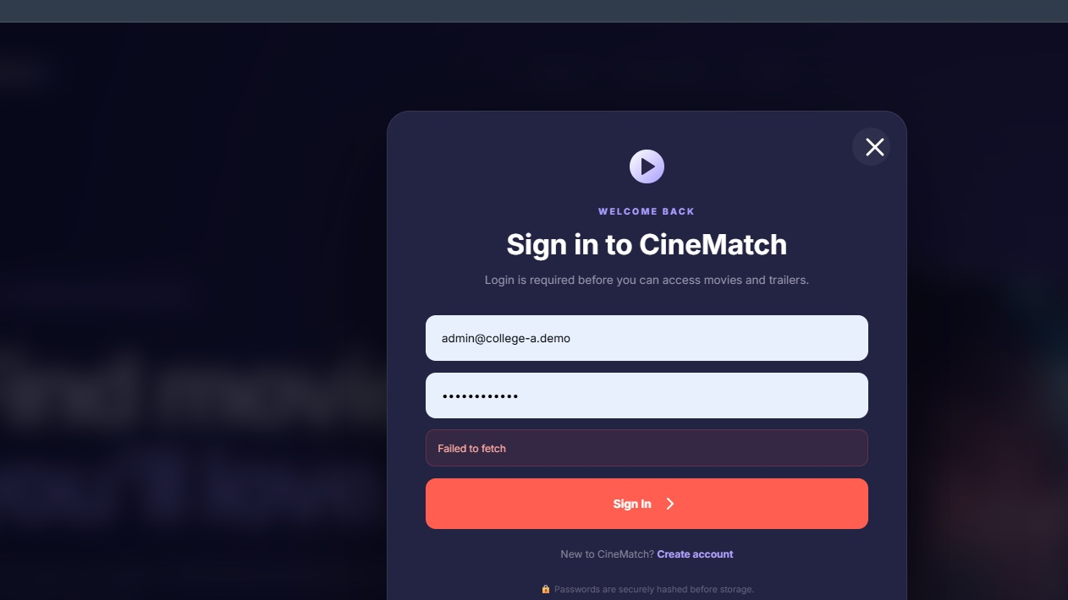
Fig No. 4.7: CineMatch AI Sign In Page
Note: The current prototype includes the pages and navigation shown above. Features that are not yet implemented in the running build should be described as planned enhancements rather than completed functionality.

CHAPTER 5

Conclusion and Future Aspects

5.1 Conclusion
The project "CineMatch AI: Movie Recommendation System" aims to make movie discovery easier and more personalized. It allows users to explore movies, search by title and genre, view movie details, watch trailers, and save their favourite movies.
The system uses React.js for frontend development, Python with FastAPI for backend services, and SQLite for data storage. It focuses on AI-based recommendation techniques to suggest movies according to users' interests, preferences, and moods.
Through this project, we gained practical knowledge of web development, database management, API integration, and recommendation systems. Overall, CineMatch AI provides a simple and user-friendly platform that improves the movie selection experience and offers opportunities for future enhancements.
5.2 Future Aspects
- Advanced AI-Based Recommendations:
Machine learning algorithms can be implemented to provide more accurate movie recommendations based on users' interests, preferences, and viewing history.

- Mood-Based Movie Recommendations:
A feature can be added to recommend movies according to the user's mood, such as happy, sad, romantic, or adventurous, making movie selection more personalized.

- User Ratings and Reviews:
Users can be allowed to rate movies and share their reviews. These ratings can help improve recommendations and assist other users in selecting movies.

CHAPTER 6
BIBLIOGRAPHY
The following official documentation and development resources were used as references while developing CineMatch AI. The original project source files are included in Chapter 7.
1. React Documentation. https://react.dev/
2. Vite Documentation. https://vite.dev/guide/
3. FastAPI Documentation. https://fastapi.tiangolo.com/
4. Python Documentation. https://docs.python.org/3/
5. SQLite Documentation. https://www.sqlite.org/docs.html
6. Pydantic Documentation. https://docs.pydantic.dev/
7. Lucide React Documentation. https://lucide.dev/guide/packages/lucide-react
8. MDN Web Docs – CSS. https://developer.mozilla.org/en-US/docs/Web/CSS
9. MDN Web Docs – JavaScript. https://developer.mozilla.org/en-US/docs/Web/JavaScript
10. YouTube IFrame Player API. https://developers.google.com/youtube/iframe_api_reference
CHAPTER 7
APPENDICES – ORIGINAL PROJECT SOURCE CODE
This chapter contains original source files extracted from the supplied CineMatch AI project ZIP. The frontend is implemented using React and CSS. The backend uses Python with FastAPI and SQLite for account and session data.
7.1 Frontend Source Code – src/main.jsx
React entry point that renders the CineMatch AI interface, movie catalogue, navigation, sign-in/sign-up interactions, and movie details/trailer interface.
import React, { useEffect, useMemo, useState } from "react";
import { createRoot } from "react-dom/client";
import {
Bell, Bookmark, ChevronRight, CircleHelp, Compass, Heart, Home,
LogIn, LogOut, Menu, Play, Search, Settings, Sparkles, Star,
Tv, UserPlus, X, Zap
} from "lucide-react";
import "./styles.css";

const API = "http://127.0.0.1:8000";

const movies = [
{id:1,title:"Interstellar",genre:"Sci-Fi • Drama",rating:"8.7",year:"2014",duration:"2h 49m",poster:"https://images.unsplash.com/photo-1446776877081-d282a0f896e2?auto=format&fit=crop&w=700&q=90",trailer:"zSWdZVtXT7E"},
{id:2,title:"The Batman",genre:"Action • Crime",rating:"7.8",year:"2022",duration:"2h 56m",poster:"https://images.unsplash.com/photo-1485230405346-71acb9518d9c?auto=format&fit=crop&w=700&q=90",trailer:"mqqft2x_Aa4"},
{id:3,title:"Dune",genre:"Sci-Fi • Epic",rating:"8.0",year:"2021",duration:"2h 35m",poster:"https://images.unsplash.com/photo-1500534623283-312aade485b7?auto=format&fit=crop&w=700&q=90",trailer:"n9xhJrPXop4"},
{id:4,title:"The Mandalorian",genre:"Sci-Fi • Adventure",rating:"8.6",year:"2019",duration:"3 Seasons",poster:"https://images.unsplash.com/photo-1534447677768-be436bb09401?auto=format&fit=crop&w=700&q=90",trailer:"aOC8E8z_ifw"},
{id:5,title:"House of the Dragon",genre:"Fantasy • Drama",rating:"8.3",year:"2022",duration:"2 Seasons",poster:"https://images.unsplash.com/photo-1518709268805-4e9042af9f23?auto=format&fit=crop&w=700&q=90",trailer:"DotnJ7tTA34"},
{id:6,title:"Dark",genre:"Mystery • Sci-Fi",rating:"8.7",year:"2017",duration:"3 Seasons",poster:"https://images.unsplash.com/photo-1500534623283-312aade485b7?auto=format&fit=crop&w=700&q=90",trailer:"rrwycJ08PSA"},
{id:7,title:"Breaking Bad",genre:"Crime • Drama",rating:"9.5",year:"2008",duration:"5 Seasons",poster:"https://images.unsplash.com/photo-1500673922987-e212871fec22?auto=format&fit=crop&w=700&q=90",trailer:"HhesaQXLuRY"},
{id:8,title:"Money Heist",genre:"Crime • Thriller",rating:"8.2",year:"2017",duration:"5 Seasons",poster:"https://images.unsplash.com/photo-1517248135467-4c7edcad34c4?auto=format&fit=crop&w=700&q=90",trailer:"_InqQJRqGW4"}
];

const hero = {
title:"The Last of Us", genre:"Thriller", year:"2023", rating:"4.7",
description:"After a global pandemic destroys civilization, a hardened survivor must escort a teenage girl across a dangerous post-apocalyptic world.",
image:"https://images.unsplash.com/photo-1500534623283-312aade485b7?auto=format&fit=crop&w=1600&q=90",
trailer:"uLtkt8BonwM"
};

function Landing({openAuth}) {
return <div className="landing">
<header className="landing-nav">
<div className="brand"><div className="brand-mark"><Play size={16} fill="currentColor"/></div><span>Movie<span>K</span></span></div>
<div className="landing-links"><a href="#features">Features</a><a href="#how">How it works</a><a href="#about">About</a></div>
<button className="signin-top" onClick={()=>openAuth("login")}>Sign In</button>
</header>
<section className="landing-hero">
<div className="landing-copy">
<div className="badge"><Sparkles size={13}/> AI-POWERED MOVIE DISCOVERY</div>
<h1>Find movies<br/><span>you'll love.</span></h1>
<p>CineMatch learns your taste, understands your mood, and finds your next perfect movie in seconds.</p>
<div className="landing-actions">
<button className="primary big" onClick={()=>openAuth("signup")}>Start Exploring <ChevronRight size={17}/></button>
<button className="secondary big" onClick={()=>openAuth("login")}><Play size={14} fill="currentColor"/> Sign in to watch trailers</button>
</div>
<div className="trust"><div className="trust-avatars"><i>ST</i><i>AK</i><i>RM</i><i>+</i></div><div><b>50K+ movie lovers</b><small>discover better movies every week</small></div></div>
</div>
<div className="landing-visual">
<div className="visual-glow"></div>
<div className="stack back"><img src={movies[2].poster}/></div>
<div className="stack main"><img src={movies[0].poster}/><div className="visual-gradient"></div><div className="visual-info"><span>AI MATCH • 98%</span><h3>Interstellar</h3><p>Because you love epic sci-fi stories</p><div><Star size={11} fill="currentColor"/> 8.7 • Sci-Fi • 2014</div></div><button className="visual-play" onClick={()=>openAuth("login")}><Play size={16} fill="currentColor"/></button></div>
<div className="float-card match"><Sparkles size={15}/><div><b>Perfect match</b><small>Based on your taste</small></div></div>
<div className="float-card rate"><Star size={13} fill="currentColor"/><b>4.9</b><small>user rating</small></div>
</div>
</section>
<section className="features" id="features">
<div><Sparkles/><b>AI Recommendations</b><small>Personalized picks that improve as you watch.</small></div>
<div><Heart/><b>Made for your mood</b><small>Happy, emotional, thrilling or mind-blowing.</small></div>
<div><Zap/><b>Discover faster</b><small>Find something great without endless scrolling.</small></div>
</section>
<section className="landing-bottom" id="how"><div><small>YOUR NEXT FAVORITE IS WAITING</small><h2>Stop scrolling.<br/><span>Start watching.</span></h2></div><button onClick={()=>openAuth("signup")}>Create your free account <ChevronRight size={16}/></button></section>
</div>
}

function AuthModal({mode,setMode,onClose,onSuccess}) {
const [name,setName]=useState("");
const [email,setEmail]=useState("");
const [password,setPassword]=useState("");
const [loading,setLoading]=useState(false);
const [error,setError]=useState("");

async function submit(e){
e.preventDefault(); setLoading(true); setError("");
try{
const endpoint = mode==="signup" ? "/auth/signup" : "/auth/login";
const body = mode==="signup" ? {name,email,password} : {email,password};
const r = await fetch(API+endpoint,{method:"POST",headers:{"Content-Type":"application/json"},body:JSON.stringify(body)});
const data = await r.json();
if(!r.ok) throw new Error(data.detail || "Authentication failed");
localStorage.setItem("cinematch_token",data.token);
localStorage.setItem("cinematch_user",JSON.stringify(data.user));
onSuccess(data.user);
}catch(err){setError(err.message)}finally{setLoading(false)}
}

return <div className="auth-backdrop" onClick={onClose}>
<div className="auth-card" onClick={e=>e.stopPropagation()}>
<button className="close" onClick={onClose}><X/></button>
<div className="auth-logo"><div className="brand-mark"><Play size={16} fill="currentColor"/></div></div>
<span className="auth-kicker">{mode==="signup" ? "JOIN CINEMATCH" : "WELCOME BACK"}</span>
<h2>{mode==="signup" ? "Create your account" : "Sign in to CineMatch"}</h2>
<p>{mode==="signup" ? "Save your preferences and unlock personalized recommendations." : "Login is required before you can access movies and trailers."}</p>
<form onSubmit={submit}>
{mode==="signup" && <input value={name} onChange={e=>setName(e.target.value)} placeholder="Full name" required/>}
<input type="email" value={email} onChange={e=>setEmail(e.target.value)} placeholder="Email address" required/>
<input type="password" value={password} onChange={e=>setPassword(e.target.value)} placeholder="Password" minLength="6" required/>
{error && <div className="auth-error">{error}</div>}
<button className="auth-submit" disabled={loading}>{loading ? "Please wait..." : mode==="signup" ? "Create Account" : "Sign In"} <ChevronRight size={16}/></button>
</form>
<div className="switch-auth">{mode==="signup" ? "Already have an account?" : "New to CineMatch?"} <button onClick={()=>{setError("");setMode(mode==="signup"?"login":"signup")}}>{mode==="signup"?"Sign In":"Create account"}</button></div>
<small className="secure-note">🔒 Passwords are securely hashed before storage.</small>
</div>
</div>
}

function Dashboard({user,onLogout}){
const [search,setSearch]=useState("");
const [watchlist,setWatchlist]=useState(new Set());
const [selected,setSelected]=useState(null);
const [trailer,setTrailer]=useState(null);
const [mobile,setMobile]=useState(false);

const filtered=useMemo(()=>{const q=search.toLowerCase().trim();return q?movies.filter(m=>(m.title+" "+m.genre+" "+m.year).toLowerCase().includes(q)):movies},[search]);
const toggle=id=>setWatchlist(prev=>{const n=new Set(prev);n.has(id)?n.delete(id):n.add(id);return n});

return <div className="dashboard">
<aside className={`sidebar ${mobile?"open":""}`}>
<div className="brand"><div className="brand-mark"><Play size={16} fill="currentColor"/></div><span>Movie<span>K</span></span></div>
{[[Home,"Home"],[Compass,"Discover"],[Heart,"Favorites"],[Settings,"Settings"],[CircleHelp,"Help"]].map(([Icon,label])=><button className="nav-item active-if" key={label}><Icon size={17}/><span>{label}</span></button>)}
<div className="sidebar-user"><div className="avatar">{(user.name||"U").slice(0,2).toUpperCase()}</div><div><b>{user.name}</b><small>Member</small></div></div>
<button className="nav-item logout" onClick={onLogout}><LogOut size={17}/><span>Logout</span></button>
</aside>
<main className="dash-main">
<header className="topbar"><button className="mobile-menu" onClick={()=>setMobile(!mobile)}><Menu/></button><div className="tabs"><b>Movies</b><span>TV Shows</span><span>Series</span><span>Videos</span></div><div className="top-right"><label className="search"><Search size={16}/><input value={search} onChange={e=>setSearch(e.target.value)} placeholder="Search movies"/></label><button className="bell"><Bell size={17}/></button><div className="avatar">{(user.name||"U").slice(0,2).toUpperCase()}</div></div></header>
<section className="hero">
<img src={hero.image} className="hero-bg"/><div className="hero-overlay"/>
<div className="hero-copy"><small>HBO ORIGINAL SERIES</small><h1>{hero.title}</h1><div className="meta"><span className="score"><Star size={10} fill="currentColor"/> {hero.rating}</span><span>{hero.genre}</span><span>{hero.year}</span></div><p>{hero.description}</p><div className="actions"><button className="primary" onClick={()=>setTrailer(hero)}><Play size={15} fill="currentColor"/> Watch Trailer</button><button className="secondary" onClick={()=>toggle(999)}><Bookmark size={15}/> {watchlist.has(999)?"Saved":"Watchlist"}</button></div></div>
<div className="episodes">{["Echoes","New World","Dead or Alive","Haunted"].map((x,i)=><div key={x}><b>{x}</b><small>Episode {i+1}</small><div className="ep-img" style={{backgroundImage:`url(${movies[(i+2)%movies.length].poster})`}}><span>{42+i*3}m</span></div></div>)}</div>
</section>
<section className="content-section"><div className="section-title"><h2>{search?"Search results":"Recommended for you"} <Sparkles size={15}/></h2><span>See all</span></div><div className="poster-grid">{filtered.map(m=><article className="poster" key={m.id} onClick={()=>setSelected(m)}><div><img src={m.poster}/><button onClick={e=>{e.stopPropagation();toggle(m.id)}}><Bookmark size={14} fill={watchlist.has(m.id)?"currentColor":"none"}/></button><span><Star size={9} fill="currentColor"/> {m.rating}</span></div><b>{m.title}</b><small>{m.genre}</small></article>)}</div></section>
<section className="content-section"><div className="section-title"><h2>Trending now <Zap size={15}/></h2></div><div className="trending">{movies.slice(4,8).map((m,i)=><button key={m.id} onClick={()=>setSelected(m)}><img src={m.poster}/><strong>0{i+1}</strong><div><b>{m.title}</b><small>{m.genre}</small></div></button>)}</div></section>
</main>
{selected && <div className="modal-bg" onClick={()=>setSelected(null)}><div className="movie-modal" onClick={e=>e.stopPropagation()}><button className="close" onClick={()=>setSelected(null)}><X/></button><img src={selected.poster}/><div><span className="match">AI MATCH • 94%</span><h2>{selected.title}</h2><p>{selected.genre} • {selected.year} • {selected.duration}</p><div className="why"><Sparkles size={17}/><span><b>Why you'll like it</b><small>Matches your viewing taste and favorite genres.</small></span></div><button className="primary" onClick={()=>setTrailer(selected)}><Play size={15} fill="currentColor"/> Watch Trailer</button></div></div></div>}
{trailer && <div className="trailer-bg" onClick={()=>setTrailer(null)}><div className="trailer-modal" onClick={e=>e.stopPropagation()}><button className="close" onClick={()=>setTrailer(null)}><X/></button><div className="trailer-head"><div><span>TRAILER</span><h2>{trailer.title}</h2></div><button className="trailer-youtube" onClick={()=>window.open("https://www.youtube.com/watch?v="+trailer.trailer,"_blank")}>YouTube ↗</button></div><div className="video-wrap"><iframe src={`https://www.youtube.com/embed/${trailer.trailer}?autoplay=1&rel=0`} title={`${trailer.title} trailer`} allow="autoplay; encrypted-media; picture-in-picture" allowFullScreen/></div></div></div>}
</div>
}

function App(){
const [authOpen,setAuthOpen]=useState(false);
const [authMode,setAuthMode]=useState("login");
const [user,setUser]=useState(null);

useEffect(()=>{const saved=localStorage.getItem("cinematch_user");if(saved)try{setUser(JSON.parse(saved))}catch{}},[]);

const openAuth=(mode="login")=>{setAuthMode(mode);setAuthOpen(true)};
const logout=()=>{localStorage.removeItem("cinematch_token");localStorage.removeItem("cinematch_user");setUser(null)};

return <>
{user ? <Dashboard user={user} onLogout={logout}/> : <Landing openAuth={openAuth}/>}
{authOpen && <AuthModal mode={authMode} setMode={setAuthMode} onClose={()=>setAuthOpen(false)} onSuccess={u=>{setUser(u);setAuthOpen(false)}}/>}
</>
}

createRoot(document.getElementById("root")).render(<App/>);
7.2 Frontend Styling – src/styles.css
CSS styling for the dark cinematic theme, page layout, movie cards, dialogs, navigation, and responsive presentation.
@import url('https://fonts.googleapis.com/css2?family=Inter:wght@400;500;600;700;800&display=swap');
*{box-sizing:border-box}body{margin:0;font-family:Inter,Arial,sans-serif;background:#11122b;color:#fff}button,input{font:inherit}button{cursor:pointer;color:inherit;border:0}.landing{min-height:100vh;overflow:hidden;background:radial-gradient(circle at 75% 28%,#403773,#28254e 28%,#12132d 70%)}.landing-nav{height:78px;padding:0 6vw;display:flex;align-items:center;justify-content:space-between;border-bottom:1px solid #ffffff0b}.brand{display:flex;align-items:center;gap:8px;font-size:14px;font-weight:800}.brand>span>span{color:#9d8cff}.brand-mark{width:27px;height:27px;border-radius:50%;display:grid;place-items:center;background:linear-gradient(135deg,#fff,#aaa0ff);color:#29264b}.landing-links{display:flex;gap:32px}.landing-links a{font-size:10px;color:#9695ad;text-decoration:none}.signin-top{background:#ffffff0d;border:1px solid #ffffff15;border-radius:22px;padding:9px 18px;font-size:10px}.landing-hero{max-width:1250px;margin:auto;min-height:610px;padding:65px 6vw 40px;display:grid;grid-template-columns:1fr 1fr;align-items:center;gap:35px}.landing-copy{max-width:540px}.badge{display:inline-flex;gap:7px;align-items:center;color:#b5a6ff;background:#9c84ff12;border:1px solid #ae98ff25;padding:8px 12px;border-radius:20px;font-size:8px;font-weight:800;letter-spacing:1px}.landing-copy h1{font-size:clamp(48px,6vw,78px);line-height:.98;letter-spacing:-4px;margin:22px 0}.landing-copy h1 span{color:#aaa0ff}.landing-copy>p{max-width:450px;color:#a6a5bc;font-size:12px;line-height:1.8}.landing-actions{display:flex;gap:9px;margin-top:25px}.primary,.secondary{display:flex;align-items:center;gap:7px;border-radius:8px;padding:11px 14px;font-size:9px;font-weight:700}.primary{background:#ff5e51;box-shadow:0 10px 30px #ff5e5130}.secondary{background:#ffffff0d;border:1px solid #ffffff12}.big{padding:13px 16px}.trust{display:flex;align-items:center;gap:10px;margin-top:30px}.trust-avatars{display:flex;padding-left:7px}.trust-avatars i{width:25px;height:25px;border-radius:50%;background:#4d4775;border:2px solid #28254e;margin-left:-7px;display:grid;place-items:center;font-style:normal;font-size:6px}.trust b,.trust small{display:block}.trust b{font-size:9px}.trust small{font-size:7px;color:#77768f;margin-top:3px}.landing-visual{height:480px;position:relative;display:grid;place-items:center}.visual-glow{position:absolute;width:350px;height:350px;background:#8067d5;filter:blur(100px);opacity:.22}.stack{position:absolute;width:270px;height:380px;border-radius:18px;overflow:hidden;box-shadow:0 30px 70px #0007;border:1px solid #ffffff18}.stack img{width:100%;height:100%;object-fit:cover}.stack.back{transform:rotate(-10deg) translate(-95px,12px);opacity:.45}.stack.main{transform:rotate(5deg) translate(18px,-5px);z-index:2}.visual-gradient{position:absolute;inset:0;background:linear-gradient(0deg,#0c0c20f2,transparent 58%)}.visual-info{position:absolute;bottom:22px;left:20px}.visual-info span{font-size:7px;color:#b8a9ff;font-weight:800}.visual-info h3{font-size:22px;margin:7px 0 3px}.visual-info p,.visual-info div{font-size:7px;color:#aaa8bc;margin:0 0 6px}.visual-info div{display:flex;align-items:center;gap:4px}.visual-info div svg{color:#ffb64b}.visual-play{position:absolute;right:18px;bottom:18px;width:37px;height:37px;border-radius:50%;background:#ff5e51;display:grid;place-items:center;z-index:3}.float-card{position:absolute;z-index:4;background:#22213fdf;border:1px solid #ffffff15;backdrop-filter:blur(12px);border-radius:10px;display:flex;align-items:center;gap:8px;padding:10px 12px}.float-card.match{left:0;top:17%}.float-card.rate{right:0;bottom:17%}.float-card.match svg{color:#b59fff}.float-card.rate svg{color:#ffb64b}.float-card b,.float-card small{display:block}.float-card b{font-size:8px}.float-card small{font-size:6px;color:#85839a;margin-top:2px}.features{max-width:1150px;margin:auto;padding:20px 6vw 65px;display:grid;grid-template-columns:repeat(3,1fr);gap:14px}.features>div{padding:20px;background:#ffffff06;border:1px solid #ffffff0b;border-radius:13px;display:grid;grid-template-columns:38px 1fr;gap:3px 10px}.features svg{grid-row:span 2;color:#a89aff;background:#9a83ff12;padding:9px;width:35px;height:35px;border-radius:9px}.features b{font-size:10px}.features small{font-size:8px;color:#77768f}.landing-bottom{max-width:1150px;margin:0 auto 50px;padding:38px 40px;border-radius:18px;background:linear-gradient(110deg,#8064b833,#ffffff08);border:1px solid #ffffff10;display:flex;justify-content:space-between;align-items:center}.landing-bottom small{font-size:7px;color:#a696ff;letter-spacing:1.5px;font-weight:800}.landing-bottom h2{font-size:27px;line-height:1.1;margin:7px 0}.landing-bottom h2 span{color:#aaa0ff}.landing-bottom>button{background:#ff5e51;border-radius:8px;padding:12px 15px;font-size:9px;font-weight:700;display:flex;align-items:center;gap:7px}

.auth-backdrop,.modal-bg,.trailer-bg{position:fixed;inset:0;background:#050516c9;backdrop-filter:blur(10px);z-index:100;display:grid;place-items:center;padding:20px}.auth-card{width:min(410px,95vw);background:#232343;border:1px solid #ffffff15;border-radius:18px;padding:30px;box-shadow:0 30px 90px #0008;position:relative}.close{position:absolute;right:13px;top:13px;width:30px;height:30px;border-radius:50%;background:#ffffff0d;display:grid;place-items:center}.auth-logo{display:flex;justify-content:center}.auth-kicker{display:block;text-align:center;color:#a99cff;font-size:7px;font-weight:800;letter-spacing:1.5px;margin-top:18px}.auth-card h2{text-align:center;font-size:22px;margin:8px 0}.auth-card>p{text-align:center;color:#9695ac;font-size:9px;line-height:1.6;margin:0 0 20px}.auth-card form{display:grid;gap:9px}.auth-card input{background:#15162e;border:1px solid #ffffff0d;border-radius:8px;padding:12px;color:#fff;outline:none;font-size:9px}.auth-card input:focus{border-color:#8879dd}.auth-submit{background:#ff5e51;border-radius:8px;padding:12px;font-size:9px;font-weight:700;display:flex;justify-content:center;align-items:center;gap:7px}.auth-error{background:#ff5e5115;border:1px solid #ff5e5133;color:#ffaaa2;padding:9px;border-radius:7px;font-size:8px}.switch-auth{text-align:center;font-size:8px;color:#85849a;margin-top:15px}.switch-auth button{background:none;color:#b0a1ff;padding:0;font-weight:700}.secure-note{display:block;text-align:center;color:#66657e;font-size:7px;margin-top:18px}

.dashboard{min-height:100vh;background:radial-gradient(circle at 75% 0,#373064,#181936 40%,#11122b 75%);display:flex}.sidebar{position:fixed;inset:0 auto 0 0;width:130px;background:#0c0d25cc;border-right:1px solid #ffffff08;padding:24px 13px;z-index:20;display:flex;flex-direction:column}.sidebar .brand{justify-content:center;margin-bottom:45px}.nav-item{background:none;color:#85849d;padding:10px 8px;border-radius:8px;display:flex;gap:10px;align-items:center;font-size:9px;text-align:left}.nav-item:hover{background:#ffffff09;color:#fff}.sidebar-user{margin-top:auto;border-top:1px solid #ffffff0a;padding:14px 3px;display:flex;gap:7px;align-items:center}.sidebar-user b,.sidebar-user small{display:block}.sidebar-user b{font-size:8px}.sidebar-user small{font-size:6px;color:#77768f}.avatar{width:28px;height:28px;border-radius:50%;background:linear-gradient(135deg,#d39b85,#5e5b9a);display:grid;place-items:center;font-size:7px;font-weight:800;flex:none}.logout{margin-top:3px}.dash-main{margin-left:130px;width:calc(100% - 130px);padding:0 26px 50px}.topbar{height:70px;display:flex;align-items:center;justify-content:space-between}.tabs{display:flex;gap:30px;font-size:9px;color:#9998ad}.tabs b{color:#fff;border-bottom:2px solid #ff5e51;padding-bottom:13px}.top-right{display:flex;gap:10px;align-items:center}.search{width:190px;height:34px;border-radius:18px;background:#ffffff1a;display:flex;align-items:center;padding:0 11px;gap:6px}.search input{width:100%;background:none;border:0;outline:0;color:#fff;font-size:9px}.search input::placeholder{color:#aaa8bb}.bell{background:#ffffff0d;width:32px;height:32px;border-radius:50%;display:grid;place-items:center}.mobile-menu{display:none;background:none}.hero{height:385px;border-radius:18px;overflow:hidden;position:relative}.hero-bg{position:absolute;width:100%;height:100%;object-fit:cover}.hero-overlay{position:absolute;inset:0;background:linear-gradient(90deg,#111225f5 0,#111225c7 38%,#11122522 78%),linear-gradient(0deg,#080916d9,transparent 55%)}.hero-copy{position:absolute;left:34px;top:48px;width:45%;z-index:2}.hero-copy>small{font-size:8px;color:#bbb9c8}.hero-copy h1{font-size:29px;margin:8px 0}.meta{display:flex;gap:10px;color:#c1bfd0;font-size:8px;align-items:center}.score{display:flex;align-items:center;gap:3px;background:#ff5e51;padding:4px 6px;border-radius:5px}.hero-copy p{font-size:9px;color:#aaa8bb;line-height:1.7;max-width:370px}.actions{display:flex;gap:8px}.episodes{position:absolute;z-index:3;left:18px;right:18px;bottom:15px;background:#26263dE8;border:1px solid #ffffff12;border-radius:12px;padding:10px;display:grid;grid-template-columns:repeat(4,1fr);gap:10px}.episodes>div>b,.episodes>div>small{display:block}.episodes b{font-size:7px}.episodes small{font-size:6px;color:#8c8ba1;margin:3px 0}.ep-img{height:48px;border-radius:6px;background-size:cover;background-position:center;position:relative}.ep-img span{position:absolute;bottom:4px;right:4px;background:#ff5e51;border-radius:3px;padding:2px 4px;font-size:5px}.content-section{margin-top:30px}.section-title{display:flex;justify-content:space-between;align-items:center;margin-bottom:14px}.section-title h2{font-size:12px;display:flex;align-items:center;gap:5px;margin:0}.section-title h2 svg{color:#ffb64b}.section-title>span{font-size:8px;color:#88879e}.poster-grid{display:grid;grid-template-columns:repeat(6,1fr);gap:13px}.poster{min-width:0;cursor:pointer}.poster>div{height:205px;border-radius:8px;overflow:hidden;position:relative}.poster img{width:100%;height:100%;object-fit:cover;transition:.3s}.poster:hover img{transform:scale(1.05)}.poster>div:after{content:"";position:absolute;inset:0;background:linear-gradient(0deg,#080818aa,transparent 50%);pointer-events:none}.poster button{position:absolute;z-index:2;right:6px;top:6px;width:25px;height:25px;border-radius:50%;background:#08081799;display:grid;place-items:center}.poster>div>span{position:absolute;z-index:2;left:6px;bottom:7px;background:#ffffff18;border-radius:4px;padding:4px 5px;font-size:6px;display:flex;gap:3px;align-items:center}.poster>div>span svg{color:#ffb64b}.poster>b,.poster>small{display:block}.poster>b{font-size:8px;margin:7px 2px 3px}.poster>small{font-size:6px;color:#77768e;margin:0 2px}.trending{display:grid;grid-template-columns:repeat(4,1fr);gap:10px}.trending>button{height:80px;background:#ffffff06;border:1px solid #ffffff0a;border-radius:9px;overflow:hidden;display:flex;align-items:center;text-align:left}.trending img{width:75px;height:100%;object-fit:cover}.trending>button>strong{font-size:17px;color:#6f6e88;margin:0 9px}.trending b,.trending small{display:block}.trending b{font-size:8px}.trending small{font-size:6px;color:#77768f;margin-top:4px}.movie-modal{width:min(650px,95vw);background:#252546;border-radius:16px;overflow:hidden;display:grid;grid-template-columns:240px 1fr;position:relative;border:1px solid #ffffff15}.movie-modal>img{width:100%;height:100%;object-fit:cover;min-height:350px}.movie-modal>div{padding:30px}.match{font-size:7px;color:#a99cff;font-weight:800}.movie-modal h2{font-size:25px;margin:9px 0}.movie-modal p{font-size:8px;color:#9291a8}.why{display:flex;gap:8px;background:#ffffff06;border-radius:9px;padding:11px;margin:20px 0}.why svg{color:#a99cff}.why b,.why small{display:block}.why b{font-size:8px}.why small{font-size:7px;color:#85849a;margin-top:4px}.trailer-modal{width:min(900px,96vw);background:#18182f;border:1px solid #ffffff15;border-radius:15px;overflow:hidden;position:relative}.trailer-head{padding:15px 18px;display:flex;justify-content:space-between;align-items:center}.trailer-head span{font-size:7px;color:#a99cff;font-weight:800}.trailer-head h2{font-size:18px;margin:4px 0}.trailer-youtube{background:#ff5e51;border-radius:6px;padding:8px 10px;font-size:8px}.video-wrap{aspect-ratio:16/9;background:#000}.video-wrap iframe{width:100%;height:100%;border:0}

@media(max-width:950px){.sidebar{width:90px}.sidebar .brand>span,.sidebar .nav-item span,.sidebar-user>div:not(.avatar){display:none}.sidebar .nav-item{justify-content:center}.dash-main{margin-left:90px;width:calc(100% - 90px)}.poster-grid{grid-template-columns:repeat(4,1fr)}.trending{grid-template-columns:repeat(2,1fr)}}
@media(max-width:700px){.landing-links{display:none}.landing-hero{grid-template-columns:1fr;padding:45px 20px 20px}.landing-copy h1{font-size:54px}.landing-visual{height:410px}.features{grid-template-columns:1fr;padding:20px}.landing-bottom{margin:0 15px 35px;flex-direction:column;align-items:flex-start;padding:25px}.landing-bottom>button{width:100%;justify-content:center}.sidebar{transform:translateX(-100%);width:180px;transition:.2s}.sidebar.open{transform:none}.sidebar .brand>span,.sidebar .nav-item span,.sidebar-user>div:not(.avatar){display:block}.dash-main{margin-left:0;width:100%;padding:0 14px}.mobile-menu{display:block}.tabs{display:none}.search{width:145px}.hero{height:480px}.hero-copy{width:75%;left:22px;top:30px}.episodes{grid-template-columns:repeat(2,1fr)}.poster-grid{grid-template-columns:repeat(2,1fr)}.poster>div{height:240px}.movie-modal{grid-template-columns:1fr}.movie-modal>img{height:230px;min-height:0}.trending{grid-template-columns:1fr}}
7.3 Backend API – backend/main.py
FastAPI backend that configures CORS, creates SQLite user/session tables, hashes passwords, verifies login credentials, and manages sessions.
import hashlib, hmac, secrets, sqlite3
from datetime import datetime, timezone
from pathlib import Path
from fastapi import FastAPI, HTTPException
from fastapi.middleware.cors import CORSMiddleware
from pydantic import BaseModel, EmailStr

BASE = Path(__file__).resolve().parent
DB = BASE / "cinematch.db"

app = FastAPI(title="CineMatch AI API")

app.add_middleware(
CORSMiddleware,
allow_origins=["http://localhost:5173", "http://127.0.0.1:5173"],
allow_credentials=True,
allow_methods=["*"],
allow_headers=["*"],
)

def db():
con = sqlite3.connect(DB)
con.row_factory = sqlite3.Row
return con

def init_db():
con = db()
con.execute("""CREATE TABLE IF NOT EXISTS users(
id INTEGER PRIMARY KEY AUTOINCREMENT,
name TEXT NOT NULL,
email TEXT NOT NULL UNIQUE,
password_hash TEXT NOT NULL,
created_at TEXT NOT NULL
)""")
con.execute("""CREATE TABLE IF NOT EXISTS sessions(
token TEXT PRIMARY KEY,
user_id INTEGER NOT NULL,
created_at TEXT NOT NULL,
FOREIGN KEY(user_id) REFERENCES users(id)
)""")
con.commit(); con.close()

init_db()

def hash_password(password: str):
salt = secrets.token_bytes(16)
digest = hashlib.pbkdf2_hmac("sha256", password.encode(), salt, 310000)
return salt.hex() + ":" + digest.hex()

def verify_password(password, stored):
salt_hex, digest_hex = stored.split(":")
check = hashlib.pbkdf2_hmac("sha256", password.encode(), bytes.fromhex(salt_hex), 310000)
return hmac.compare_digest(check.hex(), digest_hex)

class Signup(BaseModel):
name: str
email: EmailStr
password: str

class Login(BaseModel):
email: EmailStr
password: str

def create_session(user_id):
token = secrets.token_urlsafe(32)
con = db()
con.execute("INSERT INTO sessions(token,user_id,created_at) VALUES(?,?,?)",
(token,user_id,datetime.now(timezone.utc).isoformat()))
con.commit(); con.close()
return token

def user_response(row):
return {"id":row["id"],"name":row["name"],"email":row["email"]}

@app.get("/health")
def health():
return {"status":"ok","service":"CineMatch AI"}

@app.post("/auth/signup")
def signup(data: Signup):
if len(data.password) < 6:
raise HTTPException(400,"Password must be at least 6 characters.")
con = db()
existing = con.execute("SELECT id FROM users WHERE email=?", (data.email.lower(),)).fetchone()
if existing:
con.close()
raise HTTPException(409,"An account with this email already exists.")
cur = con.execute(
"INSERT INTO users(name,email,password_hash,created_at) VALUES(?,?,?,?)",
(data.name.strip(),data.email.lower(),hash_password(data.password),datetime.now(timezone.utc).isoformat())
)
con.commit()
user_id = cur.lastrowid
row = con.execute("SELECT * FROM users WHERE id=?", (user_id,)).fetchone()
con.close()
return {"token":create_session(user_id),"user":user_response(row)}

@app.post("/auth/login")
def login(data: Login):
con = db()
row = con.execute("SELECT * FROM users WHERE email=?", (data.email.lower(),)).fetchone()
con.close()
if not row or not verify_password(data.password,row["password_hash"]):
raise HTTPException(401,"Invalid email or password.")
return {"token":create_session(row["id"]),"user":user_response(row)}
7.4 Backend Dependencies – backend/requirements.txt
Python packages required by the backend.
fastapi
uvicorn[standard]
email-validator
7.5 Project Run Commands
Commands supplied with the project for starting the backend and frontend locally.
1️⃣ Backend
cd C:\Users\BTECH\Downloads\CineMatch-AI-FullStack-v3\backend
python -m pip install -r requirements.txt
python -m uvicorn main:app --reload --port 8000
2️⃣ Frontend
cd C:\Users\BTECH\Downloads\CineMatch-AI-FullStack-v3
npm install
npm run dev

