Analysis on the Relationship between GDP and Total Crime

Course – (510) Bachelor’s of Economics Honours

Submitted to – Ms. Nikita Gupta

Subject- 12273303: Data Analysis

Submitted by: Mohit – 21/28036, Manas – 21/28091,

and Yash Nanda-21/28094

Department of Economics Shivaji College (University of Delhi)

Accredited by NAAC ‘A’ Grade

New Delhi



**Introduction**

RESEARCH QUESTION - Does the states' economic growth (GDP) have any impact on total crime from 2011-2020 using a panel data set for five Indian states. And also To study the impact of socio-economic conditions on total crime.

India is a developing country of 1.3 billion people with soaring crime rates. The crime and socio-economic statistics differ inside the states of India. So, States have enormous cultural, social and geographical disparity. We have also chosen three socio economic indicator and tried to study its relationship with total crime rate.

**Variables and Data Sources**

For our question analysis, we have chosen five states i.e., Delhi, Gujarat, Kerala, Uttar Pradesh, and Maharashtra for analyzing the relationship between SGDP and Total crime and for census the Variables that we have chosen are GDP per capita, the total crime, unemployment, poverty, and literacy of each state. The datasets are taken from the National Crime Records Bureau and RBI which are publicly available. For better interpretation and conclusions, we are using the past 10 years of data which is from 2011-2020

Meaning of Variables –

1. GDP - GDP is the gross domestic product of a country. It measures the total final market value of all goods and services produced within a country during a given period.
2. Total crime - It is total crime that is registered under IPC.

1. Unemployment rate - A situation where a person actively searches for employment but is unable to find work.
2. Literacy rate - The literacy rate is the total percentage of the population of an area at a particular time aged seven years or above who can read and write with understanding.
3. Poverty - Poverty is a state or condition in which a person or community lacks the financial resources and essentials for a minimum standard of living. Monthly per capita consumption expenditure of Rs. 972 in rural areas and Rs. 1407 in urban areas is recommended as the poverty line at the all-India level.

**Data Cleansing**

As mentioned earlier the datasets are downloaded from the website of the National Crime Record Bureau and RBI. To perform our analysis, we first did some data cleansing as dropping the unwanted columns, transposing the data rows and columns as per requirement, tidying up fields in data, renaming column headings and skipping the rows, and restructuring the format of data. All this process has been done in Excel and we have used Excel as our major tool for visualization and interpretation.

**Summary Stats and Visual Representation**



Converted into lakhs, thousands

1. Kurtosis - basically, the work of kurtosis is it checks the peak of the distribution so we got the value -1.72 which indicates a distribution that is too flat, it is widely spread. Therefore, in the case of total crime distribution is too flat and the same with the rest of the variables.
2. Skewness - it checks the symmetry of the distribution our skewness for total crime is -o.24 which means that the data are negatively skewed meaning that the left tail is longer. In the case of life total crime skewness is coming out to be negative so its left tail is longer and similarly we can interpret ret result for the rest of the variables.
3. Coefficient of variation – this helps in comparing 2 or more data sets i.e. how many values are spread in data sets our value is 0.64 which means it is tightly clustered around the mean.
4. Here, the Minimum and Maximum values of all the selected variables are representing the lowest and highest value

**Data Visualization**

FOR THE Relationship between SGDP ( states GDP ) and Total Crime. We have taken GDP of five states Delhi, Gujarat, Kerala, Uttar Pradesh, and Maharashtra and tried to understand its relation with total crime.

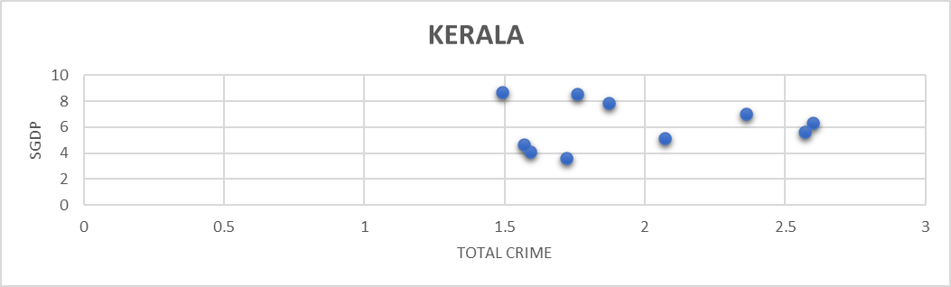

**SGDP (Economic growth)**

The above figure demonstrates the relationship between the state GDP and the total crime of selected states from 2011 to 2020. When we visualized our data using a scatter plot, we saw that in Delhi and four states, as SGDP rises, crime rates also tend to rise; however, several minor turning points in the curves are detected. However, the curves eventually seemed to decline and form an inverted U-shape. We can see a non-linear relationship between the two variables. The theory behind this could be as income rises, inequality in economic growth first rises and then starts to decline. During the early stages of economic growth, inequality increases and leads to more crime, but it starts to decline over time as the state becomes prosperous.

It was based on the idea of the Kuznets curve, he states that as income rises, inequality in economic growth first rises and then starts to decline.

An increase in per capita state product increases the crime rate, due to the rising inequality resulting from GDP growth.

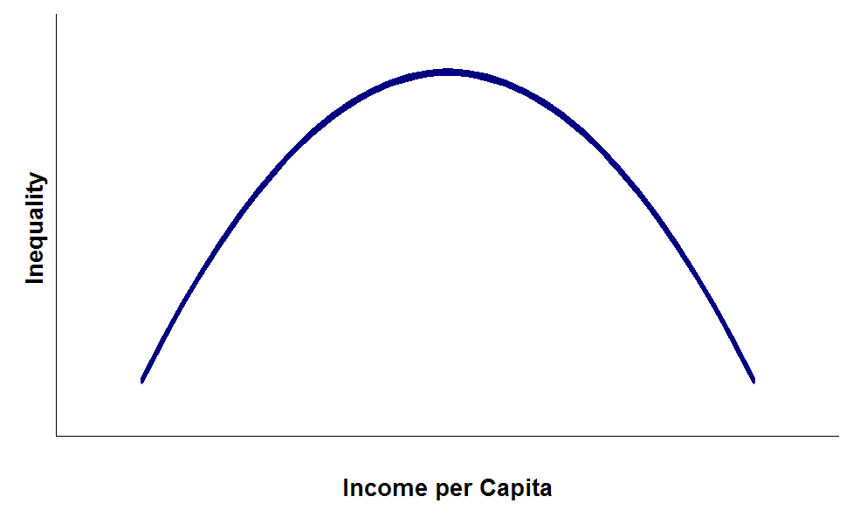

**Correlation**

we have tried to correlate Total crime with SGDP, poverty, unemployment, and literacy rate

|  |  |  |  |  |  |
| --- | --- | --- | --- | --- | --- |
|  | Total crime | GDP | Poverty | Unemployment | literacy rate |
| Total crime | 1 |  |  |  |  |
| GDP | 0.190512849 | 1 |  |  |  |
| Poverty | 0.56421772 | 0.246771056 | 1 |  |  |
| Unemployment | -0.266965718 | -0.540496989 | -0.41406849 | 1 |  |
| literacy rate | -0.236207789 | 0.072271098 | -0.62319216 | 0.574473482 | 1 |

**1.POVERTY**

The poverty variable is positively related to the crime categories and significantly impacts total crime and we expected a positive correlation between total crime and poverty. We got similar result with a positive correlation of 0.564 .Our Theory behind it is that there are multiple channels and circumstances through which poverty can impact or aggravate crime . Rising poverty increases the inequality between rich and poor, reducing the opportunity for better education, increasing unemployment, and worsening living conditions. All these factors can lead to crime. that poverty is a more valid factor influencing crime. As we know that India suffers from poverty, and at least two-thirds of the population live in poverty. For a vast population, that number is enormous. We cannot always conclude that only poor people commit crimes, but poverty likely creates a premise for criminal behavior. Apart from property crime, poverty can also influence a person to commit violent crimes and crimes against women by affecting their psychological well-being.

**2.UNEMPLOYMENT**

We expected positive correlation relationship between unemployment and total crime. due to the motivation effect that unemployment motivates people to commit crimes as criminal activities more attractive to generate more immediate financial gain. But too our surprise ,we got negative correlation of -0.266 between unemployment and total crime. But we have a theory to back our result , the crime rate may decrease due to increased unemployment as the opportunity to commit the crime is reduced because of increased guardianship by the unemployed population. Unemployed are available to provide better security and protection to their properties and families than people at work, creating less opportunity for criminals to participate in any criminal activities. Hence, it will create a negative effect on crime rates.

**3. LITERACY**

We expected the literacy rate and crime rate are negatively correlated and we got similar result with a negative correlation of -0.236 theory behind this is ,if the literacy rate are high , people are educated and crime rate are thus low as education impowers people and enhances human ability to think and comprehend .

So, education is the key here which can enhance human capital. Investment in human capital accumulation would target the problem areas like unemployment and poverty and reduce crimes in future. Furthermore, to overcome the ignorance of general population, government officials should educate people about poverty programs through various channels like advertisements on radios, TV and encourage them to participate.

**Hypothesis Testing**

We are conducting a hypothesis test ---- testing the crime committed by two genders. mean of male crime and female crime

|  |  |  |
| --- | --- | --- |
|  |  |  |
|  | total crime(Male) | total crime(Female) |
| Mean | 2915054.2 | 175902 |
| Variance | 3.14905E+12 | 22316458045 |
| Observations | 5 | 5 |
| Hypothesized Mean Difference | 0 |  |
| df | 4 |  |
| t Stat | 3.439361415 |  |
| P(T<=t) one-tail | 0.013154557 |  |
| t Critical one-tail | 2.131846786 |  |
| P(T<=t) two-tail | 0.026309113 |  |
| t Critical two-tail | 2.776445105 |  |

ho => MU1= MU2 ( Mean of male crime is less than equal to mean of female crime)

ha => MU1>MU2 ( Mean of male crime is more than mean of female crime)

if t stat is larger than then critical one tail value we reject Ho

Thus, we reject our null hypothesis.

**Inferences**

1. Male commits more crime than female and the reasons that we can draw is that it might be due to social or biological factors for example, release of testosterone has been linked to male being more aggressive and thus committing for crime.

2. Thinking the other way around women have pregnancy, responsibility for small children, etc.Thus have less chances of indulging in crime.

**Limitation and future recommendation**

There are certain limitations to this research. First is the availability of the data. The census of India is taken every ten years, and the latest data available was from 2011. Some essential variables that can influence crime, like inequality and population, are not included because the data are unavailable.

For future research, high crime states and low crime states can be studied separately to have a more concrete idea about which policies or program works better in each case. If data permits, including data points from districts, towns, and villages can also give a new approach to this research. The Indian legal system should be more versatile. Incorporating new laws and procedures according to the present crime scenario can enhance the effectiveness of the justice system. The major drawbacks of Indian legal system are the lack of transparency, lack of coordination and 47 corruption. This should be addressed to have consistency in the working of the legal system. More fast track courts, judges and lawyers should be appointed for speedy trials and conviction.

**Conclusion**

This study highlights the intricate relationship between economic growth (GDP) and crime rates in various Indian states. The findings reveal that, while rising GDP initially correlates with increased crime rates, this trend eventually reverses, forming an inverted U-shaped curve. This supports the Kuznets curve theory, suggesting that economic growth initially exacerbates inequality and crime but eventually leads to reduced crime as prosperity spreads.

The correlation analysis further emphasizes the significant role of socio-economic factors like poverty, unemployment, and literacy in influencing crime rates. Poverty, in particular, shows a strong positive correlation with crime, indicating that economic disparities and lack of resources can drive criminal behavior. On the other hand, unemployment and literacy show inverse relationships with crime, suggesting that higher education and better employment opportunities can mitigate criminal activities.

Although this research provides valuable insights, it is limited by the availability of data and the exclusion of other potential factors such as inequality and population. Future studies could benefit from a more granular analysis at the district or village level and consider additional variables to deepen the understanding of crime dynamics across different regions of India.

In conclusion, addressing socio-economic disparities through targeted policies on education, employment, and poverty reduction could play a crucial role in reducing crime rates. Moreover, reforms in the legal system and a more transparent and coordinated approach are essential for ensuring justice and maintaining social order.