Name: Mohitmaan Singh

Student Id: C0732141

2019W-T3 CSD 3184 - Mobile Development 04

Assignment 2

Screenshot 1

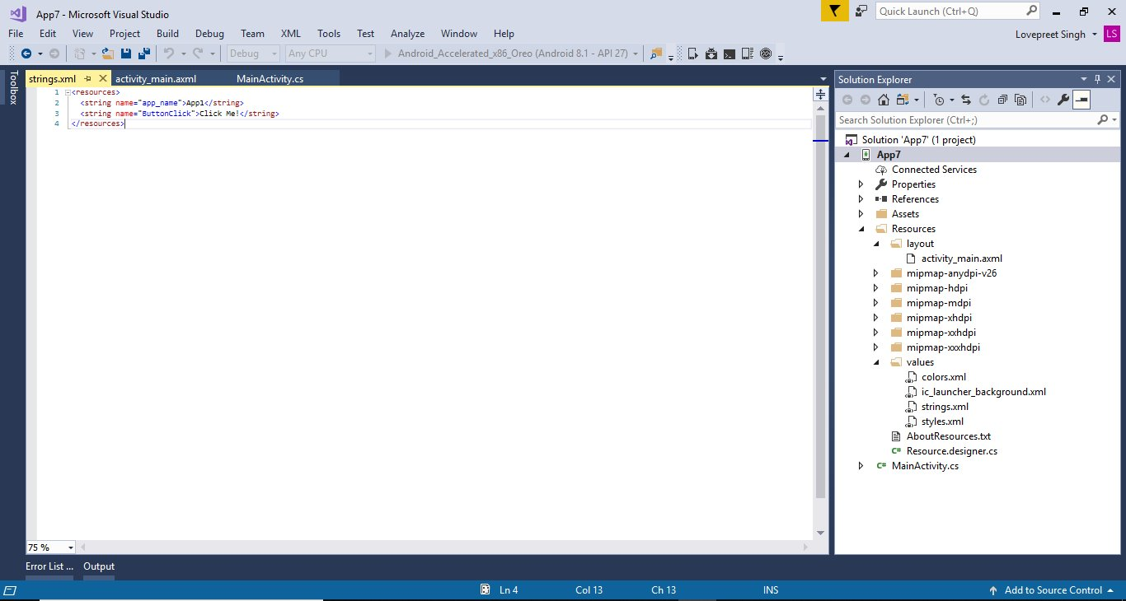

Screenshot 2

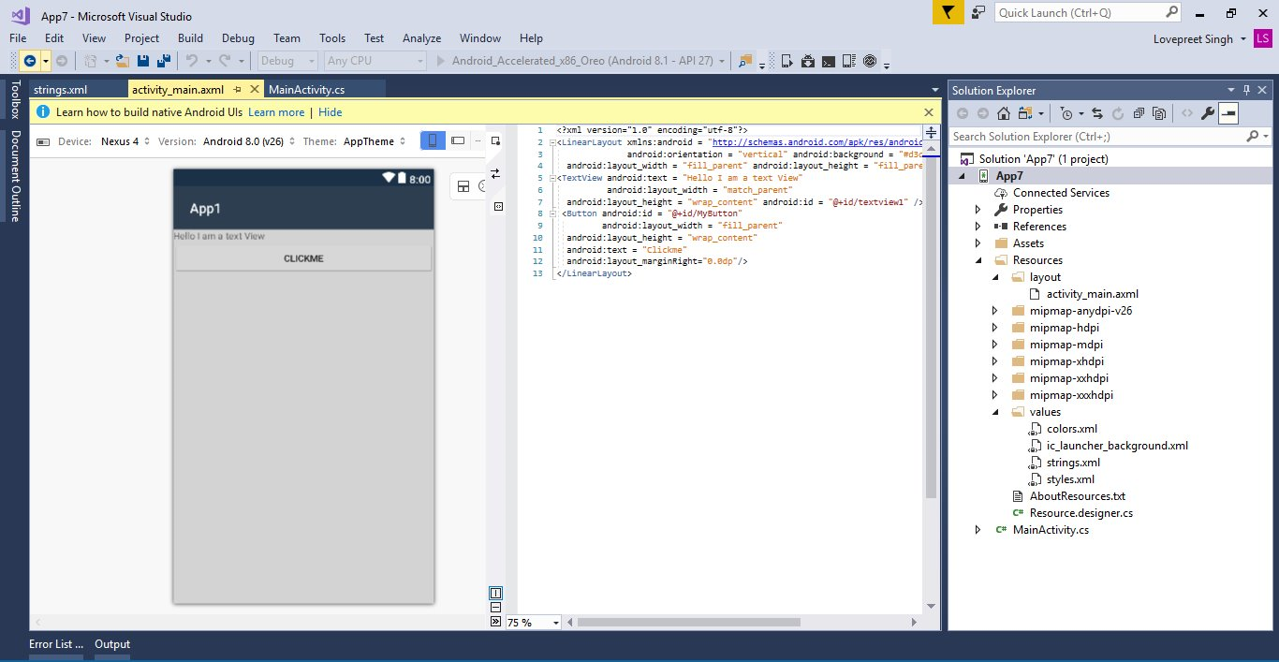

Screenshot 3

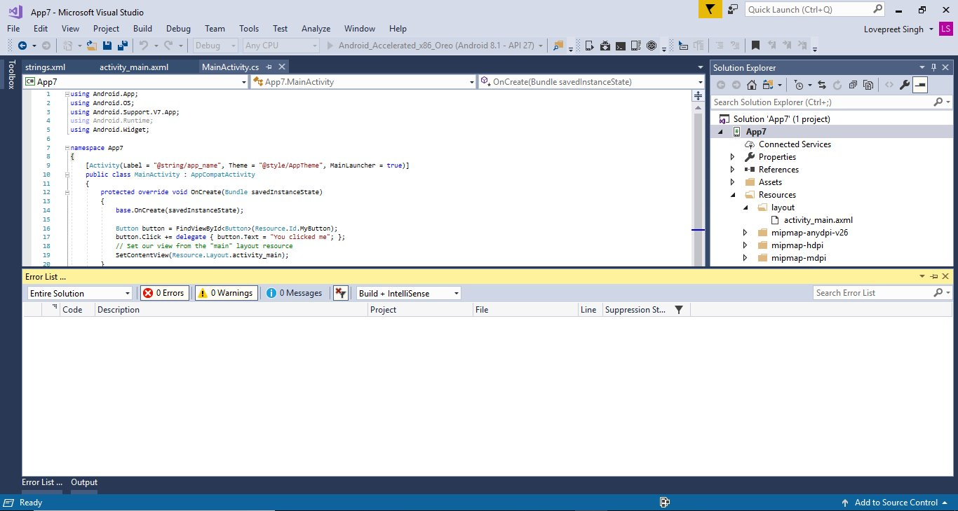

Screenshot 4

