**Name: Mohitmaan Singh**

**Student Id: C0732141**

**Mobile Development 04**

**CSD 3184**

**Assignment 3**

**Date Picker**: The following screenshots are

Screenshot 1

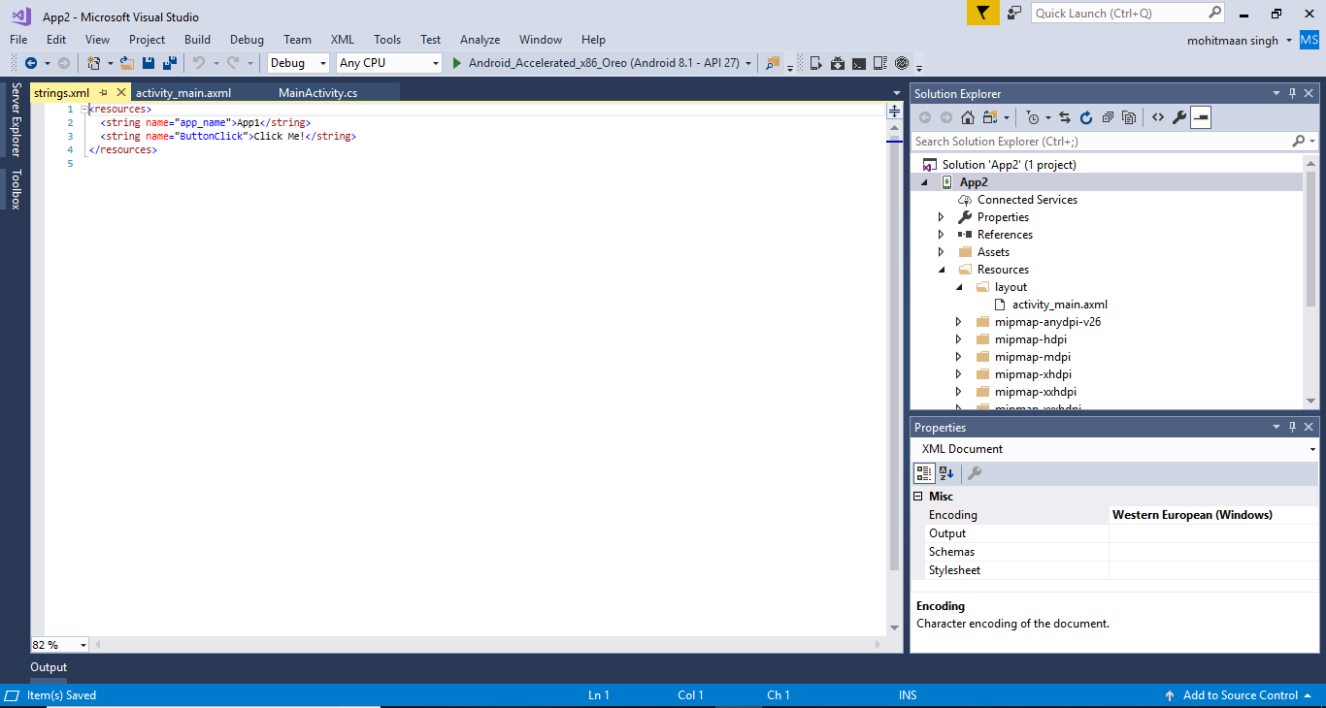

Screenshot 2

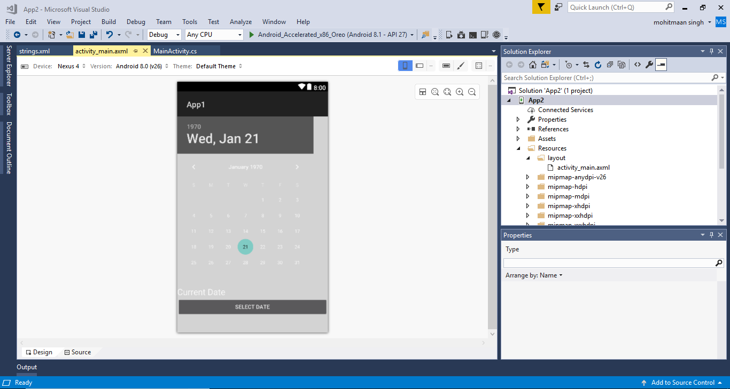

Screenshot 3

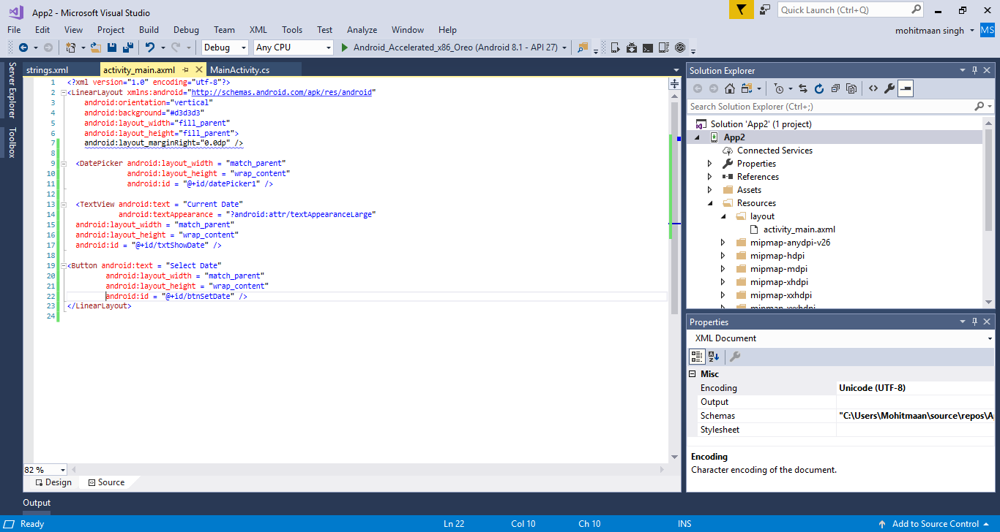

Screenshot 4

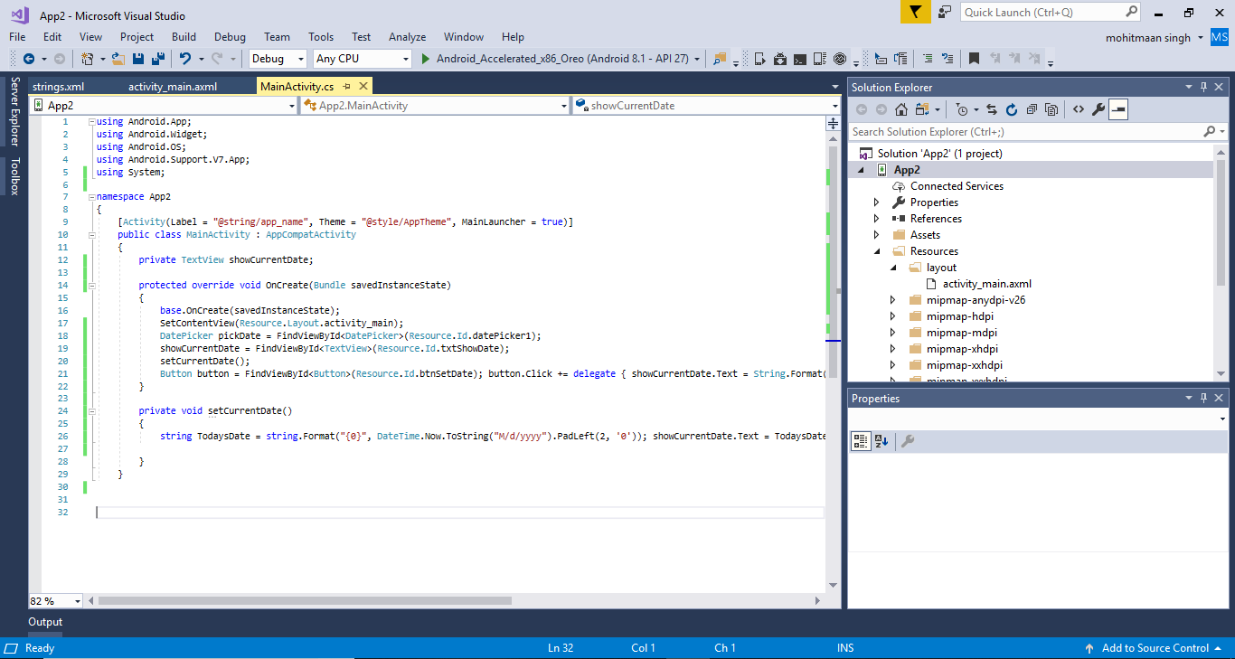

**Time Picker**: The following screenshots are

Screenshot 1

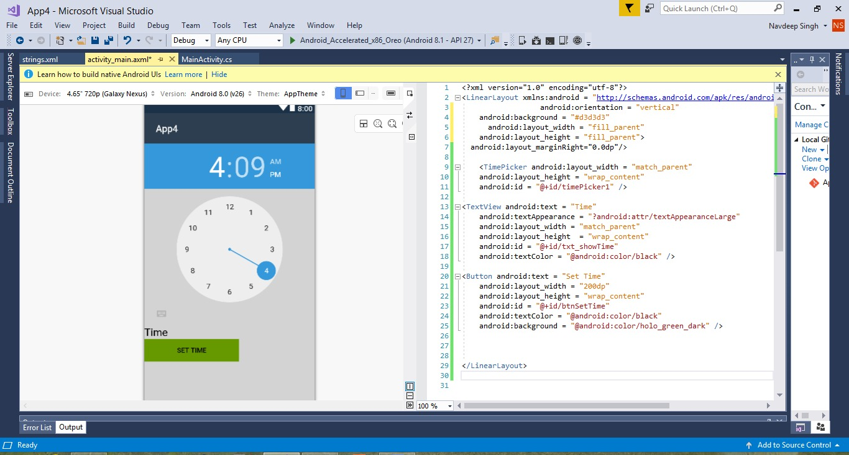

Screenshot 2

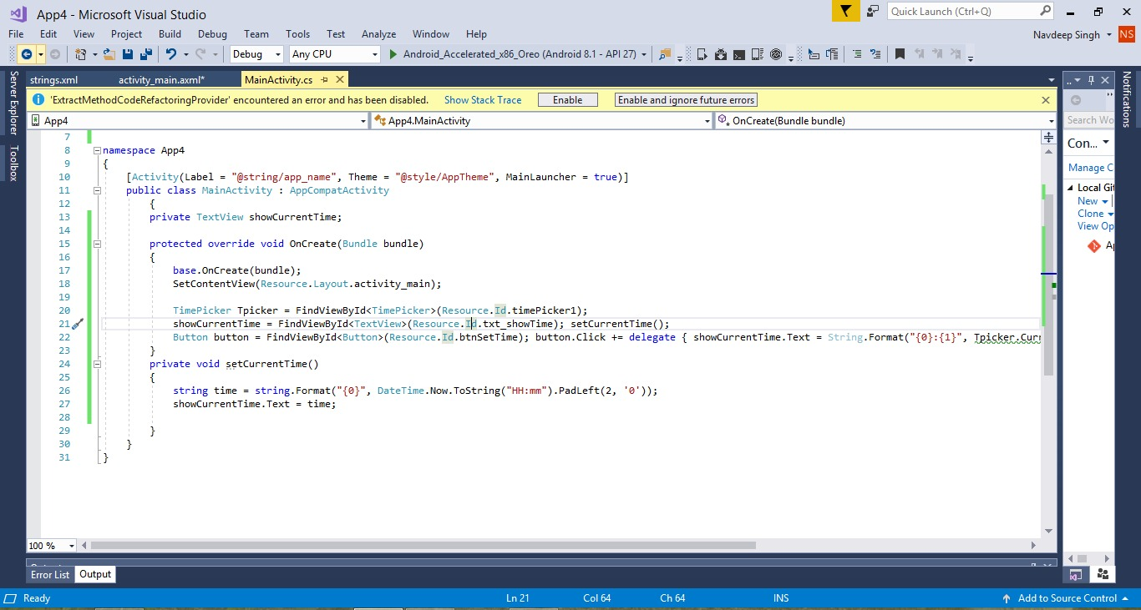

Screenshot 3

