EXPERIMENT 2

NAME:MOHIT PATIL CLASS:D15A ROLL NO:37

**Aim** :To Build Your Application using AWS CodeBuild and Deploy on S3 / SEBS using AWS CodePipeline, deploy Sample Application on EC2 instance using AWS CodeDeploy.

**Elastic Beanstalk**

Step 1: create environment

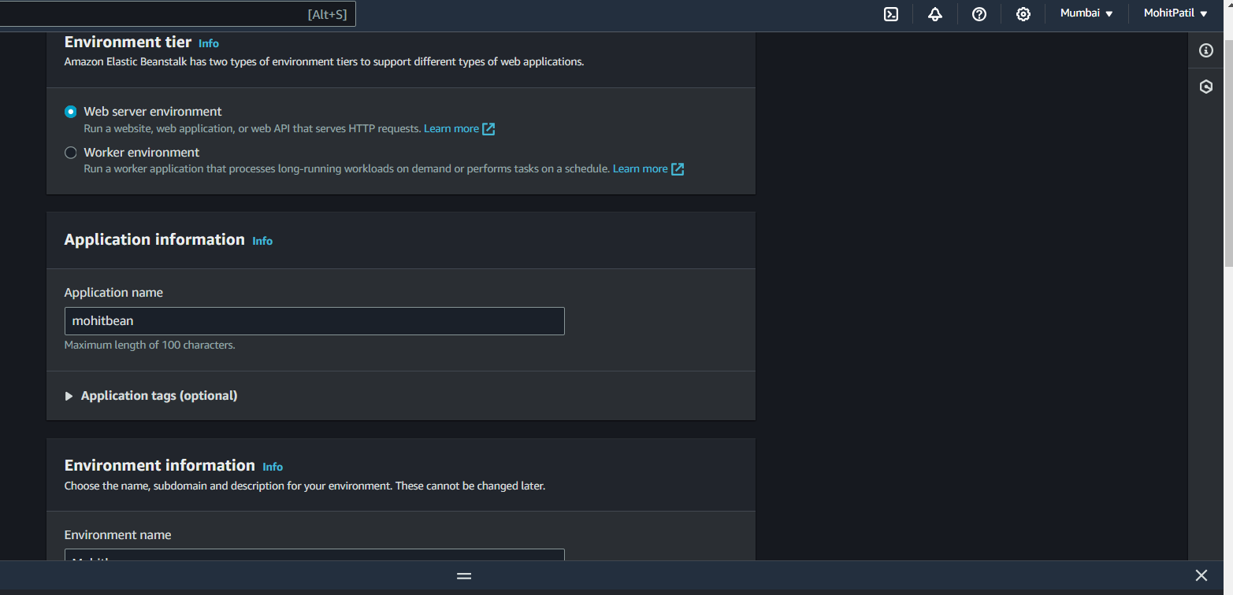

Step 2 : add your Ec2 key pair and instance profile

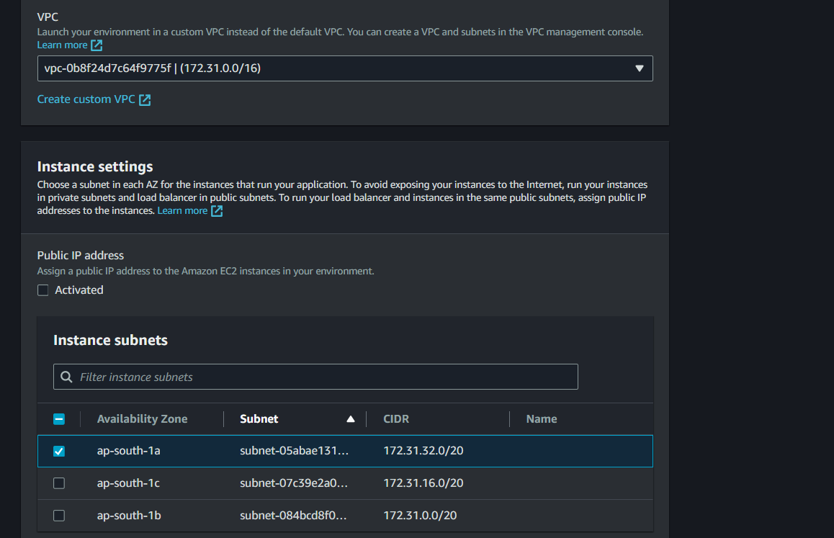

Step 3 : add security config and review all settings

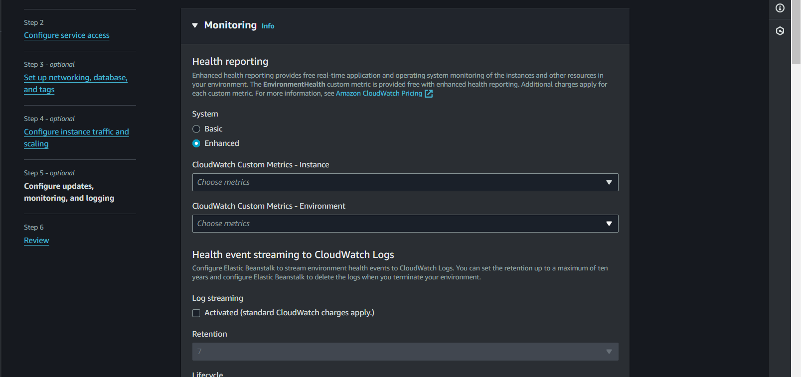

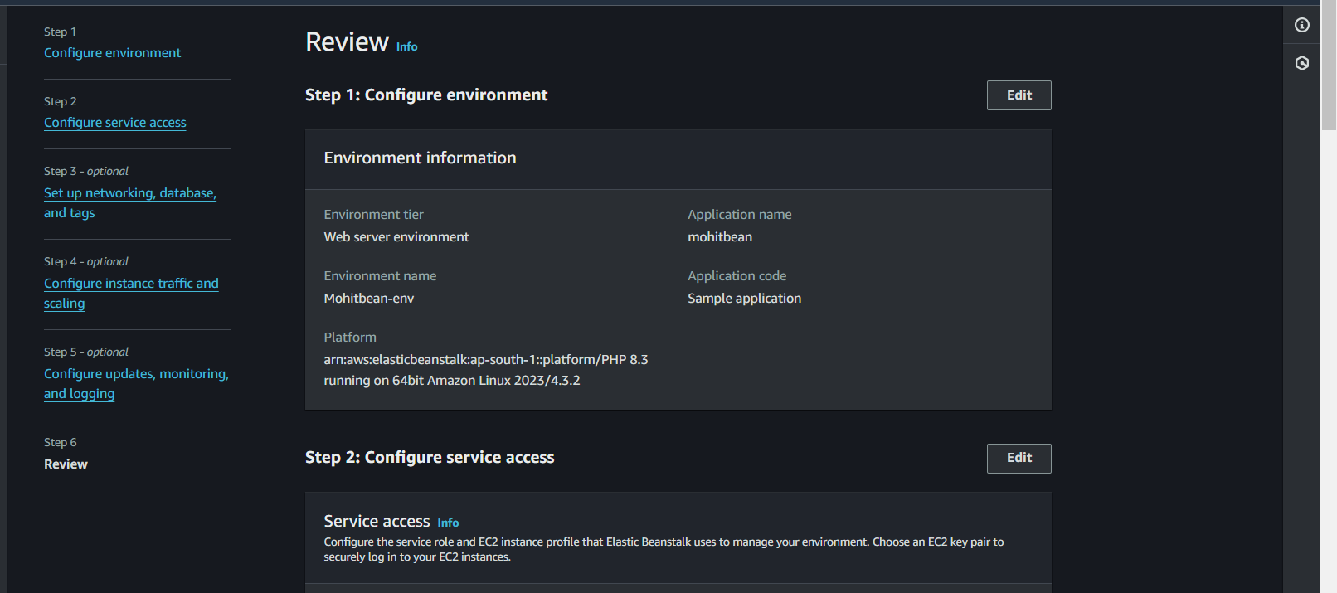

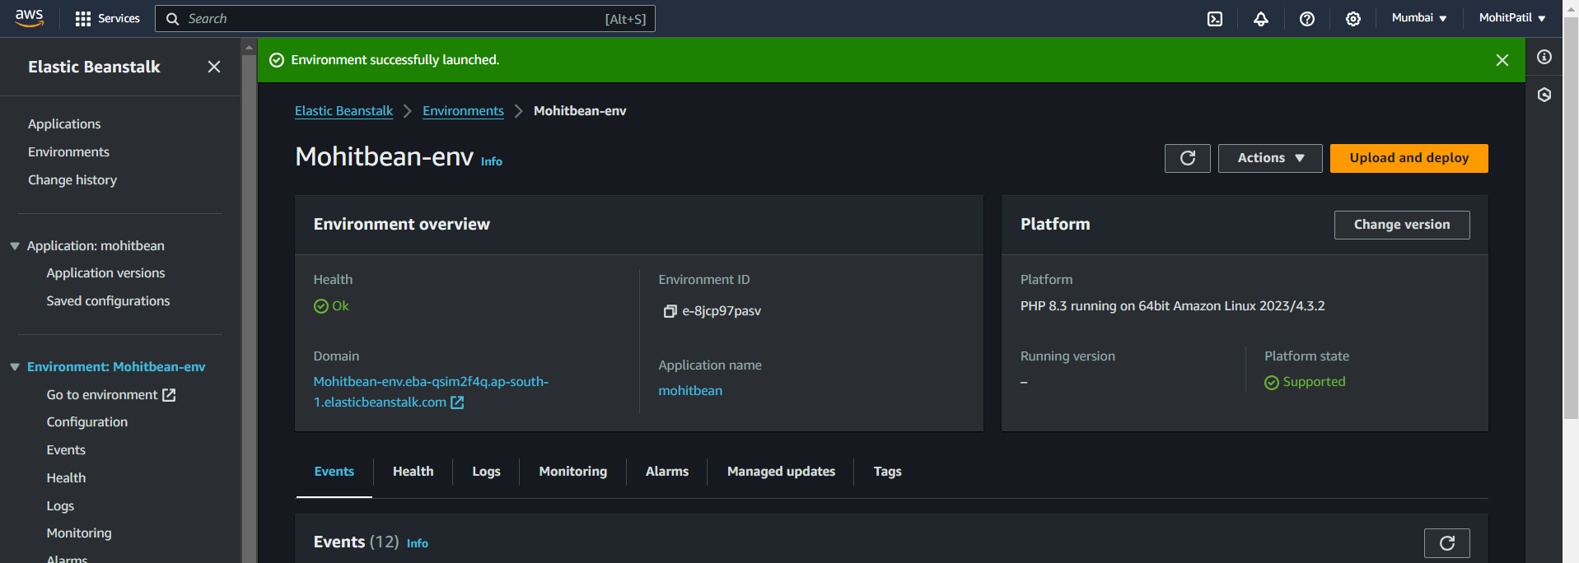

Step 4 : Beanstalk environment is created

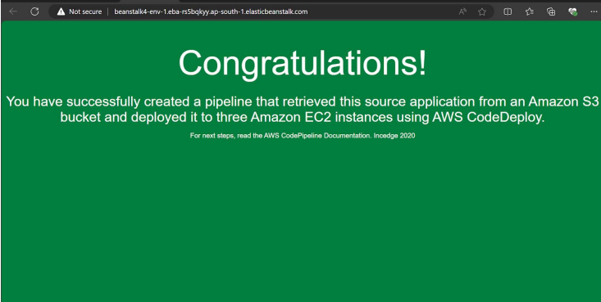

view the pipeline build and deployment

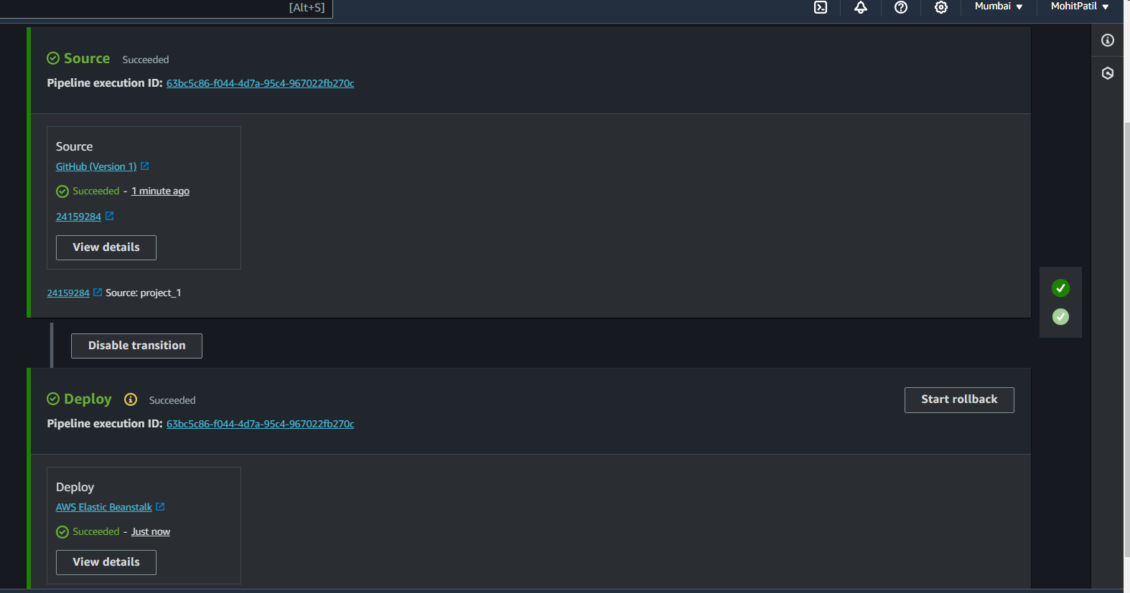

Check the deployed website at beanstalk link

