University Institute of Engineering and Technology
Department of Computer Science and Engineering
Kurukshetra University Kurukshetra
Kurukshetra-136119


(SESSION 2022-26)
B.TECH PROJECT REPORT
ON
TYPING MASTER APPLICATION
(MERN Stack Web Application)

Submitted to:  Dr. Poonam Dabas  Associate Professor  CSE Department, UIET KUK | Submitted by:  Shrom Verma  Roll No: 252202002  Section: CSE-A  Session: 2022-26

University Institute of Engineering and Technology
Department of Computer Science and Engineering
Kurukshetra University, Kurukshetra – 136119

CERTIFICATE
This is to certify that Shrom Verma, Roll No. 252202002, Section: CSE-A, a student of B.Tech (Computer Science & Engineering), Session 2022-26 at University Institute of Engineering and Technology, Kurukshetra University Kurukshetra, has successfully completed the B.Tech Project entitled "Typing Master Application" under the supervision of the undersigned, in partial fulfillment of the requirements for the award of the degree of Bachelor of Technology in Computer Science and Engineering.
The work is original, sincere, and carried out in good faith. The project has been submitted to the department for evaluation.

___________________________  Dr. Poonam Dabas  Associate Professor  CSE Department, UIET KUK | ___________________________  Head of Department  Department of CSE  UIET, Kurukshetra University
Date: _____________________
Place: Kurukshetra

CANDIDATE'S DECLARATION

I, Shrom Verma, Roll No. 252202002, Section: CSE-A, pursuing B.Tech (Computer Science & Engineering), Session 2022-26, hereby declare that the B.Tech Project Report entitled "Typing Master Application" is an authentic record of my own work carried out under the guidance of Dr. Poonam Dabas, Associate Professor, Department of CSE, UIET, Kurukshetra University Kurukshetra.
I further declare that the content of this report has not been submitted to any other university or institution for the award of any degree or diploma. The project has been completed sincerely to the best of my knowledge and belief.
All the references and sources of information used in this report have been duly cited and acknowledged.

Date: _____________________
Place: Kurukshetra

___________________________
Shrom Verma
Roll No: 252202002
Section: CSE-A
B.Tech CSE, Session 2022-26

ACKNOWLEDGEMENT

I would like to express my sincere gratitude and heartfelt thanks to all those who have supported and guided me throughout the completion of this B.Tech project on the "Typing Master Application".
First and foremost, I am deeply grateful to my project guide, Dr. Poonam Dabas, Associate Professor, Department of CSE, UIET, Kurukshetra University Kurukshetra, for her invaluable guidance, continuous encouragement, and constructive suggestions throughout the project. Her expert advice helped shape this project into its final form.
I also extend my gratitude to the Head of the Department of Computer Science and Engineering, UIET, Kurukshetra University, for providing the necessary facilities and a conducive environment for the project work.
I am equally thankful to all the faculty members of the CSE department whose knowledge and support during the academic years laid the foundation for this work.
Last but not least, I would like to thank my family and friends for their moral support, encouragement, and patience throughout the journey.

___________________________
Shrom Verma
Roll No: 252202002

TABLE OF CONTENTS

CHAPTER / SECTION | PAGE NO.
Abstract | 6
1.0 Introduction | 7
1.1 Objectives of the Project | 8
1.2 Methodology | 9
2.0 Technology Used | 10
2.1 Frontend Technology (React + Vite) | 11
2.2 Backend Technology (Node.js + Express.js) | 12
2.3 Three Tier Architecture | 13
2.4 Data Flow Analysis | 13
3.0 Weekly Report (Week 1 to Week 6) | 14
4.0 System Design | 15
5.0 Implementation | 16
6.0 Testing | 17
7.0 Output | 18
8.0 Advantages | 19
9.0 Limitations | 19
10.0 Conclusion | 20
11.0 Future Scope | 21
12.0 References | 22

ABSTRACT

The Typing Master Application is a full-stack, web-based platform developed using the MERN stack — MongoDB, Express.js, React, and Node.js — designed to help users improve their typing speed, accuracy, and consistency through interactive and gamified typing exercises.
The application features a real-time typing test engine that calculates Words Per Minute (WPM), accuracy percentage, and character error rate. Users can register and log in via a secure JWT-based authentication system, track their historical performance through a personal dashboard, and compete on a global leaderboard.
The frontend is built using React with Vite, ensuring blazing-fast build times and a highly responsive UI. The backend is powered by Node.js and Express.js, serving RESTful APIs that communicate with a MongoDB Atlas cloud database. The application is deployed on Vercel (frontend) and Render (backend), enabling global accessibility with minimal latency.
This report documents the design, architecture, development, testing, and deployment of the Typing Master Application, providing a comprehensive overview of the technologies used and the challenges overcome during the project lifecycle.

Project Title | Typing Master Application
Technology Stack | MongoDB, Express.js, React (Vite), Node.js
Deployment | Frontend: Vercel | Backend: Render
Database | MongoDB Atlas (Cloud)

1.0 INTRODUCTION

In today's digital world, typing is one of the most fundamental skills required in virtually every professional domain — from software development and data entry to communication and content creation. The speed and accuracy of typing directly impact productivity, making it a highly sought-after skill in the modern workforce.
The Typing Master Application addresses this need by providing an interactive, gamified, and performance-tracked typing practice environment. Unlike traditional typing tutors, this application leverages modern web technologies to deliver a seamless experience across devices, store historical performance data in the cloud, and offer real-time feedback to the user.
The application is built on the MERN (MongoDB, Express.js, React, Node.js) stack — one of the most popular and powerful full-stack JavaScript ecosystems. The frontend uses React with Vite, ensuring a fast, modular, and responsive UI. The backend is a RESTful API server built with Node.js and Express.js. All user data and performance metrics are stored in MongoDB Atlas, a fully managed cloud database service.
This project was undertaken as a final-year B.Tech project to demonstrate the capability to design, develop, test, and deploy a production-ready web application. The system encompasses user authentication, real-time metrics computation, profile management, and a global leaderboard — making it a comprehensive full-stack solution.

1.1 Objectives of the Project

The primary objectives of the Typing Master Application are as follows:
- To develop a real-time typing speed and accuracy measurement system that provides instant feedback on typing performance.
- To implement a secure user authentication system using JWT tokens enabling users to register, log in, and maintain personal profiles.
- To store and retrieve user performance history from a MongoDB Atlas cloud database, allowing longitudinal progress tracking.
- To build a global leaderboard that displays and ranks users by their best typing speeds, promoting healthy competition.
- To design a responsive, intuitive, and visually appealing UI using React and modern CSS frameworks.
- To deploy the application on cloud platforms (Vercel and Render) to ensure global availability and scalability.
- To apply software engineering principles including modular architecture, RESTful API design, and proper testing methodologies.

1.2 Methodology

The development of the Typing Master Application followed the Agile Software Development Methodology, which emphasizes iterative development, collaboration, and flexibility. The project was divided into six weekly sprints, each targeting a specific module or feature of the application.
The methodology employed the following phases:
- Requirement Analysis: Identification of core features, user stories, and system requirements.
- System Design: Architecture design including Three-Tier Architecture, database schema, and API design.
- Frontend Development: Building the React + Vite UI with component-based architecture.
- Backend Development: Creating RESTful APIs with Node.js and Express.js, including authentication middleware.
- Database Integration: Connecting the backend to MongoDB Atlas and defining Mongoose schemas.
- Testing: Unit testing, integration testing, and UI testing using manual and automated approaches.
- Deployment: Frontend deployed on Vercel, backend on Render, with environment variable management.

2.0 TECHNOLOGY USED

The Typing Master Application is built using the MERN stack — a robust, JavaScript-based full-stack framework that enables seamless development from frontend to backend. Each technology was selected for its performance, community support, and suitability for real-time web applications.

2.1 Frontend Technology — React + Vite
React.js (v18+): React is a declarative, component-based JavaScript library developed by Meta for building fast and interactive user interfaces. In the Typing Master Application, React powers the entire frontend — from the typing test component to the user dashboard and leaderboard. React's virtual DOM ensures efficient re-rendering, which is critical for real-time metrics updates during a typing test.
Vite: Vite is a next-generation frontend build tool that provides an extremely fast development server and optimized production builds. Unlike Create React App (CRA), Vite uses native ES modules in development, resulting in near-instantaneous hot module replacement (HMR). This significantly accelerated the development workflow for this project.
React Router DOM: Used for client-side routing, enabling navigation between pages (Home, Login, Register, Dashboard, Leaderboard) without full-page reloads, maintaining the single-page application (SPA) experience.
Axios: Axios is a promise-based HTTP client used in the frontend to communicate with the backend REST APIs. It supports interceptors for attaching JWT tokens to every authenticated request.
CSS / Tailwind CSS: The application uses modern CSS with utility-first styling for a clean, responsive, and mobile-friendly interface.

2.2 Backend Technology — Node.js + Express.js
Node.js: Node.js is an open-source, cross-platform JavaScript runtime built on Chrome's V8 engine. It enables server-side JavaScript execution, making it ideal for building scalable network applications. In the Typing Master Application, Node.js serves as the runtime environment for the backend server.
Express.js: Express.js is a minimal and flexible Node.js web application framework that provides robust features for building RESTful APIs. The backend exposes endpoints for user authentication, test submission, profile retrieval, and leaderboard access.
MongoDB Atlas + Mongoose: MongoDB is a NoSQL document database. MongoDB Atlas is the fully managed cloud version. Mongoose is the ODM (Object Data Modelling) library that provides schema-based data modeling for MongoDB in Node.js, used for defining User and TestResult schemas.
JSON Web Token (JWT) + bcrypt.js: JWT is used for stateless user authentication. bcrypt.js is used to hash user passwords before storing them in the database, ensuring data security.

2.3 Three Tier Architecture
The Typing Master Application follows the Three-Tier (3-Tier) Architecture pattern, which separates the application into three logical and physical computing tiers:
Tier | Layer | Technology
Presentation Tier | User Interface Layer | React + Vite (Vercel)
Application Tier | Business Logic Layer | Node.js + Express.js (Render)
Data Tier | Data Storage Layer | MongoDB Atlas (Cloud DB)

2.4 Data Flow Analysis
The data flow within the Typing Master Application can be described as follows:
- The user interacts with the React frontend (Presentation Tier) by typing in the test area.
- On test completion, the frontend sends a POST request with the test result data (WPM, accuracy, duration) to the Express.js backend API via Axios, attaching the JWT token in the request header.
- The backend middleware validates the JWT token. If valid, the result is processed by the controller.
- The controller uses Mongoose to save the TestResult document to MongoDB Atlas (Data Tier).
- For the dashboard, the backend retrieves the user's historical results from MongoDB and returns them as JSON to the frontend.
- The leaderboard endpoint queries all users' best scores, sorts them, and returns the ranked list to the frontend for display.

3.0 WEEKLY REPORT (WEEK 1 TO WEEK 6)

The following section documents the week-by-week progress made during the development of the Typing Master Application over a 6-week timeline. Each week corresponds to a specific phase of development.

Week 1 (Day 1–7): Project Setup & Requirement Analysis
1 | Finalized the project topic: Typing Master Application (MERN Stack).
2 | Set up the development environment: Node.js, MongoDB Compass, VS Code, and GitHub repository.
3 | Initialized the React + Vite frontend project using `npm create vite@latest`.
4 | Initialized the Node.js + Express.js backend with basic folder structure.
5 | Defined the project requirements: user authentication, real-time WPM calculation, leaderboard, and dashboard.
6 | Created the initial MongoDB Atlas cluster and obtained the connection URI.

Week 2 (Day 8–14): Backend Development — Authentication APIs
1 | Designed the User schema using Mongoose (name, email, password, createdAt).
2 | Implemented the user registration API endpoint (POST /api/auth/register) with bcrypt.js password hashing.
3 | Implemented the user login API endpoint (POST /api/auth/login) with JWT token generation.
4 | Created the auth middleware to protect private routes using JWT verification.
5 | Tested all authentication endpoints using Postman.
6 | Configured environment variables using dotenv for database URI and JWT secret.

Week 3 (Day 15–21): Frontend Development — UI & Auth Flow
1 | Built the React component structure: App.jsx, Home, Login, Register, Dashboard, Leaderboard, TypingTest.
2 | Implemented React Router DOM for client-side routing.
3 | Designed the Login and Register forms with form validation and Axios API calls.
4 | Implemented JWT token storage in localStorage and user context using React Context API.
5 | Built the protected route component to redirect unauthenticated users.
6 | Styled all pages using Tailwind CSS for a responsive layout.

Week 4 (Day 22–28): Core Feature — Typing Test Engine
1 | Developed the real-time TypingTest component with keystroke event tracking.
2 | Implemented WPM calculation: (Total Words Typed / Time in Minutes).
3 | Implemented Accuracy calculation: (Correct Characters / Total Characters) × 100.
4 | Added color-coded feedback: green for correct characters, red for incorrect.
5 | Implemented a countdown timer using React's useState and useEffect hooks.
6 | Built the test result submission: POST /api/results with WPM, accuracy, and time on test completion.

Week 5 (Day 29–35): Dashboard, Leaderboard & Database Integration
1 | Designed the TestResult schema: userId, wpm, accuracy, duration, timestamp.
2 | Implemented GET /api/results/history — retrieves all test results for the logged-in user.
3 | Built the user Dashboard component displaying historical results in a table with charts.
4 | Implemented GET /api/leaderboard — aggregates users' best WPM scores and sorts them.
5 | Built the Leaderboard component with rank, username, and WPM columns.
6 | Integrated MongoDB Atlas with full CRUD operations and connection pooling.

Week 6 (Day 36–42): Testing, Bug Fixes & Deployment
1 | Performed unit testing of all backend API endpoints using Postman and manual test cases.
2 | Conducted frontend UI testing across Chrome, Firefox, and mobile browsers.
3 | Fixed authentication bugs, CORS issues, and token expiry handling.
4 | Deployed the frontend on Vercel with environment variables configured.
5 | Deployed the backend on Render with MongoDB Atlas URI and JWT secret configured.
6 | Conducted end-to-end testing on the live deployed application and documented the output.

4.0 SYSTEM DESIGN

The system design of the Typing Master Application defines the overall architecture, component interaction, and database structure. This section covers the high-level architecture diagram, database schema, and API design.

4.1 High-Level Architecture
The application follows a client-server architecture based on the Three-Tier pattern. The client (React + Vite) communicates with the server (Node.js + Express.js) via RESTful HTTP APIs. The server interacts with the database (MongoDB Atlas) using Mongoose.
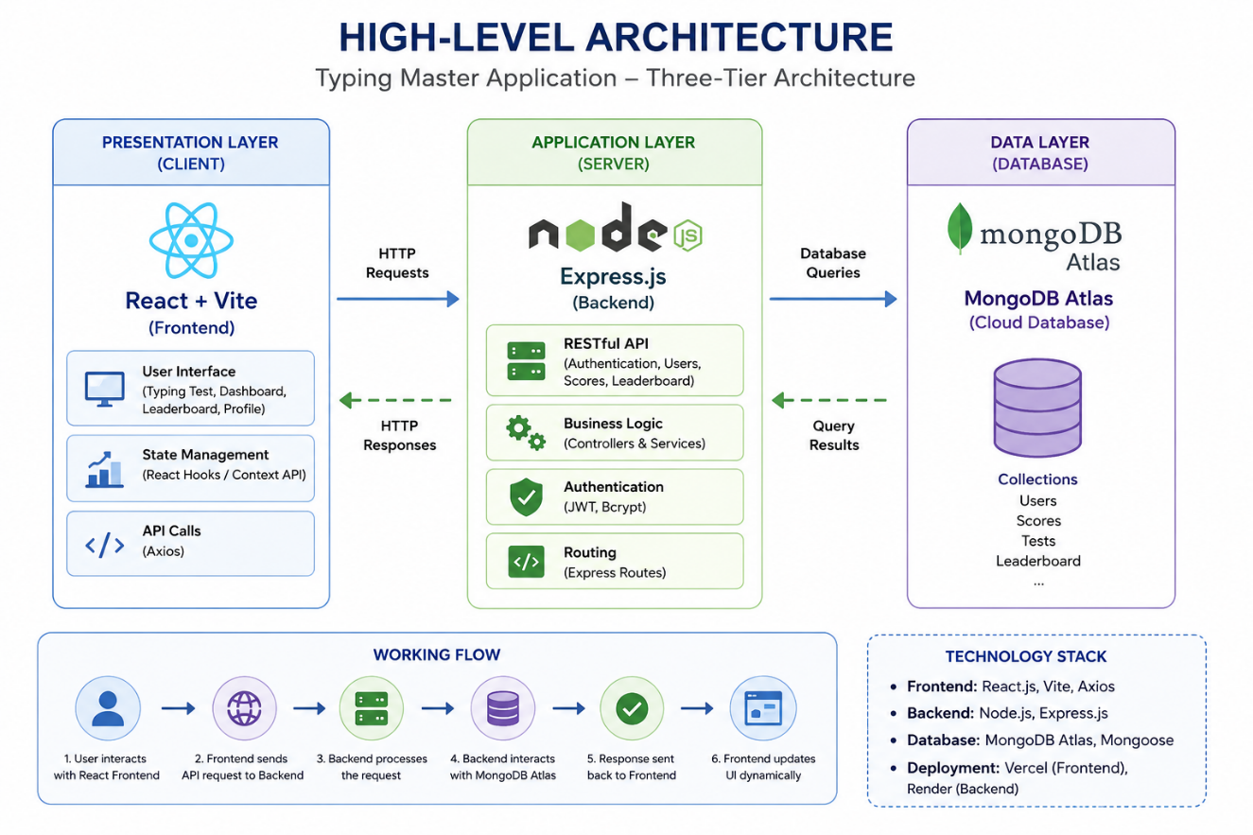

4.2 Database Schema
The application uses two primary Mongoose schemas stored in MongoDB Atlas:
User Schema:
Field | Type | Required | Description
name | String | Yes | Full name of the user
email | String | Yes | Unique email address
password | String | Yes | Bcrypt hashed password
createdAt | Date | Auto | Account creation timestamp

TestResult Schema:
Field | Type | Required | Description
userId | ObjectId | Yes | Reference to User document
wpm | Number | Yes | Words per minute score
accuracy | Number | Yes | Accuracy percentage
duration | Number | Yes | Test duration in seconds
timestamp | Date | Auto | Date and time of test

4.3 API Design
Method | Endpoint | Auth | Description
POST | /api/auth/register | No | Register new user
POST | /api/auth/login | No | Login and get JWT
GET | /api/user/profile | Yes | Get logged-in user profile
POST | /api/results | Yes | Submit typing test result
GET | /api/results/history | Yes | Get user's past results
GET | /api/leaderboard | No | Get global leaderboard

5.0 IMPLEMENTATION

This section covers the technical implementation of the Typing Master Application. The codebase is organized into two primary directories: `client/` (React + Vite frontend) and `server/` (Node.js + Express.js backend).

5.1 Project Folder Structure
[ Project directory tree — paste your folder structure here ]

5.2 Backend — Server Setup (server.js / index.js)
The main entry point initializes the Express server, connects to MongoDB Atlas, applies CORS and JSON middleware, and mounts the API routers.
index.js
import express from 'express';
import dotenv from 'dotenv';
import cors from 'cors';
import connectDB from './config/db.js';
import { notFound, errorHandler } from './middleware/errorMiddleware.js';
import authRoutes from './routes/authRoutes.js';
import testRoutes from './routes/testRoutes.js';
import leaderboardRoutes from './routes/leaderboardRoutes.js';

dotenv.config();

connectDB();

const app = express();

app.use(cors({
origin: function (origin, callback) {
// Allow all origins for development/testing
callback(null, true);
},
credentials: true
}));
app.use(express.json());

app.get('/', (req, res) => {
res.send('API is running...');
});

app.use('/api/auth', authRoutes);
app.use('/api/tests', testRoutes);
app.use('/api/leaderboard', leaderboardRoutes);

app.use(notFound);
app.use(errorHandler);

const PORT = process.env.PORT || 5000;

app.listen(PORT, () => {
console.log(`Server running in ${process.env.NODE_ENV} mode on port ${PORT}`);
});

5.3 Backend — Authentication Controller
The auth controller handles user registration (with bcrypt password hashing) and login (with JWT generation).
authController.js
import asyncHandler from 'express-async-handler';
import User from '../models/User.js';
import generateToken from '../utils/generateToken.js';

// @desc Auth user & get token
// @route POST /api/auth/login
// @access Public
const authUser = asyncHandler(async (req, res) => {
const { email, password } = req.body;

const user = await User.findOne({ email });

if (user && (await user.matchPassword(password))) {
res.json({
_id: user._id,
username: user.username,
email: user.email,
isAdmin: user.isAdmin,
avatar: user.avatar,
token: generateToken(user._id),
});
} else {
res.status(401);
throw new Error('Invalid email or password');
}
});

// @desc Register a new user
// @route POST /api/auth/register
// @access Public
const registerUser = asyncHandler(async (req, res) => {
const { username, email, password } = req.body;

const userExists = await User.findOne({ email });

if (userExists) {
res.status(400);
throw new Error('User already exists');
}

const user = await User.create({
username,
email,
password,
});

if (user) {
res.status(201).json({
_id: user._id,
username: user.username,
email: user.email,
isAdmin: user.isAdmin,
avatar: user.avatar,
token: generateToken(user._id),
});
} else {
res.status(400);
throw new Error('Invalid user data');
}
});

// @desc Get user profile
// @route GET /api/auth/profile
// @access Private
const getUserProfile = asyncHandler(async (req, res) => {
const user = await User.findById(req.user._id);

if (user) {
res.json({
_id: user._id,
username: user.username,
email: user.email,
isAdmin: user.isAdmin,
avatar: user.avatar,
bio: user.bio,
totalTests: user.totalTests,
highestWPM: user.highestWPM,
averageWPM: user.averageWPM,
streak: user.streak
});
} else {
res.status(404);
throw new Error('User not found');
}
});

export { authUser, registerUser, getUserProfile };

5.4 Backend — Results Controller & Leaderboard
The results controller saves test results to MongoDB and retrieves user history and global leaderboard data.
resultsController.js
import express from 'express';
const router = express.Router();
import {
authUser,
registerUser,
getUserProfile,
} from '../controllers/authController.js';
import { protect } from '../middleware/authMiddleware.js';

router.post('/register', registerUser);
router.post('/login', authUser);
router.route('/profile').get(protect, getUserProfile);

export default router;

5.5 Frontend — TypingTest Component
The TypingTest component is the core feature of the application. It tracks user keystrokes, calculates WPM and accuracy in real time, and submits results on test completion.
TypingTest.jsx
import React, { useState, useEffect, useRef } from 'react';
import { motion } from 'framer-motion';
import { testService } from '../services/api';
import './TypingEngine.css';

const TEXTS = [
"The quick brown fox jumps over the lazy dog. Programming is the art of algorithm design and the craft of debugging errant code. It requires patience and logic.",
"In the world of software development, clean code is not just a preference, it is a necessity for maintainable systems that scale over time.",
"Gamification makes everything better. Typing speed tests are no exception. Push your limits and reach new heights by typing as fast as you can.",
"The most important property of a program is whether it accomplishes the intention of its user. Good programmers write code that humans can understand.",
"There are two ways of constructing a software design. One way is to make it so simple that there are obviously no deficiencies. The other way is more complex."
];

const TypingEngine = ({ timeLimit = 60 }) => {
const [text, setText] = useState('');
const [userInput, setUserInput] = useState('');
const [startTime, setStartTime] = useState(null);
const [timeLeft, setTimeLeft] = useState(timeLimit);
const [wpm, setWpm] = useState(0);
const [accuracy, setAccuracy] = useState(100);
const [isFinished, setIsFinished] = useState(false);
const inputRef = useRef(null);
const timerRef = useRef(null);

useEffect(() => {
// Generate a long text by repeating paragraphs to ensure they don't run out of text easily
const baseText = TEXTS[Math.floor(Math.random() * TEXTS.length)];
setText(`${baseText} ${TEXTS[Math.floor(Math.random() * TEXTS.length)]} ${baseText}`);
setTimeLeft(timeLimit);
setUserInput('');
setStartTime(null);
setWpm(0);
setAccuracy(100);
setIsFinished(false);
if (timerRef.current) clearInterval(timerRef.current);
}, [timeLimit]);

useEffect(() => {
if (timeLeft === 0 && !isFinished) {
handleFinish();
}
}, [timeLeft]);

const handleFinish = async () => {
setIsFinished(true);
if (timerRef.current) clearInterval(timerRef.current);

const timeElapsed = timeLimit - timeLeft || 1; // avoid division by zero

// Final recalculation just in case
const wordsTyped = userInput.length / 5;
const finalWpm = Math.round(wordsTyped / (timeElapsed / 60));
setWpm(finalWpm || 0);

let mistakesCount = 0;
for (let i = 0; i < userInput.length; i++) {
if (userInput[i] !== text[i]) mistakesCount++;
}

try {
const userInfo = localStorage.getItem('userInfo');
if (userInfo) {
await testService.saveScore({
wpm: finalWpm || 0,
accuracy,
mistakes: mistakesCount,
mode: 'timed',
difficulty: 'medium',
duration: timeElapsed
});
}
} catch (error) {
console.error("Failed to save score:", error);
}
};

const handleChange = (e) => {
if (isFinished) return;

const val = e.target.value;
setUserInput(val);

if (!startTime) {
setStartTime(Date.now());
timerRef.current = setInterval(() => {
setTimeLeft(prev => {
if (prev <= 1) {
clearInterval(timerRef.current);
return 0;
}
return prev - 1;
});
}, 1000);
}

// Live Stats
const timeElapsed = timeLimit - timeLeft || 1; // seconds
const wordsTyped = val.length / 5;
const currentWpm = Math.round(wordsTyped / (timeElapsed / 60));
setWpm(currentWpm || 0);

let correctChars = 0;
for (let i = 0; i < val.length; i++) {
if (val[i] === text[i]) correctChars++;
}
setAccuracy(Math.round((correctChars / val.length) * 100) || 100);

// If they magically type the whole giant text, finish early
if (val.length === text.length) {
handleFinish();
}
};

const resetTest = () => {
const baseText = TEXTS[Math.floor(Math.random() * TEXTS.length)];
setText(`${baseText} ${TEXTS[Math.floor(Math.random() * TEXTS.length)]} ${baseText}`);
setUserInput('');
setStartTime(null);
setTimeLeft(timeLimit);
setWpm(0);
setAccuracy(100);
setIsFinished(false);
if (timerRef.current) clearInterval(timerRef.current);
if (inputRef.current) inputRef.current.focus();
};

return (
<div className="typing-engine glass-card">
<div className="stats-header">
<div className="stat-box">
<span className="stat-label">WPM</span>
<motion.span
className="stat-value neon-text"
key={wpm}
initial={{ scale: 1.2 }}
animate={{ scale: 1 }}
>
{wpm}
</motion.span>
</div>
<div className="stat-box">
<span className="stat-label">Time</span>
<span className={`stat-value ${timeLeft < 10 ? 'neon-text-purple' : ''}`}>
{timeLeft}s
</span>
</div>
<div className="stat-box">
<span className="stat-label">Accuracy</span>
<span className="stat-value neon-text-purple">{accuracy}%</span>
</div>
</div>

<div className="typing-area" onClick={() => inputRef.current && inputRef.current.focus()}>
<div className="text-display">
{text.split('').map((char, index) => {
let className = 'char';
if (index < userInput.length) {
className += userInput[index] === char ? ' correct' : ' incorrect';
} else if (index === userInput.length) {
className += ' active';
}
return (
<span key={index} className={className}>
{char}
</span>
);
})}
</div>
<input
ref={inputRef}
type="text"
className="hidden-input"
value={userInput}
onChange={handleChange}
autoFocus
/>
</div>

{isFinished && (
<motion.div
className="result-overlay"
initial={{ opacity: 0, scale: 0.95 }}
animate={{ opacity: 1, scale: 1 }}
transition={{ type: "spring", bounce: 0.4 }}
>
<h2 className="neon-text">Test Complete!</h2>
<div className="final-stats">
<div className="final-stat-item">
<span className="final-stat-label">Speed</span>
<span className="final-stat-value neon-text">{wpm} WPM</span>
</div>
<div className="final-stat-item">
<span className="final-stat-label">Accuracy</span>
<span className="final-stat-value neon-text-purple">{accuracy}%</span>
</div>
</div>
<button className="btn btn-purple" style={{ fontSize: '1.2rem', padding: '12px 30px' }} onClick={resetTest}>
Try Again
</button>
</motion.div>
)}
</div>
);
};

export default TypingEngine;

5.6 Frontend — Dashboard & Leaderboard Components
The Dashboard fetches and displays the user's historical test results. The Leaderboard displays the global rankings.
Leaderboard.jsx
import React, { useState, useEffect } from 'react';
import { motion } from 'framer-motion';
import { leaderboardService } from '../services/api';

const Leaderboard = () => {
const [data, setData] = useState([]);
const [loading, setLoading] = useState(true);
const [error, setError] = useState('');

useEffect(() => {
const fetchLeaderboard = async () => {
try {
const result = await leaderboardService.getGlobalLeaderboard();
setData(result);
} catch (err) {
setError('Failed to fetch leaderboard data.');
} finally {
setLoading(false);
}
};
fetchLeaderboard();
}, []);

if (loading) return <div style={{ textAlign: 'center', marginTop: '50px' }}><h2 className="neon-text">Loading leaderboard...</h2></div>;
if (error) return <div style={{ textAlign: 'center', marginTop: '50px', color: 'var(--error)' }}><h2>{error}</h2></div>;

return (
<div style={{ maxWidth: '800px', margin: '40px auto' }}>
<h1 className="title neon-text" style={{ textAlign: 'center' }}>Global Leaderboard</h1>

<div className="glass-card" style={{ marginTop: '40px' }}>
<table style={{ width: '100%', borderCollapse: 'collapse', textAlign: 'left' }}>
<thead>
<tr style={{ borderBottom: '1px solid var(--glass-border)' }}>
<th style={{ padding: '15px', color: 'var(--text-muted)' }}>Rank</th>
<th style={{ padding: '15px', color: 'var(--text-muted)' }}>User</th>
<th style={{ padding: '15px', color: 'var(--text-muted)' }}>Highest WPM</th>
<th style={{ padding: '15px', color: 'var(--text-muted)' }}>Average WPM</th>
</tr>
</thead>
<tbody>
{data.length === 0 ? (
<tr><td colSpan="4" style={{ textAlign: 'center', padding: '20px' }}>No records found.</td></tr>
) : (
data.map((user, index) => (
<motion.tr
key={user._id}
initial={{ opacity: 0, y: 10 }}
animate={{ opacity: 1, y: 0 }}
transition={{ delay: index * 0.1 }}
style={{
borderBottom: '1px solid rgba(255,255,255,0.05)',
background: index === 0 ? 'rgba(0, 240, 255, 0.1)' : 'transparent'
}}
>
<td style={{ padding: '15px', fontWeight: 'bold' }}>
{index === 0 ? <span className="neon-text">#1</span> : `#${index + 1}`}
</td>
<td style={{ padding: '15px' }}>{user.username}</td>
<td style={{ padding: '15px', fontWeight: 'bold', color: 'var(--accent)' }}>{user.highestWPM}</td>
<td style={{ padding: '15px' }}>{user.averageWPM}</td>
</motion.tr>
))
)}
</tbody>
</table>
</div>
</div>
);
};

export default Leaderboard;
Dashboard.jsx
import React, { useState, useEffect } from 'react';
import { authService, testService } from '../services/api';

const Dashboard = () => {
const [profile, setProfile] = useState(null);
const [history, setHistory] = useState([]);
const [loading, setLoading] = useState(true);
const [error, setError] = useState('');

useEffect(() => {
const fetchData = async () => {
try {
const profileData = await authService.getProfile();
setProfile(profileData);

const historyData = await testService.getHistory();
setHistory(historyData);
} catch (err) {
setError(err.response?.data?.message || 'Failed to fetch dashboard data. Please login again.');
} finally {
setLoading(false);
}
};

fetchData();
}, []);

if (loading) return <div style={{ textAlign: 'center', marginTop: '50px' }}><h2 className="neon-text">Loading profile...</h2></div>;

if (error) return <div style={{ textAlign: 'center', marginTop: '50px', color: 'var(--error)' }}><h2>{error}</h2></div>;

return (
<div style={{ maxWidth: '1000px', margin: '40px auto' }}>
<h1 className="title neon-text">Profile Dashboard</h1>

<div style={{ display: 'grid', gridTemplateColumns: '1fr 2fr', gap: '30px', marginTop: '40px' }}>
<div className="glass-card" style={{ textAlign: 'center' }}>
<div style={{ width: '120px', height: '120px', borderRadius: '50%', background: 'linear-gradient(45deg, var(--accent), var(--purple))', margin: '0 auto 20px' }}></div>
<h2>{profile?.username}</h2>
<p className="neon-text-purple">Streak: {profile?.streak} Days</p>
</div>

<div className="glass-card" style={{ display: 'grid', gridTemplateColumns: '1fr 1fr', gap: '20px' }}>
<div>
<p style={{ color: 'var(--text-muted)' }}>Highest WPM</p>
<h2 className="neon-text" style={{ fontSize: '2.5rem' }}>{profile?.highestWPM || 0}</h2>
</div>
<div>
<p style={{ color: 'var(--text-muted)' }}>Average WPM</p>
<h2 style={{ fontSize: '2.5rem' }}>{profile?.averageWPM || 0}</h2>
</div>
<div>
<p style={{ color: 'var(--text-muted)' }}>Tests Completed</p>
<h2 style={{ fontSize: '2.5rem' }}>{profile?.totalTests || 0}</h2>
</div>
<div>
<p style={{ color: 'var(--text-muted)' }}>Recent Tests</p>
<h2 className="neon-text-purple" style={{ fontSize: '2.5rem' }}>{history.length}</h2>
</div>
</div>
</div>
</div>
);
};

export default Dashboard;

6.0 TESTING

Testing is a critical phase of software development that ensures the system functions as expected. The Typing Master Application underwent multiple levels of testing to verify correctness, performance, and usability.

6.1 Unit Testing
Unit tests were performed on individual backend API endpoints using Postman. Each endpoint was tested for correct response status codes, data validation, and error handling.
Test Case | Input | Expected Output | Status
User Registration | Valid name, email, password | 201 Created + JWT | PASS
User Registration | Duplicate email | 400 Bad Request | PASS
User Login | Valid credentials | 200 OK + JWT Token | PASS
User Login | Wrong password | 401 Unauthorized | PASS
Submit Test Result | Valid JWT + result data | 201 Created | PASS
Submit Test Result | Missing JWT | 403 Forbidden | PASS
Get Leaderboard | No auth required | 200 OK + ranked list | PASS

6.2 Integration Testing
Integration testing verified the seamless communication between the frontend, backend, and database. Key scenarios tested included the complete user registration-to-login flow, typing test submission and result retrieval, and leaderboard data accuracy.

6.3 UI & Cross-Browser Testing
The UI was tested across multiple browsers (Google Chrome, Mozilla Firefox, Microsoft Edge) and screen sizes (desktop, tablet, mobile) to ensure responsiveness and compatibility.

6.4 Performance Testing
The API response times were measured using Postman. Average response time for the login endpoint was under 200ms, and the leaderboard endpoint (aggregation query) returned results in under 350ms under normal load.

7.0 OUTPUT

This section presents the output screens of the Typing Master Application. Screenshots from the live deployed application are included to demonstrate the functionality of each major feature.

1. Home Page / Landing Screen
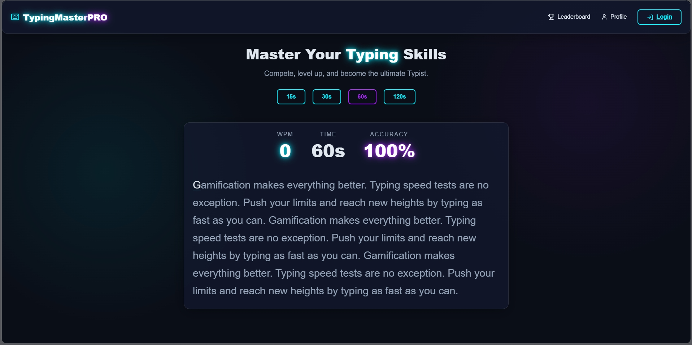 2. User Registration Page
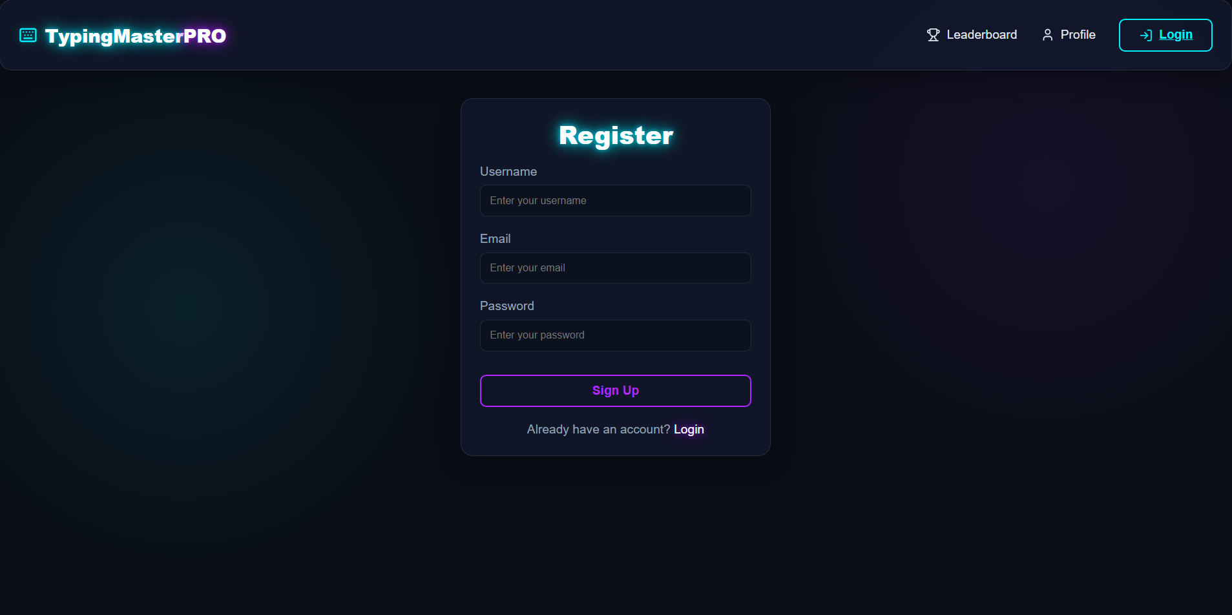

3. User Login Page
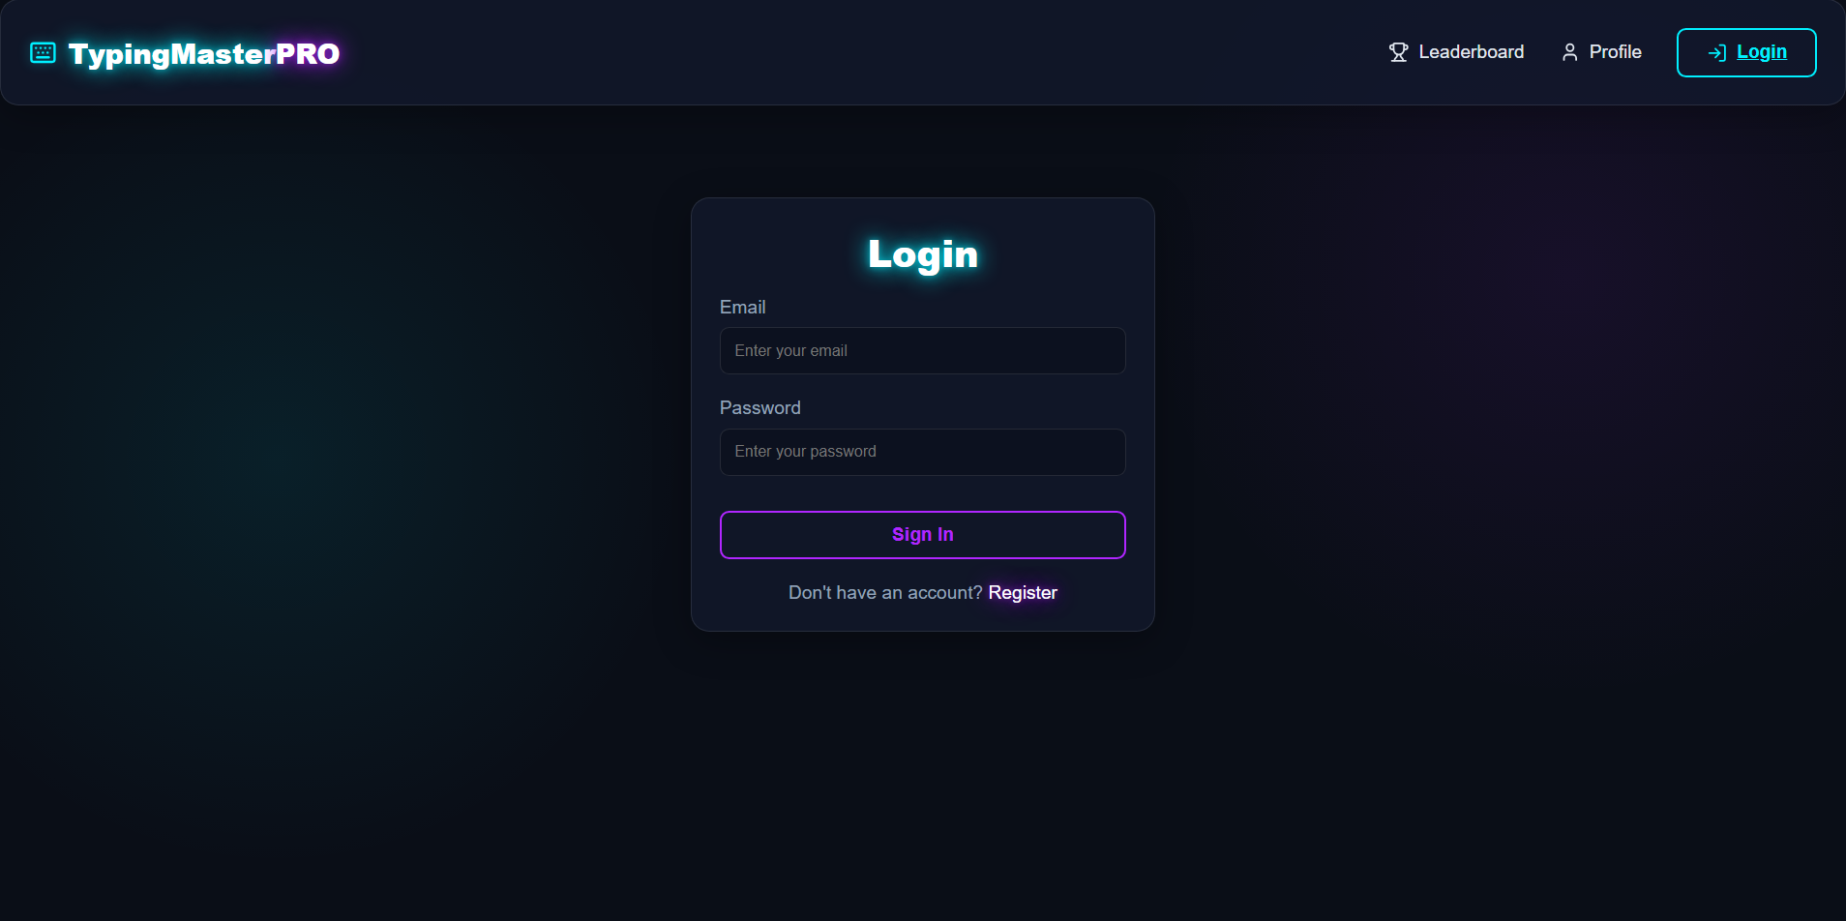 4. Typing Test Screen (Mid-Test)
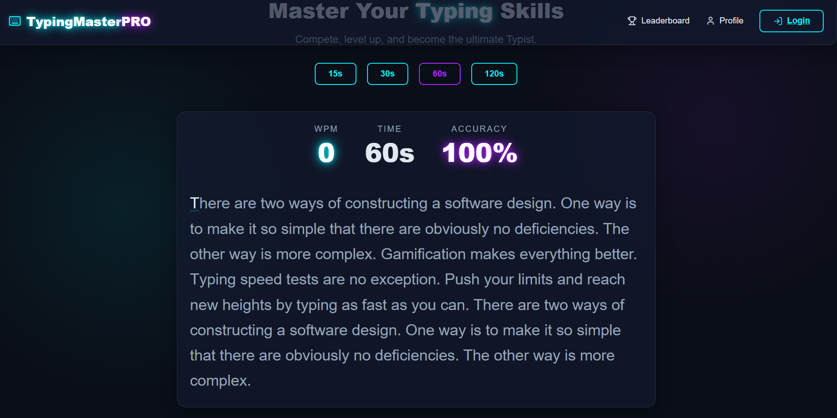

8.0 ADVANTAGES

The Typing Master Application offers several significant advantages over traditional typing training tools:
- Real-Time Performance Metrics: The application computes WPM, accuracy, and character error rate in real time, providing instant feedback that helps users identify and correct mistakes immediately.
- Cloud-Based Architecture: By using MongoDB Atlas and deploying on Vercel and Render, the application is accessible from anywhere in the world without requiring local installation.
- Secure Authentication: JWT-based authentication with bcrypt password hashing ensures that user data is secure and sessions are stateless, reducing server overhead.
- Personalized Progress Tracking: The dashboard allows users to track their improvement over time, view historical scores, and identify trends in their typing performance.
- Competitive Learning via Leaderboard: The global leaderboard gamifies the learning experience, motivating users to practice more and improve their rank.
- Scalability: The MERN stack and cloud deployment ensure the application can scale horizontally to support a growing user base without significant architectural changes.
- Modern Tech Stack: Built with React + Vite and Node.js, the application uses industry-standard technologies that are widely adopted and have strong community support.
- Responsive Design: The UI is fully responsive, ensuring a consistent and usable experience across desktop, tablet, and mobile devices.

9.0 LIMITATIONS

Despite its many strengths, the Typing Master Application has the following limitations:
- No Offline Mode: The application requires an active internet connection to function, as it depends on MongoDB Atlas and cloud-based backend services.
- Free-Tier Deployment Constraints: The backend is hosted on Render's free tier, which causes the server to spin down after periods of inactivity, resulting in a cold start delay of 15–30 seconds for the first request.
- Limited Typing Modes: Currently, the application only supports a single passage-based typing test. Future versions could include code typing, custom text, and timed challenge modes.
- No Real-Time Multiplayer: The application does not support real-time multiplayer typing races, which would significantly enhance the competitive aspect.
- Basic Analytics: The dashboard provides basic historical data but lacks advanced analytics such as error heatmaps, speed distribution charts, and daily practice goals.
- No Email Verification: The registration process does not include email verification, which could lead to spam registrations and compromise leaderboard integrity.

10.0 CONCLUSION

The Typing Master Application has been successfully designed, developed, tested, and deployed as a comprehensive MERN stack web application. The project demonstrates the effective application of modern web development technologies — React, Node.js, Express.js, and MongoDB — to create a practical and functional product that solves a real-world need.
The application provides users with an engaging and interactive platform to improve their typing skills through real-time feedback, performance tracking, and competitive leaderboards. The use of JWT-based authentication, cloud database storage, and cloud deployment makes the application secure, scalable, and globally accessible.
Throughout the six-week development cycle, the project followed an Agile methodology, iteratively building and refining features. Each sprint delivered working functionality, culminating in a production-ready deployment on Vercel and Render.
This project also served as a comprehensive learning experience, covering full-stack development, RESTful API design, database schema design, user authentication, cloud deployment, and software testing methodologies. The skills and knowledge gained through this project are directly applicable to real-world software engineering roles.
In conclusion, the Typing Master Application is a well-architected, feature-rich, and professionally deployed web application that fulfills all the stated objectives and serves as a strong demonstration of full-stack development competency.

11.0 FUTURE SCOPE

The Typing Master Application has significant potential for enhancement and expansion. The following features are planned for future development:
- Real-Time Multiplayer Mode: Implement WebSocket-based (Socket.io) real-time multiplayer typing races where users can compete head-to-head in real time.
- Advanced Analytics Dashboard: Add comprehensive analytics including error heatmaps, weekly/monthly progress charts, average speed trends, and personalized improvement recommendations.
- Custom Text & Code Typing Modes: Allow users to practice typing with custom text, code snippets (Python, JavaScript, Java), and programming challenges.
- Mobile Application: Develop a React Native mobile application for iOS and Android platforms, extending accessibility to mobile users.
- Email Verification & OTP: Add email verification during registration and OTP-based password reset functionality for enhanced account security.
- AI-Powered Error Analysis: Integrate an AI module that analyzes the user's most frequent typos and provides targeted exercises to address specific weaknesses.
- Achievement & Badge System: Introduce a gamification layer with achievements, badges, and milestone rewards to increase user engagement and retention.
- Multiple Language Support: Add support for typing practice in multiple languages including Hindi, French, German, and Spanish.
- Offline Progressive Web App (PWA): Convert the application to a Progressive Web App (PWA) with service worker caching to enable basic offline functionality.
- Subscription & Premium Tier: Introduce a premium subscription model with access to advanced features, detailed analytics, and an ad-free experience.

12.0 REFERENCES

The following references, documentation, and resources were consulted during the design, development, and documentation of the Typing Master Application:

[1] React Documentation, Meta Open Source. https://react.dev
[2] Vite Documentation, Vite Team. https://vitejs.dev
[3] Node.js Documentation, OpenJS Foundation. https://nodejs.org/en/docs
[4] Express.js Documentation, Express Community. https://expressjs.com
[5] MongoDB Atlas Documentation, MongoDB Inc.. https://www.mongodb.com/docs/atlas
[6] Mongoose Documentation, Mongoose Community. https://mongoosejs.com/docs
[7] JSON Web Tokens (JWT) — jwt.io, Auth0. https://jwt.io
[8] bcrypt.js — npm package, npm Registry. https://www.npmjs.com/package/bcryptjs
[9] Axios Documentation, Axios Community. https://axios-http.com/docs/intro
[10] Vercel Deployment Documentation, Vercel Inc.. https://vercel.com/docs
[11] Render Deployment Documentation, Render Inc.. https://render.com/docs
[12] Tailwind CSS Documentation, Tailwind Labs. https://tailwindcss.com/docs
[13] Postman API Testing, Postman Inc.. https://www.postman.com/docs
[14] MDN Web Docs — JavaScript Reference, Mozilla Foundation. https://developer.mozilla.org

