Real-Time Stocks Data Engineering Pipeline

Architecture Overview
API
↓
Kafka Producer
↓
Kafka Topic (stock-quotes)
↓
Kafka Consumer
↓
MinIO (Bronze - Raw JSON Storage)
↓
Airflow (Orchestration Layer)
├── Task 1: COPY INTO Snowflake RAW
└── Task 2: Run dbt Models (Bronze → Silver → Gold)
↓
Snowflake Data Warehouse
↓
Power BI Dashboard

Architecture Blueprint
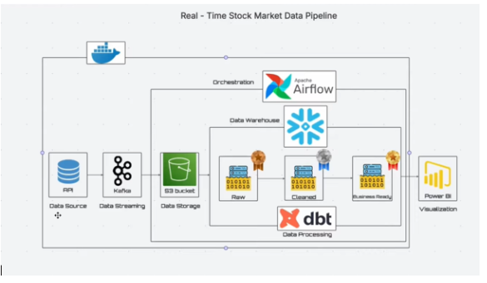

Power BI Dashboard Output
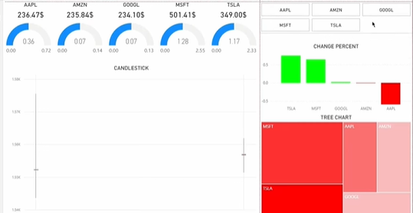

MinIO Bucket Setup (Important Step)
1. Open MinIO: http://localhost:9001
2. Login using credentials from docker-compose.
3. Click 'Create Bucket'.
4. Bucket name MUST match the name defined inside consumer.py (example: stock-raw-data).
5. Create bucket before starting the consumer.

Daily Startup Process
Terminal 1 – Start Infrastructure
cd C:\Users\lenovo\real-time-stocks-mds\infra
docker compose up -d
docker ps
Create Kafka Topic:
docker exec -it kafka kafka-topics --create --topic stock-quotes --bootstrap-server kafka:9092 --partitions 1 --replication-factor 1
Terminal 1 – Start Producer
cd C:\Users\lenovo\real-time-stocks-mds
venv\Scripts\activate
cd infra\producer
python producer.py
Terminal 2 – Start Consumer (Kafka → MinIO)
cd C:\Users\lenovo\real-time-stocks-mds
venv\Scripts\activate
cd infra\consumer
python consumer.py
Browser Verification
Kafka UI: http://localhost:9005
MinIO: http://localhost:9001
Airflow: http://localhost:8080
• Turn DAG ON
• Trigger DAG if required
Manual dbt Execution (Optional)
cd C:\Users\lenovo\real-time-stocks-mds\dbt_stocks\dbt_stocks
venv\Scripts\activate
dbt build

Snowflake Verification
USE DATABASE STOCKS_MDS;
USE SCHEMA COMMON;
SELECT COUNT(*) FROM bronze_stock_quotes_raw;
SELECT * FROM gold_kpi;

Tools Used – What | Why | How | Reusability
Docker
What: Containerization platform.
Why: Ensures consistent environments and runs distributed services reliably.
How: Used via docker-compose to run Kafka, MinIO, and Airflow.
Reusable: Any microservices or distributed data project.
Kafka
What: Distributed event streaming platform.
Why: Enables real-time stock data streaming.
How: Producer publishes to 'stock-quotes' topic; Consumer reads and processes.
Reusable: IoT systems, log pipelines, financial streaming systems.
MinIO
What: S3-compatible object storage.
Why: Stores raw JSON data (Bronze layer).
How: Consumer writes JSON files into configured bucket.
Reusable: Data lake storage layer in modern architectures.
Airflow
What: Workflow orchestration tool.
Why: Automates and schedules pipeline tasks.
How: DAG runs COPY INTO Snowflake + dbt transformations.
Reusable: ETL/ELT scheduling, ML pipelines, batch automation.
Snowflake
What: Cloud-based data warehouse.
Why: Stores structured, analytics-ready stock data.
How: RAW → Bronze → Silver → Gold transformation layers.
Reusable: Enterprise analytics and BI workloads.
dbt (Data Build Tool)
What: SQL-based transformation framework.
Why: Implements modular layered data modeling.
How: Builds Bronze staging, Silver cleaning, Gold KPI models.
Reusable: Modern ELT pipelines across cloud warehouses.
Power BI
What: Business Intelligence visualization tool.
Why: Creates interactive real-time stock dashboards.
How: Connects to Snowflake Gold tables for visualization.
Reusable: Executive dashboards, reporting, business analytics.

End of Day Shutdown
docker compose down
Press Ctrl + C in Producer & Consumer terminals

